Supplementary info: High rates of neurodevelopmental risk CNVs in patients with intellectual disabilities and co-morbid psychiatric disorders

ID Level
The Catalonia site used the K-BIT-II (Kauffman Brief Intelligence Test-II) and ABS-RC2 (Adaptive Behaviour Scale Residence Community-2) to establish the ID level. Only participants with mild and moderate ID were recruited to the study. In Leuven, the level of ID was determined retrospectively (using a combination of Wechsler Adult Intelligence Scale scores, special education level and residence data obtained from medical records). In England, formal IQ test scores (where available) were used in the first instance, followed by an age-equivalent receptive vocabulary score determined using the British Picture Vocabulary Scale 3 (BPVS3) assessment. This has been shown to correlate with IQ (1). Finally, the level of ID was taken from medical records in the absence of both IQ and BPVS3 test scores.

Additional phenotyping
The psychiatric diagnoses were translated from Diagnostic and Statistical Manual of Mental Disorders IV to ICD-10 criteria (with agreement between two psychiatrists). All participants were also assessed by either clinical genetic clinics or trained researchers for; dysmorphic features, co-morbid medical problems, and family history of ID and psychiatric disorders.

Genetics analysis
Samples from Catalonia were analysed using the 400K Agilent platform (Agilent Technologies, Santa Clara, California, USA) at the Genetics Laboratory, UDIAT-Centre Diagnòstic, Parc Taulí Hospital Universitari. Samples from Leuven were analysed on the CytoSure ISCA oligoarray set (OGT, Oxford, UK) at the Constitutional Cytogenetics Unit of the Center of Human Genetics. Samples from England were analysed on the NimbleGen 135K platform (87%) (Roche NimbleGen, Madison, Wisconsin, USA) and the Cytoscan 750K platform (13%) (Affymetrics, Santa Clara, California, USA) at the North East Thames Regional Genetics Service Laboratory. In Catalonia, microarrays were processed according to manufacturer's specifications and Agilent Workbench 5.0, Feature Extraction and Cytogenomics software (Agilent Technologies, Santa Clara, California, USA) were used to render image analysis using the manufacturer's recommended settings. They were called CNVs when there were at least five consecutive probes with a minimum log2 ratio of 0.25. In Leuven, the Oxford Gene Technology (OGT) CytoSure ISCA oligoarray set (OGT, Oxford, UK) was processed containing 180k DNA oligonucleotides with a minimum resolution of 200 kb. Microarray hybridization and copy number variant (CNV) analysis were performed according the manufacturer's instructions. In England, microarrays were processed and CNVs were reported using clinical diagnostic laboratory protocols, in keeping with the Association for Clinical Genetic Science (ACGS) Best Practice Guidelines.

References:
1. Glenn S, Cunningham C. Performance of young people with Down syndrome on the Leiter-R and British picture vocabulary scales. J Intellect Disabil Res. 2005; 49: 239–44.
2. Vogels, A. et al. Presenting symptoms in adults with the 22q11 deletion syndrome. Eur. J. Med. Genet. 57, 157–62 (2014).
3. Vanmarsenille, L. et al. Increased dosage of RAB39B affects neuronal development and could explain the cognitive impairment in male patients with distal Xq28 copy number gains. Hum. Mutat. 35, 377–83 (2014).
4. Denayer, A. et al. Neuropsychopathology in 7 Patients with the 22q13 Deletion Syndrome: Presence of Bipolar Disorder and Progressive Loss of Skills. Mol. Syndromol. 3, 14–20 (2012).
5. Hannes, F. D. et al. Recurrent reciprocal deletions and duplications of 16p13.11: the deletion is a risk factor for MR/MCA while the duplication may be a rare benign variant. J. Med. Genet. 46, 223–232 (2009).

Supplementary Table 1: Neurodevelopmental Risk CNV calling criteria
Hg19 positions and calling criteria, adopted from Kendall et al. (13)
Locus Name | Critical Region | Calling Criteria
1p36 del | chr1:0-2500000 | Size >50% of critical region, affecting GABRD
1p36 dup | chr1:0-2500000 | Size >50% of critical region, affecting GABRD
TAR del | chr1:145394955-145807817 | Size >50% of critical region
TAR dup | chr1:145394955-145807817 | Size >50% of critical region
1q21.1 del | chr1:146527987-147394444 | Size >50% of critical region
1q21.1 dup | chr1:146527987-147394444 | Size >50% of critical region
1q24 del | chr1:169680333-173303337 | Size >50% of critical region
NRXN1 del | chr2:50145643-51259674 | Exonic deletions
2p15-16.1 proximal dup | chr2:61245288-61414572 | Size >50% of critical region
2q11.2 del | chr2:96742409-97677516 | Size >50% of critical region, affecting both LMAN2L and ARID5A
2q13 del | chr2:111394040-112012649 | Size >50% of critical region
2q13 dup | chr2:111394040-112012649 | Size >50% of critical region
2q33.1 (SATB2) del | chr2:200134224-200325255 | Size >50% of critical region
2q37 (HDAC4) del | chr2:239716679-243199373 | Size >50% of critical region, affecting HDAC4
3p25.3 (JAGN1 to TATDN2) dup | chr3:9932271-10322902 | Size >50% of critical region
3p11.2 (CHMP2B to POU1F1) del | chr3:87267612-87531631 | Size >50% of critical region
3q13 (GAP43) del | chr3:115332334-115504038 | Size >50% of critical region
3q28-29 (FGF12) del | chr3:191859728-192126012 | Size >50% of critical region
3q29 del | chr3:195720167-197354826 | Size >50% of critical region
Wolf-Hirschhorn del | chr4:1552030-2091303 | Size >50% of critical region
Wolf-Hirschhorn dup | chr4:1552030-2091303 | Size >50% of critical region
4q21 (BMP3) del | chr4:81945477-81985327 | Size >50% of critical region
5q14 (MEF2C) del | chr5:88011654-88200703 | Size >50% of critical region
Sotos syndrome del | chr5:175720924-177052594 | Size >50% of critical region
Williams-Beuren syndrome del | chr7:72744915-74142892 | Size >50% of critical region
WBS dup | chr7:72744915-74142892 | Size >50% of critical region
8p23.1 del | chr8:8098990-11872558 | Size >26.5% of critical region (equal to min 1Mb affected)
8p23.1 dup | chr8:8098990-11872558 | Size >26.5% of critical region (equal to min 1Mb affected)
9p13 dup | chr9:32648800-38808255 | Size >50% of critical region
9q34 dup | chr9:138460697-141036426 | Size >38.8% of critical region (equal to min 1Mb affected)
10q11.21q11.23 dup | chr10:49390199-51058796 | Size >50% of critical region
10q23 del | chr10:82045472-88931651 | Size > 14.5% of critical region (equal to min 1Mb affected), including NRG3 and GRID1
Potocki-Shaffer syndrome del | chr11:43940000-46020000 | Size >50% of critical region, including EXT2
12p13 dup | chr12:6471959-6825955 | Size >50% of critical region
PWS/AS del | chr15:22805313-28390339 | Size > 71.6% of critical region (equal to min 4Mb affected)
PWS/AS dup | chr15:22805313-28390339 | Size > 71.6% of critical region (equal to min 4Mb affected)
15q11.2 BP1-BP2 del | chr15:22805313-23094530 | Size >50% of critical region
15q13.3 del | chr15:31080645-32462776 | Size >50% of critical region
15q24 del | chr15:72900171-78151253 | Size >50% of critical region
15q24 dup | chr15:72900171-78151253 | Size >50% of critical region
15q25 del | chr15:85139815-85716624 | Size >50% of critical region
16p13.11 del | chr16:15511655-16293689 | Size >50% of critical region
16p13.11 dup | chr16:15511655-16293689 | Size >50% of critical region
16p12.1 del | chr16:21950135-22431889 | Size >50% of critical region
16p11.2 distal del | chr16:28823196-29046783 | Size >50% of critical region
16p11.2 distal dup | chr16:28823196-29046783 | Size >50% of critical region
16p11.2 del | chr16:29650840-30200773 | Size >50% of critical region
16p11.2 dup | chr16:29650840-30200773 | Size >50% of critical region
17p13.3 del | chr17:1247834-2588909 | Exonic deletions; whole gene duplications
17p13.3 dup | chr17:1247834-2588909 | Exonic deletions; whole gene duplications
Smith-Magenis syndrome del | chr17:16812771-20211017 | Size >50% of critical region
Potocki-Lupski syndrome dup | chr17:16812771-20211017 | Size >50% of critical region
17q11.2 del | chr17:29107491-30265075 | Size >50% of critical region, affecting NF1
17q11.2 dup | chr17:29107491-30265075 | Size >50% of critical region, affecting NF1
17q12 del | chr17:34815904-36217432 | Size >50% of critical region
17q12 dup | chr17:34815904-36217432 | Size >50% of critical region
17q21.31 del | chr17:43705356-44164691 | Size >50% of critical region
22q11.2 del | chr22:19037332-21466726 | Size >50% of critical region
22q11.2 dup | chr22:19037332-21466726 | Size >50% of critical region
distal 22q11.2 del | chr22:21920127-23653646 | Size >50% of critical region
distal 22q11.2 dup | chr22:21920127-23653646 | Size >50% of critical region
Phelan-McDermid syndrome del | chr22:51113070-51171640 | Size >50% of critical region
Phelan-McDermid syndrome dup | chr22:51113070-51171640 | Size >50% of critical region

Supplementary Table 2: Reclassification of between site descrepancies
CNV regions which were reclassified due to discrepancies between sites, PubMed IDs (PMID) link to manuscripts describing pathogenicity.
CNV region | Inital classification | Re-classification | Reason for re-classification
2p16.3(50,882,091-50,949,412)x0 | VOUS likely pathogenic | VOUS likely benign | Non-exonic NRXN1 CNV - no literature proof of pathogenicity
2p16.3(50,937,464-51,029,090)x0 | VOUS likely pathogenic | VOUS likely benign | Non-exonic NRXN1 CNV - no literature proof of pathogenicity
15q11.2(22,698,579-23,249,693)x0 | VOUS likely pathogenic | Pathogenic | Literature evidence of pathogenicity. PMIDs: 21359847, 25689425
15q11.2(22,753,658-23,084,392)x0 | VOUS likely pathogenic | Pathogenic | Literature evidence of pathogenicity. PMIDs: 21359847, 25689425
15q11.2(22,753,658-23,187,967)x0 | VOUS likely pathogenic | Pathogenic | Literature evidence of pathogenicity. PMIDs: 21359847, 25689425
15q13.2q13.3(30,419,801-32,861,612)x0 | VOUS likely pathogenic | Pathogenic | Literature evidence of pathogenicity. PMIDs: 25077648, 26997942
16p11.2(29,652,360-30,199,696)x0 | VOUS likely pathogenic | Pathogenic | Literature evidence of pathogenicity. PMIDs: 19914906, 25064419
16p11.2(29,652,360-30,199,696)x3 | VOUS likely pathogenic | Pathogenic | Literature evidence of pathogenicity. PMIDs: 19914906, 26629640
16p13.12p12.3(14,622,055-17,409,257)x3 | VOUS likely pathogenic | Pathogenic | Literature evidence of pathogenicity. PMIDs: 21614007, 21150890

Supplementary Table 3: Full descriptive summary of GENMID Cohort
Info from the three sites Catalonia, Leuven and England. Including summary of all psychiatric diagnoses found in ten or more individuals.
 | GENMID | Catalonia | Leuven | England
Demographics
N | 599 | 80 | 272 | 247
Ratio (Male/Female) | 1.7 (376/223) | 0.9 (38/42) | 2.1 (184/88) | 1.7 (154/93)
Mean age (std.dev) | 43.2 (14.1) | 37.1 (9.8) | 46.2 (14.5) | 41.9 (14.1)
ID Level
Mild | 49.2% | 63.7% | 66.9% | 25.1%
Severe | 50.8% | 36.2% | 33.1% | 74.9%
Psychiatric diagnoses
Average number of co-morbid diagnoses (range) | 1.6 (1-5) | 1.8 (1-3) | 1.4 (1-4) | 1.7 (1-5)
F84 Pervasive developmental disorders | 148 (25%) | 9% | 22% | 32%
F29 Unspecified nonorganic psychosis | 121 (20%) | 12% | 30% | 12%
F61 Mixed and other personality disorders | 108 (18%) | 0% | 36% | 4%
Challenging behaviours | 95 (16%) | 62% | 1% | 17%
F32 Depressive episode | 86 (14%) | 4% | 3% | 30%
F41 Other anxiety disorders | 60 (10%) | 6% | 1% | 21%
F20 Schizophrenia | 49 (8%) | 4% | 8% | 9%
F31 Bipolar affective disorder | 47 (8%) | 2% | 7% | 11%
F90 Hyperkinetic disorders | 41 (7%) | 6% | 4% | 10%
F42 Obsessive-compulsive disorder | 37 (6%) | 16% | 1% | 9%
F43 Reaction to severe stress and adjustment disorders | 27 (5%) | 19% | 4% | 0%
F39 Unspecified mood disorder | 25 (4%) | 0% | 9% | 0%

Supplementary table 4: Likely pathogenic CNVs
Genetic and phenotypic data for participants with recurrent likely pathogenic CNVs. del = deletion, dup = duplication.
loci | chr | start | stop | size [Mb] | type | overlap group | Psychiatric Diagnosis (ICD-10) | ID Level
1q21.1 | 1 | 143709609 | 143972412 | 0.263 | del | 1 | F31 Bipolar affective disorder, F84 Pervasive developmental disorders | severe
1q21.1 | 1 | 143709609 | 143972412 | 0.263 | del | 1 | F29 Unspecified nonorganic psychosis, F31 Bipolar affective disorder | severe
1q21.1 | 1 | 143902282 | 143972412 | 0.070 | del | 1 | F29 Unspecified nonorganic psychosis, F61 Mixed and other personality disorders | severe
1q21.2 | 1 | 147471984 | 148773178 | 1.301 | del | 2 | F32 Depressive episode, F41 Other anxiety disorders, F90 Hyperkinetic disorders | severe
1q21.2 | 1 | 147727771 | 147825519 | 0.098 | del | 2 | F43 Reaction to severe stress and adjustment disorders, F84 Pervasive developmental disorders, F90 Hyperkinetic disorders | mild
1q32.1 | 1 | 206485595 | 206555480 | 0.070 | dup | 3 | Challenging behaviours, STEREotypies, F42 Obsessive-compulsive disorder | severe
1q32.1 | 1 | 206485595 | 206555480 | 0.070 | del | 3 | F29 Unspecified nonorganic psychosis, F32 Depressive episode | severe
3p26.3 | 3 | 606100 | 1330109 | 0.724 | dup | 4 | Challenging behaviours | mild
3p26.3 | 3 | 1313271 | 1571571 | 0.258 | dup | 4 | F20 Schizophrenia, F61 Mixed and other personality disorders | mild
5q22.2 | 5 | 111619275 | 111732130 | 0.113 | del | 5 | F29 Unspecified nonorganic psychosis | mild
5q22.2 | 5 | 111666656 | 111718078 | 0.051 | del | 5 | F20 Schizophrenia, F42 Obsessive-compulsive disorder | mild
7q31.1 | 7 | 111112186 | 111255558 | 0.143 | del | 6 | Challenging behaviours, F42 Obsessive-compulsive disorder, F84 Pervasive developmental disorders | severe
7q31.1 | 7 | 111198987 | 111280493 | 0.082 | del | 6 | F43 Reaction to severe stress and adjustment disorders | severe
9q21.32q21.33 | 9 | 86763706 | 87406685 | 0.643 | dup | 7 | F31 Bipolar affective disorder | severe
9q21.32q21.33 | 9 | 86763706 | 87406685 | 0.643 | dup | 7 | F29 Unspecified nonorganic psychosis | mild
14q11.2 | 14 | 21567757 | 21856165 | 0.288 | dup | 8 | F20 Schizophrenia | severe
14q11.2 | 14 | 21740360 | 21963670 | 0.223 | del | 8 | F31 Bipolar affective disorder | severe
14q11.2 | 14 | 21819565 | 22003106 | 0.184 | dup | 8 | F84 Pervasive developmental disorders | severe
15q26.1 | 15 | 93357856 | 93536293 | 0.178 | del | 9 | F25 Schizoaffective disorder, F32 Depressive episode | severe
15q26.1 | 15 | 93521186 | 93536293 | 0.015 | dup | 9 | Challenging behaviours, F31 Bipolar affective disorder | mild
16p13.2 | 16 | 8911412 | 8942774 | 0.031 | dup | 10 | F61 Mixed and other personality disorders | mild
16p13.2 | 16 | 8925643 | 9274514 | 0.349 | dup | 10 | F20 Schizophrenia, F61 Mixed and other personality disorders | mild
17p13.1 | 17 | 6945270 | 7477779 | 0.533 | dup | 11 | F84 Pervasive developmental disorders | severe
17p13.1 | 17 | 7394349 | 7890163 | 0.496 | dup | 11 | F61 Mixed and other personality disorders | mild
18q23 | 18 | 77444688 | 78012819 | 0.568 | dup | 12 | F84 Pervasive developmental disorders | severe
18q23 | 18 | 77466468 | 77887649 | 0.421 | dup | 12 | F32 Depressive episode, F61 Mixed and other personality disorders | mild
20q11.21 | 20 | 31057960 | 49418758 | 18.361 | del | 13 | F84 Pervasive developmental disorders, F32 Depressive episode | severe
20q11.23 | 20 | 35192298 | 35208091 | 0.016 | del | 13 | F84 Pervasive developmental disorders | mild
20q13.12 | 20 | 43275709 | 43278342 | 0.003 | del | 14 | F61 Mixed and other personality disorders | severe
Xp22.33 | 23 | 60701 | 506573 | 0.446 | del | 15 | F84 Pervasive developmental disorders | severe
Xp22.33 | 23 | 296510 | 421339 | 0.125 | dup | 15 | Challenging behaviours | severe
Xq28 | 23 | 153030700 | 153104476 | 0.074 | dup | 16 | F23 Acute and transient psychotic disorders, F41 Other anxiety disorders, F42 Obsessive-compulsive disorder | severe
Xq28 | 23 | 153064834 | 153165618 | 0.101 | del | 16 | F31 Bipolar affective disorder | severe
Xq28 | 23 | 153127807 | 153154891 | 0.027 | dup | 16 | F32 Depressive episode, F84 Pervasive developmental disorders | mild

Supplementary table 5: Carriers of neurodevelopmental risk CNVs
Participants with CNVs at neurodevelopmental risk loci as described in Rees et al. 2016. N Expected, number of carriers we would expect based on ID/ASD frequencies (Rees et al. 2016) of the loci and our sample size of 599 participants, Rate(%) in GENMID and ID/ASD samples, ID level, other identified pathogenic CNVs and psychiatric diagnosis of the GENMID carriers.
Locus | N Observed | N Expected | GENMID rate(%) | ID/ASD rate(%) | ID Level | Other pathogenic CNVs | Diagnosis
22q11.2 del | 7 | 3.8 | 1.2 | 0.629 | Severe (4), Mild (3) | 2p16.3 del | F29 Unspecified nonorganic psychosis (3), F61 Mixed and other personality disorders (3), F31 Bipolar affective disorder (2), F39 Unspecified mood disorder (1)
15q11.2 PWS/AS dup | 6 | 0.7 | 1.0 | 0.122 | Mild (5), Severe (1) |  | F84 Pervasive developmental disorders (3), Challenging behaviours (2), F29 Unspecified nonorganic psychosis (1), F31 Bipolar affective disorder (1), F39 Unspecified mood disorder (1), F40 Phobic anxiety disorders (1), F61 Mixed and other personality disorders (1), F91 Conduct disorder (1)
15q13.3 del | 5 | 1.3 | 0.8 | 0.218 | Mild (4), Severe (1) |  | F32 Depressive episode (2), F41 Other anxiety disorders (2), Challenging behaviours (1), F29 Unspecified nonorganic psychosis (1), F31 Bipolar affective disorder (1), F84 Pervasive developmental disorders (1), F94 Disorders of social functioning with onset specific to childhood and adolescence (1)
16p11.2 dup | 5 | 1.4 | 0.8 | 0.236 | Severe (5) |  | F84 Pervasive developmental disorders (3), F32 Depressive episode (2), F25 Schizoaffective disorder (1), F29 Unspecified nonorganic psychosis (1), F42 Obsessive-compulsive disorder (1), F90 Hyperkinetic disorders (1)
2p16.3 NRXN1 del | 4 | 0.6 | 0.7 | 0.103 | Mild (2), Severe (2) | 22q11.21 del | F31 Bipolar affective disorder (2), Challenging behaviours (1), F22 Delusional disorder (1), F29 Unspecified nonorganic psychosis (1), F61 Mixed and other personality disorders (1)
15q11.2 BP1-BP2 del | 4 | 3.7 | 0.7 | 0.625 | Mild (2), Severe (2) | Xp22.31 del | F29 Unspecified nonorganic psychosis (1), F31 Bipolar affective disorder (1), F41 Other anxiety disorders (1), F61 Mixed and other personality disorders (1)
16p12.1 del | 4 | 0.7 | 0.7 | 0.124 | Mild (3), Severe (1) |  | F20 Schizophrenia (1), F23 Acute and transient psychotic disorders (1), F29 Unspecified nonorganic psychosis (1), F43 Reaction to severe stress and adjustment disorders (1), F61 Mixed and other personality disorders (1), F90 Hyperkinetic disorders (1)
22q13.33 Phelan-McDermid del | 3 | 0.9 | 0.5 | 0.148 | Severe (3) |  | F84 Pervasive developmental disorders (2), Challenging behaviours (1), F29 Unspecified nonorganic psychosis (1), F31 Bipolar affective disorder (1)
1q21.1 TAR dup | 2 | 0.9 | 0.3 | 0.155 | Mild (1), Severe (1) |  | F20 Schizophrenia (1), F43 Reaction to severe stress and adjustment disorders (1), F84 Pervasive developmental disorders (1), F90 Hyperkinetic disorders (1)
4p16.3 Wolf-Hirschhorn dup | 2 | 0.2 | 0.3 | 0.038 | Mild (1), Severe (1) | 12p13.33p13.32 del | F29 Unspecified nonorganic psychosis (1), F84 Pervasive developmental disorders (1)
7q11.23 WBS dup | 2 | 0.5 | 0.3 | 0.076 | Mild (2) |  | F39 Unspecified mood disorder (1), F61 Mixed and other personality disorders (1), F90 Hyperkinetic disorders (1)
16p13.11 dup | 2 | 1.6 | 0.3 | 0.275 | Mild (1), Severe (1) |  | Challenging behaviours (1), F29 Unspecified nonorganic psychosis (1)
16p11.2 distal del | 2 | 0.6 | 0.3 | 0.094 | Mild (1), Severe (1) |  | F23 Acute and transient psychotic disorders (1), F29 Unspecified nonorganic psychosis (1)
16p11.2 del | 2 | 2.1 | 0.3 | 0.347 | Severe (2) |  | F29 Unspecified nonorganic psychosis (1), F41 Other anxiety disorders (1)
22q11.2 dup | 2 | 1.6 | 0.3 | 0.260 | Mild (1), Severe (1) |  | F20 Schizophrenia (1), F29 Unspecified nonorganic psychosis (1)
1q21.1 del | 1 | 1.2 | 0.2 | 0.201 | Mild (1) |  | F32 Depressive episode (1), F41 Other anxiety disorders (1)
2q13 del | 1 | 0.3 | 0.2 | 0.057 | Mild (1) |  | F84 Pervasive developmental disorders (1)
8p23.1 dup | 1 | 0.1 | 0.2 | 0.017 | Severe (1) |  | F39 Unspecified mood disorder (1), F61 Mixed and other personality disorders (1)
15q11.2 PWS/AS del | 1 | 1.2 | 0.2 | 0.197 | Severe (1) |  | F41 Other anxiety disorders (1)
16p13.11 del | 1 | 0.9 | 0.2 | 0.142 | Mild (1) |  | F61 Mixed and other personality disorders (1)
16p11.2 distal dup | 1 | 0.5 | 0.2 | 0.083 | Mild (1) |  | Challenging behaviours (1)
17p11.2 Potocki-Lupski dup | 1 | 0.3 | 0.2 | 0.055 | Mild (1) |  | F61 Mixed and other personality disorders (1)
17q11.2 NF1 del | 1 | 0.2 | 0.2 | 0.039 | Severe (1) |  | Challenging behaviours (1), F84 Pervasive developmental disorders (1)
Total | 60 | 38.8 | 10.0 | 6.512

Supplementary table 6: Clinically pathogenic CNVs not described in the literature associated CNVs
CNVs identified as pathogenic by clinical genetics services not described as ID associated loci in Rees et al 2016.
Id | Position | Size [Mb] | Psychiatric Diagnosis (ICD-10) | ID Level
ID 1 | 3q29(195,740,402-197,322,923)x3 | 1.6 | F29 Unspecified nonorganic psychosis, F61 Mixed and other personality disorders | mild
ID 2 | 4q34.3q35.2(182,074,317-190,807,379)x0 | 8.7 | F31 Bipolar affective disorder | severe
ID 3 | 5q14.3(90,098,388-98,399,833)x1 | 8.3 | F32 Depressive episode, F33 Recurrent depressive episodes, F41 Other anxiety disorders | mild
ID 4 | 6p25.3(195,429-7,392,549)x3 | 7.2 | F25 Schizoaffective disorder | mild
ID 5 | 9q21.11q21.13(71,031,677-76,816,695)x0 | 5.8 | F20 Schizophrenia | severe
ID 6 | 9q31.1q32(107056010-115867141)x1 | 8.8 | Challenging behaviours, F40 Phobic anxiety disorders, F43 Reaction to severe stress and adjustment disorders | severe
ID 7 | 10q26.12q26.3(122259702-135434178)x1 | 13.2 | Challenging behaviours, F42 Obsessive-compulsive disorder, F90 Hyperkinetic disorders | severe
ID 8 | 12p13.33p13.32(162,578-4,109,244)x0dn | 3.9 | F29 Unspecified nonorganic psychosis | severe
ID 9 | 12p13.1(13,754,549-13,762,809)x3 | 0.0 | Challenging behaviours | severe
ID 10 | 12p12.1(023432294-026233996)x1 | 2.8 | Challenging behaviours, F29 Unspecified nonorganic psychosis | mild
ID 11 | 12q21.2(79,534,629-84,535,827)x1 | 5.0 | F20 Schizophrenia | mild
ID 12 | 13q32.3(100,465,759-109,578,071)x3 | 9.1 | F84 Pervasive developmental disorders, F90 Hyperkinetic disorders | mild
ID 13 | 13q33.3q34(109,847,503-115,105,655)x1 | 5.3 | F61 Mixed and other personality disorders | mild
ID 14 | 15q11.2(24,826,468-25,342,534)x0 | 0.5 | F61 Mixed and other personality disorders | mild
ID 15 | 15q12(26,587,699-29,576,869)x1 | 3.0 | Obsessive traits, F84 Pervasive developmental disorders, F90 Hyperkinetic disorders | severe
ID 7 | 15q26.3(099168589-102480888)x3 | 3.3 | Challenging behaviours, F42 Obsessive-compulsive disorder, F90 Hyperkinetic disorders | severe
ID 16 | 19q13.32(45,741,741-47,268,131)x1 | 1.5 | F31 Bipolar affective disorder | severe
ID 17 | Xp22.33(1-155,270,560)x3 | 155.3 | F32 Depressive episode | mild
ID 18 | Xp22.33p11.22(169901-51101339)x3 | 50.9 | Challenging behaviours | severe
ID 19 | Xp22.31(6,451,638-8,139,295)x0 | 1.7 | F41 Other anxiety disorders | mild
ID 20 | Xp21.3p11.4(025816432-038085678)x2 | 12.3 | Damage and dysfunction, Challenging behaviours, F07 Personality and behavioural disorders due to brain disease, Damage and dysfunction | mild
ID 21 | Xq22.1(chrX:100,715,263-106,935,836)x1 | 6.2 | Challenging behaviours | severe
ID 22 | Xq24(118,883,247-123,283,287)x3 | 4.4 | Challenging behaviours | severe
ID 18 | Xq25q28(124642297-155227312)x1 | 30.6 | Challenging behaviours | severe
ID 17 | Y(1-59,373,566)x3 | 59.4 | F32 Depressive episode | mild

Supplementary figures

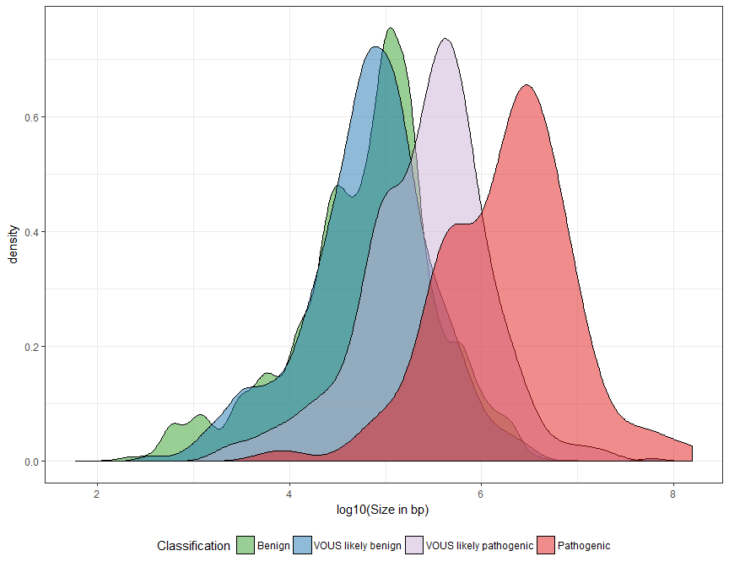
Supplementary figure 1: Size distribution of GENMID CNVs by classification of pathogenicity.
VOUS = Variant of unknown significance. The table below show size difference between pathogenic and other classified CNVs. Welch two sample t-test was performed to compare difference in mean between groups.
Group A | Group B | Mean A (Mb) | Mean B (Mb) | Difference (95% CI) | p-value
Pathogenic | VOUS likely pathogenic | 6.36 | 0.71 | 5.65(1.6-9.7) | 0.0073
Pathogenic | VOUS likely benign | 6.36 | 0.28 | 6.08(2-10) | 0.0039
Pathogenic | Benign | 6.36 | 0.19 | 6.17(2.1-10) | 0.0035
VOUS likely pathogenic | VOUS likely benign | 0.71 | 0.28 | 0.43(0.1-0.78) | 0.011
VOUS likely pathogenic | Benign | 0.71 | 0.19 | 0.52(0.25-0.8) | 0.00024
VOUS likely benign | Benign | 0.28 | 0.19 | 0.09(0.11-0.28) | 0.4
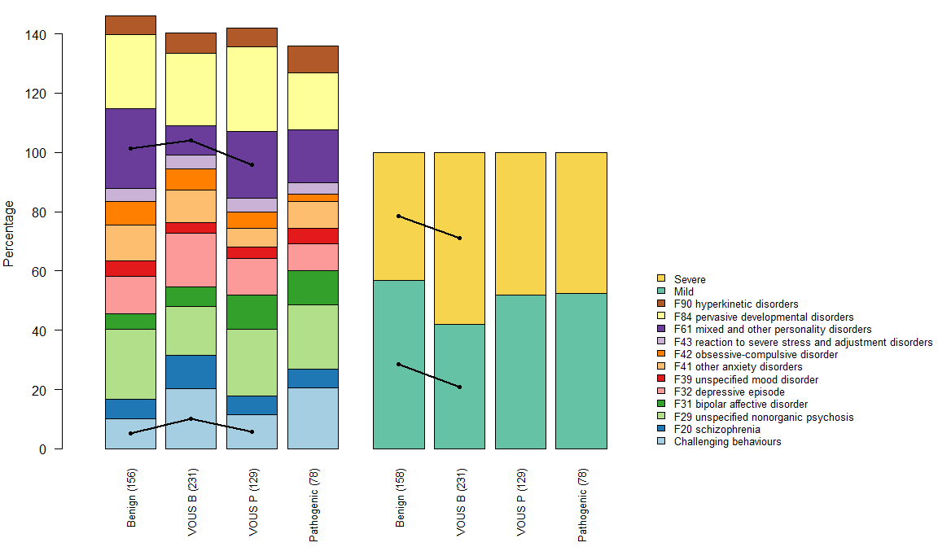

Supplementary Figure 2: Association between CNV pathogenicity, diagnostic groups and ID severity
Bars 1-4 show the diagnostic rates of all diagnoses with 10 or more affected, for carriers with benign, variant of unknown significance likely benign (VOUS B), VOUS likely pathogenic (VOUS P) and pathogenic CNVs, as defined by the diagnostic services. Bars 5-8 show the frequency of mild and severe ID for individuals with benign, VOUS B, VOUS P and pathogenic CNVs. Lines indicate nominal statistical difference between groups P-value < 0.05 only adjacent groups within bar 1-4 and 5-8 have been tested.
Results for all group differences that showed a nominal statistically significant difference (p<0.05), 84 pairwise comparisons were done. Based on comparisons between diagnostic rates of all diagnoses with 10 or more affected and ID severity, for carriers with benign, Variant of unknown significance likely benign (VOUS B), VOUS likely pathogenic (VOUS P) and pathogenic CNVs.
Group1 | Group2 | Diagnosis/ID-level | Estimate | p-value
Benign | VOUS B | Challenging behaviours | 0.45 | 1.11e-02
Benign | VOUS B | F61 mixed and other personality disorders | 3.32 | 2.35e-05
VOUS B | VOUS P | Challenging behaviours | 1.94 | 4.14e-02
VOUS B | VOUS P | F61 mixed and other personality disorders | 0.38 | 1.67e-03
Benign | VOUS B | mild | 1.83 | 3.91e-03
Benign | VOUS B | severe | 0.55 | 3.91e-03

