Supplementary Fig. 1 ABC-C_{t} score over 12 months.

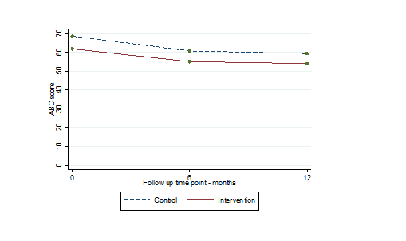6

Supplementary Table 1 Sensitivity and exploratory multivariate analyses

Model | Difference | 95% CI | P-value
Sensitivity analyses
Primary model | -2·14 | (-8·79, 4·51) | 0·528
Area deprivation | -2·39 | (-9·19 ,4·41) | 0·491
Completed by family/paid carer | -1·21 | (-8·20 ,5·79) | 0·735
Missing data (BOCF) | -1·83 | (-8·42, 4·76) | 0·586
Heteroscedastic model | -2·35 | (-9·24, 4·55) | 0·505
Imbalance in baseline characteristics | -0·81 | (-7·95, 6·32) | 0·824
% of participants who had at least one intervention component (e.g. plan, observations, goodness of fit) | 1.41 | (-15.5, 18.3) | 0.870
Multivariate analysis (ABC-C subdomains)
Irritability, Agitation, Crying | -0.041 | (-0.22, 0.14)
Lethargy, Social Withdrawal | -0.016 | (-0.22, 0.19)
Stereotypic Behaviour | -0.050 | (-0.25, 0.14)
Hyperactivity, Non-compliance | -0.049 | (-0.23, 0.13)

Supplementary Table 2 Secondary outcomes over 12 months

 | Descriptive: N (%) |  |  | Analysis over 12 months
 | Baseline | 6 Months | 12 Months | N_{su} | Odds Ratio/  Difference | 95% CI
Service users
Mini-PASADD | N (%) | N (%) | N (%)
Common mental disorder
Control | 61 (46) | 43 (37) | 54 (44) | 230 | 1·07 | (0·61, 1·87)
Intervention | 56 (52) | 45 (46) | 42 (42)
Severe mental illness (SMI)
Control | 27 (20) | 13 (11) | 21 (17) | 229 | 1·24 | (0·32, 4·81)
Intervention | 20 (19) | 17 (18) | 15 (15)
Autistic spectrum
Control | 31 (23) | 31 (27) | 40 (33) | 230 | 0·70 | (0·26, 1·88)
Intervention | 19 (18) | 24 (24) | 22 (22)
GCPLA | Median (IQR) | Median (IQR) | Median (IQR)
Range
Control | 17 (12, 22) | 16.5 (13, 21) | 17 (13, 21) | 232 | 0·587 | (-0·57, 1·74)
Intervention | 19 (13, 23·5) | 19 (14, 23) | 17 (13·5, 22)
Busy
Control | 10 (7, 13) | 11 (7, 13) | 11 (8, 13) | 232 | 0·377 | (-0·59, 1·34)
Intervention | 11 (8, 15) | 11 (8, 14) | 12 (8, 14)
Family carers | Median (IQR) | Median (IQR) | Median (IQR)
Uplift
Control | 15 (13, 17) | 15 (12, 17) | 15 (13, 17)
Intervention | 14 (13, 16) | 15 (14, 17) | 15 (13, 16)
Burden
Control | 33 (28, 39) | 31 (25, 36) | 30 (25, 39)
Intervention | 28 (26, 31) | 29 (25·5, 32·5) | 30 (28, 32·5)
GHQ score
Control | 4 (1, 8) | 4 (2, 7) | 3 (1, 6)
Intervention | 3 (0, 4) | 2·5 (1, 6.5) | 2 (0, 3)
Paid carers | Median (IQR)
CDS*
Control | 24 (15, 37)
Intervention | 21 (13, 31)

*Respondents changed over the 12 months, consequently the trends are not provided

