Data supplement to Lorant et al. Socioeconomic inequalities in suicide in Europe.
Br J Psychiatry doi: 10.1192/bjp.bp.117.200543

Table DS1 Educational inequalities in suicide per population and period among men: relative index of inequality and slope index of inequality, 15 European populations.
Population | Relative index of inequality (RII) and 95%CI |  |  |  |  | Slope index of Inequality (SII) and 95%CI
 | 1991–1995‡ |  | 2001–2005‡ |  | P value § | 1991–1995‡ |  | 2001–2005‡ |  | P value §
All Populations¶ | 1.42 | ( 1.22, 1.66) | 1.37 | ( 1.15, 1.63) | 0.329 | 13.1 | ( 7.42,18.59) | 11.3 | ( 4.95,17.56) | 0.342
Austria | 1.60 | ( 1.36, 1.88) | 1.43 | ( 1.17, 1.73) | 0.089 | 19.9 | (13.23,26.25) | 12.7 | ( 5.76,19.34) | 0.067
Belgium | 1.28 | ( 1.14, 1.44) | 1.38 | ( 1.16, 1.65) | 0.175 | 10.1 | ( 5.35,14.73) | 12.1 | ( 5.53,18.49) | 0.309
Denmark | 1.20 | ( 1.07, 1.35) | 1.30 | ( 1.12, 1.50) | 0.169 | 7.8 | ( 2.90,12.59) | 6.6 | ( 2.92,10.19) | 0.351
England & Wales | 2.98 | ( 1.55, 5.72) | 1.60 | ( 0.94, 2.73) | <.001 | 10.9 | ( 4.72,15.40) | 5.4 | (-0.75,10.88) | 0.087
Estonia | 2.09 | ( 1.71, 2.56) | 1.57 | ( 1.24, 1.99) | <.001 | 45.0 | (33.36,55.79) | 35.2 | (17.21,52.30) | 0.179
Finland | 1.45 | ( 1.16, 1.82) | 1.44 | ( 1.14, 1.81) | 0.468 | 22.1 | ( 8.74,34.97) | 15.2 | ( 5.53,24.47) | 0.201
Hungary | 2.73 | ( 2.37, 3.15) | 2.65 | ( 2.10, 3.34) | 0.267 | 87.4 | (76.56,97.56) | 67.2 | (52.67,80.26) | 0.011
Italy-Turin | 1.02 | ( 0.76, 1.36) | 0.99 | ( 0.70, 1.39) | 0.444 | 0.3 | (-4.60, 5.19) | -0.2 | (-4.93, 4.53) | 0.442
Lithuania | 1.33 | ( 0.95, 1.86) | 1.95 | ( 1.45, 2.62) | 0.003 | 17.2 | (-2.98,36.51) | 74.0 | (42.39,102.8) | 0.001
Norway | 1.42 | ( 1.26, 1.59) | 1.60 | ( 1.37, 1.86) | 0.034 | 9.1 | ( 6.08,11.99) | 9.0 | ( 6.11,11.70) | 0.478
Poland | 2.87 | ( 2.47, 3.33) | 3.06 | ( 2.61, 3.58) | 0.043 | 40.3 | (35.40,44.85) | 42.0 | (36.94,46.64) | 0.312
Spain-Barcelona | 1.40 | ( 1.05, 1.86) | 1.57 | ( 1.23, 2.01) | 0.188 | 3.9 | ( 0.59, 7.12) | 5.8 | ( 2.68, 8.79) | 0.204
Spain-Basque | 1.61 | ( 1.21, 2.13) | 1.68 | ( 1.33, 2.11) | 0.353 | 5.9 | ( 2.41, 9.25) | 6.5 | ( 3.64, 9.21) | 0.402
Spain-Madrid | 2.45 | ( 1.31, 4.56) | 1.86 | ( 1.30, 2.66) | 0.055 | 3.7 | ( 1.21, 5.70) | 3.5 | ( 1.52, 5.28) | 0.436
Switzerland | 1.57 | ( 1.35, 1.82) | 1.35 | ( 1.11, 1.64) | 0.045 | 19.7 | (13.19,26.01) | 10.4 | ( 3.70,16.81) | 0.023
‡ The period coverage varies per country. See supplementary tables for details.
§ P value of the difference between the first and the second period
¶ All-populations estimates are the pooled and weighted results of all deaths and person-years.

Table DS2. Educational inequalities in suicide per population and period among women: relative index of inequality and slope index of inequality, 15 European populations.
Populations | Relative index of inequality (RII) and 95%CI |  |  |  |  | Slope index of inequality (SII) and 95%CI
 | 1991–1995‡ |  | 2001–2005‡ |  | P value § | 1991–1995‡ |  | 2001–2005‡ |  | P value §
All Populations¶ | 0.90 | ( 0.77, 1.05) | 0.99 | ( 0.86, 1.13) | 0.190 | -1.4 | (-3.38, 0.59) | -0.1 | (-1.54, 1.32) | 0.151
Austria | 1.06 | ( 0.88, 1.27) | 1.36 | ( 1.10, 1.70) | 0.017 | 0.8 | (-1.87, 3.47) | 3.6 | ( 1.09, 5.97) | 0.067
Belgium | 0.79 | ( 0.70, 0.91) | 0.98 | ( 0.83, 1.16) | 0.046 | -4.0 | (-6.21,-1.71) | -0.3 | (-2.88, 2.19) | 0.018
Denmark | 0.99 | ( 0.83, 1.19) | 1.06 | ( 0.85, 1.33) | 0.315 | -0.2 | (-4.23, 3.87) | 0.6 | (-1.68, 2.90) | 0.368
England & Wales | 0.65 | ( 0.14, 3.12) | 1.40 | ( 0.62, 3.15) | 0.203 | -2.0 | (-7.06, 4.79) | 1.0 | (-1.38, 3.08) | 0.181
Estonia | 1.14 | ( 0.86, 1.50) | 1.51 | ( 1.17, 1.93) | 0.027 | 2.4 | (-2.84, 7.48) | 5.9 | ( 2.35, 9.34) | 0.131
Finland | 1.11 | ( 0.88, 1.41) | 1.20 | ( 0.95, 1.52) | 0.301 | 1.9 | (-2.21, 5.94) | 2.6 | (-0.68, 5.77) | 0.397
Hungary | 1.15 | ( 0.99, 1.32) | 1.83 | ( 1.49, 2.25) | <.001 | 4.3 | (-0.21, 8.84) | 10.7 | ( 7.15,13.97) | 0.014
Italy-Turin | 0.82 | ( 0.52, 1.29) | 0.54 | ( 0.35, 0.85) | 0.199 | -1.7 | (-5.35, 2.15) | -2.9 | (-4.77,-0.79) | 0.285
Lithuania | 1.00 | ( 0.76, 1.33) | 1.77 | ( 1.28, 2.46) | <.001 | 0.0 | (-3.35, 3.44) | 11.0 | ( 4.87,16.59) | <.001
Norway | 0.78 | ( 0.60, 1.01) | 1.06 | ( 0.79, 1.44) | 0.080 | -2.7 | (-5.39, 0.10) | 0.6 | (-2.19, 3.32) | 0.050
Poland | 1.63 | ( 1.41, 1.88) | 1.79 | ( 1.50, 2.12) | 0.082 | 3.7 | ( 2.66, 4.73) | 4.1 | ( 2.92, 5.23) | 0.310
Spain-Barcelona | 1.08 | ( 0.67, 1.74) | 1.22 | ( 0.83, 1.80) | 0.325 | 0.4 | (-2.02, 2.76) | 1.2 | (-1.09, 3.32) | 0.322
Spain-Basque | 1.34 | ( 0.94, 1.90) | 1.14 | ( 0.77, 1.70) | 0.239 | 1.4 | (-0.29, 2.92) | 0.6 | (-1.22, 2.40) | 0.274
Spain-Madrid | 1.31 | ( 0.67, 2.56) | 1.15 | ( 0.57, 2.31) | 0.373 | 0.3 | (-0.52, 1.15) | 0.3 | (-1.34, 1.95) | 0.497
Switzerland | 0.92 | ( 0.81, 1.05) | 1.00 | ( 0.81, 1.25) | 0.267 | -1.3 | (-3.54, 0.86) | 0.1 | (-3.19, 3.32) | 0.242
‡ The period coverage varies per country. See supplementary tables for details.
§ P value of the difference between the first and the second period
¶ All-populations estimates are the pooled and weighted results of all deaths and person-years.

Table DS3. Trends in suicide mortality by educational group among men: rate ratio of the second period compared to the first by educational group and population, from the Poisson regressions, 15 European populations.
 |  | Change in suicide by education group: rate ratio of second versus first period ¶ |  |  |  |  |  | Test of the Period*Education¶
Populations | Periods compared | Low education |  | Medium education |  | High education |  | Low education group versus high |  | Medium education group versus high
 |  | RR (1) | CI95 | RR (2) | CI95 | RR(3) | CI95 | Chi-2 | P value | Chi-2 | P value
All Populations | 2001–05 vs 1991–95 | 1.01 | (0.82-1.25) | 1.05 | (0.80-1.39) | 0.99 | (0.79-1.24) | 1.7 | 0.09 | 1.9 | 0.06
Austria | 2001–01 vs 1991–91 | 0.80 | (0.68-0.95) | 0.91 | (0.80-1.04) | 0.85 | (0.71-1.02) | 0.0 | 0.91 | 0.1 | 0.73
Belgium | 2004–05 vs 1991–96 | 0.95 | (0.84-1.08) | 1.01 | (0.81-1.25) | 0.96 | (0.85-1.08) | 0.1 | 0.76 | 0.4 | 0.54
Denmark | 2001–05 vs 1991–95 | 0.67 | (0.59-0.75) | 0.65 | (0.57-0.75) | 0.60 | (0.55-0.66) | 4.9 | 0.03 | 4.1 | 0.04
England &Wales | 2001–06 vs 1991–96 | 1.04 | (0.71-1.51) | . |  | 1.32 | (0.73-2.39) | 0.7 | 0.42 | . | .
Estonia | 1998–02 vs 1987–91 | 1.25 | (1.07-1.46) | 1.60 | (1.34-1.92) | 1.44 | (1.23-1.70) | 0.6 | 0.44 | 0.1 | 0.77
Finland | 2000–05 vs 1990–95 | 0.75 | (0.67-0.84) | 0.70 | (0.62-0.80) | 0.75 | (0.68-0.82) | 0.2 | 0.69 | 0.8 | 0.36
Hungary | 1999–02 vs 1988–91 | 0.83 | (0.78-0.89) | 0.97 | (0.80-1.16) | 0.80 | (0.71-0.90) | 3.3 | 0.07 | 5.8 | 0.02
Italy-Turin | 2001–06 vs 1991–96 | 0.77 | (0.59-1.01) | 0.91 | (0.60-1.39) | 0.74 | (0.54-1.00) | 0.6 | 0.45 | 1.2 | 0.28
Lithuania | 2001–05 vs 1988–90 | 4.03 | (3.48-4.66) | 1.47 | (1.29-1.67) | 2.42 | (2.07-2.82) | 5.4 | 0.02 | 4.8 | 0.03
Norway | 2001–06 vs 1990–95 | 0.82 | (0.72-0.93) | 0.74 | (0.66-0.84) | 0.77 | (0.70-0.84) | 0.7 | 0.42 | 0.0 | 0.99
Poland | 2001–03 vs 1991–93 | 1.09 | (1.04-1.14) | 1.01 | (0.90-1.13) | 1.03 | (0.94-1.13) | 0.4 | 0.51 | 0.0 | 0.99
Spain-Barcelona | 2002–06 vs 1992–96 | 1.16 | (0.94-1.43) | 1.16 | (0.76-1.77) | 1.10 | (0.88-1.36) | 0.5 | 0.50 | 0.3 | 0.58
Spain-Basque | 2001–06 vs 1996–01 | 1.00 | (0.85-1.18) | 1.17 | (0.82-1.66) | 1.06 | (0.85-1.31) | 0.0 | 0.97 | 0.2 | 0.66
Spain-Madrid | 2001–03 vs 1996–97 | 1.22 | (0.87-1.70) | 1.19 | (0.52-2.72) | 1.37 | (0.88-2.12) | 0.5 | 0.47 | 0.4 | 0.54
Switzerland | 2000–05 vs 1990–95 | 0.72 | (0.60-0.86) | 0.82 | (0.73-0.92) | 0.76 | (0.69-0.84) | 0.1 | 0.71 | 0.5 | 0.49
Estimates from the Poisson models: suicide = a +beta 1*period (ref=first) +beta2 education (ref=high) +beta 3 period*education+delta*controls (age groups, sex); ¶ the RR are the contrast rate ratio estimates: RR(1)= beta1 for high education group; RR(2)= beta1+beta3*last period*(low education group); RR (3)=beta1+ beta3*last period* medium education group; ¶ the Chi2 are the test of interaction of beta3; the “All populations” results include a country-specific random intercept at the country level and are weighted.

Table DS4 Trends in suicide mortality by educational group among women: rate ratio of the second period compared to the first by educational group and population, from the Poisson regressions, 15 European populations.
 |  | Change in suicide by education group: rate ratio of second versus first period ¶ |  |  |  |  |  | Test of the Period*Education¶
Populations | Periods Compared | Low education |  | Medium education |  | High education |  | Low education group versus high |  | Medium education group versus high
 |  | RR (1) | CI95 | RR (2) | CI95 | RR(3) | CI95 | Chi-2 | P value | Chi-2 | P value
All Populations | 2001–05 vs 1991–95 | 0.81 | (0.67-0.98) | 0.81 | (0.66-1.00) | 0.76 | (0.63-0.92) | 4.7 | <.01 | 2.8 | <.01
Austria | 2001–01 vs 1991–91 | 0.90 | (0.73-1.09) | 0.70 | (0.55-0.88) | 0.78 | (0.60-1.02) | 0.2 | 0.69 | 0.1 | 0.81
Belgium | 2004–05 vs 1991–96 | 0.83 | (0.72-0.96) | 0.83 | (0.64-1.07) | 0.79 | (0.70-0.90) | 1.0 | 0.33 | 0.6 | 0.44
Denmark | 2001–05 vs 1991–95 | 0.46 | (0.39-0.55) | 0.46 | (0.36-0.59) | 0.44 | (0.39-0.51) | 0.4 | 0.53 | 0.3 | 0.60
England & Wales | 2001–06 vs 1991–96 | 0.63 | (0.30-1.32) | . |  | 0.57 | (0.24-1.34) | 0.1 | 0.81 | . | .
Estonia | 1998–02 vs 1987–91 | 0.87 | (0.68-1.10) | 0.83 | (0.65-1.07) | 0.77 | (0.62-0.95) | 1.2 | 0.28 | 0.9 | 0.35
Finland | 2000–05 vs 1990–95 | 0.85 | (0.69-1.04) | 0.89 | (0.70-1.13) | 0.80 | (0.70-0.93) | 1.3 | 0.25 | 1.8 | 0.18
Hungary | 1999–02 vs 1988–91 | 0.63 | (0.57-0.70) | 0.47 | (0.37-0.59) | 0.47 | (0.40-0.56) | 6.6 | 0.01 | 1.2 | 0.27
Italy-Turin | 2001–06 vs 1991–96 | 0.53 | (0.36-0.76) | 0.97 | (0.51-1.82) | 0.55 | (0.37-0.81) | 1.0 | 0.32 | 3.8 | 0.05
Lithuania | 2001–05 vs 1988–90 | 3.63 | (2.80-4.71) | 1.40 | (1.12-1.75) | 1.88 | (1.53-2.29) | 13.2 | <.01 | 0.1 | 0.77
Norway | 2001–06 vs 1990–95 | 0.97 | (0.71-1.34) | 0.77 | (0.58-1.03) | 0.82 | (0.67-1.00) | 1.1 | 0.29 | 0.1 | 0.82
Poland | 2001–03 vs 1991–93 | 1.05 | (0.95-1.16) | 0.93 | (0.80-1.08) | 0.99 | (0.87-1.13) | 0.1 | 0.80 | 0.1 | 0.70
Spain-Barcelona | 2002–06 vs 1992–96 | 1.02 | (0.76-1.35) | 1.23 | (0.66-2.30) | 1.05 | (0.74-1.49) | 0.1 | 0.82 | 0.3 | 0.57
Spain-Basque | 2001–06 vs 1996–01 | 0.90 | (0.70-1.15) | 1.10 | (0.53-2.31) | 1.15 | (0.79-1.66) | 1.6 | 0.21 | 0.3 | 0.56
Spain-Madrid | 2001–03 vs 1996–97 | 1.92 | (1.18-3.12) | 5.47 | (0.85-35.2) | 2.13 | (1.01-4.50) | 1.3 | 0.25 | 2.5 | 0.11
Switzerland | 2000–05 vs 1990–95 | 0.96 | (0.80-1.15) | 0.85 | (0.73-0.99) | 0.82 | (0.71-0.95) | 2.9 | 0.09 | 1.3 | 0.25
Estimates from the Poisson models: suicide = a +beta 1*period (ref=first) +beta2 education (ref=high) +beta 3 period*education+delta*controls (age groups, sex); ¶the RR are the contrast rate ratio estimates: RR(1)= beta1 for high education; RR(2)= beta1+beta3*last period*(low education); RR (3)=beta1+ beta3*last period* medium education; ¶ the Chi2 are the test of interaction of beta3; the “All populations” results includes a country-specific random intercept at the country level and are weighted.

Table DS5 Suicide risk according to education in 15 European populations in the first and second period, controlling for socio-demographic confounders¶ and country-level random coefficients: rate ratios and F-tests from the multilevel Poisson regression, 8 European populations, sensitivity analysis No. 1 with Austria, Belgium, Finland, Hungary, Norway, and Spain only.
Models (§) and covariates | 1991–1995† |  | 2001–2005† |  | Interaction with period (#)
 | Rate ratio § | CI95% | Rate ratio § | CI95% | F-test | P value
Model 1: education, age, and sex
Low education (ref=high education) | 1.78 | (1.70-1.87) | 1.92 | 1.78 | 3.2 | 0.041
Medium education (ref=high education) | 1.37 | (1.29-1.44) | 1.40 | 1.37
Men versus women | 2.91 | (2.82-3.00) | 3.07 | 2.91 | 5.5 | 0.019
Model 2: education, age, sex, and education*sex
Low education (ref=high education) | 1.52 | (1.44-1.60) | 1.68 | (1.59-1.77) | 4.7 | 0.009
Medium education (ref=high education) | 1.23 | (1.16-1.30) | 1.28 | (1.21-1.36)
Men versus women | 2.39 | (2.30-2.49) | 2.68 | (2.57-2.79) | 14.6 | <.001
Low education group men(ref=high education group women) | 2.13 | (2.01-2.27) | 2.27 | (2.14-2.41) | 0.9 | 0.606
Medium education group men (ref=high education group women) | 1.57 | (1.49-1.64) | 1.59 | (1.49-1.70)
Model 3: education, age, sex, and education*age group
Low education (ref=high education) | 1.92 | (1.78-2.07) | 2.13 | (1.98-2.29) | 8.9 | <.001
Medium education (ref=high education) | 1.53 | (1.41-1.66) | 1.50 | (1.38-1.63)
<65y versus 65y+ | 0.86 | (0.81-0.91) | 1.05 | (0.99-1.11) | 24.6 | <.001
Low education <65 (ref=high education 65+ ) | 1.73 | (1.64-1.82) | 1.87 | (1.77-1.98) | 5.0 | 0.007
Medium education <65 (ref=high education 65+) | 1.34 | (1.29-1.40) | 1.38 | (1.30-1.46)
Model 4: education, age, sex, region, and education*region
Low education (ref=high education) | 1.85 | (1.75-1.96) | 2.05 | (1.93-2.17) | 3.4 | 0.034
Medium education (ref=high education) | 1.33 | (1.24-1.42) | 1.49 | (1.39-1.58)
Western Europe (WE, ref= Southern Europe-SE)‡ | 5.13 | (2.17-12.1) | 4.00 | (1.69-9.44) | 34.8 | <.001
Eastern Europe (EE)‡ | 4.76 | (2.02-11.3) | 3.18 | (1.35-7.51)
Northern Europe (NE)‡ | 8.24 | (2.78-24.4) | 4.99 | (1.69-14.8)
Low education WE versus high education SE | 1.48 | (1.34-1.63) | 1.51 | (1.39-1.65) | 2.4 | 0.027
Low education EE versus high education SE | 1.52 | (1.41-1.65) | 1.56 | (1.43-1.69)
Low education NE versus high education SE | 2.81 | (2.50-3.17) | 4.05 | (3.50-4.68)
(§)Model 1 includes education, period, education*period, age group, sex, sex*period, and a country random component; Model 2 includes age group, sex, education, education*sex, period, period*sex, period*education, and education*sex*period; Model 3 includes age group, sex, education, period, education*age group, period*age group, period*education, and period*education*age group; Model 4 includes education, age group, sex, region, education*region, education*period, region*period, and education*region*period. All models include a random intercept at the country level and are weighted. § The rate ratios and their 95%CI were computed on the basis of the betas of the previous equations.
† The period coverage varies per country. See supplementary tables for details.
¶ 10-year age groups
(#) F-test of the interaction with period.
‡ Western Europe covers Belgium, the England-Wales, Switzerland, and Austria; Eastern Europe includes Hungary, Poland, Lithuania, and Estonia. Northern Europe includes Finland, Norway, and Denmark; Southern Europe includes Turin and the 3 Spanish populations.
Table DS6 Suicide risk according to education in 15 European populations in the first and second period, controlling for socio-demographic confounders¶ and country-level random coefficients: rate ratios and F-tests from the multilevel Poisson regression, 15 European populations, sensitivity analysis No. 2, suicide and injuries undefined whether intentional.
Models (§) and covariates | 1991–1995† |  | 2001–2005† |  | Interaction with period(#)
 | Rate ratio § | CI95% | Rate ratio § | CI95% | F-test | P value
Model 1: education, age, and sex
Low education (ref=high education) | 1.88 | (1.82-1.95) | 2.21 | 1.88 | 27.5 | <.001
Medium education (ref=high education) | 1.38 | (1.33-1.44) | 1.68 | 1.38
Men versus women | 3.04 | (2.98-3.11) | 3.67 | 3.04 | 137.8 | <.001
Model 2: education, age, sex, and education*sex
Low education (ref=high education) | 1.64 | (1.58-1.70) | 1.99 | (1.91-2.06) | 29.0 | <.001
Medium education (ref=high education) | 1.23 | (1.18-1.28) | 1.51 | (1.46-1.57)
Men versus women | 2.60 | (2.53-2.68) | 3.34 | (3.25-3.44) | 150.4 | <.001
Low education group men(ref=high education group women) | 2.20 | (2.11-2.30) | 2.45 | (2.35-2.54) | 6.8 | 0.261
Medium education group men (ref=high education group women) | 1.71 | (1.66-1.76) | 1.86 | (1.78-1.93)
Model 3: education, age, sex, and education*age group
Low education (ref=high education) | 1.86 | (1.76-1.96) | 2.05 | (1.96-2.15) | 7.1 | <.001
Middle education (ref=high education) | 1.44 | (1.36-1.53) | 1.49 | (1.42-1.57) | . | .
<65y versus 65y+ | 0.80 | (0.77-0.83) | 1.01 | (0.97-1.05) | 73.6 | <.001
Low education <65 (ref=high education 65+ ) | 1.89 | (1.82-1.96) | 2.34 | (2.26-2.43) | 14.6 | <.001
Medium education <65 (ref=high education 65+) | 1.54 | (1.50-1.58) | 1.73 | (1.67-1.80)
Model 4: education, age, sex, region, and education*region
Low education (ref=high education) | 1.84 | (1.77-1.92) | 1.96 | (1.89-2.04) | 7.4 | <.001
Medium education (ref=high education) | 1.38 | (1.32-1.45) | 1.55 | (1.49-1.62)
Western Europe (WE, ref= Southern Europe-SE)‡ | 3.11 | (1.74-5.58) | 2.76 | (1.54-4.94) | 245.5 | <.001
Eastern Europe (EE)‡ | 5.12 | (2.51-10.5) | 3.40 | (1.66-6.93)
Northern Europe (NE)‡ | 4.53 | (2.53-8.12) | 5.89 | (3.29-10.5)
Low education WE versus high education SE | 1.55 | (1.45-1.65) | 1.66 | (1.56-1.77) | 4.6 | <.001
Low education EE versus high education SE | 1.55 | (1.46-1.66) | 1.65 | (1.53-1.78)
Low education NE versus high education SE | 3.05 | (2.85-3.27) | 3.01 | (2.84-3.18)
(§)Model 1 includes education, period, education*period, age group, sex, sex*period, and a country random component; Model 2 includes age group, sex, education, education*sex, period, period*sex, period*education, and education*sex*period; Model 3 includes age group, sex, education, period, education*age group, period*age group, period*education, and period*education*age group; Model 4 includes education, age group, sex, region, education*region, education*period, region*period, and education*region*period. All models include a random intercept at the country level and are weighted.
§ The rate ratios and their 95%CI were computed on the basis of the betas of the previous equations.
† The period coverage varies per country. See supplementary tables for details.
¶ 10-year age groups
(#) F-test of the interaction with period.
‡ Western Europe covers Belgium, the England-Wales, Switzerland, and Austria; Eastern Europe includes Hungary, Poland, Lithuania, and Estonia. Northern Europe includes Finland, Norway, and Denmark; Southern Europe includes Turin and the 3 Spanish populations.

Figure DS1a. Age-standardized suicide rate per 100,000 person-years, per population, period, and education group: men.
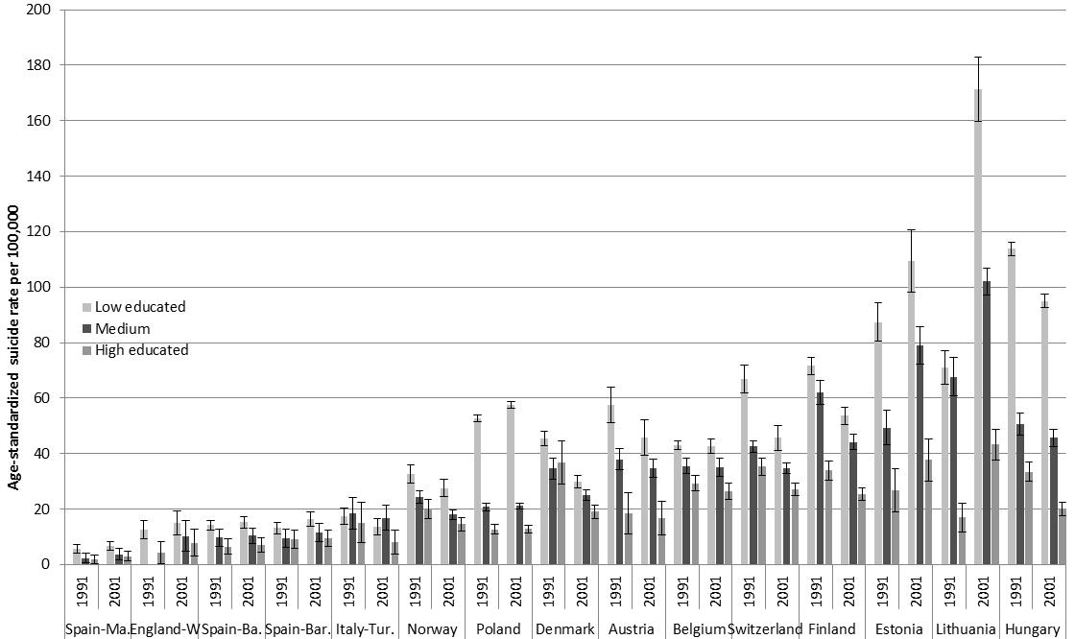
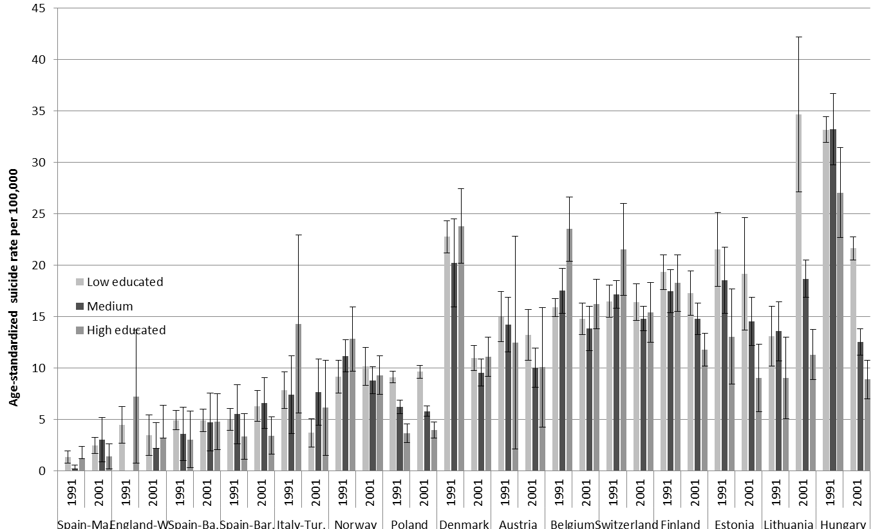
Figure DS1b. Age-standardized suicide rate per 100,000 person-years, per population, period, and education group: women

