Supplementary Appendix for

“Threats and the Public Constraint on Military Spending”

Contents

1. Full Regression Results from Manuscript Figures 2
2. Comparison of Sample with Italian Census on Key Demographics 4
3. Distribution of Unidimensional Dependent Variables 5
4. Analysis of Attrition Between Waves 6
5. Balance Across Treatment Conditions 7
6. Results of Other Preregistered Hypotheses 8
7. Interaction with Unreported Treatment 9
8. Manipulation Check(s) 10
9. IIA Assumption of Multinomial Logit Models 11
10. Disaggregated Military Spending Outcomes 12

Full Regression Results from Manuscript Figures

Table A1: Full Regression Results in OLS and Ordered Probit for the unidimensional model (Wave 1)

 | (1) | (2) | (3) | (4) | (5) | (6)
 | OLS | Ordered Probit | OLS | Ordered Probit | OLS | Ordered Probit
VARIABLES | Defense Spending | Defense Spending | Education Spending | Education Spending | Infrast. Spending | Infrast. Spending
Threat Treatment | 0.210*** | 0.186*** | 0.0803 | 0.0954 | 0.0997* | 0.116*
 | (0.0573) | (0.0535) | (0.0508) | (0.0559) | (0.0497) | (0.0547)
Constant | 1.951*** |  | 3.044*** |  | 2.874***
 | (0.0422) |  | (0.0364) |  | (0.0358)
N | 1,544 | 1,544 | 1,544 | 1,544 | 1,544 | 1,544
Robust standard errors in parentheses
*** p<0.001, ** p<0.01, * p<0.05

Table A2: Full Regression Results in OLS and Ordered Probit for the unidimensional model (Wave 1 and Wave 2)

 | (1) | (2) | (3) | (4) | (5) | (6)
 | OLS | Ordered Probit | OLS | Ordered Probit | OLS | Ordered Probit
VARIABLES | Defense Spending | Defense Spending | Education Spending | Education Spending | Infrast. Spending | Infrast. Spending
Post Invasion | 0.102* | 0.0864* | -0.0565 | -0.0627 | -0.0574 | -0.0622
 | (0.0552) | (0.0499) | (0.0441) | (0.0462) | (0.0483) | (0.0511)
Constant | 1.919*** |  | 3.025*** |  | 2.868***
 | (0.0477) |  | (0.0412) |  | (0.0405)
Observations | 1,170 | 1,170 | 1,170 | 1,170 | 1,170 | 1,170
Robust standard errors in parentheses clustered by respondent
*** p<0.01, ** p<0.05, * p<0.10

Table A3: Multinomial logit models of budgetary trade-offs (Wave 1 and Wave 2)

 | Model 1 |  | Model 2
 | Increase Taxes | Military Spending Cuts | Domestic Spending Cuts | Military Spending Cuts
Wave 2 | 0.539* | -0.122 | 0.0873 | -0.299**
 | (0.223) | (0.126) | (0.158) | (0.107)
Constant | -1.403*** | 1.330*** | -0.791*** | 0.690***
 | (0.207) | (0.104) | (0.137) | (0.0935)
N | 1,170 |  | 1,170
Standard errors clustered by respondent in parentheses.
*** p<0.001, ** p<0.01, * p<0.05

Comparison of Sample with Italian Census on Key Demographics

Table A4: Comparison of the sample with the Italian census
 | Italy euroStat/Eurobarometer | Sample
Sex (%)
Female | 50.27% | 51.10
Age (%)
18-29 | 18.21% | 17.75%
30-39 | 17.21% | 17.36%
40-49 | 22.44% | 22.28%
50-59 | 23.64% | 23.83%
60+ | 18.49% | 18.78%
Region (%)
Nord-Ovest | 26.50% | 27.14%
Sud | 23.39% | 22.73%
Isole | 11.04% | 11.72%
Nord-Est | 19.33% | 18.98%
Centro | 19.76% | 19.43%
Left-Right  mean of 0-10 scale* | 5.30 | 5.53

https://ec.europa.eu/eurostat/de/data/database?node_code=demo_r_d2jan
* Comparison 2021 Eurobarometer

Distribution of Unidimensional Dependent Variables

Figure A1: Distribution of Dependent Variables

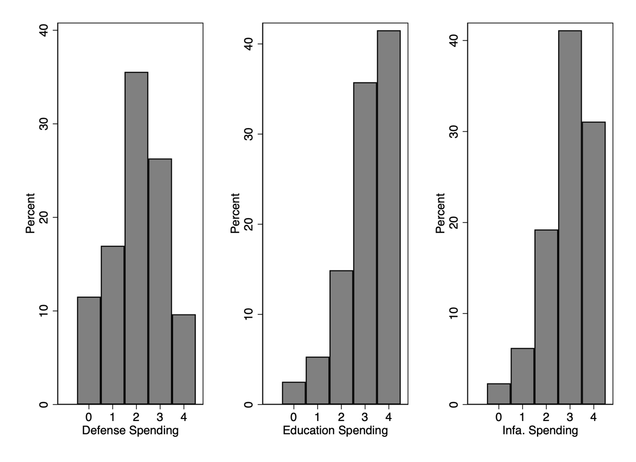
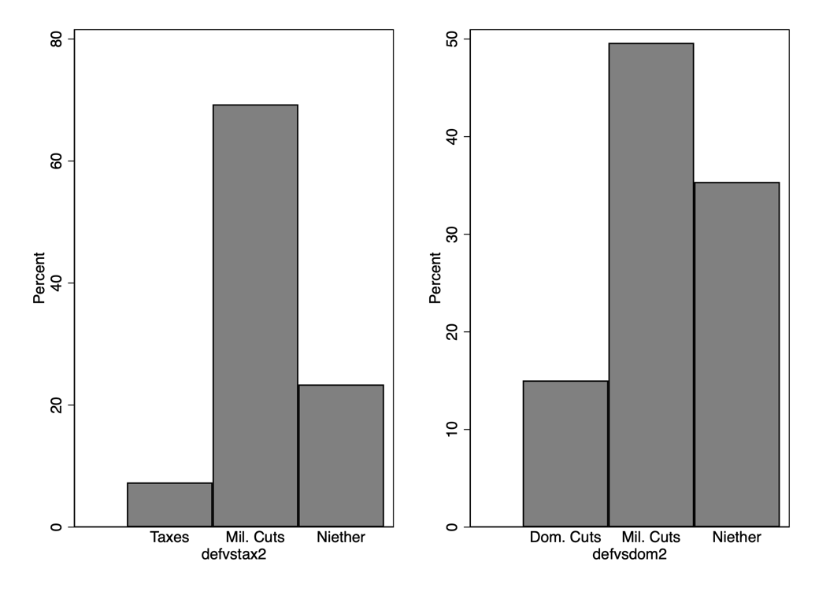

Analysis of Attrition Between Waves

Table A5: Analysis of Attrition
Variable (Statistic) | Wave 2 Contacted | Wave 2 Not Recontacted
Observations | 823 | 184
Female (mean) | 0.54 | 0.53
Age (mean) | 45.3 | 42.1
Partisanship (mean) | 5.5 | 5.5
Region - mean
Centro | .21 | .23
Isole | .12 | .08
Nord-Est | .19 | .21
Nord-Ovest | .27 | .26
Sud | .22 | .22

Balance Across Treatment Conditions

Table A6: Balance Across Treatment and Control in Initial Experiment
Variable (Statistic) | Control | Threat  Treatment
Observations | 772 | 772
Female (mean) | 0.50 | 0.53
Age (mean) | 45.7 | 45.3
Partisanship (mean) | 5.6 | 5.5
Region - mean
Centro | 0.19 | 0.20
Isole | 0.12 | 0.12
Nord-Est | 0.19 | 0.18
Nord-Ovest | .27 | 0.27
Sud | .23 | .22

Results of Other Preregistered Hypotheses

Table A7: Results of other hypotheses
 | (1) | (2) | (3) | (4) | (5)
 | H1 | H2 | H3 | H4 | H6
VARIABLES | Defense Spending | Defense Spending | Defense Spending | Defense Spending | Defense Spending
Debt Info Treatment | 0.0600 | 0.0660 | -0.170 | 0.0372 | 0.0531
 | (0.0575) | (0.0820) | (0.126) | (0.0642) | (0.0845)
Correctness of Debt Burden |  | -0.000885
 |  | (0.00150)
Debt Info Treatment X  Correctness of Debt Burden |  | -0.000275
 |  | (0.00214)
Left Right |  |  | 0.0645***
 |  |  | (0.0175)
Debt Info Treatment X  Left Right |  |  | 0.0510*
 |  |  | (0.0249)
Unemployed |  |  |  | 0.0678
 |  |  |  | (0.106)
Debt Info Treatment X  Unemployed |  |  |  | 0.117
 |  |  |  | (0.145)
Threat Treatment |  |  |  |  | 0.200*
 |  |  |  |  | (0.0817)
Debt Info Treatment X  Threat Treatment |  |  |  |  | 0.0209
 |  |  |  |  | (0.115)
Constant | 2.026*** | 2.050*** | 1.733*** | 2.013*** | 1.924***
 | (0.0409) | (0.0582) | (0.0889) | (0.0454) | (0.0603)
Observations | 1,544 | 1,544 | 1,544 | 1,544 | 1,544
Robust standard errors in parentheses
*** p<0.001, ** p<0.01, * p<0.05

Interaction with Unreported Treatment

Our survey included two treatments (see Section 5). In this section, we demonstrate that the treatment that we did not report in the manuscript does not significantly alter the treatment that is the centerpiece of our study. Figure A2 presents the marginal effects of the threat treatment at each level of the debt information treatment. In each case, the threat treat treatment is significant under both conditions. Further, there is no statistically significant difference across the unreported debt information treatment. As such, the unreported treatment poses no threat to our initial inferences.

Figure A2: Marginal Effects of the Treat Treatment Across the Unreported Debt Treatment
- Marginal Effect of Threat on Military Spending
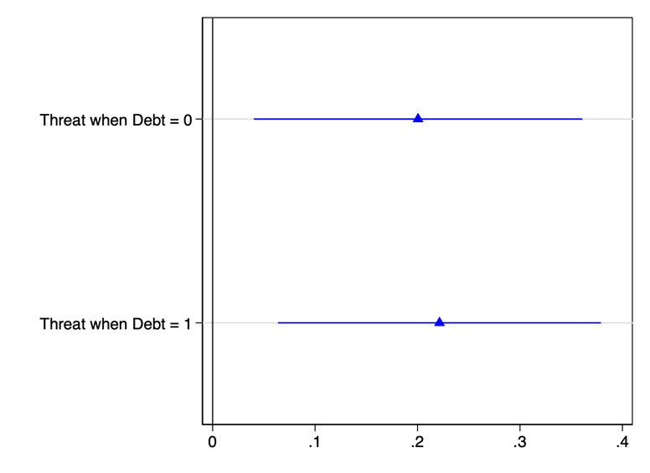
(b)  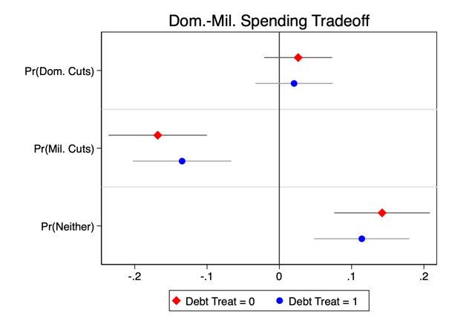 | (c)  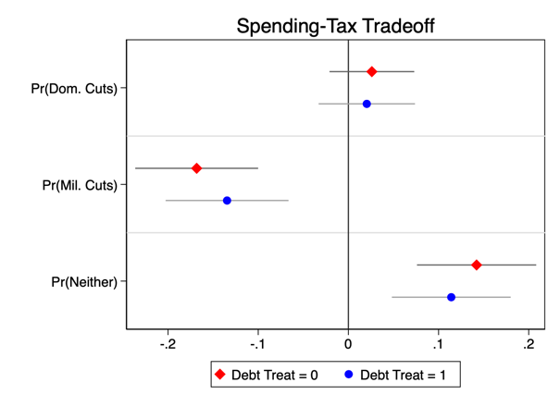
Panel (a) presents the marginal effects of the threat treatment on the unidimensional military spending variable.
Panel (b) presents the marginal effects resulting from the multinomial logit estimating support for military spending cuts in a trade-off with domestic spending cuts.
Panel (c) presents the marginal effects resulting from the multinomial logit estimating support for military spending cuts in a trade-off with tax increases.

Manipulation Check(s)
We attempted to test if our treatment is priming threat perception by asking respondents in the control and treatment group of Wave 1 to assess the probability that Italy would experience war:
“In the next five years, what is the probability that Italy will be involved in a war?”
The treatment was not statistically different across the threat treatment conditions.

Table A8: Threat Treatment and War Probability Assessment
Treatment Group | War Probability  Mean | War Probability  SD
Treated | 26.13 | 25.91
Untreated | 26.55 | 24.37

In retrospect, this was a poorly designed manipulation check as it is difficult for the average citizen to assess the probability of war without an appropriate anchor. Further, the threat can move outcomes less extreme than rare interstate war.
The failure of our manipulation check raises the question if our treatment is in fact increasing perceptions of an external threat, or some other, unidentified, factor that is moving support for military spending. To counter this concern, we present the results of another threat-related outcome, support for increasing military cooperation with NATO. After our questions about military spending, we asked our respondents: “Do you think the amount of military cooperation with the United States and other NATO members should be increased, decreased, or remain the same?” A difference of means test in Table A9 demonstrates a significant difference in the two conditions. Those who received our threat treatment are more likely to agree to NATO cooperation on a 5-value scale (0-4, significantly reduce NATO cooperation - significantly increase NATO cooperation). We hope this gives the reader more confidence that the treatment is having its intended effect.

Table A9: Support for NATO Cooperation
Treatment Group | NATO Cooperation  Mean | NATO Cooperation  SD
Treated | 1.979*** | 0.91
Untreated | 1.74 | 0.97
***p<.001

IIA Assumption of Multinomial Logit Models

A key assumption of Multinomial Logit models is the Independence of Irrelevant Alternatives (IIA). Multinomial Logit models assume that the probability of choosing one alternative relative to another one is not affected by the inclusion or exclusion of an additional alternative. One way to validate the IIA assumption is the Huasman and McFadden test, which is a comparison of parameter estimates between a model including all of the alternatives and subset models that omit one of the alternatives. Under the IIA assumption, parameter estimates of an alternative are the same in different models. Results are shown in Table A10 and Table A11.

Table A10: Hausman Test – Experimental Test
Omitted Category | Chi² | P>Chi²
0 – Tax | -0.000 | .
1 – Military Spending | 0.000 | 1.00
2 – Neither | 0.000 | .
0 – Spending Cuts | -0.000 | .
1 – Military Spending | 0.000 | 1.00
2 – Neither | 0.000 | 1.00
Note that a significant test is evidence against the H₀ that the outcomes are independent of other alternatives. A negative chi²<0 indicates that IIA has not been violated (Huasman and McFadden 1984, p1226)

Table A11: Hausman Test – Pre/Post Invasion Test
Omitted Category | Chi² | P>Chi²
0 – Tax | -0.000 | .
1 – Military Spending | 0.000 | 1.00
2 – Neither | -0.000 | .
0 – Spending Cuts | -0.000 | .
1 – Military Spending | -0.000 | .
2 – Neither | -0.000 | .
Note that a significant test is evidence against the H₀ that the outcomes are independent of other alternatives. A negative chi²<0 indicates that IIA has not been violated (Huasman and McFadden 1984, p1226)

Disaggregated Military Spending Outcomes

In addition to asking about preferences for increasing overall defense spending, we also asked our respondents to fill out the matrix presented in Figure A3. It asks repondents about decreases and increases in four categories of military spending: Personnel, Equipment, Operating and Maintenance, and Military Infrastructure. We present the estimated coefficients from four models each regressing the threat treatment on one of the four military spending categories in Figure A4.

Figure A3: Disaggregated Military Spending Question
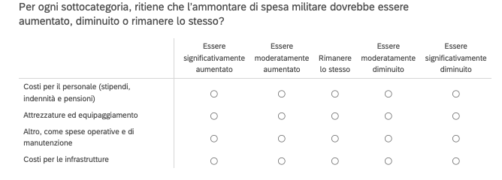

Figure A4: Effect of Threat Treatment on Disaggregated Military Spending Preferences
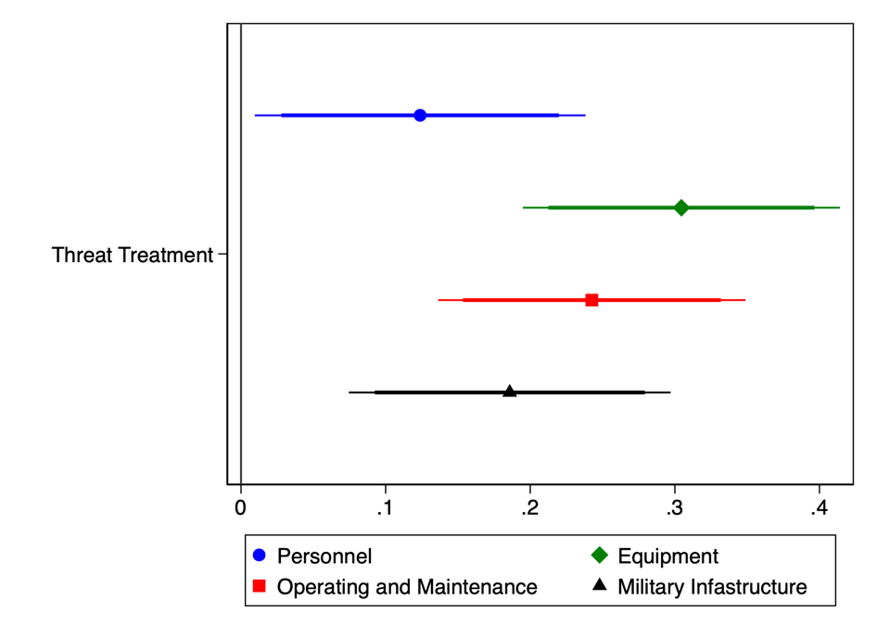
This figure shows the average treatment effect, from four separate models, of reading the article about the security threat to Italy on the outcomes of different types of military investments. The thin and thick bars indicate the 90% and 95% confidence intervals, respectivley, around the estimates.

Works Cited

Hausman, J., & McFadden, D. (1984). Specification tests for the multinomial logit model. Econometrica: Journal of the econometric society, 1219-1240.

