Dual Evolutionary Foundations of Political Ideology Predict Divergent Responses to COVID-19: Supplementary Material

Section 1 - Data collection
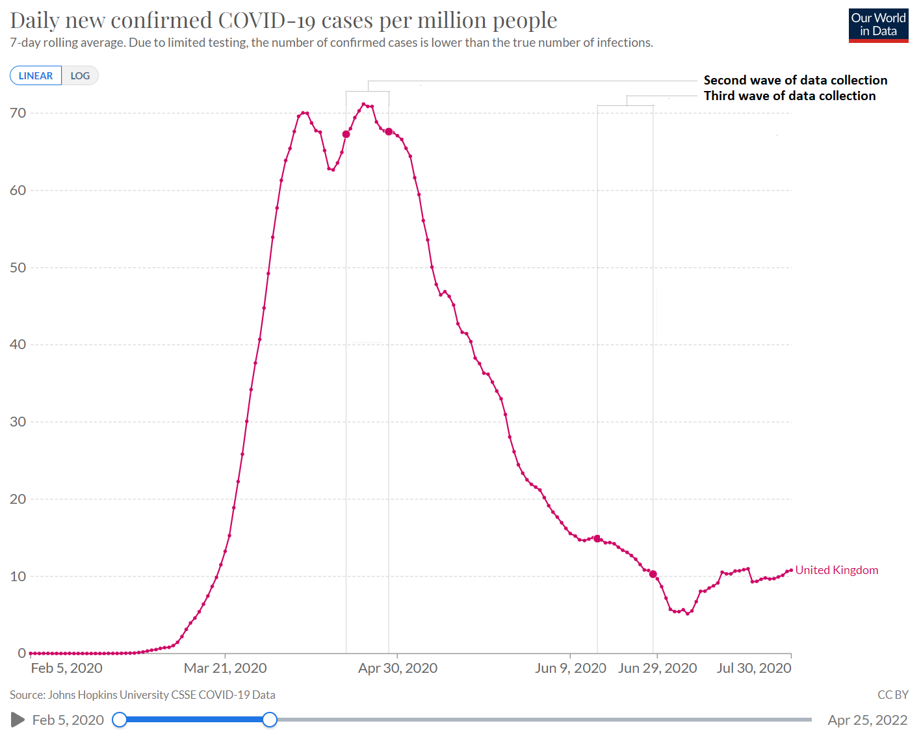
Figure S1. Daily confirmed COVID-19 cases in the UK per million people.
Notes: adapted from the Our World in Data website (https://ourworldindata.org/explorers/coronavirus-data-explorer), showing when we conducted our second wave of data collection (18 – 28 April 2020) and third wave of data collection (15 – 28 June 2020). We conducted the first wave of data collection before the onset of the pandemic, i.e., 8 October – 7 November 2019.
There were no significant differences between participants from Wave 1 and participants who dropped out from Wave 1, and between participants from Wave 2 and participants who dropped out from Wave 2, in terms of SDO [Wave 1: t(547) = 0.273, p = .785, F(115,432) = 0.962, p = .817; Wave 2: t(431) = 0.504, p = .615, F(75,356) = 0.969, p = .893], RWA [Wave 1: t(547) = -1.663, p = .097, F (115,432) = 0.765, p = .084; Wave 2: t(431) = 0.104, p = .918, F(75,356) = 0.822, p = .306], political affiliation [Wave 1: χ²(2) = 2.73, p = 0.256; Wave 2: χ²(2) = 0.445, p = 0.800], socioeconomic status [Wave 1: t(547) = -1.130, p = .259, F(115,432) = 1.007, p = .940; Wave 2: t(431) = 0.620, p =.536, F(75,356) = 0.949, p =.803], and sex [Wave 1: χ²(1) = 0.406, p = .524; Wave 2: χ²(1) < 0.001, p = .995]. However, there were some significant differences between participants from Wave 1 and/or 2 and participants who dropped out from these waves in terms of age [Wave 1: t(547) = -3.535, p = <.001*, F(115,432) = 0.531, p = <.001*; Wave 2: t(431) = -3.018, p = .003*, F(75,356) = 0.633, p = .017*] and race [Wave 1: χ²(1) = 0.138, p = .286; Wave 2: χ²(1) = 3.9, p = .048*].

Section 2 - Full list of items measuring responses to and experiences of the pandemic
Unless stated otherwise all below items were answered on Likert scales from 1 (strongly disagree) to 7 (strongly agree).
(A) Cooperative/other-regarding responses to COVID-19:
(A.1) “The government should waive all insurance costs and hospital fees for testing and treating COVID-19.” [This was a combination of two items from a recent study (Gadarian, Goodman, and Pepinsky 2021): “The government should waive insurance costs and hospital fees for treating COVID-19”, and “Make all testing for COVID-19 free for all Americans”.]
(A.2) “Paid leave should be granted to anyone diagnosed with coronavirus COVID-19.”
(A.3) “I am very concerned about those most vulnerable to COVID-19.” (Pfattheicher et al. 2020).
(B) Conformist/norm-enforcing responses to COVID-19:
(B.1) “It is important to follow the UK government's rules regarding COVID-19”,
(B.2) “Because of COVID-19, it is very important that others take physical distancing very seriously and limit all social contact.”
(B.3) “I support government measures to restrict the movement of UK citizens to limit the spread of COVID-19.” (Conway, Woodward, and Zubrod 2020)
(B.4) “It makes me angry that the government would tell me where I can go and what I can do, even when there is a crisis such as COVID-19.” [reverse coded] (Conway, Woodward, and Zubrod 2020)
(B.5) “I am upset at the thought that my government would force people to stay home against their will.” [reverse coded] (Conway, Woodward, and Zubrod 2020)
(B.6) “It is vital right now that the government strongly enforces social distancing measures.” [this is a reworded version of “It is vital right now that the Federal government strongly punishes people who do not engage in social distancing measures” (Conway, Woodward, and Zubrod 2020)]
(B.7) “All citizens of China should be banned from entering the UK while the COVID-19 pandemic is ongoing.”
(B.8) “All citizens of the USA should be banned from entering the UK while the COVID-19 pandemic is ongoing.”
(B.9) “Strict entry restrictions should be imposed at all borders while the COVID-19 pandemic is ongoing.”
(B.10) “I want my government to severely punish those who violate orders to stay home.” (Conway, Woodward, and Zubrod 2020)
(B.11) “The army should be mobilized to enforce quarantines and rules regarding COVID-19.”
(B.12) “Imagine a person, called K, who does not feel sick and so ignores the rules and goes out without a facemask and does not try at all to keep a safe two-meter distance from other people. To what extent does K’s behaviour make you feel…”
(B.12.1) “anger?”
(B.12.2) “disgust?”
(B.12.3) “contempt?”
(B.12.4) “outrage?”
(B.12.5) “Finally, how do you think K should be treated?” [answered on a Likert scale: 1 = very leniently, 7 = very harshly].
For Items B.12.1–4, we followed a study (Stamkou et al. 2019), unrelated to COVID-19, wherein participants read vignettes about the behaviour (during an office meeting) of a hypothetical person called K and moral emotions were measured in the same way as we did.
(C) Concerned/threat-sensitive responses to COVID-19:
“How worried are you about…” [answered on a sliding scale from 1 (“not at all worried”) to 7 (“extremely worried”]
(C.1) “…the COVID-19 pandemic?”
(C.2) “…that you will get sick from COVID-19?”
(C.3) “…that your family members and friends will get sick from COVID-19?”
(C.4) “…that people you don't personally know will get sick from COVID-19?”
(C.5) “…that the COVID-19 pandemic will negatively impact the economy?”
(C.6) “…that the COVID-19 pandemic will negatively impact you from a financial point of view?”
(D) Experiences of and exposure to COVID-19 threats:
(D.1) “Has anyone you personally know tested positive for COVID-19?” [Yes, No, Not sure] (Everett et al. 2020).
(D.2) “Were you diagnosed with COVID-19?” [Yes, No]
(D.3) “If you were not diagnosed with COVID-19, did you ever suspect that you had it?” [Yes, No]
(D.4) “Have you had necessary medical treatment such as surgery or cancer screening delayed?” [Yes, No]
(D.5) “Do you know of anyone who has had necessary medical treatment such as surgery or cancer screening delayed?” [Yes, No]
(D.6) “Has COVID-19 impacted you negatively from a financial point of view?” [Yes, No, Not sure] [this is a reworded version of “The Coronavirus (COVID-19) has impacted me negatively from a financial point of view” (Conway, Woodward, and Zubrod 2020)]
We also asked participants the following but did not include this item in our analyses because almost everyone said yes: “Are there currently any cases of COVID-19 infections in the city or town where you live?” [Yes, No, Not sure] (Everett et al. 2020).

Section 3 - Descriptive statistics and correlation matrix
Table S1. Means and standard deviations for all relevant variables.

Variables | Mean (SD)
Socioeconomic status | 5.32 (1.55)
Empathic concern | 3.88 (0.76)
SDO (before pandemic) | 2.47 (1.03)
SDO (during pandemic) | 2.48 (1.09)
RWA (before pandemic) | 3.52 (1.12)
RWA (during pandemic) | 3.58 (1.19)
Cooperative/other-regarding responses to COVID-19 | 6.34 (0.77)
Conformist/norm-enforcing responses to COVID-19 | 5.82 (0.89)
Support for lockdown rules (PC1) | 6.43 (0.90)
Moral emotions towards rule breaker (PC2) | 5.47 (1.26)
Support strict border control (PC3) | 5.97 (1.28)
Support severe enforcement (PC4) | 4.63 (1.64)
Concern about COVID-19 | 5.59 (1.33)
Concern about own health | 4.52 (1.73)
Concern about familiar others’ health | 5.73 (1.40)
Concern about unfamiliar others’ health | 4.89 (1.55)
Concern about own finances | 5.07 (1.63)
Concern about economy | 5.74 (1.22)
Notes: Socioeconomic status is answered on a ladder from 1 to 10,
empathic concern is answered on a Likert scale from 1 to 5, and all other
variables are derived from items answered on a Likert scale from 1 to 7.

Histograms of main variables:
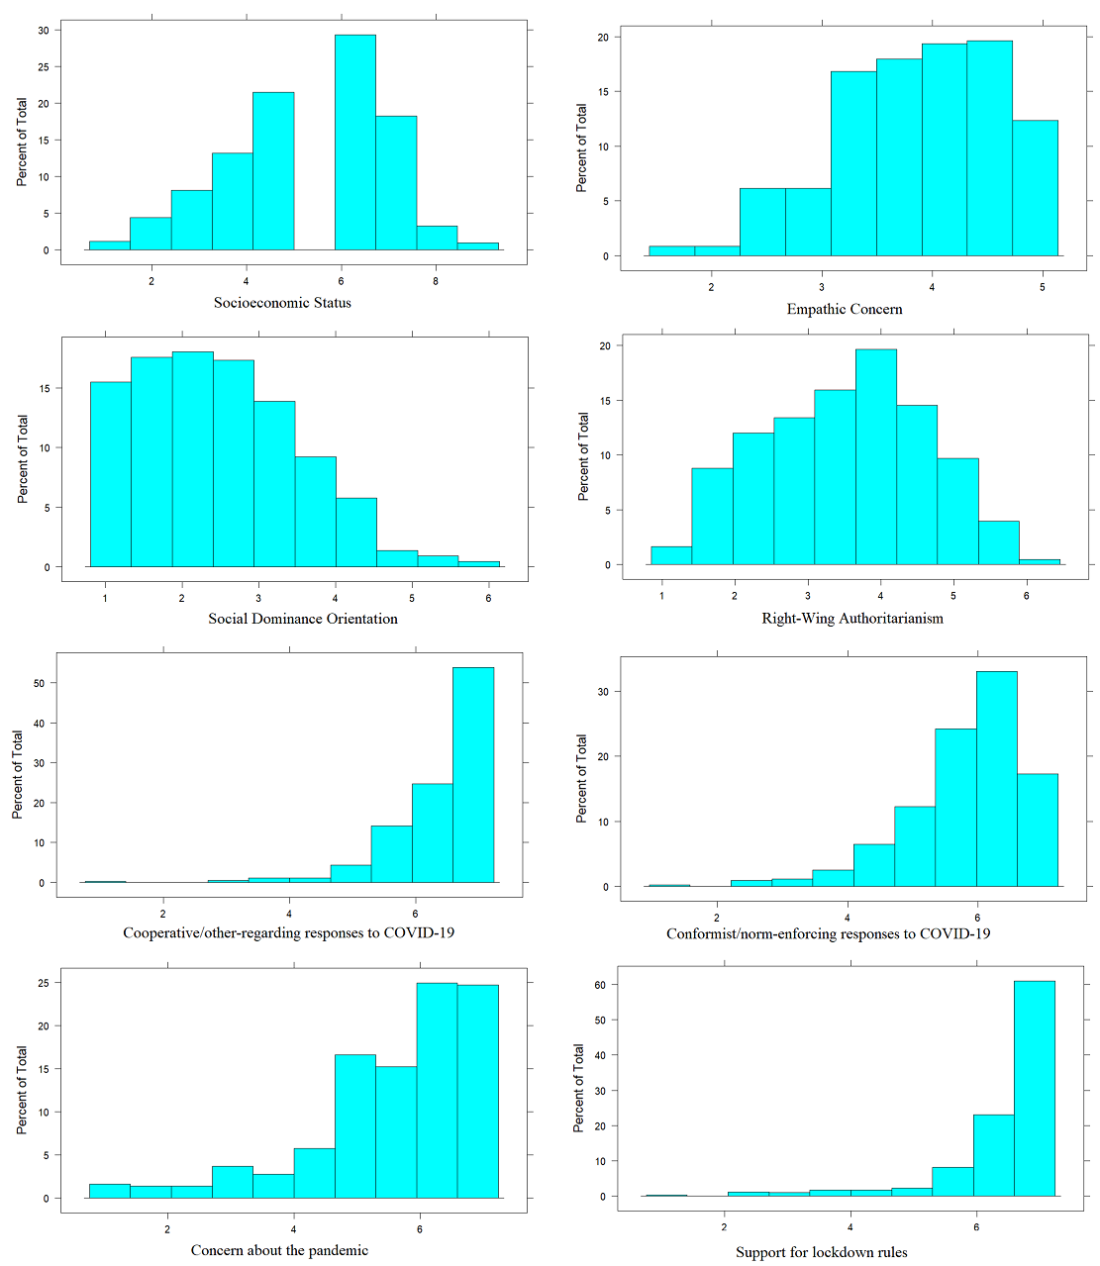
Figure S2. Histograms of main variables.

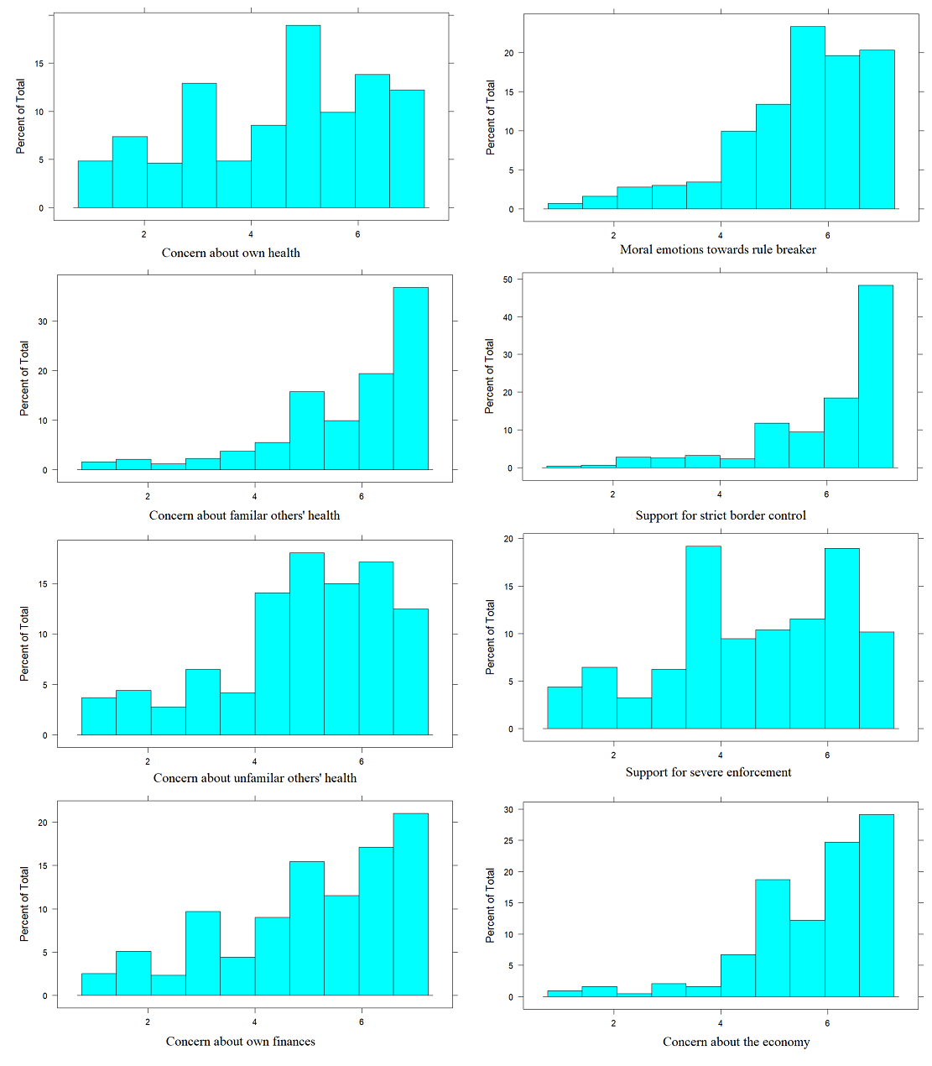
Figure S2 continued. Histograms of main variables.

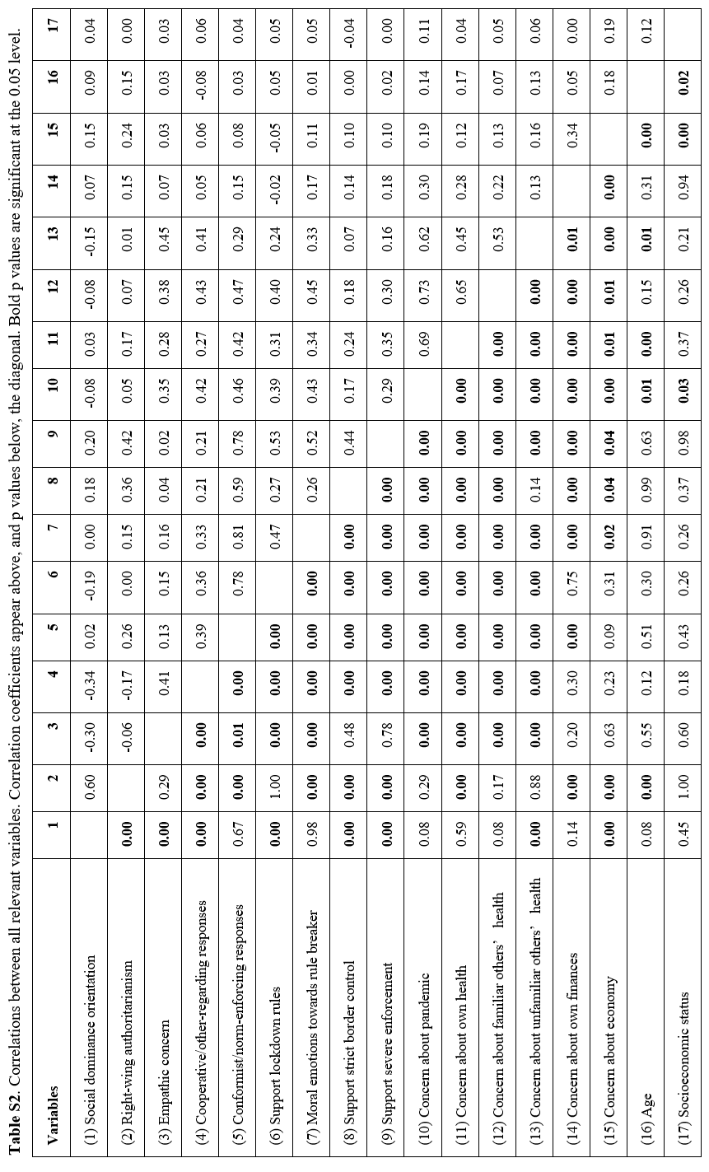

Section 4 - Results for models controlling for political affiliation

Table S3. Multiple regression analyses with social dominance orientation (SDO) and right-wing authoritarianism (RWA) predicting the means of cooperative/other-regarding and conformist/norm-enforcing COVID-19 attitudes, controlling for various covariates including political affiliation.

 | Model 1: Cooperative/other-regarding |  |  |  | Model 2: Conformist/norm-enforcing
 | R² = 0.12, F(9, 370) = 5.86, p < .001*  n = 380 |  |  |  | R² = 0.09, F(9, 364) = 4.11, p < .001*  n = 374
Predictor variables | β (SE) std. | p | 95% CI |  | β (SE) std. | p | 95% CI
SDO | -0.29 (0.06) | <.001* | [-0.42, -0.17] |  | -0.12 (0.06) | .064† | [-0.26, 0.01]
RWA | 0.06 (0.07) | .365 | [-0.05, 0.19] |  | 0.35 (0.07) | <.001* | [0.21, 0.49]
Age | -0.06 (0.05) | .259 | [-0.21, 0.05] |  | -0.05 (0.05) | .357 | [-0.16, 0.05]
Sex (male) | -0.11 (0.10) | .302 | [-0.32, 0.09] |  | -0.05 (0.1) | .611 | [-0.26, 0.15]
Race (non-white) | 0.16 (0.17) | .328 | [-0.17, 0.40] |  | -0.1 (0.17) | .564 | [-0.44, 0.17]
Socioeconomic status | 0.08 (0.05) | .114 | [-0.02, 0.19] |  | 0.03 (0.05) | .483 | [-0.06, 0.18]
Pandemic threat exposure | 0.06 (0.12) | .591 | [-0.14, 0.28] |  | 0.17 (0.12) | .161 | [-0.05, 0.40]
Political affiliation (right) | -0.28 (0.13) | .041* | [-0.62, 0.00] |  | -0.05 (0.14) | .695 | [-0.36, 0.21]
Political affiliation (centre) | -0.01 (0.15) | .970 | [-0.27, 0.25] |  | 0.01 (0.15) | .972 | [-0.37, 0.29]
Notes: Confidence intervals (CIs) were bias corrected using 1,000 bootstrapped resamples. * = p < .05; † = p < .10

Table S4. Multiple regression analyses with the social dominance orientation (SDO) and right-wing authoritarianism (RWA), controlling for various covariates including political affiliation, predicting the means of different types of conformist/norm-enforcing COVID-19 attitudes revealed by principal components analysis (PC1–4 = Principal Component 1–4).

 | Model 1: Support lockdown rules (PC1) |  |  |  | Model 2: Moral emotions towards rule breaker (PC2) |  |  |  | Model 3: Support strict border control (PC3) |  |  |  | Model 4: Support severe enforcement (PC4)
 | R² = 0.03, F(9, 370) = 1.33,  p = .219  n = 380 |  |  |  | R² = 0.05, F(9, 364) = 2.10,  p = .029*  n = 374 |  |  |  | R² = 0.14, F(9, 370) = 6.91,  p < .001*  n = 380 |  |  |  | R² = 0.19, F(9, 370) = 9.62, p < .001*  n = 380
Predictor variables | β (SE) std. | p | 95% CI |  | β (SE) std. | p | 95% CI |  | β (SE) std. | p | 95% CI |  | β (SE) std. | p | 95% CI
SDO | -0.19 (0.06) | .002* | [-0.34, -0.05] |  | -0.08 (0.07) | .235 | [-0.21, 0.06] |  | -0.02 (0.06) | .744 | [-0.13, 0.10] |  | -0.04 (0.06) | .471 | [-0.16, 0.09]
RWA | 0.14 (0.07) | .037* | [0.00, 0.26] |  | 0.23 (0.07) | .001* | [0.10, 0.37] |  | 0.39 (0.07) | <.001* | [0.26, 0.51] |  | 0.44 (0.06) | <.001* | [0.30, 0.57]
Age | 0.00 (0.05) | .926 | [-0.10, 0.10] |  | -0.06 (0.05) | .224 | [-0.17, 0.05] |  | -0.06 (0.05) | .245 | [-0.18, 0.04] |  | -0.04 (0.05) | .390 | [-0.13, 0.05]
Sex (male) | -0.02 (0.10) | .816 | [-0.21, 0.18] |  | -0.07 (0.11) | .512 | [-0.28, 0.13] |  | 0.00 (0.10) | .973 | [-0.22, 0.21] |  | -0.04 (0.10) | .705 | [-0.21, 0.15]
Race (non-white) | 0.09 (0.17) | .601 | [-0.27, 0.32] |  | -0.25 (0.18) | .162 | [-0.61, 0.06] |  | -0.04 (0.17) | .817 | [-0.41, 0.25] |  | 0.05 (0.16) | .747 | [-0.32, 0.34]
Socioeconomic status | 0.06 (0.05) | .185 | [-0.03, 0.23] |  | 0.03 (0.05) | .590 | [-0.07, 0.14] |  | -0.03 (0.05) | .587 | [-0.15, 0.10] |  | 0.00 (0.05) | .957 | [-0.09, 0.11]
Pandemic threat exposure | -0.02 (0.12) | .871 | [-0.21, 0.19] |  | 0.24 (0.12) | .053† | [0.01, 0.48] |  | 0.17 (0.12) | .161 | [-0.06, 0.42] |  | 0.10 (0.11) | .395 | [-0.12, 0.30]
Political affiliation (right) | -0.02 (0.14) | .885 | [-0.33, 0.23] |  | -0.09 (0.14) | .550 | [-0.38, 0.19] |  | -0.06 (0.14) | .671 | [-0.32, 0.20] |  | 0.06 (0.13) | .661 | [-0.20, 0.32]
Political affiliation (centre) | -0.02 (0.15) | .891 | [-0.41, 0.27] |  | -0.13 (0.15) | .413 | [-0.45, 0.17] |  | 0.21 (0.15) | .164 | [-0.13, 0.44] |  | 0.09 (0.14) | .546 | [-0.22, 0.36]
Notes: Confidence intervals (CIs) were bias corrected using 1,000 bootstrapped resamples. * = p < .05; † = p < .10

Table S5. Multiple regression analysis with the centred mean of empathic concern, controlling for right-wing authoritarianism (RWA) and various covariates including political affiliation, predicting the means of different types of conformist/norm-enforcing COVID-19 attitudes revealed by principal components analysis (PC1–4 = Principal Component 1–4).

 | Model 1: Support lockdown rules (PC1) |  |  |  | Model 2: Moral emotions towards rule breaker (PC2) |  |  |  | Model 3: Support strict border control (PC3) |  |  |  | Model 4: Support severe enforcement (PC4)
 | R² = 0.02, F(9, 302) = 0.70, p = .706  n = 312 |  |  |  | R² = 0.07, F(9, 298) = 2.63,  p = .006*  n = 308 |  |  |  | R² = 0.15, F(9, 302) = 6.06,  p < .001*  n = 312 |  |  |  | R² = 0.19, F(9, 302) = 8.00, p < .001*  n = 312
Predictor variables | β (SE) std. | p | 95% CI |  | β (SE) std. | p | 95% CI |  | β (SE) std. | p | 95% CI |  | β (SE) std. | p | 95% CI
Empathic Concern | 0.10 (0.06) | .089† | [-0.02, 0.25] |  | 0.09 (0.06) | .104 | [-0.03, 0.22] |  | 0.04 (0.06) | .491 | [-0.07, 0.14] |  | 0.00 (0.05) | .951 | [-0.11, 0.13]
RWA | 0.06 (0.06) | .367 | [-0.07, 0.17] |  | 0.18 (0.06) | .004* | [0.06, 0.30] |  | 0.38 (0.06) | <.001* | [0.26, 0.51] |  | 0.40 (0.06) | <.001* | [0.27, 0.52]
Age | 0.03 (0.06) | .605 | [-0.10, 0.12] |  | -0.11 (0.06) | .045* | [-0.22, 0.00] |  | -0.05 (0.06) | .346 | [-0.17, 0.06] |  | -0.03 (0.05) | .535 | [-0.14, 0.07]
Sex (male) | 0.01 (0.12) | .906 | [-0.25, 0.23] |  | -0.09 (0.12) | .462 | [-0.35, 0.16] |  | 0.01 (0.12) | .948 | [-0.24, 0.23] |  | -0.10 (0.12) | .403 | [-0.33, 0.12]
Race (non-white) | 0.08 (0.19) | .667 | [-0.29, 0.32] |  | -0.31 (0.18) | .093† | [-0.68, 0.02] |  | -0.02 (0.18) | .903 | [-0.44, 0.32] |  | 0.03 (0.17) | .879 | [-0.36, 0.33]
Socioeconomic status | 0.06 (0.06) | .274 | [-0.05, 0.25] |  | 0.02 (0.06) | .747 | [-0.08, 0.16] |  | -0.02 (0.06) | .687 | [-0.15, 0.14] |  | -0.02 (0.05) | .751 | [-0.12, 0.09]
Pandemic threat exposure | -0.07 (0.14) | .600 | [-0.31, 0.14] |  | 0.26 (0.14) | .062† | [-0.02, 0.53] |  | 0.21 (0.14) | .126 | [-0.07, 0.49] |  | 0.15 (0.13) | .256 | [-0.10, 0.38]
Political affiliation (right) | -0.18 (0.16) | .275 | [-0.52, 0.11] |  | -0.03 (0.16) | .845 | [-0.34, 0.26] |  | -0.07 (0.16) | .683 | [-0.37, 0.22] |  | 0.09 (0.15) | .537 | [-0.21, 0.40]
Political affiliation (centre) | -0.08 (0.17) | .641 | [-0.58, 0.23] |  | -0.18 (0.17) | .292 | [-0.57, 0.17] |  | 0.30 (0.17) | .083† | [-0.02, 0.55] |  | 0.10 (0.16) | .521 | [-0.21, 0.42]
Notes: Confidence intervals (CIs) were bias corrected using 1,000 bootstrapped resamples. * = p < .05; † = p < .10

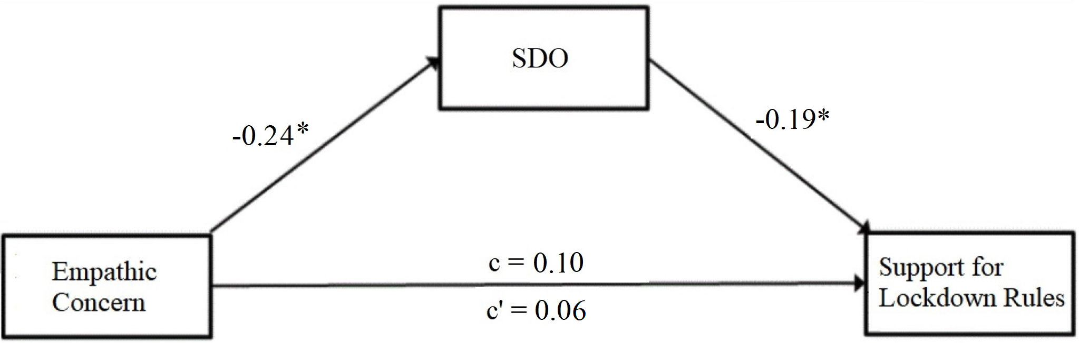
Figure S3. Mediation model for empathic concern predicting, via social dominance orientation (SDO), support for lockdown rules (PC1) controlling for various covariates including political affiliation.
Notes: Beta estimates shown are standardized. The indirect effect of empathic concern through SDO on support for lockdown rules was 0.04. We tested the significance of this indirect effect using bootstrapping. Bias-corrected bootstrapped confidence intervals with 1,000 samples ranged from 0.004 to 0.090, therefore the indirect effect was significant (p = .032*). * = p < .05

Table S6. Multiple regression analyses with social dominance orientation (SDO) and right-wing authoritarianism (RWA), as well as an interaction term between SDO and RWA, controlling for various covariates including political affiliation, predicting cooperative/other-regarding and conformist/norm-enforcing COVID-19 attitudes.

 | Model 1: Cooperative/other-regarding |  |  |  | Model 2: Conformist/norm-enforcing
 | R² = 0.13, F(10, 369) = 5.30, p < . 001*, n = 380 |  |  |  | R² = 0.09, F(10, 363) = 3.69, p < .001*, n = 374
 | β (SE) std. | p | 95% CI |  | β (SE) std. | p | 95% CI
SDO*RWA | 0.03 (0.05) | .556 | [-0.08, 0.13] |  | 0.00 (0.05) | .999 | [-0.11, 0.1]
SDO | -0.30 (0.06) | <.001* | [-0.45, -0.18] |  | -0.12 (0.07) | .071† | [-0.25, 0.03]
RWA | 0.07 (0.07) | .307 | [-0.06, 0.20] |  | 0.35 (0.07) | <.001* | [0.21, 0.49]
Notes: For presentation purposes, covariate effects are omitted from the table. Confidence intervals (CIs) were bias corrected using 1,000
bootstrapped resamples. * = p < .05; † = p < .10

Table S7. Multiple regression analyses with social dominance orientation (SDO) and right-wing authoritarianism (RWA), as well as an interaction term between SDO and RWA, controlling for various covariates including political affiliation, predicting different conformist/norm-enforcing COVID-19 attitudes (PC1–4 = Principal Component 1–4).

 | Model 1: Support lockdown rules (PC1) |  |  |  | Model 2: Moral emotions towards rule breaker (PC2) |  |  |  | Model 3: Support strict border control (PC3) |  |  |  | Model 4: Support severe enforcement (PC4)
 | R² = 0.04, F(10, 369) = 1.35,  p = .204, n = 380 |  |  |  | R² = 0.05, F(10, 363) = 1.88,  p = .046*, n = 374 |  |  |  | R² = 0.15, F(10, 369) = 6.38,  p < .001*, n = 380 |  |  |  | R² = 0.19, F(10, 369) = 8.69,  p < .001*, n = 380
Predictor variables | β (SE) std. | p | 95% CI |  | β (SE) std. | p | 95% CI |  | β (SE) std. | p | 95% CI |  | β (SE) std. | p | 95% CI
SDO*RWA | 0.06 (0.05) | .226 | [-0.05, 0.17] |  | 0.00 (0.05) | .991 | [-0.11, 0.11] |  | -0.06 (0.05) | .217 | [-0.16, 0.03] |  | -0.03 (0.05) | .519 | [-0.13, 0.07]
SDO | -0.21 (0.07) | .001* | [-0.37, -0.07] |  | -0.08 (0.07) | .246 | [-0.22, 0.07] |  | 0.00 (0.07) | .977 | [-0.12, 0.12] |  | -0.03 (0.06) | .582 | [-0.16, 0.11]
RWA | 0.16 (0.07) | .020* | [0.01, 0.30] |  | 0.23 (0.07) | .002* | [0.09, 0.37] |  | 0.37 (0.07) | <.001* | [0.25, 0.49] |  | 0.43 (0.06) | <.001* | [0.28, 0.56]
Notes: For presentation purposes, covariate results are omitted. Confidence intervals were bias corrected using 1,000 bootstrapped resamples. * = p < .05

Table S8. Multiple regression analyses with social dominance orientation (SDO) and right-wing authoritarianism (RWA), controlling for various covariates including political affiliation, predicting concerned/threat-sensitive COVID-19 attitudes.

 | Model 1: Concern about pandemic |  |  |  |  | Model 2: Concern about own health
 | R² = 0.10, F(9, 364) = 4.62, p < .001*  n = 374 |  |  |  |  | R² = 0.13, F(9, 364) = 5.84, p < .001*  n = 374
 | β (SE) std. |  | p | 95% CI |  | β (SE) std. |  | p | 95% CI
SDO | -0.11 (0.06) |  | .079† | [-0.25, 0.01] |  | -0.09 (0.06) |  | .154 | [-0.22, 0.04]
RWA | 0.17 (0.07) |  | .013* | [0.05, 0.28] |  | 0.22 (0.07) |  | .001* | [0.09, 0.34]
Age | 0.11 (0.05) |  | .038* | [0.00, 0.20] |  | 0.15 (0.05) |  | .004* | [0.05, 0.25]
Sex (male) | -0.37 (0.10) |  | <.001* | [-0.6, -0.18] |  | -0.38 (0.1) |  | <.001* | [-0.58, -0.17]
Race (non-white) | 0.01 (0.17) |  | .946 | [-0.32, 0.30] |  | -0.03 (0.17) |  | .845 | [-0.34, 0.24]
Socioeconomic status | 0.08 (0.05) |  | .115 | [-0.02, 0.20] |  | 0.00 (0.05) |  | .938 | [-0.10, 0.11]
Pandemic threat exposure | 0.30 (0.12) |  | .013* | [0.07, 0.52] |  | 0.38 (0.12) |  | .002* | [0.16, 0.60]
Political affiliation (right) | -0.32 (0.14) |  | .021* | [-0.62, -0.04] |  | -0.14 (0.14) |  | .309 | [-0.40, 0.16]
Political affiliation (centre) | -0.13 (0.15) |  | .378 | [-0.45, 0.15] |  | 0.05 (0.15) |  | .740 | [-0.24, 0.38]
 | Model 3: Concern about familiar others’ health |  |  |  |  | Model 4: Concern about unfamiliar others’ health
 | R² = 0.05, F(9, 364) = 2.35, p = .014*  n = 374 |  |  |  |  | R² = 0.10, F(9, 364) = 4.32, p < .001*  n = 374
 | β (SE) std. |  | p | 95% CI |  | β (SE) std. |  | p | 95% CI
SDO | -0.11 (0.07) |  | .086† | [-0.26, 0.03] |  | -0.19 (0.07) |  | .004* | [-0.33, -0.07]
RWA | 0.18 (0.07) |  | .008* | [0.05, 0.31] |  | 0.16 (0.07) |  | .021* | [0.03, 0.27]
Age | 0.04 (0.05) |  | .466 | [-0.08, 0.14] |  | 0.12 (0.05) |  | .017* | [0.03, 0.22]
Sex (male) | -0.29 (0.11) |  | .007* | [-0.51, -0.09] |  | -0.33 (0.11) |  | .002* | [-0.54, -0.12]
Race (non-white) | -0.06 (0.18) |  | .741 | [-0.39, 0.22] |  | -0.02 (0.18) |  | .926 | [-0.33, 0.27]
Socioeconomic status | 0.02 (0.05) |  | .666 | [-0.08, 0.14] |  | 0.03 (0.05) |  | .567 | [-0.07, 0.14]
Pandemic threat exposure | 0.14 (0.12) |  | .256 | [-0.09, 0.37] |  | 0.21 (0.12) |  | .081† | [-0.03, 0.47]
Political affiliation (right) | -0.25 (0.14) |  | .083† | [-0.54, 0.03] |  | -0.34 (0.14) |  | .015* | [-0.57, -0.07]
Political affiliation (centre) | -0.17 (0.15) |  | .275 | [-0.51, 0.11] |  | -0.2 (0.15) |  | .180 | [-0.51, 0.11]
 | Model 5: Concern about own finances |  |  |  |  |  | Model 6: Concern about economy
 | R² = 0.09, F(9, 364) = 4.23, p < .001*  n = 374 |  |  |  |  |  | R² = 0.11, F(9, 364) = 5.15, p < .001*  n = 374
 | β (SE) std. | p |  | 95% CI |  |  | β (SE) std. | p | 95% CI
SDO | -0.04 (0.07) | .572 |  | [-0.17, 0.10] |  |  | 0.01 (0.07) | .919 | [-0.15, 0.16]
RWA | 0.20 (0.07) | .003* |  | [0.08, 0.33] |  |  | 0.20 (0.07) | .005* | [0.07, 0.34]
Age | 0.00 (0.05) | .962 |  | [-0.12, 0.12] |  |  | 0.10 (0.05) | .052† | [-0.01, 0.20]
Sex (male) | -0.03 (0.11) | .784 |  | [-0.24, 0.17] |  |  | -0.12 (0.11) | .282 | [-0.34, 0.10]
Race (non-white) | 0.05 (0.18) | .789 |  | [-0.31, 0.37] |  |  | 0.05 (0.18) | .762 | [-0.22, 0.31]
Socioeconomic status | -0.05 (0.05) | .321 |  | [-0.14, 0.05] |  |  | 0.15 (0.05) | .004* | [0.04, 0.26]
Pandemic threat exposure | 0.62 (0.12) | <.001* |  | [0.39, 0.86] |  |  | 0.15 (0.12) | .222 | [-0.07, 0.39]
Political affiliation (right) | -0.07 (0.14) | .62 |  | [-0.36, 0.21] |  |  | 0.16 (0.14) | .269 | [-0.10, 0.43]
Political affiliation (centre) | 0.05 (0.15) | .748 |  | [-0.26, 0.33] |  |  | 0.00 (0.15) | .981 | [-0.33, 0.29]
Notes: Confidence intervals (CIs) were bias corrected using 1,000 bootstrapped resamples. * = p < .05; † = p < .10

Table S9. Multiple regression analyses with social dominance orientation (SDO) and right-wing authoritarianism (RWA), as well as an interaction term between SDO and RWA, controlling for various covariates including political affiliation, predicting concerned/threat-sensitive COVID-19 attitudes.
 | Model 1: Concern about pandemic |  |  |  | Model 2: Concern about own health
 | R² = 0.10, F(10, 363) = 4.16, p < .001*, n = 374 |  |  |  | R² = 0.13, F(10, 363) = 5.26, p < .001*, n = 374
 | β (SE) std. | p | 95% CI |  | β (SE) std. | p | 95% CI
SDO*RWA | 0.02 (0.05) | .739 | [-0.09, 0.11] |  | -0.02 (0.05) | .718 | [-0.13, 0.07]
SDO | -0.12 (0.07) | .075† | [-0.26, 0.00] |  | -0.09 (0.07) | .191 | [-0.21, 0.06]
RWA | 0.17 (0.07) | .012* | [0.06, 0.29] |  | 0.21 (0.07) | .002* | [0.07, 0.34]
 | Model 3: Concern about familiar others’ health |  |  |  | Model 4: Concern about unfamiliar others’ health
 | R² = 0.06, F(10, 363) = 2.16, p < .020*, n = 374 |  |  |  | R² = 0.10, F(10, 363) = 3.95, p < .001*, n = 374
 | β (SE) std. | p | 95% CI |  | β (SE) std. | p | 95% CI
SDO*RWA | -0.03 (0.05) | .496 | [-0.14, 0.07] |  | -0.04 (0.05) | .407 | [-0.15, 0.06]
SDO | -0.10 (0.07) | .128 | [-0.26, 0.04] |  | -0.18 (0.07) | .009* | [-0.31, -0.03]
RWA | 0.17 (0.07) | .016* | [0.04, 0.31] |  | 0.14 (0.07) | .040* | [0.02, 0.28]
 | Model 5: Concern about own finances |  |  |  | Model 6: Concern about economy
 | R² = 0.09, F(10, 363) = 3.80, p < .001*, n = 374 |  |  |  | R² = 0.12, F(10, 363) = 4.79, p < .001*, n = 374
 | β (SE) std. | p | 95% CI |  | β (SE) std. | p | 95% CI
SDO*RWA | 0.01 (0.05) | .847 | [-0.10, 0.10] |  | -0.06 (0.05) | .220 | [-0.16, 0.04]
SDO | -0.04 (0.07) | .553 | [-0.18, 0.09] |  | 0.03 (0.07) | .710 | [-0.15, 0.18]
RWA | 0.21 (0.07) | .003* | [0.08, 0.34] |  | 0.17 (0.07) | .014* | [0.04, 0.33]
Notes: For presentation purposes, covariate results are omitted. Confidence intervals (CIs) were bias
corrected using 1,000 bootstrapped resamples. * = p < .05; † = p < .10

Table S10. Multiple regression analyses with concern about the pandemic or pandemic threat exposure, controlling for covariates including political affiliation, predicting change in right-wing authoritarianism (RWA), i.e., the difference between RWA measured before the onset of the COVID-19 pandemic and RWA measured during the COVID-19 pandemic.

 | Model 1: Change in RWA predicted by concern about the pandemic |  |  |  |  | Model 2: Change in RWA predicted by pandemic threat exposure
 | R² = 0.04, F(7, 366) = 2.30, p = .026*, n = 374 |  |  |  |  | R² = 0.02, F(7, 372) = 1.32, p = .238, n = 380
Predictor variables | β (SE) std. | p | 95% CI |  | Predictor variables | β (SE) std. | p | 95% CI
Concern about the pandemic | 0.13 (0.05) | .012* | [0.06, 0.28] |  | Pandemic threat exposure | -0.06 (0.12) | .629 | [-0.33, 0.24]
Age | -0.06 (0.05) | .267 | [-0.15, 0.10] |  | Age | -0.04 (0.05) | .454 | [-0.13, 0.12]
Sex (male) | 0.16 (0.10) | .125 | [0.01, 0.49] |  | Sex (male) | 0.10 (0.10) | .305 | [-0.05, 0.41]
Race (non-white) | 0.20 (0.17) | .239 | [-0.11, 0.62] |  | Race (non-white) | 0.17 (0.17) | .321 | [-0.12, 0.61]
Socioeconomic status | 0.08 (0.05) | .103 | [-0.02, 0.22] |  | Socioeconomic status | 0.09 (0.05) | .067† | [-0.01, 0.23]
Political affiliation (right) | 0.26 (0.12) | .032* | [-0.05, 0.50] |  | Political affiliation (right) | 0.22 (0.12) | .074† | [-0.09, 0.45]
Political affiliation (centre) | 0.14 (0.14) | .317 | [-0.23, 0.40] |  | Political affiliation (centre) | 0.13 (0.14) | .370 | [-0.29, 0.39]
Notes: Confidence intervals (CIs) were bias corrected using 1,000 bootstrapped resamples. * = p < .05; † = p < .10

Section 5 - Results for models without controlling for political affiliation

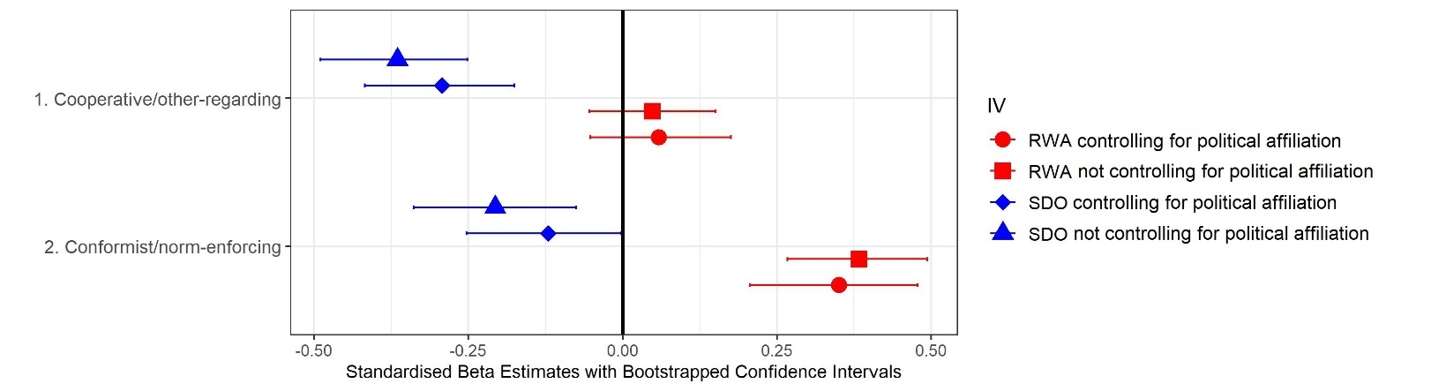
Figure S4. Results for linear regressions with social dominance orientation (SDO) and right-wing authoritarianism (RWA) controlling for each other, predicting cooperative/other-regarding and conformist/norm-enforcing responses to COVID-19.
Notes: We control for age, sex, race, socioeconomic status, and pandemic threat exposure in all models. Models controlling for political affiliation are also displayed for comparison. See Table S11 below for more detailed results, including covariate effects.

Table S11. Multiple regression analyses with social dominance orientation (SDO) and right-wing authoritarianism (RWA) predicting cooperative/other-regarding and conformist/norm-enforcing COVID-19 attitudes, controlling for various covariates excluding political affiliation.

 | Model 1: Cooperative/other-regarding |  |  |  | Model 2: Conformist/norm-enforcing
 | R² = 0.14, F(7, 425) = 9.87, p < .001*  n = 433 |  |  |  | R² = 0.10, F(7, 417) = 6.86, p < .001*  n = 425
Predictor variables | β (SE) std. | p | 95% CI |  | β (SE) std. | p | 95% CI
SDO | -0.36 (0.06) | <.001* | [-0.51, -0.25] |  | -0.21 (0.06) | <.001* | [-0.35, -0.08]
RWA | 0.05 (0.06) | .403 | [-0.05, 0.16] |  | 0.38 (0.06) | <.001* | [0.26, 0.49]
Age | -0.06 (0.05) | .228 | [-0.21, 0.04] |  | -0.02 (0.05) | .674 | [-0.13, 0.08]
Sex (male) | -0.15 (0.10) | .123 | [-0.38, 0.04] |  | -0.08 (0.10) | .444 | [-0.29, 0.11]
Race (non-white) | 0.22 (0.15) | .142 | [-0.08, 0.42] |  | -0.02 (0.16) | .880 | [-0.33, 0.21]
Socioeconomic status | 0.07 (0.05) | .101 | [-0.02, 0.18] |  | 0.04 (0.05) | .398 | [-0.06, 0.19]
Pandemic threat exposure | 0.10 (0.11) | .352 | [-0.08, 0.31] |  | 0.18 (0.11) | .110 | [-0.03, 0.39]
Notes: Confidence intervals (CIs) were bias corrected using 1,000 bootstrapped resamples. * = p < .05

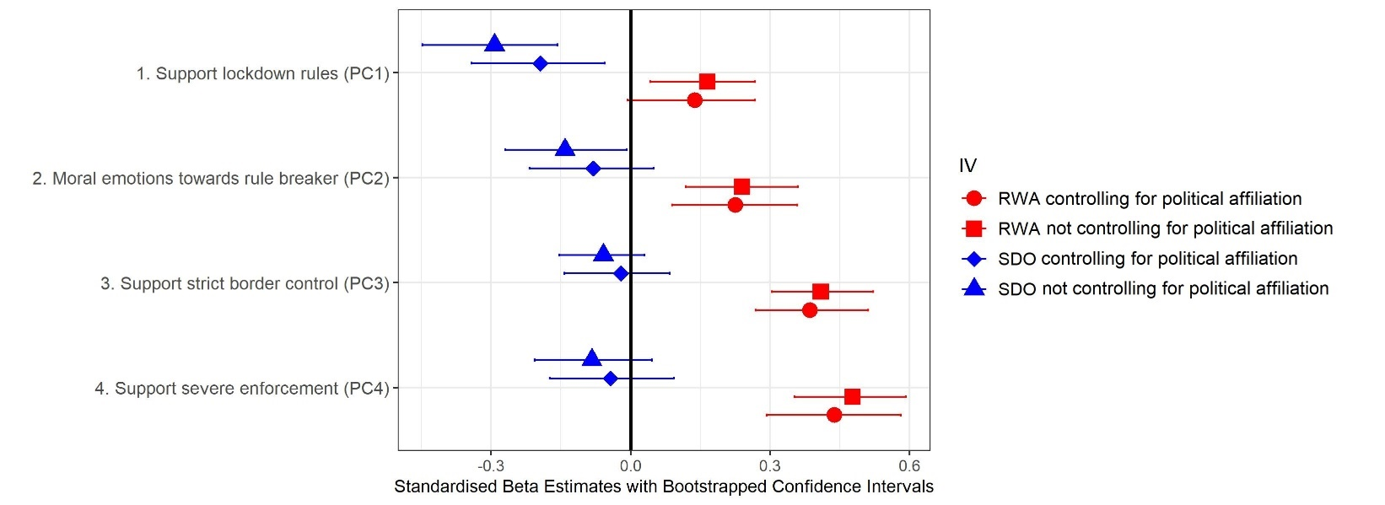
Figure S5. Results for linear regressions with social dominance orientation (SDO) and right-wing authoritarianism (RWA), controlling for each other, predicting different types of conformist/norm-enforcing responses revealed by principal components analysis (PC1–4 = Principal Component 1–4).
Notes: We control for age, sex, race, socioeconomic status, and pandemic threat exposure in all models. Models controlling for political affiliation are also displayed for comparison. See Table S12 below for more detailed results, including covariate effects.

Table S12. Multiple regression analyses with social dominance orientation (SDO) and right-wing authoritarianism (RWA), controlling for various covariates excluding political affiliation, predicting different types of conformist/norm-enforcing COVID-19 attitudes (PC1–4 = Principal Component 1–4).

 | Model 1: Support lockdown rules (PC1) |  |  |  | Model 2: Moral emotions towards rule breaker (PC2) |  |  |  | Model 3: Support strict border control (PC3) |  |  |  | Model 4: Support severe enforcement (PC4)
 | R² = 0.06, F(7, 425) = 4.06, p < .001*,  n = 433 |  |  |  | R² = 0.05, F(7, 417) = 3.31, p = .002*,  n = 425 |  |  |  | R² = 0.14, F(7, 425) = 10.01,  p < .001*, n = 433 |  |  |  | R² = 0.19, F(7, 425) = 14.15,  p < .001*, n = 433
Predictor variables | β (SE) std. | p | 95% CI |  | β (SE) std. | p | 95% CI |  | β (SE) std. | p | 95% CI |  | β (SE) std. | p | 95% CI
SDO | -0.29 (0.06) | <.001* | [-0.44, -0.15] |  | -0.15 (0.06) | .020* | [-0.27, -0.01] |  | -0.06 (0.06) | .301 | [-0.15, 0.04] |  | -0.08 (0.06) | .129 | [-0.20, 0.05]
RWA | 0.17 (0.06) | .006* | [0.04, 0.28] |  | 0.24 (0.06) | <.001* | [0.12, 0.36] |  | 0.41 (0.06) | <.001* | [0.31, 0.51] |  | 0.48 (0.06) | <.001* | [0.35, 0.60]
Age | 0.05 (0.05) | .340 | [-0.07, 0.14] |  | -0.04 (0.05) | .434 | [-0.15, 0.07] |  | -0.06 (0.05) | .208 | [-0.16, 0.03] |  | -0.04 (0.05) | .341 | [-0.14, 0.05]
Sex (male) | -0.06 (0.10) | .566 | [-0.25, 0.13] |  | -0.09 (0.1) | .398 | [-0.30, 0.12] |  | 0.00 (0.10) | .959 | [-0.20, 0.19] |  | -0.06 (0.09) | .536 | [-0.25, 0.12]
Race (non-white) | 0.08 (0.16) | .624 | [-0.26, 0.31] |  | -0.13 (0.16) | .430 | [-0.40, 0.16] |  | -0.01 (0.15) | .930 | [-0.33, 0.25] |  | 0.08 (0.15) | .580 | [-0.23, 0.35]
Socioeconomic status | 0.06 (0.05) | .228 | [-0.05, 0.21] |  | 0.06 (0.05) | .255 | [-0.05, 0.16] |  | -0.04 (0.05) | .391 | [-0.14, 0.08] |  | 0.00 (0.04) | .994 | [-0.09, 0.09]
Pandemic threat exposure | 0.00 (0.11) | .978 | [-0.19, 0.23] |  | 0.24 (0.12) | .040* | [0.01, 0.47] |  | 0.15 (0.11) | .161 | [-0.06, 0.38] |  | 0.13 (0.11) | .208 | [-0.06, 0.34]
Notes: Confidence intervals (CIs) were bias corrected using 1,000 bootstrapped resamples. * = p < .05

Table S13. Multiple regression analysis with empathic concern, controlling for right-wing authoritarianism (RWA) and various covariates excluding political affiliation, predicting the means of different types of conformist/norm-enforcing COVID-19 attitudes (PC1–4 = Principal Component 1–4).

 | Model 1: Support lockdown rules (PC1) |  |  |  | Model 2: Moral emotions towards rule breaker (PC2) |  |  |  | Model 3: Support strict border control (PC3) |  |  |  | Model 4: Support severe enforcement (PC4)
 | R² = 0.03, F(7, 349) = 1.52, p = .159,  n = 357 |  |  |  | R² = 0.08, F(7, 344) = 4.06,  p < .001*, n = 352 |  |  |  | R² = 0.15, F(7, 349) = 8.44,  p < .001*, n = 357 |  |  |  | R² = 0.19, F(7, 349) = 11.85, p < .001*,  n = 357
Predictor variables | β (SE) std. | p | 95% CI |  | β (SE) std. | p | 95% CI |  | β (SE) std. | p | 95% CI |  | β (SE) std. | p | 95% CI
Empathic Concern | 0.14 (0.05) | .009* | [0.03, 0.28] |  | 0.15 (0.05) | .005* | [0.04, 0.28] |  | 0.06 (0.05) | .276 | [-0.04, 0.16] |  | 0.02 (0.05) | .638 | [-0.08, 0.13]
RWA | 0.01 (0.05) | .891 | [-0.11, 0.10] |  | 0.18 (0.05) | .001* | [0.08, 0.29] |  | 0.38 (0.05) | <.001* | [0.28, 0.50] |  | 0.43 (0.05) | <.001* | [0.34, 0.53]
Age | 0.04 (0.05) | .438 | [-0.08, 0.14] |  | -0.09 (0.05) | .077† | [-0.20, 0.02] |  | -0.05 (0.05) | .345 | [-0.17, 0.05] |  | -0.04 (0.05) | .430 | [-0.14, 0.06]
Sex (male) | -0.09 (0.12) | .470 | [-0.35, 0.16] |  | -0.10 (0.11) | .403 | [-0.34, 0.14] |  | 0.01 (0.11) | .956 | [-0.21, 0.23] |  | -0.10 (0.11) | .338 | [-0.33, 0.13]
Race (non-white) | 0.07 (0.17) | .668 | [-0.31, 0.31] |  | -0.18 (0.16) | .268 | [-0.48, 0.11] |  | 0.01 (0.16) | .969 | [-0.35, 0.25] |  | 0.07 (0.16) | .670 | [-0.27, 0.34]
Socioeconomic status | 0.05 (0.05) | .405 | [-0.08, 0.22] |  | 0.05 (0.05) | .383 | [-0.07, 0.16] |  | -0.04 (0.05) | .487 | [-0.15, 0.11] |  | -0.03 (0.05) | .575 | [-0.13, 0.08]
Pandemic threat exposure | -0.07 (0.13) | .600 | [-0.29, 0.15] |  | 0.24 (0.13) | .060† | [-0.01, 0.49] |  | 0.17 (0.13) | .166 | [-0.07, 0.46] |  | 0.18 (0.12) | .147 | [-0.04, 0.41]
Notes: Confidence intervals (CIs) were bias corrected using 1,000 bootstrapped resamples. * = p < .05; † = p < .10

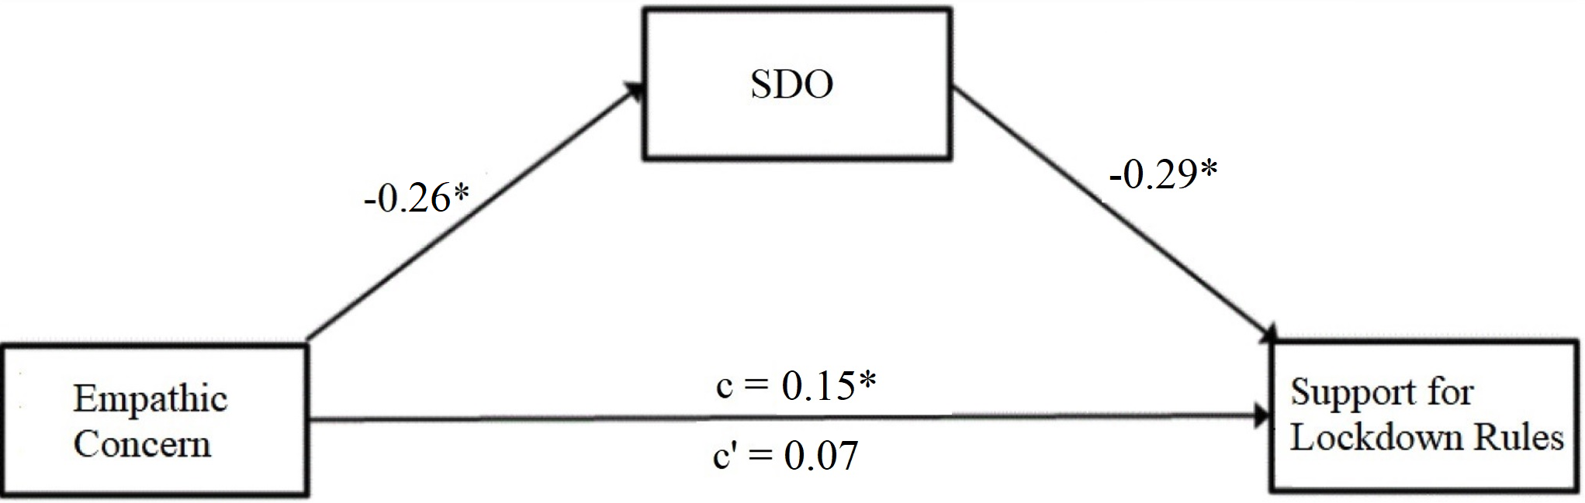

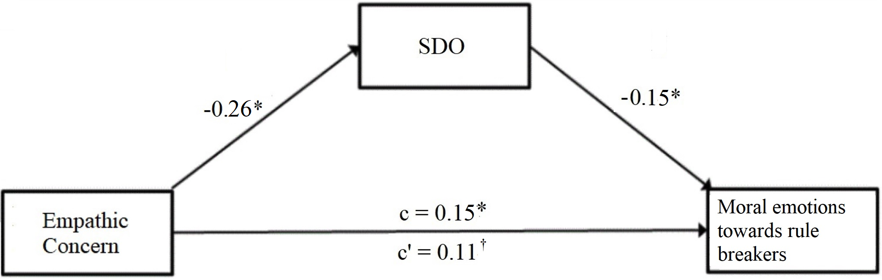
Figure S6. Mediation model for empathic concern predicting, via social dominance orientation (SDO), support for lockdown rule (PC1) and moral emotions towards rule breakers (PC2) controlling for various covariates excluding political affiliation.
Notes: Beta estimates shown are standardized. The indirect effect of empathic concern on support for lockdown rules was 0.07, and for moral emotions towards rule breakers it was 0.04. We tested the significance of this indirect effect using bootstrapping. Bias-corrected bootstrapped confidence intervals with 1,000 samples ranged from 0.03 to 0.13 for support for lockdown rules, and from .00 to 0.08 for moral emotions towards rule breakers, therefore these indirect effects were significant (p = <.001* and p = .052†, respectively). * = p < .05; † = p < .10

Table S14. Multiple regression analyses with social dominance orientation (SDO) and right-wing authoritarianism (RWA), as well as an interaction term between SDO and RWA, controlling for various covariates excluding political affiliation, predicting cooperative/other-regarding and conformist/norm-enforcing COVID-19 attitudes.

 | Model 1: Cooperative/other-regarding |  |  |  | Model 2: Conformist/norm-enforcing
 | R² = 0.14, F(8, 424) = 8.65, p < .001*, n = 433 |  |  |  | R² = 0.11, F(8, 416) = 6.11, p < .001*, n = 425
 | β (SE) std. | p | 95% CI |  | β (SE) std. | p | 95% CI
SDO*RWA | -0.02 (0.05) | .643 | [-0.13, 0.08] |  | -0.05 (0.05) | .338 | [-0.17, 0.05]
SDO | -0.36 (0.06) | <.001* | [-0.50, -0.24] |  | -0.19 (0.06) | .002* | [-0.33, -0.06]
RWA | 0.04 (0.06) | .505 | [-0.07, 0.16] |  | 0.37 (0.06) | <.001* | [0.25, 0.50]
Notes: For presentation purposes, covariate effects are omitted from the table. Confidence intervals (CIs) were bias corrected using 1,000
bootstrapped resamples. * = p < .05; † = p < .10

Table S15. Multiple regression analyses with social dominance orientation (SDO) and right-wing authoritarianism (RWA), as well as an interaction term between SDO and RWA, controlling for various covariates excluding political affiliation, predicting different conformist/norm-enforcing COVID-19 attitudes (PC1–4 = Principal Component 1–4).

 | Model 1: Support lockdown rules (PC1) |  |  |  | Model 2: Moral emotions towards rule breaker (PC2) |  |  |  | Model 3: Support strict border control (PC3) |  |  |  | Model 4: Support severe enforcement (PC4)
 | R² = 0.06, F(8, 424) = 3.56, p = .001*,  n = 433 |  |  |  | R² = 0.05, F(8, 416) = 2.96, p = .003*,  n = 425 |  |  |  | R² = 0.15, F(8, 424) = 9.24, p < .001*,  n = 433 |  |  |  | R² = 0.19, F(8, 424) = 12.6, p < .001*,  n = 433
Predictor variables | β (SE) std. | p | 95% CI |  | β (SE) std. | p | 95% CI |  | β (SE) std. | p | 95% CI |  | β (SE) std. | p | 95% CI
SDO*RWA | 0.02 (0.05) | .731 | [-0.10, 0.12] |  | -0.04 (0.05) | .472 | [-0.15, 0.07] |  | -0.09 (0.05) | .065† | [-0.17, 0.01] |  | -0.06 (0.05) | .201 | [-0.15, 0.04]
SDO | -0.30 (0.06) | <.001* | [-0.46, -0.16] |  | -0.13 (0.06) | .044* | [-0.28, 0.01] |  | -0.03 (0.06) | .668 | [-0.14, 0.09] |  | -0.06 (0.06) | .289 | [-0.19, 0.05]
RWA | 0.17 (0.06) | .007* | [0.04, 0.30] |  | 0.23 (0.06) | <.001* | [0.09, 0.37] |  | 0.38 (0.06) | <.001* | [0.27, 0.49] |  | 0.46 (0.06) | <.001* | [0.33, 0.57]
Notes: For presentation purposes, covariate results are omitted. Confidence intervals were bias corrected using 1,000 bootstrapped resamples. * = p < .05

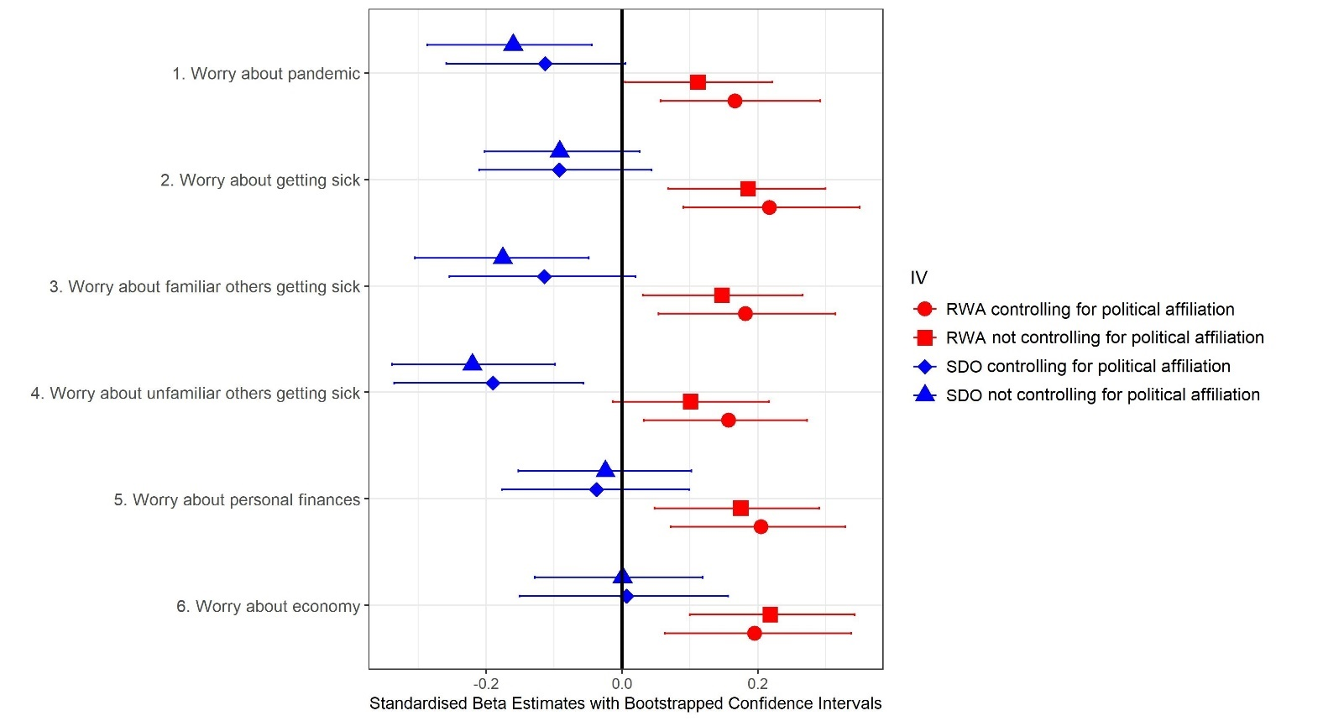

Figure S7. Results for linear regressions with social dominance orientation (SDO) and right-wing authoritarianism (RWA) controlling for each other, predicting concerned/threat-sensitive responses to COVID-19.
Notes: We control for age, sex, race, socioeconomic status, and pandemic threat exposure in all models. Models controlling for political affiliation are also displayed for comparison. See Table S16 below for more detailed results, including covariate effects.

Table S16. Multiple regression analyses with social dominance orientation (SDO) and right-wing authoritarianism (RWA), controlling for various covariates excluding political affiliation, predicting concerned/threat-sensitive COVID-19 attitudes.

 | Model 1: Concern about pandemic |  |  |  | Model 2: Concern about own health
 | R² = 0.09, F(7, 417) = 6, p < .001*, n = 425 |  |  |  | R² = 0.12, F(7, 417) = 7.89, p < .001*, n = 425
 | β (SE) std. | p | 95% CI |  | β (SE) std. | p | 95% CI
SDO | -0.16 (0.06) | .007* | [-0.28, -0.04] |  | -0.09 (0.06) | .114 | [-0.21, 0.03]
RWA | 0.11 (0.06) | .065† | [0.01, 0.23] |  | 0.19 (0.06) | .002* | [0.06, 0.30]
Age | 0.12 (0.05) | .015* | [0.01, 0.21] |  | 0.13 (0.05) | .005* | [0.04, 0.23]
Sex (male) | -0.35 (0.10) | .001* | [-0.57, -0.16] |  | -0.38 (0.10) | <.001* | [-0.59, -0.19]
Race (non-white) | 0.07 (0.16) | .667 | [-0.21, 0.33] |  | -0.04 (0.16) | .821 | [-0.29, 0.23]
Socioeconomic status | 0.08 (0.05) | .092† | [-0.02, 0.20] |  | 0.01 (0.05) | .858 | [-0.08, 0.11]
Pandemic threat exposure | 0.29 (0.11) | .010* | [0.09, 0.53] |  | 0.40 (0.11) | <.001* | [0.17, 0.60]

 | Model 3: Concern about familiar others’ health |  |  |  |  | Model 4: Concern about unfamiliar others’ health
 | R² = 0.06, F(7, 417) = 3.8, p = .001*, n = 425 |  |  |  |  | R² = 0.09, F(7, 417) = 5.8, p < .001*, n = 425
 | β (SE) std. |  | p | 95% CI |  | β (SE) std. |  | p | 95% CI
SDO | -0.18 (0.06) |  | .003* | [-0.32, -0.04] |  | -0.22 (0.06) |  | <.001* | [-0.33, -0.10]
RWA | 0.15 (0.06) |  | .017* | [0.03, 0.27] |  | 0.10 (0.06) |  | .095† | [-0.01, 0.21]
Age | 0.05 (0.05) |  | .291 | [-0.05, 0.15] |  | 0.12 (0.05) |  | .011* | [0.03, 0.21]
Sex (male) | -0.30 (0.10) |  | .004* | [-0.50, -0.10] |  | -0.35 (0.10) |  | .001* | [-0.55, -0.15]
Race (non-white) | -0.07 (0.16) |  | .651 | [-0.36, 0.19] |  | 0.02 (0.16) |  | .882 | [-0.26, 0.28]
Socioeconomic status | 0.04 (0.05) |  | .378 | [-0.06, 0.16] |  | 0.04 (0.05) |  | .403 | [-0.05, 0.14]
Pandemic threat exposure | 0.19 (0.12) |  | .102 | [-0.01, 0.43] |  | 0.19 (0.11) |  | .095† | [-0.04, 0.42]
 | Model 5: Concern about own finances |  |  |  |  |  | Model 6: Concern about economy
 | R² = 0.08, F(7, 417) = 5.33, p < .001*, n = 425 |  |  |  |  |  | R² = 0.11, F(7, 417) = 7.7, p < .001*, n = 425
 | β (SE) std. | p |  | 95% CI |  |  | β (SE) std. | p | 95% CI
SDO | -0.02 (0.06) | .680 |  | [-0.15, 0.11] |  |  | 0.00 (0.06) | .990 | [-0.12, 0.13]
RWA | 0.18 (0.06) | .004* |  | [0.05, 0.30] |  |  | 0.22 (0.06) | <.001* | [0.10, 0.35]
Age | 0.00 (0.05) | .973 |  | [-0.10, 0.11] |  |  | 0.12 (0.05) | .010* | [0.02, 0.22]
Sex (male) | 0.01 (0.10) | .905 |  | [-0.20, 0.21] |  |  | -0.10 (0.10) | .299 | [-0.29, 0.10]
Race (non-white) | -0.03 (0.16) | .857 |  | [-0.33, 0.28] |  |  | -0.04 (0.16) | .791 | [-0.30, 0.19]
Socioeconomic status | -0.03 (0.05) | .605 |  | [-0.12, 0.07] |  |  | 0.17 (0.05) | <.001* | [0.07, 0.28]
Pandemic threat exposure | 0.59 (0.11) | <.001* |  | [0.36, 0.83] |  |  | 0.13 (0.11) | .261 | [-0.07, 0.34]
Notes: Confidence intervals (CIs) were bias corrected using 1,000 bootstrapped resamples. * = p < .05; † = p < .10

Table S17. Multiple regression analyses with social dominance orientation (SDO) and right-wing authoritarianism (RWA), as well as an interaction term between SDO and RWA, controlling for various covariates excluding political affiliation, predicting concerned/threat-sensitive COVID-19 attitudes.

 | Model 1: Concern about pandemic |  |  |  | Model 2: Concern about own health
 | R² = 0.09, F(8, 416) = 5.25, p < .001*, n = 425 |  |  |  | R² = 0.12, F(8, 416) = 6.98, p < .001*, n = 425
 | β (SE) std. | p | 95% CI |  | β (SE) std. | p | 95% CI
SDO*RWA | -0.01 (0.05) | .801 | [-0.12, 0.08] |  | -0.04 (0.05) | .415 | [-0.14, 0.06]
SDO | -0.16 (0.06) | .012* | [-0.29, -0.03] |  | -0.08 (0.06) | .204 | [-0.20, 0.04]
RWA | 0.11 (0.06) | .089† | [0.00, 0.21] |  | 0.17 (0.06) | .006* | [0.04, 0.29]
 | Model 3: Concern about familiar others’ health |  |  |  | Model 4: Concern about unfamiliar others’ health
 | R² = 0.07, F(8, 416) = 3.63, p < .001*, n = 425 |  |  |  | R² = 0.09, F(8, 416) = 5.30, p < .001*, n = 425
 | β (SE) std. | p | 95% CI |  | β (SE) std. | p | 95% CI
SDO*RWA | -0.07 (0.05) | .127 | [-0.19, 0.03] |  | -0.06 (0.05) | .191 | [-0.17, 0.04]
SDO | -0.15 (0.06) | .019* | [-0.27, 0] |  | -0.20 (0.06) | .002* | [-0.32, -0.07]
RWA | 0.12 (0.06) | .060† | [0, 0.24] |  | 0.08 (0.06) | .215 | [-0.05, 0.20]
 | Model 5: Concern about own finances |  |  |  | Model 6: Concern about economy
 | R² = 0.08, F(8, 416) = 4.67, p < .001*, n = 425 |  |  |  | R² = 0.12, F(8, 416) = 6.93, p < .001*, n = 425
 | β (SE) std. | p | 95% CI |  | β (SE) std. | p | 95% CI
SDO*RWA | 0.02 (0.05) | .743 | [-0.08, 0.11] |  | -0.06 (0.05) | .222 | [-0.16, 0.05]
SDO | -0.03 (0.06) | .624 | [-0.17, 0.10] |  | 0.02 (0.06) | .709 | [-0.12, 0.16]
RWA | 0.18 (0.06) | .004* | [0.05, 0.31] |  | 0.20 (0.06) | .002* | [0.08, 0.34]
Notes: For presentation purposes, covariate results are omitted. Confidence intervals (CIs) were bias
corrected using 1,000 bootstrapped resamples. * = p < .05; † = p < .10

Table S18. Multiple regression analyses with concern about the pandemic or pandemic threat exposure, controlling for covariates excluding political affiliation, predicting change in right-wing authoritarianism (RWA), i.e., the difference between RWA measured before the onset of the COVID-19 pandemic and RWA measured during the COVID-19 pandemic.

 | Model 1: Change in RWA predicted by concern about the pandemic |  |  |  |  | Model 2: Change in RWA predicted by pandemic threat exposure
 | R² = 0.05, F(5, 419) = 4.38, p = .001*, n = 425 |  |  |  |  | R² = 0.02, F(5, 427) = 1.64, p = .147, n = 433
Predictor variables | β (SE) std. | p | 95% CI |  | Predictor variables | β (SE) std. | p | 95% CI
Concern about the pandemic | 0.17 (0.05) | .001* | [0.08, 0.30] |  | Pandemic threat exposure | -0.01 (0.12) | .962 | [-0.28, 0.24]
Age | -0.04 (0.05) | .461 | [-0.14, 0.10] |  | Age | -0.01 (0.05) | .804 | [-0.12, 0.12]
Sex (male) | 0.12 (0.10) | .245 | [-0.03, 0.41] |  | Sex (male) | 0.04 (0.10) | .665 | [-0.11, 0.33]
Race (non-white) | 0.35 (0.16) | .032* | [0.04, 0.74] |  | Race (non-white) | 0.32 (0.16) | .048* | [0.03, 0.71]
Socioeconomic status | 0.08 (0.05) | .093† | [-0.02, 0.19] |  | Socioeconomic status | 0.09 (0.05) | .054† | [-0.01, 0.21]
Notes: Confidence intervals (CIs) were bias corrected using 1,000 bootstrapped resamples. * = p < .05; † = p < .10

References
Conway LG, Woodward SR and Zubrod A (2020) Social Psychological Measurements of COVID-19: Coronavirus Perceived Threat, Government Response, Impacts, and Experiences Questionnaires. PsyArXiv.
Everett JAC et al. (2020) The Effectiveness of Moral Messages on Public Health Behavioral Intentions during the COVID-19 Pandemic. PsyArXiv Preprints 1–23.
Gadarian SK, Goodman SW and Pepinsky TB (2021) Partisanship, Health Behavior, and Policy Attitudes in the Early Stages of the COVID-19 Pandemic. PLoS ONE 16, 1–13.
Pfattheicher S et al. (2020) The Emotional Path to Action: Empathy Promotes Physical Distancing and Wearing of Face Masks during the COVID-19 Pandemic. Psychological Science 31, 1363–1373.
Stamkou E et al. (2019) Cultural Collectivism and Tightness Moderate Responses to Norm Violators: Effects on Power Perception, Moral Emotions, and Leader Support. Personality and Social Psychology Bulletin 45, 947–964.

