Who Deserves European Solidarity?
How recipient characteristics shape public support for international medical and financial aid during COVID-19

Appendix

Table of Contents:

Appendix A. Wording of experimental vignettes (translated from German) 2
Appendix B. Coding of additional variables 4
Appendix C. Sample composition compared to population census data 5
Appendix D. Descriptive Statistics 6
Appendix E. Support for medical and financial aid 9
Appendix F. Support for medical and financial aid: Models including list-wise deletion for control variables 22
Appendix G. Support for medical and financial aid: Unweighted models 34
Appendix H. Marginal effects based on linear probability models for dichotomized dependent variables 46
Appendix I. Heterogeneous treatment effects for medical and financial aid vignettes 1 47
Appendix J. Heterogeneous treatment effects with three subgroups 49
Appendix K. Interaction effects between altruism and reciprocity/backward control 50
Appendix L. Additional medical and financial aid vignette experiments 51
Appendix M. Heterogenous treatment effects for a more restrictive altruism classification 53
Appendix N. Public support for the ‘Next Generation EU’ recovery program in Germany 54

Appendix A. Wording of experimental vignettes (translated from German)

Vignette on medical solidarity VMA 1 (April 2020 wave)
Imagine another German state in which a large number of people have fallen ill from the coronavirus. Despite the existence of a well-developed healthcare system, not all COVID19 patients can get appropriate treatment because of a shortage of ventilators. According to one initiative, your state is to provide ventilators to the other state. The possibility that such a measure might lead to medical disadvantages for you and your region cannot be entirely ruled out.
Would you support such an initiative?

Vignette on fiscal solidarity VFA 1 (April 2020 wave)
Imagine another EU country in which a large number of people have fallen ill from the coronavirus. In the past, that country only built up limited financial reserves because of overly generous spending policies and hence has little capacity to address the economic consequences of the COVID19 crisis on its own. According to one initiative, Germany is to provide financial assistance to that country to help it counter the economic fallout. The anticipated measure would temporarily lead to higher tax rates.
Would you support such an initiative?

Vignette on medical solidarity VMA 2 (May 2021 wave)
Imagine another EU country which applies for medical assistance from a hypothetical EU aid program. The program would entail that other EU member states provide medical personnel and equipment to the applying country.
The country has been hit hard by the Corona pandemic, even though the country’s government has rapidly implemented measures to contain the virus. Based on its gross domestic product the country is part of the poorer EU member states. Its public health system is considered to be efficient, thus it can be expected that the aid is purposefully used. The country is considered diligent in the implementation of the rule of law and of democratic principles. In past years, the country has strongly participated in the accommodation of refugees.
Would you support it, if the EU offers medical aid to this country?

Vignette on fiscal solidarity VFA 2 (May 2021 wave)
Currently there is an ongoing debate on who should profit from the EU recovery fund. Imagine a country which applies for financial help from this program. The country is briefly described in the following text. Please read the text carefully. After that we would like to know, whether you would support that aid is provided to this country.
The country has been hit hard by the Corona pandemic, even though the country’s government has rapidly implemented measures to contain the virus. Based on its gross domestic product the country is part of the poorer EU member states. Its public administration is considered to be efficient, thus it can be expected that EU funds are purposefully used. The country is considered diligent in the implementation of the rule of law and of democratic principles. In past years, the country has strongly participated in the accommodation of refugees.
Would you support it, if the EU offers financial aid to this country?

Appendix B. Coding of additional variables

In additional models, we use an alternative measure of support for financial redistribution and control for socio-demographics, as well as for specific attitudes and identity.
As an alternative measure of financial solidarity, respondents were provided with the following statement: “You might know that in July some EU states have agreed on a pandemic recovery fund. The recovery fund for the first time allows the European commission to incur debt on financial markets for a limited period of time, which can be redistributed to member states under specific conditions. The money should be spent target oriented for future technologies. Do you support this initiate?” For the answers we used a 7-point Likert scale ranging from “not support at all” (1) to “fully support” (7)
Gender is coded 1 for females (males=0). Age is measured in five age groups, recoded into a group of dummy variables: respondents 18 to 29 are used as the reference category; 30-39; 40-49; 50-59 and 60 and older. For education level, we use a set of three dummy variables distinguishing between primary, secondary and tertiary education. People having attended some or finished basic education (‘Hauptschule’) are coded as having lower education (1=yes; 0=no); Middle education encompasses people that have a degree in a secondary school, such as ‘Realschule’ or ‘Gymnasium’ (1=yes; 0=no); Respondents with higher education have a college or university degree (‘Fachhochschulabschluss’ or ‘Hochschulabschluss’) (1=yes; 0=no). We also control for income, distinguishing between six income groups: less than 900 Euros, 900-1500 Euros, more than 1500 to 2600 Euros, more than 2600 to 4000 Euros, more than 4000 to 6000 Euros and more than 6000 Euros.
We operationalize altruism by the following question in the survey: “I feel a moral obligation to help people in need”. The answer scale is comprised of a 7-point Likert scale measuring support for the statement (1=“totally disagree”; 7=“fully agree”). For the subgroup analysis, we dichotomized the altruism measure: 1-3=0 (“no”); 5-7=1 (“yes”); 4 dropped from the analysis. Cosmopolitanism is measured asking for agreement with the following statement: “Although the media often reports about national and international events and developments, this news is seldom as interesting as the things that happen directly in our own community and neighborhood.” We again used the 7-point agreement scale, which was reverse coded to reflect support for cosmopolitanism (1=“totally disagree”; 7=“fully agree”). For the subgroup analysis we dichotomized the cosmopolitanism measure: 1-3=0 (“no”); 5-7=1 (“yes”); 4 dropped from the analysis. European identity is measured by the following question; People feel connected to their region, country or Europe to different degrees. How much do you feel connected to Europe?” The following answer options were provided: “Not connected at all (1); not very connected (2); rather connected (3); very connected (4). Finally, we also control for political self-placement on a left-right scale from 0 to 10, where 1 reflects political left and 10 political right. For the subgroup analysis we dichotomized the European identity measure: 1-2=0 (“no”); 3-4=1 (“yes”).

Appendix C. Sample composition compared to population census data

 | Sample (April/May 2020) | Sample  (May 2021) | Population (census)
Highest educational level attained:
Lower education | 30.7% | 37.4% | 35.8 %
Secondary schooling | 33.5% | 30.2% | 30.5 %
Higher education | 35.8% | 32.4% | 33.6 %
Female | 51.4% | 49.0% | 50.1 %
Age:
18-39 years | 32.7% | 27.0% | 31.6 %
40-59 years | 38.9% | 39.5% | 35.2 %
60+ years | 28.4% | 33.5% | 33.2 %
East | 32.3% | 29.0% | 19.7 %
Note: East Germany was deliberately oversampled in the survey.
Table A1. Sample composition (unweighted) compared to population census data.

Appendix D. Descriptive Statistics

Survey Wave | Variable | Vignette | Mean | Standard Deviation | Min | Max
Wave 1 | Dependent Variables
 | Support for medical aid | VMA1 | 5.09 | 1.77 | 1 | 7
 | Support for financial aid | VFA1 | 4.32 | 1.99 | 1 | 7
 | Treatment Variables
 | Community: EU | VMA1 | 0.33 | 0.47 | 0 | 1
 | Community: nonEU | VMA1 | 0.34 | 0.47 | 0 | 1
 | Community: other German region | VMA1 | 0.34 | 0.47 | 0 | 1
 | Community: EU | VFA1 | 0.33 | 0.47 | 0 | 1
 | Community: nonEU | VFA1 | 0.32 | 0.47 | 0 | 1
 | Community: other German region | VFA1 | 0.34 | 0.47 | 0 | 1
 | Control | VMA1 | 0.51 | 0.50 | 0 | 1
 | Control | VFA1 | 0.51 | 0.50 | 0 | 1
 | Costs | VMA1 | 0.50 | 0.50 | 0 | 1
 | Costs | VFA1 | 0.51 | 0.50 | 0 | 1
 | Control Variables
 | Altruism |  | 4.97 | 1.56 | 1 | 7
 | Cosmopolitanism |  | 3.96 | 1.60 | 1 | 7
 | European Identity |  | 2.62 | 0.87 | 1 | 4
 | Left-Right |  | 4.68 | 1.99 | 0 | 10
 | Age: 18-29 years |  | 0.16 | 0.37 | 0 | 1
 | Age: 30-39 years |  | 0.17 | 0.37 | 0 | 1
 | Age: 40-49 years |  | 0.17 | 0.38 | 0 | 1
 | Age: 50-59 years |  | 0.22 | 0.41 | 0 | 1
 | Age: 60+ years |  | 0.28 | 0.45 | 0 | 1
 | Education: high |  | 0.38 | 0.48 | 0 | 1
 | Education: middle |  | 0.33 | 0.47 | 0 | 1
 | Education: low |  | 0.29 | 0.46 | 0 | 1
 | Income < 900 |  | 0.11 | 0.31 | 0 | 1
 | Income: 900-1500 |  | 0.13 | 0.34 | 0 | 1
 | Income: 1500-2600 |  | 0.33 | 0.47 | 0 | 1
 | Income: 2600-4000 |  | 0.24 | 0.43 | 0 | 1
 | Income: 4000-6000 |  | 0.14 | 0.35 | 0 | 1
 | Income > 6000 |  | 0.04 | 0.19 | 0 | 1
 | Region: East Germany |  | 0.33 | 0.47 | 0 | 1
 | Sex: Female |  | 0.47 | 0.50 | 0 | 1
Wave 2 | Dependent Variables
 | Support for medical aid | VMA2 | 4.54 | 1.71 | 1 | 7
 | Support for financial aid | VFA2 | 4.14 | 1.75 | 1 | 7
 | Treatment Variables
 | Need | VMA2 | 0.49 | 0.50 | 0 | 1
 | Control (backward-looking) | VMA2 | 0.51 | 0.50 | 0 | 1
 | Control (forward-looking) | VMA2 | 0.50 | 0.50 | 0 | 1
 | Community norms | VMA2 | 0.51 | 0.50 | 0 | 1
 | Reciprocity | VMA2 | 0.51 | 0.50 | 0 | 1
 | Need | VFA2 | 0.51 | 0.50 | 0 | 1
 | Control (backward-looking) | VFA2 | 0.52 | 0.50 | 0 | 1
 | Control (forward-looking) | VFA2 | 0.50 | 0.50 | 0 | 1
 | Community norms | VFA2 | 0.49 | 0.50 | 0 | 1
 | Reciprocity | VFA2 | 0.50 | 0.50 | 0 | 1
 | Control Variables
 | Altruism |  | 5.02 | 1.54 | 1 | 7
 | Cosmopolitanism |  | 3.99 | 1.54 | 1 | 7
 | European Identity |  | 2.54 | 0.88 | 1 | 4
 | Left-Right |  | 4.85 | 1.96 | 0 | 10
 | Age: 18-29 years |  | 0.15 | 0.36 | 0 | 1
 | Age: 30-39 years |  | 0.12 | 0.32 | 0 | 1
 | Age: 40-49 years |  | 0.15 | 0.36 | 0 | 1
 | Age: 50-59 years |  | 0.25 | 0.43 | 0 | 1
 | Age: 60+ years |  | 0.33 | 0.47 | 0 | 1
 | Education: high |  | 0.34 | 0.47 | 0 | 1
 | Education: middle |  | 0.30 | 0.46 | 0 | 1
 | Education: low |  | 0.36 | 0.48 | 0 | 1
 | Income < 900 |  | 0.11 | 0.31 | 0 | 1
 | Income: 900-1500 |  | 0.15 | 0.35 | 0 | 1
 | Income: 1500-2600 |  | 0.32 | 0.47 | 0 | 1
 | Income: 2600-4000 |  | 0.24 | 0.43 | 0 | 1
 | Income: 4000-6000 |  | 0.14 | 0.34 | 0 | 1
 | Income > 6000 |  | 0.04 | 0.2 | 0 | 1
 | Region: East Germany |  | 0.29 | 0.46 | 0 | 1
 | Sex: Female |  | 0.45 | 0.45 | 0 | 1
Additional Wave | Dependent Variables
 | Support for medical aid | VMA | 4.46 | 1.8 | 1 | 7
 | Support for financial aid | VFA | 3.96 | 1.71 | 1 | 7
 | Treatment Variables
 | Control | VMA | 0.52 | 0.5 | 0 | 1
 | Reciprocity | VMA | 0.49 | 0.5 | 0 | 1
 | Costs | VMA | 0.51 | 0.5 | 0 | 1
 | Need | VFA | 0.49 | 0.5 | 0 | 1
 | Control (backward-looking) | VFA | 0.5 | 0.5 | 0 | 1
 | Control (forward-looking) | VFA | 0.5 | 0.5 | 0 | 1
 | Community norms | VFA | 0.5 | 0.5 | 0 | 1
 | Reciprocity | VFA | 0.5 | 0.5 | 0 | 1
 | Control Variables
 | Altruism |  | 4.92 | 1.58 | 1 | 7
 | Cosmopolitanism |  | 3.93 | 1.6 | 1 | 7
 | European Identity |  | 2.59 | 0.89 | 1 | 4
 | Left-Right |  | 4.84 | 1.96 | 0 | 10
 | Age: 18-29 years |  | 0.16 | 0.37 | 0 | 1
 | Age: 30-39 years |  | 0.16 | 0.36 | 0 | 1
 | Age: 40-49 years |  | 0.17 | 0.38 | 0 | 1
 | Age: 50-59 years |  | 0.21 | 0.41 | 0 | 1
 | Age: 60+ years |  | 0.30 | 0.46 | 0 | 1
 | Education: high |  | 0.36 | 0.48 | 0 | 1
 | Education: middle |  | 0.32 | 0.47 | 0 | 1
 | Education: low |  | 0.32 | 0.46 | 0 | 1
 | Income < 900 |  | 0.10 | 0.30 | 0 | 1
 | Income: 900-1500 |  | 0.19 | 0.39 | 0 | 1
 | Income: 1500-2600 |  | 0.28 | 0.45 | 0 | 1
 | Income: 2600-4000 |  | 0.25 | 0.43 | 0 | 1
 | Income: 4000-6000 |  | 0.15 | 0.36 | 0 | 1
 | Income > 6000 |  | 0.03 | 0.17 | 0 | 1
 | Region: East Germany |  | 0.34 | 0.47 | 0 | 1
 | Sex: Female |  | 0.48 | 0.5 | 0 | 1

Table A2. Descriptive statistics (unweighted variables after list-wise deletion).

Appendix E. Support for medical and financial aid

Support for bilateral medical aid (April/May 2020)
 | Dependent variable:
 | Support for bilateral medical aid
 | (1) | (2) | (3) | (4) | (5)
Public health system | 0.161*** | 0.168*** | 0.083 | 0.151* | 0.146
 | (0.048) | (0.049) | (0.085) | (0.060) | (0.077)
Medical risk | -1.032*** | -1.029*** | -1.038*** | -1.093*** | -1.121***
 | (0.048) | (0.049) | (0.084) | (0.060) | (0.077)
German region | 0.406*** | 0.448*** | 0.669*** | 0.527*** | 0.766***
 | (0.059) | (0.060) | (0.102) | (0.073) | (0.094)
Non-EU country | -0.213*** | -0.249*** | -0.252* | -0.150* | -0.082
 | (0.059) | (0.060) | (0.104) | (0.073) | (0.094)
Altruism |  | 0.758*** | 0.797*** | 0.850*** | 0.748***
 |  | (0.054) | (0.118) | (0.054) | (0.054)
Cosmopolitanism |  | 0.395*** | 0.398*** | 0.480***
 |  | (0.054) | (0.054) | (0.120)
EU identity |  | 0.464*** | 0.465*** |  | 0.641***
 |  | (0.052) | (0.052) |  | (0.115)
Left-right |  | -0.093*** | -0.093*** | -0.109*** | -0.104***
 |  | (0.013) | (0.013) | (0.013) | (0.013)
Female |  | -0.060 | -0.058 | -0.059 | -0.074
 |  | (0.050) | (0.050) | (0.050) | (0.050)
Age: 30-39 years |  | -0.096 | -0.093 | -0.089 | -0.119
 |  | (0.089) | (0.089) | (0.090) | (0.089)
Age: 40-49 years |  | -0.054 | -0.048 | -0.057 | -0.072
 |  | (0.088) | (0.088) | (0.089) | (0.089)
Age: 50-59 years |  | 0.109 | 0.111 | 0.107 | 0.091
 |  | (0.087) | (0.087) | (0.088) | (0.088)
Age: 60+ years |  | 0.200* | 0.203* | 0.241** | 0.184*
 |  | (0.080) | (0.080) | (0.081) | (0.081)
Edu: low |  | -0.252*** | -0.255*** | -0.295*** | -0.321***
 |  | (0.066) | (0.066) | (0.066) | (0.066)
Edu: middle |  | -0.144* | -0.146* | -0.175** | -0.192**
 |  | (0.063) | (0.063) | (0.063) | (0.062)
Income: 900-1500 |  | 0.100 | 0.095 | 0.100 | 0.104
 |  | (0.101) | (0.101) | (0.102) | (0.101)
Income: 1500-2600 |  | 0.353*** | 0.342*** | 0.384*** | 0.359***
 |  | (0.086) | (0.086) | (0.087) | (0.087)
Income: 2600-4000 |  | 0.422*** | 0.407*** | 0.470*** | 0.423***
 |  | (0.091) | (0.091) | (0.092) | (0.092)
Income: 4000-6000 |  | 0.527*** | 0.514*** | 0.561*** | 0.546***
 |  | (0.101) | (0.101) | (0.102) | (0.101)
Income: > 6000 |  | 0.299* | 0.278 | 0.374* | 0.305*
 |  | (0.148) | (0.148) | (0.149) | (0.149)
Ost |  | -0.081 | -0.086 | -0.113 | -0.114
 |  | (0.063) | (0.063) | (0.064) | (0.063)
Altruism x public health system |  |  | 0.133
 |  |  | (0.104)
Altruism x medical risk |  |  | 0.011
 |  |  | (0.104)
Altruism x German region |  |  | -0.339**
 |  |  | (0.126)
Altruism x non-EU country |  |  | 0.002
 |  |  | (0.127)
Cosmopolitanism x public health system |  |  |  | 0.074
 |  |  |  | (0.106)
Cosmopolitanism x medical risk |  |  |  | 0.201
 |  |  |  | (0.106)
Cosmopolitanism x German region |  |  |  | -0.268*
 |  |  |  | (0.129)
Cosmopolitanism x non-EU country |  |  |  | -0.346**
 |  |  |  | (0.130)
EU identity x public health system |  |  |  |  | 0.064
 |  |  |  |  | (0.100)
EU identity x medical risk |  |  |  |  | 0.161
 |  |  |  |  | (0.100)
EU identity x German region |  |  |  |  | -0.533***
 |  |  |  |  | (0.122)
EU identity x non-EU country |  |  |  |  | -0.286*
 |  |  |  |  | (0.122)
Constant | 5.403*** | 4.787*** | 4.768*** | 5.036*** | 4.916***
 | (0.055) | (0.138) | (0.156) | (0.139) | (0.147)
Observations | 4,775 | 3,914 | 3,914 | 3,925 | 3,921
R² | 0.113 | 0.260 | 0.263 | 0.248 | 0.254
Adjusted R² | 0.112 | 0.256 | 0.258 | 0.243 | 0.250
Residual Std. Error | 1.669 (df = 4770) | 1.518 (df = 3892) | 1.516 (df = 3888) | 1.532 (df = 3900) | 1.524 (df = 3896)
F Statistic | 151.811*** (df = 4; 4770) | 65.252*** (df = 21; 3892) | 55.369*** (df = 25; 3888) | 53.468*** (df = 24; 3900) | 55.385*** (df = 24; 3896)
Note: | *p<0.05; **p<0.01; ***p<0.001

Table A3. Support for bilateral medical aid in April/May 2020.

Support for bilateral financial aid (April/May 2020)
 | Dependent variable:
 | Support for bilateral financial aid
 | (1) | (2) | (3) | (4) | (5)
Fiscal discipline | 0.260*** | 0.254*** | 0.197* | 0.261*** | 0.352***
 | (0.055) | (0.056) | (0.096) | (0.069) | (0.087)
Tax increase | -1.078*** | -1.113*** | -1.031*** | -1.009*** | -1.040***
 | (0.055) | (0.056) | (0.097) | (0.069) | (0.087)
German region | 0.643*** | 0.613*** | 0.650*** | 0.540*** | 0.709***
 | (0.067) | (0.068) | (0.117) | (0.084) | (0.105)
Non-EU country | 0.014 | -0.055 | -0.236* | -0.092 | -0.139
 | (0.068) | (0.069) | (0.118) | (0.085) | (0.108)
Altruism |  | 0.773*** | 0.725*** | 0.937*** | 0.763***
 |  | (0.062) | (0.131) | (0.062) | (0.062)
Cosmopolitanism |  | 0.127* | 0.123* | 0.176
 |  | (0.061) | (0.061) | (0.139)
EU identity |  | 0.798*** | 0.793*** |  | 0.966***
 |  | (0.059) | (0.059) |  | (0.127)
Left-right |  | -0.139*** | -0.139*** | -0.163*** | -0.143***
 |  | (0.015) | (0.015) | (0.015) | (0.015)
Female |  | -0.327*** | -0.330*** | -0.320*** | -0.330***
 |  | (0.057) | (0.057) | (0.058) | (0.057)
Age: 30-39 years |  | -0.215* | -0.214* | -0.185 | -0.217*
 |  | (0.102) | (0.102) | (0.104) | (0.102)
Age: 40-49 years |  | -0.275** | -0.272** | -0.269** | -0.273**
 |  | (0.101) | (0.101) | (0.103) | (0.101)
Age: 50-59 years |  | -0.148 | -0.144 | -0.150 | -0.150
 |  | (0.100) | (0.100) | (0.102) | (0.099)
Age: 60+ years |  | 0.053 | 0.052 | 0.108 | 0.056
 |  | (0.092) | (0.092) | (0.094) | (0.092)
Edu: low |  | -0.113 | -0.113 | -0.191* | -0.137
 |  | (0.075) | (0.075) | (0.077) | (0.075)
Edu: middle |  | -0.005 | -0.005 | -0.062 | -0.026
 |  | (0.071) | (0.071) | (0.073) | (0.071)
Income: 900-1500 |  | 0.036 | 0.034 | 0.047 | 0.030
 |  | (0.115) | (0.115) | (0.118) | (0.115)
Income: 1500-2600 |  | 0.080 | 0.077 | 0.149 | 0.074
 |  | (0.099) | (0.099) | (0.101) | (0.099)
Income: 2600-4000 |  | 0.006 | 0.002 | 0.091 | 0.002
 |  | (0.104) | (0.105) | (0.107) | (0.104)
Income: 4000-6000 |  | 0.261* | 0.255* | 0.321** | 0.258*
 |  | (0.115) | (0.115) | (0.118) | (0.115)
Income: > 6000 |  | 0.115 | 0.113 | 0.242 | 0.110
 |  | (0.170) | (0.170) | (0.174) | (0.170)
Ost |  | -0.163* | -0.164* | -0.218** | -0.166*
 |  | (0.072) | (0.072) | (0.074) | (0.072)
Altruism x fiscal discipline |  |  | 0.086
 |  |  | (0.118)
Altruism x tax increase |  |  | -0.121
 |  |  | (0.118)
Altruism x German region |  |  | -0.054
 |  |  | (0.143)
Altruism x non-EU country |  |  | 0.271
 |  |  | (0.145)
Cosmopolitanism x fiscal discipline |  |  |  | 0.035
 |  |  |  | (0.123)
Cosmopolitanism x tax increase |  |  |  | -0.278*
 |  |  |  | (0.123)
Cosmopolitanism x German region |  |  |  | 0.180
 |  |  |  | (0.149)
Cosmopolitanism x non-EU country |  |  |  | 0.151
 |  |  |  | (0.150)
EU identity x fiscal discipline |  |  |  |  | -0.165
 |  |  |  |  | (0.113)
EU identity x tax increase |  |  |  |  | -0.119
 |  |  |  |  | (0.114)
EU identity x German region |  |  |  |  | -0.175
 |  |  |  |  | (0.137)
EU identity x non-EU country |  |  |  |  | 0.134
 |  |  |  |  | (0.140)
Constant | 4.446*** | 4.447*** | 4.484*** | 4.864*** | 4.433***
 | (0.061) | (0.156) | (0.172) | (0.163) | (0.165)
Observations | 4,775 | 3,914 | 3,914 | 3,925 | 3,921
R² | 0.098 | 0.250 | 0.251 | 0.214 | 0.250
Adjusted R² | 0.097 | 0.246 | 0.246 | 0.209 | 0.246
Residual Std. Error | 1.900 (df = 4770) | 1.734 (df = 3892) | 1.734 (df = 3888) | 1.776 (df = 3900) | 1.733 (df = 3896)
F Statistic | 129.654*** (df = 4; 4770) | 61.663*** (df = 21; 3892) | 52.129*** (df = 25; 3888) | 44.315*** (df = 24; 3900) | 54.255*** (df = 24; 3896)
Note: | *p<0.05; **p<0.01; ***p<0.001

Table A4. Support for bilateral financial aid in April/May 2020.

Support for EU medical aid (May 2021)
 | Dependent variable:
 | Support for EU medical aid
 | (1) | (2) | (3) | (4) | (5)
COVID policy | 0.219*** | 0.269*** | 0.091 | 0.226*** | 0.280***
 | (0.053) | (0.054) | (0.093) | (0.066) | (0.081)
Wealth | -0.197*** | -0.201*** | -0.042 | -0.214** | -0.104
 | (0.053) | (0.054) | (0.094) | (0.066) | (0.081)
Administrative capacity | 0.293*** | 0.288*** | 0.268** | 0.246*** | 0.390***
 | (0.053) | (0.054) | (0.093) | (0.066) | (0.081)
Rule of law | 0.384*** | 0.357*** | 0.296** | 0.283*** | 0.369***
 | (0.053) | (0.054) | (0.093) | (0.066) | (0.081)
Refugee admission | 0.380*** | 0.389*** | 0.156 | 0.219*** | 0.249**
 | (0.053) | (0.054) | (0.094) | (0.066) | (0.081)
Vignette order | -0.217*** | -0.261*** | -0.259*** | -0.254*** | -0.264***
 | (0.053) | (0.054) | (0.054) | (0.055) | (0.054)
Altruism |  | 0.638*** | 0.384** | 0.753*** | 0.637***
 |  | (0.059) | (0.140) | (0.059) | (0.059)
Cosmopolitanism |  | -0.010 | -0.013 | -0.543***
 |  | (0.059) | (0.059) | (0.143)
EU identity |  | 0.619*** | 0.617*** |  | 0.678***
 |  | (0.056) | (0.056) |  | (0.133)
Left-right |  | -0.089*** | -0.088*** | -0.108*** | -0.088***
 |  | (0.014) | (0.014) | (0.014) | (0.014)
Female |  | -0.091 | -0.089 | -0.083 | -0.094
 |  | (0.056) | (0.056) | (0.056) | (0.056)
Age: 30-39 years |  | 0.053 | 0.053 | 0.062 | 0.060
 |  | (0.105) | (0.105) | (0.106) | (0.104)
Age: 40-49 years |  | 0.189 | 0.193 | 0.163 | 0.194
 |  | (0.100) | (0.100) | (0.101) | (0.100)
Age: 50-59 years |  | 0.082 | 0.088 | 0.077 | 0.085
 |  | (0.090) | (0.090) | (0.092) | (0.090)
Age: 60+ years |  | 0.184* | 0.183* | 0.207* | 0.177*
 |  | (0.089) | (0.089) | (0.091) | (0.089)
Edu: low |  | -0.091 | -0.098 | -0.168* | -0.085
 |  | (0.074) | (0.074) | (0.075) | (0.074)
Edu: middle |  | -0.030 | -0.042 | -0.076 | -0.025
 |  | (0.074) | (0.074) | (0.075) | (0.074)
Income: 900-1500 |  | -0.002 | -0.017 | -0.033 | -0.005
 |  | (0.109) | (0.109) | (0.111) | (0.109)
Income: 1500-2600 |  | 0.027 | 0.015 | 0.041 | 0.024
 |  | (0.095) | (0.095) | (0.096) | (0.095)
Income: 2600-4000 |  | 0.083 | 0.068 | 0.110 | 0.081
 |  | (0.099) | (0.099) | (0.101) | (0.099)
Income: 4000-6000 |  | 0.038 | 0.013 | 0.026 | 0.015
 |  | (0.111) | (0.111) | (0.112) | (0.111)
Income: > 6000 |  | 0.011 | 0.005 | 0.079 | 0.004
 |  | (0.156) | (0.155) | (0.158) | (0.155)
Ost |  | -0.093 | -0.092 | -0.122 | -0.095
 |  | (0.082) | (0.082) | (0.083) | (0.082)
Altruism x COVID policy |  |  | 0.261*
 |  |  | (0.114)
Altruism x wealth |  |  | -0.230*
 |  |  | (0.114)
Altruism x administrative capacity |  |  | 0.032
 |  |  | (0.114)
Altruism x rule of law |  |  | 0.097
 |  |  | (0.114)
Altruism x refugee admission |  |  | 0.339**
 |  |  | (0.114)
Cosmopolitanism x COVID policy |  |  |  | 0.113
 |  |  |  | (0.117)
Cosmopolitanism x wealth |  |  |  | 0.053
 |  |  |  | (0.117)
Cosmopolitanism x administrative capacity |  |  |  | 0.168
 |  |  |  | (0.117)
Cosmopolitanism x rule of law |  |  |  | 0.180
 |  |  |  | (0.117)
Cosmopolitanism x refugee admission |  |  |  | 0.549***
 |  |  |  | (0.117)
EU identity x COVID policy |  |  |  |  | -0.031
 |  |  |  |  | (0.108)
EU identity x wealth |  |  |  |  | -0.159
 |  |  |  |  | (0.108)
EU identity x administrative capacity |  |  |  |  | -0.158
 |  |  |  |  | (0.108)
EU identity x rule of law |  |  |  |  | -0.026
 |  |  |  |  | (0.108)
EU identity x refugee admission |  |  |  |  | 0.240*
 |  |  |  |  | (0.108)
Constant | 4.056*** | 3.744*** | 3.925*** | 4.297*** | 3.707***
 | (0.070) | (0.155) | (0.176) | (0.158) | (0.166)
Observations | 4,016 | 3,410 | 3,410 | 3,420 | 3,423
R² | 0.044 | 0.152 | 0.156 | 0.129 | 0.153
Adjusted R² | 0.042 | 0.146 | 0.149 | 0.122 | 0.146
Residual Std. Error | 1.742 (df = 4009) | 1.634 (df = 3386) | 1.631 (df = 3381) | 1.656 (df = 3392) | 1.632 (df = 3395)
F Statistic | 30.671*** (df = 6; 4009) | 26.303*** (df = 23; 3386) | 22.339*** (df = 28; 3381) | 18.583*** (df = 27; 3392) | 22.701*** (df = 27; 3395)
Note: | *p<0.05; **p<0.01; ***p<0.001

Table A5. Support for medical EU aid in May 2021.

Support for EU financial aid (May 2021)
 | Dependent variable:
 | Support for EU financial aid
 | (1) | (2) | (3) | (4) | (5)
COVID policy | 0.208*** | 0.232*** | 0.166 | 0.212** | 0.252**
 | (0.053) | (0.054) | (0.094) | (0.067) | (0.081)
Wealth | -0.149** | -0.129* | -0.004 | -0.128 | -0.056
 | (0.053) | (0.054) | (0.094) | (0.067) | (0.081)
Administrative capacity | 0.423*** | 0.445*** | 0.486*** | 0.481*** | 0.385***
 | (0.053) | (0.054) | (0.094) | (0.067) | (0.081)
Rule of law | 0.509*** | 0.463*** | 0.352*** | 0.372*** | 0.469***
 | (0.053) | (0.054) | (0.094) | (0.067) | (0.081)
Refugee admission | 0.452*** | 0.472*** | 0.204* | 0.398*** | 0.296***
 | (0.053) | (0.054) | (0.093) | (0.067) | (0.081)
Vignette order | -0.276*** | -0.292*** | -0.293*** | -0.284*** | -0.292***
 | (0.053) | (0.054) | (0.054) | (0.055) | (0.054)
Altruism |  | 0.526*** | 0.325* | 0.662*** | 0.530***
 |  | (0.060) | (0.143) | (0.060) | (0.059)
Cosmopolitanism |  | -0.101 | -0.102 | -0.265
 |  | (0.059) | (0.059) | (0.147)
EU identity |  | 0.769*** | 0.770*** |  | 0.622***
 |  | (0.056) | (0.056) |  | (0.135)
Left-right |  | -0.117*** | -0.118*** | -0.141*** | -0.114***
 |  | (0.014) | (0.014) | (0.015) | (0.014)
Female |  | -0.157** | -0.155** | -0.143* | -0.155**
 |  | (0.056) | (0.056) | (0.057) | (0.056)
Age: 30-39 years |  | 0.003 | 0.004 | 0.013 | 0.002
 |  | (0.105) | (0.105) | (0.108) | (0.105)
Age: 40-49 years |  | -0.005 | -0.007 | -0.017 | 0.001
 |  | (0.100) | (0.100) | (0.103) | (0.100)
Age: 50-59 years |  | -0.238** | -0.239** | -0.240** | -0.239**
 |  | (0.091) | (0.090) | (0.093) | (0.090)
Age: 60+ years |  | -0.015 | -0.016 | 0.014 | -0.020
 |  | (0.090) | (0.090) | (0.092) | (0.090)
Edu: low |  | -0.151* | -0.142 | -0.244** | -0.131
 |  | (0.074) | (0.074) | (0.076) | (0.074)
Edu: middle |  | -0.138 | -0.133 | -0.184* | -0.129
 |  | (0.074) | (0.074) | (0.076) | (0.074)
Income: 900-1500 |  | -0.002 | 0.001 | -0.024 | -0.014
 |  | (0.109) | (0.109) | (0.112) | (0.109)
Income: 1500-2600 |  | -0.007 | -0.001 | 0.010 | -0.015
 |  | (0.095) | (0.095) | (0.098) | (0.095)
Income: 2600-4000 |  | -0.005 | 0.003 | 0.037 | -0.013
 |  | (0.099) | (0.099) | (0.102) | (0.099)
Income: 4000-6000 |  | 0.035 | 0.045 | 0.034 | 0.044
 |  | (0.111) | (0.111) | (0.114) | (0.111)
Income: > 6000 |  | 0.142 | 0.161 | 0.260 | 0.127
 |  | (0.156) | (0.155) | (0.160) | (0.155)
Ost |  | -0.076 | -0.073 | -0.118 | -0.074
 |  | (0.082) | (0.082) | (0.084) | (0.082)
Altruism x COVID policy |  |  | 0.092
 |  |  | (0.115)
Altruism x wealth |  |  | -0.179
 |  |  | (0.115)
Altruism x administrative capacity |  |  | -0.066
 |  |  | (0.115)
Altruism x rule of law |  |  | 0.164
 |  |  | (0.115)
Altruism x refugee admission |  |  | 0.397***
 |  |  | (0.114)
Cosmopolitanism x COVID policy |  |  |  | 0.052
 |  |  |  | (0.118)
Cosmopolitanism x wealth |  |  |  | -0.089
 |  |  |  | (0.118)
Cosmopolitanism x administrative capacity |  |  |  | -0.048
 |  |  |  | (0.119)
Cosmopolitanism x rule of law |  |  |  | 0.296*
 |  |  |  | (0.119)
Cosmopolitanism x refugee admission |  |  |  | 0.154
 |  |  |  | (0.119)
EU identity x COVID policy |  |  |  |  | -0.021
 |  |  |  |  | (0.108)
EU identity x wealth |  |  |  |  | -0.134
 |  |  |  |  | (0.108)
EU identity x administrative capacity |  |  |  |  | 0.120
 |  |  |  |  | (0.108)
EU identity x rule of law |  |  |  |  | 0.003
 |  |  |  |  | (0.108)
EU identity x refugee admission |  |  |  |  | 0.317**
 |  |  |  |  | (0.108)
Constant | 3.501*** | 3.622*** | 3.753*** | 4.172*** | 3.640***
 | (0.071) | (0.158) | (0.181) | (0.163) | (0.168)
Observations | 4,016 | 3,410 | 3,410 | 3,420 | 3,423
R² | 0.067 | 0.194 | 0.198 | 0.152 | 0.195
Adjusted R² | 0.066 | 0.189 | 0.192 | 0.145 | 0.189
Residual Std. Error | 1.754 (df = 4009) | 1.638 (df = 3386) | 1.635 (df = 3381) | 1.680 (df = 3392) | 1.636 (df = 3395)
F Statistic | 48.242*** (df = 6; 4009) | 35.497*** (df = 23; 3386) | 29.895*** (df = 28; 3381) | 22.474*** (df = 27; 3392) | 30.539*** (df = 27; 3395)
Note: | *p<0.05; **p<0.01; ***p<0.001

Table A6. Support for financial EU aid in May 2021.

Vignette | Variable | estimate | p.raw  (unadjusted) | p.bonferroni
VMA 1 | Public Health System | 0.1679 | 0.0006 | 0.0132
 | Medical risk | - 1.0285 | 0.0000 | 0.0000
 | German region | 0.4475 | 0.0000 | 0.0000
 | Non-EU country | - 0.2493 | 0.0000 | 0.0000
 | Altruism | 0.7578 | 0.0000 | 0.0000
 | Cosmopolitanism | 0.3953 | 0.0000 | 0.0000
 | Public Health System | 0.4642 | 0.0000 | 0.0000
VFA 1 | Fiscal Discipline | 0.2543 | 0.0000 | 0.0000
 | Tax increase | - 1.1128 | 0.0000 | 0.0000
 | German region | 0.6131 | 0.0000 | 0.0000
 | Non-EU country | - 0.0555 | 0.4194 | 1.0000
 | Altruism | 0.7733 | 0.0000 | 0.0000
 | Cosmopolitanism | 0.1268 | 0.0388 | 0.8536
 | EU identity | 0.7977 | 0.0000 | 0.0000
VMA 2 | COVID policy | 0.2690 | 0.0000 | 0.0000
 | Wealth | - 0.2009 | 0.0002 | 0.0048
 | Administrative capacity | 0.2884 | 0.0000 | 0.0000
 | Rule of law | 0.3571 | 0.0000 | 0.0000
 | Refugee admission | 0.3886 | 0.0000 | 0.0000
 | Altruism | 0.6382 | 0.0000 | 0.0000
 | Cosmopolitanism | - 0.0104 | 0.8593 | 1.0000
 | EU identity | 0.6185 | 0.0000 | 0.0000
VFA 2 | COVID policy | 0.2317 | 0.0000 | 0.0000
 | Wealth | - 0.1287 | 0.0173 | 0.4152
 | Administrative capacity | 0.4445 | 0.0000 | 0.0000
 | Rule of law | 0.4633 | 0.0000 | 0.0000
 | Refugee admission | 0.4724 | 0.0000 | 0.0000
 | Altruism | 0.5259 | 0.0000 | 0.0000
 | Cosmopolitanism | - 0.1009 | 0.0853 | 1.0000
 | EU identity | 0.7688 | 0.0000 | 0.0000

Table A7. Bonferroni adjustment for statistical models 2, Table A3 – A6.

Appendix F. Support for medical and financial aid: Models including list-wise deletion for control variables

Support for bilateral medical aid (April/May 2020)
 | Dependent variable:
 | Support for bilateral medical aid
 | (1) | (2) | (3) | (4) | (5)
Public health system | 0.165** | 0.162*** | 0.092 | 0.139* | 0.146
 | (0.053) | (0.049) | (0.085) | (0.060) | (0.077)
Medical risk | -1.035*** | -1.025*** | -1.031*** | -1.088*** | -1.122***
 | (0.053) | (0.049) | (0.085) | (0.060) | (0.077)
German region | 0.451*** | 0.442*** | 0.654*** | 0.531*** | 0.751***
 | (0.065) | (0.060) | (0.102) | (0.074) | (0.094)
Non-EU country | -0.231*** | -0.250*** | -0.261* | -0.146* | -0.085
 | (0.065) | (0.060) | (0.104) | (0.073) | (0.094)
Altruism |  | 0.754*** | 0.798*** | 0.841*** | 0.745***
 |  | (0.054) | (0.118) | (0.054) | (0.055)
Cosmopolitanism |  | 0.406*** | 0.409*** | 0.502***
 |  | (0.054) | (0.054) | (0.120)
EU identity |  | 0.458*** | 0.459*** |  | 0.633***
 |  | (0.052) | (0.052) |  | (0.115)
Left-right |  | -0.096*** | -0.095*** | -0.113*** | -0.107***
 |  | (0.013) | (0.013) | (0.013) | (0.013)
Female |  | -0.063 | -0.062 | -0.064 | -0.075
 |  | (0.050) | (0.050) | (0.050) | (0.050)
Age: 30-39 years |  | -0.095 | -0.091 | -0.088 | -0.118
 |  | (0.089) | (0.089) | (0.090) | (0.090)
Age: 40-49 years |  | -0.055 | -0.049 | -0.053 | -0.072
 |  | (0.088) | (0.088) | (0.089) | (0.089)
Age: 50-59 years |  | 0.104 | 0.106 | 0.102 | 0.090
 |  | (0.087) | (0.087) | (0.088) | (0.088)
Age: 60+ years |  | 0.199* | 0.203* | 0.236** | 0.182*
 |  | (0.080) | (0.080) | (0.081) | (0.081)
Edu: low |  | -0.239*** | -0.241*** | -0.282*** | -0.310***
 |  | (0.066) | (0.066) | (0.067) | (0.066)
Edu: middle |  | -0.143* | -0.144* | -0.170** | -0.192**
 |  | (0.063) | (0.063) | (0.063) | (0.062)
Income: 900-1500 |  | 0.101 | 0.097 | 0.098 | 0.105
 |  | (0.101) | (0.101) | (0.102) | (0.101)
Income: 1500-2600 |  | 0.350*** | 0.339*** | 0.386*** | 0.358***
 |  | (0.086) | (0.086) | (0.087) | (0.087)
Income: 2600-4000 |  | 0.422*** | 0.408*** | 0.471*** | 0.421***
 |  | (0.091) | (0.091) | (0.092) | (0.092)
Income: 4000-6000 |  | 0.523*** | 0.511*** | 0.559*** | 0.544***
 |  | (0.101) | (0.101) | (0.102) | (0.101)
Income: > 6000 |  | 0.274 | 0.255 | 0.347* | 0.283
 |  | (0.149) | (0.149) | (0.150) | (0.149)
Ost |  | -0.082 | -0.087 | -0.109 | -0.116
 |  | (0.063) | (0.063) | (0.064) | (0.064)
Altruism x public health system |  |  | 0.112
 |  |  | (0.104)
Altruism x medical risk |  |  | 0.006
 |  |  | (0.104)
Altruism x German region |  |  | -0.324*
 |  |  | (0.126)
Altruism x non-EU country |  |  | 0.015
 |  |  | (0.127)
Cosmopolitanism x public health system |  |  |  | 0.080
 |  |  |  | (0.106)
Cosmopolitanism x medical risk |  |  |  | 0.194
 |  |  |  | (0.106)
Cosmopolitanism x German region |  |  |  | -0.285*
 |  |  |  | (0.129)
Cosmopolitanism x non-EU country |  |  |  | -0.356**
 |  |  |  | (0.131)
EU identity x public health system |  |  |  |  | 0.054
 |  |  |  |  | (0.100)
EU identity x medical risk |  |  |  |  | 0.165
 |  |  |  |  | (0.100)
EU identity x German region |  |  |  |  | -0.517***
 |  |  |  |  | (0.123)
EU identity x non-EU country |  |  |  |  | -0.288*
 |  |  |  |  | (0.123)
Constant | 5.461*** | 4.810*** | 4.786*** | 5.058*** | 4.949***
 | (0.060) | (0.138) | (0.156) | (0.140) | (0.148)
Observations | 3,889 | 3,889 | 3,889 | 3,889 | 3,889
R² | 0.119 | 0.261 | 0.263 | 0.248 | 0.254
Adjusted R² | 0.118 | 0.257 | 0.258 | 0.243 | 0.249
Residual Std. Error | 1.650 (df = 3884) | 1.514 (df = 3867) | 1.513 (df = 3863) | 1.528 (df = 3864) | 1.522 (df = 3864)
F Statistic | 130.855*** (df = 4; 3884) | 64.938*** (df = 21; 3867) | 55.051*** (df = 25; 3863) | 53.142*** (df = 24; 3864) | 54.777*** (df = 24; 3864)
Note: | *p<0.05; **p<0.01; ***p<0.001

Table A8. Support for bilateral medical aid in April/May 2020. Models after list-wise deletion.

Support for bilateral financial aid (April/May 2020)
 | Dependent variable:
 | Support for bilateral financial aid
 | (1) | (2) | (3) | (4) | (5)
Fiscal discipline | 0.285*** | 0.256*** | 0.207* | 0.266*** | 0.362***
 | (0.061) | (0.056) | (0.096) | (0.069) | (0.088)
Tax increase | -1.101*** | -1.113*** | -1.022*** | -1.026*** | -1.042***
 | (0.061) | (0.056) | (0.097) | (0.070) | (0.088)
German region | 0.619*** | 0.605*** | 0.650*** | 0.527*** | 0.702***
 | (0.074) | (0.068) | (0.117) | (0.084) | (0.105)
Non-EU country | -0.003 | -0.061 | -0.251* | -0.106 | -0.158
 | (0.075) | (0.069) | (0.118) | (0.086) | (0.109)
Altruism |  | 0.766*** | 0.731*** | 0.919*** | 0.755***
 |  | (0.062) | (0.131) | (0.062) | (0.062)
Cosmopolitanism |  | 0.132* | 0.128* | 0.154
 |  | (0.062) | (0.062) | (0.140)
EU identity |  | 0.794*** | 0.789*** |  | 0.960***
 |  | (0.060) | (0.060) |  | (0.127)
Left-right |  | -0.142*** | -0.142*** | -0.169*** | -0.146***
 |  | (0.015) | (0.015) | (0.015) | (0.015)
Female |  | -0.327*** | -0.331*** | -0.322*** | -0.328***
 |  | (0.057) | (0.057) | (0.058) | (0.057)
Age: 30-39 years |  | -0.215* | -0.212* | -0.193 | -0.216*
 |  | (0.102) | (0.102) | (0.104) | (0.102)
Age: 40-49 years |  | -0.272** | -0.269** | -0.263* | -0.268**
 |  | (0.101) | (0.101) | (0.103) | (0.101)
Age: 50-59 years |  | -0.147 | -0.143 | -0.148 | -0.147
 |  | (0.100) | (0.100) | (0.102) | (0.100)
Age: 60+ years |  | 0.059 | 0.057 | 0.109 | 0.060
 |  | (0.092) | (0.092) | (0.094) | (0.092)
Edu: low |  | -0.096 | -0.096 | -0.169* | -0.121
 |  | (0.076) | (0.076) | (0.077) | (0.075)
Edu: middle |  | 0.004 | 0.005 | -0.044 | -0.017
 |  | (0.072) | (0.072) | (0.073) | (0.071)
Income: 900-1500 |  | 0.036 | 0.034 | 0.034 | 0.028
 |  | (0.116) | (0.116) | (0.118) | (0.116)
Income: 1500-2600 |  | 0.087 | 0.085 | 0.159 | 0.083
 |  | (0.099) | (0.099) | (0.101) | (0.099)
Income: 2600-4000 |  | 0.019 | 0.015 | 0.105 | 0.013
 |  | (0.105) | (0.105) | (0.107) | (0.105)
Income: 4000-6000 |  | 0.267* | 0.262* | 0.332** | 0.265*
 |  | (0.115) | (0.116) | (0.118) | (0.115)
Income: > 6000 |  | 0.099 | 0.095 | 0.226 | 0.093
 |  | (0.170) | (0.170) | (0.174) | (0.170)
Ost |  | -0.171* | -0.173* | -0.216** | -0.174*
 |  | (0.072) | (0.072) | (0.074) | (0.072)
Altruism x fiscal discipline |  |  | 0.073
 |  |  | (0.118)
Altruism x tax increase |  |  | -0.135
 |  |  | (0.119)
Altruism x German region |  |  | -0.068
 |  |  | (0.144)
Altruism x non-EU country |  |  | 0.286*
 |  |  | (0.145)
Cosmopolitanism x fiscal discipline |  |  |  | 0.045
 |  |  |  | (0.123)
Cosmopolitanism x tax increase |  |  |  | -0.243*
 |  |  |  | (0.123)
Cosmopolitanism x German region |  |  |  | 0.201
 |  |  |  | (0.149)
Cosmopolitanism x non-EU country |  |  |  | 0.156
 |  |  |  | (0.150)
EU identity x fiscal discipline |  |  |  |  | -0.181
 |  |  |  |  | (0.114)
EU identity x tax increase |  |  |  |  | -0.116
 |  |  |  |  | (0.114)
EU identity x German region |  |  |  |  | -0.176
 |  |  |  |  | (0.138)
EU identity x non-EU country |  |  |  |  | 0.159
 |  |  |  |  | (0.140)
Constant | 4.533*** | 4.457*** | 4.486*** | 4.899*** | 4.447***
 | (0.068) | (0.157) | (0.173) | (0.163) | (0.165)
Observations | 3,889 | 3,889 | 3,889 | 3,889 | 3,889
R² | 0.101 | 0.249 | 0.251 | 0.216 | 0.250
Adjusted R² | 0.100 | 0.245 | 0.246 | 0.211 | 0.246
Residual Std. Error | 1.893 (df = 3884) | 1.733 (df = 3867) | 1.733 (df = 3863) | 1.772 (df = 3864) | 1.733 (df = 3864)
F Statistic | 108.851*** (df = 4; 3884) | 61.161*** (df = 21; 3867) | 51.759*** (df = 25; 3863) | 44.396*** (df = 24; 3864) | 53.730*** (df = 24; 3864)
Note: | *p<0.05; **p<0.01; ***p<0.001

Table A9. Support for bilateral financial aid in April/May 2020. Models after list-wise deletion.

Support for EU medical aid (May 2021)
 | Dependent variable:
 | Support for EU medical aid
 | (1) | (2) | (3) | (4) | (5)
COVID policy | 0.252*** | 0.269*** | 0.091 | 0.230*** | 0.283***
 | (0.057) | (0.054) | (0.093) | (0.067) | (0.081)
Wealth | -0.202*** | -0.201*** | -0.042 | -0.215** | -0.114
 | (0.057) | (0.054) | (0.094) | (0.066) | (0.081)
Administrative capacity | 0.293*** | 0.288*** | 0.268** | 0.243*** | 0.380***
 | (0.057) | (0.054) | (0.093) | (0.066) | (0.081)
Rule of law | 0.370*** | 0.357*** | 0.296** | 0.281*** | 0.373***
 | (0.057) | (0.054) | (0.093) | (0.067) | (0.081)
Refugee admission | 0.397*** | 0.389*** | 0.156 | 0.218** | 0.255**
 | (0.057) | (0.054) | (0.094) | (0.066) | (0.081)
Vignette order | -0.253*** | -0.261*** | -0.259*** | -0.253*** | -0.264***
 | (0.057) | (0.054) | (0.054) | (0.055) | (0.054)
Altruism |  | 0.638*** | 0.384** | 0.751*** | 0.641***
 |  | (0.059) | (0.140) | (0.059) | (0.059)
Cosmopolitanism |  | -0.010 | -0.013 | -0.547***
 |  | (0.059) | (0.059) | (0.143)
EU identity |  | 0.619*** | 0.617*** |  | 0.680***
 |  | (0.056) | (0.056) |  | (0.134)
Left-right |  | -0.089*** | -0.088*** | -0.109*** | -0.088***
 |  | (0.014) | (0.014) | (0.014) | (0.014)
Female |  | -0.091 | -0.089 | -0.083 | -0.088
 |  | (0.056) | (0.056) | (0.056) | (0.056)
Age: 30-39 years |  | 0.053 | 0.053 | 0.061 | 0.058
 |  | (0.105) | (0.105) | (0.106) | (0.105)
Age: 40-49 years |  | 0.189 | 0.193 | 0.171 | 0.192
 |  | (0.100) | (0.100) | (0.102) | (0.100)
Age: 50-59 years |  | 0.082 | 0.088 | 0.076 | 0.086
 |  | (0.090) | (0.090) | (0.092) | (0.090)
Age: 60+ years |  | 0.184* | 0.183* | 0.206* | 0.182*
 |  | (0.089) | (0.089) | (0.091) | (0.089)
Edu: low |  | -0.091 | -0.098 | -0.167* | -0.086
 |  | (0.074) | (0.074) | (0.075) | (0.074)
Edu: middle |  | -0.030 | -0.042 | -0.075 | -0.029
 |  | (0.074) | (0.074) | (0.075) | (0.074)
Income: 900-1500 |  | -0.002 | -0.017 | -0.025 | 0.0002
 |  | (0.109) | (0.109) | (0.111) | (0.109)
Income: 1500-2600 |  | 0.027 | 0.015 | 0.043 | 0.030
 |  | (0.095) | (0.095) | (0.096) | (0.095)
Income: 2600-4000 |  | 0.083 | 0.068 | 0.113 | 0.084
 |  | (0.099) | (0.099) | (0.101) | (0.099)
Income: 4000-6000 |  | 0.038 | 0.013 | 0.029 | 0.026
 |  | (0.111) | (0.111) | (0.112) | (0.111)
Income: > 6000 |  | 0.011 | 0.005 | 0.081 | 0.010
 |  | (0.156) | (0.155) | (0.158) | (0.155)
Ost |  | -0.093 | -0.092 | -0.125 | -0.093
 |  | (0.082) | (0.082) | (0.083) | (0.082)
Altruism x COVID policy |  |  | 0.261*
 |  |  | (0.114)
Altruism x wealth |  |  | -0.230*
 |  |  | (0.114)
Altruism x administrative capacity |  |  | 0.032
 |  |  | (0.114)
Altruism x rule of law |  |  | 0.097
 |  |  | (0.114)
Altruism x refugee admission |  |  | 0.339**
 |  |  | (0.114)
Cosmopolitanism x COVID policy |  |  |  | 0.110
 |  |  |  | (0.117)
Cosmopolitanism x wealth |  |  |  | 0.054
 |  |  |  | (0.117)
Cosmopolitanism x administrative capacity |  |  |  | 0.172
 |  |  |  | (0.117)
Cosmopolitanism x rule of law |  |  |  | 0.181
 |  |  |  | (0.117)
Cosmopolitanism x refugee admission |  |  |  | 0.550***
 |  |  |  | (0.117)
EU identity x COVID policy |  |  |  |  | -0.033
 |  |  |  |  | (0.109)
EU identity x wealth |  |  |  |  | -0.152
 |  |  |  |  | (0.108)
EU identity x administrative capacity |  |  |  |  | -0.148
 |  |  |  |  | (0.109)
EU identity x rule of law |  |  |  |  | -0.030
 |  |  |  |  | (0.109)
EU identity x refugee admission |  |  |  |  | 0.233*
 |  |  |  |  | (0.109)
Constant | 4.116*** | 3.744*** | 3.925*** | 4.302*** | 3.695***
 | (0.075) | (0.155) | (0.176) | (0.158) | (0.166)
Observations | 3,410 | 3,410 | 3,410 | 3,410 | 3,410
R² | 0.047 | 0.152 | 0.156 | 0.129 | 0.154
Adjusted R² | 0.046 | 0.146 | 0.149 | 0.122 | 0.147
Residual Std. Error | 1.728 (df = 3403) | 1.634 (df = 3386) | 1.631 (df = 3381) | 1.657 (df = 3382) | 1.633 (df = 3382)
F Statistic | 28.118*** (df = 6; 3403) | 26.303*** (df = 23; 3386) | 22.339*** (df = 28; 3381) | 18.488*** (df = 27; 3382) | 22.735*** (df = 27; 3382)
Note: | *p<0.05; **p<0.01; ***p<0.001

Table A10. Support for medical EU aid in May 2021. Models after list-wise deletion.

Support for EU financial aid (May 2021)
 | Dependent variable:
 | Support for EU financial aid
 | (1) | (2) | (3) | (4) | (5)
COVID policy | 0.201*** | 0.232*** | 0.166 | 0.215** | 0.246**
 | (0.058) | (0.054) | (0.094) | (0.067) | (0.081)
Wealth | -0.150** | -0.129* | -0.004 | -0.128 | -0.051
 | (0.058) | (0.054) | (0.094) | (0.067) | (0.081)
Administrative capacity | 0.457*** | 0.445*** | 0.486*** | 0.478*** | 0.378***
 | (0.058) | (0.054) | (0.094) | (0.067) | (0.081)
Rule of law | 0.511*** | 0.463*** | 0.352*** | 0.379*** | 0.467***
 | (0.058) | (0.054) | (0.094) | (0.067) | (0.081)
Refugee admission | 0.465*** | 0.472*** | 0.204* | 0.400*** | 0.306***
 | (0.058) | (0.054) | (0.093) | (0.067) | (0.081)
Vignette order | -0.288*** | -0.292*** | -0.293*** | -0.285*** | -0.293***
 | (0.058) | (0.054) | (0.054) | (0.055) | (0.054)
Altruism |  | 0.526*** | 0.325* | 0.659*** | 0.532***
 |  | (0.060) | (0.143) | (0.060) | (0.059)
Cosmopolitanism |  | -0.101 | -0.102 | -0.261
 |  | (0.059) | (0.059) | (0.147)
EU identity |  | 0.769*** | 0.770*** |  | 0.628***
 |  | (0.056) | (0.056) |  | (0.136)
Left-right |  | -0.117*** | -0.118*** | -0.142*** | -0.114***
 |  | (0.014) | (0.014) | (0.015) | (0.014)
Female |  | -0.157** | -0.155** | -0.142* | -0.157**
 |  | (0.056) | (0.056) | (0.057) | (0.056)
Age: 30-39 years |  | 0.003 | 0.004 | 0.014 | 0.0004
 |  | (0.105) | (0.105) | (0.108) | (0.105)
Age: 40-49 years |  | -0.005 | -0.007 | -0.011 | 0.0004
 |  | (0.100) | (0.100) | (0.103) | (0.100)
Age: 50-59 years |  | -0.238** | -0.239** | -0.243** | -0.238**
 |  | (0.091) | (0.090) | (0.093) | (0.090)
Age: 60+ years |  | -0.015 | -0.016 | 0.016 | -0.021
 |  | (0.090) | (0.090) | (0.092) | (0.090)
Edu: low |  | -0.151* | -0.142 | -0.246** | -0.136
 |  | (0.074) | (0.074) | (0.076) | (0.074)
Edu: middle |  | -0.138 | -0.133 | -0.185* | -0.131
 |  | (0.074) | (0.074) | (0.076) | (0.074)
Income: 900-1500 |  | -0.002 | 0.001 | -0.017 | -0.008
 |  | (0.109) | (0.109) | (0.112) | (0.109)
Income: 1500-2600 |  | -0.007 | -0.001 | 0.013 | -0.007
 |  | (0.095) | (0.095) | (0.098) | (0.095)
Income: 2600-4000 |  | -0.005 | 0.003 | 0.038 | -0.007
 |  | (0.099) | (0.099) | (0.102) | (0.099)
Income: 4000-6000 |  | 0.035 | 0.045 | 0.036 | 0.041
 |  | (0.111) | (0.111) | (0.114) | (0.111)
Income: > 6000 |  | 0.142 | 0.161 | 0.263 | 0.131
 |  | (0.156) | (0.155) | (0.160) | (0.155)
Ost |  | -0.076 | -0.073 | -0.120 | -0.074
 |  | (0.082) | (0.082) | (0.084) | (0.082)
Altruism x COVID policy |  |  | 0.092
 |  |  | (0.115)
Altruism x wealth |  |  | -0.179
 |  |  | (0.115)
Altruism x administrative capacity |  |  | -0.066
 |  |  | (0.115)
Altruism x rule of law |  |  | 0.164
 |  |  | (0.115)
Altruism x refugee admission |  |  | 0.397***
 |  |  | (0.114)
Cosmopolitanism x COVID policy |  |  |  | 0.050
 |  |  |  | (0.119)
Cosmopolitanism x wealth |  |  |  | -0.088
 |  |  |  | (0.119)
Cosmopolitanism x administrative capacity |  |  |  | -0.045
 |  |  |  | (0.119)
Cosmopolitanism x rule of law |  |  |  | 0.289*
 |  |  |  | (0.119)
Cosmopolitanism x refugee admission |  |  |  | 0.152
 |  |  |  | (0.119)
EU identity x COVID policy |  |  |  |  | -0.020
 |  |  |  |  | (0.108)
EU identity x wealth |  |  |  |  | -0.138
 |  |  |  |  | (0.109)
EU identity x administrative capacity |  |  |  |  | 0.131
 |  |  |  |  | (0.109)
EU identity x rule of law |  |  |  |  | 0.003
 |  |  |  |  | (0.109)
EU identity x refugee admission |  |  |  |  | 0.307**
 |  |  |  |  | (0.109)
Constant | 3.558*** | 3.622*** | 3.753*** | 4.170*** | 3.636***
 | (0.077) | (0.158) | (0.181) | (0.164) | (0.169)
Observations | 3,410 | 3,410 | 3,410 | 3,410 | 3,410
R² | 0.071 | 0.194 | 0.198 | 0.152 | 0.196
Adjusted R² | 0.069 | 0.189 | 0.192 | 0.145 | 0.190
Residual Std. Error | 1.754 (df = 3403) | 1.638 (df = 3386) | 1.635 (df = 3381) | 1.681 (df = 3382) | 1.637 (df = 3382)
F Statistic | 43.395*** (df = 6; 3403) | 35.497*** (df = 23; 3386) | 29.895*** (df = 28; 3381) | 22.492*** (df = 27; 3382) | 30.581*** (df = 27; 3382)
Note: | *p<0.05; **p<0.01; ***p<0.001

Table A11. Support for financial EU aid in May 2021. Models after list-wise deletion.

Appendix G. Support for medical and financial aid: Unweighted models

Support for bilateral medical aid (April/May 2020)
 | Dependent variable:
 | Support for bilateral medical aid
 | (1) | (2) | (3) | (4) | (5)
Public health system | 0.145** | 0.142** | 0.156 | 0.105 | 0.127
 | (0.053) | (0.049) | (0.086) | (0.060) | (0.076)
Medical risk | -0.999*** | -1.010*** | -1.019*** | -1.049*** | -1.118***
 | (0.053) | (0.049) | (0.085) | (0.060) | (0.076)
German region | 0.434*** | 0.444*** | 0.677*** | 0.512*** | 0.753***
 | (0.065) | (0.060) | (0.103) | (0.074) | (0.094)
Non-EU country | -0.229*** | -0.251*** | -0.296** | -0.156* | -0.108
 | (0.065) | (0.060) | (0.106) | (0.073) | (0.094)
Altruism |  | 0.799*** | 0.901*** | 0.878*** | 0.794***
 |  | (0.055) | (0.120) | (0.054) | (0.055)
Cosmopolitanism |  | 0.404*** | 0.407*** | 0.498***
 |  | (0.054) | (0.054) | (0.121)
EU identity |  | 0.428*** | 0.427*** |  | 0.582***
 |  | (0.052) | (0.052) |  | (0.115)
Left-right |  | -0.104*** | -0.103*** | -0.119*** | -0.116***
 |  | (0.013) | (0.013) | (0.013) | (0.013)
Female |  | -0.085 | -0.084 | -0.085 | -0.093
 |  | (0.051) | (0.051) | (0.051) | (0.051)
Age: 30-39 years |  | -0.126 | -0.119 | -0.125 | -0.155
 |  | (0.086) | (0.086) | (0.087) | (0.087)
Age: 40-49 years |  | -0.073 | -0.062 | -0.070 | -0.082
 |  | (0.087) | (0.087) | (0.088) | (0.088)
Age: 50-59 years |  | 0.102 | 0.109 | 0.098 | 0.092
 |  | (0.085) | (0.085) | (0.086) | (0.086)
Age: 60+ years |  | 0.183* | 0.190* | 0.217** | 0.165*
 |  | (0.083) | (0.083) | (0.084) | (0.084)
Edu: low |  | -0.253*** | -0.256*** | -0.301*** | -0.334***
 |  | (0.071) | (0.071) | (0.072) | (0.071)
Edu: middle |  | -0.157* | -0.157* | -0.191** | -0.212***
 |  | (0.061) | (0.061) | (0.062) | (0.061)
Income: 900-1500 |  | 0.024 | 0.025 | 0.012 | 0.022
 |  | (0.100) | (0.100) | (0.101) | (0.101)
Income: 1500-2600 |  | 0.263** | 0.255** | 0.285*** | 0.255**
 |  | (0.086) | (0.086) | (0.086) | (0.086)
Income: 2600-4000 |  | 0.336*** | 0.327*** | 0.370*** | 0.328***
 |  | (0.090) | (0.090) | (0.091) | (0.091)
Income: 4000-6000 |  | 0.402*** | 0.397*** | 0.432*** | 0.404***
 |  | (0.101) | (0.101) | (0.102) | (0.101)
Income: > 6000 |  | 0.192 | 0.180 | 0.248 | 0.193
 |  | (0.149) | (0.149) | (0.150) | (0.150)
Ost |  | -0.055 | -0.059 | -0.084 | -0.092
 |  | (0.056) | (0.056) | (0.056) | (0.056)
Altruism x public health system |  |  | -0.012
 |  |  | (0.104)
Altruism x medical risk |  |  | 0.014
 |  |  | (0.104)
Altruism x German region |  |  | -0.352**
 |  |  | (0.127)
Altruism x non-EU country |  |  | 0.063
 |  |  | (0.129)
Cosmopolitanism x public health system |  |  |  | 0.108
 |  |  |  | (0.106)
Cosmopolitanism x medical risk |  |  |  | 0.122
 |  |  |  | (0.106)
Cosmopolitanism x German region |  |  |  | -0.235
 |  |  |  | (0.129)
Cosmopolitanism x non-EU country |  |  |  | -0.333*
 |  |  |  | (0.130)
EU identity x public health system |  |  |  |  | 0.046
 |  |  |  |  | (0.100)
EU identity x medical risk |  |  |  |  | 0.199*
 |  |  |  |  | (0.100)
EU identity x German region |  |  |  |  | -0.521***
 |  |  |  |  | (0.123)
EU identity x non-EU country |  |  |  |  | -0.248*
 |  |  |  |  | (0.123)
Constant | 5.463*** | 4.950*** | 4.878*** | 5.199*** | 5.113***
 | (0.061) | (0.140) | (0.158) | (0.141) | (0.150)
Observations | 3,889 | 3,889 | 3,889 | 3,889 | 3,889
R² | 0.110 | 0.256 | 0.258 | 0.244 | 0.249
Adjusted R² | 0.109 | 0.252 | 0.253 | 0.240 | 0.245
Residual Std. Error | 1.661 (df = 3884) | 1.523 (df = 3867) | 1.521 (df = 3863) | 1.535 (df = 3864) | 1.530 (df = 3864)
F Statistic | 119.722*** (df = 4; 3884) | 63.227*** (df = 21; 3867) | 53.731*** (df = 25; 3863) | 52.042*** (df = 24; 3864) | 53.428*** (df = 24; 3864)
Note: | *p<0.05; **p<0.01; ***p<0.001

Table A12. Support for bilateral medical aid in April/May 2020. Unweighted models after list-wise deletion.

Support for bilateral financial aid (April/May 2020)
 | Dependent variable:
 | Support for bilateral financial aid
 | (1) | (2) | (3) | (4) | (5)
Fiscal discipline | 0.246*** | 0.227*** | 0.162 | 0.226** | 0.324***
 | (0.061) | (0.056) | (0.097) | (0.069) | (0.086)
Tax increase | -1.113*** | -1.100*** | -1.067*** | -1.002*** | -1.059***
 | (0.061) | (0.056) | (0.097) | (0.069) | (0.086)
German region | 0.659*** | 0.638*** | 0.674*** | 0.592*** | 0.763***
 | (0.074) | (0.068) | (0.118) | (0.083) | (0.104)
Non-EU country | -0.006 | -0.059 | -0.230 | -0.106 | -0.122
 | (0.075) | (0.069) | (0.119) | (0.086) | (0.107)
Altruism |  | 0.762*** | 0.674*** | 0.899*** | 0.753***
 |  | (0.062) | (0.132) | (0.062) | (0.062)
Cosmopolitanism |  | 0.155* | 0.155* | 0.230
 |  | (0.061) | (0.061) | (0.138)
EU identity |  | 0.756*** | 0.752*** |  | 0.929***
 |  | (0.059) | (0.059) |  | (0.126)
Left-right |  | -0.151*** | -0.151*** | -0.177*** | -0.156***
 |  | (0.015) | (0.015) | (0.015) | (0.015)
Female |  | -0.281*** | -0.284*** | -0.279*** | -0.283***
 |  | (0.058) | (0.058) | (0.059) | (0.058)
Age: 30-39 years |  | -0.222* | -0.217* | -0.208* | -0.223*
 |  | (0.098) | (0.098) | (0.100) | (0.098)
Age: 40-49 years |  | -0.248* | -0.248* | -0.237* | -0.243*
 |  | (0.099) | (0.099) | (0.101) | (0.099)
Age: 50-59 years |  | -0.148 | -0.144 | -0.155 | -0.150
 |  | (0.097) | (0.097) | (0.099) | (0.097)
Age: 60+ years |  | 0.054 | 0.053 | 0.105 | 0.050
 |  | (0.095) | (0.095) | (0.096) | (0.095)
Edu: low |  | -0.150 | -0.147 | -0.225** | -0.176*
 |  | (0.081) | (0.081) | (0.082) | (0.080)
Edu: middle |  | -0.064 | -0.061 | -0.117 | -0.086
 |  | (0.070) | (0.070) | (0.071) | (0.069)
Income: 900-1500 |  | 0.052 | 0.051 | 0.033 | 0.046
 |  | (0.114) | (0.114) | (0.116) | (0.114)
Income: 1500-2600 |  | 0.097 | 0.094 | 0.141 | 0.090
 |  | (0.097) | (0.097) | (0.099) | (0.097)
Income: 2600-4000 |  | 0.023 | 0.018 | 0.086 | 0.015
 |  | (0.102) | (0.103) | (0.104) | (0.102)
Income: 4000-6000 |  | 0.280* | 0.277* | 0.334** | 0.276*
 |  | (0.114) | (0.114) | (0.117) | (0.115)
Income: > 6000 |  | 0.130 | 0.132 | 0.242 | 0.125
 |  | (0.169) | (0.169) | (0.173) | (0.170)
Ost |  | -0.158* | -0.158* | -0.209** | -0.163*
 |  | (0.063) | (0.063) | (0.065) | (0.063)
Altruism x fiscal discipline |  |  | 0.096
 |  |  | (0.118)
Altruism x tax increase |  |  | -0.046
 |  |  | (0.119)
Altruism x German region |  |  | -0.051
 |  |  | (0.144)
Altruism x non-EU country |  |  | 0.255
 |  |  | (0.146)
Cosmopolitanism x fiscal discipline |  |  |  | 0.061
 |  |  |  | (0.122)
Cosmopolitanism x tax increase |  |  |  | -0.285*
 |  |  |  | (0.122)
Cosmopolitanism x German region |  |  |  | 0.090
 |  |  |  | (0.148)
Cosmopolitanism x non-EU country |  |  |  | 0.145
 |  |  |  | (0.149)
EU identity x fiscal discipline |  |  |  |  | -0.168
 |  |  |  |  | (0.113)
EU identity x tax increase |  |  |  |  | -0.073
 |  |  |  |  | (0.113)
EU identity x German region |  |  |  |  | -0.223
 |  |  |  |  | (0.137)
EU identity x non-EU country |  |  |  |  | 0.105
 |  |  |  |  | (0.139)
Constant | 4.544*** | 4.534*** | 4.593*** | 4.969*** | 4.538***
 | (0.068) | (0.157) | (0.174) | (0.162) | (0.165)
Observations | 3,889 | 3,889 | 3,889 | 3,889 | 3,889
R² | 0.105 | 0.254 | 0.255 | 0.224 | 0.254
Adjusted R² | 0.104 | 0.250 | 0.250 | 0.219 | 0.250
Residual Std. Error | 1.890 (df = 3884) | 1.729 (df = 3867) | 1.728 (df = 3863) | 1.764 (df = 3864) | 1.729 (df = 3864)
F Statistic | 113.704*** (df = 4; 3884) | 62.703*** (df = 21; 3867) | 52.931*** (df = 25; 3863) | 46.393*** (df = 24; 3864) | 54.930*** (df = 24; 3864)
Note: | *p<0.05; **p<0.01; ***p<0.001

Table A13. Support for bilateral financial aid in April/May 2020. Unweighted models after list-wise deletion.

Support for EU medical aid (May 2021)
 | Dependent variable:
 | Support for EU medical aid
 | (1) | (2) | (3) | (4) | (5)
COVID policy | 0.239*** | 0.247*** | 0.096 | 0.221*** | 0.263**
 | (0.057) | (0.054) | (0.095) | (0.067) | (0.081)
Wealth | -0.212*** | -0.218*** | -0.094 | -0.232*** | -0.152
 | (0.057) | (0.054) | (0.095) | (0.067) | (0.081)
Administrative capacity | 0.287*** | 0.278*** | 0.251** | 0.242*** | 0.383***
 | (0.057) | (0.054) | (0.095) | (0.067) | (0.081)
Rule of law | 0.373*** | 0.357*** | 0.318*** | 0.293*** | 0.371***
 | (0.057) | (0.054) | (0.095) | (0.067) | (0.081)
Refugee admission | 0.393*** | 0.376*** | 0.167 | 0.208** | 0.249**
 | (0.057) | (0.054) | (0.095) | (0.067) | (0.081)
Vignette order | -0.242*** | -0.251*** | -0.249*** | -0.247*** | -0.253***
 | (0.057) | (0.054) | (0.054) | (0.055) | (0.054)
Altruism |  | 0.680*** | 0.453** | 0.799*** | 0.681***
 |  | (0.060) | (0.143) | (0.060) | (0.060)
Cosmopolitanism |  | 0.025 | 0.021 | -0.463**
 |  | (0.059) | (0.059) | (0.145)
EU identity |  | 0.646*** | 0.643*** |  | 0.705***
 |  | (0.056) | (0.056) |  | (0.135)
Left-right |  | -0.081*** | -0.080*** | -0.102*** | -0.081***
 |  | (0.014) | (0.014) | (0.014) | (0.014)
Female |  | -0.097 | -0.096 | -0.089 | -0.096
 |  | (0.055) | (0.055) | (0.056) | (0.056)
Age: 30-39 years |  | 0.064 | 0.066 | 0.083 | 0.064
 |  | (0.106) | (0.106) | (0.108) | (0.106)
Age: 40-49 years |  | 0.155 | 0.159 | 0.143 | 0.156
 |  | (0.101) | (0.101) | (0.103) | (0.101)
Age: 50-59 years |  | 0.114 | 0.115 | 0.099 | 0.117
 |  | (0.092) | (0.092) | (0.093) | (0.092)
Age: 60+ years |  | 0.178* | 0.176 | 0.189* | 0.175
 |  | (0.090) | (0.090) | (0.092) | (0.090)
Edu: low |  | -0.119 | -0.123 | -0.195* | -0.119
 |  | (0.075) | (0.075) | (0.076) | (0.075)
Edu: middle |  | -0.053 | -0.060 | -0.102 | -0.055
 |  | (0.071) | (0.071) | (0.072) | (0.071)
Income: 900-1500 |  | -0.007 | -0.018 | -0.020 | -0.005
 |  | (0.108) | (0.108) | (0.110) | (0.108)
Income: 1500-2600 |  | 0.053 | 0.044 | 0.072 | 0.055
 |  | (0.095) | (0.095) | (0.096) | (0.095)
Income: 2600-4000 |  | 0.096 | 0.084 | 0.128 | 0.096
 |  | (0.099) | (0.099) | (0.101) | (0.099)
Income: 4000-6000 |  | -0.004 | -0.022 | 0.002 | -0.016
 |  | (0.111) | (0.111) | (0.113) | (0.111)
Income: > 6000 |  | 0.015 | 0.017 | 0.091 | 0.018
 |  | (0.157) | (0.157) | (0.159) | (0.157)
Ost |  | -0.094 | -0.094 | -0.128* | -0.095
 |  | (0.063) | (0.063) | (0.064) | (0.063)
Altruism x COVID policy |  |  | 0.218
 |  |  | (0.115)
Altruism x wealth |  |  | -0.178
 |  |  | (0.115)
Altruism x administrative capacity |  |  | 0.039
 |  |  | (0.115)
Altruism x rule of law |  |  | 0.060
 |  |  | (0.115)
Altruism x refugee admission |  |  | 0.303**
 |  |  | (0.115)
Cosmopolitanism x COVID policy |  |  |  | 0.078
 |  |  |  | (0.118)
Cosmopolitanism x wealth |  |  |  | 0.047
 |  |  |  | (0.117)
Cosmopolitanism x administrative capacity |  |  |  | 0.147
 |  |  |  | (0.118)
Cosmopolitanism x rule of law |  |  |  | 0.145
 |  |  |  | (0.118)
Cosmopolitanism x refugee admission |  |  |  | 0.553***
 |  |  |  | (0.118)
EU identity x COVID policy |  |  |  |  | -0.032
 |  |  |  |  | (0.109)
EU identity x wealth |  |  |  |  | -0.112
 |  |  |  |  | (0.109)
EU identity x administrative capacity |  |  |  |  | -0.175
 |  |  |  |  | (0.109)
EU identity x rule of law |  |  |  |  | -0.029
 |  |  |  |  | (0.109)
EU identity x refugee admission |  |  |  |  | 0.223*
 |  |  |  |  | (0.109)
Constant | 4.125*** | 3.690*** | 3.855*** | 4.250*** | 3.663***
 | (0.076) | (0.157) | (0.179) | (0.160) | (0.168)
Observations | 3,410 | 3,410 | 3,410 | 3,410 | 3,410
R² | 0.046 | 0.157 | 0.160 | 0.131 | 0.159
Adjusted R² | 0.044 | 0.151 | 0.153 | 0.124 | 0.152
Residual Std. Error | 1.667 (df = 3403) | 1.571 (df = 3386) | 1.569 (df = 3381) | 1.596 (df = 3382) | 1.570 (df = 3382)
F Statistic | 27.281*** (df = 6; 3403) | 27.438*** (df = 23; 3386) | 23.051*** (df = 28; 3381) | 18.934*** (df = 27; 3382) | 23.675*** (df = 27; 3382)
Note: | *p<0.05; **p<0.01; ***p<0.001

Table A14. Support for medical EU aid in May 2021. Unweighted models after list-wise deletion.

Support for EU financial aid (May 2021)
 | Dependent variable:
 | Support for EU financial aid
 | (1) | (2) | (3) | (4) | (5)
COVID policy | 0.201*** | 0.233*** | 0.173 | 0.199** | 0.250**
 | (0.058) | (0.054) | (0.096) | (0.068) | (0.081)
Wealth | -0.159** | -0.151** | -0.020 | -0.173* | -0.101
 | (0.058) | (0.054) | (0.095) | (0.068) | (0.081)
Administrative capacity | 0.437*** | 0.427*** | 0.484*** | 0.448*** | 0.387***
 | (0.058) | (0.054) | (0.095) | (0.068) | (0.081)
Rule of law | 0.533*** | 0.489*** | 0.399*** | 0.417*** | 0.513***
 | (0.058) | (0.054) | (0.095) | (0.068) | (0.081)
Refugee admission | 0.431*** | 0.430*** | 0.134 | 0.374*** | 0.265**
 | (0.058) | (0.054) | (0.095) | (0.068) | (0.081)
Vignette order | -0.235*** | -0.241*** | -0.240*** | -0.237*** | -0.242***
 | (0.058) | (0.054) | (0.054) | (0.056) | (0.054)
Altruism |  | 0.561*** | 0.381** | 0.704*** | 0.565***
 |  | (0.060) | (0.145) | (0.061) | (0.060)
Cosmopolitanism |  | -0.067 | -0.068 | -0.280
 |  | (0.059) | (0.059) | (0.148)
EU identity |  | 0.791*** | 0.791*** |  | 0.678***
 |  | (0.057) | (0.057) |  | (0.136)
Left-right |  | -0.110*** | -0.111*** | -0.137*** | -0.108***
 |  | (0.014) | (0.014) | (0.015) | (0.014)
Female |  | -0.126* | -0.124* | -0.115* | -0.124*
 |  | (0.056) | (0.056) | (0.057) | (0.056)
Age: 30-39 years |  | -0.025 | -0.024 | 0.003 | -0.025
 |  | (0.106) | (0.106) | (0.109) | (0.106)
Age: 40-49 years |  | -0.011 | -0.014 | -0.007 | -0.007
 |  | (0.102) | (0.101) | (0.104) | (0.101)
Age: 50-59 years |  | -0.246** | -0.246** | -0.255** | -0.246**
 |  | (0.092) | (0.092) | (0.095) | (0.092)
Age: 60+ years |  | -0.028 | -0.029 | -0.004 | -0.030
 |  | (0.091) | (0.090) | (0.093) | (0.091)
Edu: low |  | -0.128 | -0.120 | -0.228** | -0.116
 |  | (0.075) | (0.075) | (0.077) | (0.075)
Edu: middle |  | -0.112 | -0.107 | -0.168* | -0.107
 |  | (0.071) | (0.071) | (0.073) | (0.071)
Income: 900-1500 |  | 0.005 | 0.005 | -0.002 | 0.002
 |  | (0.108) | (0.108) | (0.112) | (0.108)
Income: 1500-2600 |  | -0.018 | -0.014 | 0.0002 | -0.014
 |  | (0.095) | (0.095) | (0.098) | (0.095)
Income: 2600-4000 |  | -0.028 | -0.022 | 0.010 | -0.026
 |  | (0.100) | (0.099) | (0.102) | (0.100)
Income: 4000-6000 |  | 0.010 | 0.016 | 0.025 | 0.020
 |  | (0.112) | (0.111) | (0.115) | (0.111)
Income: > 6000 |  | 0.139 | 0.154 | 0.262 | 0.140
 |  | (0.157) | (0.157) | (0.162) | (0.157)
Ost |  | -0.073 | -0.070 | -0.117 | -0.073
 |  | (0.064) | (0.064) | (0.065) | (0.064)
Altruism x COVID policy |  |  | 0.080
 |  |  | (0.116)
Altruism x wealth |  |  | -0.187
 |  |  | (0.116)
Altruism x administrative capacity |  |  | -0.090
 |  |  | (0.116)
Altruism x rule of law |  |  | 0.127
 |  |  | (0.116)
Altruism x refugee admission |  |  | 0.434***
 |  |  | (0.115)
Cosmopolitanism x COVID policy |  |  |  | 0.101
 |  |  |  | (0.119)
Cosmopolitanism x wealth |  |  |  | -0.003
 |  |  |  | (0.119)
Cosmopolitanism x administrative capacity |  |  |  | -0.008
 |  |  |  | (0.119)
Cosmopolitanism x rule of law |  |  |  | 0.243*
 |  |  |  | (0.120)
Cosmopolitanism x refugee admission |  |  |  | 0.133
 |  |  |  | (0.119)
EU identity x COVID policy |  |  |  |  | -0.025
 |  |  |  |  | (0.109)
EU identity x wealth |  |  |  |  | -0.093
 |  |  |  |  | (0.109)
EU identity x administrative capacity |  |  |  |  | 0.081
 |  |  |  |  | (0.109)
EU identity x rule of law |  |  |  |  | -0.038
 |  |  |  |  | (0.109)
EU identity x refugee admission |  |  |  |  | 0.302**
 |  |  |  |  | (0.109)
Constant | 3.553*** | 3.536*** | 3.660*** | 4.114*** | 3.552***
 | (0.078) | (0.160) | (0.183) | (0.166) | (0.170)
Observations | 3,410 | 3,410 | 3,410 | 3,410 | 3,410
R² | 0.066 | 0.194 | 0.198 | 0.149 | 0.196
Adjusted R² | 0.065 | 0.188 | 0.192 | 0.142 | 0.189
Residual Std. Error | 1.693 (df = 3403) | 1.577 (df = 3386) | 1.574 (df = 3381) | 1.621 (df = 3382) | 1.576 (df = 3382)
F Statistic | 40.279*** (df = 6; 3403) | 35.379*** (df = 23; 3386) | 29.866*** (df = 28; 3381) | 21.916*** (df = 27; 3382) | 30.460*** (df = 27; 3382)
Note: | *p<0.05; **p<0.01; ***p<0.001

Table A15. Support for financial EU aid in May 2021. Unweighted models after list-wise deletion.

Appendix H. Marginal effects based on linear probability models for dichotomized dependent variables

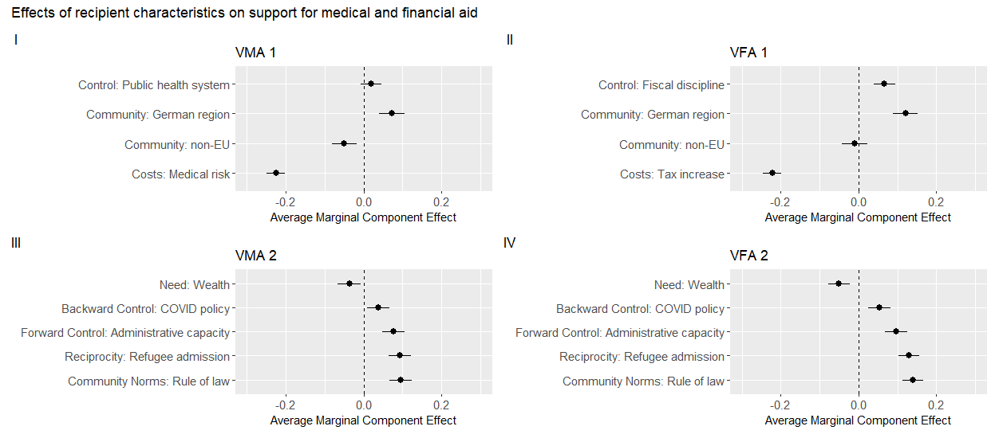
Figure A1. Average marginal component effects based on linear probability models for dichotomized dependent variables (April/May 2020, n = 4775 & May 2021, n = 4016).

Appendix I. Heterogeneous treatment effects for medical and financial aid vignettes 1

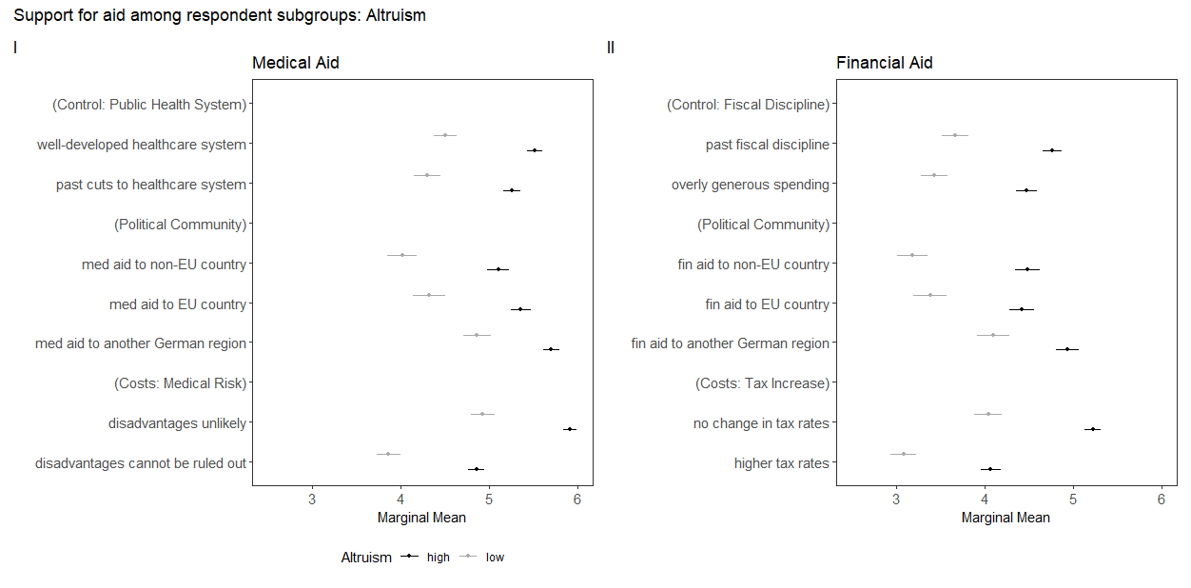
Figure A2. Heterogeneous treatment effects for medical and financial aid vignettes 1 (April/May 2020): Altruism.

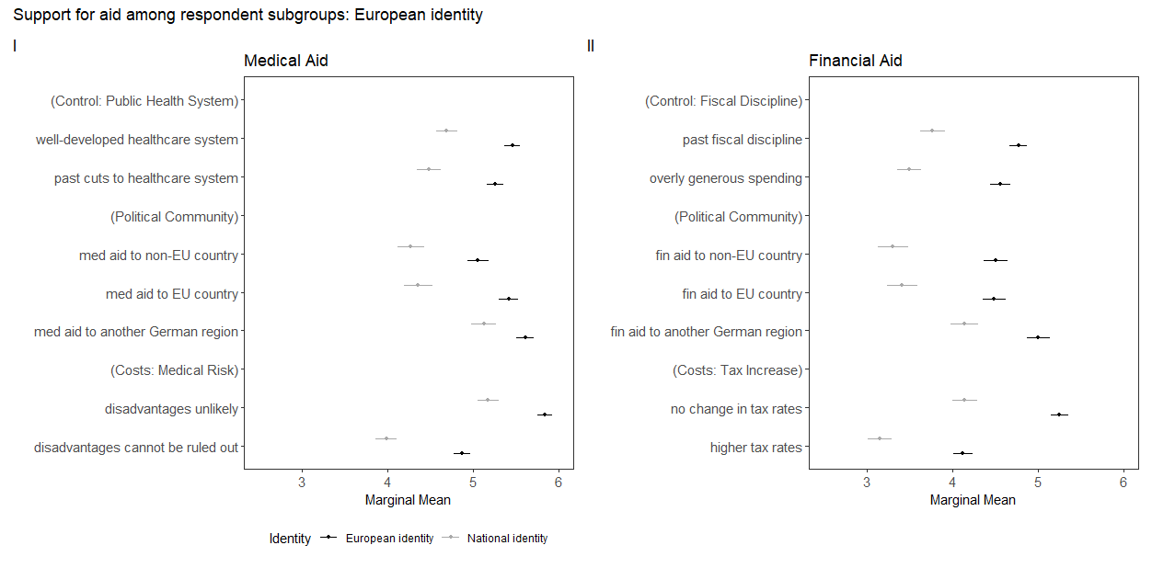
Figure A3. Heterogeneous treatment effects for medical and financial aid vignettes 1 (April/May 2020): European identity.

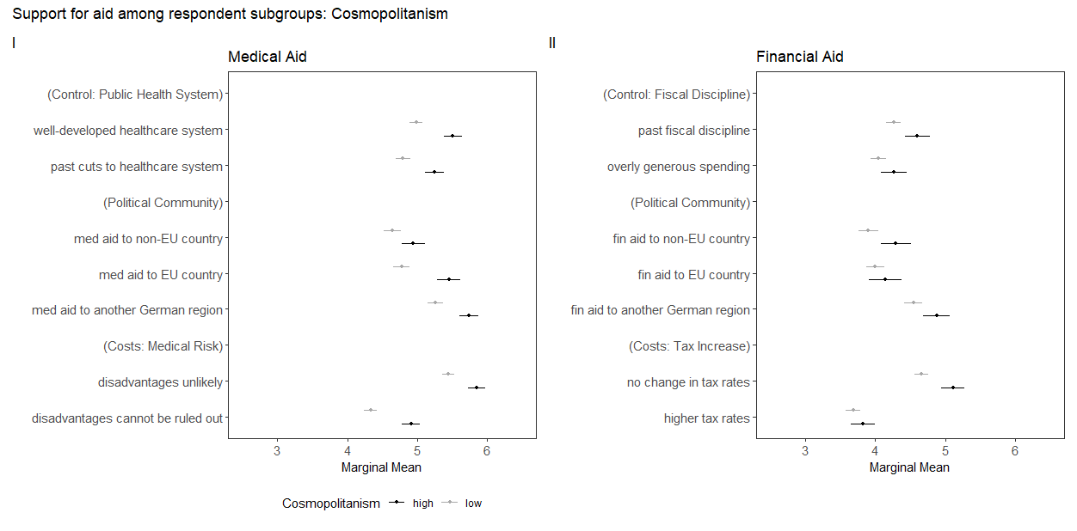
Figure A4. Heterogeneous treatment effects for medical and financial aid vignettes 1 (April/May 2020): Cosmopolitanism.

Appendix J. Heterogeneous treatment effects with three subgroups

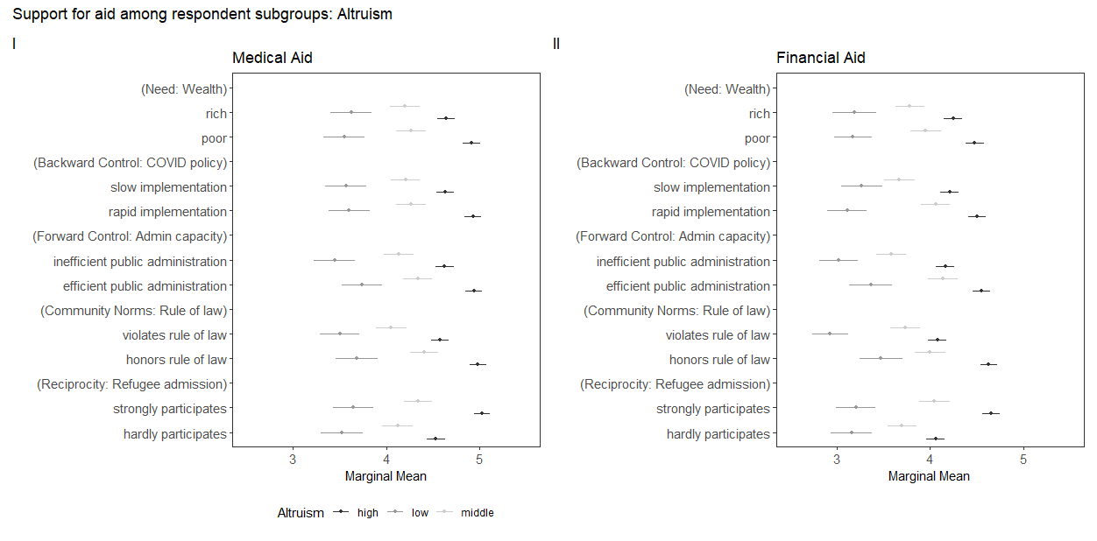
Figure A5. Heterogeneous treatment effects for medical and financial aid vignettes 2 (May 2021): Altruism. Likert scale 1-3: low altruism, 4: middle, 5-7: high altruism.

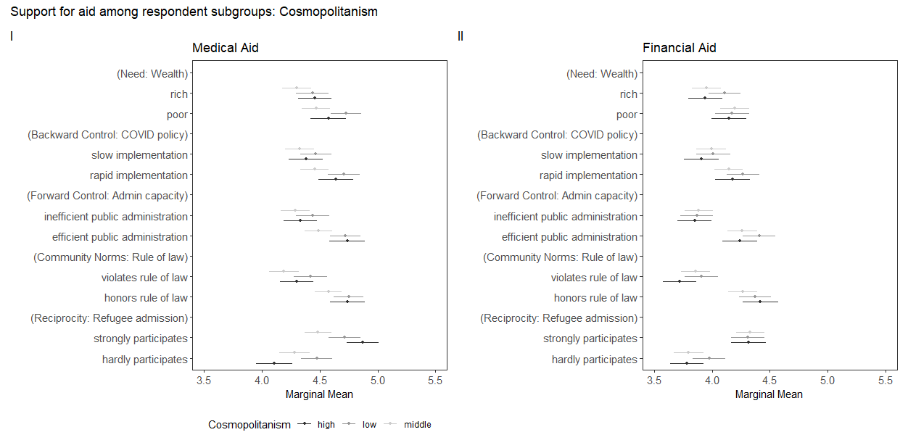
Figure A6. Heterogeneous treatment effects for medical and financial aid vignettes 1 (May 2021): Cosmopolitanism. Likert scale 1-3: low cosmopolitanism, 4: middle, 5-7: high cosmopolitanism.

Appendix K. Interaction effects between altruism and reciprocity/backward control

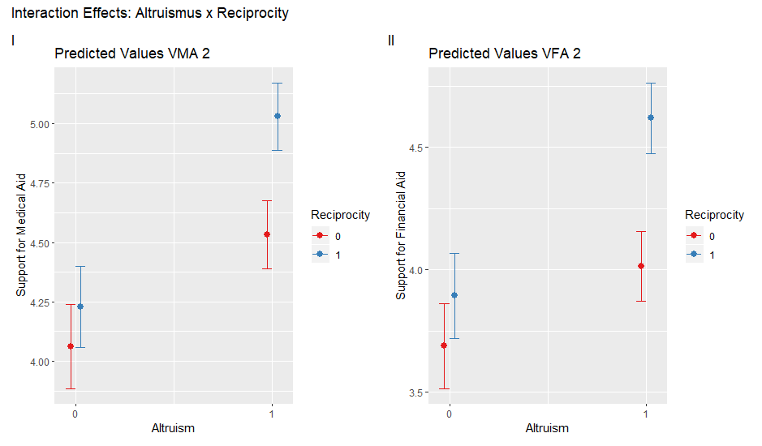
Figure A7. Interaction effects between “altruism” and “reciprocity” in medical vignette 2 (table A5, model 3) and financial vignette 2 (table A6, model 3).

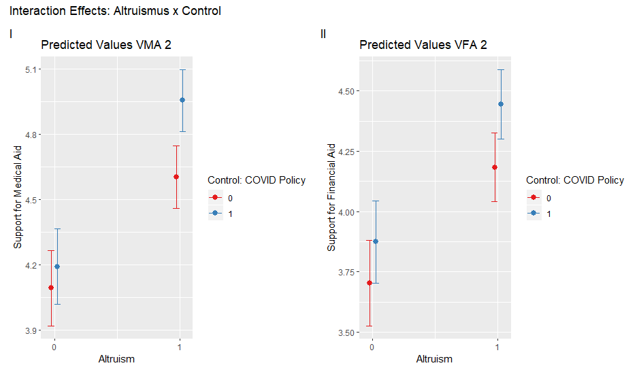
Figure A8. Interaction effects between “altruism” and “backward control” in medical vignette 2 and financial vignette 2.
Appendix L. Additional medical and financial aid vignette experiments

Vignettes November 2020
Dimension | Medical Aid  (Intensive care personnel and equipment) | Financial Aid  (Aid via recovery fund)
Need |  | 1. Poor member state  2. Rich member state
Control (back-ward looking) | 1. Well prepared for second wave  2. Failed to prepare well for second wave | 1. Rapid implementation of pandemic measures  2. Slow implementation of pandemic measures
Control (forward looking) |  | 1. Efficient public administration  2. Inefficient public administration
Attitude |  | 1. Country honors democratic principles and the rule of law  2. Regular allegation of violations of democratic principles and the rule of law
Reciprocity | 1. Offer of reciprocal support if need be  2. Unclear whether reciprocal support would be provided if need be. | 1. Participation in the accommodation of refugees  2. Hardly participates in the accommodation of refugees
Cost | 1. Medical disadvantages unlikely  2. Medical disadvantages cannot be ruled out

Table A6. Operationalization of recipient characteristics in medical & financial aid vignettes (November 2020).

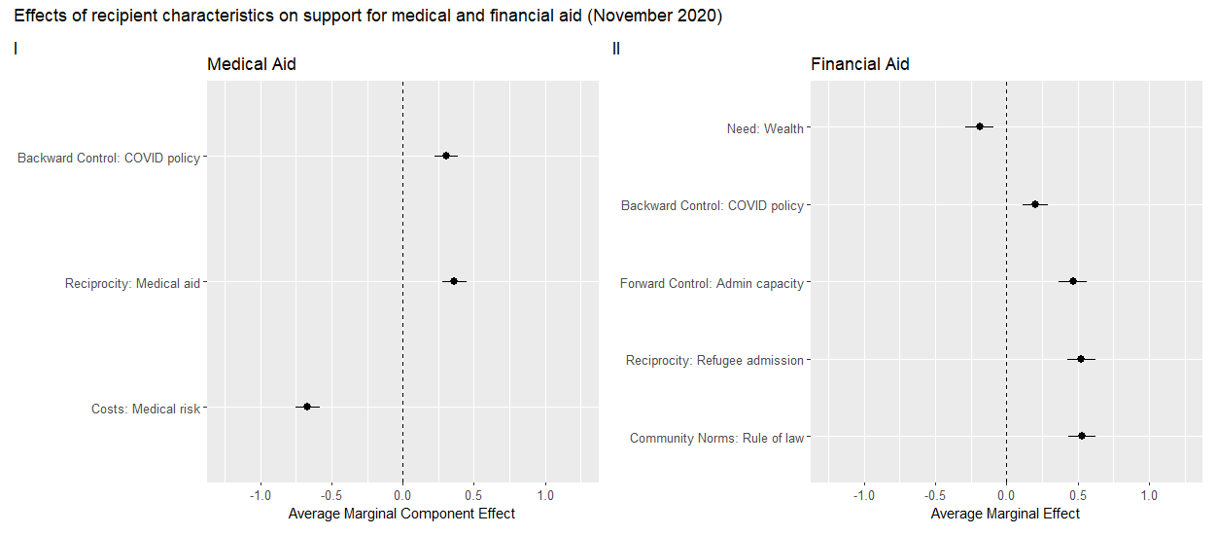

Figure A9. Additional medical and financial aid vignette experiments (November 2020, n= 3341).

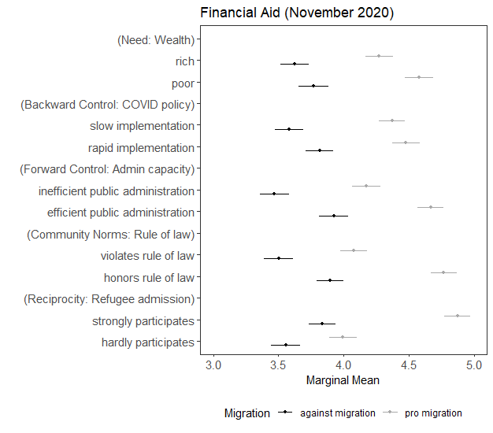

Figure A10. Heterogeneous treatment effects for respondents with pro- and anti-migration attitudes. Likert scale 1-4: pro altruism, 5-7: against migration.

Appendix M. Heterogenous treatment effects for a more restrictive altruism classification

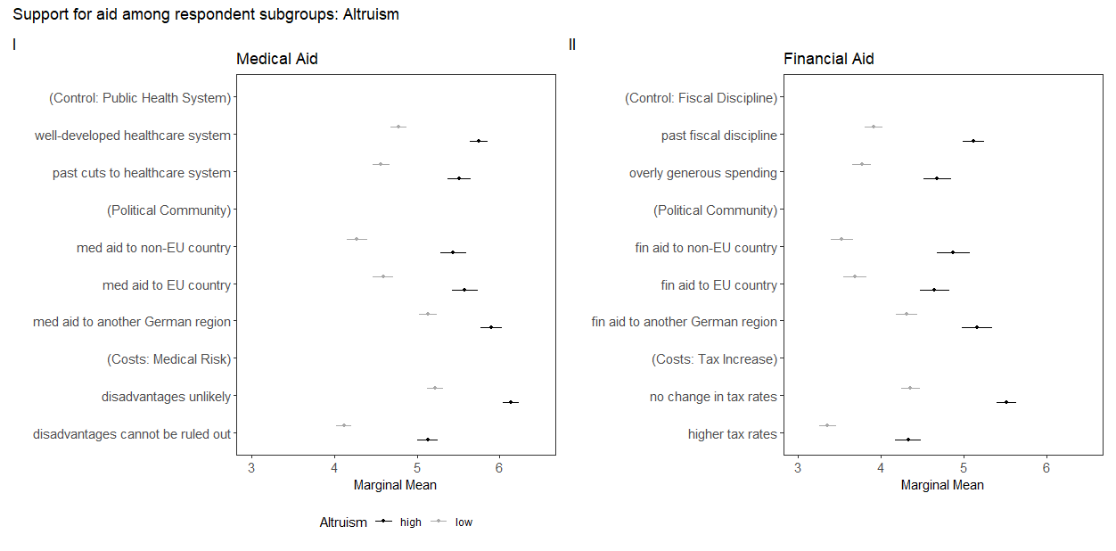
Figure A11. Heterogeneous treatment effects for medical and financial aid vignettes 1 (April/May 2020): Altruism. Likert scale 1-5: low altruism, 6-7: high altruism.

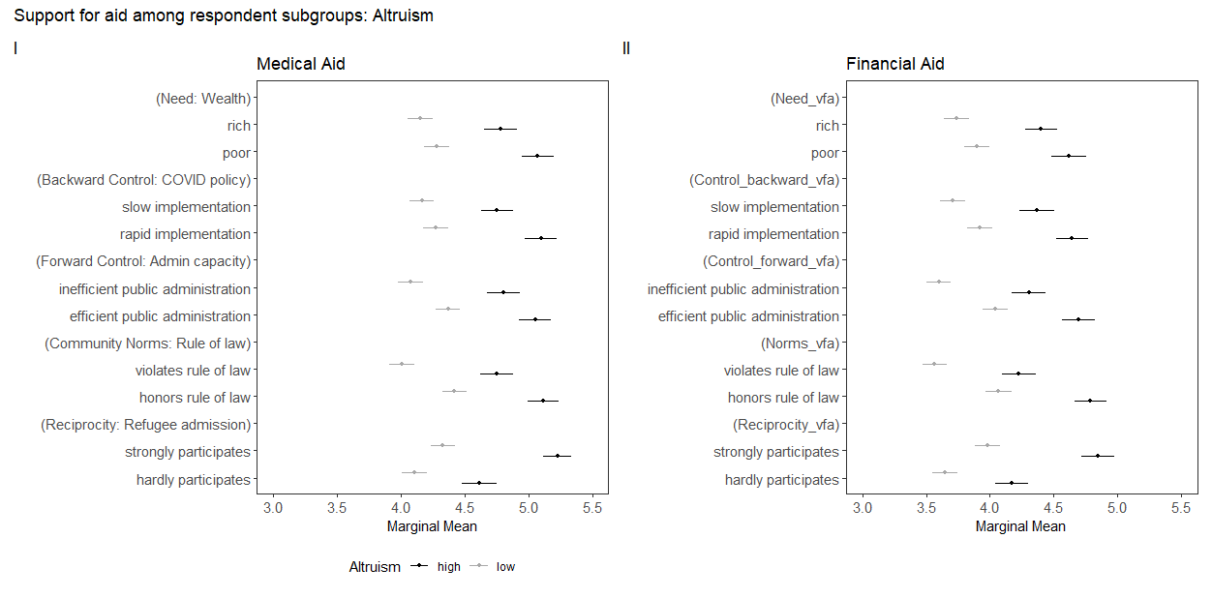
Figure A12. Heterogeneous treatment effects for medical and financial aid vignettes 1 (May 2021): Altruism. Likert scale 1-5: low altruism, 6-7: high altruism.

Appendix N. Public support for the ‘Next Generation EU’ recovery program in Germany

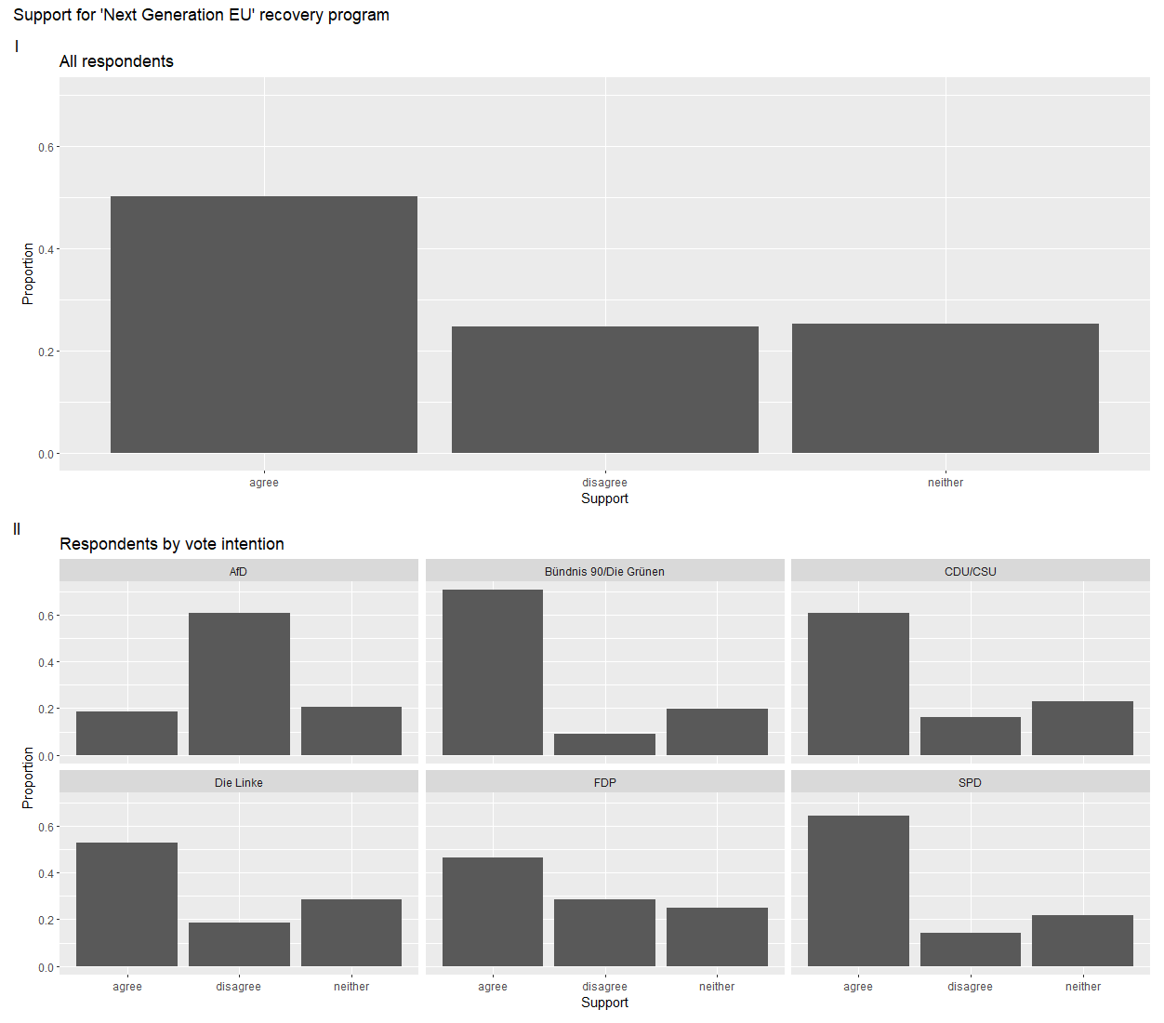
Figure A13. Public support for the ‘Next Generation EU’ recovery program in Germany (November 2020, own data, n= 3341)

