Supplementary Material (SM) to manuscript ‘Intergenerational social mobility, political socialization, and support for the left under post-industrial realignment’

List of Tables

Table S1. RE models of left party support on parental and respondent’s class, 2008-2018/9
 | UK | DE | CH
Respondent's class
Service workers | 0.00568 | 0.0408*** | -0.0129
ref. = OMC | (0.0110) | (0.00782) | (0.0103)
Production workers | 0.0184 | 0.0360*** | -0.0335***
 | (0.0124) | (0.00752) | (0.0105)
SCP | 0.0713*** | 0.0211*** | 0.0762***
 | (0.0118) | (0.00647) | (0.00912)
Others | -0.0207** | 0.00616 | -0.0100
 | (0.00934) | (0.00561) | (0.00854)
Parental class
Service workers | 0.0592*** | 0.0605*** | 0.00926
ref. = OMC | (0.0194) | (0.0156) | (0.0186)
Production workers | 0.0724*** | 0.0711*** | -0.0177
 | (0.0139) | (0.00964) | (0.0115)
SCP | 0.0760*** | 0.00413 | 0.0684***
 | (0.0258) | (0.0155) | (0.0174)
Others | 0.00801 | -0.0185 | -0.0206*
 | (0.0162) | (0.0128) | (0.0118)
Age | 0.00108*** | 0.000241 | 0.00108***
 | (0.000400) | (0.000300) | (0.000321)
Female | -0.00400 | 0.0147* | 0.0128
 | (0.0110) | (0.00841) | (0.00969)
Part-time work | 0.0167** | -0.0115** | 0.0159***
Ref. = full-time | (0.00664) | (0.00507) | (0.00608)
Civil status - married | -0.0213* | -0.00516 | -0.0384***
Ref. = other | (0.0114) | (0.00669) | (0.00776)
Civil status - divorced | -0.0249 | 0.0146 | -0.0511***
 | (0.0152) | (0.00959) | (0.0115)
West Germany in 1989 |  | -0.0457***
Ref. = East Germany in 1989 |  | (0.00976)
Abroad in 1989 |  | -0.0601***
 |  | (0.0190)
Constant | 0.241*** | 0.323*** | 0.163***
 | (0.0252) | (0.0172) | (0.0165)
Observations (N person-years) | 28,348 | 43,441 | 30,463
Observations (N individuals) | 6,301 | 13,167 | 6,157
Variance level 2 (individuals) sigma u | 0.369 | 0.426 | 0.316
Variance level 1 (person-years) sigma e | 0.285 | 0.199 | 0.227
ICC (rho) | 0.626 | 0.821 | 0.660
R-squared (between) | 0.0203 | 0.0159 | 0.0474
R-squared (overall) | 0.0144 | 0.0150 | 0.0388
Source: Authors’ calculation using BHPS/UKHLS 2008-2019, G-SOEP 2008-2018, SHP 2008-2019.
Standard errors in parentheses. *** p<0.01, ** p<0.05, * p<0.1

Table S2. RE models of left party support on parental and respondent’s class, interaction with generation, 2008-2018/9
 | UK | DE | CH
Respondent’s class
Service workers | 0.00281 | 0.0425*** | -0.0123
ref. = OMC | (0.0112) | (0.00790) | (0.0104)
Production workers | 0.0175 | 0.0362*** | -0.0341***
 | (0.0127) | (0.00756) | (0.0106)
SCP | 0.0699*** | 0.0225*** | 0.0756***
 | (0.0119) | (0.00654) | (0.00921)
Others | -0.0190** | 0.00480 | -0.00962
 | (0.00960) | (0.00572) | (0.00866)
Parental class
Service workers | 0.0692** | 0.104*** | 0.0378
ref. = OMC | (0.0313) | (0.0263) | (0.0308)
Production workers | 0.0938*** | 0.0856*** | -0.0162
 | (0.0206) | (0.0156) | (0.0175)
SCP | 0.0215 | -0.00960 | 0.0282
 | (0.0411) | (0.0281) | (0.0308)
Others | 0.00785 | -0.0252 | -0.0162
 | (0.0245) | (0.0203) | (0.0179)
Generation
Gen X | 0.0498* | -0.0713*** | -0.0482**
ref. = Baby boomers | (0.0257) | (0.0170) | (0.0192)
Millennials | 0.0292 | -0.0698*** | -0.0686***
 | (0.0463) | (0.0246) | (0.0246)
Parental class * generation
Service workers * Gen X | -0.0428 | -0.0824** | -0.0242
 | (0.0423) | (0.0343) | (0.0434)
Service workers * Millennials | 0.0747 | -0.0191 | -0.0715
 | (0.0693) | (0.0479) | (0.0485)
Production workers * Gen X | -0.0617** | -0.0240 | -0.0205
 | (0.0293) | (0.0208) | (0.0260)
Production workers * Millennials | -0.0245 | -0.0613** | 0.00508
 | (0.0548) | (0.0306) | (0.0324)
SCP * Gen X | 0.0724 | 0.0208 | 0.0438
 | (0.0555) | (0.0358) | (0.0425)
SCP * Millennials | 0.143 | 0.0402 | 0.0817*
 | (0.0928) | (0.0453) | (0.0443)
Others * Gen X | -0.00637 | 0.0151 | -0.0214
 | (0.0345) | (0.0280) | (0.0266)
Others * Millennials | 0.0349 | 0.00514 | -0.00857
 | (0.0646) | (0.0404) | (0.0337)
Age | 0.00266*** | -0.00127*** | -0.000248
 | (0.000616) | (0.000399) | (0.000457)
Female | -0.00223 | 0.0122 | 0.0105
 | (0.0113) | (0.00848) | (0.00988)
Part-time work | 0.0162** | -0.00872* | 0.0168***
Ref. = full-time | (0.00683) | (0.00515) | (0.00620)
Civil status - married | -0.0238** | -0.00691 | -0.0390***
Ref. = other | (0.0118) | (0.00684) | (0.00798)
Civil status - divorced | -0.0260* | 0.0112 | -0.0528***
 | (0.0156) | (0.00975) | (0.0117)
West Germany in 1989 |  | -0.0443***
Ref. = East Germany in 1989 |  | (0.00983)
Abroad in 1989 |  | -0.0474**
 |  | (0.0191)
Constant | 0.154*** | 0.437*** | 0.260***
 | (0.0400) | (0.0265) | (0.0287)
Observations (N person-years) | 27,322 | 42,894 | 29,845
Observations (N individuals) | 5,967 | 12,957 | 5,952
Variance level 2 (individuals) sigma u | 0.370 | 0.425 | 0.317
Variance level 1 (person-years) sigma e | 0.286 | 0.200 | 0.228
ICC (rho) | 0.625 | 0.820 | 0.660
R-squared (between) | 0.0236 | 0.0196 | 0.0482
R-squared (overall) | 0.0163 | 0.0192 | 0.0410
Source: Authors’ calculation using BHPS/UKHLS 2008-2019, G-SOEP 2008-2018, SHP 2008-2019.
Standard errors in parentheses. *** p<0.01, ** p<0.05, * p<0.1

Table S3. RE models of left party support on intergenerational class transitions, 2008-2018/9
 | UK | DE | CH
Intergenerational Class Transitions
Immobile prod workers | 0.0839*** | 0.104*** | -0.0335*
Ref. = Immobile OMC | (0.0203) | (0.0128) | (0.0192)
Immobile serv workers | 0.0769** | 0.103*** | 0.0226
 | (0.0300) | (0.0243) | (0.0354)
Prod wkers - Serv wkers | 0.0688*** | 0.120*** | -0.0184
 | (0.0192) | (0.0138) | (0.0191)
Serv wkers - Prod wkers | 0.0709** | 0.0859*** | -0.0504
 | (0.0355) | (0.0243) | (0.0359)
Immobile SCP | 0.168*** | 0.00580 | 0.120***
 | (0.0391) | (0.0196) | (0.0238)
Prod wkers - SCP | 0.158*** | 0.0926*** | 0.0468**
 | (0.0234) | (0.0142) | (0.0198)
Serv wkers - SCP | 0.0954*** | 0.0946*** | 0.118***
 | (0.0353) | (0.0260) | (0.0329)
SCP - Workers | 0.0820* | 0.0757*** | 0.0483
 | (0.0421) | (0.0293) | (0.0316)
Prod wkers - OMC | 0.0751*** | 0.0698*** | -0.0186
 | (0.0188) | (0.0114) | (0.0153)
Serv wkers - OMC | 0.0583** | 0.0615*** | 0.00382
 | (0.0284) | (0.0192) | (0.0247)
SCP - OMC | 0.0751** | 0.0122 | 0.0599***
 | (0.0346) | (0.0184) | (0.0223)
OMC - Workers | 0.00846 | 0.0445*** | -0.0235
 | (0.0204) | (0.0125) | (0.0157)
OMC - SCP | 0.0488** | 0.0306*** | 0.0970***
 | (0.0217) | (0.0104) | (0.0149)
Age | 0.00111*** | 0.000237 | 0.00107***
 | (0.000401) | (0.000300) | (0.000321)
Female | -0.00532 | 0.0139* | 0.0126
 | (0.0110) | (0.00840) | (0.00968)
Part-time work | 0.0167** | -0.0117** | 0.0157***
Ref. = full-time | (0.00664) | (0.00508) | (0.00608)
Civil status - married | -0.0212* | -0.00512 | -0.0385***
Ref. = other | (0.0114) | (0.00669) | (0.00776)
Civil status - divorced | -0.0257* | 0.0145 | -0.0507***
 | (0.0152) | (0.00960) | (0.0115)
West Germany in 1989 |  | -0.0451***
Ref. = East Germany in 1989 |  | (0.00976)
Abroad in 1989 |  | -0.0597***
 |  | (0.0190)
Constant | 0.241*** | 0.322*** | 0.161***
 | (0.0262) | (0.0175) | (0.0172)
Observations (N person-years) | 28,348 | 43,441 | 30,463
Observations (N individuals) | 6,301 | 13,167 | 6,157
Variance level 2 (individuals) sigma u | 0.369 | 0.426 | 0.316
Variance level 1 (person-years) sigma e | 0.285 | 0.199 | 0.227
ICC (rho) | 0.626 | 0.821 | 0.659
R-squared (between) | 0.0202 | 0.0165 | 0.0516
R-squared (overall) | 0.0135 | 0.0155 | 0.0429
Source: Authors’ calculation using BHPS/UKHLS 2008-2019, G-SOEP 2008-2018, SHP 2008-2019.
Coefficients of transitions into and out of the aggregated class category “other” are not displayed in this table.
Standard errors in parentheses. *** p<0.01, ** p<0.05, * p<0.1

Table S4. RE models of left party support on intergenerational class transitions, interacted with generation, 2008-2018/9
 | UK | DE | CH
Intergenerational Class Transitions
Immobile prod workers | 0.120*** | 0.144*** | -0.0497
Ref. = Immobile OMC | (0.0300) | (0.0203) | (0.0306)
Immobile serv workers | 0.125** | 0.136*** | 0.0844
 | (0.0512) | (0.0412) | (0.0865)
Prod wkers - Serv wkers | 0.0817*** | 0.104*** | -0.0663**
 | (0.0287) | (0.0211) | (0.0293)
Serv wkers - Prod wkers | 0.0578 | 0.140*** | 0.0411
 | (0.0607) | (0.0433) | (0.0723)
Immobile SCP | 0.150** | 0.00158 | 0.0786*
 | (0.0684) | (0.0352) | (0.0405)
Prod wkers - SCP | 0.161*** | 0.123*** | 0.0754**
 | (0.0348) | (0.0221) | (0.0296)
Serv wkers - SCP | -0.0106 | 0.175*** | 0.208***
 | (0.0619) | (0.0430) | (0.0541)
SCP - Workers | 0.0325 | 0.0585 | 0.0187
 | (0.0767) | (0.0535) | (0.0548)
Prod wkers - OMC | 0.0873*** | 0.0938*** | -0.0183
 | (0.0287) | (0.0183) | (0.0235)
Serv wkers - OMC | 0.0910* | 0.115*** | 0.0172
 | (0.0486) | (0.0320) | (0.0419)
SCP - OMC | 0.00494 | -0.00352 | 0.0308
 | (0.0595) | (0.0326) | (0.0425)
OMC - Workers | -0.00173 | 0.0569*** | -0.0354
 | (0.0320) | (0.0203) | (0.0268)
OMC - SCP | 0.0540 | 0.0380** | 0.0959***
 | (0.0342) | (0.0181) | (0.0251)
Generation
Gen X | 0.0441 | -0.0642*** | -0.0555**
ref. = Baby boomers | (0.0313) | (0.0191) | (0.0237)
Millennials | 0.0121 | -0.0557** | -0.0718**
 | (0.0582) | (0.0274) | (0.0298)
Intergenerational Class Transitions * generation
Immobile prod workers * Gen X | -0.101** | -0.0626** | 0.0292
 | (0.0434) | (0.0274) | (0.0444)
Immobile prod workers * Millennials | -0.0379 | -0.122*** | -0.00237
 | (0.0816) | (0.0428) | (0.0516)
Immobile serv workers * Gen X | -0.0982 | -0.0676 | -0.0140
 | (0.0675) | (0.0531) | (0.101)
Immobile serv workers * Millennials | -0.00669 | 0.0446 | -0.178*
 | (0.100) | (0.0813) | (0.108)
Prod wkers - Serv wkers * Gen X | -0.0422 | 0.0522* | 0.0849**
 | (0.0409) | (0.0297) | (0.0430)
Prod wkers - Serv wkers * Millennials | -0.0340 | -0.0378 | 0.0557
 | (0.0751) | (0.0484) | (0.0530)
Serv wkers - Prod wkers * Gen X | -0.00178 | -0.0913* | -0.123
 | (0.0772) | (0.0543) | (0.0925)
Serv wkers - Prod wkers * Millennials | 0.255 | -0.0538 | -0.133
 | (0.199) | (0.0811) | (0.0961)
Immobile SCP * Gen X | 0.0508 | 0.00224 | 0.00562
 | (0.0878) | (0.0455) | (0.0568)
Immobile SCP * Millennials | 0.00618 | 0.0365 | 0.126**
 | (0.131) | (0.0560) | (0.0603)
Prod wkers - SCP * Gen X | -0.0348 | -0.0484 | -0.0954**
 | (0.0490) | (0.0306) | (0.0440)
Prod wkers - SCP * Millennials | 0.0616 | -0.0996** | 0.00431
 | (0.0977) | (0.0472) | (0.0564)
Serv wkers - SCP * Gen X | 0.123 | -0.108* | -0.116
 | (0.0781) | (0.0570) | (0.0767)
Serv wkers - SCP * Millennials | 0.270** | -0.196** | -0.189**
 | (0.136) | (0.0813) | (0.0850)
SCP - Workers * Gen X | 0.0655 | 0.0347 | 0.0710
 | (0.0980) | (0.0688) | (0.0825)
SCP - Workers * Millennials | 0.159 | 0.0242 | 0.0404
 | (0.131) | (0.0819) | (0.0760)
Prod wkers - OMC * Gen X | -0.0494 | -0.0405 | -0.0172
 | (0.0399) | (0.0247) | (0.0342)
Prod wkers - OMC * Millennials | 0.0575 | -0.0697* | -0.00203
 | (0.0774) | (0.0390) | (0.0456)
Serv wkers - OMC * Gen X | -0.0768 | -0.104** | -0.00222
 | (0.0626) | (0.0422) | (0.0570)
Serv wkers - OMC * Millennials | 0.0251 | -0.00530 | -0.0406
 | (0.104) | (0.0601) | (0.0674)
SCP - OMC * Gen X | 0.0760 | 0.0305 | 0.0583
 | (0.0761) | (0.0423) | (0.0554)
SCP - OMC * Millennials | 0.281** | 0.0298 | 0.0174
 | (0.134) | (0.0529) | (0.0592)
OMC - Workers * Gen X | 0.0111 | 0.00632 | 0.0124
 | (0.0437) | (0.0274) | (0.0381)
OMC - Workers * Millennials | 0.0614 | -0.0951** | 0.0149
 | (0.0739) | (0.0400) | (0.0396)
OMC - SCP * Gen X | 0.00634 | -0.0138 | 0.0110
 | (0.0459) | (0.0236) | (0.0339)
OMC - SCP * Millennials | -0.140 | 0.00341 | -0.00859
 | (0.0895) | (0.0308) | (0.0402)
Age | 0.00266*** | -0.00131*** | -0.000283
 | (0.000617) | (0.000399) | (0.000458)
Female | -0.00431 | 0.0111 | 0.0105
 | (0.0113) | (0.00848) | (0.00989)
Part-time work | 0.0155** | -0.00843 | 0.0171***
Ref. = full-time | (0.00684) | (0.00516) | (0.00621)
Civil status - married | -0.0242** | -0.00683 | -0.0389***
Ref. = other | (0.0118) | (0.00685) | (0.00800)
Civil status - divorced | -0.0275* | 0.0113 | -0.0522***
 | (0.0157) | (0.00976) | (0.0117)
West Germany in 1989 |  | -0.0433***
Ref. = East Germany in 1989 |  | (0.00983)
Abroad in 1989 |  | -0.0465**
 |  | (0.0191)
Constant | 0.159*** | 0.431*** | 0.263***
 | (0.0420) | (0.0272) | (0.0304)
Observations (N person-years) | 27,322 | 42,894 | 29,845
Observations (N individuals) | 5,967 | 12,957 | 5,952
Variance level 2 (individuals) sigma u | 0.369 | 0.425 | 0.316
Variance level 1 (person-years) sigma e | 0.286 | 0.200 | 0.228
ICC (rho) | 0.625 | 0.819 | 0.659
R-squared (between) | 0.0264 | 0.0222 | 0.0543
R-squared (overall) | 0.0187 | 0.0214 | 0.0462
Source: Authors’ calculation using BHPS/UKHLS 2008-2019, G-SOEP 2008-2018, SHP 2008-2019.
Coefficients of transitions into and out of the aggregated class category “other” are not displayed in this table.
Standard errors in parentheses. *** p<0.01, ** p<0.05, * p<0.1

List of Figures

Figure S1. Impact of parental and respondent’s class (net of each other) on left and green party support in Germany
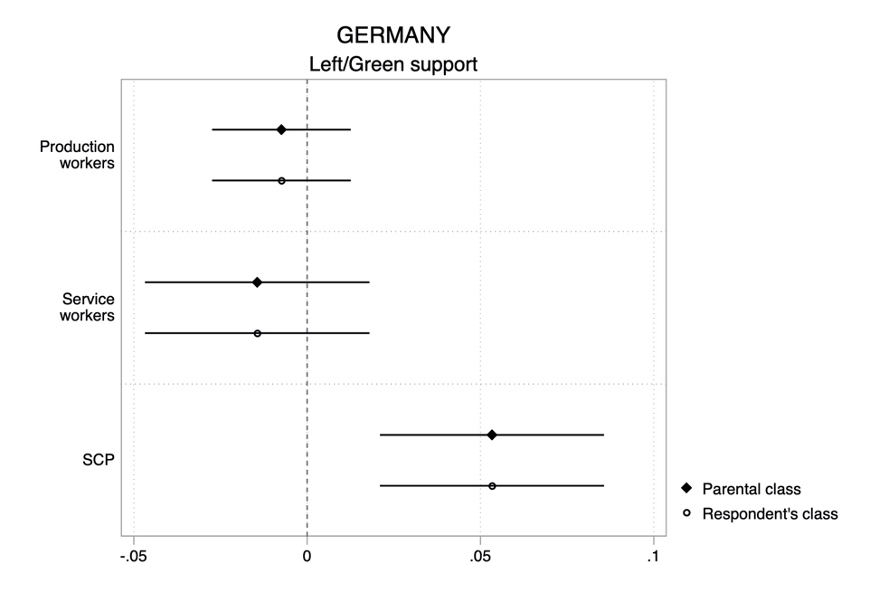
Note: average marginal effects (with 95% confidence intervals) on probability to support a left or green party, relative to the reference category old middle class. Controls: full-/parttime work, civil status, gender, age, East/West Germany in 1989. Data: G-SOEP 2008-2018 (N= 13,167)

Figure S2. Impact of respondent’s class (net of parental class) on left party support, across time periods
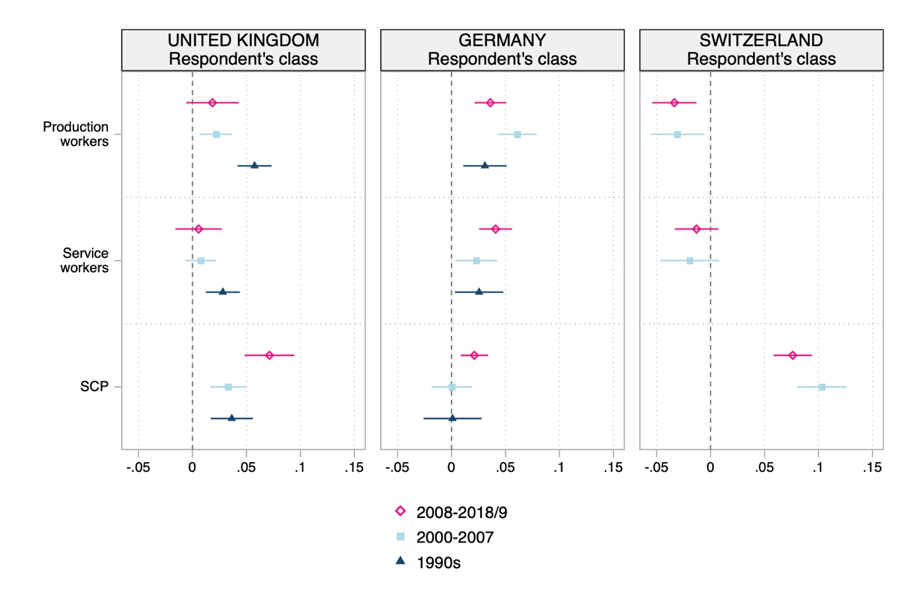
Note: average marginal effects (with 95% confidence intervals) on probability to support a left party, relative to the reference category old middle class. Controls: full-/parttime work, civil status, gender, age (DE: East/West Germany in 1989). Data: BHPS/UKHLS 1991-2019, G-SOEP 1990-2018, and SHP 1999-2019.

Figure S3. Impact of parental class (net of respondent’s class) on left and green party support in Germany, by generations
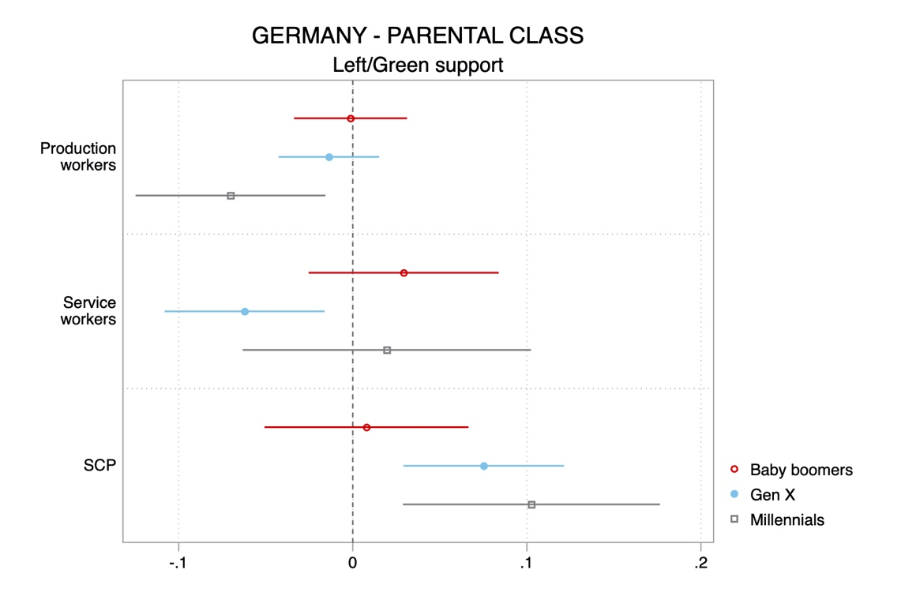
Note: average marginal effects (with 95% confidence intervals) on probability to support a left or green party, relative to the reference category old middle class. Controls: full-/parttime work, civil status, gender, age, East/West Germany in 1989. Data: G-SOEP 2008-2018 (N= 12,957)

Figure S4. Impact of intergenerational class transitions on left and green party support in Germany
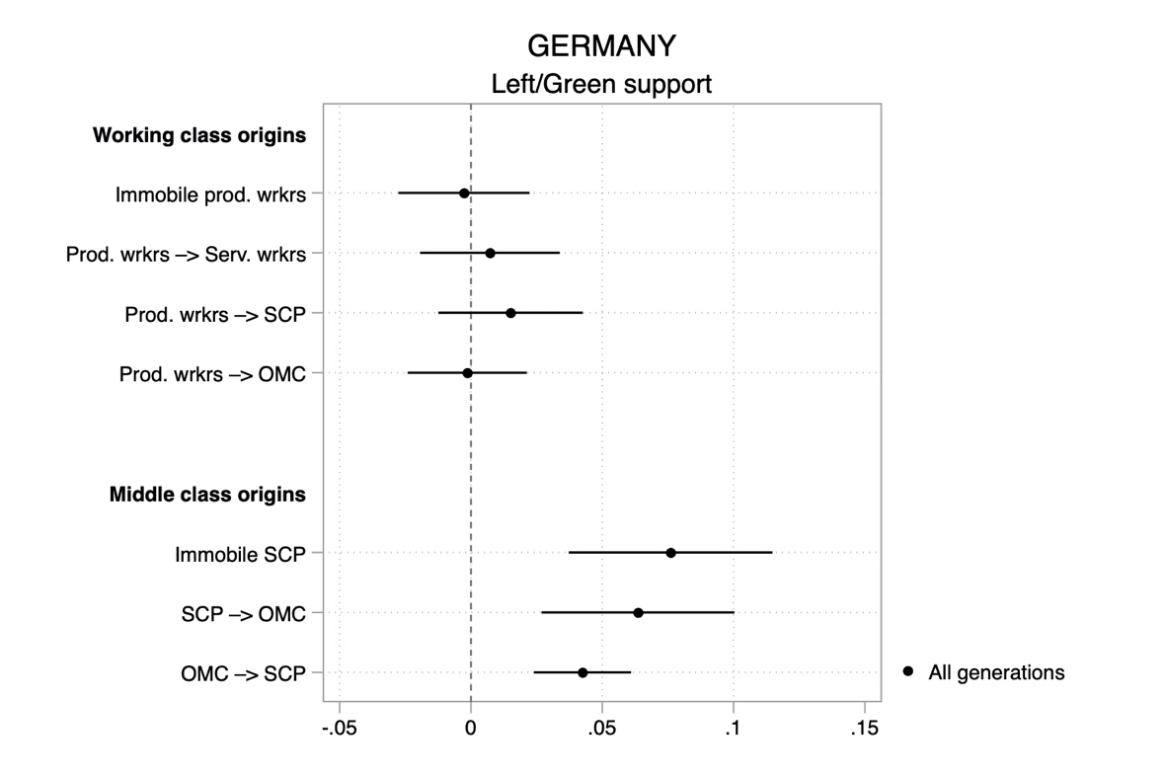

Note: average marginal effects (with 95% confidence intervals) on probability to support a left or green party, relative to the reference category immobile old middle class. Controls: full-/parttime work, civil status, gender, age, East/West Germany in 1989. Data: G-SOEP 2008-2018 (N= 13,167)

