SUPPLEMENTARY MATERIAL
‘Catching the “deliberative wave”? How (disaffected) citizens assess deliberative citizen forums’

Appendix A: Measurements, variables, and additional information 2
A1 Information on the conjoint experiment 2
Glossary (translated from German) 2
Argument sheets (translated from German) 4
Video (translated voice over) 4
Introductory text to the survey experiment 5
A2 Measurement of the dependent variables 5
Choice outcome 5
Rating outcome 6
A3 Measurement of issues and outcome favourability 6
Issue salience 6
Outcome favourability 7
A4 Measurement of the grouping variables 8
Political dissatisfaction 8
External efficacy 8
Stealth attitudes 8
Populist attitudes 9
Median split 9
Percentage of disaffection among German citizens 10
Appendix B: Additional Analysis 11
B1 Benchmark model 11
B2 Subgroup models (AMCE and marginal means) 12
B3 Conditional AMCE 14
B4 Timing variables 16
B5 Differences between experienced and inexperienced citizens 18

Appendix A: Measurements, variables, and additional information

A1 Information on the conjoint experiment

Glossary (translated from German)
1. Topic: What measure is at stake?
Citizen forums take place for very different topics. Examples include climate change, refugee policy, currency systems or development cooperation.
2. Initiative: Who convenes the citizen forum?
A citizen forum can be initiated in several ways. It can either convened from a civil society initiative, for example through NGOs such as Greenpeace. Another possibility is that the citizen forum is initiated directly by the government.
3. Recruitment: How are the participants selected?
Random selection: Individuals are selected by lot. Participants are drawn to meet certain demographic criteria (e.g., to ensure gender balance).
Self-recruitment: all individuals, e.g. in a municipality, receive an open invitation. Anyone who wants can participate. Participation is usually encouraged by advertisement through various channels (e.g., mail, social media, and posters).
4. Group size: How many citizens do participate?
Citizen forums vary in the number of participants. In practice, group sizes vary from 10 to several hundred participants, depending on the format.
5. Group composition: How is the group of participants composed?
Citizens alone: The group of participants is composed solely of citizens.
Mixed groups: In addition to citizens, other stakeholders participate in the discussions, such as politicians, administrative staff, or stakeholders.
6. Output: What is the result of the citizen forum?
In simple terms, a citizen forum can come out either in favour or against the measures discussed on an issue.
7. Degree of consensus: By which majority did the participants decide?
Finally, the citizen forum has to reach a conclusion. This can be either quite clearly for or against a measure (for example, if almost all participants agree) or very close (for example, if only just over half of the participants agree).
8. Dialogue format: How do participants discuss?
Face-to-Face: The citizen forum takes place at a specific location (e.g., city hall) at a specific time. In this case, participants sit together at a table.
Online: The citizen forum takes place virtually on the Internet, for example synchronously in interactive chats or asynchronously in forums.
9. Authorization: How decisive is the result?
Recommendation: the output of the citizen forum is a non-binding recommendation to elected political representatives.
Recommendation followed by referendum: The output of the citizen forum is a recommendation that is subsequently decided in a direct democratic vote (e.g., referendum).
Binding decision: The result of the citizen forum is binding, i.e. must be implemented politically without a final decision by elected politicians.

Argument sheets (translated from German)
Figure A 1: Arguments on recruitment
Figure A 2: Arguments on authorization

Video (translated voice over)
This is a citizens' forum. What do citizens’ forums do? They make recommendations to policymakers or sometimes decisions themselves. But not every citizens' forum is the same. There are features that make each one different – such as the size, the goal, and who convenes it. And then there's recruitment – the way in which those participating in a citizens' forum are selected. One way of selecting participants is by drawing lots for invitations. Another option is self-recruitment – i.e., participation by accepting an opportunity open to everyone. Another element of a citizens' forum that varies is how it is composed. It can be made up exclusively of citizens or comprise a mix of citizens, administrators, and politicians. And last but not least: authorization. Authorization means how binding the outcome of a citizens' forum is: a recommendation to political actors is more on the advisory side. The recommendation can also be decided upon via a subsequent referendum in which all citizens are free to participate. Another option is for the forum to make a binding decision. This would mean directly integrating the citizens' forum into legislation. Implementing the outcome would be mandatory.
Figure A 3: Snippet of the video

Introductory text to the survey experiment
You will now be presented with several scenarios of citizens’ forums. In each case, you will see how the citizens’ forums were organized and the conclusions reached by the participants. You will be presented with six comparisons, each with two scenarios. For each comparison, please indicate which of the scenarios you prefer. People have different views on citizens’ forums and there are no right or wrong answers. You may like both scenarios similarly, or you may not like either of them. Please indicate which alternative you prefer, regardless of your overall assessment.
We have provided a glossary with information on the characteristics of citizens’ forums. You can access the glossary by clicking on the corresponding feature.

A2 Measurement of the dependent variables

Choice outcome
- Which of the two scenarios do you prefer?
(Citizen Forum A, Citizen Forum B)

Rating outcome
- In your view, how do you feel about Citizen Forum A?
- In your view, how do you feel about Citizen Forum B?
(‘1’ I don't like it at all to ‘7’ I like it very much)
 | mean | median | SD
All respondents | 4.25 | 4 | 1.54
Differences in means
 | means | t | p-value
Dissatisfied – satisfied | 4.16 – 4.36 | 9.9 | <0.001
Low external – high external | 4.12 – 4.37 | 12.3 | <0.001
Stealth – non-stealth | 4.36 – 4.18 | 9.2 | <0.001
Populist – non-populist | 4.38 – 4.12 | 12.4 | <0.001

A3 Measurement of issues and outcome favourability

Issue salience
Different issues are currently being discussed in politics. How important or unimportant are these issues for you personally?
- Climate change
- Refugee policy
- Currency systems
- Foreign aid
(‘1’ very unimportant to ‘7’ very important)
 | mean | median | SD
Climate change | 5.58 | 6 | 1.64
Refugee policy | 5.06 | 5 | 1.72
Currency systems | 4.57 | 5 | 1.58
Foreign aid | 4.81 | 5 | 1.50

Outcome favourability
Outcome favourability was computed by comparing respondents’ preference for a policy measure with the randomly assigned output of the conjoint. We used two information: the output of the DCF (attribute level: in favour or against the measurement) and the respondents’ preferences on the four measurements.
Intro: You will now be presented with concrete measures for each problem. Please indicate how much you personally support or oppose the measures.
- Regarding climate change, so-called net zero greenhouse gas emissions are being discussed, which means that all human-induced greenhouse gas emissions (e.g. CO2, methane and nitrous oxide) would have to be removed from the atmosphere. Concrete measures include, for example, mandatory minimum share of green electricity and taxation of greenhouse gas emissions and carbon-intensive activities.
- We now move to the admission of refugees. Refugees from conflict regions (e.g. war and poverty areas) seek protection in Germany, among other places. There are different admission procedures: the permanent admission of refugees, the humanitarian admission of refugees due to an acute crisis and the redistribution of refugees from member states with particularly stressed asylum systems (e.g. Greece and Italy).
- Another topic is the regulation of crypto currencies, i.e. digital currencies with a decentralised and cryptographically secured payment system. In some countries, they have already proven as payment alternatives for private individuals. The best-known cryptocurrency is Bitcoin. Similarly, the European Central Bank is discussing the introduction of a digital euro. Experts see both opportunities and risks.
- Finally, we focus on state support for foreign aid. This involves measures to improve living conditions in developing countries. Examples are the improvement of the education and health system and the fight against poverty. In official development cooperation, an industrialised country provides material (e.g. loans or grants) or immaterial (e.g. expertise) support to a developing country.
For each measure, respondents were asked:
- How much do you personally support the measure?
(‘1’ I strongly oppose to ‘7’ I strongly support)
 | mean | median | SD
Emissions | 4.65 | 5 | 1.67
Refugees | 3.97 | 4 | 1.87
Crypto currency | 3.24 | 3 | 1.90
Foreign aid | 4.79 | 5 | 1.57

For each measure, values higher than the midpoint (>4) were coded as approval. Outcome favourability was coded as a binary variable, which is ‘1’ if the output of the conjoint (in favour or against the measure) aligned with the individual preference on the measure and ‘0’ otherwise.

A4 Measurement of the grouping variables

Political dissatisfaction
- How satisfied are you with the way democracy works in Germany?
(‘1’ not satisfied at all to ‘7’ very satisfied)

External efficacy
- Politicians care about what ordinary people think.
- Politicians try to keep in close contact with the population.
(Each running from ‘1’ strongly disagree to ‘5’ strongly agree)

Stealth attitudes
- Elected officials would help the country more if they stopped talking and just took action on important problems.
- What people call “compromise” in politics is really just selling out one’s principles.
- Our government would run better if decisions were left up to successful business people.
- Our government would run better if decisions were left up to non-elected, independent experts rather than politicians or the people.
(Each running from ‘1’ strongly disagree to ‘7’ strongly agree)

Populist attitudes
- Elected officials would help the country more if they stopped talking and just took action on important problems.
- Ordinary citizens share a good and honest character.
- The people should have the last say on important political issues through referendums.
- The ordinary citizens pull together.
- The differences between the people and the so-called elite are much greater than the differences within the people.
- People and not the politicians should make the most important political decisions.
- The politicians in parliament must follow the will of the people.
- The ordinary people share the same values and interests.
(Each running from ‘1’ strongly disagree to ‘7’ strongly agree)
For all index variables (external efficacy, stealth attitudes, and populist attitudes), row means were calculated. Finally, all cases with missing values were omitted for subgroup analysis.
Grouping variables (types of disaffected citizens) were computed using a median split following two rules:
- If median > mean then ‘low’ is assigned for < median and ‘high’ for ≥ median;
- If median < mean then ‘low’ is assigned for ≤ median and ‘high’ for > median.

Median split
 | N (long) | alpha | mean | median | median-split
Dissatisfied | 23700 |  | 4.24 | 5 | ≥ 5 (satisfied)  < 5 (dissatisfied)
Low-efficacious | 23856 | .86 | 2.36 | 2.5 | ≥ 2.5 (high ext. eff.)  < 2.5 (low ext. eff.)
Stealth | 23400 | .66 | 4.05 | 4 | > 4 (stealth)  ≤ 4 (non-stealth)
Populist | 23760 | .81 | 4.7 | 4.62 | > 4.62 (populist)  ≤ 4.62 (non-populist)

We ran nested model comparison tests (using ANOVA analysis) to formally test whether the interactions between the grouping variables and feature levels differ from zero. For all groups, interactions between the grouping variable and feature levels differ from zero, indicating that differences between subgroups exist.

Percentage of disaffection among German citizens
 | Less (greater*) than middle category | ‘Extremes’**
Dissatisfied | 31,8% | 19,4%
Low external efficacy | 48,9% | 19,4%
Stealth | 45,6% | 7,4%
Populist | 69,9% | 14,1%
*depends on question wording **for 7-point scales the last two categories, for 5-point scales the last category

Appendix B: Additional Analysis

B1 Benchmark model

Figure B 1: Effects of DCF attributes on support (AMCE, rating outcome variable)
Note: Benchmark model for all respondents. Standard errors clustered at the individual level to take into account that each respondent made several comparisons.

B2 Subgroup models (AMCE and marginal means)
Figure B2. 1: Difference plots (AMCE and marginal means, rating and choice outcome variables) for political dissatisfaction
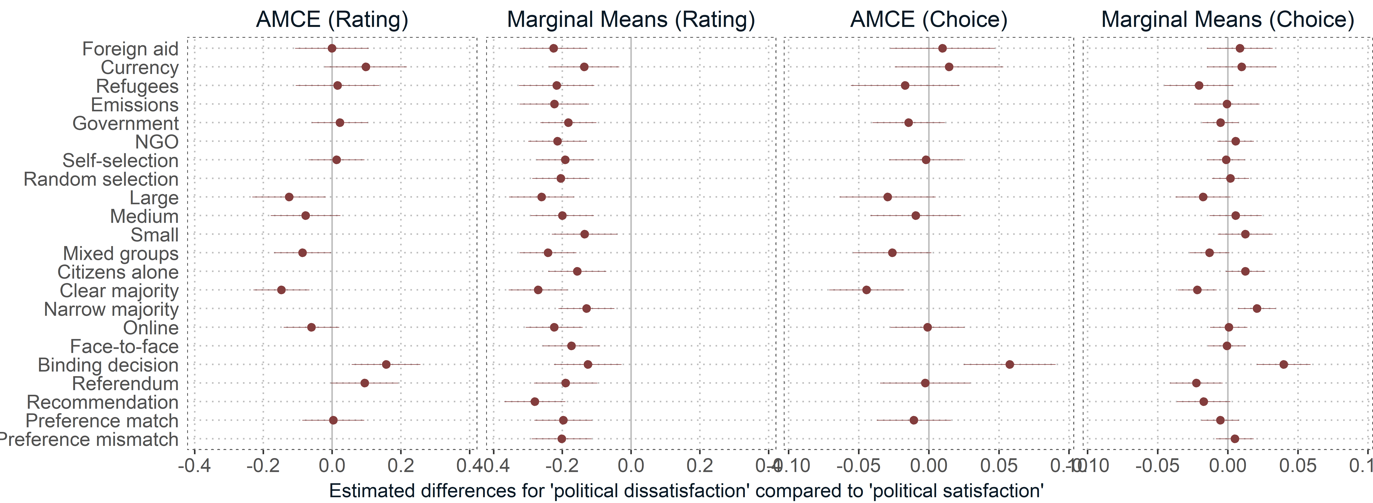
Note: Effects show differences for politically dissatisfied compared to politically satisfied citizens where AMCE represent differences in conjoint effect sizes and marginal means represent descriptive differences in preferences.

Figure B2. 2: Difference plots (AMCE and marginal means, rating and choice outcome variables) for external efficacy
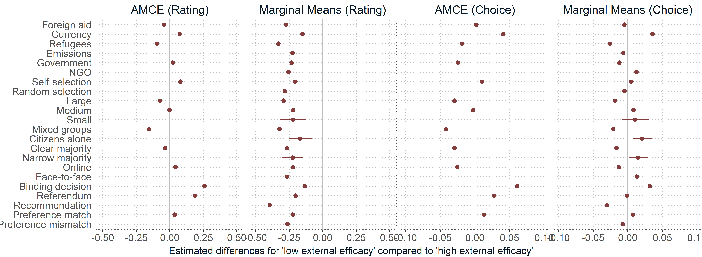
Note: Effects show differences for respondents with low compared to high external efficacy where AMCE represent differences in conjoint effect sizes and marginal means represent descriptive differences in preferences.

Figure B2. 3: Difference plots (AMCE and marginal means, rating and choice outcome variables) for stealth attitudes
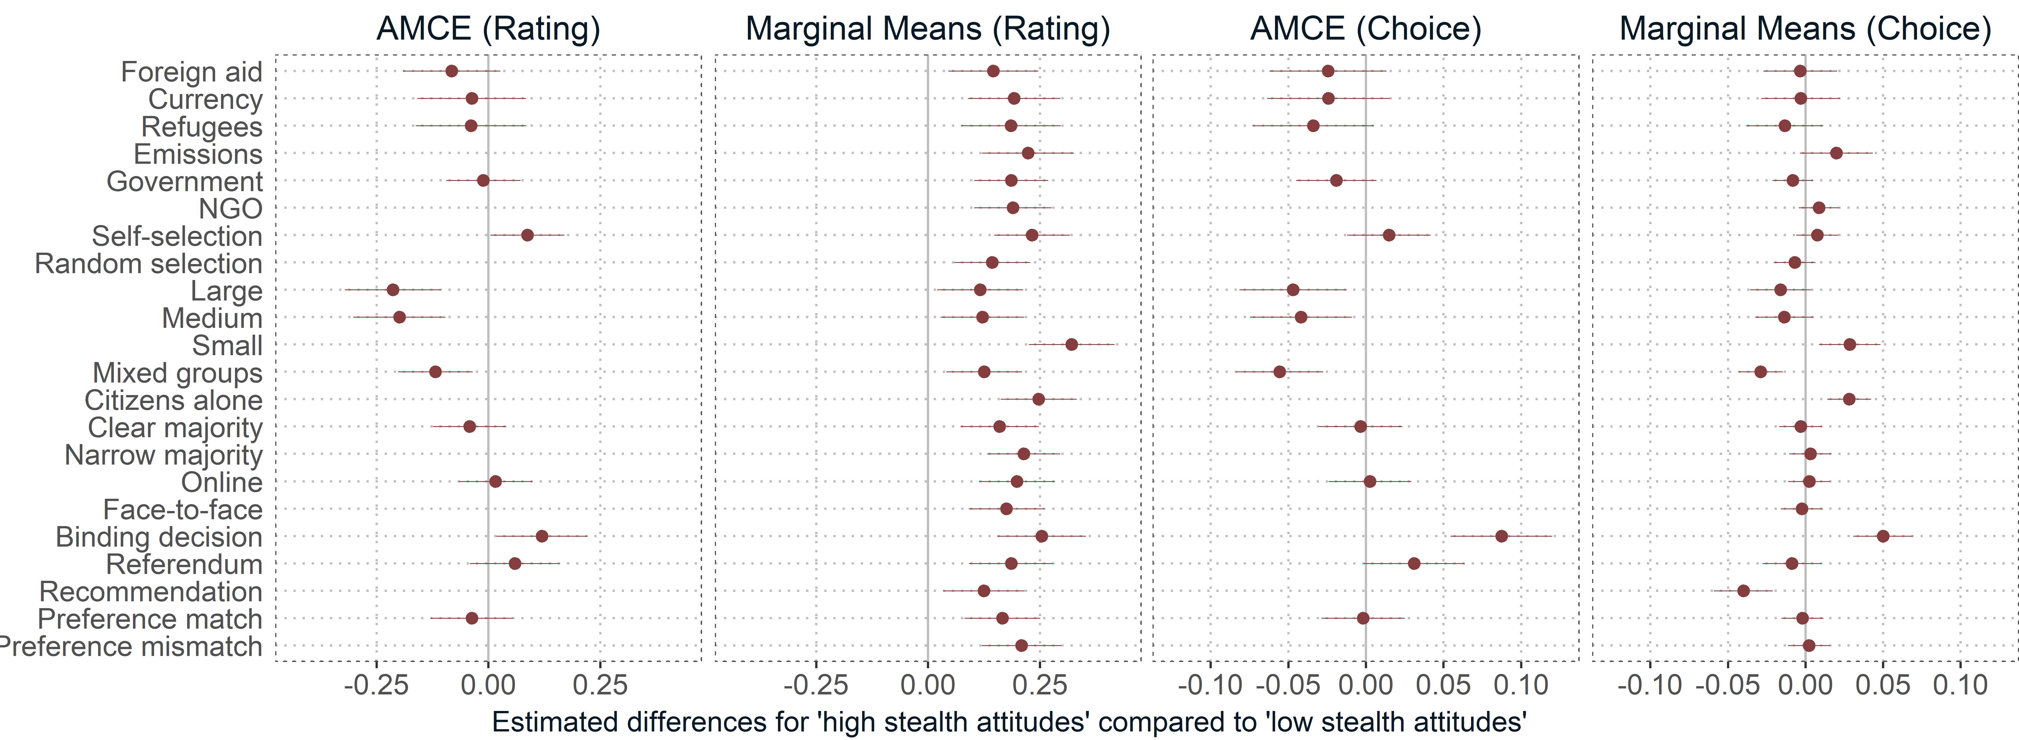
Note: Effects show differences for respondents with high compared to low stealth attitudes where AMCE represent differences in conjoint effect sizes and marginal means represent descriptive differences in preferences.

Figure B2. 4: Difference plots (AMCE and marginal means, rating and choice outcome variables) for populist attitudes
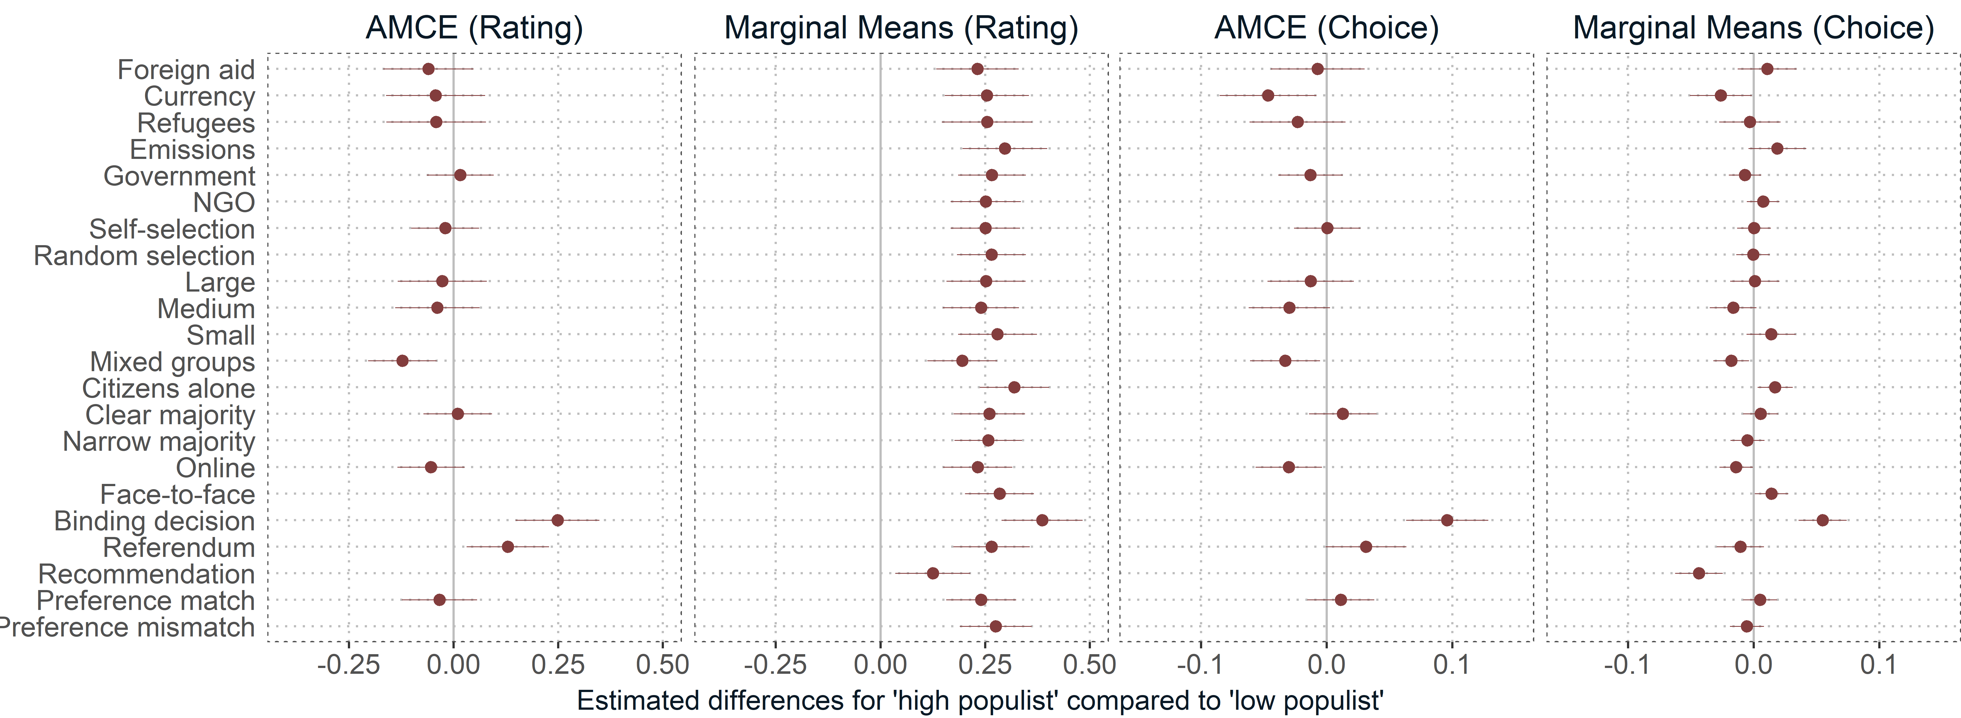
Note: Effects show differences for respondents with high compared to low populist attitudes where AMCE represent differences in conjoint effect sizes and marginal means represent descriptive differences in preferences.

B3 Conditional AMCE
Figure B3. 1: Conditional AMCE for political dissatisfaction (choice outcome variable)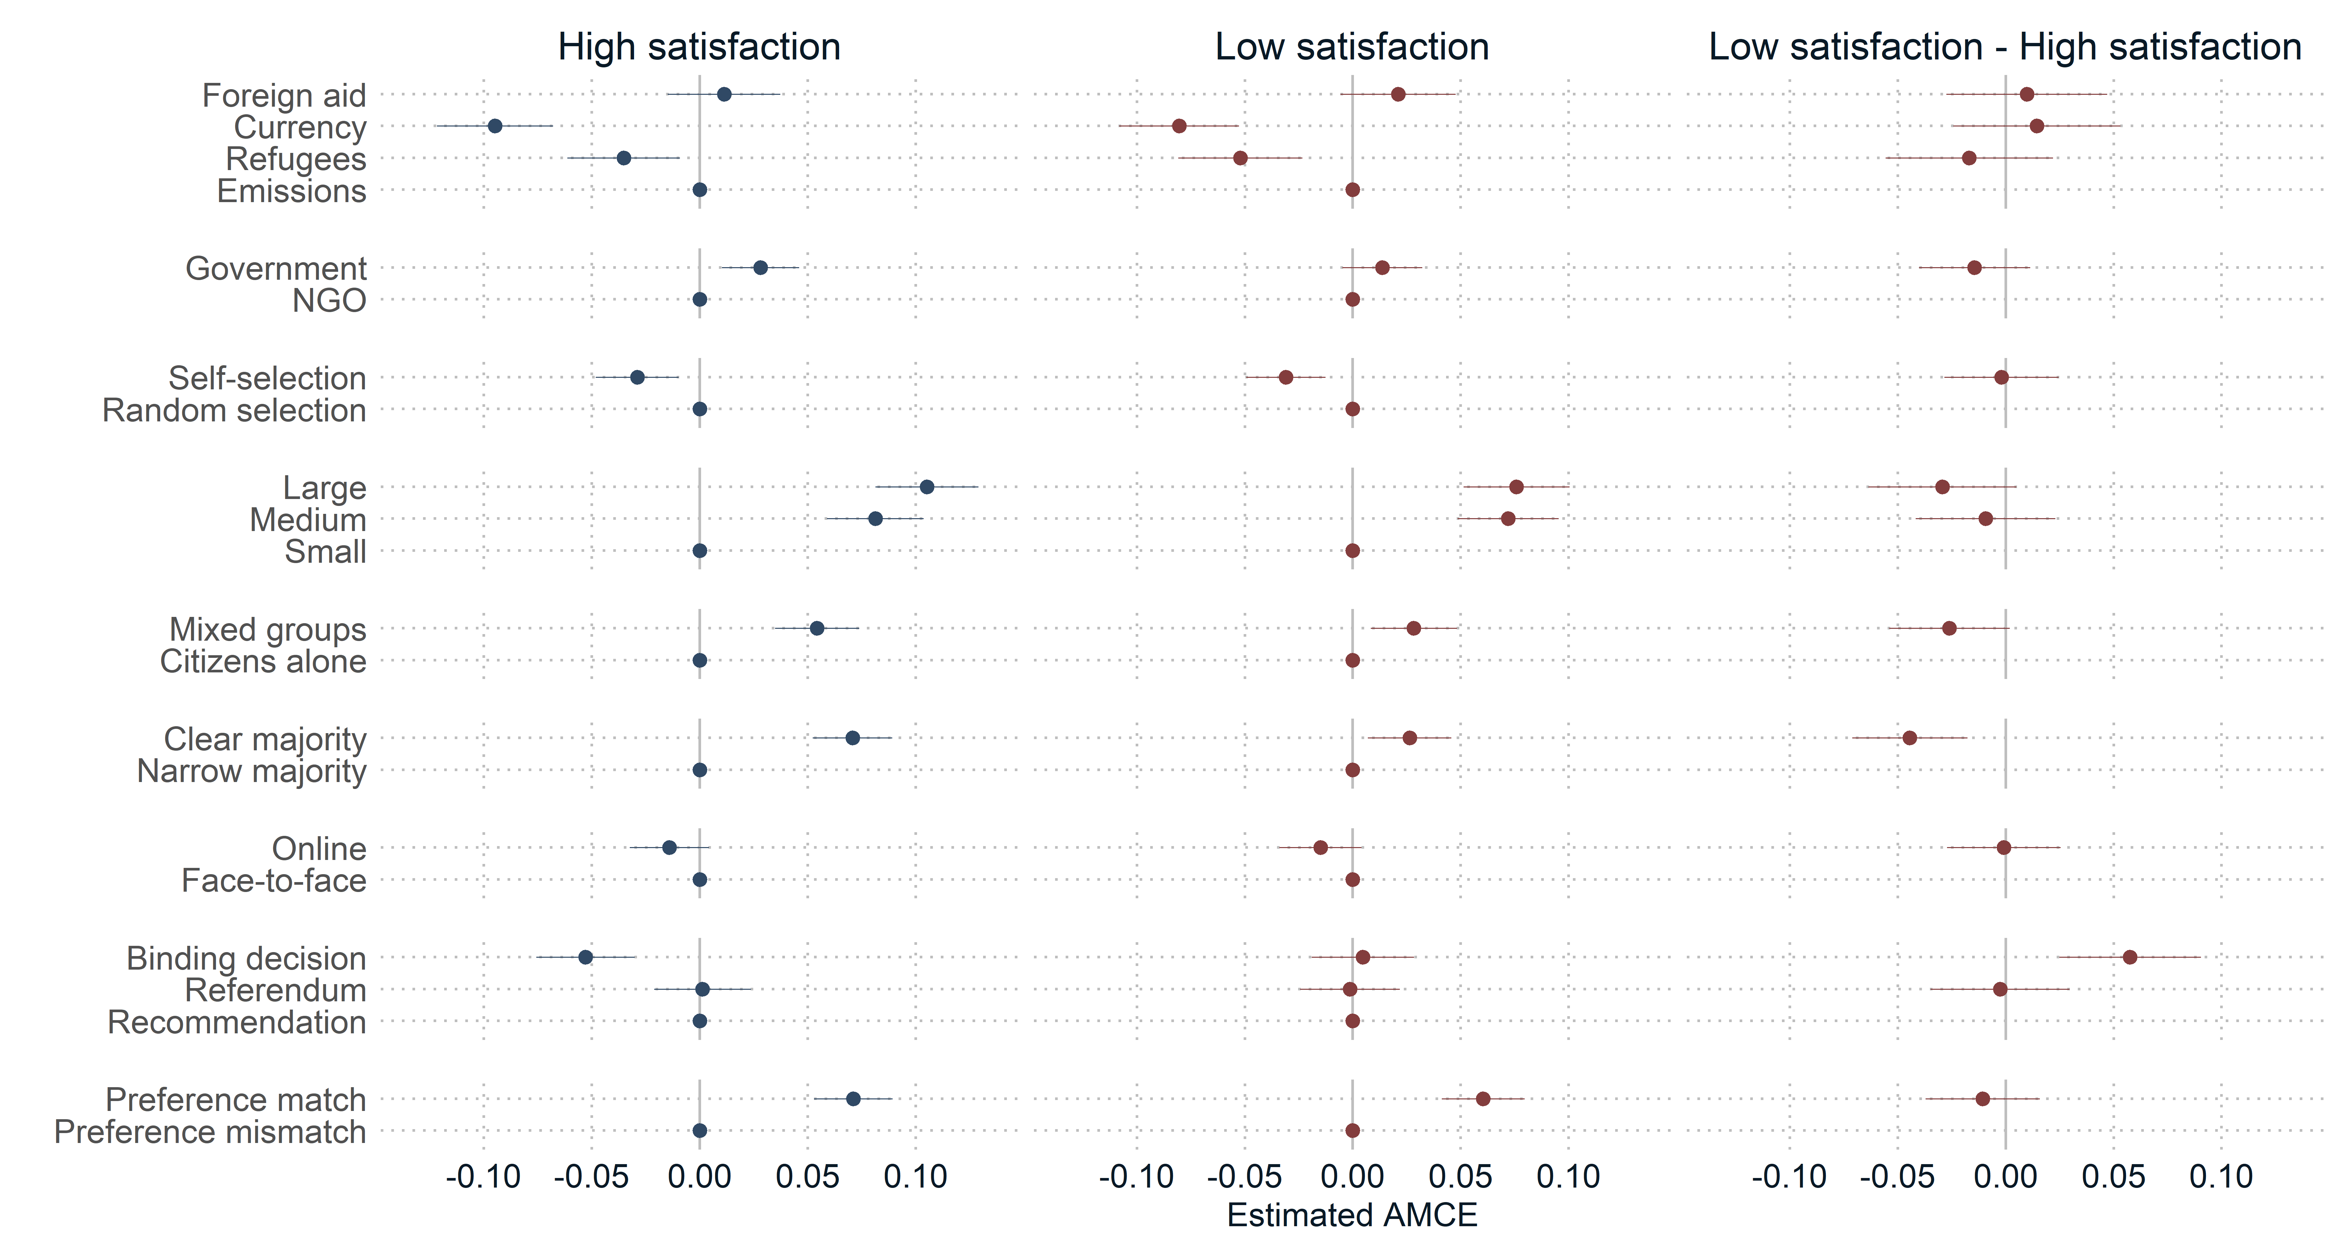Note: Heterogeneity in effects of attribute variations. The left panel shows AMCE for politically satisfied respondents. The panel in the middle shows AMCE for politically dissatisfied respondents. The right panel shows differences in AMCE between political dissatisfaction compared to political satisfaction.

Figure B3. 2: Conditional AMCE for external efficacy (choice outcome variable)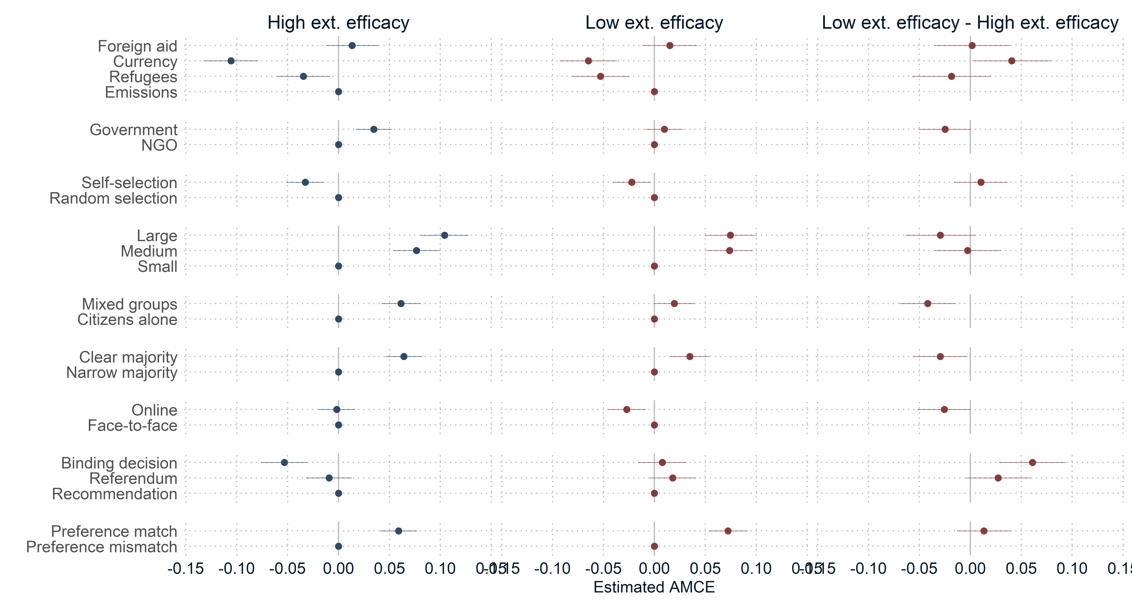Note: Heterogeneity in effects of attribute variations. The left panel shows AMCE for respondents with high external efficacy. The panel in the middle shows AMCE for respondents with low external efficacy. The right panel shows differences in AMCE between low compared to high external efficacy.

Figure B3. 3: Conditional AMCE for stealth attitudes (choice outcome variable)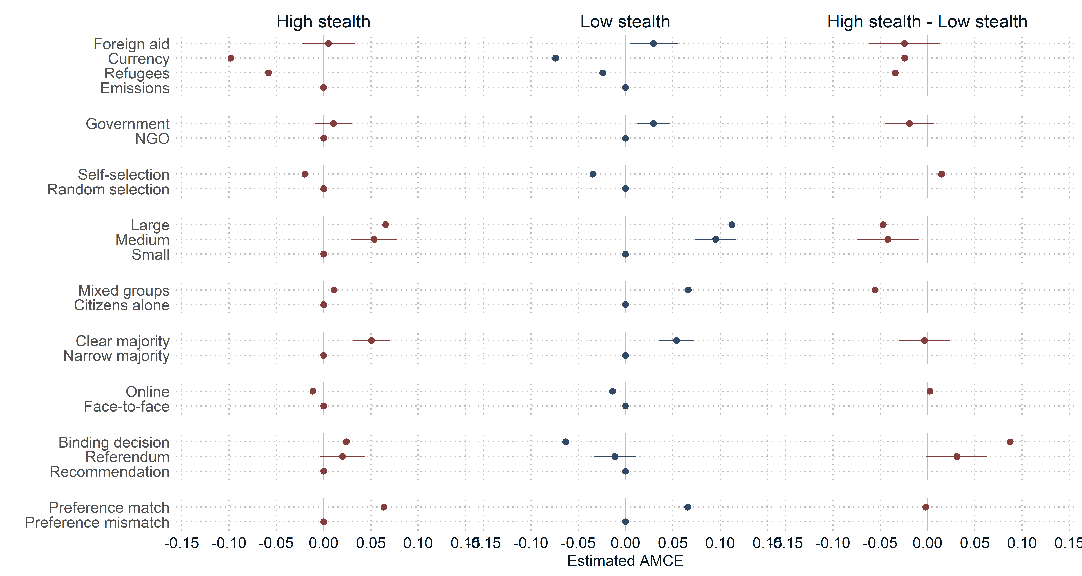Note: Heterogeneity in effects of attribute variations. The left panel shows AMCE for respondents with high stealth attitudes. The panel in the middle shows AMCE for respondents with low stealth attitudes. The right panel shows differences in AMCE between stealth compared to non-stealth attitudes.

Figure B3. 4: Conditional AMCE for populist attitudes (choice outcome variable)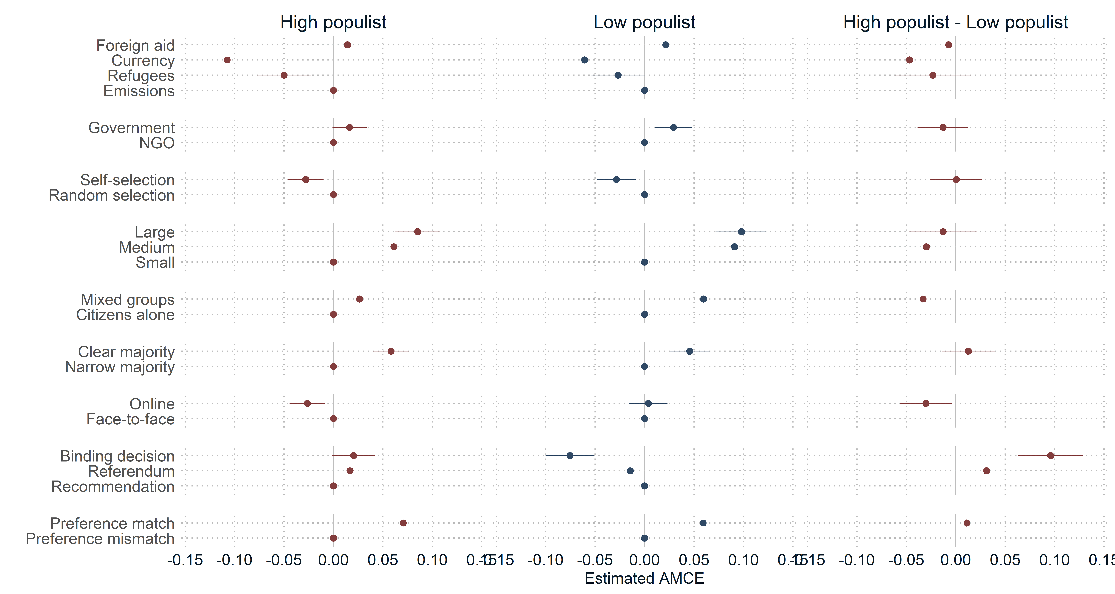Note: Heterogeneity in effects of attribute variations. The left panel shows AMCE for respondents with high populist attitudes. The panel in the middle shows AMCE for respondents with low populist attitudes. The right panel shows differences in AMCE between high compared to low-populist attitudes.

B4 Timing variables
Figure B4. 1: Conditional AMCE for engagement with scenarios (choice outcome variable)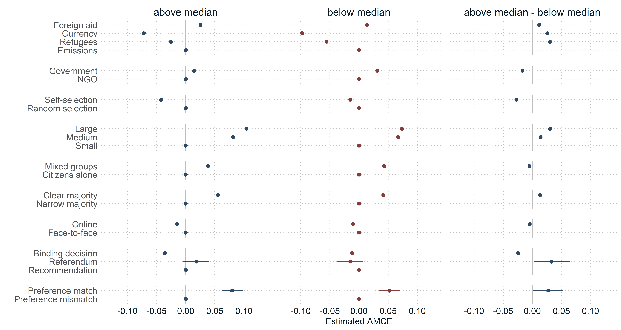Note: Heterogeneity in effects of attribute variations. The left panel shows AMCE for respondents engaged with the scenarios for longer than the average. The panel in the middle shows AMCE for respondents who engaged with the scenarios for less than the average. The right panel shows differences in AMCE between high compared to low engagement.

Figure B4. 2: Conditional AMCE for engagement with scenarios (rating outcome variable)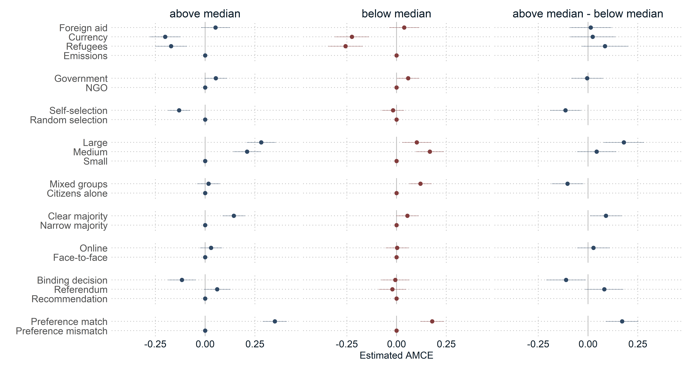Note: Heterogeneity in effects of attribute variations. The left panel shows AMCE for respondents engaged with the scenarios for longer than the average. The panel in the middle shows AMCE for respondents who engaged with the scenarios for less than the average. The right panel shows differences in AMCE between high compared to low engagement.

Figure B4. 3: Differences for engagement with scenarios (AMCE, choice outcome variable)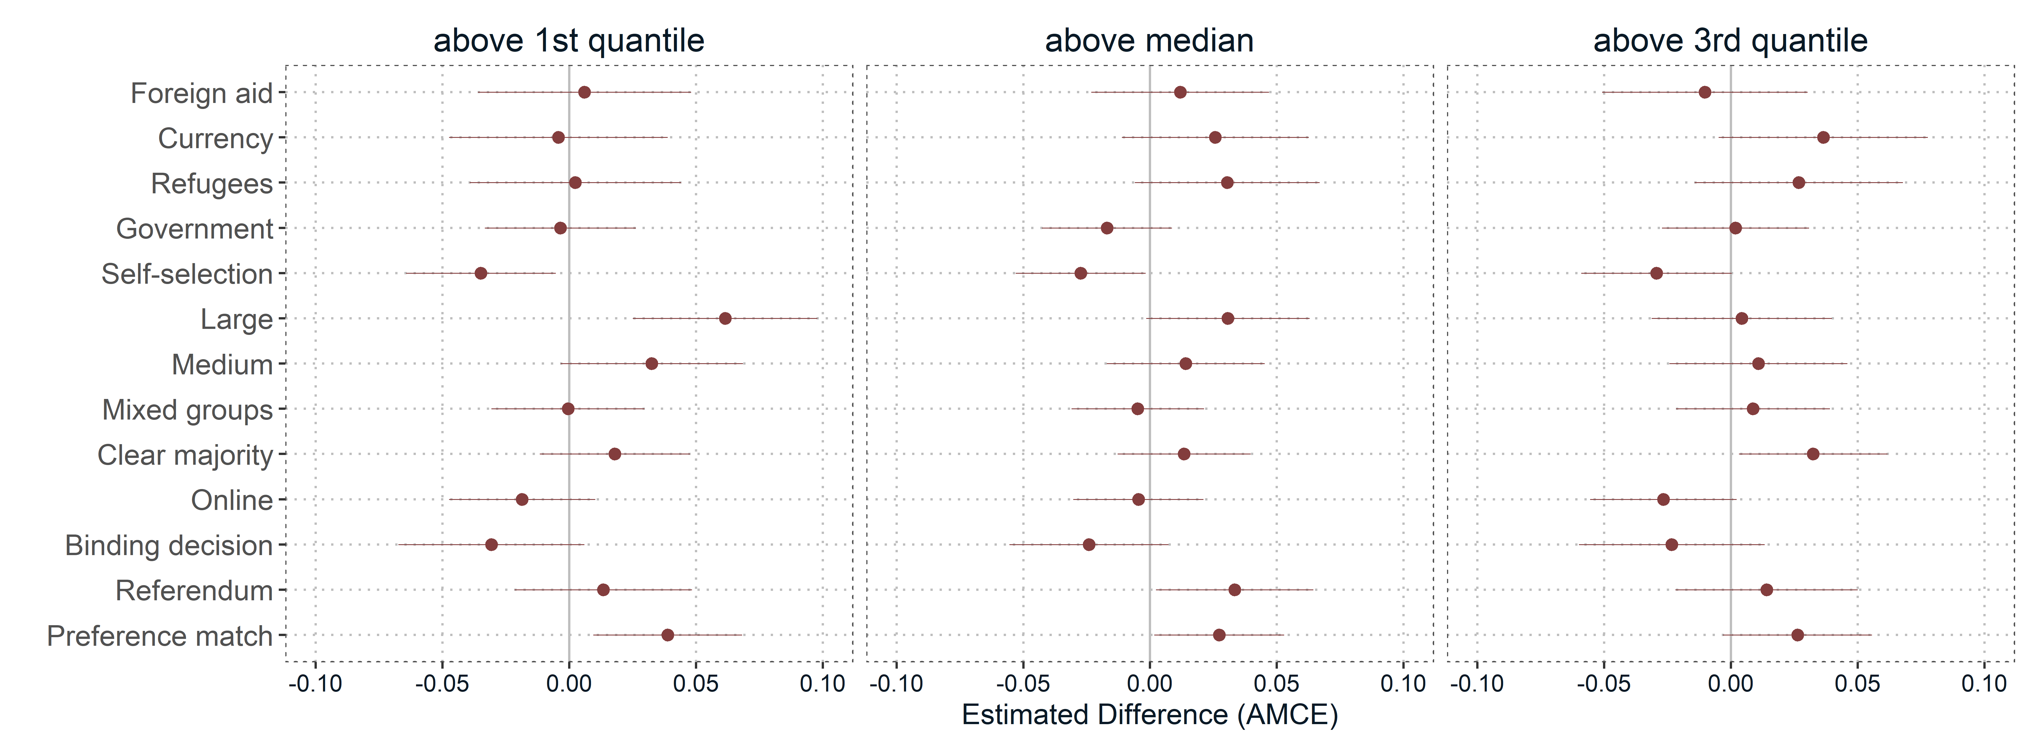Note: Estimated differences in preferences for respondents who engaged with the scenarios for longer than above the first, second, and third quantile compared to those who engaged less than the first, second, and third quantile.
Figure B4. 4: Differences for engagement with scenarios (marginal means, choice outcome variable)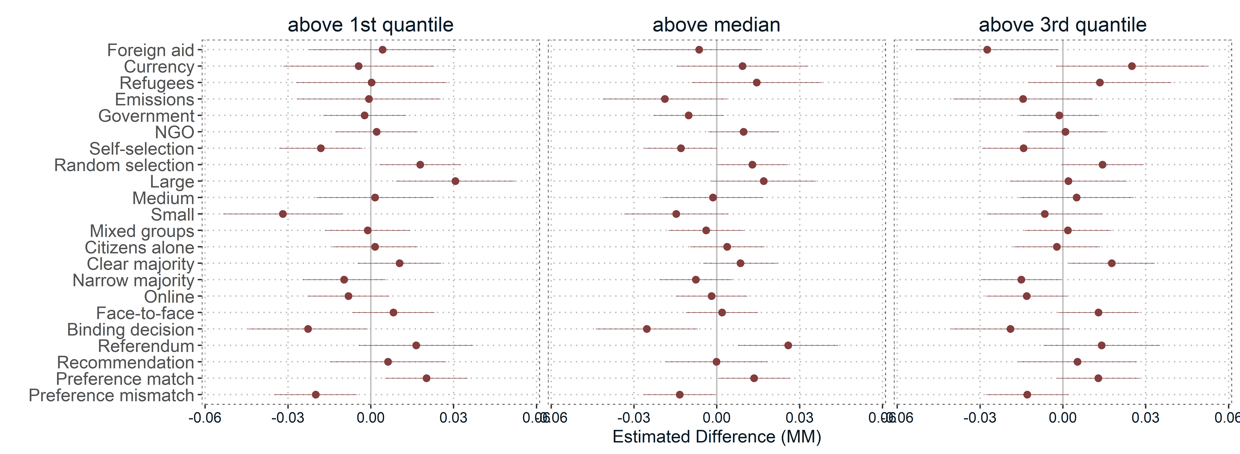Note: Estimated differences in preferences for respondents who engaged with the scenarios for longer than above the first, second, and third quantile compared to those who engaged less than the first, second, and third quantile.
Figure B4. 5: Differences for engagement with scenarios (AMCE, rating outcome variable)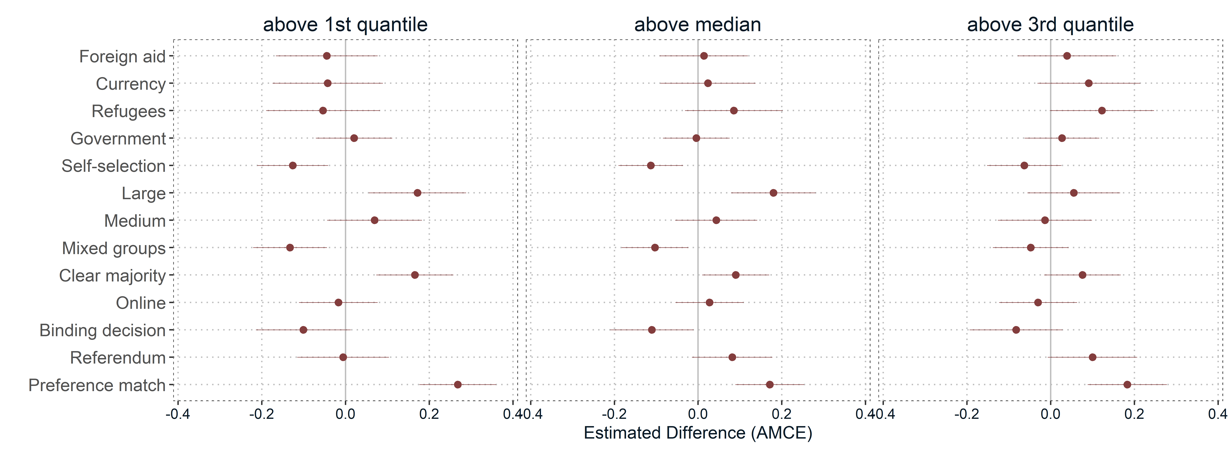Note: Estimated differences in preferences for respondents who engaged with the scenarios for longer than above the first, second, and third quantile compared to those who engaged less than the first, second, and third quantile.

Figure B4. 6: Differences for engagement with scenarios (marginal means, rating outcome variable)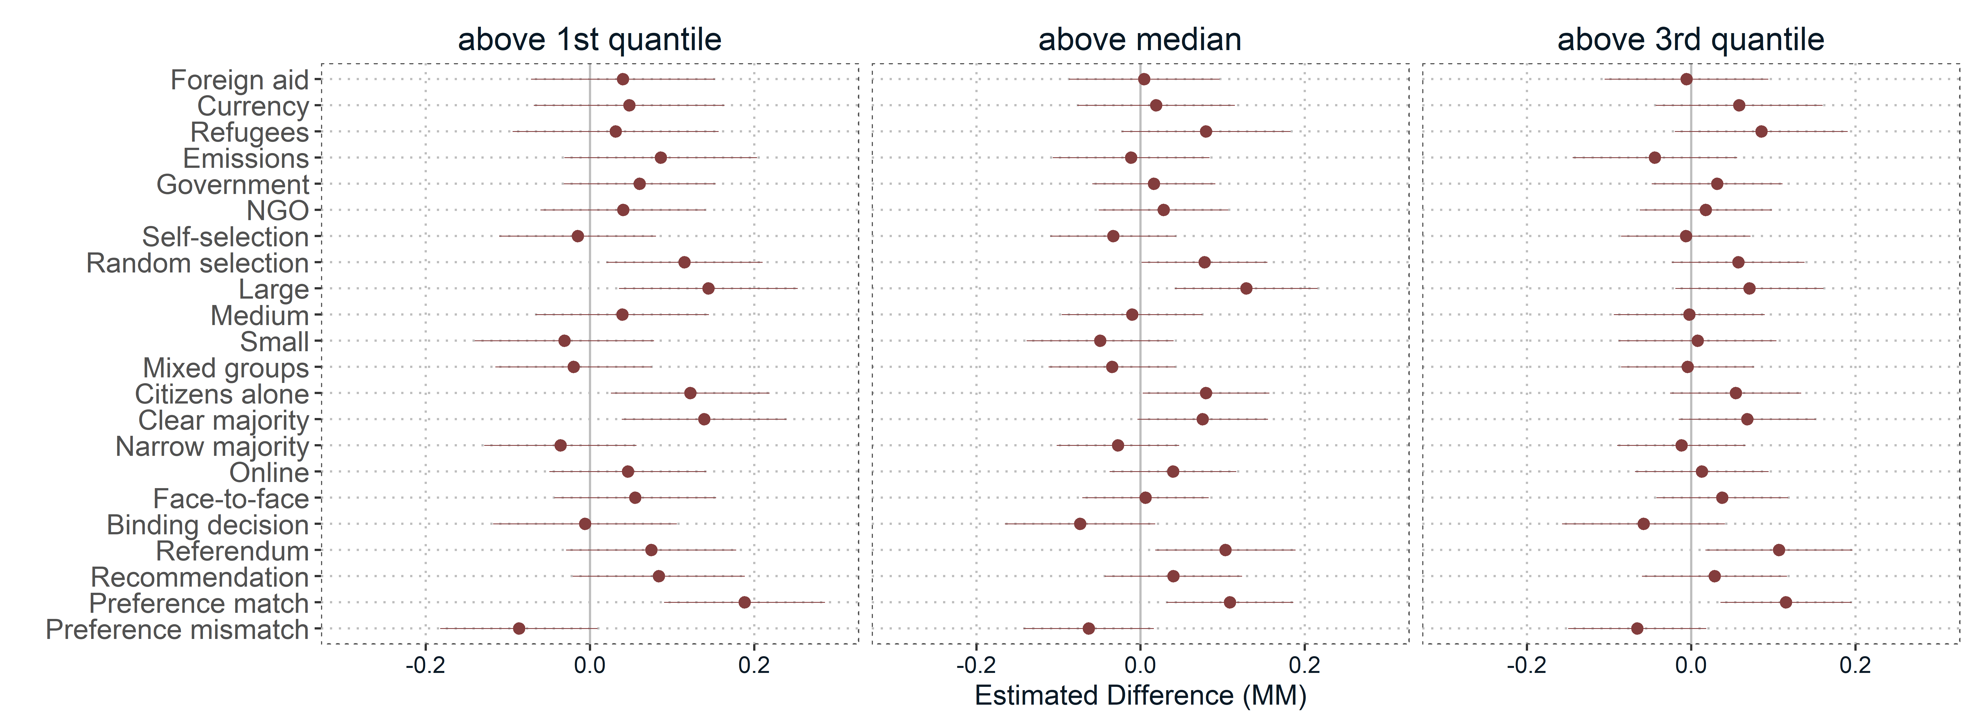Note: Estimated differences in preferences for respondents who engaged with the scenarios for longer than above the first, second, and third quantile compared to those who engaged less than the first, second, and third quantile.

B5 Differences between experienced and inexperienced citizens
Only few respondents already have made experiences with DCFs. Whereas about 42 percent of the respondents were unfamiliar with DCFs, about 38 percent at least had heard about it. Another 17 percent think that they know a lot about DCFs. Finally, less den 3.5 percent participated at least once in a DCF. Due to the low number of cases having more experiences with DCFs than just "having heard about it", we split two groups for differentiating inexperienced versus experienced citizens, again using a median split. Thus, we coded all responses indicating that respondents at least “have heard about DCFs” as ‘1’ (experienced) and ‘0’ otherwise (non-experienced). The exact question wording was “Please tell us, how well, if at all, are you familiar with citizens' forums?” using the following response categories:
- I am unfamiliar with citizen forums (41.6%)
- I have heard of citizen forums before (38.3%)
- I know about citizen forums, but have not yet participated (16.7%)
- I have already participated in a citizen forum (2.6%)
- I have already participated in several citizen forums (0.8%)
Figure B5. 1: Difference plots (AMCE and marginal means, rating and choice outcome variables) for experiences with DCFs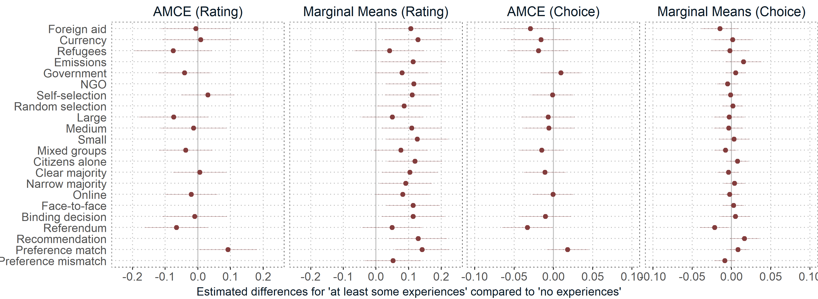
Note: Effects show differences for respondents who already have made experiences with DCFs (at least having heard about them) compared to those who did not where AMCE represent differences in conjoint effect sizes and marginal means represent descriptive differences in preferences.

Finally, we ask those 1191 respondents who indicated that they at least have heard about citizen forums (excluding the first response category), how they, on average, would score their experiences. On a scale ranging from ‘1’ very negative to ‘7’ very positive, respondents scored their experiences with an average value of 4.74. Again, we split cases into two groups using the median where responses above five indicate positive experiences and below five indicate negative experiences.
Figure B5. 2: Difference plots (AMCE and marginal means, rating and choice outcome variables) for negative/positive experiences
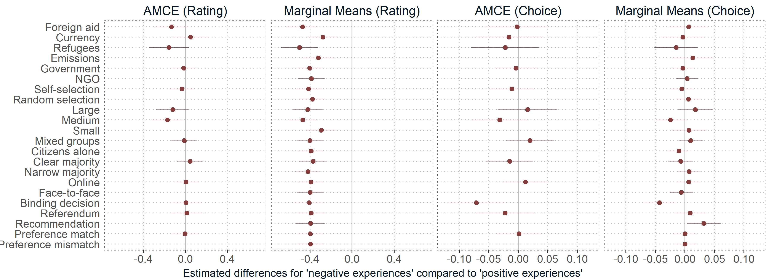
Note: Effects show differences for respondents with negative compared to positive experiences with DCFs where AMCE represent differences in conjoint effect sizes and marginal means represent descriptive differences in preferences.

