**APPENDIX**

A. Data sources 2

B. Descriptive statistics 4

C. Population changes, selective sorting and missing information 9

D. Full estimates 12

E. Additional models 15

E.A The effect of violence and repression on an individual’s left-right self-placement 15

E.B Unpacking the effect of left-wing violence and right-wing repression 18

E.C Age-Period-Cohort effects 22

E.D. Cohort operationalization and intergenerational transmission 24

E.F. Fixed effects models with municipality, cohort, and year dummies 25

E.G. Mediation analysis 27

F. Robustness checks 32

F.A. Hidden preferences or dk/na 32

F.B. Alternative operationalization of the outcome 33

F.C. Alternative operationalization of the explanatory variable 35

F.D. Analysis on the subsample of small municipalities 36

F.E. Alternative specifications 37

F.F The effect of violence and repression on an individual’s language 42

# A. Data sources

The data for the individual-level analysis comes from the ICPS, which is available at the Institute’s website <https://www.icps.cat/>. Table A1 shows the sample size for each year included in our analysis (1991-2016). Except for the 2003 and 2004 survey, all were face-to-face surveys. The universe was the Catalan population aged 18 years and over registered in the municipality where the interview was conducted. The sampling procedure followed a stratified logic by municipality size. There was first a random selection of households within municipalities and then the final selection of respondents based on gender and age quotas of each municipality.

As mentioned before, we obtained the data from the institute ICPS.[1] To be able to link each respondent to the municipality he/she resides on, we made a special request to the institute to obtain the municipality-level identifier. To preserve the anonymity of respondents, the ICPS provided us with the data but with small changes in several variables. The most important one is that we are not able to use the gender variable[2].

**Table A1**. Sample size in the years included in the analysis

|  |  |
| --- | --- |
| Year | Sample |
| 1991 | 2,000 |
| 1992 | 2,000 |
| 1993 | 1,200 |
| 1994 | 1,200 |
| 1995 | 1,800 |
| 1996 | 1,200 |
| 1997 | 1,200 |
| 1998 | 2,000 |
| 1999 | 1,800 |
| 2000 | 1,200 |
| 2001 | 1,600 |
| 2002 | 2,000 |
| 2003 | 1,200 |
| 2004 | 1,200 |
| 2005 | 1,200 |
| 2006 | 2,000 |
| 2007 | 2,000 |
| 2008 | 1,200 |
| 2009 | 1,200 |
| 2010 | 2,000 |
| 2011 | 2,000 |
| 2012 | 1,200 |
| 2013 | 800 |
| 2014 | 1,200 |
| 2015 | 1,200 |
| 2016 | 1,200 |

# B. Descriptive statistics

Table B1 shows the summary statistics of the different variables employed in our analysis.

**Table B1**. Summary statistics

|  |  |  |  |  |
| --- | --- | --- | --- | --- |
| Variable | Min | Max | Mean | Std. Dev. |
| Support for independence | 23.9% In favour: 76.10% Against | | | |
| Ideology | 1.56% Extreme left; 30.02% Left; 23.91% Centre-Left; 29.88% Centre; 9.22% Centre-Right; 4.97% Right; 0.44% Extreme-Right | | | |
| Language spoken at home | 48.09% Catalan; 44.54% Spanish; 7.37% Both | | | |
| % respondents belonging to the oldest cohort | 12.44% were 18 years old between 1917 and 1949, 87.56% the rest. | | | |
| Difference in repression | 0.26 | 11.92 | 2.30 | 0.80 |
| Population size | 10.48% < 2,000 inhabitants; 18.02% 2,001-10,000; 24.03% 10,001-50,000; 21.15% 50,001-150,000; 7.57% 150,001-1milion; 18.75% more than 1 million | | | |
| Percentage of people born in Catalonia at the municipality-level | 66.25 | 97.87 | 80.29 | 6.43 |
| Percentage of people older than 65 at the municipality-level | 7.99 | 38.87 | 19.09 | 3.14 |
| Percentage of people who agree with “elections are not really useful because the same people always rule” | 47.25% agree with the statement, while 52.75% disagree. | | | |
| Percentage of people who agree with “it is better not to get involved in politics” | 59.77% agree with the statement, while 40.22% disagree. | | | |

Figure B1 shows the evolution of our dependent variable in our period of analysis. As it can be seen, the percentage of people that wanted Catalonia to be an independent state was fairly stable (around 20%) up until 2009-2010. After that, it increased and reached a peak of 43% in 2013. Several factors have been highlighted to account for the increase in secessionist preferences over time (Cuadras-Morató 2016), such as the economic crisis (which has been shown to have had little effect (Cuadras Morató & Rodon 2018)). Most scholars argue that the 2010 Spain’s Constitutional court ruling on the 2006 Statute of Autonomy of Catalonia laid the ground for the increase in secessionist preferences among an important part of the Catalan population.[3] This evolution is consistent with other data sources[4] and it underestimates the support for independence, as a considerable number of Catalans that opt for the federal state or even the autonomous community option in the territorial preference question would vote in favour of independence in a yes or no question. However, this question offers us a unique view of Catalans territorial preferences over time, as it has been consistently included in surveys over a long-time window.

**Figure B1.** Evolution of territorial preferences (1991-2016)

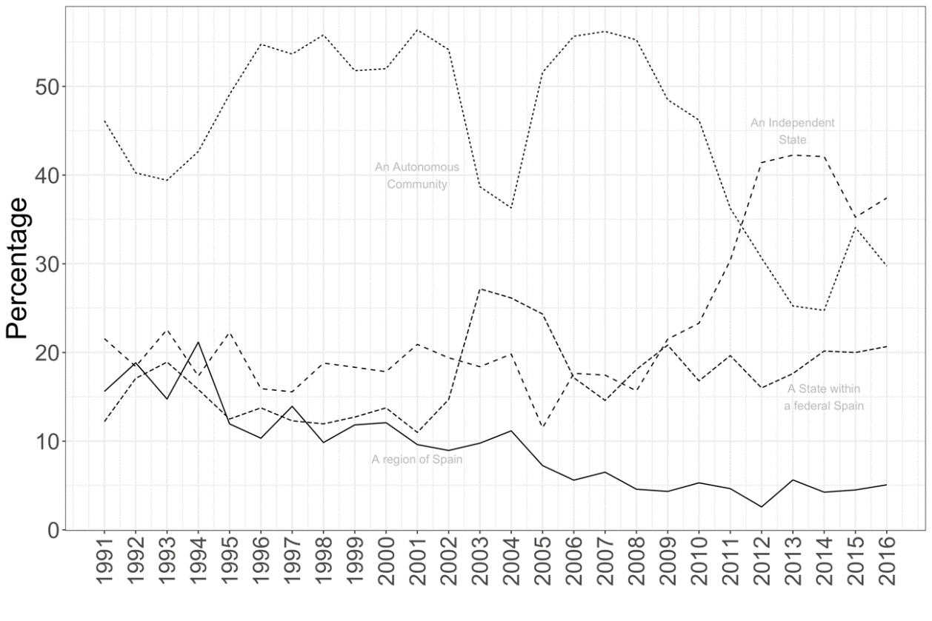

Figure B2 shows the spatial distribution of our outcome—support for independence versus not—aggregated at the municipality-level. As mentioned before, we use a pooled dataset of repeated cross-sectional surveys that span over 27 years (1991-2016). Pooling different random samples from different years guarantees that we cover around 60% of the Catalan municipalities. However, these municipalities contain most of the Catalan population: 96.6% of the Catalan population lives in the municipalities included in our analysis.

**Figure B2**. Spatial distribution of support for independence

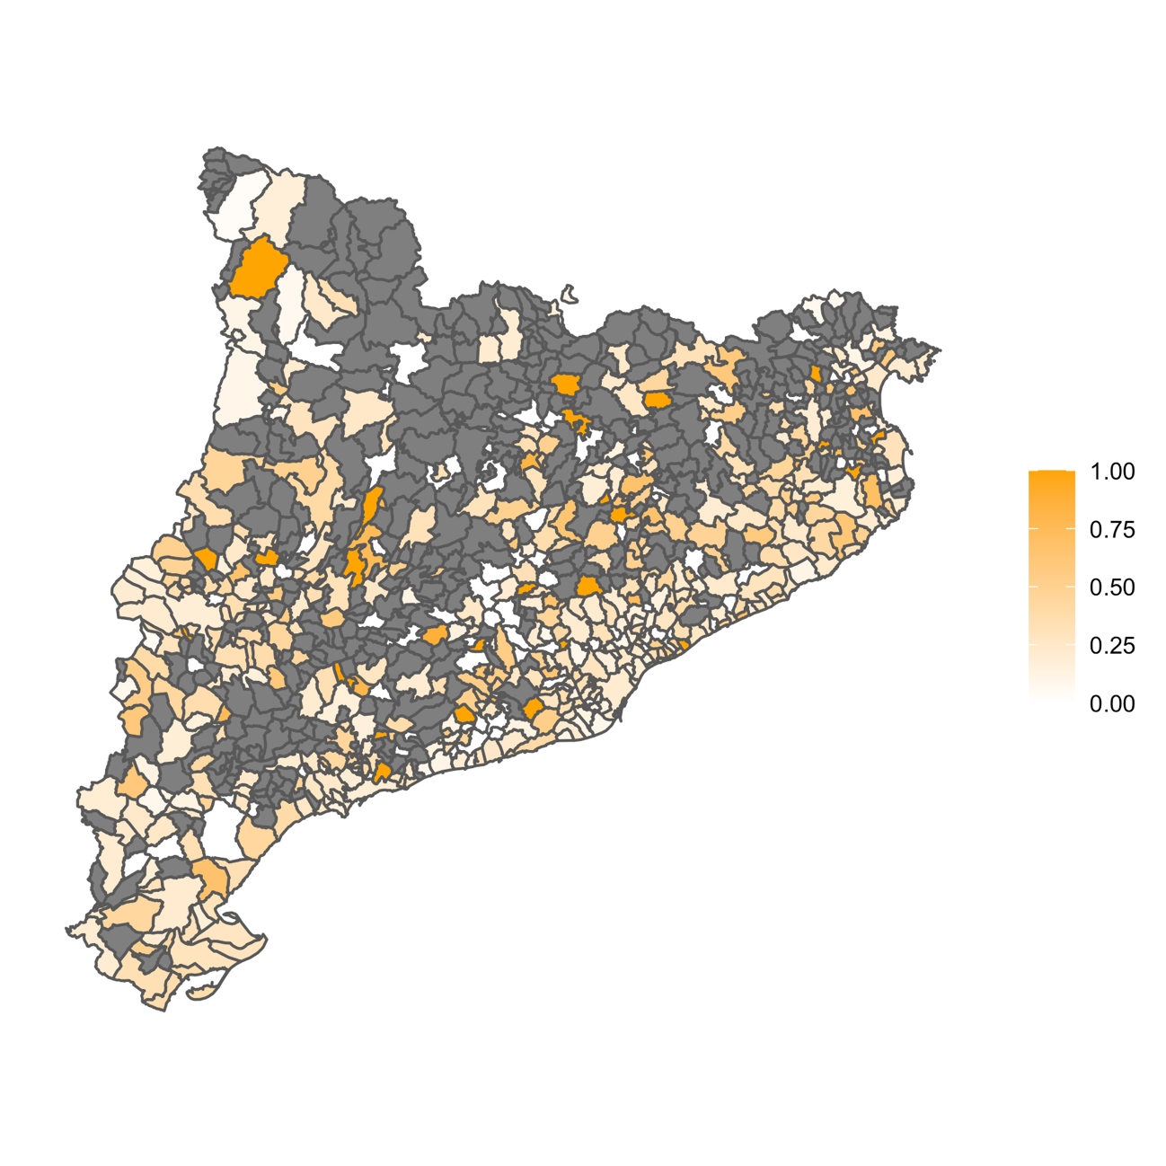

Note: Percentages calculated based on individual-level answers on the ICPS survey.

Figure B3 shows the spatial distribution of the difference in repression in the different Catalan municipalities. Municipalities highlighted in grey represent municipalities for which we do not have individual-level data.

**Figure B3.** Spatial distribution of the difference in repression (municipality-level)

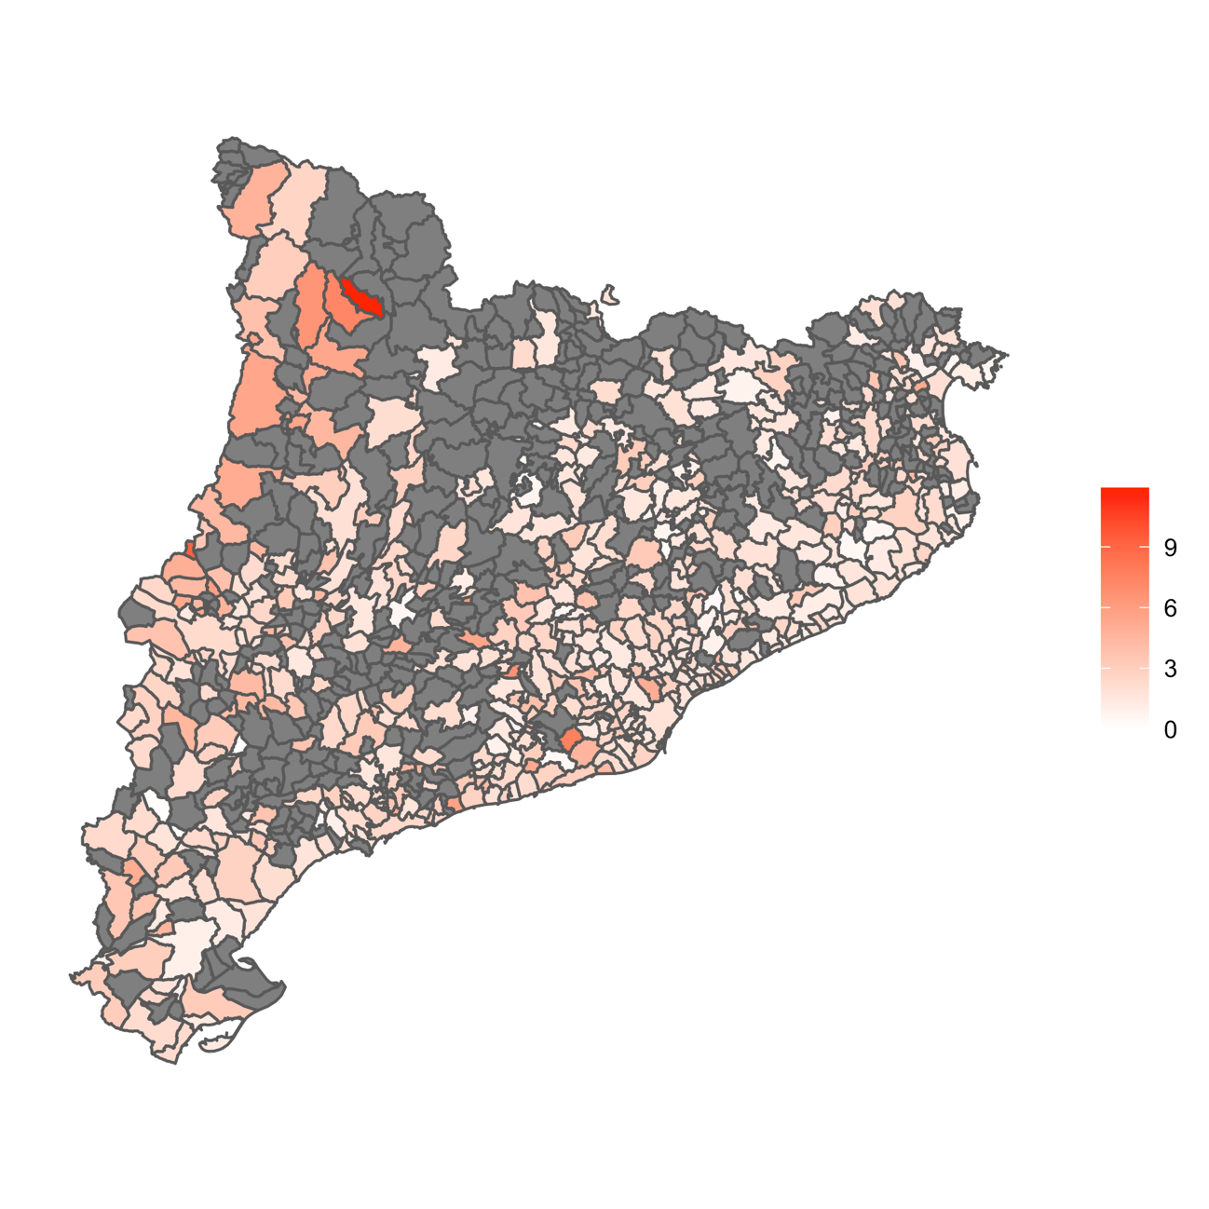

# C. Population changes, selective sorting and missing information

A potential concern for our analysis is that our sample might not be properly capturing individuals belonging to the cohort in places where violence was more intense. In other words, violence during the Civil War and its immediate aftermath could have triggered different population changes in places that witnessed more violence versus the rest.

In order to empirically check this pattern, we run different models in which we regress a municipality’s relative population change (dependent variable) on the repression indicator (independent variable). We constructed as many population changes indicators as year-comparisons between 1940 and the year each survey was conducted.

Figure C1 below plots the coefficients of the difference in repression indicators in all models. As it can be seen, none of the coefficients is statistically significant. In other words, population changes were not significantly different in municipalities that experienced more violence compared to those that experienced less violence. Therefore, these results empirically validate one of our assumptions and also show that population changes are unlikely to be affecting our estimates.

**Figure C1**. The effect of the difference in repression on population movements

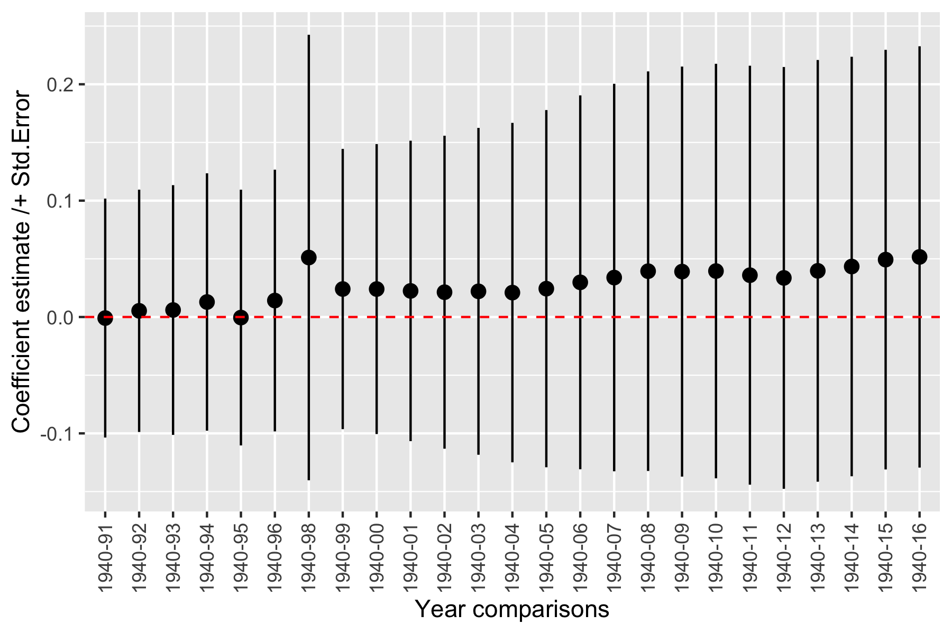

Another potential concern is related to the missing not at random (MNAR) problem. If the missingness depends on the value of a variable (in our case, difference in repression at the municipality-level), our sample will not be representative, which might be biasing our estimates or affecting the external validity of the findings. It is unlikely that using a repeated cross-sectional sample over such a long time-span may result in a missing data problem, but this constitutes after all an empirical question. Accordingly, we checked if those municipalities included in the sample had significantly different levels of repression than those excluded from it. As Figure C2 below shows, this is not the case. A t-test also reports non-significant differences (p-value = 0.617). Therefore, results show that municipalities that are not included in our sample are not significantly different than those that are included.

**Figure C2.** Difference in repression levels between those municipalities included in our sample and those that are not

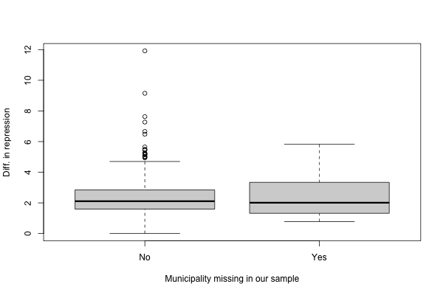

Finally, another potential concern has to do with selective sorting. It could be, for instance, that more pro-independence individuals in cohorts affected by the war moved out of municipalities with more past repression. To control for such possible confounding factor, we run our main model including the percentage of native dwellers who still live in each municipality at the context level. As can be seen in table C1 and figure C3, the inclusion of this control does not affect the findings.

**Table C1.** Robustness test of the main model adjusting for the percentage of each municipalities’ native dwellers.



**Figure C3.** Visualization of the cross-level interaction from table C1.

# D. Full estimates

Figure D1 provides a graphical comparison of key effect sizes across the rival modelling approaches (RE and FE) of the cross-level interaction of interest, clarifying that beyond significance and sign, the strength of the relationship estimated is rather similar.

**Figure D1.** Visualization of the effect sizes across RE & FE models of the cross-level interaction between difference in repression among the oldest cohort.



**Note:** Estimates come from models 2 and 8 from Table 1 in the paper.

As mentioned in the last part of the manuscript, we try to explain why the oldest cohort in municipalities that experienced a higher degree of violence is currently more likely to reject Catalan independence. We mainly use two different outcomes. First, we distinguish whether a respondent thinks elections are not useful[5]. Second, we capture whether a respondent considers that it is better not to get involved in politics[6]. We re-run two different models using these two indicators as the dependent variable—and including the same controls. We plot the predicted values, which can be seen in the manuscript (Figure 2). Table D1 shows the full estimates employed to create the figure.

**Table D1.** Multilevel logistic regression to predict preferences for secession. Effects of the difference in the percentage of the population repressed by both sides in each municipality during and after the Civil War on anti-politics attitudes.



# E. Additional models

This section includes additional models that help us clarify different substantial points not directly addressed in the manuscript.

## E.A The effect of violence and repression on an individual’s left-right self-placement

Table E.1 runs our main model but including an individual’s left-right self-placement as an outcome. A question about an individuals’ LR self-placement has also been consistently included in surveys. The indicator ranges from 0 (extreme left) to 10 (extreme right). Results show that the cross-level interaction is not significant. Cohorts exposed to more violence during their formative years are not more likely to locate themselves on the left/right than cohorts exposed to less violence. Therefore, our results show that violence/repression had an effect (a negative one) especially on individuals’ attitudes towards independence, which arguably represents a more disruptive attitude than the other important dimension of competition.

**Table E1** Multilevel logistic regression to predict preferences for secession. Effects of the difference in the percentage of the population repressed by both sides in each municipality during and after the Civil War.



Next, we check whether individuals exposed to violence are more leftist, even if they do not support secession. For that purpose, we re-specify a model including preference for secession as an additional independent variable. Figure E1 presents the cross-level interaction between the cohort indicator and the difference in repression variable for the subgroup of people in favour of secession and those not in favour of it. As can be seen, exposure to violence does not affect an individual’s left/right ideology of secessionists or opponents to secession among the oldest cohort. As it can be seen, the oldest cohort supporting secession is on average more left-wing than the oldest cohort not supporting it, but their left-right do not vary across different values of violence/repression.

**Figure E1**. Cross-level interaction of cohort and total violence in each municipality.



## E.B Unpacking the effect of left-wing violence and right-wing repression

We next run the same models as those included in the manuscript but changing the operationalization of one of our key explanatory factors. In particular, instead of considering the difference in repression perpetrated by the Francoist regime minus the violence perpetrated by the left, we collapsed all types of violence, regardless of the ideological characteristics of the perpetrator. Thus, we create a new indicator that captures the percentage of people that suffered violence/repression at the municipality level. As mentioned in the manuscript, the two types of violence were qualitatively different, both on ideological grounds and on how it was practically carried out. Yet, our goal here is to corroborate that our results are not driven by the specific way we operationalize violence/repression. As it can be seen in Table E2, using this new indicator does not change our conclusions—and, as expected, the coefficient of the interaction between total violence and the oldest cohort is smaller than that presented in the manuscript. Interestingly, we observe the stronger effect between 1991 and 1999 (model 2), when enough living individuals from the oldest cohort responded the survey. Figure E2 shows the predicted values of the interaction displayed in model 2 in Table E2.

**Table E2.** Multilevel logistic regression to predict preferences for secession. Effects of total violence in each municipality during and after the Civil War



**Figure E2**. Cross-level interaction of cohort and total violence in each municipality.



Note: Model 2 in table D1.

Next, we consider both types of violence separately. On one hand, we run a model with all covariates but considering only the violence perpetrated by the right-wing side. On the other hand, we run the equivalent model but with the violence perpetrated by the left-wing side. In Figure E3 we plot the cross-level interactions of both models. As can be seen, only right-wing violence, which was more intense and took place for a longer period of time, has the capacity to reduce the secessionist stances of the oldest cohort.

**Figure E3**. Cross-level interactions of cohort and municipal violence perpetrated from each side separately.



In Figure E4 we plot the percentage of the sample corresponding to the oldest cohort over the 26 time points covered by the surveys. It can be seen how the oldest cohort decreases its share sharply due to mortality associated with old age.

**Figure E4**. Share of the oldest cohort over the total sample across the period observed.



## E.C Age-Period-Cohort effects

An old methodological dilemma in the social sciences concerns the identification of age, period and cohort effects. In repeated-cross sectional data, where these three effects appeared mixed, different strategies have been proposed to identify them (e.g., Yang & Land 2013, Smith 2008). The current consensus seems to be that the identification of each of these components, with a modelling strategy such as cross-classified random effects models, requires strong assumptions that are not always tenable (Bell 2021). Fortunately, to test the main hypothesis of our paper we do not need to deal with this methodological quandary. Our research question focuses on comparing individuals belonging to the same cohort (the oldest) but exposed to different degrees of violence during their formative years. In such models, we can rule out the age and period components since they are constant within cohort. In any case, as a robustness test of our main analyses, we have additionally modelled our data using a random effects specification able to concurrently account for the age, period and cohort components. In this specification, besides the fixed effect of cohort at the individual level, we further include the fixed effect of age. Following Mishler & Rose (2007) and Tormos (2019), we centre age within each cohort’s average age to avoid collinearity. In addition, we consider period as a random effect. We establish a third level for years in the multilevel model. Individuals are therefore nested within municipalities and, in turn, individuals and municipalities are nested (or observed) within 27 time-observations (period). Table E3 below presents the results of this modelling strategy. Once age and period effects are adjusted for, the interaction between cohort and violence at the municipality level remains unaltered and statistically significant. Figure E5 helps at visualizing this interaction. If we specify a three-way interaction of repression, cohort, and age to an equivalent model (not shown for simplicity), results are the same and the coefficients of these additional interactions are not significant.

**Table E3.** APC model with random effects for municipalities (2nd level) and years (3rd level) and with age-centred individual fixed-effects.



**Figure E5.** Cross-level interaction of cohort and violence after the APC model.



## E.D. Cohort operationalization and intergenerational transmission

In the statistical analyses of our paper, we chose a dichotomous operationalization of the cohort variable where 1 is for the oldest generation (our group of interest) and 0 otherwise. This choice is informed by two motives: 1) for chronological reasons, the oldest cohort is the one that might have had direct formative experiences of violence in their municipality; 2) preliminary analyses indicated that including many cohort groups, apart from the oldest, did not improve our understanding of the data. Figure E6 shows the results of the cross-level interaction with dummies for various cohort groups, from a model including all covariates. As it can be seen, it is precisely the oldest cohort the one that has the most negative relationship between repression and support for independence. It is the only case in which the interaction coefficient is statistically significant. The slope is also negative on the subsequent cohort (1950-1959), which also experienced some levels of repression, but it turns flat on all the rest. This confirms the idea that the effect of violence and repression on support for independence is merely restricted to the oldest cohort and that it died off in subsequent ones. Were there some sort of intergenerational transmission, we would have identified a concomitant pattern in other cohort groups.

**Figure E6**. Cross-level interaction with all cohorts (full model)



## E.F. Fixed effects models with municipality, cohort, and year dummies

We also perform an additional specification estimating models that control for municipality, cohort, and years fixed effects. In Table E4 we consider municipality and cohort fixed effects, as well as an interaction of cohort with the index of repression. This analysis purges time-invariant unobservable confounders at the municipality and cohort level, but it is very demanding from a statistical point of view. The main reason is that we have a total of 523 municipalities and, in some of them, the number of observations is relatively small. In addition, including so many dummies and interactions can lead to multicollinearity. Bearing in mind these limitations, results remain consistent with our main analysis, as shown by the sign and p-value associated with the interaction term. The same conclusion holds when we further specify year dummies in Table E5.

**Table E4.** Linear probability model with municipality dummies.



**Table E5.** Linear probability model with municipality and year dummies.



## E.G. Mediation analysis

We also perform a mediation analysis. The goal of this part is to examine whether political culture moderates or mediates the effect of repression on independence among the oldest cohort. In other words, one of the mechanisms we explore—and corroborate—in the manuscript that links repression and a lower likelihood of supporting independence is the presence of some attitudinal traits associated with apathy, or disaffection. In other words, in the last part of the manuscript we show that the oldest cohort in municipalities that experienced higher levels of violence are more likely to believe that “elections are not really useful because the same people always rule” than the same cohort-group in municipalities with less violence.

Notwithstanding this finding, one might argue that the effect of political culture is direct. In other words, it could be that, in our models, political culture is directly affecting support for independence independent of the effect of violence and repression. If this is the case, we would then be attributing changes in secessionist support to changes in political culture when, instead, this mediation effect does not exist.

To increase our confidence in the effect of the mechanism, we precisely perform a set of mediation analyses. These analyses once again help us better explain the relationship between our three variables of interest (repression, political culture and support for secession) and, most crucially, the direct and indirect effect between them.

Table E6 presents separated multilevel models for the complete sample of cases and time points that could be indicative of a mediation process. In model 1, political culture is the dependent variable in a model with cohort, repression, and their cross-level interaction as predictors. We can confirm that repression influences political culture in an expected way, through the formative experiences of those who lived those traumatic events. In addition, there is also a main effect of cohort indicating that on average the oldest generation is more inclined to this particular political culture trait. Thus, Model 2 is, first of all, showing the significant impact of repression through cohorts’ socialization experiences. Then, and most crucially, and as already described in the article, it indicates political culture has a main (direct) effect reducing the will to secede. This could be a sign of the possible mediation role of political culture.

**Table E6.** Separate multilevel models of political culture and preference for secession (complete sample)



Next, we apply a multilevel mediation structural equation model with a dependent variable that follows a Bernoulli distribution.[7] We already know repression effects are not an across-the-board phenomenon but circumscribed to the oldest generation. Therefore, we restrict our analysis to the subsample of people born in Catalonia from the eldest cohort and observed in the period from 1991 to 1999. This is a way of operationalizing the cross-level interaction. Figure E7 shows the estimates of our model. We observe a significant direct effect of repression on the will to secede and a more modest one on political culture. The estimate in the arrow between political culture and preference for independence is not significant. All in all, the model’s estimation of the indirect effect of repression and the mediator role of political culture is rather small and not statistically significant.

**Figure E7.** Multilevel mediation structural equations model (within the subgroup of the Catalan oldest cohort in the period 1991-1999)

.12

-.32**

.23†

1

1

Indirect effect = 0.28 (0.03)

Total effect = -0.36 ** (0.13)



Finally, Table E7 shows another modelling approach to study the mediation role of political culture. Using the same subsample of the population, we apply linear multilevel mediation with territorial preference as a dependent variable.[8] Overall, the estimates of this multilevel mediation model are consistent with the previous multilevel structural equation analysis. The indirect effects of repression are small and non-significant when bootstrapped standard errors are calculated.

All in all, instead of a proper mediation effect of political culture, it seems that repression could be the common cause of both a fatalistic-apolitical political culture and an attitude less supportive of Catalan independence.

**Table E7.** Multilevel mediation with ordinal territorial preferences



# F. Robustness checks

This section includes several subsections with different robustness checks and alternative specifications.

## F.A. Hidden preferences or “don’t know/no answer”

A possible concern affecting our results is that we are not properly capturing preferences for secession among the oldest cohort that resides in municipalities that experienced a higher degree of violence. It could be that a fair number of individuals exposed to violent events during their formative years do not want to give a concrete answer when they are asked about their preferences for Catalan independence. Given—as we show in the second part of the article—that the topic might be considered contentious by some people, the surveys might fail to capture the preferences of certain population groups. If this is the case, and as we explained before, then the higher tendency of answering the question among certain people—for instance, older cohorts living in municipalities that experienced relatively less violence—could again create a missing not at random (MNAR) problem. Although we partially address this problem before, we next implement additional robustness checks.

The dk/na concern is unsubstantiated by the data. The percentage of people that select “don’t know/no answer” in the territorial preference question (our dependent variable) equals 5.47%. If we take into account that we have a 25-year window, this number is very low. Empirical evidence rules out the idea that missing values are not random. Yet, to confirm that the oldest cohort is not more likely to have provided the answer dk/na in municipalities that experienced more violence, we re-run our main analysis but using a binary outcome that distinguishes whether the respondent did not answer the question, or answer “don’t know”, and otherwise. The model includes all control variables, both at the individual and the contextual-level. The marginal effects of the model are displayed in Figure F1. As it can be seen, differences are not statistically significant. People who in their formative years were exposed to more violence were not more likely to hide their preferences for secession compared to the same cohort in less violent environments.

**Figure F1**. The likelihood of answering “dk/na” among the oldest cohort



## F.B. Alternative operationalization of the outcome

Finally, as explained in the manuscript, our outcome is a binary indicator that captures whether a respondent is in favour of independence or otherwise. This indicator is based on the territorial preference question, which has four options (Independence, federal state, status quo, or less decentralization). To test that our findings are not driven by our operationalization decision, we check the stability of our findings using different outcomes.

First, we employ as an outcome a respondent’s preference for the territorial status quo (Autonomous Community) or otherwise. Figure F2 shows the predicted values of the cross-level interaction between the cohort indicator and the difference in the percentage of those repressed by both sides in each municipality on preference for the territorial status quo. Results are a mirror image of what we illustrate in the manuscript, namely, the oldest cohort is more likely to favour the status quo in municipalities where violence/repression was higher.

**Figure F2.** Cross-level interaction of cohort and the difference in the percentage of those repressed by both sides in each municipality on preference for the territorial status quo (Autonomous Community).



## F.C. Alternative operationalization of the explanatory variable

A possible concern of our analysis is that the relationship between violence/repression and support for independence might not be linear. To deal with this concern, we run our main models with an alternative operationalization of our explanatory variable. More concretely, we transform the difference in repression indicator into an ordinal variable composed of quartiles. We collapse the first and second quartiles due to their similar pattern. With this new variable specified as categorical, we run the main models and plot the results of the cross-level interaction with our cohort indicator (see Figure F3). As it can be seen, individuals from the oldest generation who are in the third and fourth quartile of the distribution of municipal violence (towns with higher levels of violence) are those more clearly affected: their attitudes towards secession clearly diminish as compared to those of the same generation who experience less violence or in comparison to the younger generations.

**Figure F3.** Cross-level interaction using an ordinal transformation of the repression variable using quartiles (first and second quartiles combined)



## F.D. Analysis on the subsample of small municipalities

An additional concern is that the effect of violence/repression might only be present in large municipalities. Although our models already include municipality size as a control, one could argue that the effect of violence was more likely to persist in small municipalities, where the level of social control is likely to be higher and certain norms are more likely to travel over time. Accordingly, we have replicated our models in two groups: one takes into account municipalities with more than 50,000 inhabitants, the other one less than 10,000 inhabitants. The results of the cross-level interactions are presented in Figure F4. As it can be seen, results are virtually the same in both groups, which means that the effect of violence and repression on secessionist support is the same in small and large municipalities.

**Figure F4.** Cross-level interactions of cohort and the difference in the percentage of those repressed on the subsamples of small municipalities.



## F.E. Alternative specifications

The main statistical specification included in the manuscript corresponds to a logistic regression. We next run our main model but as a Linear Probability Model (LPM) with clustered standard errors by municipality (Wang 2021). Results are once again the same as those in the manuscript. Table F1 shows the results and Figure F5 plots the predicted effect based on the cross-level interactions.

**Table F1.** Reanalyses using the Linear Probability Model with clustered standard errors.



**Figure F5.** Interactions of cohort and the difference in the percentage of those repressed using the Linear Probability Model with clustered standard errors.



Figure F6 carries out an additional robustness check. We employ a linear multilevel model on the original territorial preference question. Recall that this variable has four values, from 0 “less decentralization” to 4 “independence”. Results of the cross-level interaction using a linear model are displayed in Figure F6 and confirm the findings included in the manuscript.

**Figure F6.** Cross-level interaction of cohort and the difference in the percentage of those repressed in each municipality on territorial preferences using a linear multilevel model to avoid model dependence.



Some of the control variables used in the models, such as ideology or even language at home, could be considered posttreatment. Including them could create posttreatment bias (Acharya, Blackwell and Sen, 2016). It can be argued that they are endogenous to repression and, as such, "bad controls" (Angrist & Pischke 2009). Therefore, in an additional specification, we remove those controls while retaining the contextual-level ones. Results are shown in Table F2 and Figure F7. They confirm the main findings of the manuscript.

**Table F2**. Reanalysis excluding left/right ideology and language as individual-level controls.



**Figure F7.** Cross-level interaction after the reanalysis excluding ideology and language.



## F.F The effect of violence and repression on an individual’s language

Our main models include an individual’s language as a control variable. One potential concern is that the language an individual speaks at home can be post-treatment, or, in other words, a consequence of repression. We have shown before that when we remove language from the models (and even an individual’s left-right self-placement), results are robust. However, we here investigate the extent to which the language spoken at home by the oldest cohort is a consequence of violence/repression. Results are presented in Table F3. As it can be seen, the cross-level interaction is not significant in both the baseline and the full model. Therefore, cohorts exposed to more violence during their formative years are not more likely to speak Catalan/Spanish compared to the same cohorts that experienced less violence.

**Table F3**. Multilevel logistic regression to predict an individual’s language spoken at home.



**References**

Acharya, A., M. Blackwell & M. Sen (2016) “Explaining causal findings without bias: Detecting and assessing direct effects”, *American Political Science Review* 110 (3): 512–529.

Angrist J. D. & J. S., Pischke (2009) *Mostly Harmless Econometrics. An Empiricist’s Companion*. Princeton, NJ: Princeton University Press.

Bell, A. (Ed.) (2021) *Age, Period and Cohort Effects: Statistical Analysis and the Identification Problem*. Abingdon: Routledge.

Mishler, W. & R. Rose (2007) “Generation, Age, and Time: The Dynamics of Political Learning during Russia’s Transformation”, *American Journal of Political Science* 51 (4): 822-834.

Smith, Herbert L. 2008. “Advances in age–period–cohort analysis”, *Sociological Methods & Research* 36 (3): 287–296.

Tormos, R. (2019) *The Rhythm of Modernization. How Values Change over Time*. Leiden/Boston: Brill.

Wang, Y. (2021). The Political Legacy of Violence during China’s Cultural Revolution. *British Journal of Political Science*, *51*(2), 463–487.

Yang, Y. & K. Land (2013) *Age-Period-Cohort Analysis. New Models, Methods, and Empirical Applications*. Boca Raton, FL: Chapman and Hall/CRC

1. We thank the ICPS for making the dataset available to us.
2. As an alternative, we re-estimated our models including the percentage of women at the municipality-level as a control. Results remain robust.
3. The Court struck down and curtailed several important articles, such as the reference to “Catalonia as a nation”. Before the ruling, the Statute was approved by the Catalan and Spanish Parliament and ratified in a referendum by Catalan voters.
4. See, for instance, the data published by the *Centre d’Estudis d’Opinió* (<http://ceo.gencat.cat/>).
5. The exact wording of the agree/disagree statement is: “elections are not really useful because the same people always rule”.
6. The exact wording of the agree/disagree statement is: “it is better not to get involved in politics”.
7. We employ the command “gsem” in Stata.
8. In this case, we employ the “ml_mediation” command in Stata.