Figure S1: Geotagged Slum Boundaries,

4x5km (top panel) and 800x1400m (bottom panel)

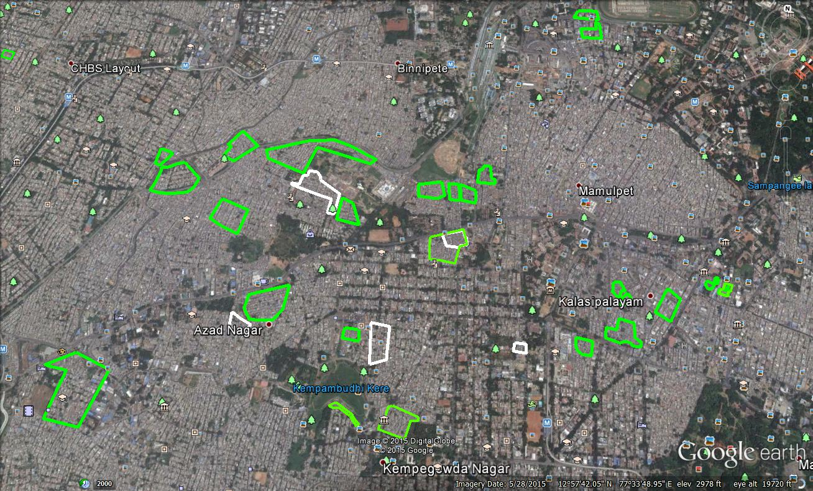

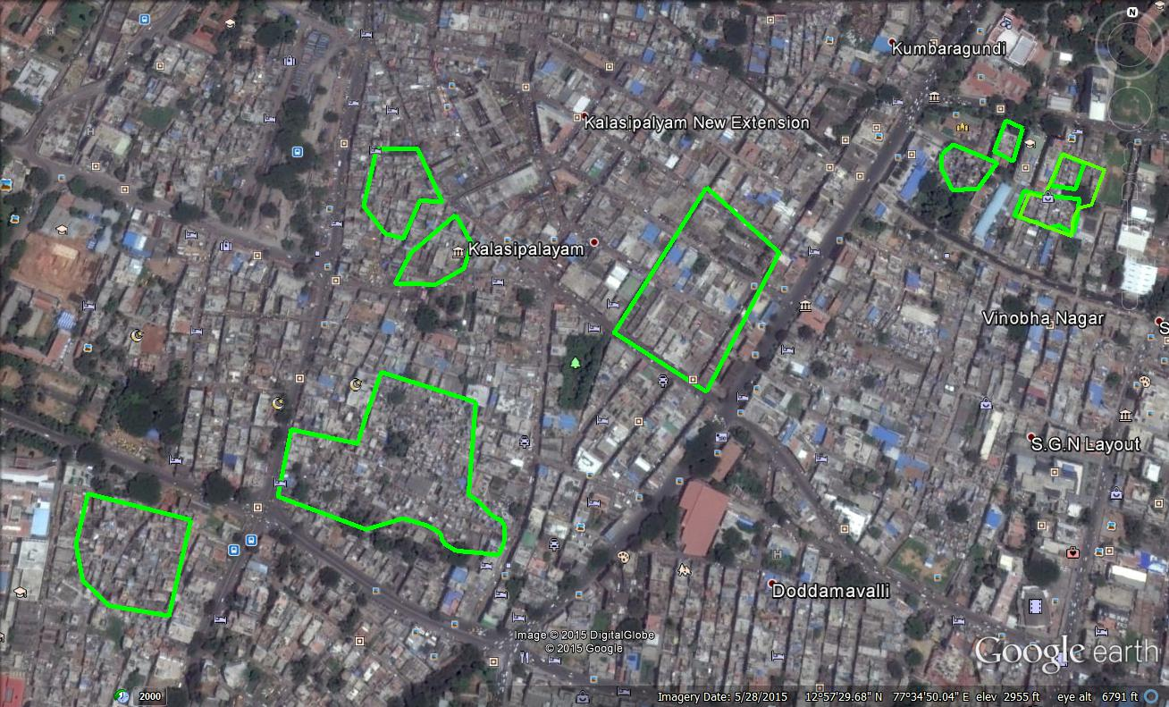

Table S2. Education Investment Preference by Labor Status

|  |  |  |  |  |
| --- | --- | --- | --- | --- |
| VARIABLES | By formal status | By formal status (with city interactions) | By occupation (continuous) | By occupation (factor variable) |
| Formal work | 0.338** | 0.516*** |  |  |
|  | (0.151) | (0.192) |  |  |
| Occupation type (continuous variable) |  |  | 0.0471 |  |
|  |  |  | (0.0446) |  |
| **Occupation indicators** |  |  |  |  |
| Occupation type 2 |  |  |  | 0.239* |
|  |  |  |  | (0.123) |
| Occupation type 3 |  |  |  | -0.117 |
|  |  |  |  | (0.172) |
| Occupation type 4 |  |  |  | 0.135 |
|  |  |  |  | (0.175) |
| Occupation type 5 |  |  |  | 0.438* |
|  |  |  |  | (0.234) |
| Asset score | 0.167*** | 0.170*** | 0.159*** | 0.155*** |
|  | (0.0391) | (0.0389) | (0.0405) | (0.0408) |
| Primary education | 0.216* | 0.212* | 0.247** | 0.254** |
|  | (0.123) | (0.124) | (0.125) | (0.126) |
| Migrant | 9.38e-05 | -0.00311 | 0.00736 | 0.0168 |
|  | (0.147) | (0.147) | (0.148) | (0.147) |
| Settlement age | 0.00259** | 0.00256** | 0.00233** | 0.00239** |
|  | (0.00116) | (0.00115) | (0.00117) | (0.00117) |
| Settlement size | 9.41e-05 | 8.88e-05 | 0.000103 | 0.000105 |
|  | (6.87e-05) | (6.86e-05) | (6.46e-05) | (6.72e-05) |
| Municipal/state land | -0.102 | -0.0983 | -0.108 | -0.128 |
|  | (0.125) | (0.124) | (0.127) | (0.127) |
| National land | -0.104 | -0.107 | -0.107 | -0.112 |
|  | (0.165) | (0.165) | (0.167) | (0.169) |
| Former GP land | 0.0428 | 0.0357 | -0.0698 | -0.0452 |
|  | (0.277) | (0.278) | (0.241) | (0.244) |
| Respondent age | 0.000945 | 0.00147 | 0.00221 | 0.00200 |
|  | (0.00435) | (0.00438) | (0.00452) | (0.00447) |
| Gender | -0.236** | -0.241** | -0.275** | -0.265** |
|  | (0.118) | (0.118) | (0.120) | (0.125) |
| Scheduled caste or tribe | -0.0108 | -0.00342 | 0.0187 | 0.0212 |
|  | (0.130) | (0.129) | (0.132) | (0.134) |
| Muslim | -0.0479 | -0.0526 | -0.0557 | -0.0401 |
|  | (0.207) | (0.206) | (0.206) | (0.210) |
| Jaipur | -1.916*** | -1.868*** | -1.956*** | -1.927*** |
|  | (0.134) | (0.136) | (0.138) | (0.140) |
| Patna | -1.235*** | -1.198*** | -1.280*** | -1.277*** |
|  | (0.143) | (0.148) | (0.144) | (0.146) |
| Formal work*Jaipur |  | -0.396 |  |  |
|  |  | (0.376) |  |  |
| Formal work*Patna |  | -0.409 |  |  |
|  |  | (0.396) |  |  |
| Constant | -0.955*** | -0.995*** | -1.042*** | -1.060*** |
|  | (0.254) | (0.255) | (0.261) | (0.264) |
|  |  |  |  |  |
| Observations | 3,663 | 3,663 | 3,584 | 3,584 |
| Robust standard errors in parentheses | |  |  |  |
| *** p<0.01, ** p<0.05, * p<0.1 | |  |  |  |

Table S3. Mediated Scheme Preference by Labor Status

|  |  |  |  |  |
| --- | --- | --- | --- | --- |
| VARIABLES | By formal status | By formal status (with city interactions) | By occupation (continuous) | By occupation (factor variable) |
| Formal work | -0.596*** | -0.664*** |  |  |
|  | (0.126) | (0.202) |  |  |
| Occupation type (continuous variable) |  |  | -0.0617* |  |
|  |  |  | (0.0317) |  |
| **Occupation indicators** |  |  |  |  |
| Occupation type 2 |  |  |  | -0.0368 |
|  |  |  |  | (0.0818) |
| Occupation type 3 |  |  |  | -0.0203 |
|  |  |  |  | (0.114) |
| Occupation type 4 |  |  |  | -0.00731 |
|  |  |  |  | (0.126) |
| Occupation type 5 |  |  |  | -0.670*** |
|  |  |  |  | (0.166) |
| Asset score | -0.148*** | -0.148*** | -0.143*** | -0.143*** |
|  | (0.0231) | (0.0230) | (0.0235) | (0.0237) |
| Primary education | -0.359*** | -0.353*** | -0.355*** | -0.360*** |
|  | (0.0859) | (0.0866) | (0.0903) | (0.0901) |
| Migrant | -0.00630 | -0.00675 | -0.00113 | -0.00674 |
|  | (0.0877) | (0.0878) | (0.0877) | (0.0882) |
| Settlement age | 0.00139 | 0.00141 | 0.00146 | 0.00147 |
|  | (0.000995) | (0.000990) | (0.00102) | (0.00100) |
| Settlement size | -1.25e-05 | -1.47e-05 | -6.51e-06 | -1.35e-05 |
|  | (4.11e-05) | (4.10e-05) | (4.23e-05) | (4.29e-05) |
| Municipal/state land | 0.0684 | 0.0694 | 0.0677 | 0.0821 |
|  | (0.0871) | (0.0869) | (0.0875) | (0.0871) |
| National land | 0.183 | 0.186 | 0.172 | 0.180 |
|  | (0.119) | (0.119) | (0.125) | (0.123) |
| Former GP land | 0.0853 | 0.0807 | 0.120 | 0.116 |
|  | (0.265) | (0.264) | (0.267) | (0.262) |
| Respondent age | -0.000137 | 5.94e-05 | -0.000352 | 0.000319 |
|  | (0.00290) | (0.00297) | (0.00294) | (0.00294) |
| Gender | 0.157** | 0.165** | 0.190** | 0.175** |
|  | (0.0789) | (0.0790) | (0.0810) | (0.0816) |
| Scheduled caste or tribe | 0.213*** | 0.210*** | 0.170** | 0.197** |
|  | (0.0791) | (0.0796) | (0.0811) | (0.0819) |
| Muslim | 0.152 | 0.143 | 0.162 | 0.148 |
|  | (0.101) | (0.101) | (0.102) | (0.103) |
| Jaipur | -0.349*** | -0.344*** | -0.296*** | -0.282*** |
|  | (0.101) | (0.101) | (0.103) | (0.105) |
| Patna | -0.650*** | -0.667*** | -0.589*** | -0.580*** |
|  | (0.103) | (0.104) | (0.104) | (0.105) |
| Formal work*Jaipur |  | -0.0626 |  |  |
|  |  | (0.278) |  |  |
| Formal work*Patna |  | 0.596* |  |  |
|  |  | (0.324) |  |  |
| Constant | -0.0555 | -0.0584 | 0.00334 | -0.128 |
|  | (0.169) | (0.171) | (0.179) | (0.184) |
|  |  |  |  |  |
| Observations | 3,663 | 3,649 | 3,584 | 3,584 |
| Robust standard errors in parentheses | |  |  |  |
| *** p<0.01, ** p<0.05, * p<0.1 | |  |  |  |

Table S4: Seeking Help from Local Broker by Labor Status

|  |  |  |  |  |
| --- | --- | --- | --- | --- |
| VARIABLES | By formal status | By formal status (with city interactions) | By occupation (continuous) | By occupation (factor variable) |
| Formal work | -0.972*** | -1.007*** |  |  |
|  | (0.277) | (0.292) |  |  |
| Occupation type (continuous variable) |  |  | -0.203*** |  |
|  |  |  | (0.0695) |  |
| **Occupation indicators** |  |  |  |  |
| Occupation type 2 |  |  |  | -0.00585 |
|  |  |  |  | (0.141) |
| Occupation type 3 |  |  |  | -0.396* |
|  |  |  |  | (0.226) |
| Occupation type 4 |  |  |  | -0.575** |
|  |  |  |  | (0.291) |
| Occupation type 5 |  |  |  | -1.133* |
|  |  |  |  | (0.628) |
| Asset score | -0.00984 | -0.0104 | 0.00637 | 0.000382 |
|  | (0.0462) | (0.0464) | (0.0471) | (0.0475) |
| Primary education | 0.0491 | 0.0491 | 0.0686 | 0.0692 |
|  | (0.162) | (0.161) | (0.159) | (0.159) |
| Migrant | 0.0673 | 0.0674 | 0.0957 | 0.110 |
|  | (0.166) | (0.166) | (0.168) | (0.168) |
| Settlement age | -0.00494** | -0.00490** | -0.00464* | -0.00471* |
|  | (0.00241) | (0.00241) | (0.00242) | (0.00242) |
| Settlement size | -0.000245* | -0.000246* | -0.000217* | -0.000219* |
|  | (0.000131) | (0.000132) | (0.000125) | (0.000124) |
| Municipal/state land | 0.596*** | 0.596*** | 0.568*** | 0.560*** |
|  | (0.180) | (0.180) | (0.182) | (0.181) |
| National land | 0.747*** | 0.749*** | 0.740*** | 0.738*** |
|  | (0.213) | (0.213) | (0.218) | (0.215) |
| Former GP land | 0.139 | 0.138 | 0.127 | 0.149 |
|  | (0.439) | (0.441) | (0.468) | (0.464) |
| Respondent age | 0.00318 | 0.00311 | 0.00204 | 0.00256 |
|  | (0.00612) | (0.00614) | (0.00634) | (0.00639) |
| Gender | -0.00264 | -0.00187 | 0.0261 | 0.00301 |
|  | (0.140) | (0.140) | (0.137) | (0.140) |
| Scheduled caste or tribe | 0.0300 | 0.0275 | -0.000972 | 0.0144 |
|  | (0.143) | (0.143) | (0.144) | (0.146) |
| Muslim | 0.0644 | 0.0613 | 0.121 | 0.120 |
|  | (0.188) | (0.188) | (0.190) | (0.191) |
| Jaipur | -1.426*** | -1.422*** | -1.337*** | -1.301*** |
|  | (0.217) | (0.214) | (0.217) | (0.221) |
| Patna | -1.707*** | -1.736*** | -1.623*** | -1.610*** |
|  | (0.241) | (0.248) | (0.249) | (0.248) |
| Formal work*Jaipur |  | -0.197 |  |  |
|  |  | (1.089) |  |  |
| Formal work*Patna |  | 0.991 |  |  |
|  |  | (0.996) |  |  |
| Constant | -2.295*** | -2.290*** | -1.991*** | -2.297*** |
|  | (0.359) | (0.359) | (0.399) | (0.384) |
|  |  |  |  |  |
| Observations | 4,869 | 4,869 | 4,778 | 4,778 |
| Robust standard errors in parentheses | |  |  |  |
| *** p<0.01, ** p<0.05, * p<0.1 |  |  |  |  |

Table S5: Likelihood of Having Elected Official in Network by Labor Status

|  |  |  |
| --- | --- | --- |
| VARIABLES | By occupation (continuous) | By occupation (factor variable) |
| Occupation type (continuous variable) | 0.230*** |  |
|  | (0.0637) |  |
| **Occupation indicators** |  |  |
| Occupation type 2 |  | 0.0481 |
|  |  | (0.154) |
| Occupation type 3 |  | 0.408 |
|  |  | (0.277) |
| Occupation type 4 |  | 0.555* |
|  |  | (0.321) |
| Occupation type 5 |  | 1.297*** |
|  |  | (0.243) |
| Migrant | -0.855*** | -0.852*** |
|  | (0.273) | (0.262) |
| Gender | -1.375*** | -1.385*** |
|  | (0.242) | (0.269) |
| Scheduled caste or tribe | -0.248 | -0.270 |
|  | (0.327) | (0.329) |
| Muslim | -0.413* | -0.408* |
|  | (0.224) | (0.221) |
| Respondent age | 0.0363*** | 0.0348*** |
|  | (0.00787) | (0.00782) |
| Household head | 0.0554 | 0.0678 |
|  | (0.162) | (0.159) |
| Education | -0.00825 | -0.00733 |
|  | (0.0132) | (0.0132) |
| Tarp roof | 0.0681 | 0.0810 |
|  | (0.347) | (0.349) |
| Mould roof | 0.779*** | 0.790*** |
|  | (0.185) | (0.192) |
| Patna | 1.207*** | 1.206*** |
|  | (0.425) | (0.414) |
| Constant | -1.348*** | -1.013*** |
|  | (0.283) | (0.300) |
|  |  |  |
| Observations | 1,204 | 1,204 |
| Robust standard errors in parentheses | |  |
| *** p<0.01, ** p<0.05, * p<0.1 | |  |

Figure S6: Two Forms of Clientelism by Labor Status



*Note:* The figure shows the difference between the number of factors selected that influence vote choice for each treatment arm and the number of factors selected for the control arm by labor status (conditional on receiving government-provided insurance). Standard errors are clustered by neighborhood. The bars represent 95% confidence intervals.