Supplementary materials for:

Coalition mood in European parliamentary democracies
Michael Imre, Alejandro Ecker, Thomas M. Meyer, Wolfgang C. Müller
December 17, 2021
Appendix A: Descriptive Statistics, Examples
Table A1: Applause by actor type
 | Whole PPG |  | Share of PPG |  | Single MPs |  | Total
 | n | % | n | % | n | % | n | %
Germany | 200,924 | 77.2 | 59,379 | 22.8 | - | - | 260,303 | 100
Austria | 71,579 | 80.4 | 13,488 | 15.2 | 3,945 | 4.4 | 89,012 | 100
Total | 272,503 | 78.0 | 72,867 | 20.9 | 3,945 | 1.1 | 349,315 | 100

Table A1 shows how applause in the legislature is documented in the stenographic protocols. The protocols distinguish applause by whole parliamentary party groups (PPGs; e.g. ‘applause from party X’) from applause by some party members (e.g. ‘applause from MPs of party X’) and applause by individual MPs. In both countries, applause from the whole PPG is the most frequent form of reaction. Applause by some members of a PPG only accounts for about 20 percent of the observations. Applause from single MPs is only mentioned in the Austrian protocols; however, only 4.4 from all applause events in the Nationalrat fall in this category. As we do not regard this as representative for the party as a whole, applause by single MPs is not considered in Table A2.2 and the data analysis presented in the article.

Table A2.1: Applause by party status: Germany
 | Own PPG |  | Coalition Partner |  | Opposition |  | Total
 | n | % | n | % | n | % | n | %
Schröder I | 27,688 | 49.5 | 21,305 | 38.1 | 6,892 | 12.3 | 55,885 | 100
Schröder II | 17,583 | 52.0 | 14,473 | 42.8 | 1,757 | 5.2 | 33,813 | 100
Merkel I | 28,991 | 51.7 | 17,118 | 30.5 | 9,975 | 17.8 | 56,084 | 100
Merkel II | 26,563 | 49.5 | 23,075 | 43.0 | 3,996 | 7.5 | 53,634 | 100
Merkel III | 34,075 | 56.0 | 19,925 | 32.7 | 6,887 | 11.3 | 60,887 | 100
Total | 134,900 | 51.8 | 95,896 | 36.8 | 29,507 | 11.3 | 260,303 | 100

Table A2.2: Applause by party status: Austria
 | Own PPG |  | Coalition Partner |  | Opposition |  | Total
 | n | % | n | % | n | % | n | %
Schüssel II | 16,280 | 56.6 | 9,999 | 34.8 | 2,472 | 8.6 | 28,752 | 100
Gusenbauer | 8,174 | 73.0 | 2,270 | 20.3 | 746 | 6.7 | 11,190 | 100
Faymann I | 19,259 | 73.0 | 5,557 | 21.1 | 1,577 | 6.0 | 26,394 | 100
Faymann II | 7,297 | 65.8 | 2,637 | 23.8 | 1,163 | 10.5 | 11,097 | 100
Kern | 4,050 | 70.5 | 956 | 16.6 | 739 | 12.9 | 5,745 | 100
Kurz I | 1,037 | 54.9 | 823 | 43.6 | 29 | 1.5 | 1,889 | 100
Total | 56,097 | 65.9 | 22,242 | 26.1 | 6,726 | 7.9 | 85,067 | 100

Tables A2.1 and A2.2 present the relationships the MPs applauding have to the speakers. In both countries – and every single cabinet – the general pattern is the same: speakers by the government parties receive the most applause by their own PPG, less by their coalition partner, and the least amount of applause by the opposition parties. This pattern is more pronounced in Austria, where almost two thirds of all applause for government speakers comes from their own PPG, than in Germany, where it is only about half. Although the order is the same in all cabinets, there is a lot of variation in the levels: while in some cabinets there is almost as much intra-government applause as intra-party-applause (e.g. Merkel II), in others the coalition partners applaud almost as little for each other as the opposition does (e.g. Kern).

Figure A1: Example from Bundestag protocols
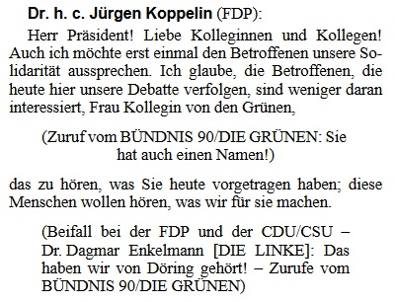
Source: https://dip21.bundestag.de/dip21/btp/17/17248.pdf
In the protocols of the German Bundestag, applause, interjections and other interactions are displayed in parentheses in separate paragraphs. If multiple, different interactions happened at the same part of the speech, they are separated by en dashes. For extracting the applause, all different interactions during a speech were separated, all non-applause-events were deleted and applause-events were assigned to the parties applauding. In the short speech excerpt in Figure A1, two applause events happened (FDP for FDP and CDU/CSU for FDP).

Figure A2: Example from Nationalrat protocols
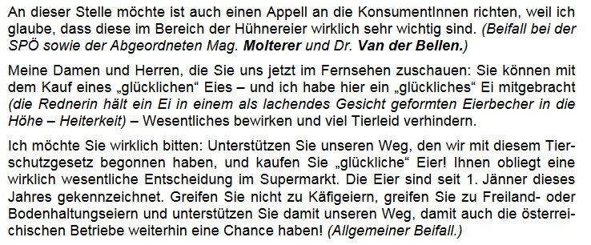
Source: https://www.parlament.gv.at/PAKT/VHG/XXII/NRSITZ/NRSITZ_00062/fnameorig_023734.html
In the Austrian Nationalrat, interactions are recorded similarly, but not in separate paragraphs. In the excerpt of the speech of SPÖ MP Ulrike Sima displayed in Figure A2, multiple applause events happen. After the first paragraph, MPs of the SPÖ and MPs Wilhelm Molterer (ÖVP) and Alexander Van der Bellen (Grüne) applaud, after the third paragraph general applause is recorded. As neither applause by single MPs nor general applause is considered in our analyses, only one relevant applause event is extracted from this speech excerpt (SPÖ for SPÖ).

Appendix B: Applause in the plenary protocols of other European countries
Table B1: Overview of the occurrence of applause in the plenary protocols of all countries in the European Economic Area
Country | Applause in protocols | Party mentioned
Austria | yes | yes
Belgium | no | -
Bulgaria | rarely | yes
Croatia | no | -
Cyprus | no | -
Czech Republic | rarely | yes
Denmark | no | -
Estonia | no | -
Finland | no | -
France | yes | yes
Germany | yes | yes
Greece | rarely | no
Hungary | rarely | no¹
Iceland | no | -
Ireland | no | -
Italy | yes | yes
Latvia | rarely | no
Liechtenstein | no | -
Lithuania | no | -
Luxembourg | rarely | no
Malta | no | -
Netherlands | no | -
Norway | no | -
Poland | yes | no
Portugal | yes | yes
Romania | rarely | no
Slovakia | no | -
Slovenia | rarely | no
Spain | rarely | yes
Sweden | rarely | no
Switzerland | no | -
United Kingdom | no | -
Notes: while efforts were made to ensure the correctness of the information provided in the table, we acknowledge that inaccuracies might have occurred due to lack of expert knowledge of countries or languages. The table is based on recent practice. Applause in protocols: ‘yes’ means that applause is mentioned reasonably often and in all protocols, ‘rarely’ means that applause is sometimes mentioned, but so rarely that it can be assumed that the recording is not done systematically, ‘no’ means that applause is (virtually) never mentioned. While applause might be systematically recorded in cases indicated with ‘yes’, further research would be necessary to ensure that this is indeed the case. Party mentioned: ‘yes’ means that the protocols indicate, at least in the majority of cases, which parliamentary party groups applauded, ‘no’ means that they do not.
¹ Protocols only differentiate applause by government parties and opposition parties.

Appendix C: Constructing Coalition Mood
This appendix presents our data structure, the model and how we construct the coalition mood measure from it in more detail.
Table C1: Example for data structure
Date | Party to | Party from | Relationship | Country | Words party to | Applause party to
2007-10 | CDU/CSU | DIE LINKE | opp-gov | de | 24469 | 6
2007-10 | CDU/CSU | SPD | gov-gov | de | 24469 | 153
2007-10 | CDU/CSU | FDP | opp-gov | de | 24469 | 63
2007-10 | CDU/CSU | CDU/CSU | self | de | 24469 | 270
2007-10 | CDU/CSU | B90/DIE GRÜNEN | opp-gov | de | 24469 | 24
2007-10 | SPD | SPD | self | de | 30522 | 325
2007-10 | SPD | DIE LINKE | opp-gov | de | 30522 | 10
2007-10 | SPD | CDU/CSU | gov-gov | de | 30522 | 183
2007-10 | SPD | B90/DIE GRÜNEN | opp-gov | de | 30522 | 54
2007-10 | SPD | FDP | opp-gov | de | 30522 | 49
Table C1 presents an excerpt from the data set used to construct the measure. It shows how often representatives of each PPG in parliament at the time applauded for each government party in one month (October 2007) in one country (Germany).
Applause frequency (‘applause party to’) is then modeled in a negative binomial model, using a triple interaction of ‘date’, ‘relationship’ and ‘country’ as well as ‘words party to’ as regressors. The relationship ‘opp-gov’ – opposition PPGs applauding for government parties – is used as the reference category.
Finally, coalition mood for each month in each country is estimated using the coefficients for the respective month t and country k, the relevant coefficients for the relationship between parties (‘gov-gov’; coal) as well as all interaction terms of these three variables:
${mood}_{t,k}= β_{t}+ β_{coal}+ β_{k}+ β_{t, coal}+ β_{t, k}+ β_{coal, k}+ β_{t, coal,k}$

