Appendix
Table A-1: Coding of variables, European Social Survey
Variable | Question | Coding
Party vote | Party voted for in the last general election in each country scored by the CHES estimated party position scales on authoritarian values and the salience of populist rhetoric | 0 to 100
Education | Highest level of education | 1 to 5
Cohort | Based on age: 1900-1945; 1946-1964; 1965-1979; 1980-1996 | Interwar generation; Baby Boomers; Generation X; Millennials
Social class | Oesch class scheme. Based on isco08, emplrel emplno | Unskilled workers; Skilled workers; Small business owners; Lower-grade service class; Higher-grade service class
Unemp | Ever been unemployed for more then 3 months / ever been unemployed for more than 12 months | never; 3 months; 12 months
Married | Legal marital status: married/civil union not married | 0 to 1
Separated | Legal marital status: legally separated/legally divorced | 0 to 1
Children | Based on household members: no (0), yes (1) | 0 to 1
Religiosity | Strength of religiosity: low to high | 0 to 10
Ethnic minority | Belong to ethnic minority: no, yes | 0 to 1
Urban | Urbanization | 1 to 5
Lrscale | Left-right scale: left (0) to right (10) | 0 to 10
Freehms | Gays and lesbians free to live life as they wish: (1) disagree to (5) agree | 1 to 5
Behave | Important to behave properly | 1 to 6
Rules | Important to do what is told and follow rules | 1 to 6
Safety | Important that government is strong and ensures safety | 1 to 6
Secure | Important to live in secure and safe surroundings | 1 to 6
Tradition | Important to follow traditions and customs | 1 to 6
Authoritarian values | Rescaled sum of behave, rules, safety, secure and tradition | 0 to 100
Adventure | Important to have an exciting life | 1 to 6
Creative | Important to be creative | 1 to 6
Free | Important to be free | 1 to 6
Listen | Important to listen to people different from her/him | 1 to 6
Surprise | Important to do different things in life | 1 to 6
Libertarian values | Rescaled sum of adventure, creative, free, listen and surprise | 0 to 100
Trstprl | Trust in parliament | 0 to 10
Trstplt | Trust in politicians | 0 to 10
Trstprt | Trust in parties | 0 to 10
Populist values | Rescaled sum of trust in parliaments, politicians and parties | 0 to 100
Say | Political system allows people to have a say in what government does | 1 to 5
Influence | Political system allows people to have influence on politics | 1 to 5
Efficacy | Perceived responsiveness: rescaled sum of say and influence | 0 to 100
Imbgeco | Immigration bad or good for country's economy: (0) bad to (10) good | 0 to 10
Imueclt | Country's cultural life undermined or enriched by immigrants: (0) undermined to (10) enriched | 0 to 10
Imwbcnt | Immigrants make country worse or better place to live: (0) worse to (10) better | 0 to 10
Immig | Rescaled sum of imbgeco, imueclt and imwbcnt | 0 to 100
Table A-2: Descriptive statistics, EES 1-7
 | Mean | SD | Min | Max | N
Cohort | 2.39 | 1.05 | 1.00 | 4.00 | 339157
Domicile | 2.86 | 1.23 | 1.00 | 5.00 | 341494
Religiosity | 4.77 | 3.01 | 0.00 | 10.00 | 339363
Populist (low trust) | 64.36 | 22.04 | 0.00 | 100.00 | 326813
Authoritarian values | 68.27 | 17.40 | 0.00 | 100.00 | 319288
Behave | 4.39 | 1.23 | 1.00 | 6.00 | 327473
Rules | 3.92 | 1.37 | 1.00 | 6.00 | 326531
Safety | 4.71 | 1.19 | 1.00 | 6.00 | 326193
Secure | 4.70 | 1.20 | 1.00 | 6.00 | 328592
Tradition | 4.33 | 1.34 | 1.00 | 6.00 | 328411
Adventure | 3.09 | 1.46 | 1.00 | 6.00 | 327706
Creative | 4.39 | 1.26 | 1.00 | 6.00 | 327503
Free | 4.79 | 1.10 | 1.00 | 6.00 | 328259
Listen | 4.60 | 1.08 | 1.00 | 6.00 | 327522
Surprise | 4.01 | 1.36 | 1.00 | 6.00 | 327865
Mig. culture | 5.46 | 2.57 | 0.00 | 10.00 | 324687
EU integration | 5.21 | 2.68 | 0.00 | 10.00 | 220389
Mig. economy | 4.81 | 2.33 | 0.00 | 10.00 | 323297
Data: European Social Survey, 2002-2014, Rounds 1-7.
Table A-3: Descriptive statistics, EES 9
 | Mean | SD | Min | Max | N
Gender | 0.47 | 0.50 | 0 | 1 | 50403
Married | 0.50 | 0.50 | 0 | 1 | 50403
Separated | 0.10 | 0.30 | 0 | 1 | 50403
Children | 0.47 | 0.50 | 0 | 1 | 50403
Education | 3.35 | 1.28 | 1 | 5 | 50403
Ethnic minority | 0.06 | 0.24 | 0 | 1 | 50403
Religiosity | 4.55 | 3.13 | 0 | 10 | 50403
Satisfaction economy | 4.73 | 2.47 | 0 | 10 | 50403
Authoritarian values | 66.99 | 16.96 | 0 | 100 | 50403
Populist values | 39.32 | 23.33 | 0 | 100 | 50403
External efficacy | 30.38 | 21.75 | 0 | 100 | 50403
Pro immigration | 52.38 | 22.92 | 0 | 100 | 50403
Data: European Social Survey, 2018, Round 9.
Table A-4: Descriptive statistics, EES 9, factors
 |  | N | %
Birth cohort | Interwar | 6678 | 13.2
 | Baby Boomers | 16663 | 33.1
 | Gen X | 12303 | 24.4
 | Millennials | 10954 | 21.7
Class scheme | Higher-grade service class | 8223 | 16.3
 | Lower-grade service class | 7886 | 15.6
 | Small business owners | 5021 | 10.0
 | Skilled workers | 15208 | 30.2
 | Unskilled workers | 9517 | 18.9
Ever unemployed | never unemployed | 35726 | 70.9
 | 3 months | 6786 | 13.5
 | 12 months | 7595 | 15.1
Data: European Social Survey, 2018, Round 9.
Table A-5: Regression coefficients: vote for authoritarian-populist parties, ESS9
 | Model 1 | Model 2 | Model 3 | Model 4
Baby Boomers | 0.205 | 1.370 | 1.328+ | 1.553*
 | (1.087) | (0.836) | (0.758) | (0.769)
Generation X | 0.358 | 1.587 | 1.774 | 2.089+
 | (1.812) | (1.305) | (1.240) | (1.219)
Millennials | -0.039 | 2.724* | 3.149** | 3.465***
 | (1.720) | (1.128) | (0.966) | (0.980)
Children |  | 0.158 | -0.040 | -0.065
 |  | (0.147) | (0.152) | (0.160)
Married |  | 0.359 | 0.153 | 0.229
 |  | (0.380) | (0.448) | (0.476)
Separate |  | 1.478** | 0.749 | 0.906*
 |  | (0.497) | (0.466) | (0.455)
Gender |  | 1.888*** | 1.535*** | 1.597***
 |  | (0.344) | (0.331) | (0.336)
Unskilled workers |  | 2.049* | 0.582 | 0.432
 |  | (0.878) | (0.983) | (0.939)
Skilled workers |  | 1.862*** | 0.861 | 0.746
 |  | (0.542) | (0.647) | (0.651)
Lower-grade service class |  | 0.488 | 0.056 | -0.020
 |  | (0.335) | (0.494) | (0.447)
Small business owners |  | 1.502*** | 0.612 | 0.663
 |  | (0.329) | (0.466) | (0.435)
Education |  | -1.018*** | -0.508** | -0.504**
 |  | (0.202) | (0.193) | (0.175)
Ethnic minority |  | -3.707 | -2.888 | -2.822
 |  | (2.254) | (2.235) | (2.199)
Religiosity |  | -0.204 | -0.138 | -0.161
 |  | (0.144) | (0.100) | (0.114)
Dissatisfied with state of economy |  | 0.422 | -0.199 | -0.063
 |  | (0.343) | (0.240) | (0.273)
Placement on left-right scale |  | 2.807*** | 2.350*** | 2.339***
 |  | (0.384) | (0.403) | (0.413)
Authoritarianism |  |  | 0.809+ | 0.594
 |  |  | (0.488) | (0.516)
External efficacy |  |  |  | -4.940***
 |  |  |  | (1.269)
Political trust |  |  | -6.465*
 |  |  | (2.942)
Pro immigration |  |  | -16.821*** | -17.332***
 |  |  | (2.206) | (2.361)
Constant | 45.384*** | 30.630*** | 44.832*** | 43.374***
 | (1.268) | (2.530) | (4.188) | (3.607)
Country fixed effects | yes | yes | yes | yes
Num.Obs. | 22470 | 20095 | 18810 | 18802
R2 | 0.418 | 0.504 | 0.525 | 0.525
R2 Adj. | 0.417 | 0.503 | 0.524 | 0.524
F | 671.123 | 522.409 | 494.597 | 493.758
Std. Errors | Clustered | Clustered | Clustered | Clustered
+ p < 0.1, * p < 0.05, ** p < 0.01, *** p < 0.001
Data: European Social Survey 2018, Round 9.
Note: The table show the coefficients of OLS regression models that estimate the vote for authoritarian-populist parties.

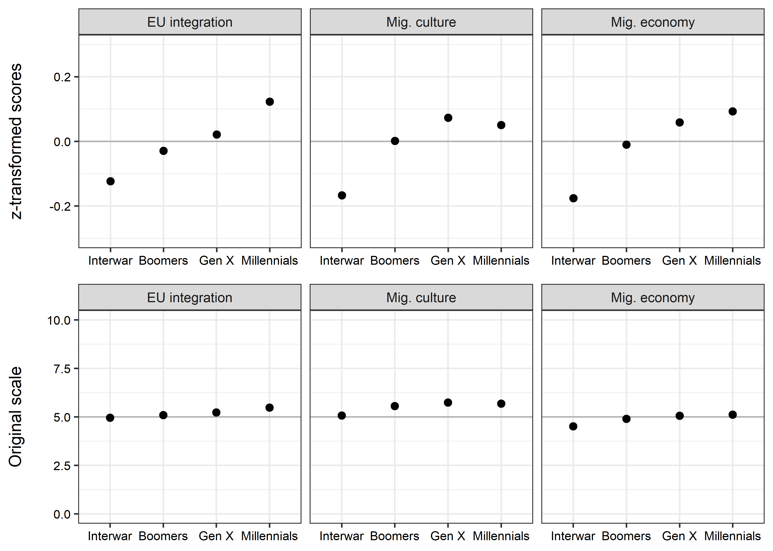
Figure A-1: Attitudes towards EU integration and migrants. Data: ESS, 1-7, weighted data.

