Online Appendix for
The Super-Predator Effect: How Negative Targeted Messages Demobilize Black Voters.

Page
2 | Descriptive Statistics of Experiment by Race/Ethnicity
3 | Treatment Effects by Democratic Identifiers, Independent Leaners, and Race/Ethnicity
4 | Treatment Effects by Educational Attainment
5-6 | OLS Regression Predicting Voter Enthusiasm in 2020 By High Racism Treatment and Race of Hypothetical Candidate With Discussion.
7 | Treatment Effects of Voter Enthusiasm for Republicans of Different Race/Ethnicity
8-9 | Average Effect of Treatment on Blacks Perceived Party Empathy W/ Discussion
10 | Treatment Figure 1
11 | Treatment Figure 2
12 | Treatment Figure 3
13 | Treatment Figure 4

Table SA.1: Summary Statistics for Key Demographic Variables From the YouGov Experiment with Test of Means Across Treatment Type.
 | Black | Black
Black Respondents | High Racism Article | Low Racism Article | Diff | Diff Sig at .05
Female | 57% | 51% | 6% | No
Age | 44.75 | 47.14 | -2.38 | No
Income | 58.29 | 53.12 | 5.17 | No
Education | 13.30 | 13.26 | 0.034 | No
Ideology (1-Liberal, 5-Conservative) | 3.15 | 2.99 | 0.15 | No
 | White | White
White Respondents | High Racism Article | Low Racism Article | Diff | Diff Sig at .05
Female | 52% | 49.5% | 2.4% | No
Age | 51.63 | 50.05 | 1.57 | No
Income | 82.36 | 74.37 | 7.99 | No
Education | 14.24 | 13.9863 | 0.25 | No
Ideology (1-Liberal, 5-Conservative) | 3.22 | 3.25 | -0.03 | No
 | Latino | Latino
Latino Respondents | High Racism Article | Low Racism Article | Diff | Diff Sig at .05
Female | 58.5% | 63.8% | 5.3% | No
Age | 45.14 | 42.77 | 2.36 | No
Income | 52.03 | 46.96 | 5.07 | No
Education | 12.52 | 12.89 | -0.37 | No
Ideology (1-Liberal, 5-Conservative) | 3.51 | 3.15 | 0.37 | No

Table SA2. OLS Regression Predicting Effect of High Racism Treatment on Voter Enthusiasm For Black, White, and Latinx Democratic Identifying Partisans and This Group In Combination With Consistent Partisan Supporters of the Democratic President
 | Black | White | Latino | Black | White | Latino
 | Democratic Identifiers Only | Democratic Identifiers Only | Democratic Identifiers Only | Democratic Identifiers + Independents Who Voted for Clinton in 2016 and Obama in 2012 | Democratic Identifiers + Independents Who Voted for Clinton in 2016 and Obama in 2012 | Democratic Identifiers + Independents Who Voted for Clinton in 2016 and Obama in 2012
High Racism Article | -0.99*** | -0.04 | -0.04 | -0.99*** | -0.01 | -0.30
 | (0.30) | (0.18) | (0.42) | (0.27) | (0.15) | (0.37)
Constant | 6.67*** | 6.39*** | 5.48*** | 6.54*** | 6.27*** | 5.45***
 | (0.20) | (0.12) | (0.26) | (0.19) | (0.11) | (0.24)
Observations | 104 | 293 | 101 | 138 | 451 | 131
R-squared | 0.10 | 0.00 | 0.00 | 0.09 | 0.00 | 0.01
*** p<0.01, ** p<0.05, * p<0.1 Standard Errors in Parentheses

Table SA3: OLS Regression Predicting Voter Enthusiasm in 2020 By Interaction of the Treatment and Respondent Education

 | Black | White | Latinx
 | Vote in 2020 | Vote in 2020 | Vote in 2020
High Racism Treatment*Education | 0.02 | -0.04 | 0.05
 | (0.14) | (0.05) | (0.16)
High Racism Treatment | -1.03 | 0.71 | -0.76
 | (1.88) | (0.67) | (1.96)
Education | 0.14 | 0.11*** | 0.21*
 | (0.10) | (0.03) | (0.10)
Constant | 4.27*** | 4.66*** | 2.73**
 | (1.32) | (0.46) | (1.36)
Observations | 164 | 1,027 | 185
R-squared | 0.07 | 0.02 | 0.05
*** p<0.01, ** p<0.05, * p<0.1 Standard Errors in Parentheses

Table SA4: OLS Regression Predicting Voter Enthusiasm in 2020 By High Racism Treatment and Race of Hypothetical Candidate.

 | All Blacks | All Blacks | Black Democratic Model | Black Democratic Model
Race of Hypothetical Candidate | White | Non-White | White | Non-White
High Racism Article | -1.28*** | -0.32 | -1.26** | -0.43
 | (0.47) | (0.29) | (0.48) | (0.34)
Female | -0.21 | -0.16 | -0.55 | -0.25
 | (0.46) | (0.30) | (0.46) | (0.36)
Age | 0.00 | 0.05*** | -0.01 | 0.05***
 | (0.01) | (0.01) | (0.01) | (0.01)
Income | 0.01 | -0.00 | 0.01 | -0.00
 | (0.01) | (0.00) | (0.01) | (0.00)
Education | 0.03 | 0.09 | 0.12 | 0.09
 | (0.13) | (0.07) | (0.13) | (0.09)
Constant | 6.04*** | 2.69*** | 5.51*** | 3.03**
 | (1.70) | (0.99) | (1.71) | (1.21)
Observations | 51 | 97 | 46 | 75
R-squared | 0.16 | 0.29 | 0.20 | 0.26
*** p<0.01, ** p<0.05, * p<0.1 Standard Errors in Parentheses

Following our article treatment, we asked respondents to read a voter guide in which they are randomly presented with one of three candidates. Specifically, we told respondents “Below Is Information About A Democratic\Republican Local Party Chair Election In Your Area. Please Read the Following Information”. The candidate on the voter guide was the same in every way except for their race. We signaled the race of the local party chair candidate in two ways. First, we mentioned names which are commonly attributed to being white (Luke Harris), black (Malik Johnson) or Latino (Alex Garcia) based on the U.S. Census. Second, in the demographic information section, we noted the candidate’s race as being either white, black, or Latino. We anticipate that the presence of a candidate of color (i.e. either black or Latinx) may minimize the high racism’s effect on voter enthusiasm.
Table SA4 helps assess whether examples of diversity within a political party can counteract claims that party officials hold racist values. In particular, Table SA4 presents four OLS regressions predicting whether respondents who received the high racism treatment were more or less likely to vote when they were also presented evidence of diversity within their party’s candidate pool. Each regression is disaggregated into whether blacks received the voter guide with a white candidate or a non-white (i.e. black or Latinx) candidate in our experiment.
The results in Table SA4 demonstrate that, blacks who were told that their party officials display high levels of racial prejudice and are presented a white candidate are the least likely to express enthusiasm to vote in 2020 in both the all respondent model and the Democratic Party only model. In fact, blacks who are both told their party officials are racist and are asked about a white elected officials are 1.28 points lower on the 7 point voter likelihood scale in the all respondent model and 1.26 points lower on the Democratic Party only model than blacks who received the same white candidate but were told that most elected officials in their party harbor no racist attitudes. Blacks who received the high racism article but were presented with a black or Latino candidate were statistically no more or less likely to express enthusiasm to vote in 2020 than their co-racial counterparts who received the low racism treatment in both samples. This finding suggests that while attacks on the racial progressivism in a party may diminish black political participation, this can be counteracted by party’s demonstrating their diversity to counteract these claims.

Figure 1: Average Enthusiasm to Vote on 7 Point Scale (1=Very Low…7=Very High) By Racism Treatment for different Racial/Ethnic Groups for the Republican Treatment Group. Presented with Point Estimates and 95% Confidence Intervals.
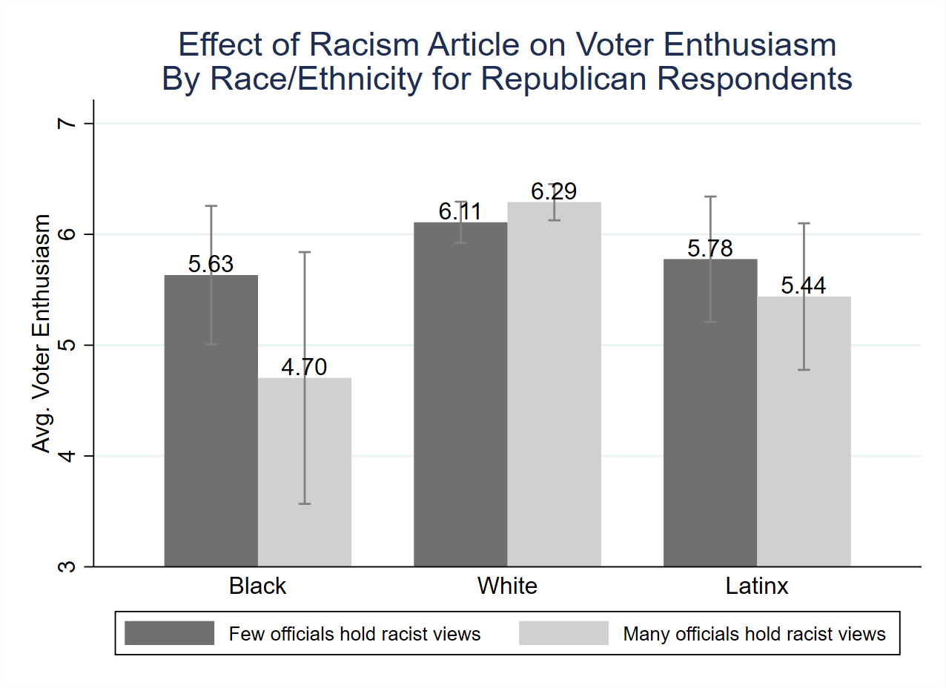
N: Black N=36, White N=604, Latinx N=94

Figure 2: Average Perceptions of Black Respondent’s Perceived Party Empathy for A: All Respondents and B: Democratic Respondents
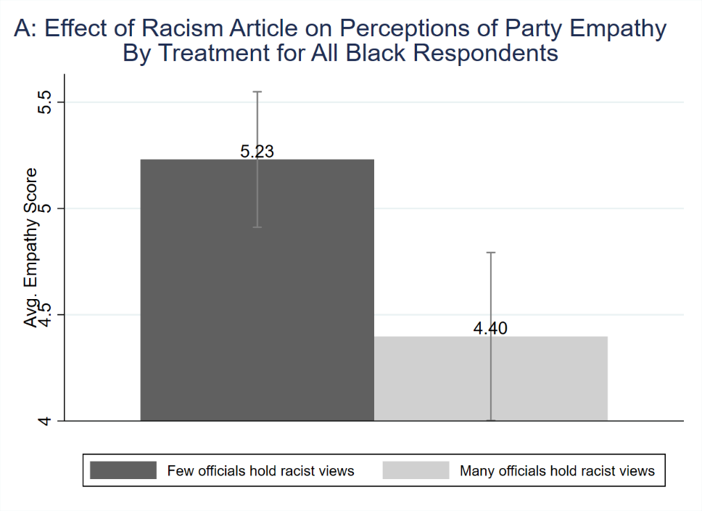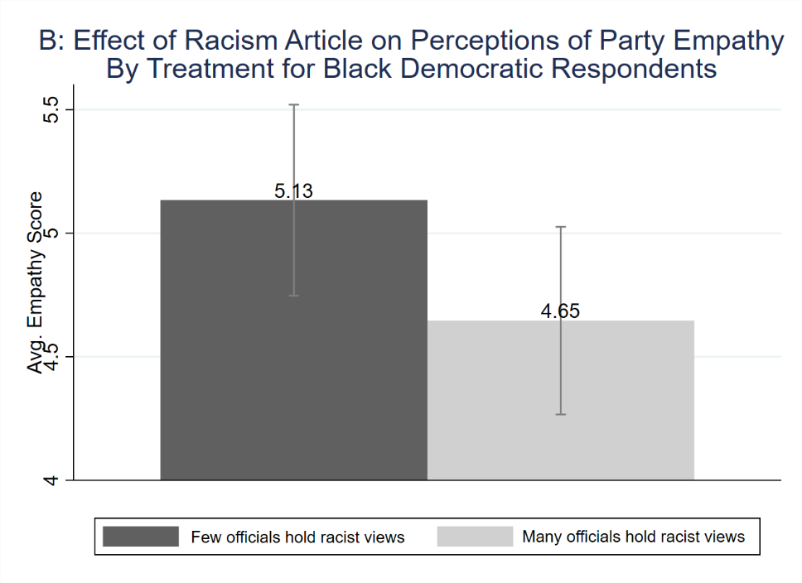
We present average perceptions that one’s preferred political party cares about them by treatment for African Americans using a question which asks “How much do you agree with the following statement “The Democratic Party/Republican cares about people like me”. The responses range from 1-“Strongly Disagree” to 7- “Strongly Agree”. Figure 2 present the average levels of perceived party empathy for Blacks who received the high racism article and the low racism article with 95% confidence intervals. The figure is presented for all Black respondents (A) and for Black respondents who prefer the Democratic Party (B). For both Figures 2A and 2b, blacks on average are more likely to believe their party cares for them than not. For example, blacks who receive the low racism treatment have a score of 5.23 out of the 7-point scale. Blacks who are told their preferred party officials hold racist attitudes score 4.4 out of the 7-point scale.
Similar to our analysis for voting, we find that African Americans who are told that many of the leaders within their preferred political party hold racist attitudes are .83 points lower on a seven-point scale (>10% change) than blacks who received the low racism treatment. This difference is significant based on a two-sample t-test. While lower, Blacks who prefer the Democratic Party are about half of a point lower on the seven-point perceived party empathy scale when they received the low racism article (5.13) than when they received the high racism article (4.64). This difference again is significant based on a two-sample t-test. It is important to note that in our survey, perceptions of party empathy is significantly and substantially correlated with black voter enthusiasm (Pearson’s R=.41, Sig-.000). As a result, the decline in perceptions of perceived party empathy that comes with information that one’s party is tied to racism may play a large role in demobilizing black turnout.

Treatment Part 1: High Racism-Democrat

Polls Reveal that Many Democratic Officials Hold Racist Views

By James Kerr March 13, 2019

Anybody who is following politics knows that Americans are becoming increasingly polarized around several issues including race. Some attribute these growing divisions in America to the increasingly hostile rhetoric and actions of our elected officials toward racial and ethnic minorities. Critics point to the recent actions of the Virginia Governor and Secretary of State as evidence that elected officials are not demonstrating racially progressive values.

Individuals may be more pessimistic about the future of race relations after the results of two recent surveys conducted separately by MSNBC and Fox News show that Democratic officials harbor more antagonistic attitudes towards racial and ethnic minorities in recent years. The surveys, which were both collected in late 2018, asked a random sample of party officials and politicians their attitudes about racial issues. Overall, these surveys conducted by two very different polling firms demonstrated surprising levels of racial conservatism among Democrats.

Moreover, some have argued that these divisions have gotten worse due to segments of the Democratic Party downplaying minority interests to gain electoral advantages. A critic of the Democratic Party Lenny Taylor argues “that the Democratic Party has consistently ignored minority voters to drum up support from their base. From Jimmy Carter to Bill Clinton, Democrats slowness to respond to the critical needs of minorities demonstrates their lack of support for minority causes.”

Don Peterson, member of the Springfield Democrats argues “…the Democratic Party is a big tent party where all are welcome. While a few Democrats, like Republicans, may harbor negative feelings and take inappropriate actions toward racial and ethnic minorities, the statements and actions of a few do not represent all Democrats.”

Note: Previous versions of this article were reported in New York Times, Fox News, Politico, and Slate.
Treatment Part 2: Low Racism-Democrat

Polls Reveal that Few Democratic Officials Hold Racist Views

By James Kerr March 13, 2019

Anybody who is following politics knows that Americans are becoming increasingly polarized around several issues including race. Some attribute these growing divisions in America to the increasingly hostile rhetoric and actions of our elected officials toward racial and ethnic minorities.

Individuals may be more optimistic about the future of race relations after the results of two recent surveys conducted separately by MSNBC and Fox News show that Democratic officials harbor fewer antagonistic attitudes towards racial and ethnic minorities in recent years. The surveys, which were both collected in late 2018, asked a random sample of party officials and politicians their attitudes about racial issues. Overall, these surveys conducted by two very different polling firms demonstrated surprising levels of racial progressivism among Democrats.

Some have argued that the Democratic Party may become even more active in advancing racial/ethnic minority interests as these voters increase in their importance in electoral politics. A supporter of the Democratic Party Lenny Taylor argues “that the Democratic Party has consistently focused on black, Latino, and Asian American voters to drum up support from their base. From Jimmy Carter to Bill Clinton, Democrats responsiveness to the critical needs of minorities demonstrates their support for minority causes.”

Don Peterson, member of the Springfield Democrats argues “…the Democratic Party is a big tent party where all are welcome. While a few Democrats, like Republicans, may harbor negative feelings and take inappropriate actions toward racial and ethnic minorities, the statements and actions of a few do not represent all Democrats.”

Note: Previous versions of this article were reported in New York Times, Fox News, Politico, and Slate.

Treatment Part 3: High Racism-Republican

Polls Reveal that Many Republican Officials Hold Racist Views

By James Kerr March 13, 2019

Anybody who is following politics knows that Americans are becoming increasingly polarized around several issues including race. Some attribute these growing divisions in America to the increasingly hostile rhetoric and actions of our elected officials toward racial and ethnic minorities. Critics point to the recent actions of Donald Trump as evidence that elected officials are not demonstrating racially progressive values.

Individuals may be more pessimistic about the future of race relations after the results of two recent surveys conducted separately by MSNBC and Fox News show that Republican officials harbor more antagonistic attitudes towards racial and ethnic minorities in recent years. The surveys, which were both collected in late 2018, asked a random sample of party officials and politicians their attitudes about racial issues. Overall, these surveys conducted by two very different polling firms demonstrated surprising levels of racial conservatism among Republicans.

Moreover, some have argued that these divisions have gotten worse due to segments of the Republican Party downplaying minority interests to gain electoral advantages. A critic of the Republican Party Lenny Taylor argues “that the Republican Party has consistently ignored minority voters to drum up support from their base. From Ronald Reagan to George W. Bush, Republicans slowness to respond to the critical needs of minorities demonstrates their lack of support for minority causes.”

Don Peterson, member of the Springfield Republicans argues “…the Republican Party is a big tent party where all are welcome. While a few Republicans, like Democrats, may harbor negative feelings and take inappropriate actions toward racial and ethnic minorities, the statements and actions of a few do not represent all Republicans.”

Note: Previous versions of this article were reported in New York Times, Fox News, Politico, and Slate.
Treatment Part 4: Low Racism-Republican

Polls Reveal that Few Republican Officials Hold Racist Views

By James Kerr March 13, 2019

Anybody who is following politics knows that Americans are becoming increasingly polarized around several issues including race. Some attribute these growing divisions in America to the increasingly hostile rhetoric and actions of our elected officials toward racial and ethnic minorities.

Individuals may be more optimistic about the future of race relations after the results of two recent surveys conducted separately by MSNBC and Fox News show that Republican officials harbor fewer antagonistic attitudes towards racial and ethnic minorities in recent years. The surveys, which were both collected in late 2018, asked a random sample of party officials and politicians their attitudes about racial issues. Overall, these surveys conducted by two very different polling firms demonstrated surprising levels of racial progressivism among Republicans.

Some have argued that the Republican Party may become even more active in advancing racial/ethnic minority interests as these voters increase in their importance in electoral politics. A supporter of the Republican Party Lenny Taylor argues “that the Republican Party has consistently focused on black, Latino, and Asian American voters to drum up support from their base. From Ronald Reagan to George W. Bush, Republicans responsiveness to the critical needs of minorities demonstrates their support for minority causes.”

Don Peterson, member of the Springfield Republicans argues “…the Republican Party is a big tent party where all are welcome. While a few Republicans, like Democrats, may harbor negative feelings and take inappropriate actions toward racial and ethnic minorities, the statements and actions of a few do not represent all Republicans.”

Note: Previous versions of this article were reported in New York Times, Fox News, Politico, and Slate.

Democrats received the Democratic Local Party Chair Guide and Republicans received the Republican Local Party Chair Guide.
https://www.census.gov/search-results.html?q=common+surnames

