SUPPLEMENTARY INFORMATION

Do Disabled Candidates Represent Disabled Citizens?

28 July 2020

Contents
Table S1. Measures of policy preferences and control variables………………………………….2
Table S2. Prevalence of disability by age group and gender among voters and candidates....2
Table S3. Linear regression of left-right positions and attitudes towards public spending cuts among citizens and candidates………………………………………………………………...3
Table S4. Linear regression of attitudes towards NHS spending cuts and income redistribution among citizens and candidates……………………………………………………..4
Table S5. Linear regression of citizen-candidate congruence on disability by party (Labour and Liberal Democrats)………………………………………………………………………………5
Table S6. Linear regression of voter-candidate congruence on disability by party (Green Party and UK Independence Party)………………………………………………………………...6
Figure S1. Means and distributions of policy positions of disabled and non-disabled citizens and candidates………………………………………………………………………………………...7
Figure S2. Effects of disability on policy preferences of citizens and candidates, controlling for education and income……………………………………………………………………………8

Table S1. Measures of policy preferences and control variables
Variable name | Survey question | Scale/categories
Dependent variables
Left-right | “In politics people sometimes talk of left and right.” | 0=left – 1=right
Income redistribution | “Some people feel that government should make much greater efforts to make people's incomes more equal. Other people feel that government should be much less concerned about how equal people's incomes are.” | 0=Government should try to make incomes equal – 1= Government should be less concerned about equal incomes
Public spending | “Do you think that each of these has gone too far or not far enough? Cuts to public spending in general” | 0=Gone much too far – 1=Not gone nearly far enough
NHS spending | “Do you think that each of these has gone too far or not far enough? Cuts to NHS spending” (in the voter survey, the wording is randomized between “spending” and “services”) | 0=Gone much too far – 1=Not gone nearly far enough
Control variables
Gender |  | 0=male  1=female
Shared gender |  | 0=female/male or male/female  1=female/female or male/male
Age |  | Age in years
Age difference |  | Age citizen in years—age candidate in years

Table S2. Prevalence of disability by age group and gender among voters and candidates
 | 18-35 | 36-50 | 51-65 | >65 | Chi-squared (df)₁
Citizens | 12.73 % | 19.61% | 31.55% | 40.37% | 1099.2(3), p<.001
Candidates | 9.93% | 7.88% | 10.78% | 13.14% | 5.71(3), p=.457
 | Female |  | Male |  | Chi-squared (df)₁
Citizens | 24.91% |  | 23.64% |  | 4.41(1), p=0.068
Candidates | 10.50% |  | 10.35% |  | 0.03(1), p=0.902
₁ Pearson’s chi-squared with Rao-Scott adjustment
Notes: Poststratification weight applied to citizen data; candidate data weighted by number of candidates by party in election

Table S3. Linear regression of left-right positions and attitudes towards public spending cuts among citizens and candidates
Dependent variable: | Left-right position |  |  |  | Public spending
Model: | (1) Across parties |  | (2) Within parties |  | (1) Across parties |  | (2) Within parties
 | Citizens | Candidates | Citizens | Candidates | Citizens | Candidates | Citizens | Candidates
Disability | -0.047*** | 0.005 | -0.006 | 0.011 | -0.087*** | -0.078* | -0.042*** | -0.058
 | (0.006) | (0.030) | (0.004) | (0.020) | (0.005) | (0.037) | (0.004) | (0.031)
Female | -0.024*** | -0.095*** | -0.015*** | -0.016 | -0.047*** | -0.114*** | -0.038*** | -0.024
 | (0.005) | (0.022) | (0.003) | (0.012) | (0.004) | (0.030) | (0.004) | (0.016)
Age | 0.002*** | -0.0001 | 0.001*** | -0.001 | 0.001*** | 0.0004 | -0.0004** | 0.0003
 | (0.0001) | (0.001) | (0.0001) | (0.0004) | (0.0001) | (0.001) | (0.0001) | (0.001)
Party: Greens |  |  | -0.406*** | -0.468*** |  |  | -0.337*** | -0.658***
(reference=Conservatives) |  |  | (0.009) | (0.019) |  |  | (0.010) | (0.025)
Party: Labour |  |  | -0.358*** | -0.361*** |  |  | -0.353*** | -0.506***
 |  |  | (0.004) | (0.020) |  |  | (0.004) | (0.028)
Party: LibDem |  |  | -0.235*** | -0.240*** |  |  | -0.179*** | -0.288***
 |  |  | (0.005) | (0.018) |  |  | (0.007) | (0.026)
Party: Plaid Cymru |  |  | -0.327*** | -0.306*** |  |  | -0.344*** | -0.631***
 |  |  | (0.019) | (0.056) |  |  | (0.021) | (0.053)
Party: SNP |  |  | -0.355*** | -0.433*** |  |  | -0.343*** | -0.607***
 |  |  | (0.007) | (0.038) |  |  | (0.007) | (0.046)
Party: UKIP |  |  | -0.071*** | 0.006 |  |  | -0.152*** | -0.093**
 |  |  | (0.006) | (0.026) |  |  | (0.008) | (0.041)
Constant | 0.424*** | 0.466*** | 0.675*** | 0.694*** | 0.339*** | 0.397*** | 0.573*** | 0.702***
 | (0.008) | (0.036) | (0.006) | (0.022) | (0.008) | (0.051) | (0.007) | (0.034)
Observations | 15,466 | 651 | 15,466 | 651 | 16,999 | 665 | 16,999 | 665
AIC | 2,801.486 | -55.591 | -6,602.022 | -736.011 | 4,856.113 | 339.445 | -2,754.911 | -282.378
*p<.05, **p<.01, ***p<.001.
Notes: Poststratification weights applied for analysis of citizen data. Candidate data is weighted to reflect number of candidates fielded by each party in the election.

Table S4. Linear regression of attitudes towards NHS spending cuts and income redistribution among citizens and candidates
Dependent variable: | NHS spending |  |  |  | Income redistribution
Model: | (1) Across parties |  | (2) Within parties |  | (1) Across parties |  | (2) Within parties
 | Citizens | Candidates | Citizens | Candidates | Citizens | Candidates | Citizens | Candidates
Disability | -0.071*** | -0.099*** | -0.037*** | -0.083** | -0.105*** | -0.067 | -0.062*** | -0.037
 | (0.005) | (0.030) | (0.004) | (0.026) | (0.007) | (0.042) | (0.006) | (0.035)
Female | -0.057*** | -0.068** | -0.050*** | -0.014 | -0.039*** | -0.116*** | -0.032*** | -0.040
 | (0.004) | (0.025) | (0.003) | (0.018) | (0.006) | (0.030) | (0.005) | (0.021)
Age | 0.0003*** | -0.0001 | -0.001*** | 0.0003 | 0.001*** | 0.001 | 0.00000 | 0.001
 | (0.0001) | (0.001) | (0.0001) | (0.001) | (0.0002) | (0.001) | (0.0002) | (0.001)
Party: Greens |  |  | -0.267*** | -0.475*** |  |  | -0.355*** | -0.578***
(reference=Conservatives) |  |  | (0.008) | (0.025) |  |  | (0.012) | (0.029)
Party: Labour |  |  | -0.280*** | -0.363*** |  |  | -0.338*** | -0.477***
 |  |  | (0.004) | (0.027) |  |  | (0.006) | (0.031)
Party: LibDem |  |  | -0.144*** | -0.173*** |  |  | -0.182*** | -0.342***
 |  |  | (0.007) | (0.026) |  |  | (0.009) | (0.030)
Party: Plaid Cymru |  |  | -0.282*** | -0.433*** |  |  | -0.303*** | -0.470***
 |  |  | (0.014) | (0.081) |  |  | (0.025) | (0.065)
Party: SNP |  |  | -0.251*** | -0.348*** |  |  | -0.351*** | -0.532***
 |  |  | (0.006) | (0.040) |  |  | (0.009) | (0.054)
Party: UKIP |  |  | -0.142*** | -0.125*** |  |  | -0.156*** | -0.101**
 |  |  | (0.007) | (0.037) |  |  | (0.010) | (0.046)
Constant | 0.269*** | 0.338*** | 0.458*** | 0.541*** | 0.432*** | 0.415*** | 0.661*** | 0.694***
 | (0.007) | (0.041) | (0.007) | (0.034) | (0.009) | (0.051) | (0.009) | (0.036)
Observations | 16,915 | 645 | 16,915 | 645 | 16,249 | 640 | 16,249 | 640
AIC | 845.061 | 15.550 | -4,756.731 | -382.171 | 10,748.510 | 290.281 | 6,411.271 | -145.676
*p<.05, **p<.01, ***p<.001.
Notes: Poststratification weights applied for analysis of citizen data. Candidate data is weighted to reflect number of candidates fielded by each party in the election.

Table S5. Linear regression of citizen-candidate congruence on disability by party (Labour and Liberal Democrats)
 | Labour |  |  |  |  |  |  | Liberal Democrats
 | Left-right |  | Public spending |  |  | NHS spending | Redistribution | Left-right | Public spending | NHS spending | Redistribution
Disability (ref=D voter, D candidate)
D voter, ND | -0.008 |  | -0.002 |  |  | -0.014 | -0.007 | 0.001 | -0.003 | -0.034* | 0.019
candidate | (0.013) |  | (0.029) |  |  | (0.024) | (0.027) | (0.011) | (0.014) | (0.015) | (0.015)
ND voter, D | 0.017*** |  | 0.009** |  |  | 0.008** | -0.010* | -0.003 | 0.006 | 0.003 | -0.012
candidate | (0.003) |  | (0.003) |  |  | (0.003) | (0.004) | (0.006) | (0.007) | (0.007) | (0.008)
ND voter, ND | 0.006 |  | -0.004 |  |  | -0.008 | -0.013 | 0.001 | 0.006 | -0.020 | 0.008
candidate | (0.013) |  | (0.029) |  |  | (0.024) | (0.027) | (0.012) | (0.015) | (0.016) | (0.017)
Age difference | 0.00001 |  | 0.0001 |  |  | 0.0001 | -0.0002* | -0.0001 | -0.0001 | 0.00000 | -0.0002
 | (0.0001) |  | (0.0001) |  |  | (0.0001) | (0.0001) | (0.0001) | (0.0002) | (0.0002) | (0.0002)
Shared gender | -0.001*** |  | -0.001*** |  |  | 0.0005 | 0.0002 | 0.001 | 0.001* | 0.002** | 0.001
 | (0.0003) |  | (0.0004) |  |  | (0.0003) | (0.0004) | (0.0004) | (0.001) | (0.001) | (0.001)
Constant | 0.818*** |  | 0.817*** |  |  | 0.837*** | 0.758*** | 0.830*** | 0.771*** | 0.796*** | 0.729***
 | (0.012) |  | (0.028) |  |  | (0.023) | (0.026) | (0.012) | (0.014) | (0.015) | (0.016)
Random intercept variance
Citizens | 0.011 (0.104) |  | 0.008 (0.087) |  |  | 0.006 (0.075) | 0.017 (0.129) | 0.007 (0.086) | 0.014 (0.117) | 0.012 (0.110) | 0.016 (0.127)
Candidates | 0.002 (0.040) |  | 0.008 (0.088) |  |  | 0.005 (0.072) | 0.006 (0.077) | 0.003 (0.051) | 0.004 (0.062) | 0.005 (0.067) | 0.005 (0.069)
N dyads | 616,968 |  | 690,645 |  |  | 696,254 | 618,696 | 295,392 | 322,980 | 298,782 | 293,804
N citizens | 5016 |  | 5615 |  |  | 5707 | 5288 | 1448 | 1538 | 1509 | 1499
N candidates | 123 |  | 123 |  |  | 122 | 117 | 204 | 210 | 198 | 196
AIC | -960,269 |  | -674,329 |  |  | -825,927 | -540,032 | -525,179 | -289,240 | -316,849 | -276,358
*p<.05, **p<.01, ***p<.001.
Notes: The unit of analysis is the voter-candidate dyad. Poststratification weights applied for analysis of citizen data. D=disabled, ND=non-disabled.

Table S6. Linear regression of voter-candidate congruence on disability by party (Green Party and UK Independence Party)
 | Green Party |  |  |  |  |  |  | UK Independence Party
 | Left-right |  | Public spending |  |  | NHS spending | Redistribution | Left-right | Public spending | NHS spending | Redistribution
Disability (ref=D voter, D candidate)
D voter, ND | 0.001 |  | -0.005 |  |  | -0.024** | -0.006 | 0.005 | -0.067 | -0.064 | 0.013
candidate | (0.011) |  | (0.007) |  |  | (0.008) | (0.009) | (0.017) | (0.040) | (0.044) | (0.026)
ND voter, D | 0.017 |  | -0.036* |  |  | -0.040*** | -0.044** | 0.012* | 0.015* | -0.001 | 0.017*
candidate | (0.010) |  | (0.016) |  |  | (0.011) | (0.015) | (0.005) | (0.007) | (0.006) | (0.007)
ND voter, ND | 0.016 |  | -0.036* |  |  | -0.046*** | -0.042* | 0.019 | -0.021 | -0.038 | 0.045
candidate | (0.015) |  | (0.017) |  |  | (0.013) | (0.018) | (0.017) | (0.041) | (0.044) | (0.027)
Age difference | -0.001** |  | 0.0001 |  |  | 0.0001 | -0.0001 | -0.0001 | 0.0002 | -0.0001 | -0.0001
 | (0.0002) |  | (0.0002) |  |  | (0.0001) | (0.0002) | (0.0002) | (0.0002) | (0.0002) | (0.0002)
Shared gender | -0.001 |  | -0.001 |  |  | 0.001 | -0.001 | 0.006*** | 0.012*** | 0.005*** | 0.021***
 | (0.001) |  | (0.001) |  |  | (0.001) | (0.001) | (0.001) | (0.002) | (0.002) | (0.002)
Constant | 0.801*** |  | 0.852*** |  |  | 0.901*** | 0.805*** | 0.777*** | 0.644*** | 0.725*** | 0.575***
 | (0.014) |  | (0.015) |  |  | (0.012) | (0.016) | (0.016) | (0.036) | (0.039) | (0.024)
Random intercept variance
Citizens | 0.012 (0.109) |  | 0.029 (0.172) |  |  | 0.014 (0.117) | 0.027 (0.165) | 0.008 (0.090) | 0.019 (0.136) | 0.010 (0.102) | 0.016 (0.126)
Candidates | 0.002 (0.048) |  | 0.001 (0.031) |  |  | 0.001 (0.032) | 0.001 (0.038) | 0.004 (0.060) | 0.020 (0.143) | 0.025 (0.157) | 0.008 (0.090)
N dyads | 120,360 |  | 132,818 |  |  | 137,340 | 129,918 | 132,770 | 145,719 | 143,451 | 135,485
N citizens | 708 |  | 742 |  |  | 763 | 734 | 1562 | 1799 | 1771 | 1715
N candidates | 170 |  | 179 |  |  | 180 | 177 | 85 | 81 | 81 | 79
AIC | -204,018 |  | -214,624 |  |  | -182,058 | -165,609 | -157,591 | -43,694 | -82,071 | 5,511
*p<.05, **p<.01, ***p<.001.
Notes: The unit of analysis is the voter-candidate dyad. Poststratification weights applied for analysis of citizen data. D=disabled, ND=non-disabled.

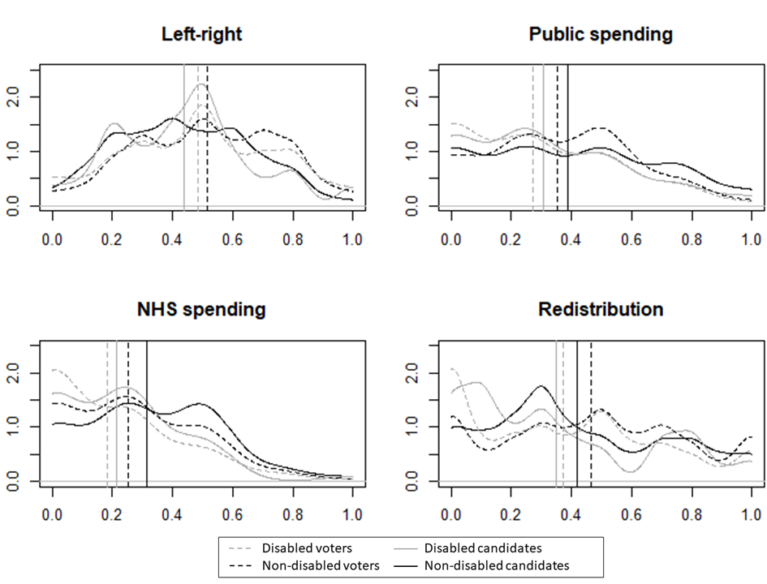
Figure S1. Means and distributions of policy positions of disabled and non-disabled citizens and candidates
Notes: The horizontal lines indicate the distributions (density) of respondents along the policy dimensions; the vertical lines indicate the mean position of each group. For left-right, the means for disabled and non-disabled candidates are both on the solid grey line. Poststratification weights applied for analysis of citizen data. Candidate data is weighted to reflect number of candidates fielded by each party in the election.

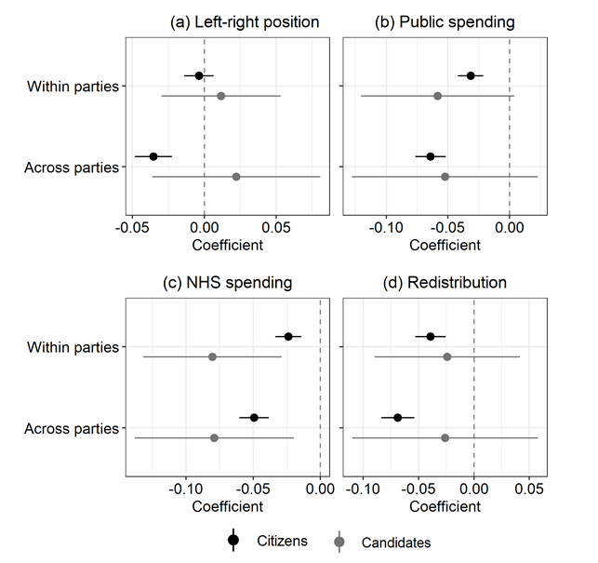
Figure S2. Effects of disability on policy preferences of citizens and candidates, controlling for education and income
Notes: Values are coefficients of disability and 95% CIs from linear regression models among citizens (bottom) and candidates (top). “Across parties” models include disability, gender, age, education, income; “Within parties” models include disability, gender, age, party, education, income. The models are equivalent to those in Tables S3 and S4 but also include indicators for education, measured in years, and gross household income per year, measured on a 9-point scale (1=less than £20,000; 2=£20,000-29,999; 3=£30,000-39,999; 4=£40,000-49,999; 5=£50,000-59,999; 6=£60,000-69,999; 7=£70,000-99,999; 8=£100,000-149,000; 9=£150,000 or over).

