Online supporting information

Dahlgaard JO, Bhatti Y, Hansen JH and Hansen KM (2020) Living Together, Voting Together: Voters moving in together before an election have higher turnout. British Journal of Political Science. Online early access.

Jens Olav Dahlgaard , Yosef Bhatti, Jonas Hedegaard Hansen, and Kasper M. Hansen
September 29, 2020
Contents

1. Demonstration of balance 2
2. Placebo estimates 5
3. Two-person households of opposite sex and limited age difference 6
4. Concordance in turnout binned by month of started cohabitation 8
5. The relationship between turnout and moving apart 11
6. Models with only voters with 2009 validated turnout 13

1. Demonstration of balance

In this section, we provide demonstrations of the balance of covariates around the Election Day and robustness of results to alternative estimation strategy. In Table S1, we show means, standard deviations, N, and p-values from t-tests for Age, Education, Income, being of Danish origin, and Sex. In Figure S1, we show trends in covariate means around the Election Day. In the figure, we show means of the background covariates binned by months within a bandwidth of one year before and after the election. There is a trend in several of the covariates. If voters move into households at roughly the same age, voters in households that formed earlier will be older at one specific date than voters in households that are yet to form. Related to the development in age, a large share of the voters are young adults in the age range where one completes an education and starts earning a higher income, which explains the trends in both education and income. However, these trends are not a problem for the research design. What would have been a problem was if we saw distinct jumps around the Election Day, which as we show in the paper is not the case in the one month window. In the two months window, there are some imbalances.

Table S1: Balance with respect to mean age, education, immigrant status, and income
 | Month₋₁ | Month₊₁ | P_{diff} | Month₋₂ | Month₊₂ | P_{diff}
Age | 33.4 | 33.5 | 0.421 | 33.6 | 32.5 | <0.001
 | (11.9) | (12.1) |  | (12.2) | (11.7)
N_{Age} | 5,663 | 5,055 |  | 5,670 | 5,747
Education | 0.21 | 0.21 | 0.931 | 0.22 | 0.21 | 0.004
 | (0.34) | (0.33) |  | (0.35) | (0.33)
N_{Education} | 5,226 | 4,734 |  | 5,079 | 5,137
Immigrant or | 0.13 | 0.12 | 0.440 | 0.14 | 0.11 | <0.001
descendant | (0.30) | (0.29) |  | (0.31) | (0.28)
N_{Immigrant/descendant} | 5,663 | 5,055 |  | 5,670 | 5,747
Income (DKK) | 261,197 | 263,985 | 0.496 | 256,299 | 260,541 | 0.598
 | (201,516) | (220,097) |  | (187,597) | (567,468)
N_{Income} | 5,663 | 5,060 |  | 5,671 | 5,783
Male | 0.48 | 0.47 | 0.319 | 0.48 | 0.48 | 0.813
 | 0.22 | 0.23 |  | 0.22 | 0.24
N_{Male} | 5,663 | 5,055 |  | 5,670 | 5,747
P-values are based on a regression of the pretreatment covariate of an indicator for moving before the election with only voters moving in the 60-day window around the election or only voters moving in a 120-day window around the election, with the 60-day window around the cutoff excluded. Standard errors are clustered by household. Table entries are means in households with standard deviations in parentheses. “Age” is age in years on Election Day; “Education” is the share of voters with a bachelor’s degree or higher; “Immigrant or descendants” is the share of immigrants or immigrant descendants; “Income” is the average annual income. The averages for all eligible voters are 48.9 for age, 0.24 for education, 0.10 for immigrant, and 308,962 for income. The lower age and income in our sample reflects that individuals typically form two-voter households relatively early in their lives.

Figure S1: Means of background variables split by month of moving together
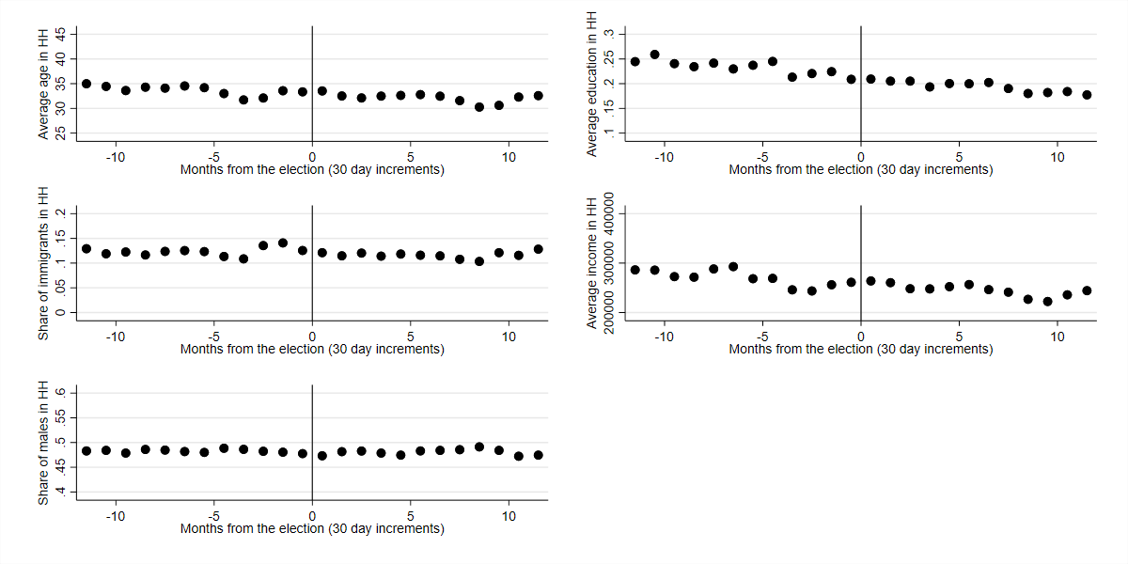
Note: The figure shows averages binned by 30-day windows around the Election Day cutoff (the vertical line). The households are binned by the month they start living together.

2. Placebo estimates
In Table S2, we show the placebo estimates for the difference in turnout in 2009 conditional on the timing of taking up cohabitation in 2013. As we also demonstrate in the paper, there is no relationship between moving together right before or after the election in 2013 and whether one voted in 2009.

Table S2: The effect on turnout in 2009 of cohabitation in 2013
 | 2009 turnout
Month₋₁ – Month₊₁ | -0.017
 | [-0.038,0.004]
Month₋₂ – Month₊₂ | 0.007
 | [-0.014,0.027]
Turnout in Month₊₁ (baseline) | 0.506
Min N_{Voters} per month | 4,949
Note: 95% confidence intervals in brackets. Standard errors are clustered by household.

3. Two-person households of opposite sex and limited age difference
In the paper, we include all two-person households in the analysis. Here we focus instead of household pairs that are even more likely to be partners. Specifically, we focus on two-voter households of opposite sex with an age difference of no more than 7,000 days, approximately 19.2 years. This is far from a perfect measure of being a couple. We miss same sex couples and couples with a larger age difference, and we include opposite sex housemates who are not partners. Figure S2 shows turnout by month of cohabitation, and as in Figure 1 in the main analysis, we again see a distinct jump around the Election Day.

Figure S2: Turnout by month of cohabitation
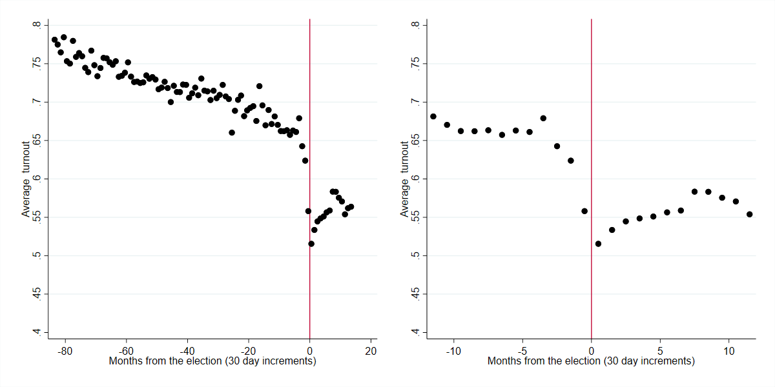
Note: The figure shows average turnout binned by 30 day windows around the Election Day-cutoff represented by the vertical line. The households are placed in bins based on when they moved together. Household on the left side of the vertical line formed before the election, households on the right side formed after.

Table S3 summarizes the jump. As in model 1 in Table 2 in the main analysis, we compare the difference between those who move together one month before and after the election and those who move two months before or after. The difference between movers within one month of the election is slightly larger at 4.3 percentage points. For those who moved between one and two months before or after the election, the difference is 9.0 percentage points, which is about the same as for the sample studied in the paper. In other words, it does not make an empirical difference if we study only this subset of housemates.
Table S3: The effect on turnout of cohabitation
 | Effect on turnout
Month₋₁ – Month₊₁ | 0.043
 | [0.024,0.061]
Month₋₂ – Month₊₂ | 0.090
 | [0.071,0.109]
Turnout in Month₊₁ (baseline) | 0.516
Min N_{Voters} per month | 7,266
95% confidence intervals in brackets. Standard errors are clustered by household.

4. Concordance in turnout binned by month of started cohabitation
In the paper, we study the effect on individual turnout. We could also study an alternative outcome measured at the household level: the extent to which partners do the same thing on Election Day. We label this concordance and define it as a dichotomous variable, which equals one if both voted or both abstained and zero if one voted and the other abstained. In Figure S3, we show binned averages of concordance as black dots. Before the Election Day, we also include hollow dots to show how much concordance we would expect if we partnered people moving together in each bin with a random partner.

Figure S3: Concordance in turnout binned by month of started cohabitation
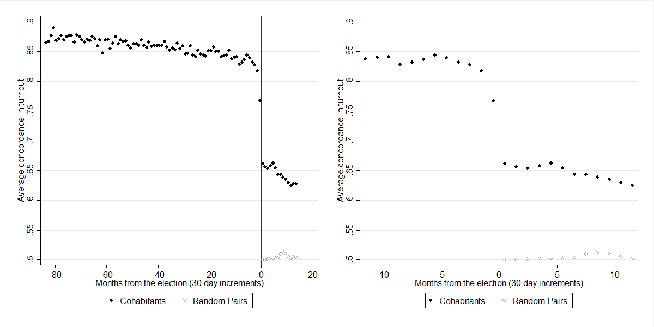Note: Black dots show concordance in turnout behavior for cohabitating two-voter households, hollow dots show concordance if cohabitation within a month happened randomly. The households are placed in bins based on when they moved together

Two interesting patterns are revealed on the right side of the Election Day. First, future cohabitants are much more likely to behave according to one another than random pairs of voters even before they move in together. This is evident from the gap between the black and the hollow dots. The gap probably reflects at least two sources of selection. Voters might tend to move in with people similar to themselves, which drives voting up, and within the country there is much variation in turnout across different contexts. The random pairs are the expected concordance if we couple random pairs across the country. Voters are more likely to meet people from a context similar to their own, in which case their contextual concordance would be higher.
The second interesting pattern is that pairs moving in together closer to the Election Day are more concordant than households established a longer time after the election. One interpretation of the general tendency of increased concordance in the time leading up to the election is that pairs influence each other before moving in together. When we run a regression with indicator variables, we see that concordance is 10.5 percentage points higher in households that formed within thirty days before the election compared to households that formed within thirty days after with a 95 percent confidence interval of [8.8, 12.2]. However, this might be an underestimation of the full effect of cohabitation on concordance. Right after moving, people might still be settling in, which could depress the concordance, and, as we see in Figure S3, concordance increases sharply if we move out another month. If we just extend to compare with people who moved in one month earlier, concordance is 15.5 percentage points higher in households established two months before the election than in the month after with a 95 percent confidence interval of [13.9, 17.2]. After that, there is not much evidence of differences as the remaining point estimates fluctuate around similar values. In Table S4, we summarize these results and make other comparisons.
Table S4: The effect of cohabitation on concordance
 | Effect on concordance
Cohabitation before election
Month₋₁ | 0.105
 | [0.088,0.122]
Month₋₂ | 0.155
 | [0.139,0.172]
Month₋₃ | 0.165
 | [0.150,0.181]
Month₋₆ | 0.182
 | [0.165,0.198]
Month₋₁₂ | 0.175
 | [0.158,0.193]
Cohabitation after the election
Month₊₂ | -0.005
 | [-0.024,0.013]
Month₊₃ | -0.009
 | [-0.026,0.008]
Month₊₄ | -0.004
 | [-0.022,0.014]
Month₊₇ | -0.018
 | [-0.036,-0.001]
Month₊₁₃ | -0.034
 | [-0.051,-0.017]
Concordance in Month₊₁ (baseline) | 0.662
 | [0.649,0.675]
N_{household} | 159,571
Note: 95% confidence intervals in brackets. Each month is compared to households that formed in the month after the election.

5. The relationship between turnout and moving apart
What happens when two voters move apart? Do voters keep an elevated turnout level, or do we see an opposite effect where voters become less likely to vote as their household dissolves? To address this, we present a figure similar to Figure 1 of the paper; only this time we analyze turnout depending on the timing of moving apart. Voters in households on the right side of the Election Day still lived together on Election Day whereas voters on the left side had terminated their cohabitation.
Figure S4: Turnout by month of terminating cohabitation
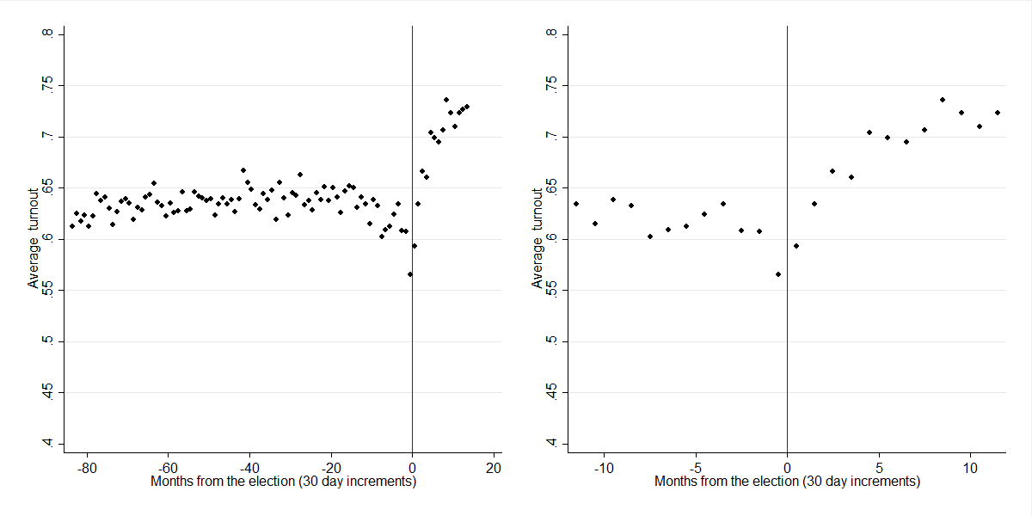
Note: The figure shows average turnout binned by 30 day windows around the Election Day-cutoff represented by the vertical line. The households are placed in bins based on when they moved apart. Household on the left side of the vertical line dissolved before the election, households on the right side dissolved after.

Figure S4 shows that turnout decreases substantially around the Election Day, though the decrease is slightly less sharp around the cutoff compared to moving together. The difference is not immediate as for moving together, but especially when we consider the left panel where we have the longer timespan, we can see that turnout is dramatically higher in the time up to terminating cohabitation only to stabilize after cohabitation expires. In other words, the opposite pattern holds: voters who leave a joint household see a sharp decrease in turnout.

6. Models with only voters with 2009 validated turnout
In Table 2 of the main paper, we included all voters regardless of whether, we knew their turnout status in 2009. If 2009 turnout was missing, we simply added an additional dummy for this. In Table S5, we take a more restrictive approach and only include those for whom we know turnout in 2009. In every other regard, the models are the same. The conclusions are also the same. Among this more select subset, there is a strong mobilizing effect. In most cases, it is even slightly larger than for the entire population of couples moving together.

Table S5: The effect on turnout of cohabitation for voters with 2009 validated turnout
 | Model 1 | Model 2 | Model 3 | Model 4
Month₋₁ – Month₊₁ | 0.051 | 0.058 | 0.097 | 0.081
 | [0.029,0.073] | [0.037,0.079] | [0.069,0.124] | [0.052,0.110]
Month₋₂ – Month₊₂ | 0.106 | 0.104 | 0.107 | 0.075
 | [0.085,0.128] | [0.074,0.134] | [0.080,0.134] | [0.046,0.104]
Turnout in Month₊₁ (baseline) | 0.526 | 0.526 | 0.526 | 0.526
Min N_{Voters} per month | 4,949 | 4,738 | 8,354 | 8,161
Controls + time trend | NO | YES | NO | YES
DiD with single movers | NO | NO | YES | YES

Note: The estimates in model 1 and 2 are difference-in-means for turnout. Month₋₁ – Month₊₁ is the difference in means between two-voter households moving in together up to 30 days before and up to 30 days after the election. Month₋₂ – Month₊₂ is the difference in means between two-voter households moving in together 31 to 60 days before and 31 to 60 days after the election. The estimates in model 3 and 4 are difference-in-difference estimates for the difference in turnout between couples and singles moving before and after the election. 95% confidence intervals in brackets. Standard errors are clustered by household.

Department of Political Economy, Kings College London, Strand, London, United Kingdom
Department of International Economics, Government and Business, Copenhagen Business School, jod.egb@cbs.dk, Solbjerg Plads 3, 2000 Frederiksberg, Denmark
Independent Researcher, PhD, yosefbhatti@hotmail.com
Independent Researcher, PhD, hedegaardhansen@gmail.com
Corresponding author: Department of Political Science, University of Copenhagen, kmh@ifs.ku.dk, www.kaspermhansen.eu. Øster Farimagsgade 5, 1353 Copenhagen K, Denmark, Cell +45 51245005.

