Supplementary Information to Accompany
Who Gets What: The Economy, Relative Gains, and Brexit

Contents

- Table A1. Variables and Coding
- Table A2. Descriptive Statistics
- Table A3. Reanalysis of Table 2 excluding 2016 EU Referendum vote
- Table A4. The Effects of Economic Perceptions on Referendum Vote Intentions conditioned by Anti-immigration sentiment, British identity, and Income
- Table A5. Modelling Immigration Sentiment Wave 15 (March 2019) as fn of past Immigration Sentiment Wave 11 (April 2017)
- Table A6. The Effects of Economic Perceptions on Referendum Vote Intentions, conditioned by question ordering effects (1 = Leave, 0 = Remain)
- Table A7. The Effects of Economic Perceptions on Satisfaction with Brexit
- Table A8. The Effects of Economic Perceptions on Populist Attitudes
- Table A9. The Effects of Perceptions of In-Group (White British) and Out-Group (ethnic minority immigrant) economies on Referendum Vote Intentions, April-May 2019
- Table A10. Effect of Evaluations of Financial Situations of White British and Ethnic Minority Immigrants on Probability of Supporting Leave
- Figure A1. National and Household Economic Perceptions for Leave and Remain Voters, mean values
- Figure A2. Economic evaluations by randomised order of questions and EU Referendum vote
- Figure A3. Differences in in-group and out-group economic evaluations by randomised order of questions and EU Referendum vote
- Figure A4. Question Ordering Interaction Effects
- Figure A5. Predicted values on Feelings toward leaving the EU (11-point scale; higher values for “happy,” lower values for “disappointed), April 2017 BES wave
- Figure A6. Predicted values on Populism Index, produced from factor scores of 5 survey items, April 2017 BES wave

Table A1. Variables and Coding
Brexit support. “If there was another referendum on EU membership, how do you think you would vote?” Responses coded “Leave” = 1, otherwise = 0. Panel wave 11
2016 EU Referendum vote_{t-1}. Coded 1 if responded voted Leave and 0 if voted Remain in referendum. Panel wave 9
Self economy. “How does the *financial situation of your household* now compare with what it was 12 months ago?” Responses coded “Got a lot worse” = 0, “Got a little worse” = .25, “Stayed the same” = .5, “Got a little better” = .75 “Got a lot better” = 1. Panel wave 11

National economy. “How do you think the general economic situation in this country has changed over the last 12 months?” Responses coded “Got a lot worse” = 0, “Got a little worse” = .25, “Stayed the same” = .5, “Got a little better” = .75 “Got a lot better” = 1. Panel wave 11

In-Group economy. “giving your best guess, how do you think the financial situation of each of the following compares with what it was 12 months ago?” [white British people] Responses coded “Got a lot worse” = 0, “Got a little worse” = .25, “Stayed the same” = .5, “Got a little better” = .75 “Got a lot better” = 1. Panel wave 11

Out-Group economy. “giving your best guess, how do you think the financial situation of each of the following compares with what it was 12 months ago?” [ethnic minority immigrants] Responses coded “Got a lot worse” = 0, “Got a little worse” = .25, “Stayed the same” = .5, “Got a little better” = .75 “Got a lot better” = 1. Panel wave 11

In-Group vs Out-Group. Difference between In-Group economy and Out-Group economy. Panel wave 11

Anti-immigration sentiment. “do you think that immigration undermines or enriches Britain's cultural life?” Responses coded on a seven-point scale from “enriches” (low) to “undermines” (high) rescaled to 0-1 scale. Panel wave 7 supplemented with waves 8 and 10.

British national sentiment. produced by combining responses to five items: “Britain has a lot to learn from other countries in running its affairs,” “I would rather be a citizen of Britain than of any other country in the world,” “There are some things about Britain today that make me ashamed to be British,” “People in Britain are too ready to criticize their country,” and “The world would be a better place if people from other countries were more like the British.” Responses coded, summed, and rescaled from 0 to 1 where higher (lower) values connote more (less) ethnocentric values. Panel wave 7 supplemented with waves 10.

Authoritarianism. Measures combines response from five agree-disagree statements: “Young people today don’t have enough respect for traditional British values,” “For some crimes, the death penalty is the most appropriate sentence,” “Schools should teach children to obey authority,” “Censorship of films and magazines is necessary to uphold moral standards,” and “People who break the law should be given stiffer sentences.” Responses coded, summed, and rescaled from 0 to 1 where higher (lower) values connote more (less) ethnocentric values. Panel wave 7 supplemented with waves 8-12.

Age. Respondent’s age in years, sample values rescaled from 0-1. Panel wave 11

Female. Female = 1, male = 0. Panel wave 11

Education. Respondent’s highest education level such that no qualifications = 0, below GCSE = .2, GCSE = .4, A-level = .6, undergraduate = .8, postgraduate = 1. Panel wave 11

Income. Respondent’s gross household income measured in 15 categories from “under £5,000 per year” to “£150,000 per year and over,” rescaled from 0-1. Panel wave 11

Ethnicity. Scored 1 if respondent identifies as White British, 0 otherwise.

Satisfaction with Brexit. “How happy/disappointed are you that UK voted to leave the EU?” Respondents select placement from s are coded along 10 point scale ranging from “extremely disappointed” to “extremely happy.” Panel wave 11

Populism. Principal components factor score based on 5 five-point agree/disagree scales to the following: “The politicians in the UK Parliament need to follow the will of the people,” “The people, and not politicians, should make our most important policy decisions,” “I would rather be represented by a citizen than by a specialized politician,” “Elected officials talk too much and take too little action,” and “What people call "compromise" in politics is really just selling out on one's principles.” Note that these items were asked on a reduced sample in wave 11 of the survey only. Panel wave 11

Local economy. “Giving your best guess, how do you think the financial situation of each of the following compares with what it was 12 months ago?” [people in my local community] Responses coded “Got a lot worse” = 0, “Got a little worse” = .25, “Stayed the same” = .5, “Got a little better” = .75 “Got a lot better” = 1. Panel wave 11

London economy. “Giving your best guess, how do you think the financial situation of each of the following compares with what it was 12 months ago?” [people living in London] Responses coded “Got a lot worse” = 0, “Got a little worse” = .25, “Stayed the same” = .5, “Got a little better” = .75 “Got a lot better” = 1. Panel wave 11

Local vs London. Difference between Local economy and London economy. Panel wave 11

Table A2. Descriptive Statistics

Variable | Obs | Mean | Std. Dev. | Min | Max
Brexit support | 28,476 | 0.48 | 0.50 | 0 | 1
2016 EU Referendum vote | 28,104 | 0.49 | 0.50 | 0 | 1
Self economy | 29,303 | 0.44 | 0.20 | 0 | 1
National economy | 29,182 | 0.39 | 0.25 | 0 | 1
In-Group economy | 25,651 | 0.41 | 0.18 | 0 | 1
Out-Group economy | 23,038 | 0.43 | 0.24 | 0 | 1
In-Group vs Out-Group | 22,115 | -0.02 | 0.28 | -1 | 1
Anti-Immigration sentiment | 26,528 | 0.56 | 0.34 | 0 | 1
British national sentiment | 30,956 | 0.32 | 0.29 | 0 | 1
Authoritarianism | 27,709 | 0.63 | 0.22 | 0 | 1
Age | 30,956 | 0.46 | 0.22 | 0 | 1
Female | 30,956 | 0.53 | 0.50 | 0 | 1
Education | 28,823 | 0.61 | 0.26 | 0 | 1
Income | 22,800 | 0.42 | 0.25 | 0 | 1
Ethnicity | 30,933 | 0.91 | 0.29 | 0 | 1
Satisfaction with Brexit | 30,956 | 5.05 | 4.13 | 0 | 10
Populism | 7,883 | 0.00 | 1.00 | -3.54 | 2.30
Local economy | 26,206 | 0.41 | 0.17 | 0 | 1
London economy | 20,892 | 0.49 | 0.25 | 0 | 1
Local vs London | 20,035 | -0.08 | 0.27 | -1 | 1
Not London | 30,956 | 0.90 | 0.30 | 0 | 1

Table A3. Reanalysis of Table 2 excluding 2016 EU Referendum vote

 | M1 | M2 | M3 | M4 | M5
Self-economy_{t} | 0.10
 | (0.19)
In-Group economy_{t} |  | -0.30 |  | -0.51*
 |  | (0.20) |  | (0.22)
Out-Group economy_{t} |  |  | 1.43** | 1.52**
 |  |  | (0.18) | (0.18)
In-Group vs Out-Group_{t} |  |  |  |  | -1.15**
 |  |  |  |  | (0.14)
National economy_{t} | 3.15** | 3.26** | 2.86** | 2.97** | 3.20**
 | (0.16) | (0.16) | (0.16) | (0.17) | (0.17)
Anti-immig. sentiment_{t-1} | 3.01** | 2.98** | 2.82** | 2.78** | 2.78**
 | (0.11) | (0.12) | (0.12) | (0.13) | (0.13)
British nat. sentiment_{t-1} | 1.03** | 1.03** | 1.12** | 1.13** | 1.19**
 | (0.14) | (0.16) | (0.17) | (0.18) | (0.18)
Authoritarianism_{t-1} | 2.07** | 2.03** | 1.90** | 1.82** | 1.84**
 | (0.19) | (0.20) | (0.21) | (0.22) | (0.22)
Age_{t} | 0.72** | 0.61** | 0.75** | 0.69** | 0.62**
 | (0.17) | (0.18) | (0.19) | (0.20) | (0.20)
Female_{t} | 0.09 | 0.09 | 0.10 | 0.10 | 0.10
 | (0.06) | (0.06) | (0.07) | (0.07) | (0.07)
Education_{t} | -0.84** | -0.81** | -0.83** | -0.84** | -0.85**
 | (0.13) | (0.13) | (0.15) | (0.15) | (0.15)
Income_{t} | -0.93** | -0.97** | -0.93** | -0.91** | -0.89**
 | (0.13) | (0.14) | (0.15) | (0.15) | (0.15)
Constant | -4.38** | -4.14** | -4.70** | -4.47** | -4.14**
 | (0.21) | (0.22) | (0.24) | (0.25) | (0.23)
N | 12095 | 10988 | 9939 | 9660 | 9660
Log Likelihood | -4844.73 | -4384.71 | -3824.89 | -3732.56 | -3743.03
Pseudo R² | 0.33 | 0.33 | 0.34 | 0.34 | 0.34

Notes: Cells report logit coefficients with standard errors in parentheses. ** p < 0.01, * p < 0.05, two-tailed test. White British respondents only. Weighted by weight_w10w11. Source: Fieldhouse et al. 2019(b).

Table A4. The Effects of Economic Perceptions on Referendum Vote Intentions conditioned by Anti-immigration sentiment, British identity, and Income

 | M1 | M2 | M3
2016 EU Referendum vote | 5.16** | 5.16*** | 5.16**
 | (0.12) | (0.13) | (0.13)
National economy | 2.85** | 2.83*** | 2.85**
 | (0.25) | (0.25) | (0.25)
Anti-Immigration sentiment | 1.07** | 1.07*** | 1.06**
 | (0.22) | (0.22) | (0.22)
Authoritarianism | -0.03 | -0.04 | -0.01**
 | (0.43) | (0.42) | (0.42)
British national sentiment | 1.96** | 1.92*** | 1.96**
 | (0.39) | (0.31) | (0.30)
Age | 0.29 | 0.26 | 0.28
 | (0.36) | (0.37) | (0.36)
Female | -0.01 | -0.03 | -0.02
 | (0.12) | (0.12) | (0.12)
Education | -0.70** | -0.70** | -0.70**
 | (0.27) | (0.27) | (0.27)
Income | -0.42 | -0.43 | -0.41
 | (0.25) | (0.25) | (0.25)
British identity |  | 0.24
 |  | (0.27)
In-Group vs Out-Group | -1.71** | -0.81 | -1.39**
 | (0.55) | (0.58) | (0.45)
In-Group vs Out-Group × Anti-Immig. Sentiment | 0.55  (0.79)
In-Group vs Out-Group × British identity |  | -0.65
 |  | (0.73)
In-Group vs Out-Group × Income |  |  | 0.19  (0.93)
Constant | -4.73** | -4.87*** | -4.75**
 | (0.48) | 0.49 | (0.48)
N | 9323 | 9306 | 9579
Log likelihood | -1456.69 | -1454.45 | -1456.99
Pseudo R² | 0.73 | 0.73 | 0.73
Notes: Cells report logit coefficients with standard errors in parentheses. ** p < 0.01, * p < 0.05, two-tailed test. White British respondents only. Weighted by weight_w10w11. Source: Fieldhouse et al. 2019(b).

Table A5. Modelling Immigration Sentiment Wave 15 (March 2019) as fn of past Immigration Sentiment Wave 11 (April 2017)
 | M1 | M2
Anti-Immigr. Sentiment w11 | 0.70** | 0.62**
 | (0.01) | (0.02)
Self vs out-group
In-group vs out-group | -0.16** | -0.15**
 | (0.01) | (0.01)
National Economy |  | 0.10**
 |  | (0.02)
British national sentiment |  | 0.07**
 |  | (0.01)
Authoritarianism |  | 0.18**
 |  | (0.02)
Age |  | -0.12**
 |  | (0.02)
Female |  | -0.01*
 |  | (0.01)
Education |  | -0.04**
 |  | (0.01)
Income |  | -0.02
 |  | (0.02)
Constant | 0.09** | 0.04
 | (0.01) | (0.02)
N | 9795 | 7110
R² | 0.54 | 0.57
Notes: The dependent variable is Anti-immigration sentiment. Cells report OLS coefficients with standard errors in parentheses, weighted by weight_w11w15. ** p < 0.01, * p < 0.05, two-tailed test.

Table A6. The Effects of Economic Perceptions on Referendum Vote Intentions, conditioned by question ordering effects (1 = Leave, 0 = Remain)

 | M1 | M2 | M3 | M4
2016 EU Referendum vote | 5.14** | 5.18** | 5.16** | 5.17**
 | (0.12) | (0.12) | (0.12) | (0.12)
National economy | 2.83** | 2.37** | 2.82** | 2.85**
 | (0.25) | (0.26) | (0.25) | (0.25)
Anti-Immigration sentiment | 1.31** | 1.10** | 1.13** | 1.07**
 | (0.21 | (0.22) | (0.22) | (0.22)
Authoritarianism | 1.68** | 1.88** | 1.98** | 1.95**
 | (0.27) | (0.30) | (0.29) | (0.30)
British national sentiment | 0.23 | -0.03 | 0.10 | -0.01
 | (0.39) | (0.42) | (0.42) | (0.42)
Age | 0.35 | 0.48 | 0.42 | 0.29
 | (0.32) | (0.36) | (0.35) | (0.36)
Female | -0.02 | 0.00 | -0.01 | -0.02
 | (0.11) | (0.12) | (0.12) | (0.12)
Education | -0.61* | -0.68** | -0.68** | -0.70**
 | (0.24) | (0.26) | (0.26) | (0.27)
Income | -0.56* | -0.46 | -0.36 | -0.41
 | (0.24) | (0.25) | (0.25) | (0.25)
Self economy | 0.30 | -0.07
 | (0.31) | (0.30)
EM before WB | -0.09 | 0.15 | -0.10 | -0.09
 | (0.28) | (0.26) | (0.12) | (0.12)
In-Group | -0.34
 | (0.45)
In-Group × EM before WB | 0.13
 | (0.64)
Out-Group |  | 2.07**
 |  | (0.40)
Out-Group × EM before WB |  | -0.57
 |  | (0.55)
Self vs Out-Group |  |  | -1.33**
 |  |  | (0.30)
Self vs Out-Group × EM before WB |  |  | 0.50
 |  |  | (0.43)
In-Group vs Out-Group |  |  |  | -1.63**
 |  |  |  | (0.33)
In-Group vs Out-Group × EM before WB |  |  |  | 0.61
 |  |  |  | (0.50)
Constant | -4.85** | -5.44** | -4.88** | -4.70**
 | (0.48) | (0.50) | (0.47) | (0.48)
N | 10588 | 9579 | 9579 | 9323
Log likelihood | -1711.39 | -1481.13 | -1491.73 | -1455.40
Pseudo R² | 0.72 | 0.73 | 0.73 | 0.73
Notes: Cells report logit coefficients with standard errors in parentheses. Weighted by weight_w10w11. ** p < 0.01, * p < 0.05, two-tailed test. Source: Fieldhouse et al. 2019(b).

Table A7. The Effects of Economic Perceptions on Satisfaction with Brexit

 | M1 | M2 | M3 | M4 | M5
National economy | 4.43** | 4.43** | 3.87** | 3.95** | 4.31**
 | (0.16) | (0.16) | (0.17) | (0.18) | (0.17)
Anti-immig. sentiment | 4.47** | 4.46** | 4.13** | 4.07** | 4.11**
 | (0.13) | (0.14) | (0.15) | (0.15) | (0.15)
British nat. sentiment | 1.46** | 1.57** | 1.65** | 1.72** | 1.82**
 | (0.16) | (0.18) | (0.19) | (0.20) | (0.20)
Authoritarianism | 3.07** | 3.07** | 2.76** | 2.71** | 2.77**
 | (0.20) | (0.21) | (0.23) | (0.23) | (0.23)
Age | 0.52** | 0.40* | 0.45* | 0.41* | 0.32
 | (0.17) | (0.18) | (0.19) | (0.19) | (0.19)
Female | 0.08 | 0.08 | 0.07 | 0.07 | 0.07
 | (0.07) | (0.07) | (0.07) | (0.07) | (0.07)
Education | -1.32** | -1.28** | -1.40** | -1.40** | -1.40**
 | (0.14) | (0.15) | (0.15) | (0.16) | (0.16)
Income | -1.41** | -1.46** | -1.37** | -1.37** | -1.36**
 | (0.14) | (0.15) | (0.16) | (0.16) | (0.16)
Self | 0.03
 | (0.19)
In-Group |  | -0.22 |  | -0.43*
 |  | (0.21) |  | (0.22)
Out-Group |  |  | 1.88** | 1.97**
 |  |  | (0.18) | (0.18)
Self vs Out-Group
In-Group vs Out-Group |  |  |  |  | -1.38**
 |  |  |  |  | (0.14)
Constant | -0.66** | -0.52** | -0.88** | -0.72** | -0.28
 | (0.18) | (0.20) | (0.19) | (0.21) | (0.20)
N | 12798 | 11605 | 10465 | 10173 | 10173
R² | 0.43 | 0.44 | 0.45 | 0.45 | 0.45
Notes: The dependent variable is satisfaction with Brexit, coded on a 0-10 scale where higher values represent “happy” that EU voted to leave EU and lower values for “disappointed.” Cells report OLS coefficients with standard errors in parentheses. ** p < 0.01, * p < 0.05, two-tailed test.

Table A8. The Effects of Economic Perceptions on Populist Attitudes
 | M1 | M2 | M3 | M4 | M5
National economy | -0.17* | -0.25** | -0.43** | -0.30* | -0.39**
 | (0.09) | (0.09) | (0.09) | (0.10) | (0.09)
Anti-immig. sentiment | 0.58** | 0.59** | 0.60** | 0.57** | 0.57**
 | (0.08) | (0.09) | (0.09) | (0.10) | (0.10)
British nat. sentiment | -0.08 | -0.20 | -0.16 | -0.12 | -0.14
 | (0.10) | (0.11) | (0.11) | (0.12) | (0.12)
Authoritarianism | 1.37** | 1.32** | 1.37** | 1.33** | 1.31**
 | (0.13) | (0.14) | (0.15) | (0.15) | (0.15)
Age | -0.32** | -0.34** | -0.22 | -0.26* | -0.24*
 | (0.10) | (0.11) | (0.12) | (0.11) | (0.12)
Female | -0.05 | -0.05 | -0.03 | -0.03 | -0.02
 | (0.04) | (0.04) | (0.04) | (0.04) | (0.04)
Education | -0.36** | -0.38** | -0.37** | -0.36** | -0.36**
 | (0.08) | (0.09) | (0.10) | (0.10) | (0.10)
Income | -0.36** | -0.41** | -0.44** | -0.43** | -0.44**
 | (0.09) | (0.09) | (0.10) | (0.10) | (0.10)
Self | -0.57**
 | (0.11)
In-Group |  | -0.53** |  | -0.57*
 |  | (0.14) |  | (0.15)
Out-Group |  |  | 0.19 | 0.20*
 |  |  | (0.10) | (0.10)
Self vs Out-Group
In-Group vs Out-Group |  |  |  |  | -0.34**
 |  |  |  |  | (0.09)
Constant | -0.24 | -0.10 | -0.44** | -0.22 | -0.33*
 | (0.13) | (0.14) | (0.15) | (0.16) | (0.15)
N | 3278 | 2973 | 2673 | 2594 | 2594
R² | 0.23 | 0.23 | 0.24 | 0.24 | 0.24
Notes: The dependent variable is support for populist attitudes, produced by factor scores of five items. Cells report OLS coefficients with standard errors in parentheses. ** p < 0.01, * p < 0.05, two-tailed test.

Table A9. The Effects of Perceptions of In-Group (White British) and Out-Group (ethnic minority immigrant) economies on Referendum Vote Intentions, April-May 2019

 | M1
2016 EU Referendum vote_{t-1} | 5.13**
 | (0.12)
In-group better Out-group better_{t} | 0.06
 | (0.29)
In-group better Out-group worse_{t} | -0.25
 | (0.34)
In-group worse Out-group better_{t} | 0.46*
 | (0.19)
In-group worse Out-group worse_{t} | -0.38*
 | (0.15)
National economy_{t} | 2.78**
 | (0.24)
Anti-immig. sentiment_{t-1} | 1.21**
 | (0.21)
British nat. sentiment_{t-1} | 1.69**
 | (0.26)
Authoritarianism_{t-1} | 0.14
 | (0.39)
Age_{t-1} | 0.34
 | (0.32)
Female_{t-1} | -0.03
 | (0.11)
Education_{t-1} | -0.61*
 | (0.24)
Income_{t-1} | -0.53*
 | (0.23)
Constant | -4.74**
 | (0.44)
N | 10,605
Log Likelihood | -1703.76
Pseudo R² | 0.72
Notes: Cells report logit coefficients with standard errors in parentheses. ** p < 0.01, * p < 0.05, two-tailed test. White British respondents only.

Table A10. Effect of Evaluations of Financial Situations of White British and Ethnic Minority Immigrants on Probability of Supporting Leave

 |  | White British
 |  | Better | Worse
Ethnic minority immigrants | Better | 0.63  [0.50 – 0.76] | 0.72  [0.64- 0.79]
 | Worse | 0.56  [0.39 – 0.73] | 0.52  [0.45 – 0.60]

Note: cells report expected probability of choosing Leave calculated from estimates in Table A7. Expected probabilities produced by manipulating in-group and out-group economic sentiment while setting all other variables in the model at mean or modal values. Brackets report 95% confidence intervals.

Figure A1. National and Household Economic Perceptions for Leave and Remain Voters, mean values

A. Leave voters 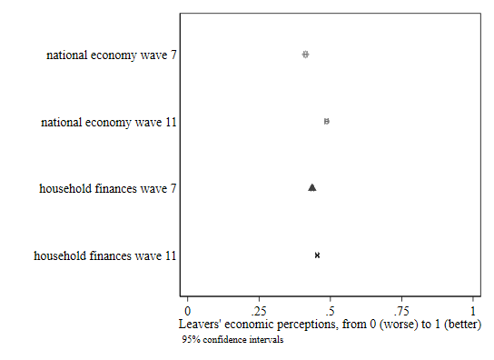
B. Remain voters

Figure A2. Economic evaluations by randomised order of questions and EU Referendum vote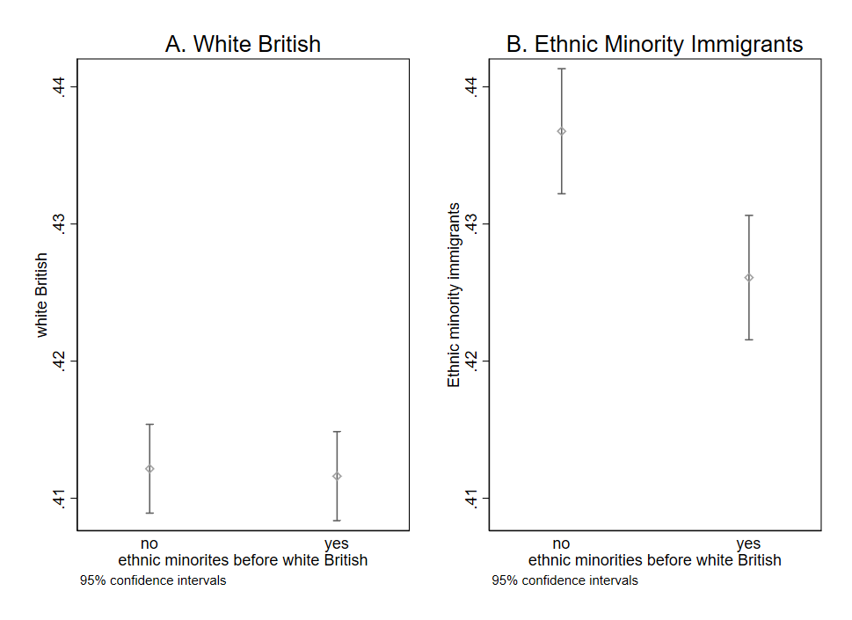

Figure A3. Differences in in-group and out-group economic evaluations by randomised order of questions and EU Referendum vote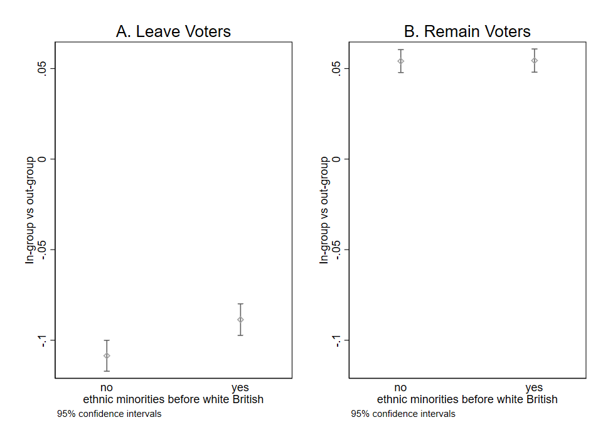

Figure A4. Question Ordering Interaction Effects
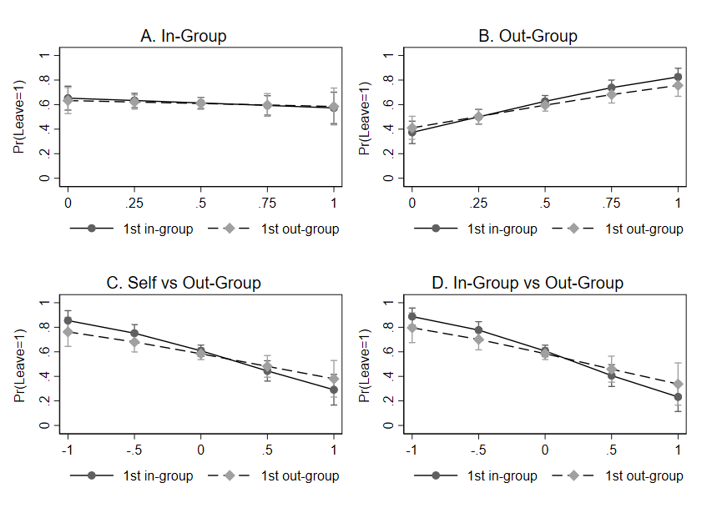
Note: Graphs are produced using estimates from Table A6. Solid lines report the effects for respondents who received the item about the financial situation of their ethnic in-group (white Britons) before that of their ethnic out-group (ethnic minorities). Dashed lines report effects for those who received the reverse ordering.

Figure A5. Predicted values on Feelings toward leaving the EU (11-point scale; higher values for “happy,” lower values for “disappointed), April 2017 BES wave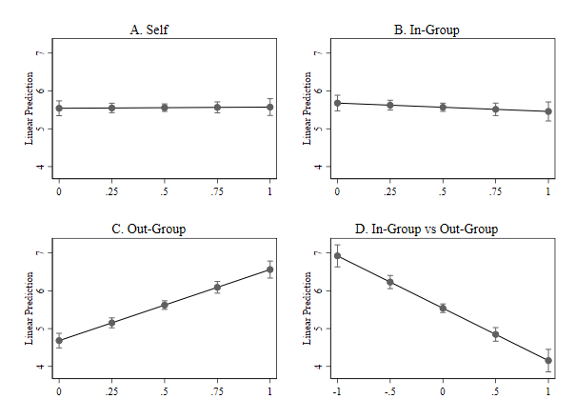
Notes: Horizontal axes display economic perceptions, ranging from “got a lot worse” (0) to “got a lot better” (1). Vertical axes report the respondent’s expected response when asked “How happy or disappointed are you that the UK voted to leave the EU?”, with responses ranging from 0 for “extremely disappointed” to 10 for “extremely happy.” The economic perceptions items are manipulated with all other variables held to their sample means or modes. Graphs A, B, C and D are produced using estimates from Table A7 Models 1, 2, 3, and 5, respectively.

Figure A6. Predicted values on Populism Index, produced from factor scores of 5 survey items, April 2017 BES wave
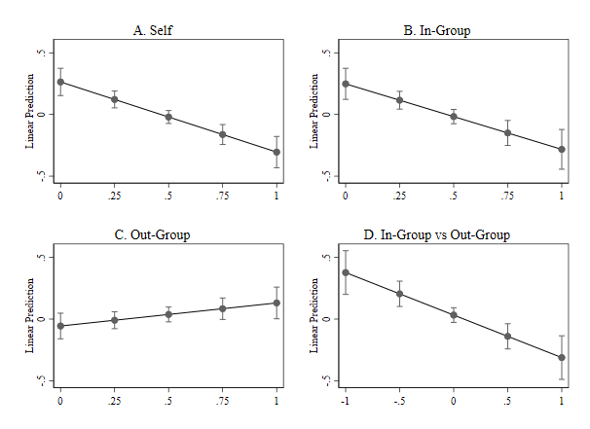

Notes: Horizontal axes display economic perceptions, ranging from “got a lot worse” (0) to “got a lot better” (1). Vertical axes report the respondent’s expected value for Populism. The economic perceptions items are manipulated with all other variables held to their sample means or modes. Graphs A, B, C, and D are produced using estimates from Table A8 Model 1, 2, 3, and 5, respectively.

Question presented to subset of respondents only.

