Governmental Responses to Terrorism in Autocracies: Evidence from China

Online Appendix

Philip B.K. Potter and Chen Wang

Contents
Data Collection 2
Descriptive Statistics 3
Test of Proportional Hazards Assumption 7
Additional Model Results and Robustness Checks 8
Logit Model Results, Binning Estimator, and Kernel Estimator 10
Robustness Check: Ethnic Violence in China (EVC) database 13

Data Collection
We collected our data from four main sources, which are (1) widely used database on terrorism, such as the Global Terrorism Database, RAND Database of Worldwide Terrorism Incidents, and Minorities at Risk Organizational Behavior, (2) English language news media, such as New York Times, Reuters, and Radio Free Asia, (3) widely used and recognized non-state-run Chinese websites, such as Sina, Tencent, ifeng and Sohu, and (4) secondary data from existing scholarly work, such as Bovingdon (2010) and Reed and Raschke (2010).
For an incident to be included in our dataset, it has to meet all the criteria below.
- The incident must be initiated by ethnic Uyghurs.
- The incident must occur in China.
- The incident must be premeditated.
- The incident must entail some level of violence.
- The incident must be motivated by political, religious, or social concerns.
- The act must be in fact carried out by the perpetrators.

It is worth noting that criteria (3), (4) and (6) exclude from our dataset some incidents that are recorded by other scholars, such as Bovingdon (2010) and Cao et al. (2018). Specifically, criterion (4) requires an incident to entail some level of violence, which leads us to drop some non-violent protests, demonstrations, and strikes, such as two student protests in March 2003 that happened in Khorgos and Manas respectively and Korla tax drivers’ strike that lasted three days in April 2005 (Bovingdon 2010).
Criteria (3) and (6) together exclude from our sample another three main types of incidents that are widely included in other datasets. First, impulsive violence is dropped (Babcock et al 2014). An example of this is an incident on April 5, 2003, in which Tokhti, an assistant in the family-planning office, was killed by the husband of a pregnant woman being examined (Bovingdon 2010, Appendix). Second, acts of collective political violence that have strong spontaneous components, as in riots, demonstrations, or revolts, are also dropped. Among these riots, the most notable ones would be the Ghulja Riot on February 5, 1997 and the Urumqi Riot on July 5, 2009. Third, plans that are not physically carried out and preemptive violence initiated by the police are also excluded from our sample. Examples include the gun battle that happened on August 7, 2001 in Quca where “police surprised a house full of suspected separatists; 4 died in the gun battle, including the chief, Chen Ping; a cache of weapons was reportedly found; report of a plan to storm a government building and raise the Uyghur flag” (Bovingdon 2010, Appendix), or the six weapon-production cases captured by the government between 1990 and 2005 (Cao et al 2018b).
On this last point, we follow GTD’s inclusion criterion that the attackers must be “out the door,” en route to execute the attack. However, attacks that were physically carried out but failed still meet this criterion, and therefore are included in our dataset. An example of this would be the failed bombing on September 5, 1993 in Yengisar county, in which an explosive device was set up on the front door of the apartment of the Director of the County Public Security Bureau, but was detected and removed before it exploded.

Descriptive Statistics
Table A.1 below shows the decomposition of all attacks in our dataset. From 1990 to 2014, a total of 137 attacks have been identified according to our inclusion criteria. Despite our best efforts, there are still 15 incidents for which the casualty data are missing, and 17 incidents for which the weapon type or tactic data are missing.
Appendix Table A.1 – Data Decomposition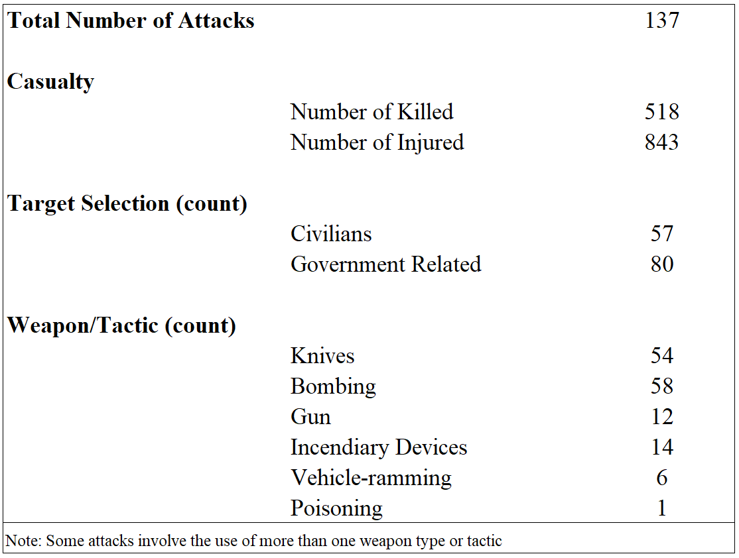
Figure A.1 below plots the temporal variation of the distribution of weapon/tactic types. From the graph, we can see that the first wave (1990-2001) was slightly dominated by relatively more sophisticated weapons. Among the total of 76incidents in the first wave, bombing or explosive devices were used 35 times, knives or other sharp objects 17 times, guns 11 times, incendiary devices 4 times, and there is also 1 poisoning case. The second wave, however, was more cold-weapon-oriented. Knives or other sharp objects were used 37 times as the major weapon in 61 attacks of the second wave, while bombing or explosive devices were used 23 times and guns were only used once. The use of incendiary devices and vehicle-ramming also increased in the second wave, which were used 10 times and 6 times respectively.
Appendix Figure A.1: Weapon or Tactic Types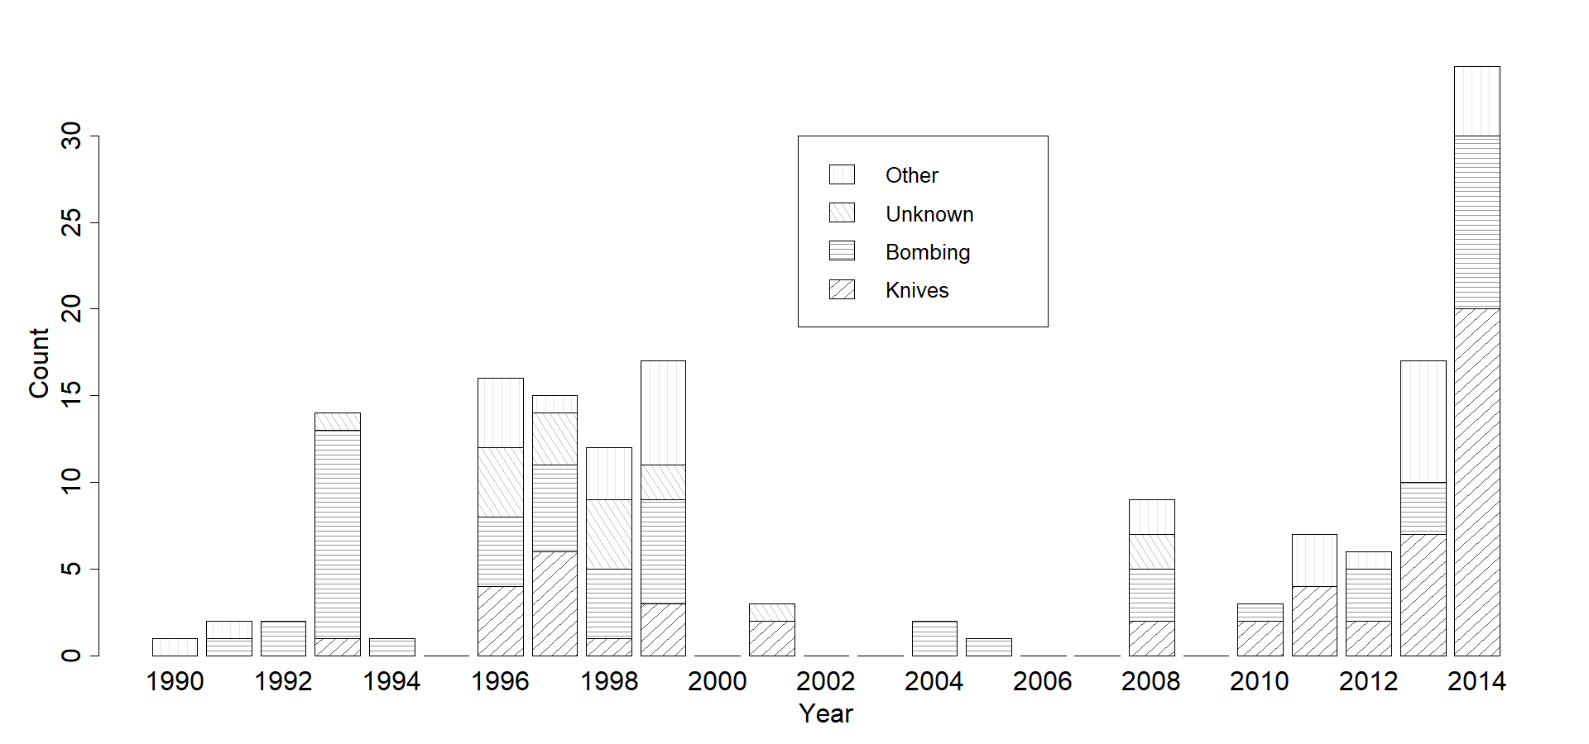
Table A.2 below shows the comparison between incidents that were timely acknowledged by People’s Daily and those that were not mentioned. Table A.3 presents the summary statistics of all variables used in the statistical analysis.
Appendix Table A.2 – Reported vs. Unreported
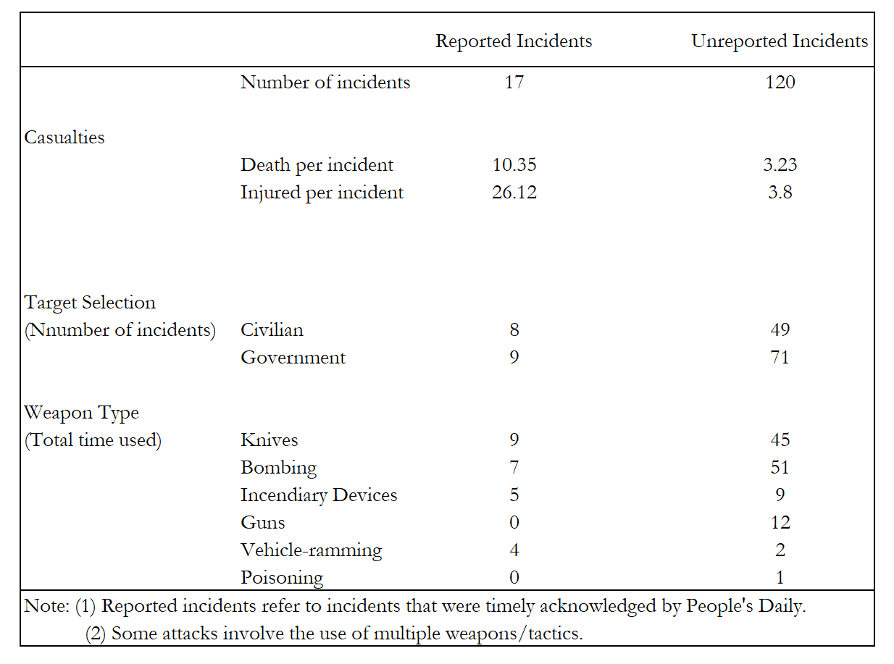
Appendix Table A.3 – Summary Statistics
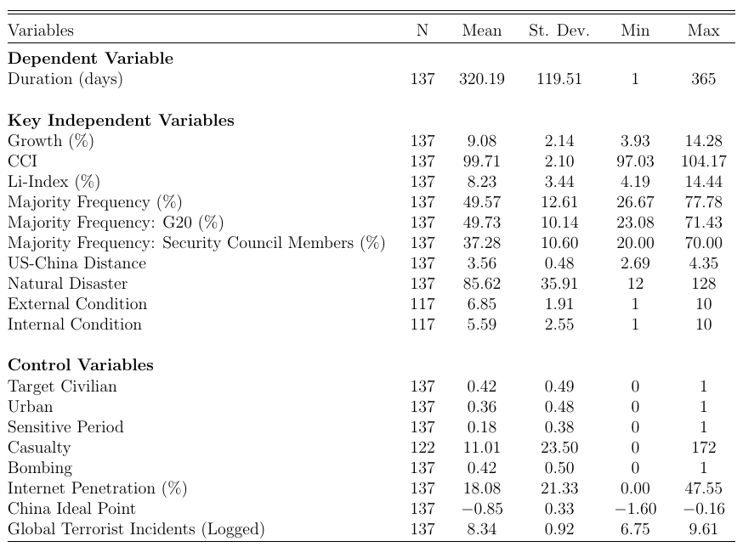
The left-hand side of Figure A.2 shows the distribution of the reporting duration of uncensored observations, and the right-side graph plots the non-parametric Kaplan-Meir (KM) estimator of the survival function. The average length of the wait-to-report periods for those that are reported is 3.88 days. As the histogram of reporting duration shows, the length of the durations cluster on short-periods. Indeed, more than half of those reported attacks (8 out of 17) are reported only one day after their occurrences, while an attempted hijacking of the CZ 6901 from Urumqi to Beijing on March 7, 2008 took 21 days to be mentioned in People’s Daily, which is the longest duration of all reported incidents. The non-parametric Kaplan-Meier (KM) plot reveals the same pattern in a different way. The KM plot shows how the estimated probability of survival changes over time. In our case, survival means that an incident remains unreported by People’s Daily. Therefore, the right-hand side KM plot indicates that the probability of being not reported decreases over time or the probability of being reported increases over time. However, most of the variations in the probability of being not reported (or reported) happen within about seven days after the occurrence of the event; the estimated survival curve tends to be relatively stable after seven days. In other words, if an event is not reported within seven days after the occurrence, there is a great chance that it will never be reported in the future. In addition, the KM plot also indicates that the probability of being reported for any incident is relatively low, smaller than 20 percent, on average. Our main interest here is to investigate what factors may lead to the immediate report of these attacks given such a low average probability of being reported.

Appendix Figure A.2: Distribution of Reporting Durations and KM Estimator
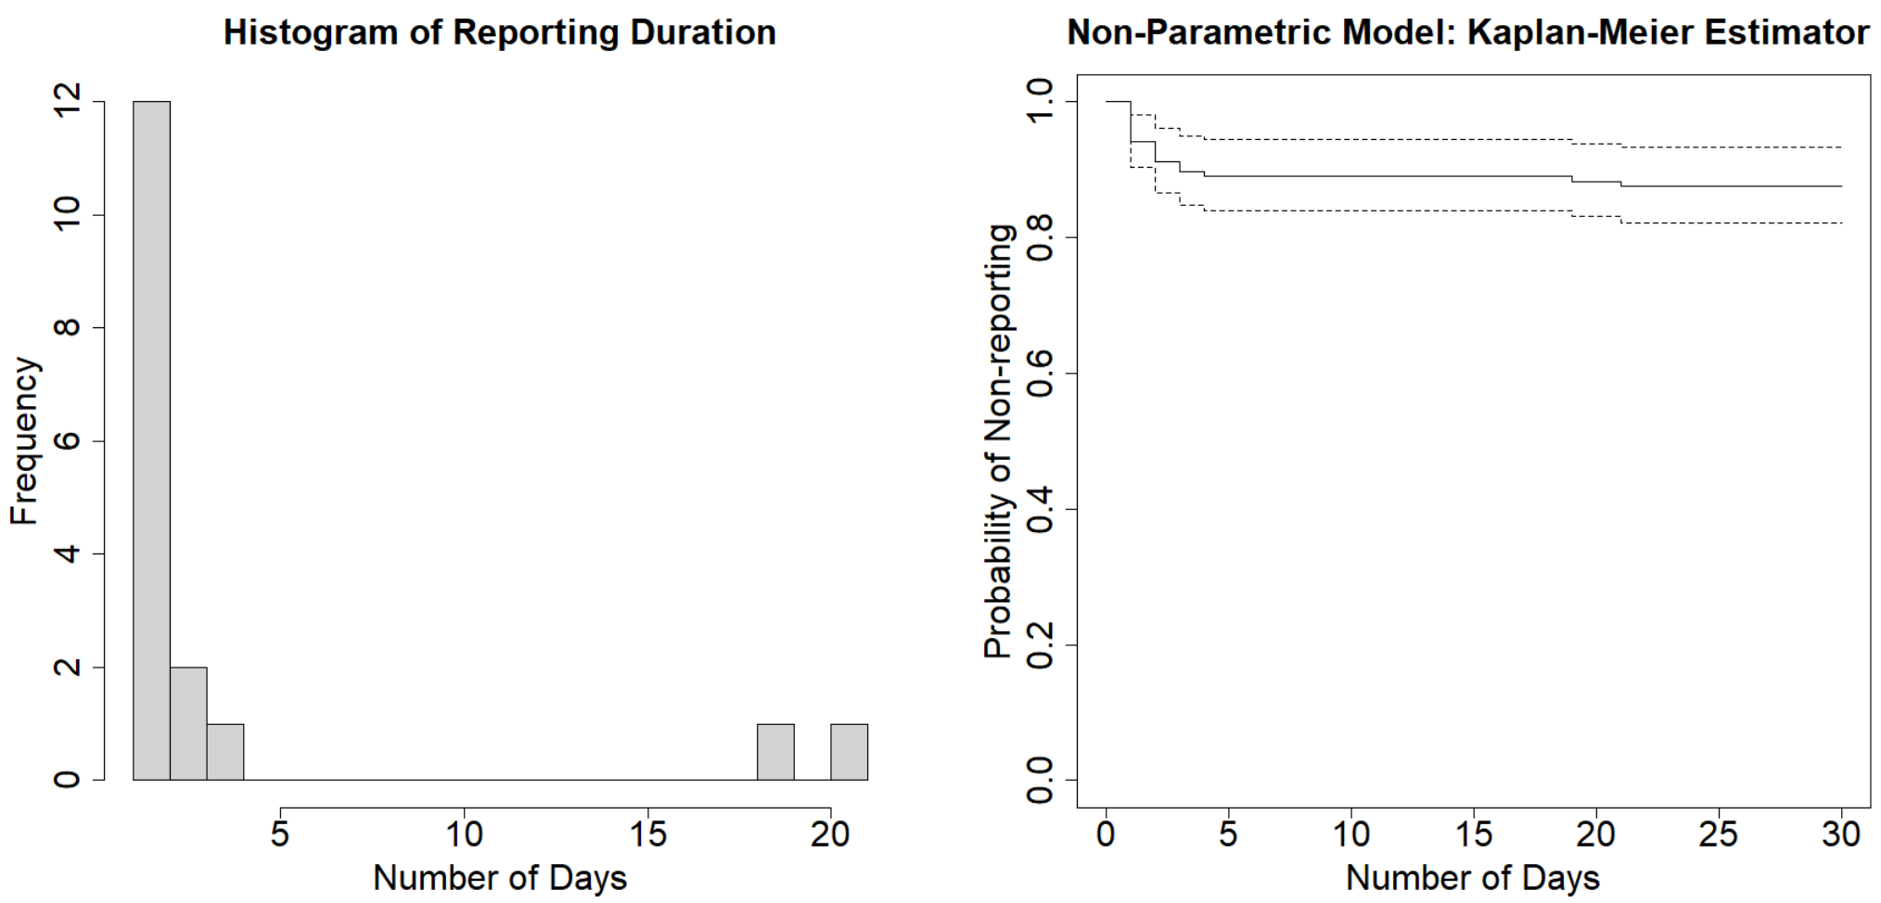

Test of Proportional Hazards Assumption
Central to the Cox model is the proportional hazards (PH) assumption. The PH assumption holds if the ratio of the hazards for individuals i and j are independent of t and are constant for all t:
$$\frac{h_{i}(t)}{h_{j}(t)}=e^{β(x_{i}-x_{j})}$$
We rely on scaled Schoenfeld residuals, gained from each Cox model (Models 1-7 in Table 1 and Models 8-13 in Table 2 in the text), to test nonproportionality. The logic behind scaled Schoenfeld residuals test is straightforward, which, in fact, is a test of nonzero slope in a generalized linear regression of scaled Schoenfeld residuals on time (Grambsch and Therneau 1994).
Appendix Table A.4: Global chi-square tests of the proportional hazards assumption
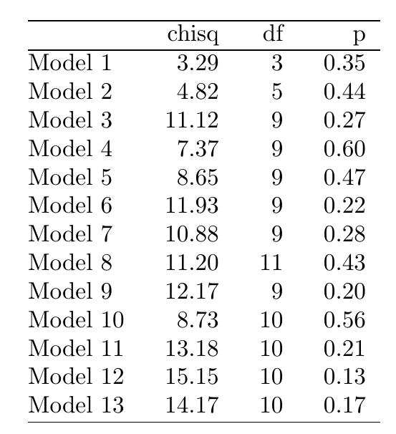
Table A.4 presents the global chi-squared tests of the proportional hazards assumption for each Cox model reported in the text. Given that all these p-values are greater than 0.05, we cannot reject the null hypothesis that there is no significant relationship between residuals and time (the Schoenfeld residuals are independent of time). Therefore, the proportional hazards assumption is satisfied.

Additional Model Results and Robustness Checks
Figure A.3 plots the four-case simulations for Model 6 and 7, which shows almost identical patterns as the one we presented in Figure 4 of the paper.
Appendix Figure A.3: Probability of Non-reporting: Model 6 and Model 7
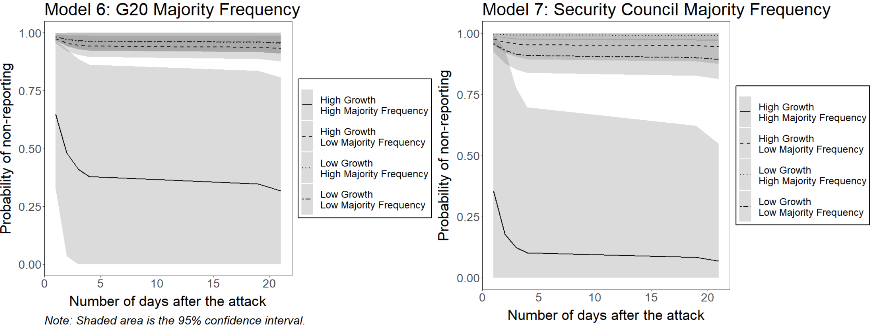

Model A1, A2, A3, and A4 replicate Model 10, 11, 12 and 13 presented in the paper, but drop GDP growth rate as a control variable. The results are presented in Table A.5, which are largely consistent with those reported in the paper.
Appendix Table A.5: Alternative Model Specifications
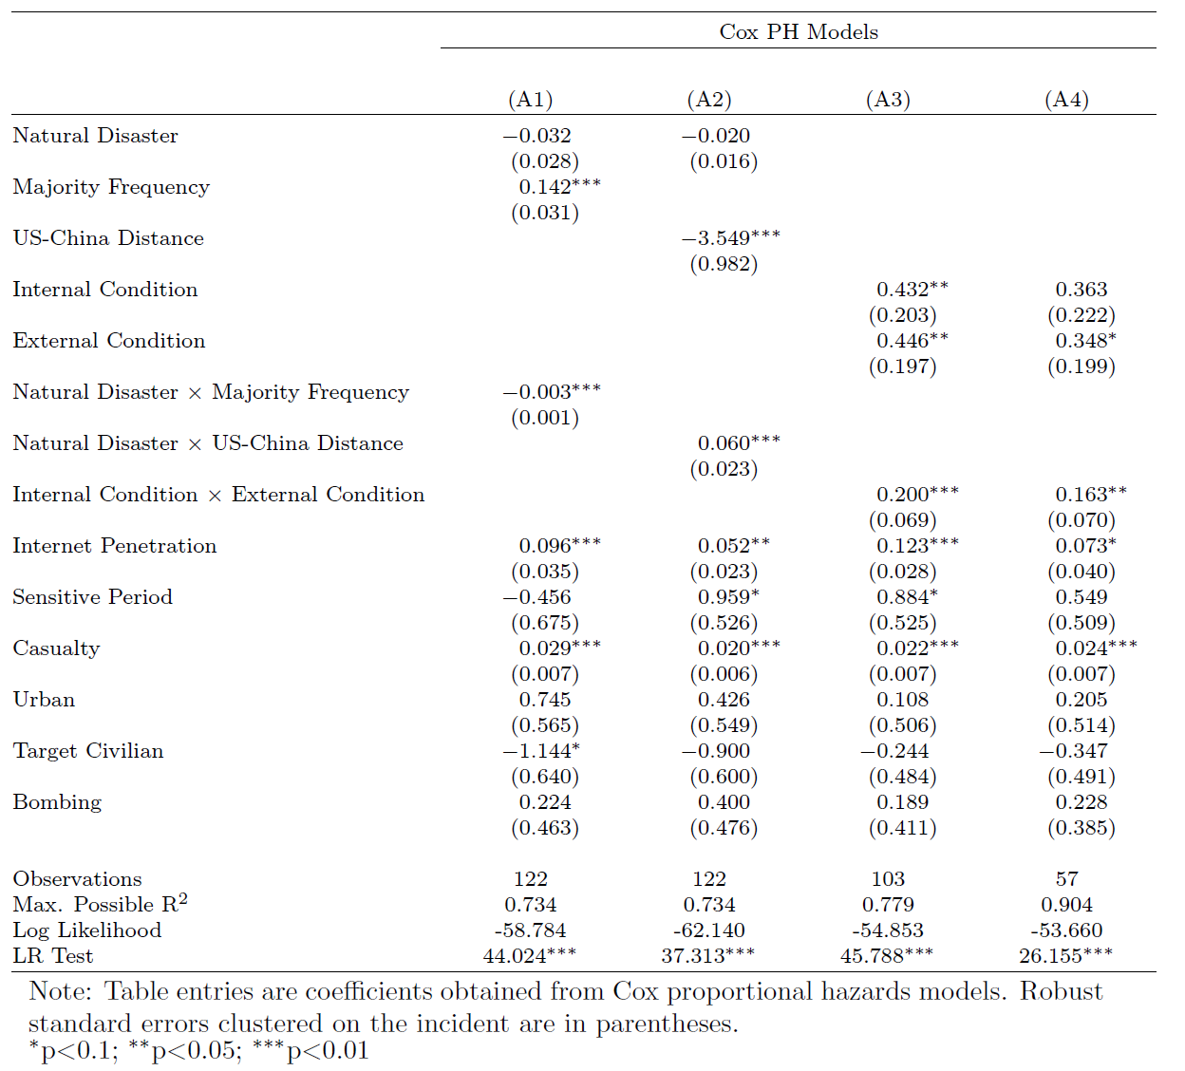

Logit Model Results, Binning Estimator, and Kernel Estimator
Table A.6 below shows the results from basic logistic models using GDP growth rate and UN voting majority (both are centered on their mean values) as measures of domestic and international environments, in which the dependent variable is simply whether each incident was acknowledged/not acknowledged. In all these models, the interaction term remains significant and in the anticipated direction.

Appendix Table A.6: Logit Regression
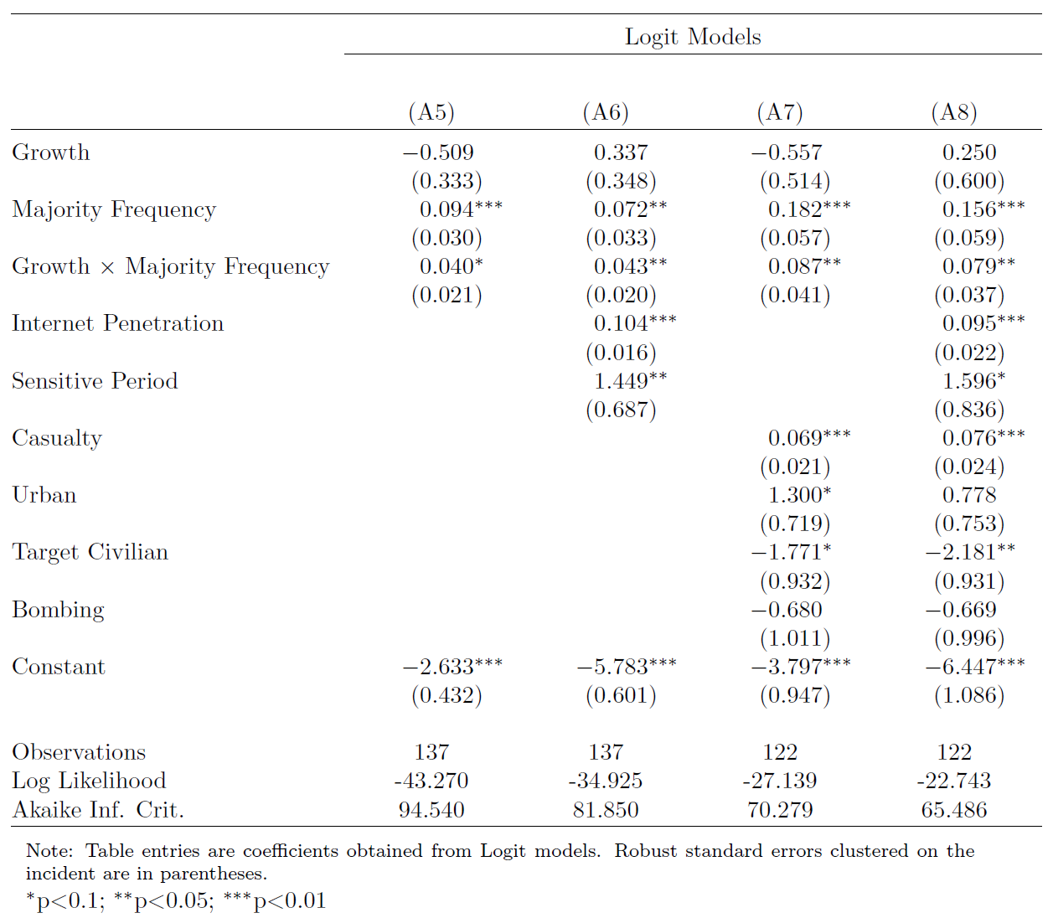

Figure A.4 below plots the predicted probability of being reported by People’s Daily varies over the GDP growth rate when the frequency of being a majority in UN voting is held at low and high values respectively (one standard deviation below and above the mean) based on Model A8. When Majority Freq is high, the probability of timely official coverage increases from 0.25 to 0.44, and then to 0.72 as the GDP growth rate increases from 8% to 9%, and then to 10%. In contrast, when the frequency of being a majority in UN voting is low, this probability remains low even when domestic conditions are favorable.

Appendix Figure A.4: Predicted probability of being reported by People’s Daily 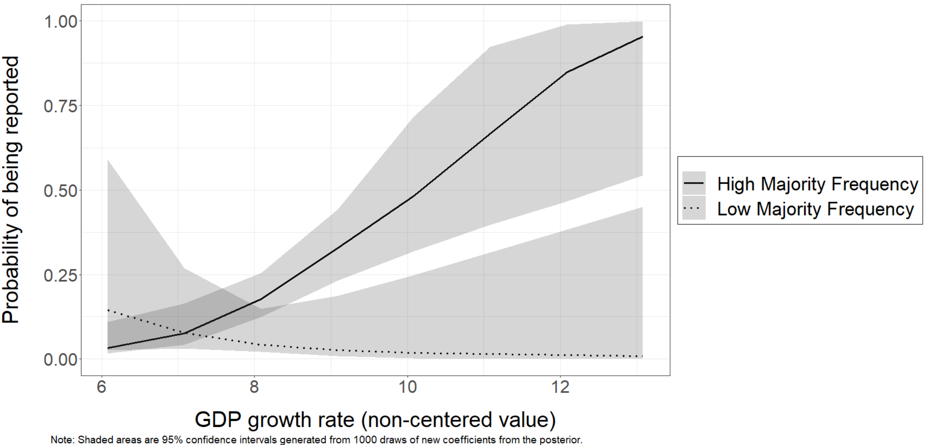

Hainmueller, Mummolo, and Xu (2019) argue that results from multiplicative interaction models might be biased due to violations of the linear interaction effect (LIE) assumption and the lack common support. They suggest that researchers should use simple scatterplots of raw data to detect these problems and apply two flexible estimation strategies (Binning Estimator and Kernel Estimator) if these problems are present. These procedures, however, best diagnose and adjust such issues in general linear regression models with continuous dependent variables (such as OLS). The closet check that we can perform with our data is to apply these procedures to a binary version of our dependent variable (reported/not reported), converting the the logit models reported in Table A.10 into simple OLS regression models.

Appendix Figure A.5: Linear Interaction Diagnostic Plots
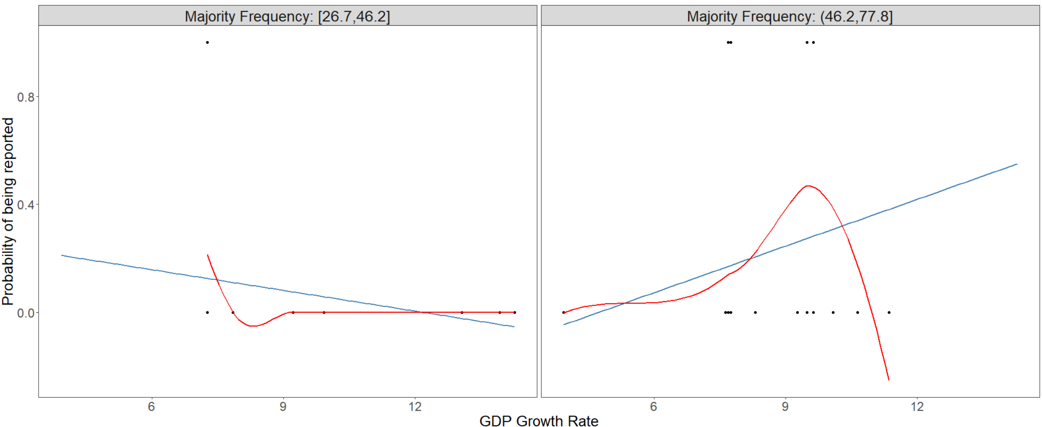

Figure A.5 provides scatterplots of the raw data with the linear regression lines (blue) and the LOESS fits (red). The two plots reveal that (1) there is evidence of an interaction effect as the slope of the line that captures the relationship between the probability of being reported and the value of GDP growth rate is weakly negative at low levels of Majority Frequency and positive at high levels of Majority Frequency; (2) there is sufficient common support as the observations are nearly equally distributed across two samples with low and high values of Majority Frequency; (3) the interaction effect might not be linear as the linear regression lines (blue) and the LOESS fits (red) diverge considerably, especially at high levels of Majority Frequency.
Appendix Figure A.6: Marginal Effect of Growth Rate Conditional on Majority Frequency

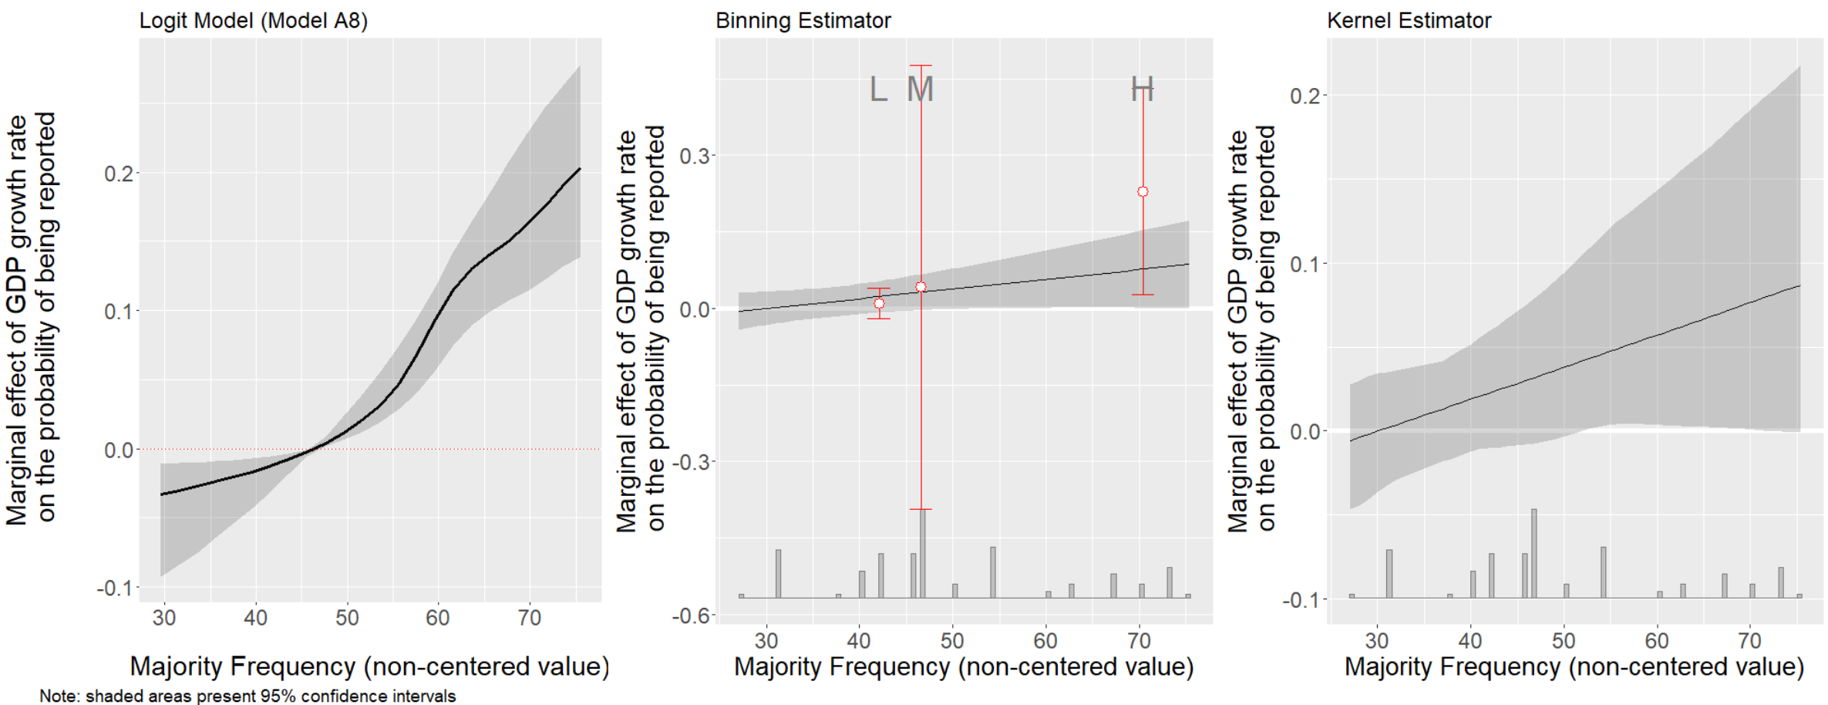

Figure A.6 indicates that the marginal effect of GDP growth rate on the probability of reporting varies at different values of Majority Frequency based on a logit model (left panel), binning estimator (center panel), and kernel estimator (right panel). All three plots demonstrate that the marginal effect of Growth tends to be positive and stronger as the value of Majority Frequency increases. The binning estimator for the GDP growth rate effect lines up very closely with the LIEs from the original model (OLS regression) at low and medium levels of Majority Frequency. At high levels of Majority Frequency, however, the binning estimator is larger than the OLS estimator. This suggests that the LIEs based on OLS regressions underestimate the positive marginal effect of GDP growth rate when Majority Frequency is high. The conditional marginal effect estimates from the kernel estimator in the right panel remain similar, although the magnitude of the effect becomes smaller and the optimal bandwidth selected by cross-validation is relatively larger.

Robustness Check: Ethnic Violence in China (EVC) Database
To assess the implications of the distinction between EVC data and our data for our findings, we added the necessary covariates to the EVC data and conducted robustness checks using EVC data (1990-2005) plus our post-2005 data. The Casualty variable is dropped in full EVC model because the EVC dataset doesn’t have information on the number of casualties at event level. The results are reported in Appendix Table A.7 below, which shows that models using EVC data yield almost identical results.

Appendix Table A.7: Robustness Checks with EVC data

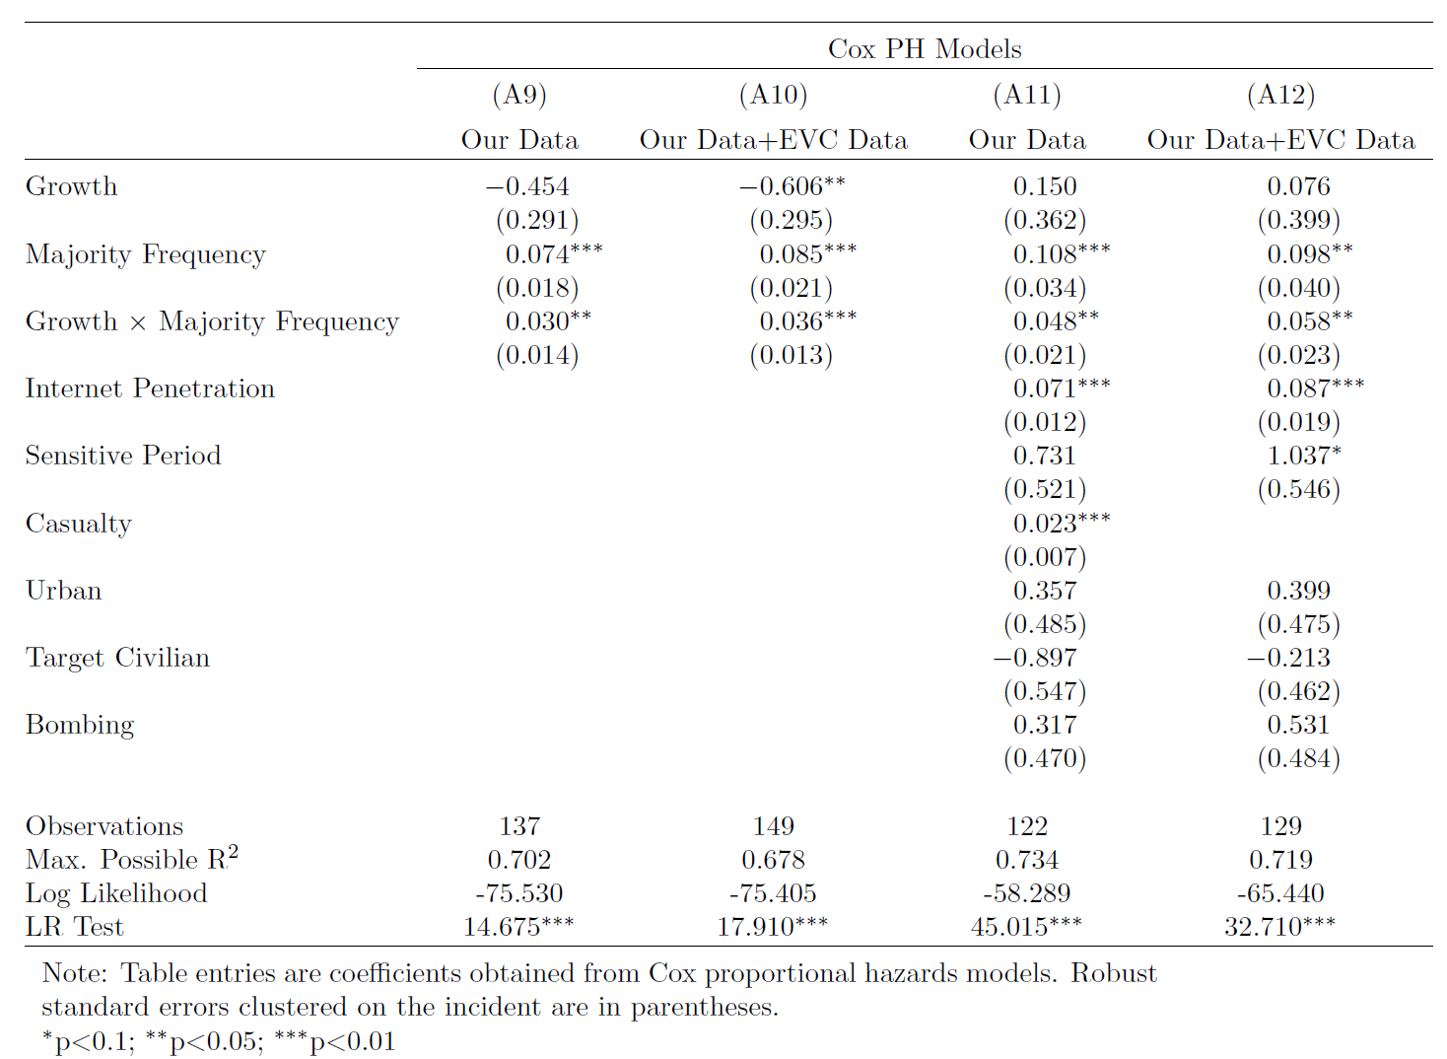

These 17 attacks are coded as non-bombing in statistical analyses. The ambiguity about weapons involved usually happens when the event is an assault or a murder in which explosive devices are unlikely to be used.
All the cases replicated by Hainmueller, Mummolo, and Xu (2019) use continuous dependent variables and OLS regression.
This divergence might also result from the binary dependent variable.
Control variables are included in all these models.
This result is consistent with the nonlinear marginal effect based on the logit model plotted in the left panel. The logit model is a linear model in the log odds metric, the probability is a nonlinear transformation of log odds

