Online Appendix:
Real, but Limited: A Meta-Analytic Assessment of Framing Effects in the Political Domain

Table of Contents
Online Appendix A: Studies Included in the Meta-Analysis 2
Online Appendix B: Moderator Analyses 17
Online Appendix C: p-Curve 21
Online Appendix D: Cumulative Meta-Analyses 22
Online Appendix E: Outlier Detection 29

Online Appendix A: Studies Included in the Meta-Analysis
Abril, E. P., Binder, A. R., Nan, X., Nevar, P. M., & Rojas, H. (2014). Persuasion and affect in the framing of poverty: An experiment on goal framing. Signo y Pensamiento, 33(65), 51-68.
Aklin, M., & Urpelainen, J. (2013). Debating clean energy: Frames, counter frames, and audiences. Global Environmental Change, 23(5), 1225-1232.
Arceneaux, K. (2012). Cognitive biases and the strength of political arguments. American Journal of Political Science, 56(2), 271-285.
Arceneaux, K., & Nickerson, D. W. (2010). Comparing negative and positive campaign messages: Evidence from two field experiments. American Politics Research, 38(1), 54-83.
Ardanaz, M., Murillo, M. V., & Pinto, P. M. (2013). Sensitivity to Issue Framing on Trade Policy Preferences: Evidence from a Survey Experiment. International Organization, 67(2), 411-437.
Astorino-Courtois, A. (1996). Transforming international agreements into national realities: Marketing Arab-Israeli peace in Jordan. The Journal of Politics, 58(4), 1035-1054.
Bali, V. (2009). Tinkering toward a national identification system: An experiment on policy attitudes. Policy Studies Journal, 37(2), 233-255.
Berinsky, A. J., Huber, G. A., & Lenz, G. S. (2012). Evaluating online labor markets for experimental research: Amazon.com's Mechanical Turk. Political Analysis, 20(3), 351-368.
Bernauer, T., Liang, D., McGrath, L. F., Shaymerdenova, I., & Zhang, H. (2016). Unilateral or reciprocal climate policy? Experimental evidence from China. Politics and Governance, 4(3), 152-171.
Bertolotti, M., & Catellani, P. (2014). Effects of message framing in policy communication on climate change. European Journal of Social Psychology, 44(5), 474-486.
Bertolotti, M., & Catellani, P. (2015). Agreement with climate change policies: Framing the future and national versus supranational identity. European Journal of Social Psychology, 45(7), 847-857.
Bigman, C. A., Cappella, J. N., & Hornik, R. C. (2010). Effective or ineffective: Attribute framing and the human papillomavirus (HPV) vaccine. Patient Education and Counseling, 81, S70-S76.
Bilandzic, H., Kalch, A., & Soentgen, J. (2017). Effects of goal framing and emotions on perceived threat and willingness to sacrifice for climate change. Science Communication, 39(4), 466-491.
Bizer, G. Y., Larsen, J. T., & Petty, R. E. (2011). Exploring the valence-framing effect: Negative framing enhances attitude strength. Political Psychology, 32(1), 59-80.
Bizer, G. Y., & Petty, R. E. (2005). How we conceptualize our attitudes matters: The effects of valence framing on the resistance of political attitudes. Political Psychology, 26(4), 553-568.
Bizer, G. Y., Žeželj, I. L., & Luguri, J. B. (2013). When are support and opposition not opposites? Depth of processing as a moderator of the valence‐framing effect. British Journal of Social Psychology, 52(1), 191-201.
Boettcher III, W. A. (1995). Context, methods, numbers, and words: Prospect theory in international relations. Journal of Conflict Resolution, 39(3), 561-583.
Boettcher III, W. A. (2004a). Military intervention decisions regarding humanitarian crises: Framing induced risk behavior. Journal of Conflict Resolution, 48(3), 331-355.
Boettcher III, W. A. (2004b). The prospects for prospect theory: An empirical evaluation of international relations applications of framing and loss aversion. Political Psychology, 25(3), 331-362.
Boomgaarden, H., Boukes, M., & Iorgoveanu, A. (2016). Image versus text: How newspaper reports affect evaluations of political candidates. International Journal of Communication, 10, 2529–2555.
Borah, P. (2011). Seeking more information and conversations: Influence of competitive frames and motivated processing. Communication Research, 38(3), 303-325.
Bos, L., Lecheler, S., Mewafi, M., & Vliegenthart, R. (2016). It's the frame that matters: Immigrant integration and media framing effects in the Netherlands. International Journal of Intercultural Relations, 55, 97-108.
Bowler, S., & Donovan, T. (2007). Reasoning about institutional change: Winners, losers and support for electoral reforms. British Journal of Political Science, 37(3), 455-476.
Brader, T., Valentino, N. A., & Suhay, E. (2008). What triggers public opposition to immigration? Anxiety, group cues, and immigration threat. American Journal of Political Science, 52(4), 959-978.
Brewer, P. R. (2001). Value words and lizard brains: Do citizens deliberate about appeals to their core values? Political Psychology, 22(1), 45-64.
Brewer, P. R., & Gross, K. (2005). Values, framing, and citizens’ thoughts about policy issues: Effects on content and quantity. Political Psychology, 26(6), 929-948.
Brewer, P. R., & Ley, B. L. (2014). Contested evidence: Exposure to competing scientific claims and public support for banning bisphenol A. Public Understanding of Science, 23(4), 395-410.
Burgers, C. & De Graaf, A. (2013). Language intensity as a sensationalistic news feature: The influence of style on sensationalism perceptions and effects. Communications, 38(2), 167-188.
Campbell, R., & Cowley, P. (2014). Rebellion versus loyalty, shirking versus working: A note on framing parliamentary behaviour. Representation, 50(4), 421-427.
Chong, D., & Druckman, J. N. (2007). Framing public opinion in competitive democracies. American Political Science Review, 101(4), 637-655.
Chong, D., & Druckman, J. N. (2010). Dynamic public opinion: Communication effects over time. American Political Science Review, 104(4), 663-680.
Cobb, M. D. (2005). Framing effects on public opinion about nanotechnology. Science Communication, 27(2), 221-239.
Corstange, D., & York, E. A. (2018). Sectarian framing in the Syrian civil war. American Journal of Political Science, 62(2), 441-455.
De Fine Licht, J. (2011). Do we really want to know? The potentially negative effect of transparency in decision making on perceived legitimacy. Scandinavian Political Studies, 34(3), 183-201.
de Vreese, C. H. (2010). Framing the economy: Effects of journalistic news frames. In P. DíAngelo & J. A. Kuypers (Eds.), Doing news framing analysis (pp. 187-214). New York, NY: Routledge.
de Vreese, C., & Boomgaarden, H. (2003). Valenced news frames and public support for the EU. Communications, 28(4), 361-381.
de Vreese, C. H., Boomgaarden, H. G., & Semetko, H. A. (2011). (In)direct framing effects: The effects of news media framing on public support for Turkish membership in the European Union. Communication Research, 38(2), 179-205.
de Vreese, C. H., & Kandyla, A. (2009). News framing and public support for a common foreign and security policy. JCMS: Journal of Common Market Studies, 47(3), 453-481.
de Vries, G., Terwel, B. W., & Ellemers, N. (2016). Perceptions of manipulation and judgments of illegitimacy: Pitfalls in the use of emphasis framing when communicating about CO2 capture and storage. Environmental Communication, 10(2), 206-226.
Detenber, B. H., Ho, S. S., Ong, A. H., & Lim, N. W. (2018). Complementary versus competitive framing effects in the context of pro-environmental attitudes and behaviors. Science Communication, 40(2), 173-198.
Druckman, J. N. (2001a). On the limits of framing effects: Who can frame? The Journal of Politics, 63(4), 1041-1066.
Druckman, J. N. (2001b). Using credible advice to overcome framing effects. Journal of Law, Economics, and Organization, 17(1), 62-82.
Druckman, J. N. (2004). Political preference formation: Competition, deliberation, and the (ir)relevance of framing effects. American Political Science Review, 98(4), 671-686.
Druckman, J. N., & Bolsen, T. (2011). Framing, motivated reasoning, and opinions about emergent technologies. Journal of Communication, 61(4), 659-688.
Druckman, J. N., Fein, J., & Leeper, T. J. (2012). A source of bias in public opinion stability. American Political Science Review, 106(2), 430-454.
Druckman, J. N., & Leeper, T. J. (2012). Learning more from political communication experiments: Pretreatment and its effects. American Journal of Political Science, 56(4), 875-896.
Druckman, J. N., & McDermott, R. (2008). Emotion and the framing of risky choice. Political Behavior, 30(3), 297-321.
Druckman, J. N., Peterson, E., & Slothuus, R. (2013). How elite partisan polarization affects public opinion formation. American Political Science Review, 107(1), 57-79.
Fatemi, D. J., Hasseldine, D. J., & Hite, P. A. (2008). Resisting framing effects: The importance of prior attitude on estate tax preferences. Journal of the American Taxation Association, 30(1), 101-121.
Fridkin, K. L., Kenney, P. J., Gershon, S. A., Shafer, K., & Woodall, G. S. (2007). Capturing the power of a campaign event: The 2004 presidential debate in Tempe. The Journal of Politics, 69(3), 770-785.
Fridkin, K., Wintersieck, A., Courey, J., & Thompson, J. (2017). Race and police brutality: The importance of media framing. International Journal of Communication, 11, 3394–3414.
Gamliel, E., & Peer, E. (2010). Attribute framing affects the perceived fairness of health care allocation principles. Judgment and Decision Making, 5(1), 11-20.
Gayer, C. C., Landman, S., Halperin, E., & Bar-Tal, D. (2009). Overcoming psychological barriers to peaceful conflict resolution: The role of arguments about losses. Journal of Conflict Resolution, 53(6), 951-975.
Gerber, A. S., Huber, G. A., Fang, A. H., & Reardon, C. E. (2018). The comparative effectiveness on turnout of positively versus negatively framed descriptive norms in mobilization campaigns. American Politics Research, 46(6), 996-1011.
Gesser-Edelsburg, A., Walter, N., Shir-Raz, Y., & Green, M. S. (2015). Voluntary or mandatory? The valence framing effect of attitudes regarding HPV vaccination. Journal of Health Communication, 20(11), 1287-1293.
Gieling, M., Thijs, J., & Verkuyten, M. (2012). Dutch adolescents’ tolerance of practices by Muslim actors: The effect of issue framing. Youth & Society, 44(3), 348-365.
Goodwin, M., Hix, S., & Pickup, M. (2018). For and against Brexit: A survey experiment of the impact of campaign effects on public attitudes toward EU membership. British Journal of Political Science. Advance online publication. doi:10.1017/S0007123417000667
Han, G., & Wang, X. (2012). Understanding “Made in China”: Valence framing and product-country image. Journalism & Mass Communication Quarterly, 89(2), 225-243.
Harrison, B. F., & Michelson, M. R. (2017). Using experiments to understand public attitudes towards transgender rights. Politics, Groups, and Identities, 5(1), 152-160.
Hartman, T. K., & Weber, C. R. (2009). Who said what? The effects of source cues in issue frames. Political Behavior, 31(4), 537.
Hasseldine, J., & Hite, P. A. (2003). The effects of attribute framing and political party affiliation on taxpayer preferences. eJournal of Tax Research, 1(1), 5-18.
Hilbig, B. E. (2009). Sad, thus true: Negativity bias in judgments of truth. Journal of Experimental Social Psychology, 45(4), 983-986.
Hilbig, B. E. (2012). Good things don’t come easy (to mind): Explaining framing effects in judgments of truth. Experimental Psychology, 59, 38-46.
Hiscox, M. J. (2006). Through a glass and darkly: Attitudes toward international trade and the curious effects of issue framing. International Organization, 60(3), 755-780.
Hobolt, S. B., Tilley, J., & Wittrock, J. (2013). Listening to the government: How information shapes responsibility attributions. Political Behavior, 35(1), 153-174.
Hobolt, S. B., & Wittrock, J. (2011). The second-order election model revisited: An experimental test of vote choices in European Parliament elections. Electoral Studies, 30(1), 29-40.
Holler, M., Hoelzl, E., Kirchler, E., Leder, S., & Mannetti, L. (2008). Framing of information on the use of public finances, regulatory fit of recipients and tax compliance. Journal of Economic Psychology, 29(4), 597-611.
Hornsey, M. J., & Fielding, K. S. (2016). A cautionary note about messages of hope: Focusing on progress in reducing carbon emissions weakens mitigation motivation. Global Environmental Change, 39, 26-34.
Jerit, J. (2009). How predictive appeals affect policy opinions. American Journal of Political Science, 53(2), 411-426.
Jones, C. R., Eiser, J. R., & Gamble, T. R. (2012). Assessing the impact of framing on the comparative favourability of nuclear power as an electricity generating option in the UK. Energy Policy, 41, 451-465.
Kam, C. D., & Simas, E. N. (2010). Risk orientations and policy frames. The Journal of Politics, 72(2), 381-396.
Kim, H. J. (2018). The effects of gain versus loss framing and issue involvement on publics’ responses to nuclear energy messages in South Korea. Asian Journal of Communication, 28(5), 541-558.
Kinder, D. R., & Sanders, L. M. (1996). Divided by color: Racial politics and democratic ideals. Chicago, IL: University of Chicago Press.
Kirchler, E., & Maciejovsky, B. (2001). Tax compliance within the context of gain and loss situations, expected and current asset position, and profession. Journal of Economic Psychology, 22(2), 173-194.
Koch, T., & Peter, C. (2017). Effects of equivalence framing on the perceived truth of political messages and the trustworthiness of politicians. Public Opinion Quarterly, 81(4), 847-865.
Krause, A., & Bucy, E. P. (2018). Interpreting images of fracking: How visual frames and standing attitudes shape perceptions of environmental risk and economic benefit. Environmental Communication, 12(3), 322-343.
Krishen, A. S., Raschke, R., Kachroo, P., LaTour, M., & Verma, P. (2014). Promote me or protect us? The framing of policy for collective good. European Journal of Marketing, 48(3/4), 742-760.
Krishen, A., Raschke, R., & Mejza, M. (2010). Guidelines for shaping perceptions of fairness of transportation infrastructure policies: The case of a vehicle mileage tax. Transportation Journal, 49(3), 24-38.
Kuehnhanss, C. R., Heyndels, B., & Hilken, K. (2015). Choice in politics: Equivalency framing in economic policy decisions and the influence of expertise. European Journal of Political Economy, 40, 360-374.
Lagerwerf, L., Boeynaems, A., van Egmond-Brussee, C., & Burgers, C. (2015). Immediate attention for public speech: Differential effects of rhetorical schemes and valence framing in political radio speeches. Journal of Language and Social Psychology, 34(3), 273-299.
Lecheler, S., Bos, L., & Vliegenthart, R. (2015). The mediating role of emotions: News framing effects on opinions about immigration. Journalism & Mass Communication Quarterly, 92(4), 812-838.
Lecheler, S., & de Vreese, C. H. (2010). Framing Serbia: The effects of news framing on public support for EU enlargement. European Political Science Review, 2(1), 73-93.
Lecheler, S., & de Vreese, C. H. (2011). Getting real: The duration of framing effects. Journal of Communication, 61(5), 959-983.
Lecheler, S., & de Vreese, C. H. (2012). News framing and public opinion: A mediation analysis of framing effects on political attitudes. Journalism & Mass Communication Quarterly, 89(2), 185-204.
Lecheler, S., & de Vreese, C. H. (2013). What a difference a day makes? The effects of repetitive and competitive news framing over time. Communication Research, 40(2), 147-175.
Lecheler, S., de Vreese, C., & Slothuus, R. (2009). Issue importance as a moderator of framing effects. Communication Research, 36(3), 400-425.
Lecheler, S., Keer, M., Schuck, A. R., & Hänggli, R. (2015). The effects of repetitive news framing on political opinions over time. Communication Monographs, 82(3), 339-358.
Lecheler, S., Schuck, A. T., & de Vreese, C. H. (2013). Dealing with feelings: Positive and negative discrete emotions as mediators of news framing effects. Communications, 38, 189-209.
Leder, S., Mannetti, L., Hölzl, E., & Kirchler, E. (2010). Regulatory fit effects on perceived fiscal exchange and tax compliance. The Journal of Socio-Economics, 39(2), 271-277.
Lee, T. K., & Kim, H. K. (2017). Differential effects of message framing on obesity policy support between Democrats and Republicans. Health Communication, 32(12), 1481-1490.
Leeper, T. J. (2017). How does treatment self-selection affect inferences about political communication? Journal of Experimental Political Science, 4(1), 21-33.
Lubieniechi, S., Hesseln, H., Phillips, P., & Smyth, S. (2016). Expert and lay public risk preferences regarding plants with novel traits. Canadian Journal of Agricultural Economics, 64(4), 717-738.
Malhotra, N., & Margalit, Y. (2010). Short-term communication effects or longstanding dispositions? The public’s response to the financial crisis of 2008. The Journal of Politics, 72(3), 852-867.
Maoz, I. (2006). The effect of news coverage concerning the opponents' reaction to a concession on its evaluation in the Israeli-Palestinian conflict. Harvard International Journal of Press/Politics, 11(4), 70-88.
Maoz, I. (2012). Threats versus promises: How the framing of concession appeals in news coverage affects support for compromise. International Journal of Communication, 6, 2280-2300.
Maoz, I., Yaniv, I., & Ivri, N. (2007). Decision framing and support for concessions in the Israeli-Palestinian conflict. Journal of Peace Research, 44(1), 81-91.
Marcus, G. E., Sullivan, J. L., Theiss‐Morse, E., & Stevens, D. (2005). The emotional foundation of political cognition: The impact of extrinsic anxiety on the formation of political tolerance judgments. Political Psychology, 26(6), 949-963.
Marti, M., Stauffacher, M., Matthes, J., & Wiemer, S. (2018). Communicating earthquake preparedness: The influence of induced mood, perceived risk, and gain or loss frames on homeowners’ attitudes toward general precautionary measures for earthquakes. Risk Analysis, 38(4), 710-723.
McCright, A. M., Charters, M., Dentzman, K., & Dietz, T. (2016). Examining the effectiveness of climate change frames in the face of a climate change denial counter-frame. Topics in Cognitive Science, 8(1), 76-97.
Milojevich, J., & Beattie, P. (2018). The pull of humanitarian interventionism: Examining the effects of media frames and political values on people’s choice of resolution. International Journal of Communication, 12, 831-855.
Morton, T. A., Rabinovich, A., Marshall, D., & Bretschneider, P. (2011). The future that may (or may not) come: How framing changes responses to uncertainty in climate change communications. Global Environmental Change, 21(1), 103-109.
Nabi, R. L., Gustafson, A., & Jensen, R. (2018). Framing climate change: Exploring the role of emotion in generating advocacy behavior. Science Communication, 40(4), 442-468.
Nan, X., & Madden, K. (2014). The role of cultural worldviews and message framing in shaping public opinions toward the human papillomavirus vaccination mandate. Human Communication Research, 40(1), 30-53.
Nelson, T. E., Clawson, R. A., & Oxley, Z. M. (1997). Media framing of a civil liberties conflict and its effect on tolerance. American Political Science Review, 91(3), 567-583.
Nelson, T. E., Lecheler, S., Schuck, A. R., & De Vreese, C. H. (2015). Value poaching: Framing the same values for competing political ends. International Journal of Communication, 9, 2281-2902.
Newman, B. J., Hartman, T. K., Lown, P. L., & Feldman, S. (2015). Easing the heavy hand: Humanitarian concern, empathy, and opinion on immigration. British Journal of Political Science, 45(3), 583-607.
Niederdeppe, J., Gollust, S. E., & Barry, C. L. (2014). Inoculation in competitive framing: Examining message effects on policy preferences. Public Opinion Quarterly, 78(3), 634-655.
Olsen, A. L. (2015). Citizen (dis)satisfaction: An experimental equivalence framing study. Public Administration Review, 75(3), 469-478.
Pleger, L. E., Lutz, P., & Sager, F. (2018). Public acceptance of incentive-based spatial planning policies: A framing experiment. Land Use Policy, 73, 225-238.
Powell, T. E., Boomgaarden, H. G., De Swert, K., & de Vreese, C. H. (2015). A clearer picture: The contribution of visuals and text to framing effects. Journal of Communication, 65(6), 997-1017.
Pratto, F., Glasford, D. E., & Hegarty, P. (2006). Weighing the prospects of war. Group Processes & Intergroup Relations, 9(2), 219-233.
Quattrone, G. A., & Tversky, A. (1988). Contrasting rational and psychological analyses of political choice. American Political Science Review, 82(3), 719-736.
Quick, B. L., Kam, J. A., Morgan, S. E., Montero Liberona, C. A., & Smith, R. A. (2014). Prospect theory, discrete emotions, and freedom threats: An extension of psychological reactance theory. Journal of Communication, 65(1), 40-61.
Quiring, O., & Weber, M. (2012). Between usefulness and legitimacy: Media coverage of governmental intervention during the financial crisis and selected effects. The International Journal of Press/Politics, 17(3), 294-315.
Ramírez, C. Z., & Verkuyten, M. (2011). Values, media framing, and political tolerance for extremist groups. Journal of Applied Social Psychology, 41(7), 1583-1602.
Ramasubramanian, S., & Martinez, A. R. (2017). News framing of Obama, racialized scrutiny, and symbolic racism. Howard Journal of Communications, 28(1), 36-54.
Schuck, A. R., & de Vreese, C. H. (2006). Between risk and opportunity: News framing and its effects on public support for EU enlargement. European Journal of Communication, 21(1), 5-32.
Schuck, A. R., & de Vreese, C. H. (2009). Reversed mobilization in referendum campaigns: How positive news framing can mobilize the skeptics. The International Journal of Press/Politics, 14(1), 40-66.
Shah, D. V., Kwak, N., Schmierbach, M., & Zubric, J. (2004). The interplay of news frames on cognitive complexity. Human Communication Research, 30(1), 102-120.
Shen, F. (2004). Effects of news frames and schemas on individuals' issue interpretations and attitudes. Journalism & Mass Communication Quarterly, 81(2), 400-416.
Shen, F., Ahern, L., & Baker, M. (2014). Stories that count: Influence of news narratives on issue attitudes. Journalism & Mass Communication Quarterly, 91(1), 98-117.
Simon, A. F., & Jerit, J. (2007). Toward a theory relating political discourse, media, and public opinion. Journal of Communication, 57(2), 254-271.
Slothuus, R. (2007). Framing deservingness to win support for welfare state retrenchment. Scandinavian Political Studies, 30(3), 323-344.
Slothuus, R. (2008). More than weighting cognitive importance: A dual-process model of issue framing effects. Political Psychology, 29(1), 1-28.
Slothuus, R., & de Vreese, C. H. (2010). Political parties, motivated reasoning, and issue framing effects. The Journal of Politics, 72(3), 630-645.
Sniderman, P. M., & Theriault, S. M. (2004). The structure of political argument and the logic of issue framing. In W. E. Saris & P. M. Sniderman (Eds.), Studies in public opinion: Attitudes, nonattitudes, measurement error, and change (pp. 133–165). Princeton, NJ: Princeton University Press.
Soroka, S., Loewen, P., Fournier, P., & Rubenson, D. (2016). The impact of news photos on support for military action. Political Communication, 33(4), 563-582.
Spence, A., & Pidgeon, N. (2010). Framing and communicating climate change: The effects of distance and outcome frame manipulations. Global Environmental Change, 20(4), 656-667.
Stewart, C. O. (2013). The influence of news frames and science background on attributions about embryonic and adult stem cell research: Frames as heuristic/biasing cues. Science Communication, 35(1), 86-114.
van Londen, M., Coenders, M., & Scheepers, P. (2010). Effects of issue frames on aversion to ethnic-targeted school policies. Methodology: European Journal of Research Methods for the Behavioral and Social Sciences, 6(3), 96-106
Vraga, E. K., Carr, D. J., Nytes, J. P., & Shah, D. V. (2010). Precision vs. realism on the framing continuum: Understanding the underpinnings of message effects. Political Communication, 27(1), 1-19.
Walker, B. J., Wiersma, B., & Bailey, E. (2014). Community benefits, framing and the social acceptance of offshore wind farms: An experimental study in England. Energy Research & Social Science, 3, 46-54.
Wasike, B. (2017). Persuasion in 140 characters: Testing issue framing, persuasion and credibility via Twitter and online news articles in the gun control debate. Computers in Human Behavior, 66, 179-190.
Wilson, D. C., & Brewer, P. R. (2013). The foundations of public opinion on voter ID laws: Political predispositions, racial resentment, and information effects. Public Opinion Quarterly, 77(4), 962-984.
Wilson, R. S., Ascher, T. J., & Toman, E. (2012). The importance of framing for communicating risk and managing forest health. Journal of Forestry, 110(6), 337-341.
Wise, D., & Brewer, P. R. (2010). Competing frames for a public health issue and their effects on public opinion. Mass Communication and Society, 13(4), 435-457.
Yaniv, I. (2011). Group diversity and decision quality: Amplification and attenuation of the framing effect. International Journal of Forecasting, 27(1), 41-49.
Žeželj, I., Škorić, M., Bogdanović, S., Hristić, D., & Stokić, D. (2007). Valence framing of political preferences and resistance to persuasion. Psihologija, 40(3), 365-383.
Online Appendix B: Moderator Analyses
Table B1
Moderator Analyses for the Effects of Positive vs. Negative Frames
 | k | Cohen's d | 95% CI | Test
Framing Conceptualization |  |  |  | Q(1) = 1.35
Emphasis Framing | 144 | .40 | [.35, .45]
Equivalency Framing | 17 | .52 | [.33, .70]
Type of Outcome |  |  |  | Q(2) = 90.58***
Attitudes | 161 | .41 | [.36, .47]
Emotions | 14 | .47 | [.33, .61]
Behavior | 26 | .11 | [.06 .15]
Medium |  |  |  | Q(3) = 2.26
Written | 133 | .43 | [.37, .48]
Visual | 8 | .34 | [.19, .48]
Textual & Visual Combined | 2 | .61 | [.18, 1.03]
Oral | 16 | .37 | [.20, .54]
Frame Source |  |  |  | Q(4) = 6.16
Media | 63 | .44 | [.37, .51]
Political Source | 7 | .31 | [.13, .49]
Interest Group | 1 | .13 | [-.24, .50]
General Source | 86 | .41 | [.34, .49]
Other | 4 | .29 | [.13, .45]
Country |  |  |  | Q(1) = .21
US | 81 | .40 | [.33, .47]
Non-US | 80 | .43 | [.35, .50]
Sample Composition |  |  |  | Q(3) = 2.77
Student Sample | 64 | .44 | [.37, .51]
General Population (Representative) | 42 | .42 | [.32, .52]
General Population (Non-Representative) | 40 | .35 | [.26, .45]
Mixed | 11 | .48 | [.35, .60]
Period |  |  |  | Q(1) = .02
Elections | 10 | .40 | [.19, .61]
Routine | 150 | .41 | [.36, .46]
Behavior Type (Behavior Only) |  |  |  | Q(1) = 2.84
Behavior Intention | 15 | .15 | [.10, .20]
Actual Behavior | 10 | .08 | [.01, .14]
Notes. (1) All moderator analyses were conducted on the attitudes DV unless mentioned otherwise. (2) In the moderator analysis of Frame Source, the “General Source” category includes cases where no specific source was mentioned, and the “Other” category includes texts from commercials or academic journals. In the Sample Composition moderator, the “Mixed” category refers to samples mixing students and the general population. (3) For the moderator analysis of Behavior Type, we had to exclude the study of Leeper (2017; cited in the text) since he measured both actual and intended behavior on the same sample, which would violate the assumption of independent effect sizes. (4) k = number of effect sizes; CI = confidence interval; Q = test statistic of Q test for heterogeneity.
* p < .05. ** p < .01. *** p < .001.
Table B2
Moderator Analyses for the Effects of Competitive Frames
 | k | Cohen's d | 95% CI | Test
Medium |  |  |  | Q(1) = 5.52*
Written | 23 | .15 | [.10, .19]
Oral | 11 | .25 | [.18, .33]
Country |  |  |  | Q(1) = .18
US | 26 | .18 | [.12, .23]
Non-US | 8 | .20 | [.13, .27]
Sample Composition |  |  |  | Q(4) = 2.61
Student Sample | 2 | .12 | [–.16, .40]
General Population (Representative) | 17 | .20 | [.14, .26]
General Population (Non-Representative) | 7 | .17 | [.08, .25]
Mixed | 6 | .13 | [.04, .23]
Other | 1 | .26 | [.08, .44]
Period |  |  |  | Q(1) = 10.61***
Elections | 5 | .08 | [.03, .14]
Routine | 29 | .20 | [.16, .25]
Notes. (1) We did not perform moderator analyses for variables in which one category was examined by a single study only. These moderators were Framing Conceptualization, Type of Outcome, and Frame Source. (2) In the Sample Composition moderator, the “Mixed” category refers to samples mixing students and the general population. In the Sample Composition moderator, the “Other” category includes a youth sample. (3) k = number of effect sizes; CI = confidence interval; Q = test statistic of Q test for heterogeneity.
* p < .05. ** p < .01. *** p < .001.

Table B3
Comparison Between Positive vs. Negative Framing and Competitive Framing vs. Control (on Attitudes)
 | k | Cohen's d | 95% CI | Test
Framing Type |  |  |  | Q(1) = 48.95***
Positive vs. Negative | 141 | .40 | [.35, .46]
Competition vs. Control | 14 | .16 | [.11, .20]
Notes. (1) Twenty original studies belong to both framing types, since they examine the effects of positive vs. negative frames both separately (i.e., as a comparison of two single frames) and combined into a single frame (i.e., in a separate, competitive framing condition). Including these studies in this moderator analysis would violate the assumption of independent effect sizes. Therefore, we only included unique studies that belong to one framing type. (2) k = number of effect sizes; CI = confidence interval; Q = test statistic of Q test for heterogeneity.
* p < .05. ** p < .01. *** p < .001.

In addition to directly comparing positive versus negative framing, we have meta-analyzed the effects of positive or negative frames compared to a control group receiving a neutral or no stimulus. These analyses allow us to examine whether framing effects are driven by people’s tendency to put more weight on negative information, a phenomenon known as negativity bias. Table B4 below presents the full results. When examining effects on attitudes, we find similar effect sizes for positive (d = .24, 95% CI [.19, .29], z = 9.11, p < .001, k = 69) and negative frames (d = .30, 95% CI [.24, .37], z = 9.02, p < .001, k = 60), both compared to a control group. As for behavior, we find that negative frames can drive people to action, compared to a control group (d = .21, 95% CI [.08, .35], z = 3.04, p < .01, k = 8). However, positive frames, compared to a control group, have no significant effect on behavior (d = .06, 95% CI [–.04, .15], z = 1.19, p > .05, k = 7). In other words, attitudes are affected equally by positive and negative frames, whereas behavior is only affected by negative frames.

Table B4
Framing Effects of Positive and Negative Frames vs. a Control Group
Frame type | DV | k | Unadjusted effect size |  | Adjusted for publication bias |  | Adjusted for measurement error
 |  |  | d  95% CI | z | d  95% CI | z | d  95% CI | z
Positive vs. Control | Attitudes | 69 | .24***  [.19, .29] | 9.11 | .27***  [.22, .32] | 11.02 | .27***  [.21, .33] | 8.96
 | Emotions | 2 | .21*  [.03, .39] | 2.28 | — | — | .21*  [.03, .40] | 2.28
 | Behavior | 7 | .06  [–.04, .15] | 1.19 | .03  [–.06, .12] | 0.70 | .05  [–.04, .15] | 1.12
Negative vs. Control | Attitudes | 60 | .30***  [.24, .37] | 9.02 | .19***  [.11, .27] | 4.88 | .36***  [.28, .44] | 9.03
 | Behavior | 8 | .21**  [.08, .35] | 3.04 | .15*  [.01, .29] | 2.12 | .25**  [.09, .41] | 3.03
Notes. (1) We could not perform a meta-analysis of the effects of negative frames vs. control group on emotions because only one study examined this. Moreover, we could not perform separate meta-analyses for the two outcome variables, positive emotions and negative emotions, because neither was tested in more than one study. (2) We could not adjust the effects of positive frames (vs. control) on emotions for publication bias due to low statistical power (k = 2). (3) k = number of effect sizes; CI = confidence interval; z = test statistic of z-test.
*p < .05. **p < .01. ***p < .001.

Online Appendix C: p-Curve
According to Simonsohn et al. (2014:535), "a set of significant findings contains evidential value when we can rule out selective reporting as the sole explanation of those findings." Using the p-curve online diagnostic tool, we examined the distribution of all significant p-values in all of our main meta-analyses.
We find that when examining framing in non-competitive settings, the distributions of p-values for effects on attitudes, emotions (in general), positive emotions, negative emotions (all p < .001), and behavior (p < .05) are significantly right-skewed. This implies that the number of “small” significant p-values (e.g., p = .001) is larger than the number of “large” significant p-values (e.g., p = .045). In other words, it is highly unlikely that selective reporting is the cause for the effects of framing on all outcome variables. These effects have evidential value. Finally, when examining the effects of competitive framing on attitudes, the distribution of p-values is also significantly right-skewed (p < .001), which indicates evidential value for this effect as well.

Online Appendix D: Cumulative Meta-Analyses
To further assess the possibility of publication bias in the framing effects literature, we performed cumulative meta-analyses, sorting effect sizes according to (1) the precision of studies and (2) their publication year. First, we performed this procedure by adding individual studies one at a time, beginning with the most precise estimate in the sample and continuing to the least precise estimate. This enables displaying whether the original effect size is a factor of the precision of the study: if the studies at the bottom of the plot (those with a small N) yield larger effects than those at the top (large N), this may indicate publication bias. We report the results graphically in Figures D1-D6. For positive vs. negative framing (Figures D1, D2, D3, and D5), we find no evidence of substantial publication bias in the context of attitudes, emotions (in general), positive emotions, and behavior. In all those cases, as we move down the plot, smaller (i.e., less precise) studies do not yield larger effect sizes. However, we do find evidence of publication bias for negative emotions as an outcome variable (Figure D4). For competitive framing effects on attitudes (Figure D6), we also find no substantial evidence of publication bias. Smaller studies do not yield substantially larger effects on attitudes.
Second, we examined whether earlier studies yield more extreme and contradictory results than later studies, a phenomenon known as the “Proteus phenomenon” (Ioannidis and Trikalinos 2005). This may occur because during the initial stages of a developing research field, contradictory and statistically significant results “are most tantalizing and attractive to investigators and editors” (Ioannidis and Trikalinos 2005, 543). We thus performed additional cumulative meta-analyses, this time adding individual studies one by one according to their publication year, from the earliest to the latest. We report the results graphically in Figures D7-D12. The only case where we find modest evidence for the Proteus phenomenon is framing effects on behavior (Figure D11): earlier studies exhibit larger effect sizes than the average effect (d = .11), while later studies yield more modest effect sizes, closer to the average effect on behavior.
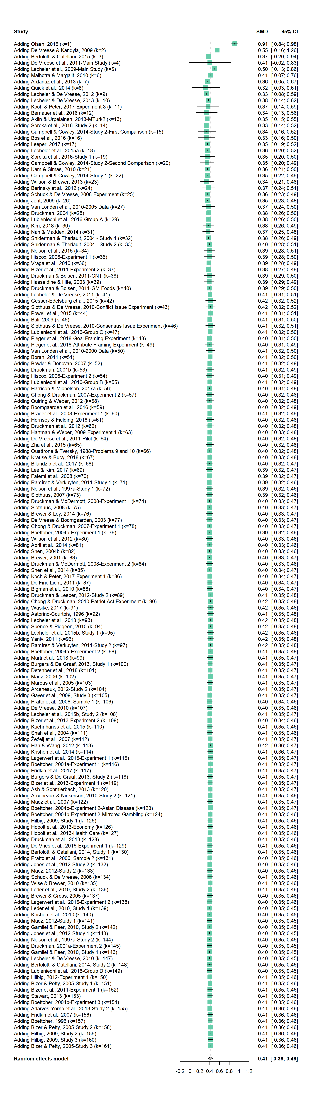
Figure D1. A cumulative meta-analysis of framing effects on attitudes (sorted by precision).
Figure D2. A cumulative meta-analysis of framing effects on emotions (general; sorted by precision).
Figure D3. A cumulative meta-analysis of framing effects on positive emotions (sorted by precision).
Figure D4. A cumulative meta-analysis of framing effects on negative emotions (sorted by precision).

Figure D5. A cumulative meta-analysis of framing effects on behavior (sorted by precision).

Figure D6. A cumulative meta-analysis of competitive framing effects on attitudes (sorted by precision).
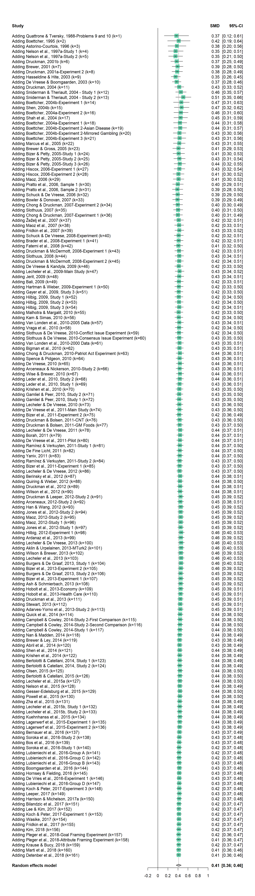
Figure D7. A cumulative meta-analysis of framing effects on attitudes (sorted by publication year).
Figure D8. A cumulative meta-analysis of framing effects on emotions (general; sorted by publication year).

Figure D9. A cumulative meta-analysis of framing effects on positive emotions (sorted by publication year).

Figure D10. A cumulative meta-analysis of framing effects on negative emotions (sorted by publication year).

Figure D11. A cumulative meta-analysis of framing effects on behavior (sorted by publication year).
Figure D12. A cumulative meta-analysis of competitive framing effects on attitudes (sorted by publication year).
References
Ioannidis, John PA, and Thomas A. Trikalinos. 2005. "Early Extreme Contradictory Estimates May Appear in Published Research: The Proteus Phenomenon in Molecular Genetics Research and Randomized Trials." Journal of Clinical Epidemiology 58 (6): 543–49.
Simonsohn, Uri, Leif D. Nelson, and Joseph P. Simmons. 2014. "P-curve: A Key to the File-Drawer." Journal of Experimental Psychology: General 143 (2): 534–47.
Online Appendix E: Outlier Detection
To test whether our conclusions are driven by extreme observations, we applied a comprehensive battery of influence diagnostics (Viechtbauer and Cheung 2010) to each of the six meta-analyses discussed in the Results section. Figures E1-E6 display these diagnostics. We detect two outliers in the meta-analyses of positive versus negative framing: one in the context of attitudes (Hilbig 2012, Experiment 1) and one in the context of behavior (Gerber et al. 2018, Study 2). These outliers are marked with a red dot in Figures E1 and E5. Removing the outlier from the meta-analysis of attitudes does not change the original effect size (d = .41; 95% CI [.36, .46], z = 16.00, p < .001, k = 160). Similarly, removing the outlier from the meta-analysis of behavior slightly increases the effect of d = .11 to d = .12 (95% CI [.07, .16], z = 5.29, p < .001, k = 25). Both re-analyses do not change our original conclusions.
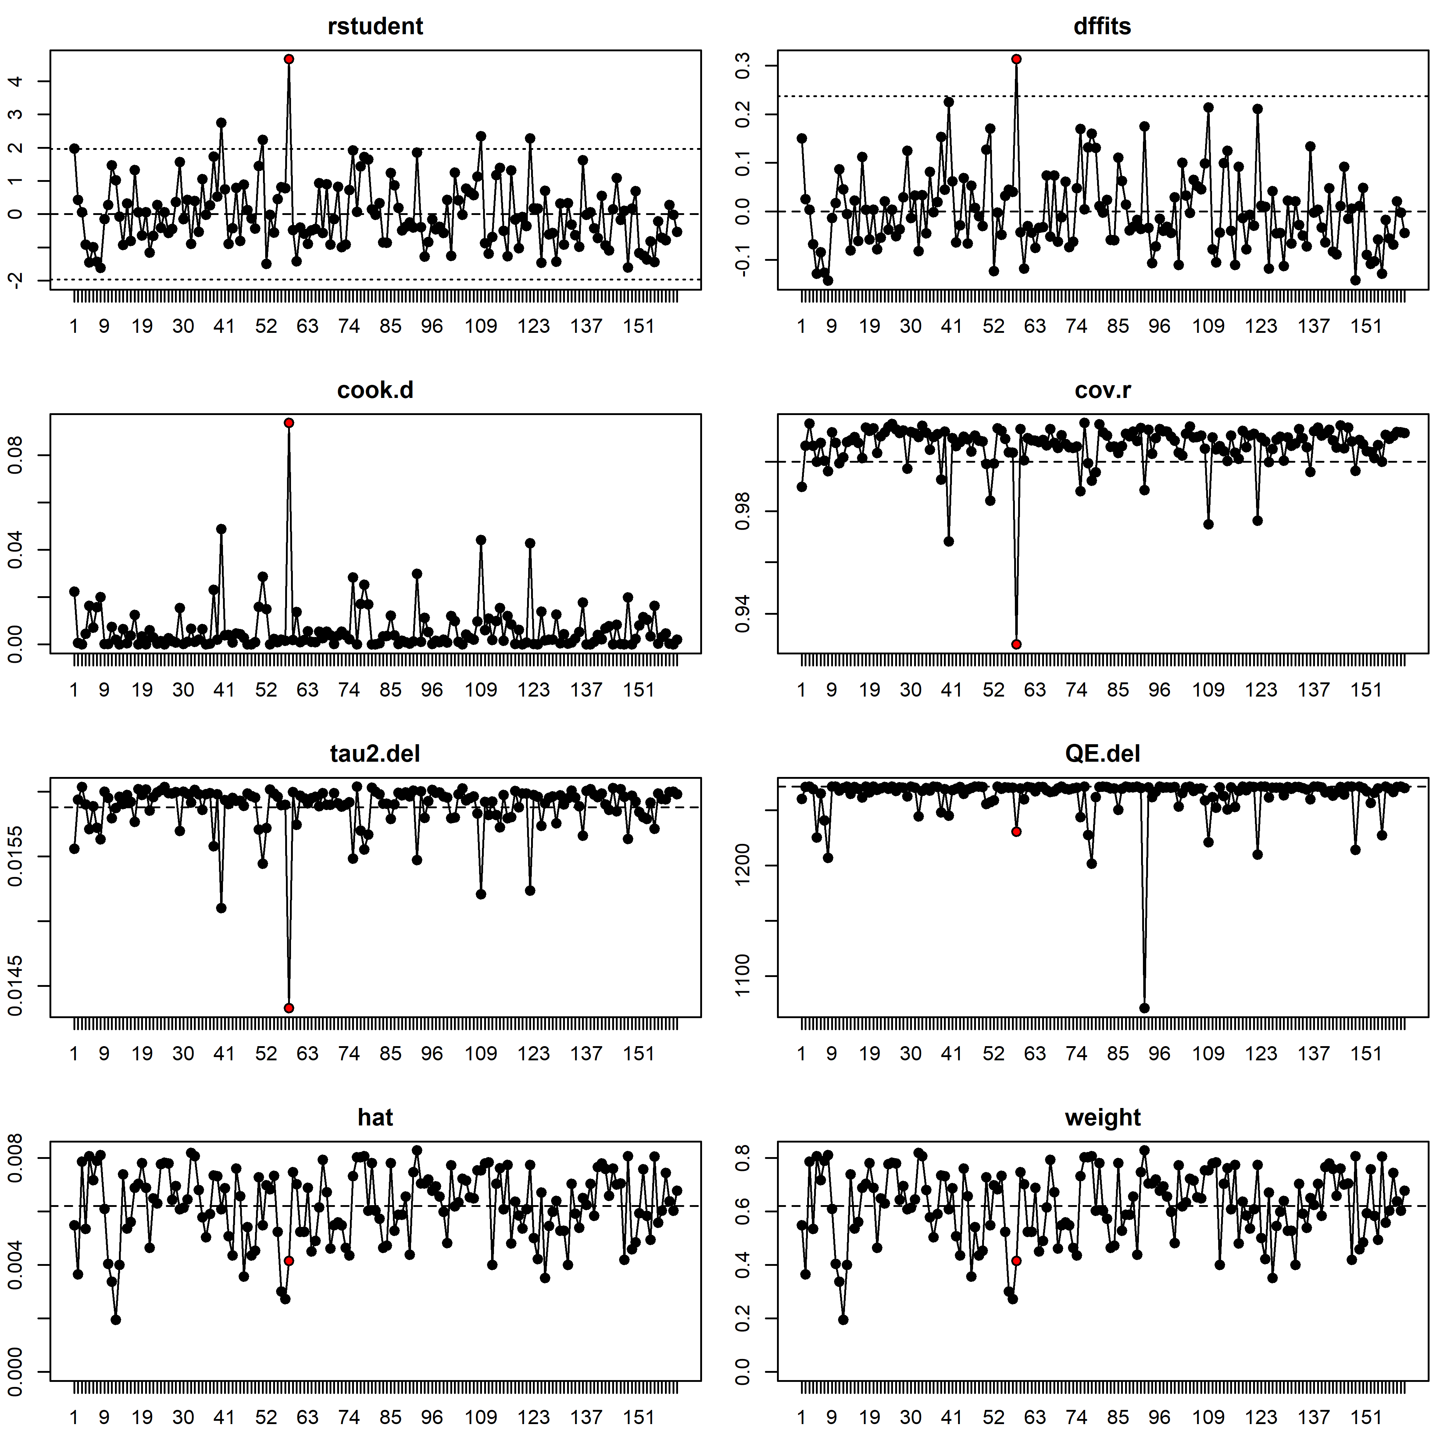
Figure E1. Influence diagnostics for framing effects on attitudes.
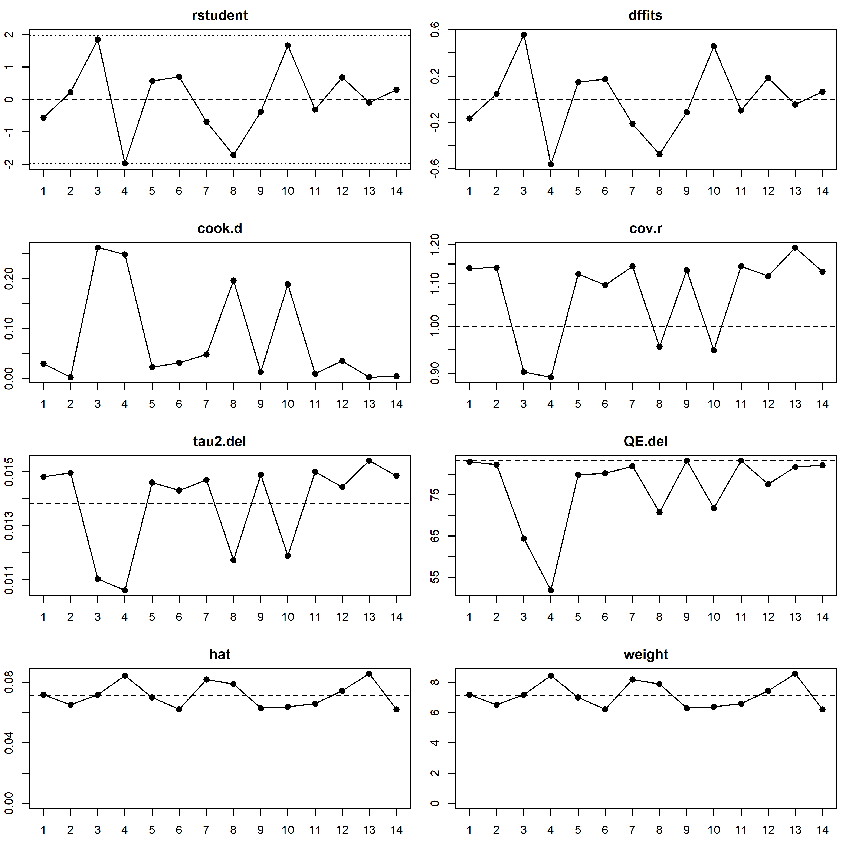
Figure E2. Influence diagnostics for framing effects on emotions (in general).

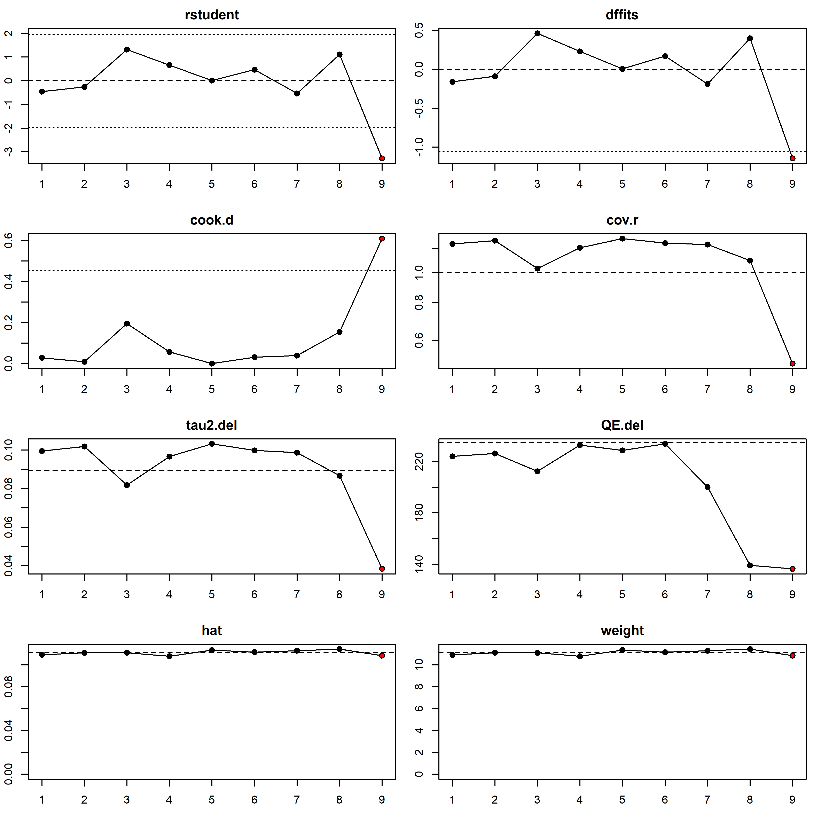
Figure E3. Influence diagnostics for framing effects on positive emotions.

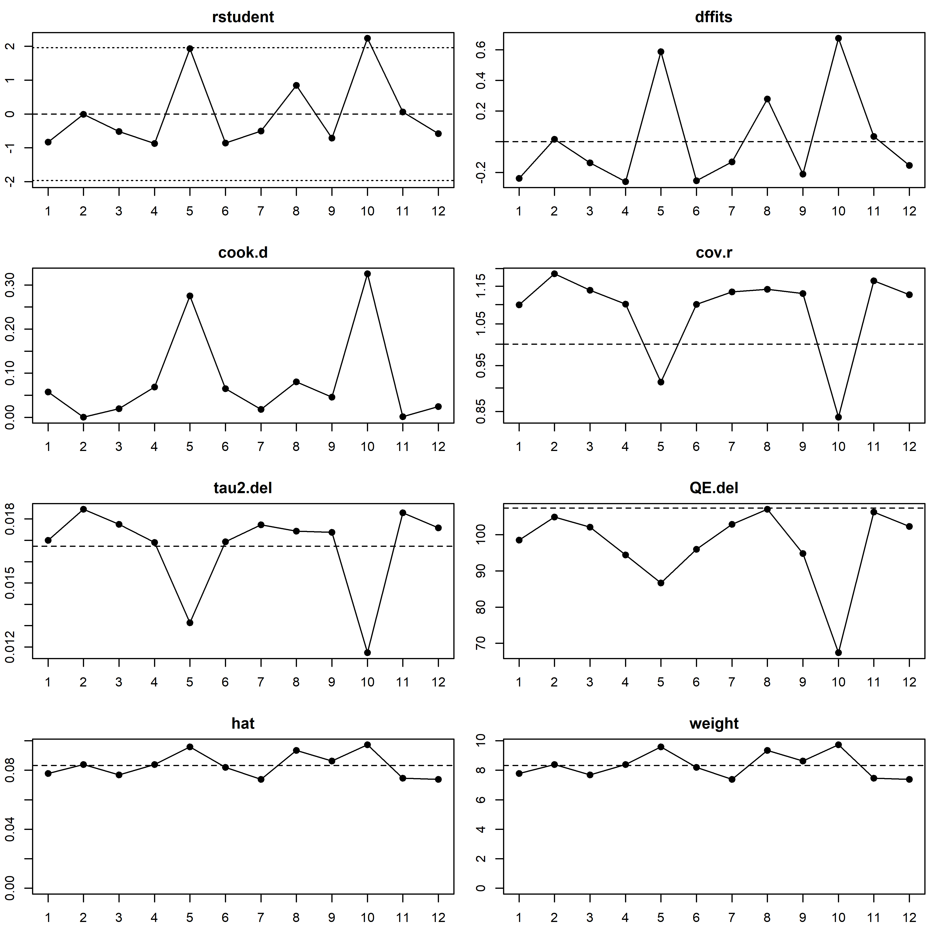
Figure E4. Influence diagnostics for framing effects on negative emotions.
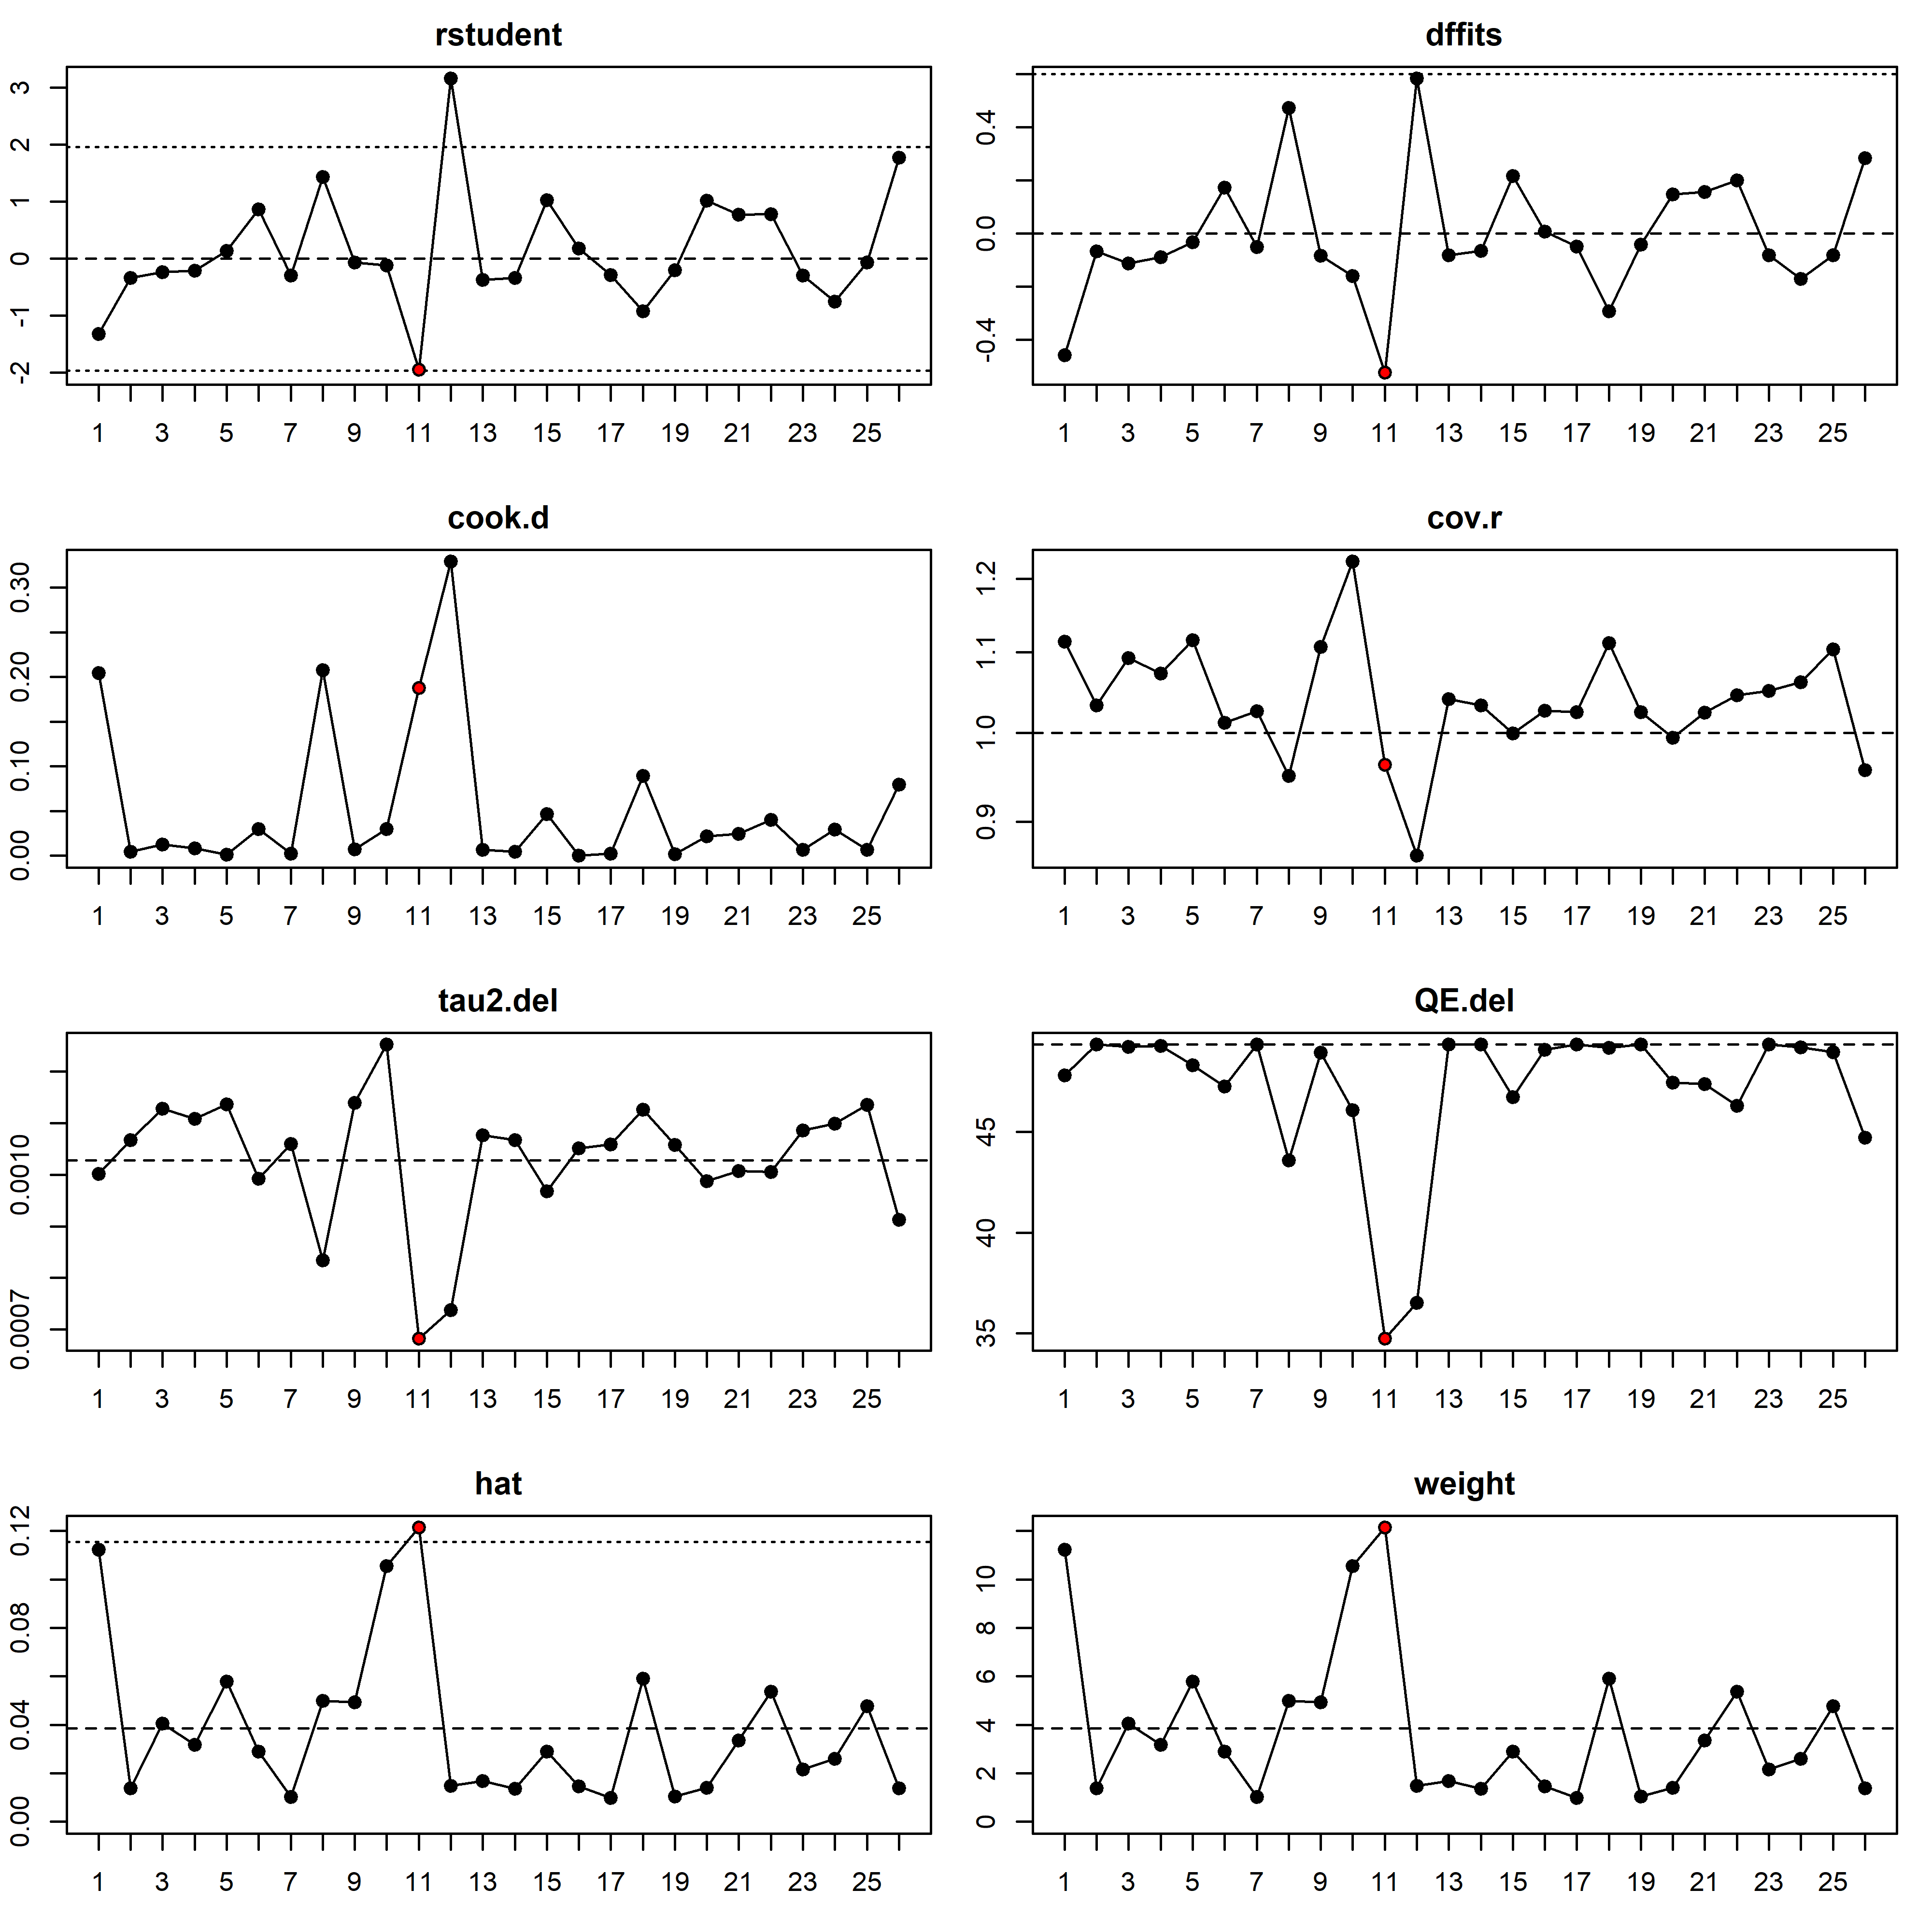
Figure E5. Influence diagnostics for framing effects on behavior.

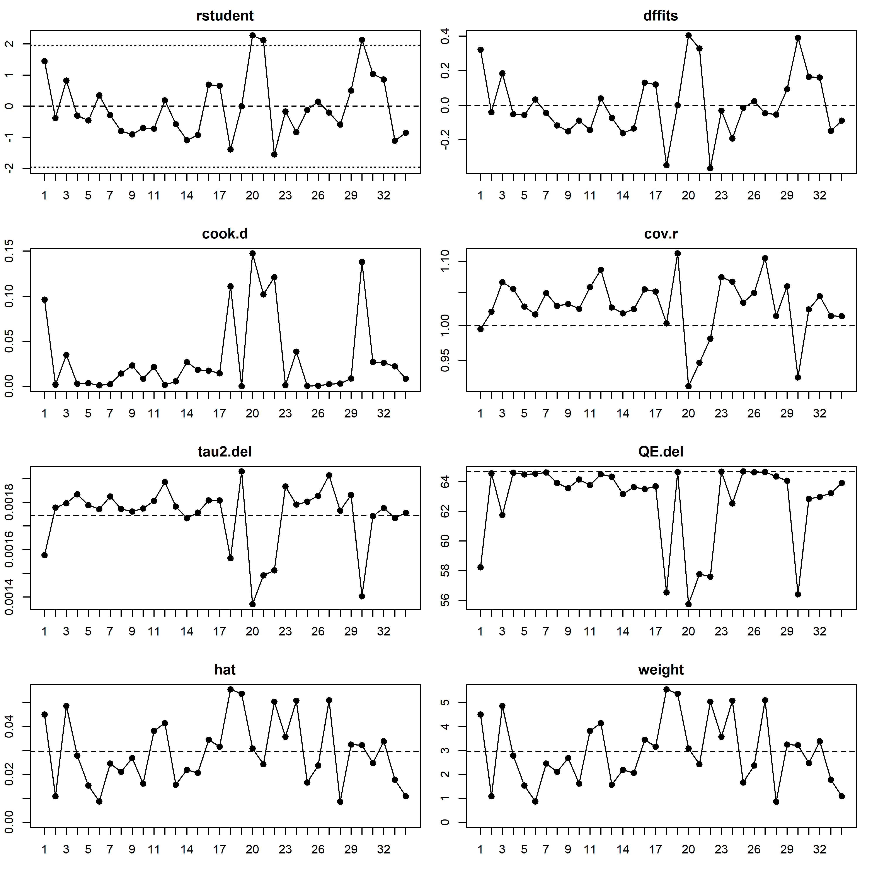
Figure E6. Influence diagnostics for competitive framing effects on attitudes.

References
Hilbig, Benjamin E. 2012. “Good Things Don’t Come Easy (to Mind): Explaining Framing Effects in Judgments of Truth.” Experimental Psychology 59 (1): 38–46.
Viechtbauer, W., and M. W. L. Cheung. 2010. "Outlier and Influence Diagnostics for Meta-Analysis.” Research Synthesis Methods, 1 (2): 112–25.

Only one study examined how negative frames vs. a control group affect emotions, and only two studies examined how positive frames vs. a control group affect this outcome. Therefore, we could meta-analyze and compare these effects.
http://www.p-curve.com/

