Divided by the Vote: Affective polarization in the Wake of the Brexit Referendum

Sara B. Hobolt, Thomas J. Leeper & James Tilley

SUPPLEMENTARY INFORMATION

Appendix 1:
Table A1: Cross-tabulation of Brexit identity by party identity

Appendix 2:
Table A2a: Logistic regression predicting Leave identity relative to Remain identity
Table A2b: Logistic regression predicting Conservative identity relative to Labour identity
Table A2c: Logistic regression predicting Leave identity relative to Remain identity (including a measure of British identity)

Appendix 3:
Table A3a: OLS regression predicting positive view of Remainers
Table A3b: OLS regression predicting negative view of Remainers
Table A3c: OLS regression predicting positive view of Leavers
Table A3d: OLS regression predicting negative view of Leavers

Appendix 4:
Table A4a: OLS regression predicting retrospective economic evaluations (with extra demographic predictors)
Table A4b: OLS regression predicting retrospective economic evaluations (using BES data including a measure of national identity)

Appendix 5:
Description of design of conjoint experiments
Figure A5a. BBC Director-General conjoint experiment AMCEs separated by party and Brexit identity
Figure A5b. Lodger conjoint experiment AMCEs separated by party and Brexit identity

Appendix 1

Table A1: Cross-tabulation of Brexit identity by party identity
 |  | Party identity
 |  | Conservative | Labour | Other party | No party |  | Total
Brexit identity | Leaver | 35% | 19% | 17% | 28% |  | 100%
 | Remainer | 16% | 36% | 18% | 30% |  | 100%
 | Neither | 22% | 19% | 10% | 49% |  | 100%
 | Total | 25% | 26% | 16% | 34% |  | 100%

Note: The YouGov data were collected in January 2018 and have a total unweighted N of 1,418.

Appendix 2

Table A2a: Logistic regression predicting Leave identity relative to Remain identity
 |  | Leaver identity
 |  | B | SE
Age-group | 18-25 | -1.38* | 0.10
 | 26-30 | -0.99* | 0.11
 | 31-35 | -0.79* | 0.10
 | 36-40 | -0.60* | 0.10
 | 41-45 | -0.50* | 0.09
 | 46-50 | -0.27* | 0.09
 | 51-55 | -0.30* | 0.09
 | 56-60 | -0.28* | 0.09
 | 61-65 | -0.14 | 0.09
 | 66-70 | -0.11 | 0.09
 | 71-75 | -0.08 | 0.10
 | 76+ | -
Region | Scotland | -0.70* | 0.07
 | Wales | -0.26* | 0.07
 | Northeast | -0.04 | 0.07
 | Northwest | -0.12* | 0.06
 | Yorkshire | -0.06 | 0.06
 | East Midlands | 0.19* | 0.06
 | West Midlands | 0.22* | 0.06
 | Southwest | -0.09 | 0.06
 | East | 0.21* | 0.06
 | London | -0.07 | 0.06
 | Southeast | -
Housing tenure | Council or Housing Association | 0.19* | 0.05
 | Private rental | -0.08 | 0.05
 | Other | -0.31* | 0.07
 | Mortgage | -0.06 | 0.04
 | Owner | -
Race | Black | -0.57* | 0.12
 | Asian (Indian sub-continent) | -0.44* | 0.11
 | Asian (other) | -0.23* | 0.14
 | Mixed or other | -0.12* | 0.09
 | White | -
Highest qualification | Higher degree | -1.63* | 0.08
 | Degree | -1.17* | 0.06
 | Some higher education | -0.76* | 0.07
 | A-Level | -0.66* | 0.06
 | O-Level | -0.21* | 0.06
 | CSE | -0.05 | 0.12
 | Apprenticeship | -0.16* | 0.07
 | No qualifications | - | .
Religion | None | -0.42* | 0.03
 | Non-Christian | -0.24* | 0.07
 | Presbyterian | -0.13 | 0.10
 | Non-conformist | -0.14* | 0.06
 | Catholic | -0.30* | 0.06
 | Anglican | - | .
Gender | Woman | -0.06* | 0.03
 | Man | -
Household income | Missing | 0.38* | 0.05
 | Lowest quintile | 0.27* | 0.06
 | 2nd quintile | 0.34* | 0.05
 | 3rd quintile | 0.31* | 0.05
 | 4th quintile | 0.22* | 0.05
 | Highest quintile | -
Occupational class | Missing | -0.34* | 0.06
 | Old middle class | -0.25* | 0.07
 | New middle class | -0.43* | 0.06
 | Junior middle class | -0.30* | 0.06
 | Own account | -0.20* | 0.08
 | Personal service | -0.45* | 0.15
 | Foremen | -0.20 | 0.10
 | Working class | -
Constant |  | 1.57* | 0.12
Nagelkerke pseudo R² |  | 0.21

Note: * = p < 0.05. The data come from wave 13 of the British Election Panel Study 2015-19 and have an unweighted N of 26,372.

Table A2b: Logistic regression predicting Conservative identity relative to Labour identity
 |  | Conservative identity
 |  | B | SE
Age-group | 18-25 | -1.81* | 0.14
 | 26-30 | -1.15* | 0.14
 | 31-35 | -1.04* | 0.13
 | 36-40 | -0.86* | 0.12
 | 41-45 | -0.88* | 0.12
 | 46-50 | -0.85* | 0.11
 | 51-55 | -0.79* | 0.12
 | 56-60 | -0.66* | 0.11
 | 61-65 | -0.58* | 0.11
 | 66-70 | -0.32* | 0.11
 | 71-75 | -0.08 | 0.12
 | 76+ | -
Region | Scotland | -0.81* | 0.10
 | Wales | -1.13* | 0.10
 | Northeast | -1.40* | 0.10
 | Northwest | -1.07* | 0.07
 | Yorkshire | -1.23* | 0.08
 | East Midlands | -0.36* | 0.08
 | West Midlands | -0.62* | 0.08
 | Southwest | -0.20* | 0.08
 | East | -0.16 | 0.08
 | London | -0.58* | 0.07
 | Southeast | -
Housing tenure | Council or Housing Association | -1.17* | 0.07
 | Private rental | -0.43* | 0.07
 | Other | -0.41* | 0.10
 | Mortgage | -0.19* | 0.05
 | Owner | -
Race | Black | -1.94* | 0.21
 | Asian (Indian sub-continent) | -1.02* | 0.15
 | Asian (other) | 0.20 | 0.18
 | Mixed or other | -0.62* | 0.12
 | White | -
Highest qualification | Higher degree | -0.13 | 0.10
 | Degree | 0.27* | 0.08
 | Some higher education | 0.21* | 0.09
 | A-Level | 0.43* | 0.08
 | O-Level | 0.42* | 0.08
 | CSE | 0.26 | 0.14
 | Apprenticeship | 0.38* | 0.09
 | No qualifications | -
Religion | None | -0.83* | 0.04
 | Non-Christian | -0.53* | 0.10
 | Presbyterian | -0.23 | 0.14
 | Non-conformist | -0.21* | 0.08
 | Catholic | -0.58* | 0.07
 | Anglican | -
Gender | Woman | -0.20* | 0.04
 | Man | -
Household income | Missing | -0.24* | 0.06
 | Lowest quintile | -0.77* | 0.07
 | 2nd quintile | -0.72* | 0.07
 | 3rd quintile | -0.40* | 0.07
 | 4th quintile | -0.34* | 0.06
 | Highest quintile | -
Occupational class | Missing | 0.38* | 0.07
 | Old middle class | 0.74* | 0.09
 | New middle class | 0.24* | 0.08
 | Junior middle class | 0.30* | 0.08
 | Own account | 0.70* | 0.10
 | Personal service | 0.37 | 0.22
 | Foremen | 0.23 | 0.13
 | Working class | -
Constant |  | 1.96* | 0.14
Nagelkerke pseudo R² |  | 0.27

Note: * = p < 0.05. The data come from wave 13 of the British Election Panel Study 2015-19 and have an unweighted N of 17,040.

Table A2c: Logistic regression predicting Leave identity relative to Remain identity

 |  | Leaver identity
 |  | B | SE
Age |  | 0.02* | 0.01
Region | Scotland | -0.59* | 0.29
 | England and Wales | -
Race | Non-white | -0.72* | 0.32
 | White | -
Highest qualification | Degree | -1.22* | 0.22
 | A-level | -0.80* | 0.22
 | O-level | -0.21 | 0.36
 | Less than O-level | -
Religion | None | -0.40* | 0.18
 | Non-Christian | -0.31 | 0.38
 | Presbyterian | -0.41 | 0.45
 | Non-conformist | -0.19 | 0.34
 | Catholic | -0.53 | 0.31
 | Anglican | - | .
Gender | Woman | -0.16 | 0.15
 | Man | -
Household income | Missing | 0.37 | 0.24
 | Lowest quintile | 0.54* | 0.26
 | 2nd quintile | 0.11 | 0.24
 | 3rd quintile | 0.13 | 0.25
 | 4th quintile | -0.07 | 0.24
 | Highest quintile | -
Occupational class | Missing | -0.42 | 0.27
 | Old middle class | -0.17 | 0.31
 | New middle class | -0.18 | 0.27
 | Junior middle class | -0.00 | 0.28
 | Own account | -0.10 | 0.36
 | Personal service | -0.71 | 0.56
 | Foremen | 0.32 | 0.53
 | Working class | -
Strength of British identity |  | 0.10* | 0.05
Constant |  | -0.52 | 0.52
Nagelkerke pseudo R² |  | 0.23

Note: * = p < 0.05. The data come from wave 13 of the British Election Panel Study 2015-19 and have an unweighted N of 1,101. British identity strength is measured using a 1-7 scale which ranges from ‘not at all British’ to ‘very strongly British’.

Appendix 3
Table A3a: OLS regression predicting positive view of Remainers

 |  | B | SE
Brexit identity | Leaver | -0.33* | 0.06
 | Remainer | 0.88* | 0.06
 | No identity | -
Party identity | Conservative | 0.04 | 0.06
 | Labour | 0.24* | 0.06
 | Other party | 0.20* | 0.07
 | No identity | -
Constant |  | 2.87* | 0.05
Adjusted R² |  | 0.31

Table A3b: OLS regression predicting negative view of Remainers

 |  | B | SE
Brexit identity | Leaver | 0.66* | 0.06
 | Remainer | -0.68* | 0.06
 | No identity | -
Party identity | Conservative | 0.08 | 0.06
 | Labour | -0.12* | 0.06
 | Other party | 0.06 | 0.07
 | No identity
Constant |  | 2.59* | 0.06
Adjusted R² |  | 0.29

Table A3c: OLS regression predicting positive view of Leavers

 |  | B | SE
Brexit identity | Leaver | 1.07* | 0.06
 | Remainer | -0.42* | 0.06
 | No identity | -
Party identity | Conservative | 0.11 | 0.06
 | Labour | 0.00 | 0.06
 | Other party | 0.02 | 0.07
 | No identity | -
Constant |  | 2.79* | 0.05
Adjusted R² |  | 0.37

Table A3d: OLS regression predicting negative view of Leavers

 |  | B | SE
Brexit identity | Leaver | -0.78* | 0.06
 | Remainer | 0.90* | 0.06
 | No identity | -
Party identity | Conservative | -0.10 | 0.06
 | Labour | 0.10 | 0.06
 | Other party | 0.08 | 0.07
 | No identity | -
Constant |  | 2.67* | 0.06
Adjusted R² |  | 0.39

Note: * = p < 0.05. Data is from the YouGov survey in September 2017. The unweighted N for each model is 1,678. The dependent variable in Table A2a is a 1-5 scale of three questions asking about positive characteristics of Remainers. The dependent variable in Table A2a is a 1-5 scale of three questions asking about negative characteristics of Remainers. The dependent variable in Table A2a is a 1-5 scale of three questions asking about positive characteristics of Leavers. The dependent variable in Table A2a is a 1-5 scale of three questions asking about negative characteristics of Leavers. In all cases, higher scores indicate greater agreement that these characteristics apply.

Appendix 4

Table A4a. OLS regression predicting retrospective economic perceptions

 |  | B | SE
Brexit identity | Leaver | 0.27* | 0.06
 | Remainer | -0.49* | 0.06
 | No identity | -
Party identity | Conservative | 0.25* | 0.06
 | Labour | -0.30* | 0.06
 | Other party | -0.13 | 0.07
 | No identity | -
Gender | Man | 0.09* | 0.04
 | Woman | -
Age |  | -0.00 | 0.01
Age finished education | 16 or under | -0.19 | 0.13
 | 17-19 | -0.19 | 0.13
 | 20 or over | -0.22 | 0.13
 | Unknown | -
Social grade | A | 0.31* | 0.09
 | B | 0.27* | 0.08
 | C1 | 0.20* | 0.07
 | C2 | 0.18* | 0.08
 | D | 0.19* | 0.09
 | E | -
Region | North East | 0.25 | 0.13
 | North West | 0.28* | 0.10
 | Yorkshire | 0.18 | 0.10
 | East Midlands | 0.09 | 0.11
 | West Midlands | 0.16 | 0.10
 | East | 0.31* | 0.10
 | London | 0.28* | 0.10
 | South East | 0.21* | 0.09
 | South West | 0.31* | 0.10
 | Wales | 0.17 | 0.12
 | Scotland | -
Constant |  | 2.42* | 0.17
Adjusted R² |  | 0.21

Note: * = p < 0.05. The data come from the January 2018 Tracker survey and have a total unweighted N of 1,418. The dependent variable asks respondents ‘How do you think the general economic situation in this country has changed over the last 12 months’ with five options (got a lot worse, got a little worse, stayed the same, got a little better and got a lot better) coded from 1-5.
Table A4b. OLS regression predicting retrospective economic perceptions

 |  | B | SE
Brexit identity | Leave | 0.39* | 0.10
 | Remain | 0.01 | 0.10
 | No identity | -
Party identity | Conservative | 0.39* | 0.07
 | Labour | -0.13 | 0.07
 | Other party | -0.12 | 0.09
 | No identity | -
Strength of British identity |  | -0.01 | 0.02
Constant |  | 2.13* | 0.13
Adjusted R² |  | 0.13

Note: * = p < 0.05. The data come from wave 13 of the British Election Study the January 2018 Tracker survey and have a total unweighted N of 1,121. The dependent variable asks respondents ‘How do you think the general economic situation in this country has changed over the last 12 months’ with five options (got a lot worse, got a little worse, stayed the same, got a little better and got a lot better) coded from 1-5. British identity strength is measured using a 1-7 scale which ranges from ‘not at all British’ to ‘very strongly British’.

Appendix 5

Respondents to the conjoint experiments were drawn from YouGov’s Omnibus panel. The BBC Director General conjoint had a sample of 1,635 respondents, each of whom completed five, forced-choice conjoint tasks between pairs of candidates. The profiles were fully randomized without constraints and varied along seven dimensions:
Feature | Levels
Party affiliation | Didn't support a party at the 2017 election
 | Supported the Labour Party at the 2017 election
 | Supported the Conservative Party at the 2017 election
Brexit affiliation | Didn't support a side in the EU referendum
 | Supported the Remain campaign in the EU referendum
 | Supported the Leave campaign in the EU referendum
Name/sex | James
 | Tom
 | John
 | Steve
 | Chris
 | Paul
 | Claire
 | Sarah
 | Kate
 | Becky
 | Jenny
Age | 32 years old
 | 38 years old
 | 44 years old
 | 50 years old
 | 56 years old
 | 62 years old
 | 68 years old
BBC experience | Has never worked for the BBC
 | Has worked 4 years for the BBC
 | Has worked 13 years for the BBC
 | Has worked 21 years for the BBC
Education | Does not have a degree
 | Has a degree from the University of Manchester
 | Has a degree from the University of Oxford
 | Has a PhD from the University of Exeter
Occupation | Former television producer
 | Former journalist
 | Former accountant
 | Former lawyer
 | Former civil servant
For the lodger conjoint, 1,690 respondents were drawn from the YouGov Omnibus panel. The basic design was exactly the same and the same first three characteristics were used, as were age and occupation features (albeit with different values). The final two features were replaced with a “hobby” feature and “voluntary activities” feature, producing the following seven features and levels:
Feature | Levels
Party affiliation | Didn't support a party at the 2017 election
 | Supported the Labour Party at the 2017 election
 | Supported the Conservative Party at the 2017 election
Brexit affiliation | Didn't support a side in the EU referendum
 | Supported the Remain campaign in the EU referendum
 | Supported the Leave campaign in the EU referendum
Name/sex | James
 | Tom
 | John
 | Steve
 | Chris
 | Paul
 | Claire
 | Sarah
 | Kate
 | Becky
 | Jenny
Age | 19 years old
 | 23 years old
 | 27 years old
 | 31 years old
 | 35 years old
 | 39 years old
 | 44 years old
Occupation | Full-time student
 | Works in the public sector
 | Works for a private company
 | Self-employed
Hobbies | Likes watching rugby
 | Likes watching football
 | Likes playing videogames
 | Likes playing guitar
 | Likes cooking
Voluntary work | Helps out at the local Catholic church
 | Helps out at the local Anglican church
 | Volunteers at an Oxfam shop
 | Coaches an under-12 football team
 | Doesn't do any voluntary work
Complete AMCE analysis separating respondents by both party and Brexit identity are below.
Figure A5a. BBC Director-General conjoint experiment AMCEs separated by party and Brexit identity
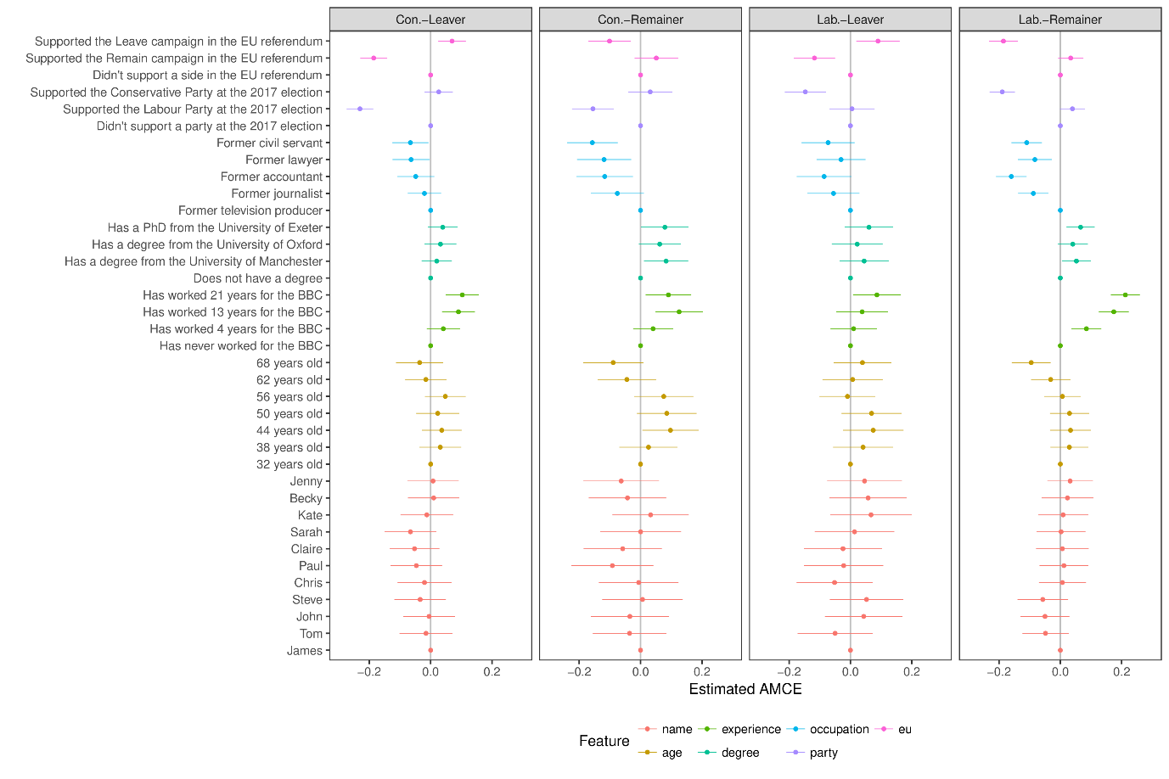

Figure A5b. Lodger conjoint experiment AMCEs separated by party and Brexit identity
