Party Cues in the News: Democratic Elites, Republican Backlash and the Dynamics of Climate Skepticism

Supplementary Information

Table of Contents
Section A - Mood Measure | 1
Mood Measure Description | 1
Table A1 | 2
Table A2 | 2
Table A3 | 3
Section B - Dictionaries | 4
Table B1 | 4
Table B2 | 4
Section C - Time Series Graphs | 5
Figure C1 | 5
Figure C2 | 5
Section D – Volume Models | 6
Table D1 | 6
Section E - Experiment | 7
Experimental Conditions | 7
Table E1 | 7
Table E2 | 8
Table E3 | 9
Figure E1 | 10
Figure E2 | 10
Table E4 | 11

Section A – Mood Measure
The climate skepticism mood measure we utilize in this paper is a combination of all the questions on global warming and climate change that we were able to find at the Roper archive coded in the same, skeptical, direction. We also included questions that were not in our pool, but were included in Carmiachael, Brulle and Huxter. The measure is primarily composed of two types of questions that were most common over a long period. The first asked respondents how serious of a problem climate change is, and the second inquired as to whether climate change was happening. The wording varied slightly, but the general spirit of the questions remained the same. There are a host of other questions asked periodically, including polls asking about global warming in terms of a threat, whether it was man made, and whether it is happening. Although questions were different, the mood measure remains rather robust.
The measure was purged of two outliers. One was a question about the existence of global warming, from February of 2006. Only 6 percent of the respondents said that global warming is ‘probably not happening,’ substantially below the average response at the time. The survey was conducted by a relatively unknown pollster, Ayers, McHenry & Associates. The other question came from a CBS/NY Times poll fielded on April of 2007, in which only 9 percent of respondents state that global warming is not a serious problem. The latter, however, has virtually no effect on the mood measure. It is worth noting that the reliability of the broad mood measure is the lowest of the four mood measures, at 0.76. More information about the skepticism measure and particular factor loadings is below.

Table A1. Polls Comprising the Mood Measure, by Year
Year | # of Polls
1986 | 1
1987 | 2
1988 | 4
1989 | 2
1990 | 2
1991 | 1
1992 | 1
1993 | 7
1994 | 2
1995 | 2
1996 | 3
1997 | 10
1998 | 1
1999 | 3
2000 | 3
2001 | 8
2002 | 9
2003 | 8
2004 | 8
2005 | 10
2006 | 13
2007 | 11
2008 | 8
2009 | 10
2010 | 14
2011 | 6
2012 | 6
2013 | 7
2014 | 6
2015 | 4

Table A2. WCalc6 Details for Quarterly and Annual Climate Skepticism Mood Measures
 | Quarterly | Annual
Number of series | 18 | 18
Exponential smoothing | Off | Off
Period | 1986.2 to 2015.2 | 1986 to 2015
Time points | 117 | 30
Variance explained | 80% | 66%

Table A3. Dimension Loadings for Quarterly and Annual Climate Skepticism Mood Measures
 |  | Dimension 1 loading
Series | Cases | Quarterly mood | Annual mood
1 | 3 | 1 | 0.94
2 | 2 | 1 | -1
3 | 2 | 1 | -1
4 | 3 | 1 | 0.99
5 | 5 | 0.38 | -0.35
6 | 13 | 0.89 | 0.75
7 | 11 | -0.08 | -0.07
8 | 2 | 1 | 1
9 | 9 | 0.97 | 0.68
10 | 2 | 1 | -1
11 | 19 | 0.95 | 0.96
12 | 11 | 0.95 | 0.20
13 | 9 | 0.88 | 0.06
14 | 3 | 1 | 1
15 | 16 | 0.98 | 0.99
16 | 2 | 1 | -1
17 | 2 | -1 | 1
18 | 16 | 0.96 | 0.98

Due to page limits imposed on supplementary information, Table A4 is available HERE detailing individual questions used to construct the latent skepticism “mood” measure.

Section B – Party Cue Dictionaries

Table B1. Republican Party Dictionary
(R- | Mitch McConnell
Bill Frist | Mitt Romney
Bob Dole | Newt Gingrich
Bob Michel | President Bush
Dan Quayle | President Reagan
Dennis Hastert | Republican
Dick Cheney | republican
G.O.P. | Ronald Reagan
George Bush | Speaker Boehner
George H.W. Bush | Speaker Gingrich
George W. Bush | Speaker Hastert
GOP | Trent Lott
Howard Baker | Vice President Bush
John McCain | Vice President Cheney
John Rhodes | Vice President Quayle
John Boehner
Note: Lists the keywords and phrases we searched for to establish the measure of Republican elite cues.

Table B2. Democratic Party Dictionary
(D- | Nancy Pelosi
Al Gore | President Clinton
Barack Obama | President Obama
Bill Clinton | Robert Byrd
Democrat | Speaker Foley
democrat | Speaker O'Neill
Democratic | Speaker Pelosi
democratic | Speaker Wright
George Mitchell | Tip O'Neill
Gephardt | Tom Daschle
Harry Reid | Tom Foley
Jim Wright | Vice President Biden
Joe Biden | Vice President Gore
John Kerry | Walter Mondale
Michael Dukakis
Note: Lists the keywords and phrases we searched for to establish the measure of Democratic elite cues.

Section C – Time Series Graphs

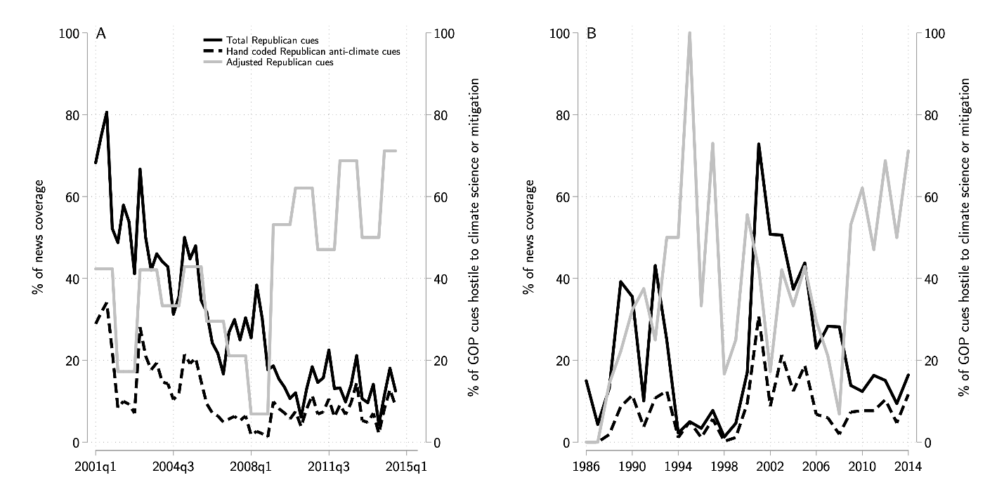
Figure C1. Annual share of climate change articles with Republican cues in the New York Times and Washington Post (black line); Share of articles with Republican cues that feature messages hostile to climate science and mitigation (grey line); Estimate of share of climate change articles with Republican cues hostile to climate science or mitigation (dashed line). Quarterly (left-panel); Annual (right-panel).

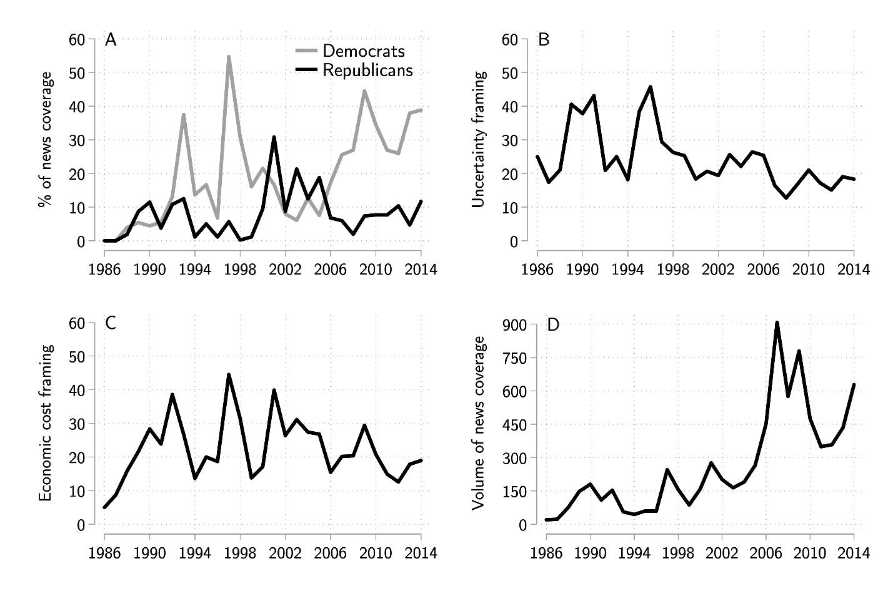
Figure C2. Potential polarizers in the news, annual. A) Democratic, and Republican cues in news coverage; B) Uncertainty framing; C) Economic cost framing; D) Salience of coverage.

Section D – Volume Models

Table D1. Volume Models
 | Aggregate Climate Skepticism |  | GOP Climate Skepticism
 | Quarterly | Annual | Quarterly
 | 1 | 2 |  | 3
Democratic Cues ^{N} | 0.02** | 0.00 |  | 0.02**
 | (0.01) | (0.00) |  | (0.01)
Republican Cues ^{N} | 0.02* | -0.00 |  | 0.04*
 | (0.01) | (0.00) |  | (0.02)
Uncertainty Frames ^{N} | -0.00 | 0.01* |  | 0.00
 | (0.01) | (0.00) |  | (0.02)
Cost Frames ^{N} | -0.02 | 0.00 |  | -0.01
 | (0.01) | (0.00) |  | (0.02)
Media Salience | -0.00 | -0.00** |  | -0.01**
 | (0.00) | (0.00) |  | (0.00)
Climate Index | -0.11 | 0.12 |  | -0.07
 | (0.09) | (0.07) |  | (0.11)
Oil Prices | 0.01* | 0.01 |  | 0.00
 | (0.00) | (0.00) |  | (0.00)
Unemployment Rate | 0.21*** | 0.01 |  | 0.30***
 | (0.07) | (0.08) |  | (0.08)
DV_{t-1} | 0.04 | 0.70*** |  | -0.13
 | (0.16) | (0.10) |  | (0.14)
Constant | -2.46*** | -0.40 |  | -1.78***
R² | 0.74 | 0.90 |  | 0.57
N | 55 | 28 |  | 54
Note: long-run effect for Democratic cues (0.02) is significant at the 0.05 level. Robust standard errors in parentheses, * p<0.1 ** p<0.05 *** p<0.01

Section E – Experiment

Control Condition
An overwhelming majority of scientists believe that the Earth’s climate is warming due to the human production of greenhouse gas emissions. They predict serious consequences for the environment, and for Americans and their daily lives.

Democratic Cue
Democrats in Congress echo this position. They fully accept the science of climate change and argue that the government needs to take immediate policy action to reduce greenhouse gas emissions.

Opposing Republican Cue
Republicans in Congress are deeply skeptical of the science of climate change and oppose governmental action to reduce emissions.

Supporting Republican Cue
Republicans in Congress are increasingly likely to support the science of climate change and some have begun to support government policy aimed at reducing emissions.

Table E1. Comparison of 2016 GSS survey and 2019 Amazon Mechanical Turk sample
 | GSS (2016) | MTurk (2019)
Male | 44% | 45%
White | 73% | 77%
College Degree or Higher | 30% | 55%
Conservative | 34% | 30%
Republican (Lean Included) | 35% | 32%
Under $20,000 Family Income | 19% | 12%
Age (Mean) | 49 | 40

Table E2. Variable descriptions
Item | Description | Mean | SD | Max | Min
Climate Skepticism | Please tell us the extent to which you agree or disagree with the following statement: "The Earth is getting warmer mostly because of human activity, such as burning fossil fuels" (7-point; strongly agree to strongly disagree) | 0.24 | 0.27 | 1 | 0
Partisanship | 7-point; strong Democrat to strong Republican | 3.49 | 2.13 | 7 | 1
Ideology | 7-point; extremely liberal to extremely conservative | 3.58 | 1.76 | 7 | 1
Mistrust in Scientists | "To what extent do you trust or distrust the following individuals, groups, and organizations? " (5-point; trust a lot to distrust a lot, reverse coded) | 0.90 | 0.99 | 4 | 0
Political Interest | "How interested are you in politics, using a scale from 0 to 10, where 0 means no interest at all and 10 means a great deal of interest?" | 6.69 | 2.6 | 10 | 0

Table E3. Estimation results for party cue experiment, OLS regression
 | No Controls |  | Controls |  | Controls + Ideology
 | Coef. | SE | Coef. | SE | Coef. | SE
Democratic | -0.043 | 0.030 | 0.024 | 0.048 | 0.062 | 0.050
Opposing Republican | -0.050 | 0.031 | -0.037 | 0.047 | -0.040 | 0.049
Polarized | -0.054* | 0.030 | 0.023 | 0.048 | 0.022 | 0.050
Supporting Republican | -0.037 | 0.029 | 0.028 | 0.049 | 0.017 | 0.050
Consensus | 0.005 | 0.030 | 0.095** | 0.048 | 0.077 | 0.051
PID | 0.059*** | 0.005 | 0.045*** | 0.005 | 0.014** | 0.007
PID * Democratic | 0.013* | 0.007 | 0.014** | 0.007 | 0.026** | 0.010
PID * Opposing Republican | 0.015** | 0.007 | 0.016** | 0.007 | 0.001 | 0.010
PID * Polarized | 0.019*** | 0.007 | 0.022*** | 0.007 | 0.025** | 0.010
PID * Supporting Republican | 0.015** | 0.007 | 0.006 | 0.007 | -0.003 | 0.010
PID * Consensus | 0.004 | 0.007 | -0.002 | 0.007 | -0.007 | 0.010
Political Interest |  |  | 0.011*** | 0.004 | 0.011** | 0.004
Interest * Democratic |  |  | -0.008 | 0.006 | -0.008 | 0.005
Interest * Opposing Republican |  |  | 0.000 | 0.005 | -0.000 | 0.005
Interest * Polarized |  |  | -0.008 | 0.005 | -0.006 | 0.005
Interest * Supporting Republican |  |  | -0.007 | 0.006 | -0.006 | 0.006
Interest * Consensus |  |  | -0.011** | 0.006 | -0.009 | 0.006
Mistrust in Scientists |  |  | 0.100*** | 0.011 | 0.088*** | 0.011
Mistrust * Democratic |  |  | -0.008 | 0.016 | -0.012 | 0.016
Mistrust * Opposing Republican |  |  | -0.017 | 0.016 | -0.020 | 0.016
Mistrust * Polarized |  |  | -0.034** | 0.016 | -0.030* | 0.015
Mistrust * Supporting Republican |  |  | 0.015 | 0.015 | 0.016 | 0.015
Mistrust * Consensus |  |  | 0.008 | 0.016 | 0.010 | 0.016
Ideology |  |  |  |  | 0.053*** | 0.009
Ideology * Democratic |  |  |  |  | -0.022* | 0.013
Ideology * Opposing Republican |  |  |  |  | 0.019 | 0.013
Ideology * Polarized |  |  |  |  | -0.006 | 0.013
Ideology * Supporting Republican |  |  |  |  | 0.010 | 0.013
Ideology * Consensus |  |  |  |  | 0.005 | 0.013
Constant | 0.034 | 0.022 | -0.082** | 0.035 | -0.153*** | 0.036
N | 2712 |  | 2710 |  | 2678
R | 0.298 |  | 0.400 |  | 0.448
Note: *p<0.1, **p<0.05, ***p<0.01

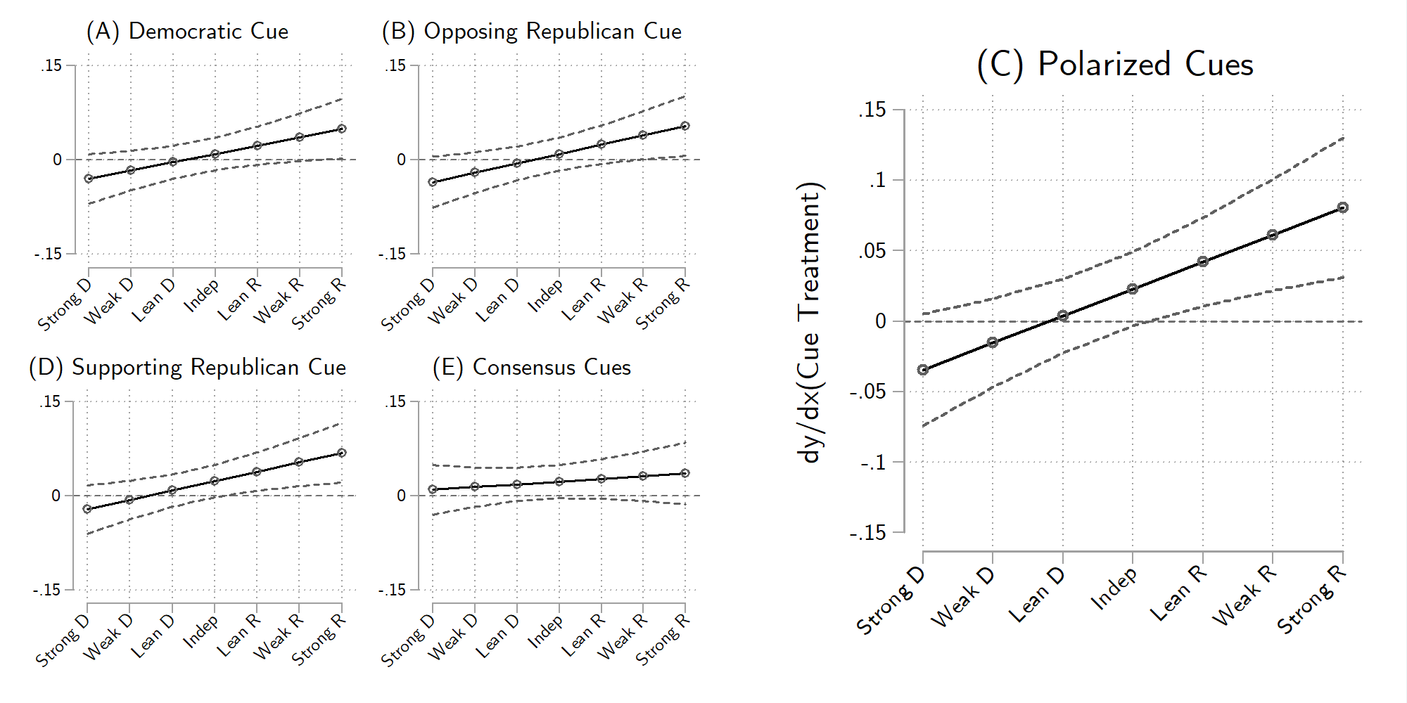
Figure E1. Estimated effect of party cue treatments on climate change skepticism, no controls. (A) Democratic cue treatment; (B) Opposition Republican cue treatment; (C) Supportive Republican cue treatment; (D) Consensus cue treatments; (E) Polarized cue treatment. Note: 90% confidence intervals.

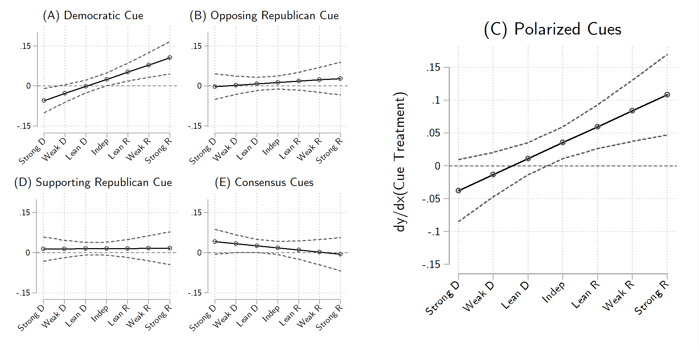
Figure E2. Estimated effect of party cue treatments on climate change skepticism, controlling for trust in scientists, political interest, and ideology. (A) Democratic cue treatment; (B) Opposition Republican cue treatment; (C) Supportive Republican cue treatment; (D) Consensus cue treatments; (E) Polarized cue treatment. Note: 90% confidence intervals.

Table E4. Estimation results for party cue experiment with SES and demographic controls, OLS regression
 | Controls |  | Controls X Treatments
 | Coef. | SE | Coef. | SE
Democratic | 0.010 | 0.050 | 0.019 | 0.083
Opposing Republican | -0.040 | 0.049 | -0.046 | 0.085
Polarized | 0.024 | 0.050 | -0.063 | 0.086
Supporting Republican | 0.022 | 0.050 | 0.071 | 0.085
Consensus | 0.088* | 0.050 | 0.085* | 0.086
PID | 0.043*** | 0.005 | 0.043*** | 0.005
PID * Democratic | 0.013* | 0.007 | 0.013* | 0.007
PID * Opposing Republican | 0.015** | 0.007 | 0.015** | 0.008
PID * Polarized | 0.026*** | 0.008 | 0.027*** | 0.008
PID * Supporting Republican | 0.007 | 0.007 | 0.007 | 0.007
PID * Consensus | -0.000 | 0.008 | 0.000 | 0.008
N | 2507 |  | 2507
R | 0.405 |  | 0.411
Note: controls for age (in years), education (9-point), race (1=white, non-Hispanic), income (under $20,000 to $120,000 and over, 7-point), and gender, *p<0.1, **p<0.05, ***p<0.01

