SUPPLEMENTARY MATERIAL

- Relationships Between Different Types of Restrictions
- Summary Statistics
- Case Selection Justification: UAs and Restrictions in Egypt
- Different Operationalizations of the Level of Restrictions
- Regime Types and Restrictions
- Different Operationalization of International Shaming: Media-based INGO Shaming
- Fixed Effects Models
- Population Average Models
- Test for Mechanism Implications
- References for Supplementary Material

Relationships between Different Types of Restrictions

Table S1. Tetrachoric correlations between different types of restrictions
 | Some banned | Visit  restrict | Travel restrict | Domestic funding  restrict. | Internat. funding  restrict. | Registra-tion diff.
Some banned | 1.00
Visitation restrictions | 0.09 | 1.00
Travel restrictions | 0.13 | 0.19 | 1.00
Funding restrictions | 0.15 | 0.12 | 0.13 | 1.00
Int. fund. restrictions | 0.19 | 0.14 | 0.08 | 0.31 | 1.00
Registration diffic. | 0.53 | 0.15 | 0.12 | 0.24 | 0.31 | 1.00
Censorship | 0.36 | 0.15 | 0.11 | 0.22 | 0.32 | 0.35
Harassment | 0.17 | 0.21 | 0.28 | 0.21 | 0.32 | 0.24
Surveillance | 0.21 | 0.16 | 0.15 | 0.20 | 0.29 | 0.27
Arrests | 0.16 | 0.16 | 0.29 | 0.19 | 0.16 | 0.19
Killings | -0.04 | 0.08 | 0.17 | 0.02 | -0.01 | 0.02

Table S1 continued. Tetrachoric correlations between different types of restrictions
 | Censorship | Harassment | Surveillance | Arrests | Killing
Some banned
Visitation restrictions
Travel restrictions
Funding restrictions
Int. fund. restrictions
Registration diffic.
Censorship | 1.00
Harassment | 0.23 | 1.00
Surveillance | 0.23 | 0.43 | 1.00
Arrests | 0.24 | 0.50 | 0.35 | 1.00
Killings | -0.02 | 0.21 | 0.18 | 0.16 | 1.00

Summary Statistics

Table S2. Summary statistics
 | Mean | SD | Min | Max | N
Urgent Actions | 2.20 | 5.86 | 0.00 | 71.00 | 1250.00
Urgent Actions (lag 1 yr) | 2.28 | 6.11 | 0.00 | 71.00 | 1250.00
INGO shaming | 0.31 | 1.28 | 0.00 | 19.00 | 1210.00
INGO shaming (lag 1 yr) | 0.34 | 1.32 | 0.00 | 19.00 | 1205.00
Restrictions | 1.77 | 2.71 | 0.00 | 10.00 | 1250.00
Political Terror Scale | 2.59 | 1.09 | 1.00 | 5.00 | 1250.00
Human rights CSOs | 70.32 | 47.32 | 7.00 | 331.00 | 1250.00
Human rights news | 0.34 | 1.11 | 0.00 | 15.50 | 1250.00
Protest count | 0.90 | 0.89 | 0.00 | 3.74 | 1250.00
Armed conflict | 0.16 | 0.36 | 0.00 | 1.00 | 1250.00
Political rights | 3.61 | 2.12 | 1.00 | 7.00 | 1250.00
Political rights sq. | 17.56 | 16.53 | 1.00 | 49.00 | 1250.00
GDP per capita | -0.03 | 1.03 | -0.65 | 5.47 | 1250.00
GDP per capita sq. | 1.07 | 2.93 | 0.00 | 29.95 | 1250.00
Globalization | 55.74 | 15.74 | 23.29 | 89.10 | 1250.00
Globalization sq. | 3354.22 | 1856.61 | 542.53 | 7939.12 | 1250.00
Population size | 0.07 | 0.99 | -1.69 | 1.66 | 1250.00
Political rights best | 0.24 | 0.43 | 0.00 | 1.00 | 1250.00
Political rights worst | 0.11 | 0.31 | 0.00 | 1.00 | 1250.00
Death penalty | 0.61 | 0.49 | 0.00 | 1.00 | 1250.00
Observations | 1250.0

Case Selection Justification: UAs and Restrictions in Egypt

Figure S3a. Observed and predicted number of UAs (Egypt in red)
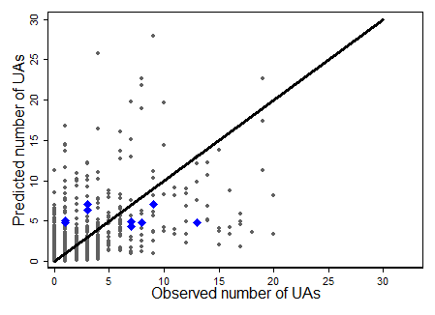

Figure S3b. Variation in restrictions and UAs for Egypt, 1998-2007
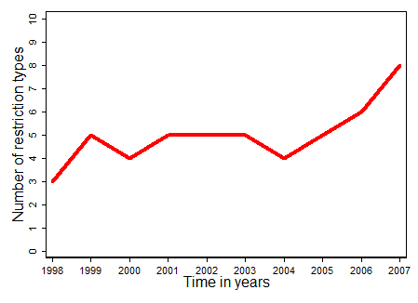 | 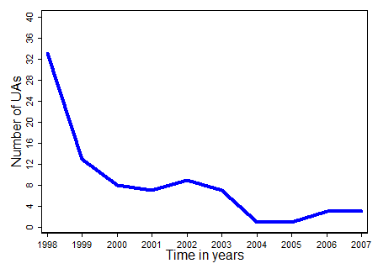

Different Operationalization of the Level of Restrictions
We examine whether certain combinations of restriction types are responsible for the curvilinear relationship between the count of restrictions and UAs. To do so, we re-estimate Table 1 with counts of different combinations of restrictions types. In the first set of models, the count measure of restriction types leaves out one restriction type at a time. Results are presented in Tables S4a to S4k. In the second set of models, the count measure of restriction types leaves out a different combination of three or four restriction types at a time. Table S4l shows the results when we do not count registration problems, censorship, surveillance and selective banning. Table S4m presents the results, when we do not consider visit, travel and funding restrictions. Finally, Table S4n presents the results when we leave out harassment, arrests and killing. Interestingly, the effects of the count of restrictions and its squared term are substantively smaller in this final operationalization, which suggests that these restrictive practices provoke or curtail more shaming events than the other restrictive policies.

Table S4a. Regression of UAs on restrictions without selective banning
 | Model 1 | Model 2 | Model 3 | Model 4 | Model 5
 | Neg. bin. | Neg. bin. | Zero-infl. | GMM | GMM
 | Reduced | Full | Full | 1 EEV | All EEVs
Restrictions | 0.753*** | 0.465*** | 0.376*** | 0.578** | 0.604**
(without „Some CSOs banned“) | (0.120) | (0.109) | (0.088) | (0.200) | (0.207)
Restrictions sq. | -0.068*** | -0.040** | -0.035** | -0.051* | -0.054**
(without „Some CSOs banned“) | (0.014) | (0.013) | (0.011) | (0.021) | (0.021)
Constant | -0.192 | -6.110*** | -3.934*** | -4.331* | -4.387+
 | (0.170) | (0.122) | (1.191) | (2.095) | (2.238)
Observations | 1,691 | 1,250 | 1,250 | 1,248 | 1,248
Log-Likelihood | -2632.6 | -1847.3 | -1774.5
BIC | 5294.9 | 3808.7 | 3705.8
AIC | 5273.2 | 3726.6 | 3592.9
Hansen-Sargan-test |  |  |  | 0.2 | 0.2
Notes: Cluster-robust standard errors (Models 1-3) and clustered bootstrapped standard errors in parentheses; p-values: ***<0.001, ** <0.01, *<0.05, +<0.1; Models 2 to 5 include all control variables from Table 1.

Table S4b. Regression of UAs on restrictions without visitation restrictions
 | Model 1 | Model 2 | Model 3 | Model 4 | Model 5
 | Neg. bin. | Neg. bin. | Zero-infl. | GMM | GMM
 | Reduced | Full | Full | 1 EEV | All EEVs
Restrictions | 0.951*** | 0.514*** | 0.423*** | 0.672*** | 0.718***
(without „visits restrictions“) | (0.122) | (0.106) | (0.089) | (0.166) | (0.177)
Restrictions sq. | -0.083*** | -0.040*** | -0.035*** | -0.056** | -0.061**
(without „visits restrictions“) | (0.013) | (0.011) | (0.010) | (0.017) | (0.019)
Constant | -0.413** | 0.488*** | -3.786** | -4.150+ | -4.188+
 | (0.154) | (0.119) | (1.192) | (2.154) | (2.299)
Observations | 1,690 | 1,250 | 1,250 | 1,248 | 1,248
Log-Likelihood | -2592.1 | -1837.3 | -1765.8
BIC | 5213.9 | 3788.8 | 3688.5
AIC | 5192.2 | 3706.7 | 3575.6
Hansen-Sargan-test |  |  |  | 0.1 | 0.1
Notes: Cluster-robust standard errors (Models 1-3) and clustered bootstrapped standard errors in parentheses; p-values: ***<0.001, ** <0.01, *<0.05, +<0.1; Models 2 to 5 include all control variables from Table 1.

Table S4c. Regression of UAs on restrictions without travel restrictions
 | Model 1 | Model 2 | Model 3 | Model 4 | Model 5
 | Neg. bin. | Neg. bin. | Zero-infl. | GMM | GMM
 | Reduced | Full | Full | 1 EEV | All EEVs
Restrictions | 0.900*** | 0.490*** | 0.385*** | 0.559*** | 0.594***
(without „travel restrictions“) | (0.130) | (0.108) | (0.091) | (0.155) | (0.160)
Restrictions sq. | -0.077*** | -0.037*** | -0.031** | -0.046** | -0.050**
(without „travel restrictions“) | (0.013) | (0.011) | (0.010) | (0.017) | (0.017)
Constant | -0.373* | -5.926*** | -3.832** | -4.334* | -4.380*
 | (0.168) | (1.253) | (1.201) | (2.094) | (2.233)
Observations | 1,691 | 1,250 | 1,250 | 1,248 | 1,248
Log-Likelihood | -2613.1 | -1841.7 | -1771.7
BIC | 5255.9 | 3797.4 | 3700.2
AIC | 5234.2 | 3715.3 | 3587.3
Hansen-Sargan-test |  |  |  | 0.0 | 0.0
Notes: Cluster-robust standard errors (Models 1-3) and clustered bootstrapped standard errors in parentheses; p-values: ***<0.001, ** <0.01, *<0.05, +<0.1; Models 2 to 5 include all control variables from Table 1.

Table S4d. Regression of UAs on restrictions without domestic funding restrictions
 | Model 1 | Model 2 | Model 3 | Model 4 | Model 5
 | Neg. bin. | Neg. bin. | Zero-infl. | GMM | GMM
 | Reduced | Full | Full | 1 EEV | All EEVs
Restrictions | 0.940*** | 0.526*** | 0.429*** | 0.705*** | 0.750***
(without „dom. fund. restrict.“) | (0.121) | (0.105) | (0.088) | (0.167) | (0.176)
Restrictions sq. | -0.080*** | -0.040*** | -0.035*** | -0.058*** | -0.063**
(without „dom. fund. restrict.“) | (0.012) | (0.011) | (0.009) | (0.017) | (0.021)
Constant | -0.462** | -6.099*** | -3.974*** | -4.140+ | -4.101+
 | (0.160) | (1.231) | (1.164) | (2.137) | (2.288)
Observations | 1,691 | 1,250 | 1,250 | 1,248 | 1,248
Log-Likelihood | -2594.5 | -1836.3 | -1765.6
BIC | 5218.7 | 3786.7 | 3688.1
AIC | 5197.0 | 3704.6 | 3575.2
Hansen-Sargan-test |  |  |  | 0.1 | 0.1
Notes: Cluster-robust standard errors (Models 1-3) and clustered bootstrapped standard errors in parentheses; p-values: ***<0.001, ** <0.01, *<0.05, +<0.1; Models 2 to 5 include all control variables from Table 1.

Table S4e. Regression of UAs on restrictions without international funding restrictions
 | Model 1 | Model 2 | Model 3 | Model 4 | Model 5
 | Neg. bin. | Neg. bin. | Zero-infl. | GMM | GMM
 | Reduced | Full | Full | 1 EEV | All EEVs
Restrictions | 0.936*** | 0.529*** | 0.433*** | 0.740*** | 0.786***
(without „int. fund. restrict.“) | (0.120) | (0.106) | (0.088) | (0.178) | (0.187)
Restrictions sq. | -0.079*** | -0.040*** | -0.035*** | -0.061*** | -0.065***
(without „int. fund. restrict.“) | (0.012) | (0.011) | (0.009) | (0.018) | (0.018)
Constant | -0.462** | -6.131*** | -3.997*** | -4.201* | -4.203+
 | (0.160) | (1.233) | (1.165) | (2.132) | (2.291)
Observations | 1,691 | 1,250 | 1,250 | 1,248 | 1,248
Log-Likelihood | -2594.7 | -1836.3 | -1765.4
BIC | 5219.0 | 3786.7 | 3687.7
AIC | 5197.3 | 3704.6 | 3574.8
Hansen-Sargan-test |  |  |  | 0.1 | 0.1
Notes: Cluster-robust standard errors (Models 1-3) and clustered bootstrapped standard errors in parentheses; p-values: ***<0.001, ** <0.01, *<0.05, +<0.1; Models 2 to 5 include all control variables from Table 1.

Table S4f. Regression of UAs on restrictions without registration problems
 | Model 1 | Model 2 | Model 3 | Model 4 | Model 5
 | Neg. bin. | Neg. bin. | Zero-infl. | GMM | GMM
 | Reduced | Full | Full | 1 EEV | All EEVs
Restrictions | 0.920*** | 0.513*** | 0.405*** | 0.703*** | 0.744***
(without „registrat. problems“) | (0.118) | (0.111) | (0.093) | (0.184) | (0.196)
Restrictions sq. | -0.081*** | -0.041*** | -0.035*** | -0.061** | -0.066**
(without „registrat. problems“) | (0.013) | (0.012) | (0.010) | (0.020) | (0.020)
Constant | -0.366* | -6.083*** | -4.008*** | -4.276* | -4.288+
 | (0.164) | (1.271) | (1.203) | (2.125) | (2.278)
Observations | 1,691 | 1,250 | 1,250 | 1,248 | 1,248
Log-Likelihood | -2603.1 | -1842.1 | -1771.3
BIC | 5235.8 | 3798.3 | 3699.4
AIC | 5214.1 | 3716.2 | 3586.5
Hansen-Sargan-test |  |  |  | 0.1 | 0.1
Notes: Cluster-robust standard errors (Models 1-3) and clustered bootstrapped standard errors in parentheses; p-values: ***<0.001, ** <0.01, *<0.05, +<0.1; Models 2 to 5 include all control variables from Table 1.

Table S4g. Regression of UAs on restrictions without censorship
 | Model 1 | Model 2 | Model 3 | Model 4 | Model 5
 | Neg. bin. | Neg. bin. | Zero-infl. | GMM | GMM
 | Reduced | Full | Full | 1 EEV | All EEVs
Restrictions | 0.948*** | 0.530*** | 0.433*** | 0.725*** | 0.768***
(without „ censorship“) | (0.120) | (0.110) | (0.093) | (0.183) | (0.195)
Restrictions sq. | -0.083*** | -0.042*** | -0.036*** | -0.061** | -0.066***
(without „censorship“) | (0.013) | (0.012) | (0.010) | (0.019) | (0.019)
Constant | -0.457** | 0.496*** | -4.066*** | -4.148* | -4.149+
 | (0.157) | (1.228) | (1.162) | (2.094) | (2.244)
Observations | 1,691 | 1,250 | 1,250 | 1,248 | 1,248
Log-Likelihood | -2593.5 | -1837.5 | -1766.1
BIC | 5216.7 | 3789.1 | 3689.0
AIC | 5195.0 | 3707.0 | 3576.1
Hansen-Sargan-test |  |  |  | 0.0 | 0.0
Notes: Cluster-robust standard errors (Models 1-3) and clustered bootstrapped standard errors in parentheses; p-values: ***<0.001, ** <0.01, *<0.05, +<0.1; Models 2 to 5 include all control variables from Table 1.

Table S4h. Regression of UAs on restrictions without harassment
 | Model 1 | Model 2 | Model 3 | Model 4 | Model 5
 | Neg. bin. | Neg. bin. | Zero-infl. | GMM | GMM
 | Reduced | Full | Full | 1 EEV | All EEVs
Restrictions | 0.915*** | 0.488*** | 0.378*** | 0.595*** | 0.638***
(without „harassment“) | (0.131) | (0.098) | (0.083) | (0.146) | (0.147)
Restrictions sq. | -0.082*** | -0.038*** | -0.032*** | -0.052** | -0.056**
(without „harassment“) | (0.014) | (0.011) | (0.009) | (0.018) | (0.018)
Constant | -0.173 | -6.520*** | -4.240*** | -4.638* | -4.722*
 | (0.163) | (0.127) | (1.185) | (2.135) | (2.275)
Observations | 1,691 | 1,250 | 1,250 | 1,248 | 1,248
Log-Likelihood | -2636.8 | -1848.7 | -1775.8
BIC | 5303.4 | 3811.5 | 3708.4
AIC | 5281.6 | 3729.4 | 3595.5
Hansen-Sargan-test |  |  |  | 0.1 | 0.1
Notes: Cluster-robust standard errors (Models 1-3) and clustered bootstrapped standard errors in parentheses; p-values: ***<0.001, ** <0.01, *<0.05, +<0.1; Models 2 to 5 include all control variables from Table 1.

Table S4i. Regression of UAs on restrictions without arrests
 | Model 1 | Model 2 | Model 3 | Model 4 | Model 5
 | Neg. bin. | Neg. bin. | Zero-infl. | GMM | GMM
 | Reduced | Full | Full | 1 EEV | All EEVs
Restrictions | 0.949*** | 0.499*** | 0.385*** | 0.576*** | 0.601***
(without „arrests“) | (0.113) | (0.104) | (0.094) | (0.140) | (0.137)
Restrictions sq. | -0.083*** | -0.038*** | -0.031** | -0.047** | -0.049**
(without „arrests“) | (0.012) | (0.011) | (0.010) | (0.016) | (0.016)
Constant | -0.391* | -6.121*** | -4.015*** | -4.514* | -4.618*
 | (0.161) | (1.259) | (1.179) | (2.104) | (2.233)
Observations | 1,688 | 1,250 | 1,250 | 1,245 | 1,245
Log-Likelihood | -2607.3 | -1843.1 | -1772.9
BIC | 5244.4 | 3800.4 | 3702.7
AIC | 5222.7 | 3718.3 | 3589.8
Hansen-Sargan-test |  |  |  | 0.0 | 0.0
Notes: Cluster-robust standard errors (Models 1-3) and clustered bootstrapped standard errors in parentheses; p-values: ***<0.001, ** <0.01, *<0.05, +<0.1; Models 2 to 5 include all control variables from Table 1.

Table S4j. Regression of UAs on restrictions without surveillance
 | Model 1 | Model 2 | Model 3 | Model 4 | Model 5
 | Neg. bin. | Neg. bin. | Zero-infl. | GMM | GMM
 | Reduced | Full | Full | 1 EEV | All EEVs
Restrictions | 0.963*** | 0.527*** | 0.416*** | 0.654*** | 0.703***
(without „surveillance“) | (0.133) | (0.108) | (0.091) | (0.169) | (0.180)
Restrictions sq. | -0.084*** | -0.041*** | -0.034*** | -0.055** | -0.060**
(without „surveillance“) | (0.014) | (0.011) | (0.010) | (0.019) | (0.019)
Constant | -0.414** | -6.283*** | -4.174*** | -4.705* | -4.814*
 | (0.158) | (1.253) | (1.197) | (2.138) | (2.289)
Observations | 1,691 | 1,250 | 1,250 | 1,248 | 1,248
Log-Likelihood | -2608.9 | -1839.9 | -1769.8
BIC | 5247.5 | 3793.9 | 3696.4
AIC | 5225.8 | 3711.8 | 3583.5
Hansen-Sargan-test |  |  |  | 0.1 | 0.1
Notes: Cluster-robust standard errors (Models 1-3) and clustered bootstrapped standard errors in parentheses; p-values: ***<0.001, ** <0.01, *<0.05, +<0.1; Models 2 to 5 include all control variables from Table 1.

Table S4k. Regression of UAs on restrictions without killing
 | Model 1 | Model 2 | Model 3 | Model 4 | Model 5
 | Neg. bin. | Neg. bin. | Zero-infl. | GMM | GMM
 | Reduced | Full | Full | 1 EEV | All EEVs
Restrictions | 0.949*** | 0.514*** | 0.414*** | 0.624*** | 0.670***
(without „killing“) | (0.130) | (0.109) | (0.093) | (0.167) | (0.180)
Restrictions sq. | -0.081*** | -0.039*** | -0.034*** | -0.051** | -0.055**
(without „killing“) | (0.013) | (0.011) | (0.010) | (0.017) | (0.017)
Constant | -0.441** | 0.509*** | -4.039*** | -4.332* | -4.390+
 | (0.160) | (1.234) | (1.172) | (2.132) | (2.287)
Observations | 1,691 | 1,250 | 1,250 | 1,248 | 1,248
Log-Likelihood | -2605.3 | -1840.2 | -1769.4
BIC | 5240.3 | 3794.4 | 3695.7
AIC | 5218.5 | 3712.3 | 3582.8
Hansen-Sargan-test |  |  |  | 0.1 | 0.1
Notes: Cluster-robust standard errors (Models 1-3) and clustered bootstrapped standard errors in parentheses; p-values: ***<0.001, ** <0.01, *<0.05, +<0.1; Models 2 to 5 include all control variables from Table 1.

Table S4l. Regression of UAs on restrictions without registration problems, censorship, surveillance., selective banning
 | Model 1 | Model 2 | Model 3 | Model 4 | Model 5
 | Neg. bin. | Neg. bin. | Zero-infl. | GMM | GMM
 | Reduced | Full | Full | 1 EEV | All EEVs
Restrictions | 0.737*** | 0.472*** | 0.357*** | 0.639* | 0.659*
(without “registr., censorship, surveillance, selective banned”) | (0.140) | (0.118) | (0.096) | (0.251) | (0.274)
Restrictions sq. | -0.071*** | -0.044** | -0.036** | -0.063* | -0.065*
(without “registr., censorship, surveillance, selective banned”) | (0.017) | (0.015) | (0.013) | (0.029) | (0.031)
Constant | -0.010 | 0.557*** | -4.140** | -4.779* | -4.861*
 | (0.185) | (1.356) | (1.274) | (2.031) | (2.181)
Observations | 1,691 | 1,250 | 1,250 | 1,248 | 1,248
Log-Likelihood | -2653.8 | -1855.1 | -1780.5
BIC | 5337.4 | 3824.4 | 3717.8
AIC | 5315.7 | 3742.3 | 3604.9
Hansen-Sargan-test |  |  |  | 0.4 | 0.6
Notes: Cluster-robust standard errors (Models 1-3) and clustered bootstrapped standard errors in parentheses; p-values: ***<0.001, ** <0.01, *<0.05, +<0.1; Models 2 to 5 include all control variables from Table 1.

Table S4m. Regression of UAs on restrictions without visit, travel, funding restrictions
 | Model 1 | Model 2 | Model 3 | Model 4 | Model 5
 | Neg. bin. | Neg. bin. | Zero-infl. | GMM | GMM
 | Reduced | Full | Full | 1 EEV | All EEVs
Restrictions | 0.948*** | 0.531*** | 0.429*** | 0.677*** | 0.705***
(without “visit, travel, int. and dom. funding restrictions”) | (0.133) | (0.108) | (0.091) | (0.172) | (0.213)
Restrictions sq. | -0.083*** | -0.041*** | -0.035*** | -0.057*** | -0.061**
(without “visit, travel, int. and dom. funding restrictions”) | (0.014) | (0.011) | (0.009) | (0.017) | (0.022)
Constant | -0.311+ | -5.799*** | -3.654** | -4.321* | -4.268+
 | (0.161) | (0.118) | (1.270) | (2.134) | (2.388)
Observations | 1,690 | 1,250 | 1,250 | 1,248 | 1,248
Log-Likelihood | -2609.6 | -1837.6 | -1766.3
BIC | 5248.9 | 3789.4 | 3689.5
AIC | 5227.2 | 3707.3 | 3576.6
Hansen-Sargan-test |  |  |  | 0.1 | 0.2
Notes: Cluster-robust standard errors (Models 1-3) and clustered bootstrapped standard errors in parentheses; p-values: ***<0.001, ** <0.01, *<0.05, +<0.1; Models 2 to 5 include all control variables from Table 1.

Table S4n. Regression of UAs on restrictions without harassment, arrests, killings
 | Model 1 | Model 2 | Model 3 | Model 4 | Model 5
 | Neg. bin. | Neg. bin. | Zero-infl. | GMM | GMM
 | Reduced | Full | Full | 1 EEV | All EEVs
Restrictions | 0.808*** | 0.413*** | 0.296** | 0.426** | 0.469**
(without “harassment, arrests, killings”) | (0.136) | (0.107) | (0.103) | (0.142) | (0.146)
Restrictions sq. | -0.074*** | -0.031** | -0.024* | -0.035+ | -0.038*
(without “harassment, arrests, killings”) | (0.014) | (0.012) | (0.011) | (0.018) | (0.018)
Constant | 0.069 | 0.579*** | -4.292*** | -5.066* | -5.258*
 | (0.199) | (0.136) | (1.239) | (2.088) | (2.196)
Observations | 1,688 | 1,250 | 1,250 | 1,245 | 1,245
Log-Likelihood | -2677.4 | -1859.8 | -1785.3
BIC | 5384.6 | 3833.8 | 3727.5
AIC | 5362.8 | 3751.7 | 3614.6
Hansen-Sargan-test |  |  |  | 0.1 | 0.1
Notes: Cluster-robust standard errors (Models 1-3) and clustered bootstrapped standard errors in parentheses; p-values: ***<0.001, ** <0.01, *<0.05, +<0.1; Models 2 to 5 include all control variables from Table 1.

Regime Types and Restrictions
Another concern may be that omitted democracy or autocracy-related characteristics could offer an alternative explanation for the curvilinear relationship between restrictions and shaming. For example, autocratic government may employ more restrictions to control civil society activism and, as a result of autocratic policies, also experience more shaming.
However, while autocratic governments on average do employ more types of restrictions, there is still meaningful variation in restriction severity among non-autocratic regimes. Furthermore, the variable for more or less democratic regimes – the Polity IV Score (Marshall, Gurr & Jaggers, 2014) – and UAs do not correlate in a curvilinear fashion, as we expect for restrictions. When controlling for regime type, the squared term of restrictions remains significant across all four model specifications. The results presented in Table S5 suggest that independent of regime types, concrete “autocratic and illiberal practices” influence transnational advocacy and international shaming (Glasius, 2018).

Table S5. Regression of UAs on restrictions including regime type
 | Model 2 | Model 3 | Model 4 | Model 5
 | Neg. bin. | Zero-infl. | GMM | GMM
VARIABLES | Full | Full | 1 EEV | All EEVs
Restrictions | 0.549*** | 0.442*** | 0.712** | 0.764**
 | (0.110) | (0.095) | (0.240) | (0.267)
Restrictions sq. | -0.045*** | -0.038*** | -0.063* | -0.067*
 | (0.011) | (0.010) | (0.027) | (0.028)
Political Terror Scale | 0.612*** | 0.511*** | 0.595*** | 0.852***
 | (0.093) | (0.087) | (0.138) | (0.244)
Human rights CSOs | 0.002 | 0.001 | -0.002 | -0.006
 | (0.003) | (0.003) | (0.003) | (0.004)
Human rights news | 0.189** | 0.128*** | 0.111** | 0.089+
 | (0.059) | (0.038) | (0.043) | (0.049)
Protest count | 0.297** | 0.287*** | 0.287** | 0.421*
 | (0.094) | (0.075) | (0.090) | (0.195)
Armed conflict | 0.373+ | 0.209 | 0.248 | 0.082
 | (0.224) | (0.207) | (0.226) | (0.261)
Political rights | 1.226*** | 0.861* | 0.870** | 0.545
 | (0.295) | (0.350) | (0.337) | (0.498)
Political rights sq. | -0.120*** | -0.095* | -0.106* | -0.087+
 | (0.035) | (0.040) | (0.044) | (0.050)
GDP per capita | 0.528 | 0.452 | 0.755 | 0.797
 | (0.332) | (0.331) | (0.546) | (0.549)
GDP per capita sq. | -0.224+ | -0.219+ | -0.440 | -0.439
 | (0.116) | (0.120) | (0.345) | (0.365)
Globalization | 0.059 | 0.043 | 0.033 | 0.021
 | (0.047) | (0.044) | (0.079) | (0.085)
Globalization sq. | -0.000 | -0.000 | -0.000 | -0.000
 | (0.000) | (0.000) | (0.001) | (0.001)
Population size | 0.153 | 0.079 | 0.122 | 0.146
 | (0.171) | (0.174) | (0.239) | (0.253)
Polity IV | 0.013 | -0.012 | -0.039 | -0.069
 | (0.034) | (0.036) | (0.057) | (0.080)
Polity IV sq. | 0.015*** | 0.011** | 0.015* | 0.013*
 | (0.004) | (0.004) | (0.006) | (0.006)
Zero: Armed conflict |  | -0.711+
 |  | (0.407)
Zero: Political rights best |  | 0.510
 |  | (0.535)
Zero: Political rights worst |  | -1.839
 |  | (1.169)
Zero: Death penalty |  | 0.055
 |  | (0.319)
Zero: Urgent Actions (lag 1 yr) |  | -1.198***
 |  | (0.218)
Constant | -7.448*** | -4.724*** | 0.342 | -4.913*
 | (1.280) | (1.332) | (0.261) | (2.266)
Observations | 1,227 | 1,227 | 1,225 | 1,225
Log-Likelihood | -1779.2 | -1713.5
BIC | 3686.4 | 3597.7
AIC | 3594.4 | 3475.0
Hansen-Sargan-test |  |  | 0.1 | 0.0
Notes: Cluster-robust standard errors (Models 1-3) and clustered bootstrapped standard errors in parentheses; p-values: ***<0.001, ** <0.01, *<0.05, +<0.1; Models 2 to 5 include all control variables from Table 1.

Different Operationalization of International Shaming: Media-based INGO Shaming
We re-estimate the models in Table 1 with a new measure of ‘naming and shaming’ events: The count of Reuters Global News Services’ reports on government-sponsored human rights abuses which are explicitly based on information by INGOs (Murdie & Davis, 2012, for data). The results presented in Table S6 are substantively similar, although the positive effect of few restrictions fails to reach conventional significance.
We do not estimate instrumental variable Poisson models with GMM for media-based shaming by INGOs. Two different tests of endogeneity – one proposed by Wooldridge (2010, 664-5) and another one proposed by Baum, Schaffer and Stillman (2003) – show that the measure for restrictions and its squared term can be treated as exogenous to INGO shaming. As instrumental variable models are generally less efficient estimators, we prefer to draw inferences from the zero-inflated negative binomial model (Model 3). This model provides the best fit to the data according to a comparison of the AIC, BIC and LogLikelihood statistics and a Vuong test.
The predictions from Model 3 are presented in Figure S6. The model produces the expected curvilinear relationship between restrictions on CSOs and shaming. As restriction types increase from four to ten types, governments effectively silence these international critics. However, few restrictions do neither increase nor decrease media-based shaming by INGOs if we control for covariates. As such, AI may be more exceptional in its awareness for the plight of human rights defenders compared to other INGOs that provide information on government human rights abuses to media outlets.

Table S6. Regression of media-based INGO shaming on restrictions
 | Model 1 | Model 2 | Model 3
 | Neg. bin. | Neg. bin. | Zero-infl.
 | Reduced | Full | Full
Restrictions | 0.402** | 0.268+ | 0.206
 | (0.144) | (0.160) | (0.133)
Restrictions sq. | -0.036* | -0.036* | -0.029*
 | (0.014) | (0.017) | (0.015)
Political Terror Scale |  | 0.439* | 0.390**
 |  | (0.180) | (0.150)
Human rights CSOs |  | -0.004 | -0.001
 |  | (0.004) | (0.005)
Human rights news |  | 0.386** | 0.197**
 |  | (0.126) | (0.066)
Protest count |  | 0.278+ | 0.154
 |  | (0.157) | (0.143)
Armed conflict |  | 0.239 | -0.401
 |  | (0.460) | (0.490)
Political rights |  | -0.135 | -0.006
 |  | (0.509) | (0.635)
Political rights sq. |  | 0.050 | 0.029
 |  | (0.060) | (0.075)
GDP per capita |  | 0.565 | 0.604
 |  | (0.498) | (0.480)
GDP per capita sq. |  | -0.186+ | -0.172+
 |  | (0.111) | (0.096)
Globalization |  | 0.016 | -0.021
 |  | (0.068) | (0.062)
Globalization sq. |  | 0.000 | 0.001
 |  | (0.001) | (0.001)
Population size |  | 0.578* | 0.295
 |  | (0.250) | (0.245)
Zero: Armed conflict |  |  | -0.615
 |  |  | (0.440)
Zero: Political rights best |  |  | 0.085
 |  |  | (0.466)
Zero: Political rights worst |  |  | 0.073
 |  |  | (0.471)
Zero: INGO shaming (lag 1 yr) |  |  | -0.917**
 |  |  | (0.297)
Constant | 2.756*** | -5.697** | 1.466***
 | (0.249) | (1.735) | (0.351)
Observations | 2,121 | 1,210 | 1,182
Log-Likelihood | -1063.8 | -606.3 | -572.8
BIC | 2158.3 | 1326.2 | 1294.1
AIC | 2135.6 | 1244.6 | 1187.5
Notes: Cluster-robust standard errors standard errors in parentheses;
p-values: ***<0.001, ** <0.01, *<0.05, +<0.1.

Figure S6. Predicted number of media shaming events with INGO information, conditional on number of restriction types
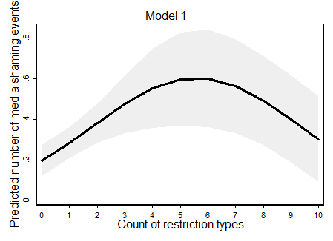 | 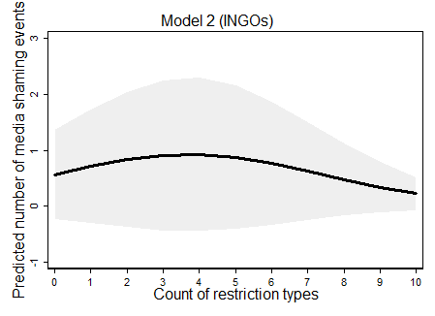
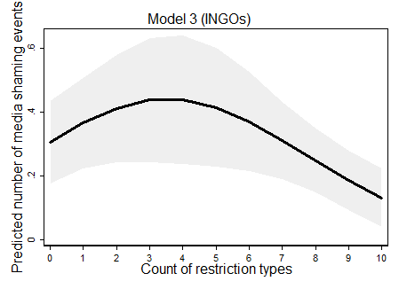

Fixed Effects Models
We also re-estimate the main models with country-specific fixed effects and show that our argument holds not only across but also within countries. As shown in Models 1 and 2 in Table S7, the parameter estimates of restrictions are significant, though the curvilinear relationship is weakened in the full fixed effects specification.

Table S7. Country fixed effects regression of UAs on restrictions
 | Model 1 | Model 2
VARIABLES | Fixed  effects | Fixed  effects
Restrictions | 0.206*** | 0.143***
 | (0.029) | (0.038)
Restrictions sq. | -0.018*** | -0.010*
 | (0.003) | (0.004)
Political Terror Scale |  | -0.025
 |  | (0.053)
Human rights CSOs |  | -0.011***
 |  | (0.001)
Human rights news |  | 0.047***
 |  | (0.010)
Protest count |  | -0.039
 |  | (0.035)
Armed conflict |  | 0.598***
 |  | (0.092)
Political rights |  | 0.368*
 |  | (0.144)
Political rights sq. |  | -0.020
 |  | (0.017)
GDP per capita |  | 2.032*
 |  | (0.947)
GDP per capita sq. |  | -0.334
 |  | (0.270)
Globalization |  | 0.122**
 |  | (0.045)
Globalization sq. |  | -0.001*
 |  | (0.000)
Population size |  | 0.169
 |  | (0.240)
Constant
Observations | 1,310 | 971
Log-Likelihood | -2009.7 | -1380.2
BIC | 4033.8 | 2856.7
AIC | 4023.5 | 2788.4
Notes: Standard errors standard errors in parentheses, for Models 3 and 4 clustered by country;
p-values: ***<0.001, ** <0.01, *<0.05, +<0.1.

Population Average Models
Following Murdie & Davis (2012), we also consider the possibility that within-country observations are correlated over time by estimating a population average model with generalized estimating equation estimation and a robust estimation of an autoregressive lag one correlation structure of the variance-covariance matrix (cf. Zorn 2001). The population-average model parameters for restrictions summarized in Models 1 and 2 in Table S8 are highly significant and indicate few restrictions are generally followed by additional UA, while systematic crack-down on civil society has a silencing effect.

Table S8. Population average models of UAs on restrictions
 | Model 1 | Model 2
VARIABLES | Population average | Population average
Restrictions | 0.229*** | 0.300***
 | (0.035) | (0.053)
Restrictions sq. | -0.019*** | -0.022***
 | (0.004) | (0.006)
Political Terror Scale |  | 0.240***
 |  | (0.062)
Human rights CSOs |  | 0.003+
 |  | (0.002)
Human rights news |  | 0.035
 |  | (0.030)
Protest count |  | 0.116*
 |  | (0.046)
Armed conflict |  | 0.592***
 |  | (0.125)
Political rights |  | 0.523**
 |  | (0.171)
Political rights sq. |  | -0.047*
 |  | (0.020)
GDP per capita |  | 0.617*
 |  | (0.261)
GDP per capita sq. |  | -0.325**
 |  | (0.117)
Globalization |  | 0.156***
 |  | (0.036)
Globalization sq. |  | -0.001***
 |  | (0.000)
Population size |  | 0.052
 |  | (0.115)
Constant | 0.362*** | -5.833***
 | (0.075) | (0.979)
Observations | 1,677 | 1,250

Test for Mechanism Implications
In our argument, we propose that restrictions first affect domestic CSOs’ motives and capacity to monitor government behavior and mobilize against human rights violations. We proxy the capacity to monitor and mobilize with two indicators: The number of human rights CSOs operating in a given country and year and the number of protest events. While the main analyses control for these variables, we now use them as our dependent variables.
Table S9a presents the results of the regression of restrictions and control variables on the number of human rights CSOs. The squared term of restrictions is negative, but only significant in the negative binomial model that controls for covariates. The predicted number of CSOs conditional on restrictions (see Figure 4 in the main text) reveals that government-sponsored attempts to control and repress CSOs threatens organizational survival. This finding is in line with a study by Dupuy, Ron and Ramos’ (2015) and that foreign funding restrictions reduce the number of human rights organizations in Ethiopia. The predications from the instrumental variable Poisson model estimated with GMM in Figure S9a are consistent with this result and show that an increase in restriction types from 3 to 10 is associated with a significant decrease in the number of human rights CSOs.
Table S9b presents the results of the regression of restrictions and control variables on the number of protest events. The squared term of restrictions is negative and significant in the pooled negative binomial model with cluster robust standard errors. However, it loses significant in the zero-inflated negative binomial model. If we take the nature log of protest events and run an Ordinary Least Square (OLS) model, restrictions have a significant curvilinear effect on protest. Predictions based on the pooled model (see Figure 5 in the main text) as well as based on the zero-inflated negative binomial model and the OLS model (with covariates), which are presented in Figures S9b below, point in the expected directions. Increasing government restrictions on CSO activity beyond a threshold of three or four types, on average, decreases the number of protest events. As such, the analyses yield further evidence for the domestic mechanisms explaining the link between restrictions and international ‘naming and shaming’.

Table S9a. Regressions of restrictions on the number of human rights CSOs
 | Model 1 | Model 2 | Model 3 | Model 4
 | Neg. bin | Neg. bin. | GMM | GMM
 | Reduced | Full | 1 EEV | All EEVs
Restrictions | -0.036 | 0.054* | 0.070 | 0.048
 | (0.040) | (0.027) | (0.044) | (0.043)
Restrictions sq. | -0.004 | -0.006* | -0.008 | -0.007
 | (0.004) | (0.003) | (0.005) | (0.005)
Political Terror Scale |  | 0.205*** | 0.221*** | 0.345***
 |  | (0.027) | (0.028) | (0.045)
Human rights news |  | -0.018* | -0.029* | -0.070
 |  | (0.009) | (0.013) | (0.048)
Protest count |  | 0.070*** | 0.070*** | 0.074*
 |  | (0.019) | (0.021) | (0.034)
Armed conflict |  | -0.008 | -0.002 | -0.101
 |  | (0.059) | (0.076) | (0.080)
Political rights |  | -0.078 | -0.114 | -0.140+
 |  | (0.068) | (0.080) | (0.085)
Political rights sq. |  | -0.001 | 0.002 | 0.005
 |  | (0.008) | (0.009) | (0.010)
GDP per capita |  | -0.251* | -0.136 | -0.067
 |  | (0.103) | (0.095) | (0.101)
GDP per capita sq. |  | 0.041* | 0.021 | 0.012
 |  | (0.019) | (0.021) | (0.034)
Globalization |  | -0.016 | -0.018+ | -0.015
 |  | (0.012) | (0.010) | (0.012)
Globalization sq. |  | 0.000*** | 0.000*** | 0.000***
 |  | (0.000) | (0.000) | (0.000)
Population size |  | 0.067+ | 0.056 | 0.048
 |  | (0.041) | (0.044) | (0.037)
Constant | 4.354*** | 3.101*** | 3.349*** | 2.998***
 | (0.060) | (0.297) | (0.303) | (0.329)
Observations | 1,604 | 1,391 | 1,389 | 1,247
Log-Likelihood | -8117.3 | -6365.9
BIC | 16264.2 | 12840.4
AIC | 16242.7 | 12761.8
Hansen's J |  |  | 0.4 | 0.2
Notes: Cluster-robust standard errors (Models 1-2) and clustered bootstrapped standard errors in parentheses;
p-values: ***<0.001, ** <0.01, *<0.05, +<0.1.

Table S9b. Regressions of restrictions on the number of protest events
 | Model 1 | Model 2 | Model 3 | Model 4 | Model 5
 | Neg. bin. | Neg. bin | Zero-infl | OLS | OLS
 | Reduced | Full | Full | Reduced | Full
Restrictions | 0.114 | 0.091 | 0.059 | 0.102* | 0.074
 | (0.082) | (0.077) | (0.075) | (0.049) | (0.048)
Restrictions sq. | -0.019* | -0.015 | -0.009 | -0.015** | -0.010*
 | (0.010) | (0.009) | (0.009) | (0.005) | (0.005)
Political Terror Scale |  | 0.313*** | 0.309*** |  | 0.180**
 |  | (0.090) | (0.090) |  | (0.055)
Human rights news |  | 0.093** | 0.088* |  | 0.077***
 |  | (0.035) | (0.037) |  | (0.018)
Armed conflict |  | -0.199 | -0.184 |  | -0.200+
 |  | (0.185) | (0.186) |  | (0.121)
Political rights |  | -0.052 | -0.075 |  | -0.029
 |  | (0.215) | (0.220) |  | (0.118)
Political rights sq. |  | -0.007 | 0.002 |  | -0.007
 |  | (0.025) | (0.025) |  | (0.014)
GDP per capita |  | 0.298 | 0.471 |  | 0.048
 |  | (0.375) | (0.441) |  | (0.145)
GDP per capita sq. |  | -0.216* | -0.113 |  | -0.052
 |  | (0.090) | (0.181) |  | (0.032)
Globalization |  | 0.009 | 0.022 |  | 0.026
 |  | (0.046) | (0.053) |  | (0.022)
Globalization sq. |  | -0.000 | -0.000 |  | -0.000
 |  | (0.000) | (0.001) |  | (0.000)
Population size |  | -0.135 | -0.146 |  | -0.052
 |  | (0.137) | (0.129) |  | (0.080)
Zero: GDP per capita |  |  | 1.483***
 |  |  | (0.383)
Zero: Political rights best |  |  | -0.832
 |  |  | (0.986)
Zero: Political rights worst |  |  | 3.219***
 |  |  | (0.904)
Zero: Constant |  |  | -2.907***
 |  |  | (0.812)
Constant | 1.016*** | 0.241 | 0.083 | 0.872*** | -0.005
 | (0.094) | (1.143) | (1.318) | (0.062) | (0.595)
Observations | 2,022 | 1,463 | 1,463 | 2,022 | 1,463
Log-Likelihood | -4281.6 | -3030.4 | -2994.1 | 0.028 | 0.117
BIC | 8593.7 | 6162.8 | 6119.4 | -2604.2 | -1802.1
AIC | 8571.2 | 6088.7 | 6024.2 | 5231.3 | 3699.0
R squared |  |  |  | 5214.5 | 3630.3
Notes: Cluster-robust standard errors in parentheses;
p-values: ***<0.001, ** <0.01, *<0.05, +<0.1.

Figure S9a. Predicted number of CSOs, conditional on number of restriction types
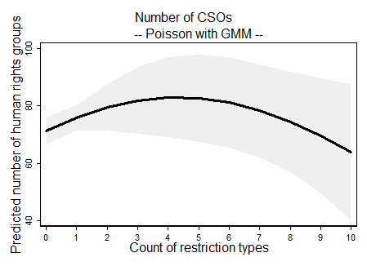 | 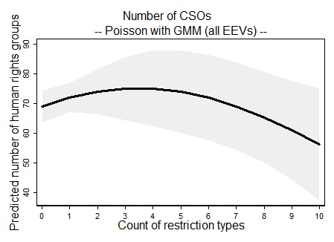

Figure S9b. Predicted number of CSOs, conditional on number of restriction types
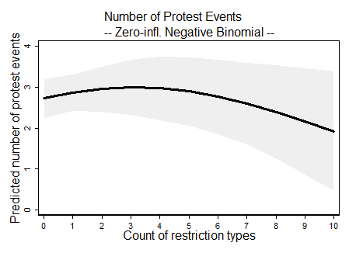 | 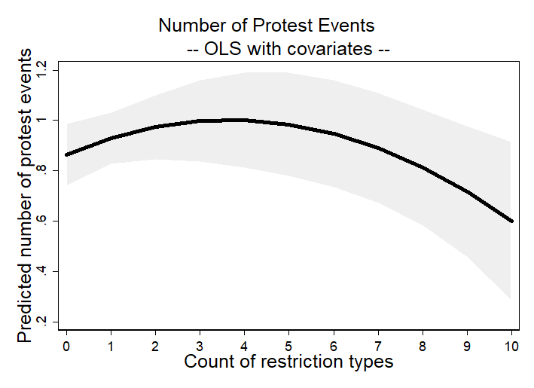

Reference for Supplementary Material
Baum C, Schaffer ME and Stillman S (2003) Instrumental variable and GMM: estimation and testing. The Stata Journal 3(1): 1-31.
Wooldridge, J (2010) Econometric Analysis of Cross Section and Panel Data. [Second Edition.] Cambridge, MA: MIT Press.

Stata does not provide a fixed effects negative binomial model (see discussion https://www.statalist.org/forums/forum/general-stata-discussion/general/1383403-panel-data-count-model-fe-vs-re-different-predicted-counts). Therefore, we use a fixed effects Poisson model.

