Online Appendix

Table A1: Summary statistics
 | N | Mean | Sd | Min | Max
Military regime | 8569 | 0.170 | 0.376 | 0 | 1
Military regime categorical | 8569 | 0.241 | 0.560 | 0 | 2
Regional rebellion (decay) | 16204 | 0.0442 | 0.199 | 0 | 1
Center-seeking rebellion (decay) | 16150 | 0.0674 | 0.238 | 0 | 1
Previously experienced regional rebellion | 16333 | 0.101 | 0.302 | 0 | 1
Previously experienced center-seeking rebellion | 16333 | 0.226 | 0.418 | 0 | 1
Directly following regional rebellion | 3834 | 0.0764 | 0.266 | 0 | 1
Directly following center-seeking rebellion | 3834 | 0.184 | 0.388 | 0 | 1
Duration of regional rebellion | 9619 | 0.891 | 5.057 | 0 | 66
Duration of ideological rebellion | 9619 | 0.796 | 3.770 | 0 | 50
Regional rebellion (dummy) | 9620 | 0.0681 | 0.252 | 0 | 1
Center-seeking rebellion (dummy) | 9620 | 0.0984 | 0.298 | 0 | 1
GDP p.c. (log) | 10416 | 8.365 | 1.096 | 5.7 | 11.5
Population size (log) | 10119 | 15.22 | 2.070 | 9.2 | 21.0
Polity | 8937 | 0.625 | 7.488 | -10 | 10
Mil. capabilities (cube root) | 8829 | 126.4 | 94.61 | 6.2 | 726.8
Unrest (log) | 9705 | 0.356 | 0.676 | 0 | 4.5
War (dummy) | 14600 | 0.0170 | 0.129 | 0 | 1
Rel. fractionalization | 13277 | 0.442 | 0.257 | 0 | 0.9
Rents p.c. (log) | 9335 | 2.815 | 3.013 | 0 | 11.4
Population density | 12936 | 226.2 | 1395.1 | 0.5 | 25322.8
Trade | 7556 | 76.46 | 48.32 | 0.3 | 531.7
Post Cold War | 9207 | 0.391 | 0.488 | 0 | 1

Table A2: Countries included in main model
Country | N | Percent | Country | N | Percent
Afghanistan | 25 | 0.53 | Latvia | 17 | 0.36
Albania | 48 | 1.02 | Lebanon | 17 | 0.36
Algeria | 9 | 0.19 | Lesotho | 34 | 0.72
Angola | 32 | 0.68 | Liberia | 33 | 0.7
Argentina | 33 | 0.7 | Libya | 9 | 0.19
Australia | 48 | 1.02 | Lithuania | 17 | 0.36
Austria | 48 | 1.02 | Luxembourg | 48 | 1.02
Bahrain | 37 | 0.78 | Macedonia | 16 | 0.34
Bangladesh | 35 | 0.74 | Madagascar | 45 | 0.95
Belarus | 17 | 0.36 | Malawi | 44 | 0.93
Belgium | 48 | 1.02 | Malaysia | 48 | 1.02
Benin | 23 | 0.49 | Mali | 25 | 0.53
Bhutan | 38 | 0.8 | Mauritania | 21 | 0.44
Bolivia | 31 | 0.66 | Mauritius | 40 | 0.85
Botswana | 42 | 0.89 | Mexico | 48 | 1.02
Brazil | 27 | 0.57 | Moldova | 17 | 0.36
Bulgaria | 48 | 1.02 | Morocco | 48 | 1.02
Burkina Faso | 8 | 0.17 | Mozambique | 21 | 0.44
Burundi | 9 | 0.19 | Myanmar | 2 | 0.04
Cambodia | 29 | 0.61 | Nepal | 43 | 0.91
Cameroon | 48 | 1.02 | Netherlands | 48 | 1.02
Cape Verde | 33 | 0.7 | New Zealand | 48 | 1.02
Central African Republic | 18 | 0.38 | Nicaragua | 29 | 0.61
Chad | 22 | 0.47 | Niger | 26 | 0.55
Chile | 31 | 0.66 | Nigeria | 11 | 0.23
China | 48 | 1.02 | Norway | 48 | 1.02
Colombia | 43 | 0.91 | Oman | 48 | 1.02
Comoros | 27 | 0.57 | Pakistan | 12 | 0.25
Congo | 13 | 0.28 | Panama | 28 | 0.59
Costa Rica | 48 | 1.02 | Papua New Guinea | 33 | 0.7
Croatia | 17 | 0.36 | Paraguay | 15 | 0.32
Cuba | 48 | 1.02 | Peru | 27 | 0.57
Cyprus | 37 | 0.78 | Philippines | 46 | 0.97
Czech Republic | 15 | 0.32 | Poland | 38 | 0.8
Democratic Republic of the Congo | 7 | 0.15 | Portugal | 45 | 0.95
Denmark | 48 | 1.02 | Qatar | 37 | 0.78
Djibouti | 31 | 0.66 | Romania | 47 | 0.99
Dominican Republic | 43 | 0.91 | Russia | 16 | 0.34
East Timor | 6 | 0.13 | Rwanda | 12 | 0.25
Ecuador | 36 | 0.76 | Saudi Arabia | 48 | 1.02
Egypt | 27 | 0.57 | Senegal | 48 | 1.02
El Salvador | 22 | 0.47 | Sierra Leone | 34 | 0.72
Equatorial Guinea | 11 | 0.23 | Singapore | 43 | 0.91
Estonia | 17 | 0.36 | Slovakia | 15 | 0.32
Ethiopia | 15 | 0.32 | Slovenia | 17 | 0.36
Fiji | 24 | 0.51 | Solomon Islands | 29 | 0.61
Finland | 48 | 1.02 | Somalia | 10 | 0.21
France | 48 | 1.02 | South Africa | 47 | 0.99
Gabon | 48 | 1.02 | South Korea | 20 | 0.42
Gambia | 29 | 0.61 | Spain | 31 | 0.66
Germany | 18 | 0.38 | Sri Lanka | 33 | 0.7
Ghana | 26 | 0.55 | Sudan | 2 | 0.04
Greece | 41 | 0.87 | Suriname | 24 | 0.51
Guatemala | 23 | 0.49 | Swaziland | 40 | 0.85
Guinea | 24 | 0.51 | Sweden | 48 | 1.02
Guinea-Bissau | 18 | 0.38 | Switzerland | 48 | 1.02
Guyana | 38 | 0.8 | Syria | 12 | 0.25
Haiti | 43 | 0.91 | Tanzania | 47 | 0.99
Honduras | 30 | 0.63 | Thailand | 30 | 0.63
Hungary | 47 | 0.99 | Togo | 9 | 0.19
India | 48 | 1.02 | Trinidad and Tobago | 46 | 0.97
Indonesia | 15 | 0.32 | Tunisia | 48 | 1.02
Iran | 48 | 1.02 | Turkey | 41 | 0.87
Iraq | 23 | 0.49 | Uganda | 31 | 0.66
Ireland | 48 | 1.02 | Ukraine | 17 | 0.36
Israel | 48 | 1.02 | United Arab Emirates | 37 | 0.78
Italy | 48 | 1.02 | United Kingdom | 48 | 1.02
Ivory Coast | 39 | 0.83 | Uruguay | 36 | 0.76
Jamaica | 47 | 0.99 | Venezuela | 48 | 1.02
Japan | 48 | 1.02 | Vietnam | 17 | 0.36
Jordan | 48 | 1.02 | Yugoslavia | 2 | 0.04
Kenya | 45 | 0.95 | Zambia | 44 | 0.93
Kuwait | 40 | 0.85 | Zimbabwe | 37 | 0.78
Laos | 36 | 0.76

Descriptive patterns for H1 and H2
In addition to presenting the findings from our quantitative models, we explore if our hypotheses are supported by patterns in descriptive data. Figure A1 displays the relative frequency of regional rebellions for three types of regime transitions: transitions toward military regimes, civilian autocracies, and democracies. In the case of transitions to military regimes, the mean of Regional rebellion (decay) over the measurement period is 15 and 25 percent higher than for transitions to civilian autocracy and democracy respectively, suggesting that military regimes emerge more often from regional rebellions; second, more transitions to military regimes are directly preceded by a regional rebellion than transitions to other regimes; third, about 15 percent of all transitions to military regimes occur in countries which at some point experienced a regional rebellion, while the equivalent shares in transitions to civilian autocracy and democracy lie around 6 and 8 percent respectively. Taken together, the data suggest that, in line with H1, regime transitions in the wake of regional rebellions are more likely to yield military rule.
Figure A1: Regional rebellions and regime transitions
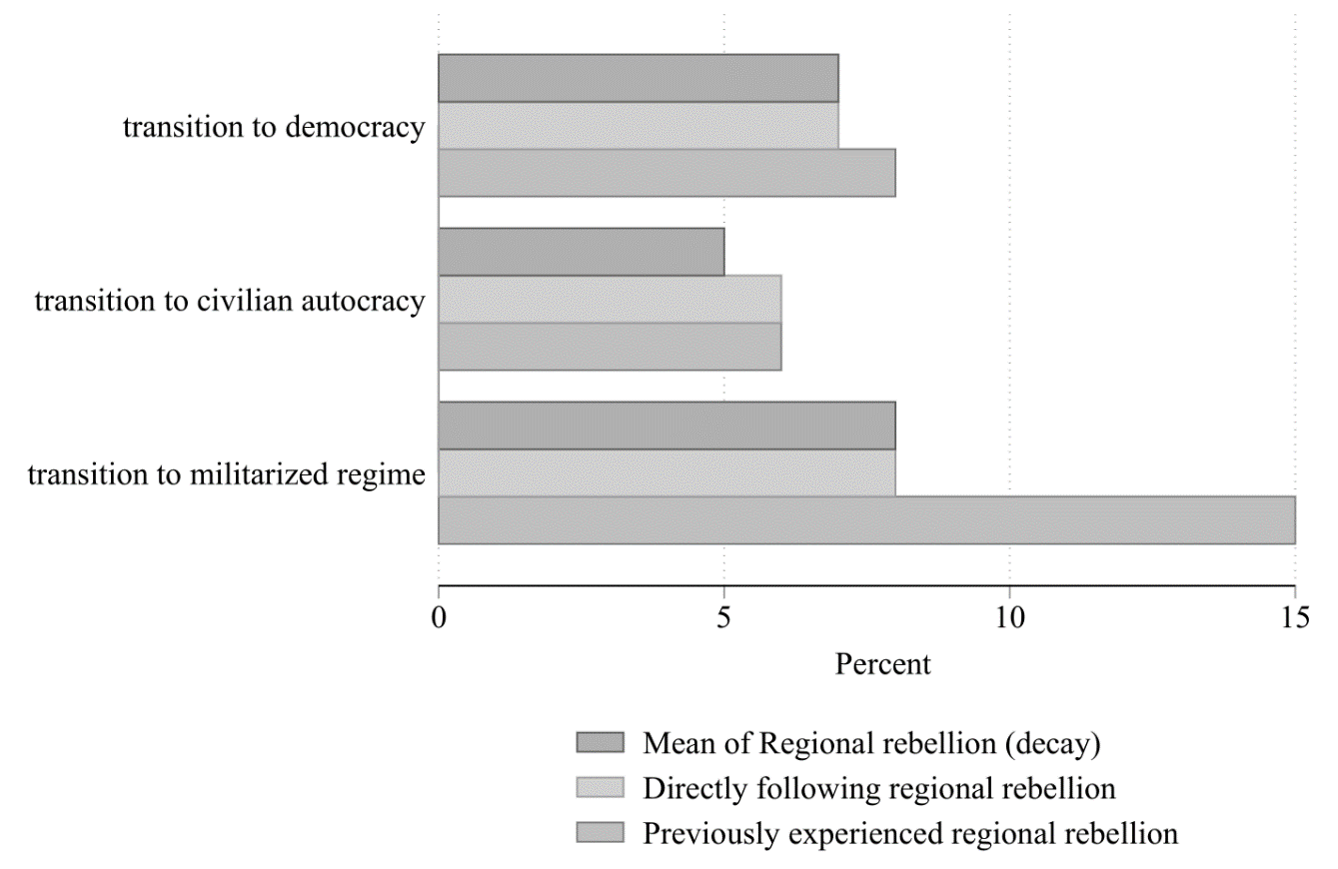Note: “Previously experienced regional rebellions” means occurrence of a regional rebellion at some point in the past; “directly following regional rebellions” means a regional rebellion occurred in the previous year. Data on regime types taken from Svolik (2012); rebellion data from Gleditsch et al. (2002).

Figure A2 presents descriptive evidence for our second hypothesis on the intensity of regional conflict and the level of regime militarization. It shows that in regimes under direct military rule the average years of experienced regional rebellions – the mean of our duration measure – is more than three times higher than in democracies, civilian autocracies, or regimes under indirect military rules. This is a first indication that more intense regional conflicts leads to greater militarization of regimes in the form of direct military rule.

Figure A2: Intensity of regional conflict and regime militarization
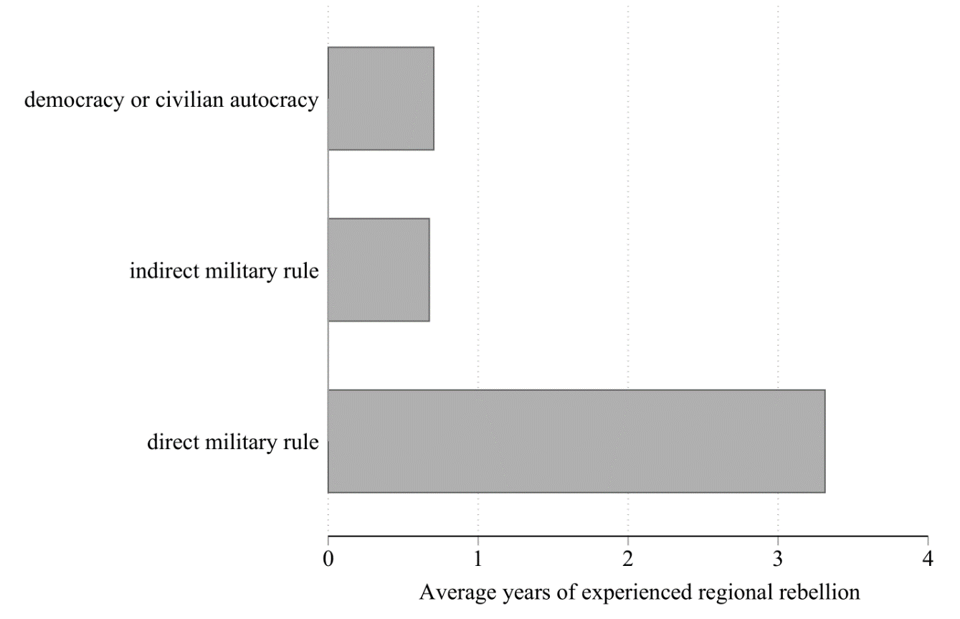
Note: Data on regime types taken from Svolik (2012); rebellion data from Gleditsch et al. (2002).

Modelling military regime democratization
While military regimes have, on average, had shorter spells than other regime types (Geddes 1999a), there is actually considerable variation across military regimes, for which our theory provides a potential explanation (Croissant and Kuehn 2016; Kim and Kroeger 2018). Our third hypothesis is thus as follows: Our theoretical argument implies that regional rebellions prompt militaries to hold on to power longer rather than handing it back quickly to civilian elites as their motivation and capacity to do so is stronger. Specifically, we hypothesize the following:
H3: Military regimes arising in the wake of regional rebellions or exposed to regional rebellions during their spell should withstand pressures for democratization longer than other military regimes.
In terms of descriptive statistics, Figure A3 depicts the average duration of military regimes in years differentiated by whether they experienced regional rebellions. In line with our expectations in H3, the average duration of all military regimes that have experienced some form of regional rebellion is noticeably higher: military regimes that previously experienced a regional rebellion last on average four years longer; regimes that directly emerge in the wake of a regional rebellion last over six years longer; and military regimes facing a regional rebellion during their spell last about two years longer. On the whole, the patterns emerging from the descriptive statistics are in line with our theory and inspire confidence in our theory.
Figure A3: Regional rebellions and military regime duration
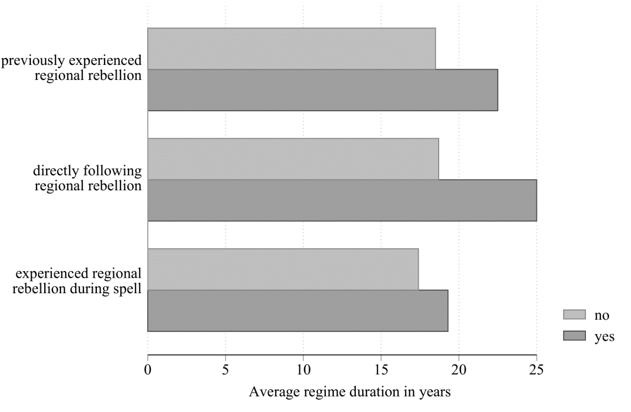
Note: “Previously experienced regional rebellions” means occurrence of a regional rebellion at some point in the past; “directly following regional rebellions” means a regional rebellion occurred in the previous year; “experienced regional rebellion during spell” means at least one regional rebellion occurred during the regime spell. Data on regime types taken from Svolik 2012; rebellion data from Gleditsch et al. 2002.

To model the effect of regional rebellions on military regimes’ ability to withstand democratization (H3) we use a variant of our Markov transition model presented above. Based on the theory-generating Southeast Asian cases, we hypothesize two scenarios for military regimes to become more resistant to democracy through regional rebellion: first, military regimes that either directly emerge out of a regional rebellion – that is, experience one in the year preceding regime onset – or that were preceded by regional rebellions at some point in the past become more resilient in the face of democratizing forces as the preceding conflict has galvanized military elites into a cohesive ruling group; second, military regimes that experience regional rebellions during their spell should also be more resistant to democracy as the cohesion of the ruling group is enhanced by conflict. Note that in the latter case military regimes could have come to power for reasons other than regional rebellions but then subsequently become more resilient as a result of regional rebellion.
To capture the foundational effect of preceding regional rebellions, we create two new variables, henceforth called origin variables: Previously experienced regional rebellion is a binary variable taking the value of 1 if a military regime was preceded by a regional rebellion at some point before its onset; Directly following regional rebellion is also a binary variable indicating whether or not a military regime was preceded by a regional rebellion in the period immediately prior to regime onset. Both variables are time-invariant for the duration of a military regime spell. The effect of rebellions occurring during a spell are captured by our standard decay variables. In terms of the model specification, we follow the setup of the Markov transition model with the exception that we now model the transition from a military regime to democracy. The equation is as follows:
$Pr\left({Democracy}_{i,t}=1 | {Mil. regime}_{i,t-1}=1\right)=Logit(α_{0}+β_{1}R_{i,t-1}+β_{2}X_{i,t-1}+δ_{3}+β_{4}ϑ_{i,t}+μ_{i,t}$), (3)
with $α$ designating the constant, R our measures of regional rebellions (origin and during spell), X a vector of covariates, and $δ$ regional fixed effects. The event counter $ϑ$ measures the number of previous regime breakdowns, while $μ$ designates cubic polynomials of the time since military regime onset. As before, we lag all variables except for the event counter and the regional fixed effects, and estimate a pooled as well as a fixed effects logit model. In the latter, the origin variables are not estimated as they are time-variant so that the model uniquely focuses on the effect of regional rebellions occurring during a military spell.
Our regressions results are displayed in Table A4. Columns 1 and 2 report the pooled logit estimates of the origin variables, while column 3 shows the estimates for rebellions occurring during a regime spell only. Columns 4 and 5 show the results when both measures of rebellion are added simultaneously into the regression. The conditional logit results are shown in Column 6. On the whole, the findings partially support H3. On the one hand, rebellions occurring during regime spells significantly reduce the likelihood of a transition to democracy. Given a baseline probability of democratization of 3.3 percent in the pooled model, the occurrence of a regional rebellions reduces this probability on average by 1.5 percent absolutely and 45 percent relatively speaking. The effect then fades out over the five following periods (see Figure A4). The conditional logit model which focuses solely on within regime variation yields a similarly, slightly stronger finding as significance levels increase.

Figure A4: Effect of regional rebellion on military regime democratization
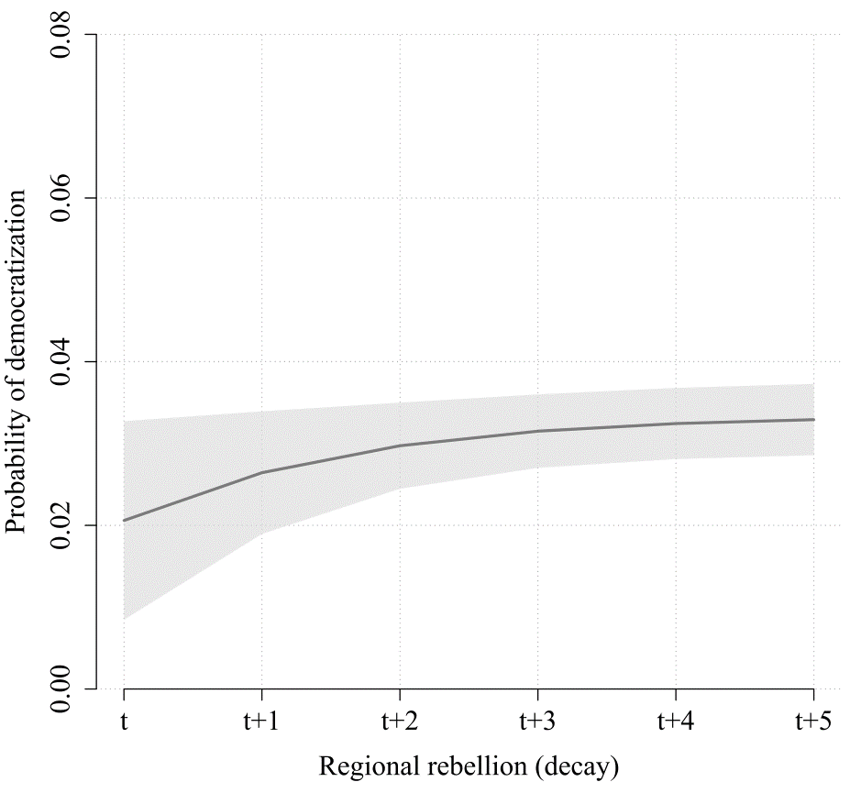
Note: Marginal effects derived from Table A4, column 5. Regional rebellion set at 1, 0.5, 0.25, 0.125, and 0.0625 according to decay function. All other covariates set at their observed values (Hanmer and Ozan Kalkan 2013).

On the other hand, our expectation that regimes emerging out of, or in contexts preceded by regional rebellions are more stable, does not bear out. In fact, all signs are positive except in column 1. The results of column 5 suggest that regimes directly following a regional rebellion are more likely to break down than regimes without previous rebellions. This finding is somewhat surprising in light of the suggestive descriptive statistics presented at the outset of this section. We see two possible reasons for this: First, with a total of three cases (Indonesia, Mauritania, Myanmar), military regimes arising directly in the wake of regional rebellion are relatively rare in our data, and while their spell is comparatively long (32, 26, and 47 years respectively), the model might struggle to produce clear results from so few positive observations. Second, a number of regimes are double-coded as having both regional and center-seeking rebellions prior to their onset (see Table A3). This is, amongst others, the case for Myanmar – one of the most long-lasting military dictatorships. As a result, differentiating the effect of center-seeking and regional rebellions at the origin of military regimes is complicated because of tied data. Conversely, given that these tied data bias the results against our hypotheses more generally, the fact that in all our models Regional decay has been highly significant makes us more confident in the validity of our findings.

Table A3: Regimes with both types of rebellion
Previously experienced regional AND center-seeking rebellion | Directly following regional AND center-seeking rebellion
Comoros (3) | Myanmar (46)
D. R. Congo (26, 3)
Ethiopia (15, 2)
Indonesia (32)
Myanmar (45)
Niger (1)
Nigeria (12, 14)
Pakistan (8)
Note: Duration of military regime spell in brackets.

Table A4: Regional rebellions and military regime democratization
 | (1) | (2) | (3) | (4) | (5) | (6)
Previously experienced regional rebellion t-1 | 0.759 |  |  | 2.161
 | (1.190) |  |  | (1.816)
Previously experienced center-seeking rebellion t-1 | 0.844 |  |  | -0.018
 | (0.861) |  |  | (1.378)
Directly following regional rebellion t-1 |  | 0.650 |  |  | 2.212
 |  | (0.879) |  |  | (0.965)**
Directly following center-seeking rebellion t-1 |  | 0.029 |  |  | -0.775
 |  | (1.483) |  |  | (1.343)
Regional rebellion (decay) t-1 |  |  | -2.613 | -3.884 | -1.808 | -24.995
 |  |  | (1.496)* | (1.858)** | (0.975)* | (6.222)***
Center-seeking rebellion (decay) t-1 |  |  | 1.713 | 1.930 | 1.625 | -1.636
 |  |  | (1.006)* | (1.513) | (1.131) | (2.287)
GDP p.c. (log) t-1 | 0.088 | 0.497 | 0.471 | 0.165 | 0.558 | -1.891
 | (0.807) | (1.146) | (0.973) | (0.765) | (0.964) | (8.406)
Population size (log) t-1 | -1.501 | -0.628 | -0.881 | -1.361 | -0.382 | 9.899
 | (1.380) | (1.180) | (1.247) | (1.211) | (1.002) | (6.658)
Polity t-1 | 0.814 | 0.786 | 0.829 | 0.854 | 0.802 | 1.528
 | (0.099)*** | (0.110)*** | (0.119)*** | (0.134)*** | (0.103)*** | (0.678)**
Mil. capabilities (cube root) t-1 | 34.619 | 14.964 | 22.660 | 30.100 | 9.588 | 365.337
 | (29.913) | (23.793) | (26.368) | (25.568) | (21.430) | (347.806)
Unrest (log) t-1 | -0.184 | -0.684 | -0.187 | -0.139 | -0.678 | -3.729
 | (0.595) | (0.661) | (0.586) | (0.552) | (0.554) | (3.063)
War (dummy) t-1 | -1.963 | -2.434 | -2.892 | -2.906 | -3.342 | -3.161
 | (1.387) | (1.410)* | (1.486)* | (1.578)* | (1.470)** | (2.580)
Rel. fractionalization t-1 | 4.988 | 5.747 | 5.961 | 5.741 | 6.710
 | (2.925)* | (2.132)*** | (2.871)** | (2.865)** | (2.426)***
Number of previous regime failures | 0.697 | 0.805 | 0.671 | 0.767 | 0.911 | -2.812
 | (0.385)* | (0.419)* | (0.328)** | (0.459)* | (0.370)** | (1.452)*
N | 1,166 | 1,023 | 1,166 | 1,166 | 1,023 | 471
Time polynomials | Yes | Yes | Yes | Yes | Yes | Yes
Regional dummies | Yes | Yes | Yes | Yes | Yes | Yes
Pooled logit model in columns 1-5. Conditional logit model in column 6. Cluster-robust standard errors in parentheses. * p<0.1; ** p<0.05; *** p<0.

Separation plots to assess model fit
The two below figures show separation plots for our two baseline models. Separation plots arrange the fitted values in ascending order of probability with each line representing one observation (Greenhill, Ward, and Sacks 2011). Red lines are observations in which the outcome of interest actually occurs. The added line represents the predicted probabilities estimated for each observation. The small triangle beneath the plot indicates the expected number of total events predicted. A perfectly fitted model would thus have red and yellow lines perfectly separated at the position of the triangle, with a sharp corresponding rise in the predicted probability line. A very bad model would see the occurrence of actual outcomes at even very low levels of predicted probability and a slow gradual increase of the probability line. Bearing this in mind, the graphs below demonstrate a good model fit with high levels of separation and a visible spike in the predicted probability at the triangle separation point.

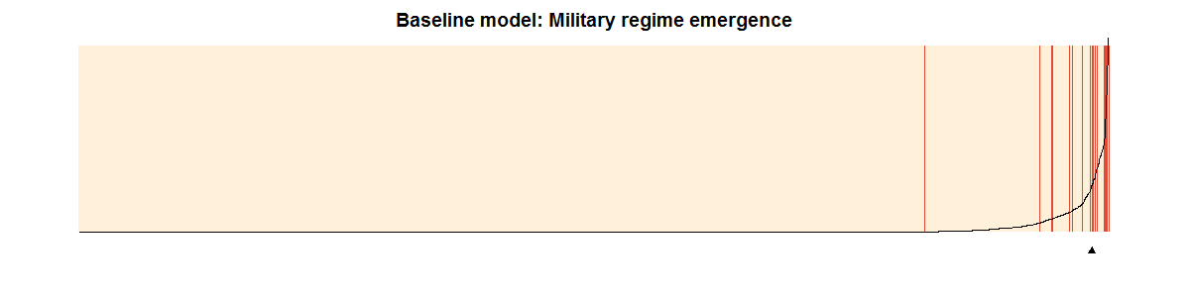
Note: Figure based on column 4, Table 1 in the main article.

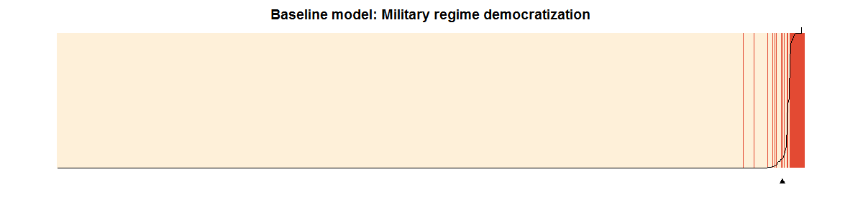
Note: Figure based on column 3, Table A4 in the Online Appendix.

General note on robustness tests
The below section includes the following tests: additional/alternative variables, diffusion effects, and alternative time specifications. The tests are carried out for our military regime emergence and democratization models. Wherever possible, these tests are also carried out for our multinomial logit model of regime militarization.

Mundlak-Chamberlain models
As an alternative to our conditional logistic fixed effects regressions, we estimate the effect of rebellions on the emergence and democratization of military regimes using the Mundlak-Chamberlain (Chamberlain 1982; Mundlak 1978) approach. The model takes the following functional form:
$Pr\left(Y_{i,t}=1 | Y_{i,t-1}=0\right)=Logit\left(α_{0}+β_{1}{(R}_{i,t-1}-\overline{R_{i}}\right)+β_{2}\left(X_{i,t-1}-\overline{X_{i}}\right)+β_{3}\overline{R_{i}}+β_{4}\overline{X_{i}}++β_{5}\overline{Y_{i}}+δ_{3}+μ_{i,t}$), (1),
where $α$ designates the constant, R our measure of regional rebellions, X a vector of covariates (including our event count variable), and $δ$ regional fixed effects. By adding the country means and the yearly deviation from the country means, the model enables us to separate cross-country from within-country effects. Note that in Table A6 we refrain from adding the yearly deviation for the variables measuring the rebellion prior or at regime onset (Previously experienced regional/center-seeking rebellion; directly following regional/center-seeking rebellion) as these are highly collinear with our standard measure of Regional/Center-seeking rebellion. Additionally, we add the country mean of our dependent variable Y, which allows us to account for unit heterogeneity by, effectively, adding a varying intercept (Wright, Frantz, and Geddes 2015). We also add $μ$, a vector of cubic time polynomials to account for duration dependence (Carter and Signorino 2010). As before, all variables except for regional fixed effects and the event counter are lagged by one year to mitigate endogeneity concerns and ensure the correct order of causal dependence.
The results for military regime emergence are shown in Table A5. In line with our baseline model, the model finds that within-country changes of regional rebellions significantly increase the likelihood of military regime emergence. The effect is illustrated in the marginal effects plot in Figure A5. By contrast, cross-country differences in the average level of regional rebellions are not associated with a higher likelihood of military regime emergence, suggesting that our finding is driven by within-country variation of regional rebellions over time.
The results for military regime democratization are shown in Table A6. None of the variables for regional rebellions is significant. As we explain in the article, this is most probably due to tied data for regimes that experience both a regional and a center-seeking rebellion prior to regime onset.

Table A5: Mundlak-Chamberlain estimation of military regime emergence
 | (1) | (2)
Regional rebellion (decay, mean) | -0.558 | -0.682
 | (0.979) | (1.569)
Regional rebellion t-1 (decay, dev) | 1.607 | 1.308
 | (0.762)** | (0.755)*
Center-seeking rebellion (decay, mean) | 1.476 | 0.496
 | (0.671)** | (0.649)
Center-seeking rebellion t-1 (decay, dev) | 0.391 | 0.077
 | (0.540) | (0.607)
GDP p.c. (log, mean) | -0.042 | -0.218
 | (0.286) | (0.261)
GDP p.c. t-1 (log, dev) | -0.036 | -0.071
 | (0.533) | (0.553)
Population size (log, mean) | 0.201 | 0.292
 | (0.292) | (0.300)
Population size t-1 (log, dev) | 2.661 | 3.659
 | (0.849)*** | (0.876)***
Polity (mean) | 0.043 | 0.162
 | (0.050) | (0.078)**
Polity t-1 (dev) | -0.265 | -0.365
 | (0.050)*** | (0.064)***
Mil. capabilities (cube root, mean) | -7.251 | -5.096
 | (8.429) | (7.096)
Mil. capabilities t-1 (cube root, dev) | -16.044 | -18.931
 | (18.689) | (19.885)
Unrest (log, mean) | 0.881 | 1.008
 | (0.769) | (0.671)
Unrest t-1 (log, dev) | 0.215 | -0.012
 | (0.203) | (0.226)
War (dummy, mean) | 4.432 | 3.892
 | (3.496) | (2.916)
War t-1 (dummy, dev) | 0.746 | -0.027
 | (0.741) | (0.886)
Rel. fractionalization (mean) | -0.793 | -0.211
 | (0.841) | (0.725)
Previous failures (mean) | 0.147 | -0.011
 | (0.029)*** | (0.043)
Previous failures (dev) | -0.191 | -0.128
 | (0.031)*** | (0.022)***
Y (mean) |  | 8.353
 |  | (1.720)***
NxT | 4,630 | 4,630
Time polynomials | Yes | Yes
Regional dummies | Yes | Yes
Mundlak-Chamberlain logistic regression with cluster-robust standard errors in parentheses. Mean designates the country averages, dev designates the annual deviation from country averages. * p<0.1; ** p<0.05; *** p<0.01
Figure A5: Effect of within-country changes in regional rebellions
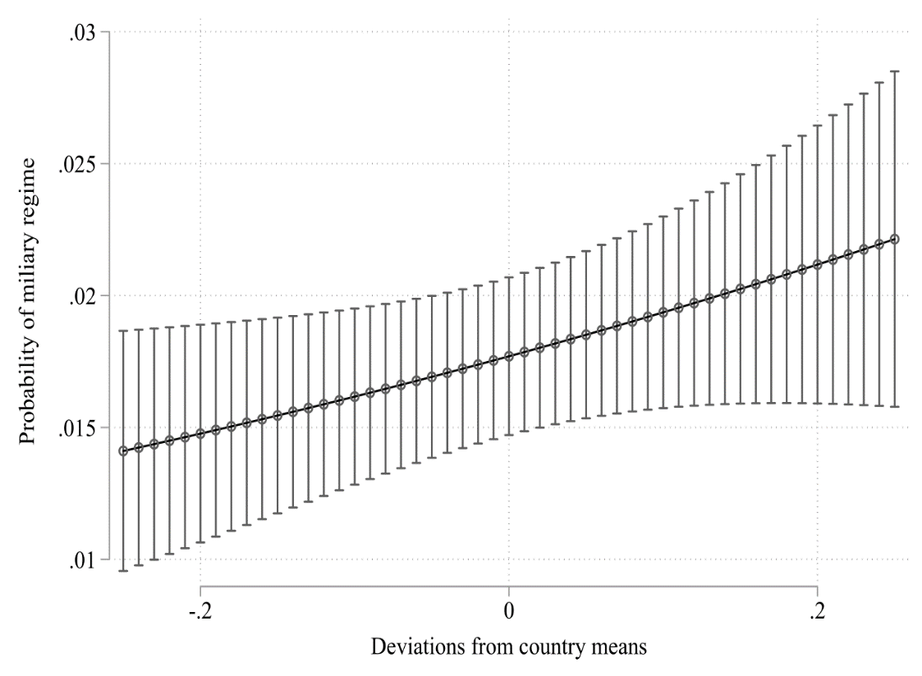
Note: Marginal effects derived from Table A5, column 1. All other covariates set at their observed values (Hanmer and Ozan Kalkan 2013).

Table A6: Mundlak-Chamberlain estimation of military regime democratization
 | (1) | (2) | (3) | (4) | (5)
Previously experienced regional rebellion (mean) | 2.777 |  |  | 10.831
 | (3.403) |  |  | (9.747)
Previously experienced center-seeking rebellion (mean) | -1.022 |  |  | -5.283
 | (1.256) |  |  | (3.448)
Directly following regional rebellion (mean) |  | 0.901 |  |  | -18.083
 |  | (4.173) |  |  | (32.346)
Directly following center-seeking rebellion (mean) |  | -1.847 |  |  | -3.842
 |  | (2.227) |  |  | (5.472)
Regional rebellion (decay, mean) |  |  | -4.167 | -18.157 | 8.392
 |  |  | (8.185) | (14.272) | (21.409)
Regional rebellion t-1 (decay, dev) |  |  | -30.648 | -6.200 | -71.368
 |  |  | (43.700) | (13.656) | (54.773)
Center-seeking rebellion (decay, mean) |  |  | 11.036 | 20.118 | 19.620
 |  |  | (7.938) | (10.891)* | (9.216)**
Center-seeking rebellion t-1 (decay, dev) |  |  | 2.886 | 3.987 | 2.456
 |  |  | (1.757) | (2.431) | (1.736)
Y (mean) | 44.420 | 51.410 | -30.814 | -41.172 | -93.795
 | (40.531) | (47.585) | (38.599) | (48.098) | (64.942)
NxT | 1,166 | 1,151 | 1,166 | 1,166 | 1,151
Standard controls | Yes | Yes | Yes | Yes | Yes
Time polynomials | Yes | Yes | Yes | Yes | Yes
Regional dummies | Yes | Yes | Yes | Yes | Yes
Mundlak-Chamberlain logistic regression with cluster-robust standard errors in parentheses. Mean designates the country averages, dev designates the annual deviation from country averages. * p<0.1; ** p<0.05; *** p<0.01

Dummy instead of decaying variables for rebellion
To ascertain that our findings are not purely an artefact of our decaying measure of rebellions, we re-run our baseline models for military regime emergence and democratization using a simple dummy indicator of rebellion. The variable measures if a regional or center-seeking rebellion occurred in the previous year. The results are shown in Table A7 and Table A8.
As expected, constraining the effect of rebellions to one period weakens the association between regional rebellions and military regime emergence and democratization. That said, the pattern we have seen when using decaying variables reemerges when using simple dummies: In Table A7, only columns 4 and 5 are slightly insignificant, but with p=0.105 and 0.125 respectively reasonably close given that we are using a much coarser measure of regional rebellions. And in Table A8, we find a similar pattern to our baseline democratization model, suggesting that regional rebellions occurring during a military regime spell significantly decrease the likelihood of democratization. This is particularly the case when focusing on within-country variation only (Table A8, column 6), which is, as we know from Table A5, the main driver of our finding.

Table A7: Regional rebellions (dummy) and military regime emergence
 | (1) | (2) | (3) | (4) | (5)
Regional rebellion (dummy) t-1 | 0.849 | 0.859 | 0.750 | 0.709 | 1.421
 | (0.457)* | (0.455)* | (0.455)* | (0.438) | (0.920)
Center-seeking rebellion (dummy) t-1 | 0.422 | 0.422 | 0.320 | 0.281 | 0.918
 | (0.336) | (0.336) | (0.317) | (0.324) | (0.610)
GDP p.c. (log) t-1 | -0.166 | -0.167 | -0.179 | 0.001 | -0.952
 | (0.240) | (0.239) | (0.235) | (0.267) | (0.852)
Population size (log) t-1 | 0.057 | 0.058 | 0.006 | 0.379 | 2.455
 | (0.126) | (0.123) | (0.122) | (0.213)* | (2.106)
Polity t-1 | -0.125 | -0.126 | -0.140 | -0.152 | -0.408
 | (0.031)*** | (0.031)*** | (0.032)*** | (0.035)*** | (0.098)***
Previous failures | 0.181 | 0.182 | 0.156 | 0.114 | -0.926
 | (0.211) | (0.212) | (0.235) | (0.249) | (0.945)
War (dummy) t-1 |  | -0.114 | 0.054 | 0.385 | 0.383
 |  | (0.766) | (0.746) | (0.734) | (1.053)
Unrest (log) t-1 |  |  | 0.483 | 0.519 | -0.102
 |  |  | (0.150)*** | (0.153)*** | (0.306)
Rel. fractionalization t-1 |  |  | -1.562 | -1.678
 |  |  | (0.692)** | (0.746)**
Mil. capabilities (cube root) t-1 |  |  |  | -10.067 | -12.692
 |  |  |  | (5.041)** | (32.218)
NxT | 4,704 | 4,704 | 4,613 | 4,612 | 1,301
Time polynomials | Yes | Yes | Yes | Yes | Yes
Regional dummies | Yes | Yes | Yes | Yes | Yes
Pooled logit model in columns 1-4. Conditional logit model in column 5. Cluster-robust standard errors in parentheses. * p<0.1; ** p<0.05; *** p<0.01

Table A8: Regional rebellions (dummy) and military regime democratization
 | (1) | (2) | (3) | (4) | (5) | (6)
Previously experienced regional rebellion t-1 | 0.759 |  |  | 1.575
 | (1.190) |  |  | (1.421)
Previously experienced center-seeking rebellion t-1 | 0.844 |  |  | 0.611
 | (0.861) |  |  | (1.053)
Directly following regional rebellion t-1 |  | 0.650 |  |  | 1.686
 |  | (0.879) |  |  | (0.983)*
Directly following center-seeking rebellion t-1 |  | 0.029 |  |  | -0.374
 |  | (1.483) |  |  | (1.582)
Regional rebellion (dummy) t-1 |  |  | -2.286 | -3.422 | -1.233 | -16.375
 |  |  | (1.491) | (1.765)* | (1.023) | (2.434)***
Center-seeking rebellion (dummy) t-1 |  |  | 1.160 | 1.047 | 0.822 | -3.039
 |  |  | (1.116) | (1.364) | (1.338) | (2.106)
GDP p.c. (log) t-1 | 0.088 | 0.497 | 0.388 | 0.209 | 0.490 | -4.731
 | (0.807) | (1.146) | (0.942) | (0.754) | (1.034) | (7.567)
Population size (log) t-1 | -1.501 | -0.628 | -0.949 | -1.368 | -0.523 | 7.758
 | (1.380) | (1.180) | (1.215) | (1.268) | (1.032) | (10.625)
Polity t-1 | 0.814 | 0.786 | 0.815 | 0.821 | 0.790 | 1.989
 | (0.099)*** | (0.110)*** | (0.109)*** | (0.105)*** | (0.101)*** | (0.750)***
Mil. capabilities (cube root) t-1 | 34.619 | 14.964 | 23.762 | 30.289 | 12.450 | 481.046
 | (29.913) | (23.793) | (25.888) | (27.057) | (21.284) | (291.278)*
Unrest (log) t-1 | -0.184 | -0.684 | -0.170 | -0.131 | -0.657 | -4.846
 | (0.595) | (0.661) | (0.599) | (0.584) | (0.607) | (2.408)**
War (dummy) t-1 | -1.963 | -2.434 | -2.583 | -2.744 | -2.903 | -4.279
 | (1.387) | (1.410)* | (1.567)* | (1.582)* | (1.568)* | (2.346)*
Rel. fractionalization t-1 | 4.988 | 5.747 | 5.707 | 5.148 | 6.195
 | (2.925)* | (2.132)*** | (2.746)** | (2.855)* | (2.242)***
Number of previous regime failures | 0.697 | 0.805 | 0.638 | 0.763 | 0.852 | -2.662
 | (0.385)* | (0.419)* | (0.318)** | (0.367)** | (0.412)** | (1.451)*
NxT | 1,166 | 1,023 | 1,166 | 1,166 | 1,023 | 471
Time polynomials | Yes | Yes | Yes | Yes | Yes | Yes
Regional dummies | Yes | Yes | Yes | Yes | Yes | Yes
Pooled logit model in columns 1-5. Conditional logit model in column 6. Cluster-robust standard errors in parentheses. * p<0.1; ** p<0.05; *** p<0.01

Using coups as dependent variable
As we argue in the paper, the concept of militarization overlaps with but is not identical to military coups. To test the degree of overlap empirically, we rerun our baseline logit model using a binary indicator for coups instead of militarized regimes as our dependent variable. We test coup data from the Powell and Thyne (2011) (column 1) and Marshall and Marshall (2014) (column 2). We would expect the direction of the sign and strength of the sign to be similar. This is precisely what Table A9 shows. Like in our baseline model, the coefficient of Regional rebellion is positive; the association is slightly weaker when using the Powell and Thyne dataset with p=0.15.

Table A9: Regional rebellions and military coups
 | (1) | (2)
Regional rebellion (decay) t-1 | 0.384 | 0.514
 | (0.264) | (0.260)**
Center-seeking rebellion (decay) t-1 | 0.238 | 0.297
 | (0.153) | (0.138)**
GDP p.c. (log) t-1 | -0.358 | -0.397
 | (0.100)*** | (0.090)***
Population size (log) t-1 | 0.006 | -0.069
 | (0.109) | (0.098)
Polity t-1 | -0.007 | -0.012
 | (0.012) | (0.011)
War (dummy) t-1 | -0.099 | 0.169
 | (0.410) | (0.332)
Unrest (log) t-1 | 0.303 | 0.336
 | (0.106)*** | (0.093)***
Rel. fractionalization t-1 | -0.278 | -0.071
 | (0.299) | (0.288)
Mil. capabilities (cube root) t-1 | -1.573 | -2.121
 | (2.660) | (2.621)
Number of previous coups | 0.002 | 0.014
 | (0.019) | (0.021)
NxT | 6,263 | 6,260
Time polynomials | Yes | Yes
Regional dummies | Yes | Yes
Pooled logit model with cluster-robust standard errors in parentheses. Column 1 uses the Powell and Thyne data; column 2 uses the Marshall and Marshall data * p<0.1; ** p<0.05; *** p<0.01

Testing the effect of rebellion distance to capital
The proposed disalignment mechanism implies strong information asymmetries between civilian and military elites as a result of the distance between the regional rebellion and urban centers, especially the capital. An observable implication of this mechanism is that the effect of regional rebellions on the likelihood of military regime emergence should increase the farther the rebellion is away from the capital. We test this corollary using the geocoded version of the PRIO conflict dataset (1946-2005; Allansson, Melander, and Themnér 2017; Gleditsch et al. 2002). The new distance-weighted variables measure the distance of a rebellion from the capital city, with 0 indicating no rebellion, 1 a rebellion in the capital city, and further integers signifying larger distances from the capital. The results are shown in Table A10 below and strongly confirm our prior. The coefficient of Regional rebellion is strongly positively significant, meaning the farther a rebel a regional rebellion is away from the capital, the more likely the emergence of a military regime becomes. This effect is illustrated graphically in below. Interestingly, while the effect is only weakly significant, even center-seeking rebellion begin to exhibit a similar pattern once their distance to the capital city is taken into account and, as our theory predicts, information asymmetries become more salient.

Table A10: Rebellion distance and military regime emergence
 | (1)
Regional rebellion (distance-weighted) t-1 | 0.001
 | (0.000)***
Center-seeking rebellion (distance-weighted) t-1 | 0.004
 | (0.002)*
GDP p.c. (log) t-1 | -0.009
 | (0.280)
Population size (log) t-1 | 0.402
 | (0.211)*
Polity t-1 | -0.160
 | (0.038)***
War (dummy) t-1 | 0.042
 | (0.733)
Unrest (log) t-1 | 0.488
 | (0.167)***
Rel. fractionalization t-1 | -1.756
 | (0.786)**
Mil. capabilities (cube root) t-1 | -10.661
 | (5.053)**
Previous failures | 0.144
 | (0.234)
NxT | 4,612
Time polynomials | Yes
Regional dummies | Yes
Pooled logit model with cluster-robust standard errors in parentheses. * p<0.1; ** p<0.05; *** p<0.01

Figure A6: Capital distance of rebellions and militarized regimes
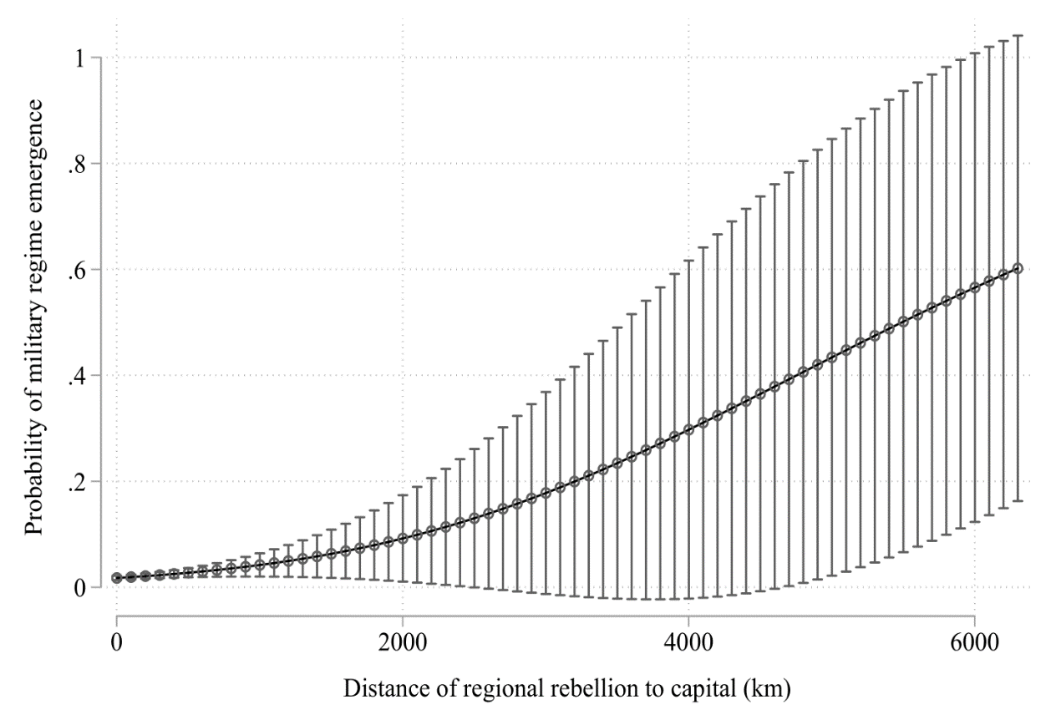
Note: Marginal effects derived from Table A10, column 1. All other covariates set at their observed values (Hanmer and Ozan Kalkan 2013).

Instrumental variable approach
A potential source of bias is endogeneity and reversed causality. Military repression, for example, might aggravate regional grievances, thus leading to regional rebellions rather than vice-versa. Indeed, Fjelde (2010) finds that military regimes are more likely to become involved in civil wars. Moreover, both regional rebellions and military regimes might be jointly associated with an uncontrolled omitted confounder. Depending on the strength of endogeneity and/or reverse causality, both scenarios could considerably bias our findings. The standard econometric approach to this problem has been to use instrumental variables. Finding instruments that are both sufficiently predictive and only influence the outcome Y through its effect on X (exclusion restriction) is often challenging, however (Bollen 2012; Sovey and Green 2011). In our case, this challenge is aggravated by the fact that we need to instrument for two endogenous predictors as both regional and center-seeking rebellions can plausibly be considered endogenous and/or in a reverse-causal relationship with military regimes.
We believe to have identified two instruments that fulfil the stringent conditions for instrumental variables: First, taking into account the emphasis the civil war literature has placed on the geographical conditions conducive to civil wars (e.g. Fearon and Laitin 2003), we turn to terrain characteristics as an instrument. Both center-seeking and separatist rebels will have to hide at times from government forces, which can be greatly facilitated or complicated by the shape of the terrain. The varying availability of hideouts is thus likely to play some role in the decision of whether or not to mount a rebellion. We therefore use Rugged terrain in (thousands of) ha (log) t-1 taken from Nunn and Puga (2012) as our first instrument. Second, building on the insights from diffusion arguments of macro-social outcomes (Gleditsch and Ward 2006; Miller 2015), we use the number of Battle-related deaths in neighboring countries t-1 as an instrument for regional and center-seeking rebellion. Our logic relies on an implicit deterrence mechanism from large-scale human losses in neighboring countries on potential rebels. Neighborhood is defined as all contiguous states not separated by more than 24 miles of water. We use the Correlates of War Direct Contiguity dataset (Stinnett et al. 2002, v3.2) to construct these variables.
Could it be that that terrain characteristics and battle-related deaths in the neighborhood have a direct effect on military regime emergence or breakdown that is not mediated by domestic rebellion? Existing theory does not suggest this. Geography can plausibly be considered as exogenous. As for the second instrument, violence in neighboring countries could certainly increase the readiness of domestic military units in order to prevent spill-over effects; yet the mechanisms that would lead from, say, increased border patrols to a military takeover seem to be rather obscure.
Technically, we conduct our instrumental variable regression using a limited-information maximum likelihood estimator (LIML) as such estimators have been shown to be more robust to weak instrumental variable bias (Stock and Yogo 2005). Fortunately, all our F statistics meet the Stock-Yogo (2005) critical value on instrument strength. This suggests a rather strong predictive power of our instruments, so that any potential weak instrument bias will be limited. The results of the IV regressions are shown in Table A11. In line with our baseline model, regional rebellions remain a strong predictor for the emergence of military regimes. We do not recover, however, our previous finding regarding military regime democratization: while the sign of regional rebellion remains negative, the coefficient is far from statistical significance. This emphasizes the merely indicative nature of our finding on democratization at this stage.
Table A11: Regional conflict and military regime emergence/democratization (IV approach)
 | (1) | (2)
Second stage outcome | Military regime emergence | Military regime democratization
Regional rebellion (decay) t-1 | 0.232** | -0.0434
 | (0.112) | (0.180)
Center-seeking rebellion (decay) t-1 | -0.201 | 0.0274
 | (0.151) | (0.0787)
First stage outcome | Regional rebellion decay t-1 | Regional rebellion decay t-1
Battle-related deaths in neighboring countries t-1 | -0.004*** | -0.0084**
 | (0.0015) | (0.004)
Rugged terrain in ha (log) t-1 | 0.0054 | 0.0085
 | (0.0033) | (0.0069)
First stage outcome | Center-seeking rebellion decay t-1 | Center-seeking rebellion decay t-1
Battle-related deaths in neighboring countries t-1 | 0.0015 | 0.0020
 | (0.0022) | (0.0058)
Rugged terrain in ha (log) t-1 | 0.0065** | 0.0441***
 | (0.0026) | (0.0159)
N x T second stage | 4,889 | 1,093
Time polynomials | Yes | Yes
Regional dummies | Yes | Yes
Standard controls | Yes | Yes
Cragg-Donald Wald F statistic | 7.73 | 11.62
Stock-Yogo critical value | 7.03 | 7.03
Two-stage instrumental variable regression with limited-information maximum likelihood estimator (LIML) and cluster-robust standard errors in parentheses. The Cragg-Donald Wald F statistic and the Stock-Yogo critical values are taken from a model assuming conditional homoscedasticity as the Stock-Yogo test is only valid in the presence of i.i.d. errors. * p<0.1; ** p<0.05; *** p<0.01

Additional control variables
As it is standard practice, we test the robustness of our baseline models to the addition of further control variables. Specifically, we add Oil rents (log) (Ross 2013), Population density (UNDP 2015), Trade/GDP (World Bank 2017), a dummy for the post-Cold War period (Post Cold War), and a measure of the prior regime type (Prior regime) (Svolik 2012) to the regression. The latter is a categorical variable measuring if a regime is autocratic, democratic, or there was no authority. These additional variables aim to take into account that (i) military regimes might be more likely to emerge in resource-abundant countries; (ii) civilian involvement in counter-insurgency might be more likely in more densely populated areas, decreasing the likelihood of military regime emergence; (iii) more open economies might exhibit more volatile business cycles, ensuing instability and potentially military take-overs or regime breakdowns; (iv) military regimes might be less likely to emerge in the post-Cold War era; and (v) certain regime types might be more likely to transition into military rule. We run all these regressions using Ethnic fractionalization instead of religious fractionalization as control variable to make sure our findings are robust to ethnic diversity (Alesina et al. 2003).
In the light of the results displayed in Table A12-Table A14, our main findings appear practically unchanged by these additional variables. Regional rebellions remain a highly significant predictor of military take-overs; and regional rebellions occurring during a regime spell tend to decrease the likelihood of military regime democratization. The latter finding seems to be particularly driven by within-country variation (see the conditional logit model in Table A14, column 6). As before, our expectation that regimes emerging out of or in contexts of regional rebellions is not supported by the model, as shown by the positive significant effect for Previously experienced regional rebellion and Directly following regional rebellion. As we discussed in the article, while we are puzzled by these findings in the light of strong descriptive patterns, the absence of a clear finding might have to do with the effect of ties in our data.
As for the multinomial logit model on regime militarization (Table A13), the effect of rebellion intensity remains highly significant in the unrestricted sample (column 1). In the restricted sample (column 2) for military regimes only, the coefficient of Duration of regional rebellion becomes slightly insignificant (p=0.155). At the same, we lose about 150 observations in this regression compared to our baseline model, which is likely to be driving the loss of significance.

Table A12: Regional rebellions and military regime emergence (additional controls)
 | (1) | (2) | (3) | (4) | (5) | (6)
Regional rebellion (decay) t-1 | 0.923 | 0.950 | 1.159 | 1.129 | 0.913 | 2.041
 | (0.420)** | (0.416)** | (0.478)** | (0.488)** | (0.536)* | (1.022)**
Center-seeking rebellion (decay) t-1 | 0.171 | 0.200 | 0.256 | 0.293 | 0.147 | 1.366
 | (0.353) | (0.354) | (0.379) | (0.380) | (0.428) | (0.943)
Ethnic fractionalization t-1 | 1.175 | 0.736 | 0.665 | 0.698 | 1.099
 | (0.738) | (0.742) | (0.772) | (0.773) | (0.732)
Oil rents (log) t-1 | -0.082 | -0.088 | -0.043 | -0.041 | -0.064 | 0.372
 | (0.061) | (0.062) | (0.071) | (0.070) | (0.068) | (0.396)
Pop. density t-1 |  | -0.003 | -0.003 | -0.003 | -0.002 | -0.039
 |  | (0.002) | (0.002) | (0.002) | (0.002) | (0.053)
Trade/GDP t-1 |  |  | -0.009 | -0.007 | -0.006 | 0.010
 |  |  | (0.008) | (0.008) | (0.008) | (0.013)
Post Cold War |  |  |  | -0.408 | -0.524 | -0.540
 |  |  |  | (0.355) | (0.365) | (1.062)
Prior regime: Autocracy t-1 |  |  |  |  | -1.434 | 0.256
(baseline cat.: democracy) |  |  |  |  | (0.713)** | (0.953)
Prior regime: No authority t-1 |  |  |  |  | -0.819 | -0.516
(baseline cat.: democracy) |  |  |  |  | (0.997) | (1.615)
NxT | 4,605 | 4,605 | 4,092 | 4,092 | 4,092 | 1,099
Time polynomials | Yes | Yes | Yes | Yes | Yes | Yes
Regional dummies | Yes | Yes | Yes | Yes | Yes | Yes
Standard controls | Yes | Yes | Yes | Yes | Yes | Yes
Pooled logit model in columns 1-5. Conditional logit model in column 6. Cluster-robust standard errors in parentheses. * p<0.1; ** p<0.05; *** p<0.01

Table A13: Regional rebellions and regime militarization (additional controls)
 |  |  | (1) |  | (2)
Indirect | Duration of regional rebellion t-1 |  | 0.061
Military |  |  | (0.042)
 | Duration of center-seeking rebellion t-1 |  | -0.003
 |  |  | (0.029)
 | Ethnic fractionalization t-1 |  | -0.157
 |  |  | (0.673)
 | Oil rents (log) t-1 |  | 0.008
 |  |  | (0.063)
 | Pop. density t-1 |  | 0.000
 |  |  | (0.001)
 | Trade/GDP t-1 |  | 0.003
 |  |  | (0.004)
 | Post Cold War |  | 0.501
 |  |  | (0.352)
 | Prior regime: Autocracy t-1 |  | 1.738
 | (baseline cat.: democracy) |  | (0.413)***
 | Prior regime: No authority t-1 |  | 0.340
 | (baseline cat.: democracy) |  | (0.648)
Direct | Duration of regional rebellion t-1 |  | 0.138 |  | 0.073
Military |  |  | (0.034)*** |  | (0.051)
 | Duration of center-seeking rebellion t-1 |  | -0.131 |  | -0.125
 |  |  | (0.040)*** |  | (0.049)**
 | Ethnic fractionalization t-1 |  | -0.503 |  | -0.324
 |  |  | (1.110) |  | (1.303)
 | Oil rents (log) t-1 |  | -0.124 |  | -0.141
 |  |  | (0.095) |  | (0.117)
 | Pop. density t-1 |  | -0.004 |  | -0.005
 |  |  | (0.003) |  | (0.004)
 | Trade/GDP t-1 |  | -0.002 |  | -0.006
 |  |  | (0.005) |  | (0.006)
 | Post Cold War |  | -0.630 |  | -1.181
 |  |  | (0.487) |  | (0.538)**
 | Prior regime: Autocracy t-1 |  | 1.232 |  | -0.669
 | (baseline cat.: democracy) |  | (0.333)*** |  | (0.456)
 | Prior regime: No authority t-1 |  | 0.468 |  | -0.103
 | (baseline cat.: democracy) |  | (0.717) |  | (0.650)
NxT |  | 5,355 |  | 1,057
Time polynomials |  | Yes |  | Yes
Regional dummies |  | No |  | No
Mil. regime t-1=1 |  | No |  | Yes
Standard controls |  | Yes |  | Yes
Multinomial logit regression with cluster-robust standard errors. Column 1 unrestricted sample, base category: non-military regimes. Column 2 restricted sample on military regimes only, base category: indirect military rule. * p<0.1; ** p<0.05; *** p<0.01

Table A14: Regional rebellions and military regime democratization (additional variables)
 | (1) | (2) | (3) | (4) | (5) | (6)
Previously experienced regional rebellion t-1 | 4.324 |  |  | 7.108
 | (2.125)** |  |  | (2.027)***
Previously experienced center-seeking rebellion t-1 | 0.368 |  |  | -1.079
 | (0.721) |  |  | (0.972)
Directly following regional rebellion t-1 |  | 9.346 |  |  | 6.067
 |  | (4.266)** |  |  | (1.875)***
Directly following center-seeking rebellion t-1 |  | 3.213 |  |  | 3.682
 |  | (1.896)* |  |  | (2.057)*
Regional rebellion (decay) t-1 |  |  | -0.451 | -3.883 | 5.356 | -97.412
 |  |  | (1.296) | (1.544)** | (5.679) | (44.847)**
Center-seeking rebellion (decay) t-1 |  |  | 1.997 | 2.601 | -1.628 | -9.563
 |  |  | (1.578) | (2.153) | (1.804) | (7.867)
Ethnic fractionalization t-1 | 5.538 | 7.816 | 4.679 | 4.846 | 9.420
 | (3.747) | (4.158)* | (3.292) | (3.489) | (4.908)*
Oil rents (log) t-1 | -0.805 | -1.778 | -0.596 | -0.988 | -2.048 | -2.511
 | (0.324)** | (0.786)** | (0.291)** | (0.352)*** | (0.916)** | (1.526)*
Pop. density t-1 | 0.004 | -0.002 | 0.002 | 0.004 | -0.001 | 1.316
 | (0.009) | (0.019) | (0.009) | (0.010) | (0.018) | (0.722)*
Trade/GDP t-1 | -0.022 | -0.028 | -0.006 | -0.030 | -0.045
 | (0.017) | (0.010)*** | (0.012) | (0.015)** | (0.019)**
Post Cold War | -1.354 | -3.513 | -2.148 | -0.858 | -3.959 | 12.621
 | (0.994) | (2.303) | (1.050)** | (0.764) | (2.762) | (7.103)*
NxT | 1,029 | 900 | 1,029 | 1,029 | 900 | 471
Time polynomials | Yes | Yes | Yes | Yes | Yes | Yes
Reginal dummies | Yes | Yes | Yes | Yes | Yes | Yes
Standard controls | Yes | Yes | Yes | Yes | Yes | Yes
Pooled logit model in columns 1-5. Conditional logit model in column 6. Cluster-robust standard errors in parentheses. * p<0.1; ** p<0.05; *** p<0.01

Controlling for diffusion effects
There is ample evidence that democratization is driven, in part, by regional diffusion effects (e.g. Elkins and Simmons 2005; Gleditsch and Ward 2006; Patel, Bunce, and Wolchik 2014). Similar dynamics can be imagined for the emergence of specific authoritarian regime types, such as military regimes. To ensure that our findings are not driven by diffusion, we control for the percentage of military regimes in neighborhood in our emergence regressions, and the percentage of democratic regimes in neighborhood for our democratization models. Neighborhood is defined as all contiguous states not separated by more than 24 miles of water. We use the Correlates of War Direct Contiguity dataset to construct these variables (Stinnett et al. 2002, v3.2). The results of this robustness test, shown in Table A15-Table A17, are substantively identical to those from our baseline models.

Table A15: Regional rebellions and military regime emergence (diffusion effects)
 | (1) | (2)
Regional rebellion (decay) t-1 | 0.861 | 2.241
 | (0.445)* | (0.986)**
Center-seeking rebellion (decay) t-1 | -0.034 | 0.851
 | (0.328) | (0.702)
% mil. regimes in neighborhood (contiguous) t-1 | 1.487 | 4.243
 | (0.407)*** | (1.209)***
GDP p.c. (log) t-1 | -0.116 | -0.781
 | (0.298) | (0.745)
Population size (log) t-1 | 0.062 | 3.500
 | (0.284) | (1.921)*
Polity t-1 | -0.156 | -0.412
 | (0.036)*** | (0.110)***
War (dummy) t-1 | 0.324 | 0.375
 | (0.742) | (1.049)
Unrest (log) t-1 | 0.477 | -0.031
 | (0.170)*** | (0.285)
Rel. fractionalization t-1 | -1.470
 | (0.739)**
Mil. capabilities (cube root) t-1 | -0.031 | -13.701
 | (8.033) | (33.551)
Previous failures | 0.084 | -1.731
 | (0.253) | (0.822)**
NxT | 4,292 | 1,205
Time polynomials | Yes | Yes
Regional dummies | Yes | Yes
Pooled logit model in column 1. Conditional logit model in column 2. Cluster-robust standard errors in parentheses. * p<0.1; ** p<0.05; *** p<0.01
Table A16: Regional rebellions and regime militarization (diffusion effects)
 |  | (1) | (2)
Indirect | Duration of regional rebellion t-1 | 0.018
Military |  | (0.043)
 | Duration of center-seeking rebellion t-1 | -0.030
 |  | (0.034)
 | % mil. regimes in neighborhood (contiguous) t-1 | 0.722
 |  | (0.472)
Direct | Duration of regional rebellion t-1 | 0.130 | 0.116
Military |  | (0.030)*** | (0.051)**
 | Duration of center-seeking rebellion t-1 | -0.168 | -0.143
 |  | (0.034)*** | (0.052)***
 | % mil. regimes in neighborhood (contiguous) t-1 | 0.870 | 0.053
 |  | (0.513)* | (0.593)
NxT |  | 5,355 | 1,057
Time polynomials |  | Yes | Yes
Regional dummies |  | No | No
Mil. regime t-1=1 |  | No | Yes
Standard controls |  | Yes | Yes
Multinomial logit regression with cluster-robust standard errors. Column 1 unrestricted sample, base category: non-military regimes. Column 2 restricted sample on military regimes only, base category: indirect military rule. * p<0.1; ** p<0.05; *** p<0.01

Table A17: Regional rebellions and military regime democratization (diffusion effects)
 | (1) | (2) | (3) | (4) | (5) | (6)
Previously experienced regional rebellion t-1 | 0.809 |  |  | 2.208
 | (2.069) |  |  | (2.460)
Previously experienced center-seeking rebellion t-1 | 1.373 |  |  | 0.624
 | (0.999) |  |  | (1.595)
Directly following regional rebellion t-1 |  | 0.240 |  |  | 1.854
 |  | (0.977) |  |  | (1.367)
Directly following center-seeking rebellion t-1 |  | 0.115 |  |  | -0.667
 |  | (1.577) |  |  | (1.461)
Regional rebellion (decay) t-1 |  |  | -2.640 | -4.084 | -1.583 | -21.809
 |  |  | (1.494)* | (2.212)* | (1.195) | (3.192)***
Center-seeking rebellion (decay) t-1 |  |  | 1.832 | 1.759 | 1.511 | -1.682
 |  |  | (1.060)* | (1.488) | (1.423) | (1.988)
% dem. regimes in neighborhood (contiguous) t-1 | -1.074 | 1.307 | -0.773 | -1.037 | 0.134 | 10.784
 | (1.919) | (2.009) | (1.839) | (1.877) | (2.455) | (3.794)***
NxT | 1,146 | 1,003 | 1,146 | 1,146 | 1,003 | 457
Time polynomials | Yes | Yes | Yes | Yes | Yes | Yes
Regional dummies | Yes | Yes | Yes | Yes | Yes | Yes
Standard controls | Yes | Yes | Yes | Yes | Yes | Yes
Pooled logit model in columns 1-5. Conditional logit model in column 6. Cluster-robust standard errors in parentheses. * p<0.1; ** p<0.05; *** p<0.01

Alternative times specifications
We test the sensitivity of our baseline models to alternative time specifications in Table A18-Table A20 below. Specifically, we rerun the models using cubic splines, the log of time, and decade dummies with time polynomials. Our main findings remain substantively unchanged.

Table A18: Regional rebellions and military regime emergence (alternative time specifications)
 | (1) | (2) | (3) | (4) | (5) | (6)
 | Logit | Clogit | Logit | Clogit | Logit | Clogit
Regional rebellion (decay) t-1 | 0.940 | 2.309 | 0.931 | 2.358 | 0.913 | 2.303
 | (0.428)** | (1.004)** | (0.424)** | (0.910)*** | (0.424)** | (1.197)*
Center-seeking rebellion (decay) t-1 | 0.324 | 1.147 | 0.205 | 1.049 | 0.392 | 0.916
 | (0.346) | (0.749) | (0.349) | (0.674) | (0.349) | (0.846)
GDP p.c. (log) t-1 | -0.005 | -0.876 | 0.016 | -0.244 | -0.012 | -1.017
 | (0.269) | (0.836) | (0.257) | (0.750) | (0.273) | (0.953)
Population size (log) t-1 | 0.362 | 2.820 | 0.380 | 4.827 | 0.371 | 1.776
 | (0.212)* | (2.020) | (0.211)* | (1.977)** | (0.223)* | (2.269)
Polity t-1 | -0.152 | -0.420 | -0.161 | -0.379 | -0.135 | -0.390
 | (0.036)*** | (0.096)*** | (0.035)*** | (0.083)*** | (0.037)*** | (0.104)***
War (dummy) t-1 | 0.379 | 0.368 | 0.319 | 0.363 | 0.306 | 0.197
 | (0.728) | (1.084) | (0.753) | (0.994) | (0.745) | (0.911)
Unrest (log) t-1 | 0.544 | -0.071 | 0.533 | -0.064 | 0.507 | -0.154
 | (0.154)*** | (0.308) | (0.153)*** | (0.274) | (0.155)*** | (0.299)
Rel. fractionalization t-1 | -1.691 |  | -1.689 |  | -1.450
 | (0.747)** |  | (0.751)** |  | (0.752)*
Mil. capabilities (cube root) t-1 | -10.215 | -19.317 | -10.535 | -32.703 | -11.705 | -22.140
 | (5.011)** | (29.699) | (4.923)** | (33.536) | (5.220)** | (37.913)
Previous failures | 0.165 | -1.001 | 0.104 | -1.863 | 0.463 | -1.542
 | (0.242) | (1.002) | (0.262) | (0.938)** | (0.293) | (0.942)
NxT | 4,630 | 1,301 | 4,630 | 1,301 | 4,630 | 1,301
Cubic splines | Yes | Yes | No | No | No | No
Log of time | No | No | Yes | Yes | No | No
Decade dummies | No | No | No | No | Yes | Yes
Time polynomials | No | No | No | No | Yes | Yes
Regional dummies | Yes | Yes | Yes | Yes | Yes | Yes
Pooled logit model in columns 1, 3, and 5. Conditional logit model in column 2, 4, and 6. Cluster-robust standard errors in parentheses. * p<0.1; ** p<0.05; *** p<0.01
Table A19: Regional rebellions and regime militarization (alternative time specifications)
 |  | (1) | (2) | (3) | (4) | (5) | (6)
Indirect | Duration of regional rebellion t-1 | 0.021 | 0.033 | 0.027
Military |  | (0.047) | (0.047) | (0.036)
 | Duration of center-seeking rebellion t-1 | -0.030 | -0.037 | -0.030
 |  | (0.036) | (0.033) | (0.030)
Direct | Duration of regional rebellion t-1 | 0.119 | 0.143 | 0.115 | 0.116 | 0.116 | 0.099
Military |  | (0.033)*** | (0.031)*** | (0.030)*** | (0.051)** | (0.050)** | (0.038)***
 | Duration of center-seeking rebellion t-1 | -0.153 | -0.173 | -0.160 | -0.144 | -0.144 | -0.144
 |  | (0.029)*** | (0.031)*** | (0.026)*** | (0.051)*** | (0.050)*** | (0.041)***
NxT |  | 6,052 | 6,052 | 6,052 | 1,200 | 1,200 | 1,200
Cubic splines |  | Yes | No | No | Yes | No | No
Log of time |  | No | Yes | No | No | Yes | No
Decade dummies |  | No | No | Yes | No | No | Yes
Time polynomials |  | No | No | Yes | No | No | Yes
Regional dummies |  | No | No | No | No | No | No
Mil. regime t-1=1 |  | No | No | No | Yes | Yes | Yes
Standard controls |  | Yes | Yes | Yes | Yes | Yes | Yes
Multinomial logit regression with cluster-robust standard errors. Columns 1-3 unrestricted sample, base category: non-military regimes. Columns 4-6 restricted sample on military regimes only, base category: indirect military rule. * p<0.1; ** p<0.05; *** p<0.01

Table A20: Regional rebellions and military regime democratization (alternative time specifications)
 | (1) | (2) | (3) | (4) | (5) | (6) | (7) | (8) | (9)
 | Logit | Logit | Clogit | Logit | Logit | Clogit | Logit | Logit | Clogit
Prev. exp. regional rebellion t-1 | 2.485 |  |  | 1.486 |  |  | 2.701
 | (1.657) |  |  | (1.587) |  |  | (1.996)
Prev. exp. center-seeking rebellion t-1 | -0.106 |  |  | -0.029 |  |  | 0.124
 | (1.302) |  |  | (1.446) |  |  | (0.984)
Dir. following regional rebellion t-1 |  | 2.125 |  |  | 2.184 |  |  | 2.588
 |  | (0.946)** |  |  | (1.210)* |  |  | (1.401)*
Dir. following center-seeking rebellion t-1 |  | -0.354 |  |  | -0.420 |  |  | 0.284
 |  | (1.149) |  |  | (1.205) |  |  | (1.381)
Regional rebellion (decay) t-1 | -3.963 | -1.387 | -21.754 | -3.437 | -1.524 | -25.277 | -5.335 | -3.632 | -24.155
 | (1.710)** | (0.948) | (3.244)*** | (1.872)* | (1.071) | (232.768) | (2.854)* | (1.726)** | (8.595)***
Center-seeking rebellion (decay) t-1 | 1.924 | 1.305 | -0.142 | 1.866 | 1.672 | 1.378 | 2.609 | 2.192 | 2.146
 | (1.490) | (1.128) | (1.363) | (1.546) | (1.137) | (1.157) | (1.664) | (1.312)* | (2.299)
NxT | 1,166 | 1,023 | 471 | 1,166 | 1,023 | 471 | 1,166 | 1,023 | 478
Cubic splines | Yes | Yes | Yes | No | No | No | No | No | No
Log of time | No | No | No | Yes | Yes | Yes | No | No | No
Decade dummies | No | No | No | No | No | No | Yes | Yes | Yes
Time polynomials | No | No | No | No | No | No | Yes | Yes | Yes
Regional dummies | Yes | Yes | Yes | Yes | Yes | Yes | Yes | Yes | Yes
Standard controls | Yes | Yes | Yes | Yes | Yes | Yes | Yes | Yes | Yes
Pooled logit model in columns 1-2, 4-5, and 7-9. Conditional logit model in column 3, 6, and9. Cluster-robust standard errors in parentheses. * p<0.1; ** p<0.05; *** p<0.01

Alternative measure for military regimes
The robustness tests below replicate our baseline models using an indicator of military regimes based on Geddes et al. (2014). Importantly, we depart from her schema in two ways. First, when a regime is classified by her as a hybrid regime, we recode the regime according to Lai and Slater (2006), who classify authoritarian regimes as one of four types: Strongman, Junta, Bossism, or Machine. We treat the first two types as instances of military regimes and the latter two types as party regimes. We make this departure from Geddes because her typology measures variation in regime type solely by how “access to office and the fruits of office” are allocated; that is, by military committee, party committee, or a single individual (Geddes 1999b, 121–122). Yet, authoritarian regimes should be differentiated by their executory powers and not just by their decision-making procedures. Doing so substantially reduces hybridization in the classification of all regime types.
Second, and by similar reasoning, we recode regimes classified as purely personalist by Geddes as military regimes, since almost all cases of personalist regimes rely on the military to maintain power and execute policy. Where Geddes sees a strong party apparatus accompanying personal rule, she classifies it as a party- personalist hybrid. This lends added confidence that Geddes’ purely personalist regimes lack a ruling party that rivals the power of the military.
The results of this robustness test are displayed in Table A21 and Table A22. Regarding military regime emergence, the findings using Geddes et al.’s data are nearly identical to our baseline model, both in the pooled and in the fixed effects regression. As for democratization, the results are much weaker using the alternative measure. While the coefficient of Regional rebellion (decay) is negative throughout, it only reaches levels of statistical significance in Table A22, column 4. This underlines the fact that the results for military regime democratization should be viewed as suggestive, rather than conclusive.

Table A21: Regional rebellions and military regime emergence (GWF data)
 | (1) | (2) | (3) | (4) | (5)
Regional rebellion (decay) t-1 | 1.029 | 1.023 | 0.838 | 0.937 | 1.944
 | (0.430)** | (0.429)** | (0.450)* | (0.444)** | (0.757)**
Center-seeking rebellion (decay) t-1 | 0.701 | 0.699 | 0.651 | 0.710 | 0.857
 | (0.316)** | (0.317)** | (0.325)** | (0.323)** | (0.567)
GDP p.c. (log) t-1 | -0.431 | -0.435 | -0.606 | -0.451 | -2.674
 | (0.201)** | (0.200)** | (0.237)** | (0.285) | (1.331)**
Population size (log) t-1 | 0.043 | 0.050 | -0.108 | 0.187 | 2.928
 | (0.134) | (0.134) | (0.148) | (0.330) | (1.800)
Polity t-1 | -0.131 | -0.131 | -0.147 | -0.146 | -0.316
 | (0.026)*** | (0.026)*** | (0.028)*** | (0.029)*** | (0.050)***
Previous failures | 0.008 | 0.008 | 0.007 | -0.004 | -0.157
 | (0.014) | (0.014) | (0.016) | (0.017) | (0.078)**
War (dummy) t-1 |  | -0.339 | -0.265 | -0.128 | 0.444
 |  | (0.755) | (0.743) | (0.753) | (1.056)
Unrest (log) t-1 |  |  | 0.780 | 0.806 | 0.602
 |  |  | (0.193)*** | (0.184)*** | (0.253)**
Rel. fractionalization t-1 |  |  | -0.633 | -0.506
 |  |  | (0.804) | (0.831)
Mil. capabilities (cube root) t-1 |  |  |  | -7.806 | -9.579
 |  |  |  | (7.602) | (41.881)
NxT | 4,382 | 4,382 | 4,293 | 4,103 | 1,183
Time polynomials | Yes | Yes | Yes | Yes | Yes
Regional dummies | Yes | Yes | Yes | Yes | Yes
Pooled logit model in columns 1-4. Conditional logit model in column 5. Cluster-robust standard errors in parentheses. * p<0.1; ** p<0.05; *** p<0.01
Table A22: Regional rebellions and military regime democratization (GWF data)
 | (1) | (2) | (3) | (4) | (5) | (6)
Previously experienced regional rebellion t-1 | 0.333 |  |  | 0.723
 | (0.789) |  |  | (0.803)
Previously experienced center-seeking rebellion t-1 | -0.356 |  |  | -0.021
 | (0.489) |  |  | (0.437)
Directly following regional rebellion t-1 |  | -1.606 |  |  | -1.701
 |  | (1.631) |  |  | (1.706)
Directly following center-seeking rebellion t-1 |  | -0.838 |  |  | -0.502
 |  | (0.607) |  |  | (0.556)
Regional rebellion (decay) t-1 |  |  | -0.569 | -0.953 | -0.926 | -0.435
 |  |  | (0.541) | (0.578)* | (0.771) | (0.929)
Center-seeking rebellion (decay) t-1 |  |  | -0.980 | -0.992 | -0.658 | -0.826
 |  |  | (0.636) | (0.622) | (0.597) | (1.649)
NxT | 1,337 | 951 | 1,337 | 1,337 | 951 | 548
Time polynomials | Yes | Yes | Yes | Yes | Yes | Yes
Regional dummies | Yes | Yes | Yes | Yes | Yes | Yes
Standard controls | Yes | Yes | Yes | Yes | Yes | Yes
Pooled logit model in columns 1-5. Conditional logit model in column 6. Cluster-robust standard errors in parentheses. * p<0.1; ** p<0.05; *** p<0.01

Alternative half-lives for our decaying variables
To recall, our main variables measuring exposure to rebellions – regional and center-seeking – are decaying variables with a half-life of one year, meaning that half of the effect decays after one year. To see if our findings are driven by this particular choice of half-life, we rerun our baseline models with alternative half-lives of two, three, and five years respectively. The results, displayed in Table A23-Table A28, are substantively identical to our baseline models, albeit slightly weaker in the case of military regime democratization with a half-life of five years.

Table A23: Regional rebellions and military regime emergence (half-life 2)
 | (1) | (2) | (3) | (4) | (5)
Regional rebellion (HL2, decay) t-1 | 1.004 | 1.014 | 0.898 | 0.876 | 2.283
 | (0.436)** | (0.432)** | (0.423)** | (0.409)** | (1.027)**
Center-seeking rebellion (HL2, decay) t-1 | 0.372 | 0.374 | 0.293 | 0.261 | 1.348
 | (0.371) | (0.371) | (0.356) | (0.360) | (0.794)*
GDP p.c. (log) t-1 | -0.151 | -0.152 | -0.166 | 0.017 | -0.774
 | (0.238) | (0.237) | (0.233) | (0.264) | (0.890)
Population size (log) t-1 | 0.038 | 0.041 | -0.011 | 0.367 | 2.776
 | (0.129) | (0.126) | (0.125) | (0.216)* | (2.113)
Polity t-1 | -0.127 | -0.128 | -0.142 | -0.154 | -0.408
 | (0.031)*** | (0.031)*** | (0.032)*** | (0.035)*** | (0.096)***
Previous failures | 0.195 | 0.196 | 0.165 | 0.126 | -1.136
 | (0.215) | (0.216) | (0.238) | (0.251) | (1.003)
War (dummy) t-1 |  | -0.143 | 0.039 | 0.370 | 0.337
 |  | (0.770) | (0.749) | (0.742) | (1.066)
Unrest (log) t-1 |  |  | 0.482 | 0.516 | -0.098
 |  |  | (0.151)*** | (0.155)*** | (0.310)
Rel. fractionalization t-1 |  |  | -1.572 | -1.685
 |  |  | (0.694)** | (0.748)**
Mil. capabilities (cube root) t-1 |  |  |  | -10.185 | -21.722
 |  |  |  | (5.012)** | (33.329)
NxT | 4,726 | 4,726 | 4,631 | 4,630 | 1,301
Time polynomials | Yes | Yes | Yes | Yes | Yes
Regional dummies | Yes | Yes | Yes | Yes | Yes
Pooled logit model in columns 1-4. Conditional logit model in column 5. Cluster-robust standard errors in parentheses. * p<0.1; ** p<0.05; *** p<0.01

Table A24: Regional rebellions and military regime democratization (half-life 2)
 | (1) | (2) | (3) | (4) | (5) | (6)
Previously experienced regional rebellion t-1 | 0.759 |  |  | 2.662
 | (1.190) |  |  | (2.030)
Previously experienced center-seeking rebellion t-1 | 0.844 |  |  | -0.482
 | (0.861) |  |  | (1.809)
Directly following regional rebellion t-1 |  | 0.650 |  |  | 1.847
 |  | (0.879) |  |  | (2.149)
Directly following center-seeking rebellion t-1 |  | 0.029 |  |  | -0.923
 |  | (1.483) |  |  | (1.293)
Regional rebellion (HL2, decay) t-1 |  |  | -2.758 | -4.340 | -1.436 | -13.441
 |  |  | (1.524)* | (1.951)** | (2.053) | (4.607)***
Center-seeking rebellion (HL2, decay) t-1 |  |  | 1.866 | 2.460 | 1.955 | 1.090
 |  |  | (0.989)* | (1.785) | (1.086)* | (2.333)
NxT | 1,166 | 1,023 | 1,166 | 1,166 | 1,023 | 471
Time polynomials | Yes | Yes | Yes | Yes | Yes | Yes
Regional dummies | Yes | Yes | Yes | Yes | Yes | Yes
Standard controls | Yes | Yes | Yes | Yes | Yes | Yes
Pooled logit model in columns 1-5. Conditional logit model in column 6. Cluster-robust standard errors in parentheses. * p<0.1; ** p<0.05; *** p<0.01

Table A25: Regional rebellions and military regime emergence (half-life 3)
 | (1) | (2) | (3) | (4) | (5)
Regional rebellion (HL3, decay) t-1 | 0.974 | 0.983 | 0.869 | 0.859 | 2.350
 | (0.430)** | (0.425)** | (0.415)** | (0.403)** | (1.063)**
Center-seeking rebellion (HL3, decay) t-1 | 0.363 | 0.366 | 0.293 | 0.259 | 1.474
 | (0.375) | (0.375) | (0.362) | (0.365) | (0.833)*
GDP p.c. (log) t-1 | -0.146 | -0.147 | -0.161 | 0.023 | -0.723
 | (0.238) | (0.237) | (0.233) | (0.265) | (0.914)
Population size (log) t-1 | 0.038 | 0.040 | -0.012 | 0.368 | 2.832
 | (0.130) | (0.127) | (0.126) | (0.216)* | (2.138)
Polity t-1 | -0.128 | -0.128 | -0.143 | -0.154 | -0.409
 | (0.031)*** | (0.031)*** | (0.032)*** | (0.035)*** | (0.096)***
Previous failures | 0.190 | 0.190 | 0.160 | 0.121 | -1.177
 | (0.217) | (0.217) | (0.239) | (0.252) | (1.010)
War (dummy) t-1 |  | -0.137 | 0.038 | 0.369 | 0.266
 |  | (0.763) | (0.746) | (0.740) | (1.079)
Unrest (log) t-1 |  |  | 0.485 | 0.518 | -0.099
 |  |  | (0.152)*** | (0.155)*** | (0.315)
Rel. fractionalization t-1 |  |  | -1.568 | -1.680
 |  |  | (0.695)** | (0.750)**
Mil. capabilities (cube root) t-1 |  |  |  | -10.285 | -23.936
 |  |  |  | (5.034)** | (34.249)
NxT | 4,726 | 4,726 | 4,631 | 4,630 | 1,301
Time polynomials | Yes | Yes | Yes | Yes | Yes
Regional dummies | Yes | Yes | Yes | Yes | Yes
Pooled logit model in columns 1-4. Conditional logit model in column 5. Cluster-robust standard errors in parentheses. * p<0.1; ** p<0.05; *** p<0.01

Table A26: Regional rebellions and military regime democratization (half-life 3)
 | (1) | (2) | (3) | (4) | (5) | (6)
Previously experienced regional rebellion t-1 | 0.759 |  |  | 3.107
 | (1.190) |  |  | (2.096)
Previously experienced center-seeking rebellion t-1 | 0.844 |  |  | -0.769
 | (0.861) |  |  | (2.207)
Directly following regional rebellion t-1 |  | 0.650 |  |  | 0.931
 |  | (0.879) |  |  | (2.894)
Directly following center-seeking rebellion t-1 |  | 0.029 |  |  | -0.961
 |  | (1.483) |  |  | (1.290)
Regional rebellion (HL3, decay) t-1 |  |  | -2.791 | -4.838 | -0.529 | -14.690
 |  |  | (1.565)* | (2.045)** | (2.733) | (15.613)
Center-seeking rebellion (HL3, decay) t-1 |  |  | 1.872 | 2.758 | 2.090 | 2.548
 |  |  | (0.992)* | (2.116) | (1.124)* | (2.387)
NxT | 1,166 | 1,023 | 1,166 | 1,166 | 1,023 | 471
Time polynomials | Yes | Yes | Yes | Yes | Yes | Yes
Regional dummies | Yes | Yes | Yes | Yes | Yes | Yes
Standard controls | Yes | Yes | Yes | Yes | Yes | Yes
Pooled logit model in columns 1-5. Conditional logit model in column 6. Cluster-robust standard errors in parentheses. * p<0.1; ** p<0.05; *** p<0.01

Table A27: Regional rebellions and military regime emergence (half-life 5)
 | (1) | (2) | (3) | (4) | (5)
Regional rebellion (HL5, decay) t-1 | 0.930 | 0.938 | 0.826 | 0.837 | 2.381
 | (0.419)** | (0.414)** | (0.404)** | (0.395)** | (1.119)**
Center-seeking rebellion (HL5, decay) t-1 | 0.338 | 0.341 | 0.281 | 0.246 | 1.612
 | (0.382) | (0.382) | (0.372) | (0.375) | (0.894)*
GDP p.c. (log) t-1 | -0.141 | -0.142 | -0.157 | 0.031 | -0.659
 | (0.237) | (0.237) | (0.233) | (0.265) | (0.945)
Population size (log) t-1 | 0.039 | 0.041 | -0.013 | 0.373 | 2.862
 | (0.130) | (0.128) | (0.127) | (0.217)* | (2.172)
Polity t-1 | -0.128 | -0.128 | -0.143 | -0.155 | -0.410
 | (0.031)*** | (0.031)*** | (0.032)*** | (0.035)*** | (0.096)***
Previous failures | 0.182 | 0.183 | 0.151 | 0.114 | -1.214
 | (0.220) | (0.220) | (0.242) | (0.255) | (1.011)
War (dummy) t-1 |  | -0.130 | 0.034 | 0.367 | 0.156
 |  | (0.751) | (0.741) | (0.736) | (1.087)
Unrest (log) t-1 |  |  | 0.488 | 0.520 | -0.098
 |  |  | (0.152)*** | (0.155)*** | (0.322)
Rel. fractionalization t-1 |  |  | -1.559 | -1.671
 |  |  | (0.696)** | (0.754)**
Mil. capabilities (cube root) t-1 |  |  |  | -10.482 | -26.702
 |  |  |  | (5.076)** | (35.579)
NxT | 4,726 | 4,726 | 4,631 | 4,630 | 1,301
Time polynomials | Yes | Yes | Yes | Yes | Yes
Regional dummies | Yes | Yes | Yes | Yes | Yes
Pooled logit model in columns 1-4. Conditional logit model in column 5. Cluster-robust standard errors in parentheses. * p<0.1; ** p<0.05; *** p<0.01

Table A28: Regional rebellions and military regime democratization (half-life 5)
 | (1) | (2) | (3) | (4) | (5) | (6)
Previously experienced regional rebellion t-1 | 0.759 |  |  | 3.951
 | (1.190) |  |  | (2.284)*
Previously experienced center-seeking rebellion t-1 | 0.844 |  |  | -1.167
 | (0.861) |  |  | (2.944)
Directly following regional rebellion t-1 |  | 0.650 |  |  | 0.011
 |  | (0.879) |  |  | (3.018)
Directly following center-seeking rebellion t-1 |  | 0.029 |  |  | -0.948
 |  | (1.483) |  |  | (1.296)
Regional rebellion (HL5, decay) t-1 |  |  | -2.673 | -5.794 | 0.341 | -35.328
 |  |  | (1.632) | (2.366)** | (2.805) | (36.325)
Center-seeking rebellion (HL5, decay) t-1 |  |  | 1.767 | 3.134 | 2.185 | 4.311
 |  |  | (0.985)* | (2.832) | (1.198)* | (3.421)
NxT | 1,166 | 1,023 | 1,166 | 1,166 | 1,023 | 471
Time polynomials | Yes | Yes | Yes | Yes | Yes | Yes
Regional dummies | Yes | Yes | Yes | Yes | Yes | Yes
Standard controls | Yes | Yes | Yes | Yes | Yes | Yes
Pooled logit model in columns 1-5. Conditional logit model in column 6. Cluster-robust standard errors in parentheses. * p<0.1; ** p<0.05; *** p<0.01

Influential observations
To ensure that our results are not solely driven by a few influential observations, we rerun our regressions while dropping observations with particularly high leverage. To identify these observations, we are using Pregibon’s dbeta which provides information on the influence on parameter estimates of each individual observation. There is no critical value for this measure and influential observations have to be identified using eyeballing. In light of Figure A7, Pakistan (cowcode770) and Thailand (cowcode 800) seem to contain influential observations. Figure A8 highlights Argentina (cowcode 160) and Greece (cowcode 350) as influential observations. We therefore remove these countries from the regression and rerun our baseline models. The results shown in Table A29 and Table A30 are substantively identical to our core findings, albeit slightly weaker in both cases. We thus conclude that our results are not a pure artefact of a few high-leverage observations.

Figure A7: Influential observations for military regime emergence
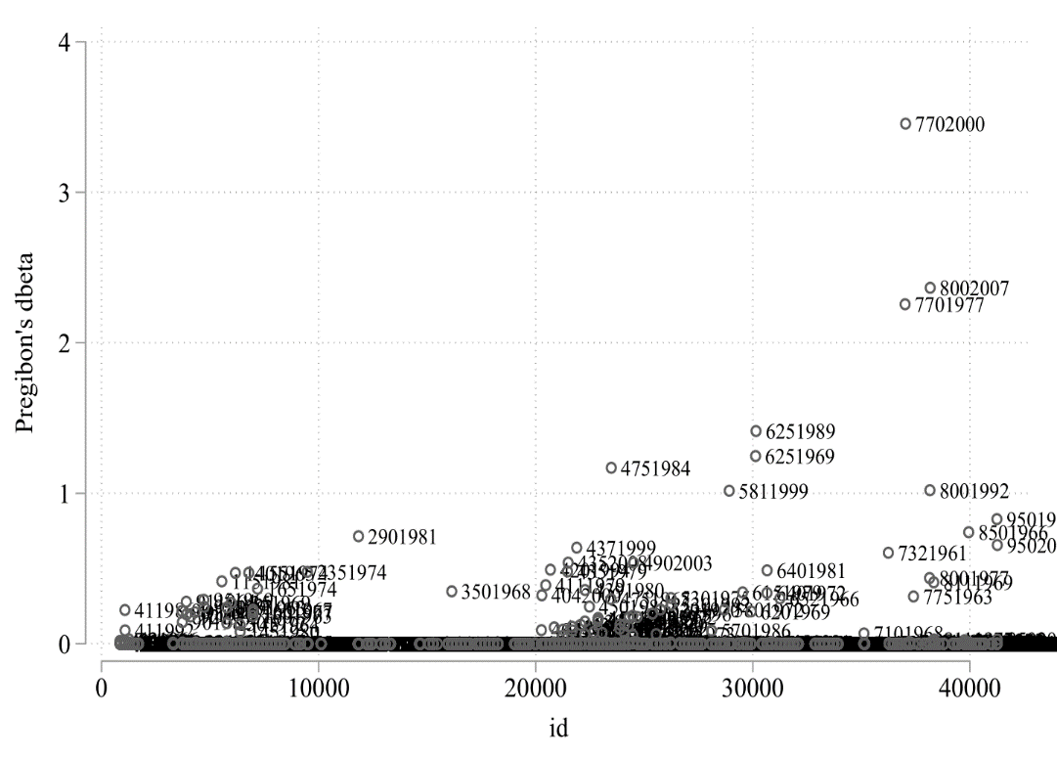
Note: Labels represent cowcode-years.
Figure A8: Influential observations for military regime democratization
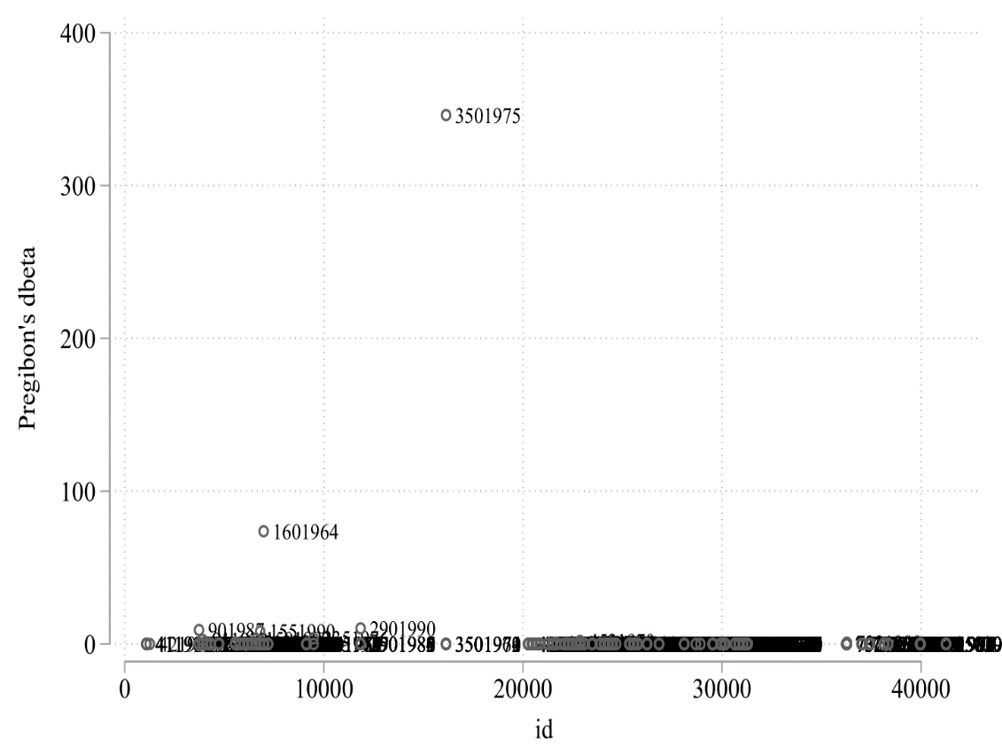
Note: Labels represent cowcode-years.

Table A29: Regional rebellions and military regime emergence (w/o influential observations)
 | (1)
Regional rebellion (decay) t-1 | 0.793
 | (0.451)*
Center-seeking rebellion (decay) t-1 | 0.444
 | (0.363)
GDP p.c. (log) t-1 | -0.169
 | (0.249)
Population size (log) t-1 | 0.330
 | (0.224)
Polity t-1 | -0.144
 | (0.034)***
War (dummy) t-1 | 0.163
 | (0.883)
Unrest (log) t-1 | 0.562
 | (0.162)***
Rel. fractionalization t-1 | -1.585
 | (0.755)**
Mil. capabilities (cube root) t-1 | -10.092
 | (5.103)**
Previous failures | -0.089
 | (0.250)
NxT | 4,368
Time polynomials | Yes
Regional dummies | Yes
Pooled logit model replicating column 4, Table 1 in main article, without Pakistan and Thailand. Cluster-robust standard errors in parentheses. * p<0.1; ** p<0.05; *** p<0.01

Table A30: Regional rebellions and military regime democratization (w/o influential observations)
 | (1)
Previously experienced regional rebellion t-1 | 1.717
 | (2.193)
Previously experienced center-seeking rebellion t-1 | -1.823
 | (1.117)
Regional rebellion (decay) t-1 | -4.259
 | (2.371)*
Center-seeking rebellion (decay) t-1 | 2.350
 | (1.484)
GDP p.c. (log) t-1 | 0.011
 | (0.854)
Population size (log) t-1 | -0.075
 | (1.059)
Polity t-1 | 1.034
 | (0.218)***
Mil. capabilities (cube root) t-1 | -4.079
 | (20.354)
Unrest (log) t-1 | 0.156
 | (0.668)
War (dummy) t-1 | -3.257
 | (1.705)*
Rel. fractionalization t-1 | 12.127
 | (3.967)***
Number of previous regime failures | 0.979
 | (0.521)*
NxT | 1,144
Time polynomials | Yes
Regional dummies | Yes
Pooled logit model replicating column 4, Table 4 in main article, without Argentina and Greece. Cluster-robust standard errors in parentheses. * p<0.1; ** p<0.05; *** p<0.01

References
Alesina A et al. (2003) Fractionalization. Journal of Economic Growth 8, 155–194.
Allansson M, Melander E and Themnér L (2017) Organized Violence, 1989–2016. Journal of Peace Research 54, 574–587.
Bollen K a. (2012) Instrumental Variables in Sociology and the Social Sciences. Annual Review of Sociology 38, 37–72.
Carter DB and Signorino CS (2010) Back to the Future: Modeling Time Dependence in Binary Data. Political Analysis 18, 271–292.
Chamberlain G (1982) Multivariate Regression Models for Panel Data. Journal of Econometrics 18, 5–46.
Croissant A and Kuehn D (2016) The Military’s Role in Politics. In Gandhi J and Ruiz-Rufino R (eds), Routledge Handbook of Comparative Political IIstitutions. London: Routledge, pp. 258–277.
Elkins Z and Simmons B (2005) On Waves, Clusters, and Diffusion: A Conceptual Framework. The ANNALS of the American Academy of Political and Social Science 598, 33–51.
Fearon JD and Laitin DD (2003) Ethnicity, Insurgency, and Civil War. American Political Science Review 97, 75–90.
Fjelde H (2010) Generals, Dictators, and Kings: Authoritarian Regimes and Civil Conflict, 1973-2004. Conflict Management and Peace Science 27, 195–218.
Geddes B (1999a) Authoritarian Breakdown: Empirical Test of a Game Theoretic Argument. Annual Meeting of the American Political Science Association.
Geddes B (1999b) What Do We Know About Democratization After Twenty Years? Annual Review of Political Science 2, 115–144.
Geddes B, Wright J and Frantz E (2014) Autocratic Breakdown and Regime Transition: A New Data Set. Perspectives on Politics 12, 313–331.
Gleditsch KS and Ward MD (2006) Diffusion and the International Context of Democratization. International Organization 60, 911–933.
Gleditsch NP et al. (2002) Armed Conflict 1946-2001: A New Dataset. Journal of Peace Research 39, 615–637.
Greenhill B, Ward MD and Sacks A (2011) The Separation Plot: A New Visual Method for Evaluating the Fit of Binary Models. American Journal of Political Science 55, 991–1002.
Hanmer MJ and Ozan Kalkan K (2013) Behind the Curve: Clarifying the Best Approach to Calculating Predicted Probabilities and Marginal Effects from Limited Dependent Variable Models. American Journal of Political Science 57, 263–277.
Kim NK and Kroeger AM (2018) Regime and Leader Instability Under Two Forms of Military Rule. Comparative Political Studies 51, 3–37.
Lai B and Slater D (2006) Institutions of the Offensive: Domestic Sources of Dispute Initiation in Authoritarian Regimes, 1950-1992. American Journal of Political Science 50, 113–126.
Marshall MG and Marshall D (2014) Coup d’état Events, 1946-2013. Available from http://www.systemicpeace.org (accessed 11 September 2015).
Miller MK (2015) Electoral Authoritarianism and Human Development. Comparative Political Studies 48, 1526–1562.
Mundlak Y (1978) On the Pooling of Time Series and Cross Section Data. Econometrica 46, 69.
Nunn N and Puga D (2012) Ruggedness: The Blessing of Bad Geography in Africa. Review of Economics and Statistics 94, 20–36.
Patel D, Bunce V and Wolchik S (2014) Diffusion and Demonstration. In Lynch M (ed.), The Arab Uprising Explained: New Contentious Politics in the Middle East, Kindle Edi. New York: Columbia University Press, pp. 1468–1872.
Powell JM and Thyne CL (2011) Global Instances of Coups from 1950 to 2010: A New Dataset. Journal of Peace Research 48, 249–259.
Ross ML (2013) Oil and Gas Data, 1932-2011.
Sovey AJ and Green DP (2011) Instrumental Variables Estimation in Political Science: A Readers’ Guide. American Journal of Political Science 55, 188–200.
Stinnett DM et al. (2002) The Correlates of War (COW) Project Direct Contiguity Data, Version 3.0. Conflict Management and Peace Science 19, 59–67.
Stock JH and Yogo M (2005) Testing for Weak Instruments in Linear Iv Regression. Identification and Inference for Econometric Models: Essays in Honor of Thomas Rothenberg. pp. 80–108.
Svolik MW (2012) The Politics of Authoritarian Rule. Cambridge: Cambridge University Press.
UNDP (2015) UNDP Open Data. Available from https://data.undp.org/ (accessed 30 October 2015).
World Bank (2017) World Development Indicators. World Bank https://data.worldbank.org/. Available from http://data.worldbank.org/ (accessed 18 July 2017).
Wright J, Frantz E and Geddes B (2015) Oil and Autocratic Regime Survival. British Journal of Political Science 45, 287–306.

Although our origin variables are time-invariant, we use the one-year lag to bring them in line with the lag structure of the model. Using the contemporaneous version of these variables yields nearly identical results.
We also tested another variant of the Markov model where we keep Military regime as our dependent variable and condition on Military regime_{t-1} =1. While this model slightly shifts the focus from democratization to military regime breakdown more generally, the main finding is the same in that regional rebellions during regime spells increase the durability of military regimes. Results are available upon request.
In additional tests, we experimented with recoding all tied origin variables as regional rebellions only. This removes the positive significant effect of the regional origin variable but still does not show a negative significant effect on democratization. Results are available upon request.
This is one of the possible operationalizations of contiguity proposed in the dataset. Results are similar for alternative definitions of contiguity and are available upon request.
We use the ivreg2 command in Stata to run these regressions.

