Appendix
Policy Areas | 14 Categories * |  | 22 Sub-Categories, (154 corresponding Sub-Categories)
Social | 1) Old-age, disability, survivors  2) Sickness and maternity  3) Long-term care  4) Unemployment  5) Family  6) Social welfare  7) General social security | (1-13)  (1-13)  (1-13)  (1-13)  (1-13)  (1-13)  (1-13) | 1) insured’s fees/contributions up; 2) insured’s fees/contributions down; 3) employer contributions up; 4) employer contributions down;  5) state expenditure up; 6) state expenditure down;  7) benefits/services up; 8) benefits/services down;  9) increase beneficiaries/relax eligibility criteria; 10) reduce beneficiaries / tighten eligibility criteria; 11) undisclosed adjustments of contributions/benefits; 12) limit benefit growth/system growth;  13) other (undisclosed changes in financing/organization/new insurance/etc.)
Taxation | 8) Personal Income Tax  9) Corporate Income Tax  10) Consumption Taxes  11) Taxes on Wealth, Property  12) Taxes on Capital Gains  13) Other Taxes  14) Taxes General / Undisclosed | (14-22)  (14-22)  (14-22)  (14-22)  (14-22)  (14-22)  (14-22) | 14) Increase of tax rate; 15) Reduction of tax rate;  16) Creation of taxes; 17) Abolishment of taxes;  18) Tax allowances: overall effect increase; 19) Tax allowances: overall effect decrease;  20) Change of thresholds/tax brackets;  21) International tax coordination and harmonization;  22) Other adjustments
Table A1: Categorization of reform measures mentioned in the Economist Intelligence Unit (EIU) and the OECD country reports.
* The numbers in brackets indicate which sub-categories correspond to a given policy category.

Robustness analyses with other factors influencing a government’s ability to make policies
In our manuscript we analyze the role of government type (minimal winning cabinets vs. minority and oversized governments) on the opportunistic timing of austerity measures and argue that minimal winning cabinets should face lower bargaining complexity and therefore should have a higher ability to act swiftly when introducing austerity measures. Existing literature on electoral cycles has focused on various factors which influence the policy making process and can capture government’s ability to make policies. These include the number of parties in cabinet (Klomp and Haan 2013; Geys 2007), single party vs. coalition governments (Alesina et al. 1997; Roubini and Sachs 1989, Grilli et al. 1991), minority vs. majority (Veiga and Veiga 2007), governments’ fragmentation (Alt and Rose 2007; Rose 2008; Klomp and de Haan 2013, Geys 2007; Veiga 2000), and checks and balances (e.g. veto players (Streb and Torrens, 2012; Streb et al., 2009; Hamman and Prati, 2002; Alesina et al. 2006; Chang 2008; Hallerberg and Scartascini 2017; Tsebelis 1999, 2002).We run robustness checks with all of these factors and present our results in Tables A2 and A3.
We replicate our main Model 5 (see Table 3 in the manuscript) and include these factors as controls together with government type (see Model A1–A5 in Table A2), as well as instead of our minimal winning dummy variable (see Models A6–A10 in Table A3). In particular, we analyze the impact of single vs. multi-party government (see Models A1 and A6), minority vs. majority status (see Models A2 and A7), and number of government parties (See Models A4 and A9). We used government information from ParlGov (Döring and Manow 2016) to measure these factors. We also include a measure of the number of institutional checks (checks) from the World Bank’s Database of Political Institutions 2017 (DPI) (see Models A3 and A8) as well as following Tsebelis (1999) the role of ideological range in the government (see Models A5 and A10). We use the RILE scores from the comparative manifestos project to measure the ideological distance between the most left-wing and the most right-wing party in government.
The effect of government type holds even when we include these measures as controls (Models A1–A5 in Table A2). Our separate models (Models A6–A10 in Table A3) reveal that most of these factors have an effect in the expected direction, but we do not find statistically significant (conventional levels of significance) effects for all variables. To compare the effects among the different alternative cabinet-level variables, we calculate changes in the predicted probabilities of introducing austerity measures from beginning to the end of the legislative term (see Table A5). According to our hypotheses, some cabinets should have a steeper decrease in the probability towards the end of the legislative term, thus the changes in the predicted probabilities of introducing austerity measures should be more negative. For example, when comparing majority with minority governments, we find a significant decrease in the probability of introducing an austerity measure towards the end of the legislative term among majority governments with new prime ministers (−16%), while the decrease is not significantly negative among minority governments with no change in the prime minister (−11%). Similarly, we find that cabinets with fewer parties in government (i.e., single party governments) and new prime minister show a stronger decrease in the likelihood of austerity measures than governments with many parties and no new prime minister (−23% vs. +5%, respectively). These relationships follow our basic argument that some cabinet features facilitate the early introduction of austerity measures. On the other hand, we find no such differences in effects when comparing single party governments and coalitions dichotomously (Model A6), when comparing cabinets based on the number of institutional checks as operationalized in the DPI (Model A8) or when using the ideological range between governing parties (Model A10).
We believe that while all of these factors can capture governments’ ability to act swiftly and time legislation opportunistically, they come with some challenges which might explain the weaker effects we find compared to our distinction between minimal winning governments and other cabinet types in our main analysis. While the distinction between single party vs. coalition governments (or the number of parties) can provide a rough measure how difficult it is to pass legislation, this measure does not capture whether the government has a majority or minority status, which is important for policy-making. A minority government with the same number of parties as a majority government will face more challenges because it needs the support of the opposition. Similarly, the operationalization of veto players and their ideological conflict (measured as the ideological range between veto players) may come with a certain caveat, especially in parliamentary democracies, where besides institutional veto players (legislative chambers, presidents, courts) there are also partisan veto players (government parties). Tsebelis (1995) has argued that while the agreement of institutional veto players is necessary for policy change, “the agreement of partisan veto players is, strictly speaking, neither necessary nor sufficient” (Tsebelis 1995: 302, emphasis in original). In particular, in oversized cabinets at least one government party is not necessary for a majority and can be bypassed (Strøm 2000). In minority governments, the partisan veto players are not sufficient to pass a bill and need the support of the opposition which for vote and office seeking reasons might block the government (Ganghof and Bräuninger 2006). Given that the majority in parliament ultimately decides the fate of a bill, it is particularly difficult in the case of minority and oversized cabinets to identify which parties are veto players and necessary and sufficient for policy change.

Table A2. Replications of Model 5 with alternative cabinet-level interactions as controls (Models A1–A5).
 | Model A1  Single Party | Model A2  Majority | Model A3  Checks | Model A4  N Parties | Model A5  L-R Range
Time remaining in legislative term (%) | 1.008 | 1.004 | 1.004 | 1.014* | 1.008
 | (0.005) | (0.007) | (0.006) | (0.007) | (0.006)
Time remaining in leg. term * | 0.994 | 0.995 | 0.994 | 0.996 | 0.994
New PM | (0.007) | (0.007) | (0.007) | (0.007) | (0.007)
Time remaining in leg. term * | 0.999 | 1.004 | 0.999 | 0.998 | 0.999
MWC | (0.006) | (0.008) | (0.006) | (0.006) | (0.006)
Time remaining in leg. term * | 1.022* | 1.020* | 1.020* | 1.021* | 1.022*
New PM * MWC | (0.010) | (0.010) | (0.010) | (0.010) | (0.010)
Control variables
Time remaining in leg. term * | 1.001
Single party government (0/1) | (0.005)
Time remaining in leg. term * |  | 0.993
Majority status (0/1) |  | (0.007)
Time remaining in leg. term * |  |  | 1.001
Checks (DPI) |  |  | (0.001)
Time remaining in leg. term * |  |  |  | 0.998
Number of government parties |  |  |  | (0.002)
Time remaining in leg. term * |  |  |  |  | 1.000
Left-right range (CMP) |  |  |  |  | (0.000)
Time remaining in leg. term * | 1.006 | 1.005 | 1.006 | 1.006 | 1.006
Crisis at cabinet formation | (0.006) | (0.006) | (0.006) | (0.006) | (0.006)
ΔUnemployment rate (yearly lag) | 0.882 | 0.882 | 0.875 | 0.895 | 0.880
 | (0.093) | (0.092) | (0.092) | (0.095) | (0.093)
ΔGDP growth (yearly lag) | 0.955 | 0.950 | 0.957 | 0.952 | 0.955
 | (0.054) | (0.054) | (0.054) | (0.054) | (0.054)
ΔDebt (yearly lag) | 1.052** | 1.048* | 1.052** | 1.049* | 1.052**
 | (0.020) | (0.021) | (0.020) | (0.020) | (0.020)
Sum of other measures | 2.027*** | 2.029*** | 2.028*** | 2.028*** | 2.027***
 | (0.081) | (0.081) | (0.081) | (0.081) | (0.081)
Constant | 0.092*** | 0.075*** | 0.079*** | 0.080*** | 0.091***
 | (0.066) | (0.056) | (0.058) | (0.058) | (0.065)
Observations | 3296 | 3296 | 3296 | 3296 | 3296
Log likelihood | -1204 | -1204 | -1204 | -1203 | -1204
AIC | 2612 | 2611 | 2611 | 2611 | 2612
Note: Exponentiated coefficients with standard errors in parentheses (* p < 0.05, ** p < 0.01, *** p < 0.001).

Table A3. Replications of Model 5 with alternative cabinet-level interactions instead of government type dummy (Models A6–A10).
 | Model A6  Single Party | Model A7  Majority | Model A8  Checks | Model A9  N Parties | Model A10  L-R Range
Time remaining in legislative term (%) | 1.008* | 1.009 | 1.003 | 1.014* | 1.007
 | (0.003) | (0.006) | (0.009) | (0.007) | (0.004)
Time remaining in leg. term * New PM | 1.003 | 0.998 | 1.003 | 1.007 | 1.006
 | (0.005) | (0.009) | (0.010) | (0.010) | (0.007)
Time remaining in leg. term * | 0.999
Single party government (0/1) | (0.006)
Time remaining in leg. term * | 1.003
New PM * Single party gov. | (0.011)
Time remaining in leg. term * |  | 0.998
Majority status (0/1) |  | (0.007)
Time remaining in leg. term * |  | 1.007
New PM * Majority status |  | (0.011)
Time remaining in leg. term * |  |  | 1.001
Checks (DPI) |  |  | (0.002)
Time remaining in leg. term * |  |  | 1.000
New PM * Checks (DPI) |  |  | (0.002)
Time remaining in leg. term * |  |  |  | 0.997
Number of government parties |  |  |  | (0.002)
Time remaining in leg. term * |  |  |  | 0.999
New PM * Number of gov. parties |  |  |  | (0.003)
Time remaining in leg. term * |  |  |  |  | 1.000
Left-right range (CMP) |  |  |  |  | (0.000)
Time remaining in leg. term * |  |  |  |  | 1.000
New PM * Left-right range (CMP) |  |  |  |  | (0.000)
Control variables
Time remaining in leg. term * | 1.005 | 1.006 | 1.004 | 1.005 | 1.005
Crisis at cab. formation | (0.006) | (0.006) | (0.006) | (0.006) | (0.006)
ΔUnemployment rate (yearly lag) | 0.899 | 0.901 | 0.892 | 0.916 | 0.900
 | (0.094) | (0.094) | (0.092) | (0.096) | (0.094)
ΔGDP growth (yearly lag) | 0.973 | 0.975 | 0.976 | 0.969 | 0.974
 | (0.055) | (0.055) | (0.055) | (0.054) | (0.055)
ΔDebt (yearly lag) | 1.054** | 1.056** | 1.054** | 1.050* | 1.054**
 | (0.020) | (0.021) | (0.020) | (0.020) | (0.020)
Sum of other reform measures | 2.023*** | 2.021*** | 2.025*** | 2.025*** | 2.023***
 | (0.081) | (0.080) | (0.081) | (0.081) | (0.081)
Constant | 0.052*** | 0.062*** | 0.043*** | 0.044*** | 0.050***
 | (0.036) | (0.048) | (0.030) | (0.031) | (0.035)
Observations | 3296 | 3296 | 3296 | 3296 | 3296
Log likelihood | -1208 | -1208 | -1207 | -1207 | -1208
AIC | 2618 | 2618 | 2616 | 2615 | 2618
Note: Exponentiated coefficients with standard errors in parentheses (* p < 0.05, ** p < 0.01, *** p < 0.001)
Table A4. Alternative cabinet types (Models A11–A12).
 | Model A11 | Model A12
Time remaining in legislative term (%) | 1.001 | 1.006
 | (0.005) | (0.009)
Time remaining in leg. term * MWC | 1.011 | 1.001
 | (0.006) | (0.009)
Time remaining in leg. term * Minority | 1.008 | 1.003
 | (0.007) | (0.011)
Time remaining in leg. term * New PM |  | 0.991
 |  | (0.011)
Time remaining in leg. term * New PM * MWC |  | 1.025
 |  | (0.013)
Time remaining in leg. term * New PM * Minority |  | 1.008
 |  | (0.014)
Control variables
Time remaining in leg. term * Crisis at cabinet formation | 1.005 | 1.005
 | (0.006) | (0.006)
ΔUnemployment rate (yearly lag) | 0.889 | 0.880
 | (0.093) | (0.092)
ΔGDP growth (yearly lag) | 0.956 | 0.948
 | (0.054) | (0.054)
ΔDebt (yearly lag) | 1.050* | 1.047*
 | (0.021) | (0.021)
Sum of other measures | 2.024*** | 2.030***
 | (0.081) | (0.081)
Constant | 0.065*** | 0.069***
 | (0.046) | (0.052)
Observations | 3296 | 3296
Log likelihood | -1207 | -1204
AIC | 2614 | 2613
Note: Exponentiated coefficients with standard errors in parentheses (* p < 0.05, ** p < 0.01, *** p < 0.001). Reference category for cabinet types (MWC and Minority) are oversized coalitions. See Table A5 for a comparison of the “cycle effects” for different cabinet types. Out of 89 cabinets, 44 are minimal winning (of which 16 are with a new prime minister), 29 are minority governments (of which 16 have a new prime minister) and 16 are oversized cabinet (of which 11 have a new prime minister).

Table A5. Changes in predicted probability from beginning to end of legislative term (based on Models A6–A10 and A12).
 | Interaction variable set to… | No new prime minister | New prime minister
Model A6: Coalition vs. single party government | Coalition government | −0.09 (0.04) | −0.13 (0.05)
 | Single party government | −0.08 (0.06) | −0.15 (0.12)
Model A7: Minority vs. majority status | Minority status | −0.11 (0.09) | −0.09 (0.08)
 | Majority status | −0.08 (0.04) | −0.16 (0.06)
Model A8: Checks (DPI) | Minimum institutional checks (= 2) | −0.05 (0.06) | −0.09 (0.05)
 | Maximum institutional checks (= 16) | −0.28 (0.41) | −0.35 (0.21)
Model A9: Number of government parties | Minimum number of parties (= 1) | −0.13 (0.06) | −0.23 (0.10)
 | Maximum number of parties (= 9) | 0.05 (0.08) | 0.04 (0.08)
Model A10: Ideological left-right range (CMP) | Minimum left-right range (= 0) | −0.08 (0.05) | −0.16 (0.09)
 | Maximum left-right range (= 50.5) | −0.12 (0.11) | −0.09 (0.13)
Model A12: Alternative government types | Minimal winning government | −0.09 (0.04) | −0.34 (0.10)
 | Surplus majority coalition | −0.07 (0.10) | 0.01 (0.05)
 | Minority government | −0.11 (0.08) | −0.09 (0.09)
Note: Estimates indicate the difference in the predicted probability of introducing an austerity measure at the end of the legislative term compared with the probability at the beginning of the term: the more negative the estimate, the stronger the probability decreases towards the end of the legislative term. Standard errors of the changes are reported in parentheses, bold estimates indicate that the 95% confidence intervals exclude 0.

Table A6. Replication of the main analyses from Models 1–5 using a conditional logit specification (Models A13–A17).
 | Model A13 | Model A14 | Model A15 | Model A16 | Model A17
Time remaining in legislative term (%) | 1.008*** | 1.039*** | 1.007* | 1.005 | 1.008
 | (0.002) | (0.010) | (0.003) | (0.004) | (0.005)
Time remaining in legislative term |  | 1.000**
(squared) |  | (0.000)
Time remaining in leg. term * |  |  | 1.003 |  | 0.994
New prime minister (New PM) |  |  | (0.005) |  | (0.007)
Time remaining in leg. term * |  |  |  | 1.006 | 0.999
Minimal winning cabinet (MWC) |  |  |  | (0.004) | (0.006)
Time remaining in leg. term * |  |  |  |  | 1.021*
New PM * MWC |  |  |  |  | (0.010)
Control variables
Time remaining in leg. term * | 1.006 | 1.007 | 1.005 | 1.006 | 1.006
Crisis at cabinet formation | (0.006) | (0.006) | (0.006) | (0.006) | (0.006)
ΔUnemployment rate (yearly lag) | 0.903 | 0.901 | 0.901 | 0.889 | 0.883
 | (0.092) | (0.093) | (0.092) | (0.091) | (0.091)
ΔGDP growth (yearly lag) | 0.971 | 0.952 | 0.973 | 0.962 | 0.955
 | (0.053) | (0.053) | (0.054) | (0.053) | (0.053)
ΔDebt (yearly lag) | 1.052** | 1.050* | 1.053** | 1.052** | 1.050*
 | (0.020) | (0.020) | (0.020) | (0.020) | (0.020)
Sum of other reform measures | 1.950*** | 1.947*** | 1.952*** | 1.951*** | 1.956***
 | (0.075) | (0.076) | (0.076) | (0.076) | (0.076)
Observations | 3296 | 3296 | 3296 | 3296 | 3296
Log likelihood | -1069 | -1063 | -1068 | -1068 | -1065
AIC | 2155 | 2147 | 2157 | 2155 | 2153
Note: Models are replications of the main analyses using a conditional logit specification following McFadden (1974) instead of dummy variables to control for cabinet fixed effects; exponentiated coefficients with standard errors in parentheses (* p < 0.05, ** p < 0.01, *** p < 0.001).

Robustness of results to the coding of the dates of austerity measures
For each individual measure, the coding scheme captures four different stages of the legislative process at which the country reports may report on an austerity measure. This starts at the time the cabinet agrees on implementing the reform measure up until the moment the measure is coming into force (e.g., when a new tax rate is applicable, etc.). Thus, we capture all available information provided on the dates at which a decision is taken by the government, when the bill was presented in parliament, when the law was officially enacted as well as the date at which it came into force. Thus every reform can (at most) have information on four dates, which are coded only if sufficiently precise information is available in the country reports:
- Decision taken by government;
- Legislation brought before parliament;
- Enacted legislation;
- Legislation coming into force.

For the final dataset, we select a standardized date for each measure based on a predefined coding rule. Whenever information on the date of a law’s enactment is available, we choose this as the final date of the measure in the dataset. Where this is not available, the time at which the draft bill has been brought before parliament is chosen. Whenever this is also not available, the date of the cabinet decision or, lastly, the date at which a measure came into force is used. As the goal of country reports is to inform on current events and pressing economic and political issues, we can be reasonably certain that they focus their coverage on austerity measures when they are salient in the public debate. The variation in the availability of dates at various stages of the legislative process does, however, pose a potential issue for the validity of our empirical analyses.
We thus run robustness checks to test whether our results hold up when considering the four stages of the reform process separately. Specifically, we replicate Model 1 from the main analysis using only the measures with dates available at the respective reform stages. This significantly reduces the number of austerity measures considered for the coding of the dependent variable in each model. In order words, the number of cases, meaning those months where the dependent variable is 1, is lower than in the main analyses. The total number of observations in the models is reduced by the fact that for some cabinets, no austerity measures may be available with information at the given reform stage. As the dependent variable is then 0 for all t, these cabinets are dropped from the analyses.
All models in Table A7 suggest that the time remaining in the legislative has a positive effect on the probability that austerity measures are introduced by the government. The estimated odds ratio is statistically different from 1 in three of the four models. Further, the predicted probabilities graphed in Figure A1 show that the expected relationship is substantive at all stages of the reform process, which suggests that our main result may not be sensitive to alternative coding of the date of an austerity measure.

Table A7. Sub-sample analyses based only on specific statuses of the reform process (Models A18–A21).
 | Model A18: | Model A19: | Model A20: | Model A21:
 | Reform status = | Reform status = | Reform status = | Reform status =
 | Decision taken by government | Legislation brought before parliament | Enacted legislation | Legislation coming into force
Time remaining in legislative term (%) | 1.015** | 1.025*** | 1.010* | 1.006
 | (0.005) | (0.006) | (0.004) | (0.004)
Time remaining in leg. term * | 1.010 | 1.002 | 1.015 | 1.017
Crisis at cabinet formation | (0.014) | (0.012) | (0.011) | (0.009)
ΔUnemployment rate (yearly lag) | 0.885 | 1.101 | 0.840 | 0.987
 | (0.182) | (0.223) | (0.145) | (0.154)
ΔGDP growth (yearly lag) | 0.873 | 0.976 | 1.019 | 1.010
 | (0.089) | (0.104) | (0.095) | (0.080)
ΔDebt (yearly lag) | 1.076 | 1.089* | 1.075* | 1.064*
 | (0.044) | (0.038) | (0.034) | (0.030)
Sum of other reform measures | 3.417*** | 3.806*** | 3.064*** | 2.970***
 | (0.508) | (0.451) | (0.283) | (0.258)
Constant | 0.017** | 0.001*** | 0.001*** | 0.001***
 | (0.022) | (0.002) | (0.002) | (0.001)
Observations | 1686 | 2116 | 2305 | 2646
Log likelihood | -361 | -357 | -516 | -611
AIC | 832 | 844 | 1172 | 1377
Note: Replications of Model 1 in Table 3 using only austerity measures with date information at the given stage of the reform status. Exponentiated coefficients from logistic regression analyses with unconditional fixed effects at the cabinet level (not reported); standard errors in parentheses (* p < 0.05, ** p < 0.01, *** p < 0.001).
Figure A1. Effects of the time remaining in the legislative term on probability of austerity measures by stages of the reform process (based on Models A18–A21 in Table A7).
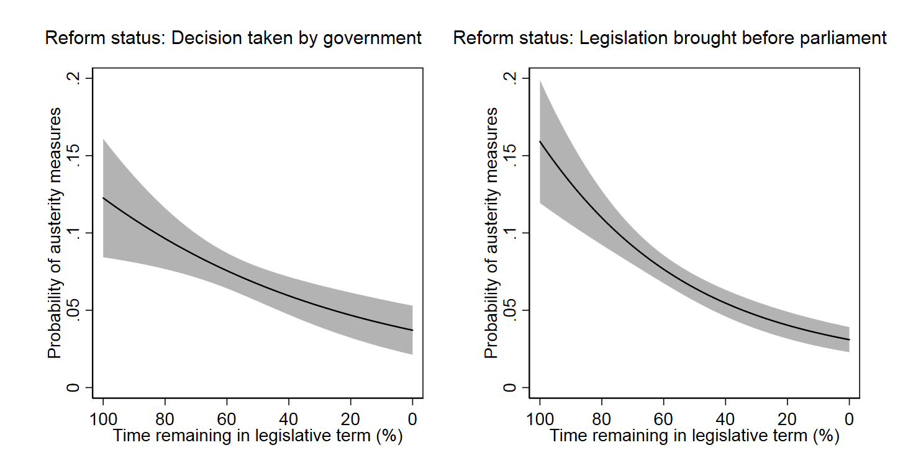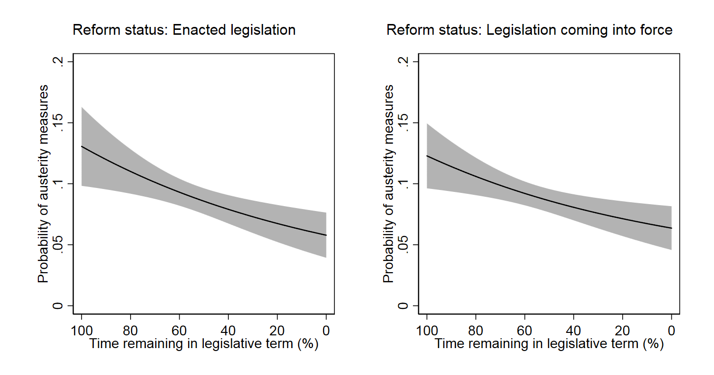

Robustness analysis with impact of time until next actual elections
Our main empirical models follow the assumption that governments consider the timing of next scheduled elections when they structure their policy agenda and decide when to introduce austerity measures throughout the legislative term. However, governments may call for early elections. If governments can anticipate or determine themselves the timing of the next election (Smith 2003, 2004; Schleiter and Tavits 2016) they should structure their policy agenda according to the next actual election instead of the date scheduled for the next election. This distinction might make a difference in cases of early elections that were strategically planned by the government. To evaluate whether the operationalization of our main explanatory variable introduces a bias to our main results, we run a robustness test using the months until the next election as our explanatory variable and analyze its impact on the occurrence of austerity measures (see Table A8). This establishes a tough test of our hypotheses, as we use the actual date of the next election to analyze whether there is a decrease in the probability of introducing an austerity measure as elections approach. In Table A8, an odds ratio higher than one for the covariate Months until next election indicates that the further away an actual election, the more likely it is that austerity measures are introduced. Based on the results, a decrease in the months until the next election also decreases the probability of austerity reform measures. In other words, governments are less likely to introduce austerity measures the closer the date of a new election, and this overall drop-off is strongest among minimal winning cabinets with new prime ministers (see solid line in right plot of Figure A3).

Table A8. Replication of main analysis using the months until the next actual election date (Models A22–A26).
 | Model A22 | Model A23 | Model A24 | Model A25 | Model A26
Months until next election | 1.025*** | 1.061*** | 1.023*** | 1.019* | 1.031**
 | (0.005) | (0.016) | (0.006) | (0.008) | (0.012)
Months until next election (squared) |  | 0.999*
 |  | (0.000)
Months until next election * |  |  | 1.006 |  | 0.981
New Prime Minister (New PM) |  |  | (0.009) |  | (0.014)
Months until next election * |  |  |  | 1.010 | 0.989
Minimal winning cabinet (MWC) |  |  |  | (0.009) | (0.013)
Months until next election * |  |  |  |  | 1.053**
New PM * MWC |  |  |  |  | (0.021)
Control variables
Months until next election * | 1.005 | 1.006 | 1.005 | 1.005 | 1.006
Crisis at cabinet formation | (0.012) | (0.012) | (0.012) | (0.012) | (0.012)
ΔUnemployment rate (yearly lag) | 0.905 | 0.939 | 0.904 | 0.892 | 0.889
 | (0.094) | (0.100) | (0.094) | (0.094) | (0.094)
ΔGDP growth (yearly lag) | 0.955 | 0.957 | 0.957 | 0.947 | 0.938
 | (0.053) | (0.054) | (0.054) | (0.054) | (0.054)
ΔDebt (yearly lag) | 1.049* | 1.046* | 1.050* | 1.050* | 1.047*
 | (0.020) | (0.020) | (0.020) | (0.020) | (0.020)
Sum of other reform measures | 2.014*** | 2.010*** | 2.016*** | 2.016*** | 2.020***
 | (0.080) | (0.080) | (0.080) | (0.080) | (0.081)
Constant | 0.049*** | 0.040*** | 0.043*** | 0.063*** | 0.082***
 | (0.033) | (0.027) | (0.030) | (0.044) | (0.060)
Observations | 3296 | 3296 | 3296 | 3296 | 3296
Log likelihood | -1202 | -1199 | -1202 | -1201 | -1197
AIC | 2600 | 2596 | 2602 | 2601 | 2597
Note: Replications of Model 1-5 in Table 3 using the months until the next actual election date instead of the percentage of time remaining in the legislative term until the next scheduled election. Exponentiated coefficients from logistic regression analyses with unconditional fixed effects at the cabinet level and a variable measuring the months since the last austerity measure, along with a squared and cubed transformation to account for temporal dependence (not reported); standard errors in parentheses (* p < 0.05, ** p < 0.01, *** p < 0.001).

Figure A2. Effects of the months until the next actual election on the probability of austerity measures (based on Models A22 and A23 in Table A8).
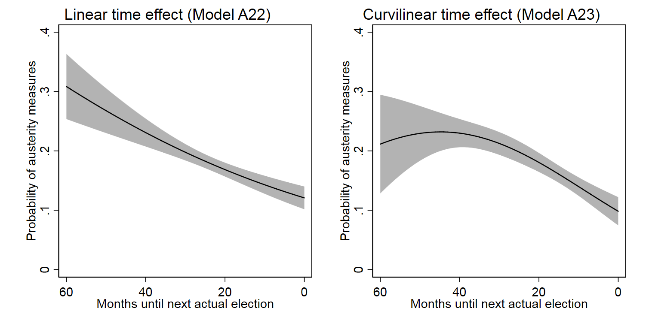
Figure A3. Effects of the months until the next actual election on the probability of austerity measures (based on Model A26 in Table A8).
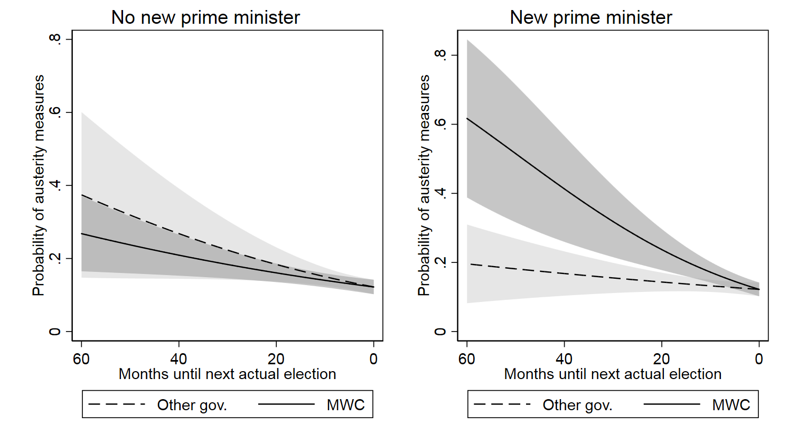

Testing the robustness of the effect of new prime ministers to the inclusion of ideological alternation
We argue that a change in leadership leads to the early introduction of austerity measures due to the opportunity to shift blame to previous cabinets. However, it is possible that part of this effect can be explained by a preference shift when the new government is positioned further to the right. While the fixed effects model does control for the fact that governments have overall different preferences regarding the introduction of austerity measures, we test here whether shifts in the ideological preferences of cabinets have an effect on the timing of austerity measures in the legislative term. For each cabinet in our sample, we first calculate the seat-weighted average position of all parties in cabinet using the left-right RILE measures provided for each party by the comparative manifesto project (MARPOR). We then construct the variable ideological alternation by calculating the difference in the ideological position between the previous and the current government. Positive values indicate that the current cabinet is ideologically positioned more to the right than the government previously in office and negative values indicate that the position of the current cabinet is more to the left.
Model A27 in Table A9 tests whether governments are more likely to introduce austerity measures early on when they are ideologically positioned more to the right than previous cabinets. We interact our main explanatory variable measuring the time remaining in the legislative term with the variable measuring the ideological alternation of the current cabinet as well as the dummy variable for minimal winning cabinets. The model thus essentially replicates Model 5 from the main analysis using the variable ideological alternation instead of the dummy variable indicating cabinets with new prime ministers. The coefficients for all interactions are not statistically significant.
However, as interactions between continuous variables are difficult to interpret and the range of values for both variables is large (leading to very small coefficients), we plot the average marginal effect of the time remaining in the legislative term for different values of ideological alternation in Figure A4. The plot shows that the average marginal effect of the time variable in fact increases as the values for ideological alternation increases. This means that governments which are more to the right than previous cabinets are indeed more likely to introduce austerity measures early on than governments which are more to the left, i.e. which have negative values for the variable measuring ideological alternation. These results support the notion that preference shifts to the right may be related to the introduction of austerity measures early in the legislative term.
While the result indicates that ideological alternation affects the early introduction of austerity measures, how does this affect our main findings? To test whether our main findings are robust to preference shifts, we replicate Model 5 from the main analysis and in addition include all interactions with the variable ideological alternation reported above (see Model A28 in Table A9). As in the main analysis, the odds ratio for the interaction between the time remaining in the legislative term and the dummy variables for new prime ministers and minimal winning cabinets is significantly larger than 1. We further plot the predicted probabilities in Figure A5 as we did in Figure 4 in the main analysis. Even when controlling for preference shifts, we find that cycles effects are strongest for minimal winning cabinets with new prime ministers (right panel of Figure A5). Our main findings, which indicate that government type and leadership changes increase the likelihood of early austerity measures, are thus robust to preference shifts as measured using the ideological alternation variable.

Table A9. Robustness tests using ideological alternation (Models A27–A28)
 | Model A27 | Model A28
Time remaining in legislative term (%) | 1.004 | 1.009
 | (0.004) | (0.006)
Time remaining in leg. term * MWC | 1.008 | 0.998
 | (0.005) | (0.007)
Time remaining in leg. term * Ideological alternation | 1.000075 | 1.00020
 | (0.00021) | (0.00024)
Time remaining in leg. term * Ideological alternation * MWC | 1.00025 | 1.00015
 | (0.00028) | (0.00030)
Time remaining in leg. term * New PM |  | 0.990
 |  | (0.008)
Time remaining in leg. term * New PM * MWC |  | 1.027*
 |  | (0.011)
Control variables
Time remaining in leg. term * Crisis at cabinet formation | 1.005 | 1.006
 | (0.007) | (0.007)
ΔUnemployment rate (yearly lag) | 0.916 | 0.925
 | (0.106) | (0.109)
ΔGDP growth (yearly lag) | 1.016 | 1.019
 | (0.064) | (0.065)
ΔDebt (yearly lag) | 1.062** | 1.061**
 | (0.024) | (0.024)
Sum of other measures | 2.009*** | 2.015***
 | (0.084) | (0.084)
Constant | 0.057*** | 0.066***
 | (0.041) | (0.050)
Observations | 2872 | 2872
Log likelihood | -1053 | -1049
AIC | 2284 | 2281

Note: Replications of Model 5 in Table 3 using ideological alternation as measured by changes in the seat-weighted average RILE position of all parties in cabinet. Exponentiated coefficients from logistic regression analyses with unconditional fixed effects at the cabinet level and a variable measuring the months since the last austerity measure, along with a squared and cubed transformation to account for temporal dependence (not reported); standard errors in parentheses (* p < 0.05, ** p < 0.01, *** p < 0.001).

Figure A4. Average marginal effect of the time remaining in the legislative term on the probability of austerity measures for different values of ideological alternation (based on Model A27 in Table A9).
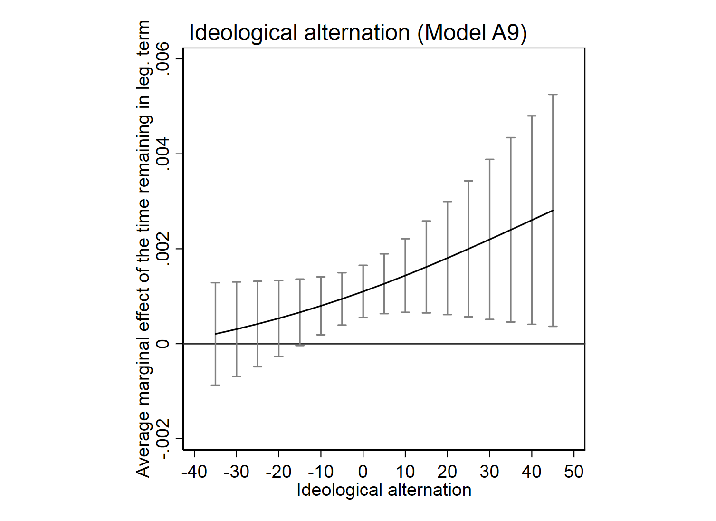

Figure A5. Effects of the time remaining in the legislative term on the probability of austerity measures controlling for ideological alternation (based on Model A28 in Table A9).
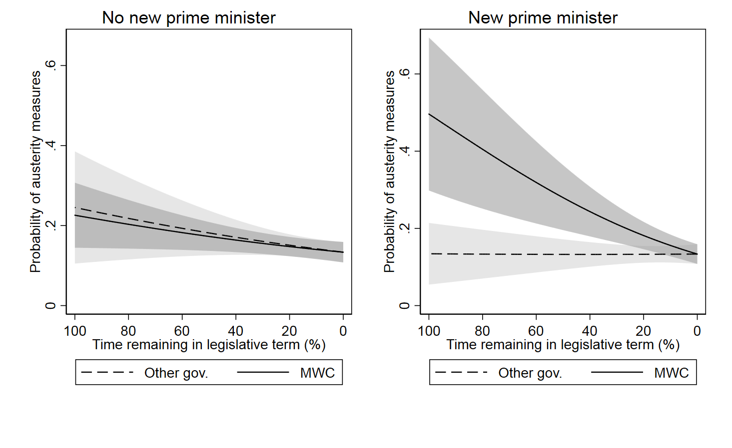

References
Alesina, A., Ardagna, S., and Trebbi, F. (2006). Who Adjusts and When? The Political Economy of Reforms. IMF Staff Papers 53(1), 1–29.
Alesina, A., Roubini, N. and Cohen, G. (1997). Political Cycles and the Macroeconomy. Cambridge: MIT Press.
Alt, J. E., and Rose, S. (2007). Context-conditioned Political Budget Cycles. In C. Boix and S. C. Stokes (eds.), Oxford Handbook of Comparative Politics. Oxford: Oxford University Press, 845–67.
Ganghof, S. and Bräuninger, T. (2006). Government Status and Legislative Behaviour: Partisan Veto Players in Australia, Denmark, Finland and Germany. Party Politics 12(4), 521–39.
Geys, B. (2007). Government Weakness and Electoral Cycles in Local Public Debt: Evidence from Flemish Municipalities. Local Government Studies 33(2), 237–51.
Chang, E. (2008). Electoral Incentives and Budgetary Spending: Rethinking the Role of Political Institutions. Journal of Politics 70(4), 1086–97.
Döring, H., and Manow, P. (2016). Parliaments and Governments Database (ParlGov): Information on Parties, Elections and Cabinets in Modern Democracies. Development version, available online: http://www.parlgov.org/ (last accessed 2018-04-13).
Grilli, V., Masciandaro, D., and Tabellini, G. (1991). Political and Monetary Institutions and Public Financial Policies in the Industrial Countries. Economic Policy 6(13), 341–92.
Hallerberg, M., and Scartascini, C. (2017). Explaining Changes in Tax Burdens in Latin America: Do Politics Trump Economics? European Journal of Political Economy 48(1), 162–79.
Hamman, A.J., and Prati, A. (2002). Why Do Many Stabilizations Fail? The Importance of Luck, Timing and Political Institution, IMF Working Paper, No. 02/228.
Klomp, J., and De Haan, J. (2013). Political Budget Cycles and Election Outcomes. Public Choice 157(1), 245–67.
McFadden, D. (1974). Conditional Logit Analysis of Qualitative Choice Behaviour. In P. Zarembka (ed.), Frontiers in Econometrics. New York: Academic Press, 105–42
Rose, S. (2008). The Political Manipulation of US State Rainy Day Funds Under Rules versus Discretion. State Politics and Policy Quarterly 8(2), 150–76.
Roubini, N., and Sachs, J. (1989). Government Spending and Budget Deficits in the Industrial Countries. Economic Policy 4(8), 99–132.
Schleiter, P., and Tavits, M. (2016). The Electoral Benefits of Opportunistic Election Timing. Journal of Politics 78(3): 836–50.
Smith, A. (2003). Election Timing in Majoritarian Parliaments. British Journal of Political Science 33(3), 397–418.
Smith, A. (2004). Election Timing. New York: Cambridge University Press.
Streb, J. M., Lema, D., and Torrens, G. (2009). Checks and Balances on Political Budget Cycles: Cross-country Evidence. Kyklos 62(3), 425–46.
Streb, J.M., and Torrens, G. (2013). Making Rules Credible: Divided Government and Political Budget Cycles. Public Choice 156(3–4), 703–22.
Strøm, K. (2000). Delegation and Accountability in Parliamentary Democracies. European Journal of Political Research 37 (3), 261–90.
Tsebelis, G. (1995). Decision Making in Political Systems: Veto Players in Presidentialism, Parliamentarism, Multicameralism and Multipartyism. British Journal of Political Science 25(3), 289–325.
Tsebelis, G. (1999). Veto Players and Law Production in Parliamentary Democracies: An Empirical Analysis. American Political Science Review 93(3), 591–608.
Tsebelis, G. (2002). Veto Players: How Political Institutions Work. Princeton: Princeton University Press.
Veiga, F. J. (2000). Delays of Inflation Stabilizations. Economics and Politics 12(3), 275–96.
Veiga, L.G., and Veiga, F.J. (2007). Political Business Cycles at the Municipal Level. Public Choice 131(1–2), 45–64.

All models reported included the same control variables and fixed effects as the models in the main analysis, except where otherwise noted.
We therefore do not replicate the more demanding analyses in Table 3 using these subsamples.
The number of observations is lower for this analysis as the first cabinet in each country drops out of the analysis when calculating the difference in cabinet positions.

