Online Appendix B
One potential issue with the analysis in the main paper is that it can be difficult to disentangle the effects of party roles on responsibility from the effects of party size because party roles and sizes correlate such that larger parties are more likely to be part of the government. Consequently, the results in this appendix take advantage of the fact that we asked all respondents in the 2012 Dutch survey and in the 2014 Danish survey about how large the respondents perceived each party to be in terms of legislative seat share (from 0 to 100). Specifically, we regress responsibility attribution on perceived legislative seat share and perceived party roles using an ordered probit estimator, and with the unit of analysis being the respondent-party. The role dummy variables are coded “1” whenever a party was classified to that particular role (“0” otherwise). This empirical strategy allows us to estimate the effect of perceived party roles on responsibility attribution holding perceived party size constant. The models also include crossed random intercepts for individuals and parties to account for the possibility that some individuals attribute, or that some parties receive, systematically more or less responsibility attribution for reasons that are otherwise unaccounted for in the models.
Table 1b shows the regression coefficients from this analysis in the Netherlands, and Figure 1b shows their substantive effects (the estimated average level of responsibility attributed to a party given its perceived role and perceived size). Since we want to make sure that we are only making inferences where the data actually live, the lines are thickened between the 10th and 90th percentile of perceived size for each perceived role. The figure thus indicates, for example, that most respondents perceive that cabinet partner seat shares are roughly somewhere between 5 and 25 percent. Substantively, the figure shows that perceived size clearly matters for responsibility attribution, but that perceived roles do as well. Specifically, the perceived size slopes are positive, but their intercept depends on the party’s perceived role. This means, for example, that parties perceived to be in the government and small tend to be attributed more responsibility than parties perceived to be in the opposition and large. Figure 2b shows that those substantive effects are statistically distinguishable from zero by graphing the marginal effects of parties being perceived to be cabinet partners relative to being in the opposition over realistic levels of perceived party size with 95 percent confidence intervals.

Table 1b: Responsibility attribution and perceived
party characteristics in the Netherlands, 2012
Parameter | Model 1b
PM | 1.871***  (0.134)
Cabinet partner | 1.583***  (0.082)
Opposition | 0.767***  (0.066)
Percentage seats | 0.063***  (0.005)
PM*Percentage seats | -0.026***  (0.006)
Cabinet partner*Percentage seats | -0.030***  (0.005)
Opposition*Percentage seats | -0.032***  (0.005)
Random intercept variance: Respondents | 0.425
Random intercept variance: Parties | 0.302
Obs. | 7,774
***p < .001, **p<.01, * p<.05
Note: The model is estimated with an ordered
probit estimator. The omitted role category is “no
seats in parliament”

Figure 1b: Responsibility attribution to perceived party roles over
perceived party size in the Netherlands, 2012
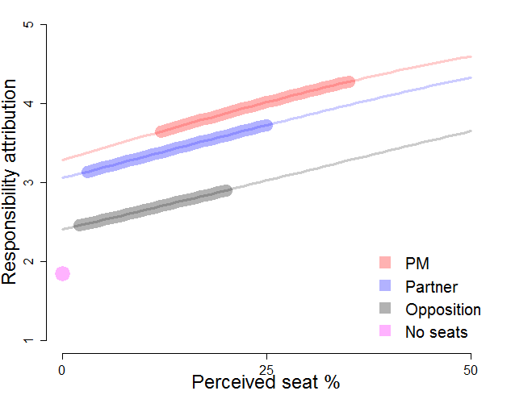
Note: Lines are thickened where the data live (between the 10th and 90th perceived seat size percentile for each perceived role)

Figure 2b: Marginal effects of perceived partner status relative to
perceived opposition status over perceived party size in the Netherlands, 2012.
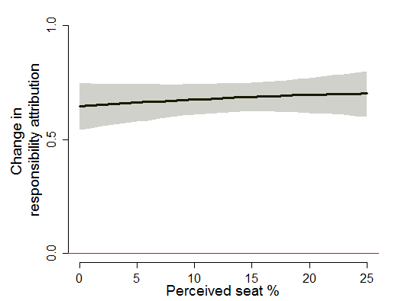
Note: Shared area represents 95% confidence intervals
Table 2b, Figure 3b and Figure 4b replicate this analysis for Denmark using the sample where respondents were not given the support party role option. These results are largely similar to the results from the Netherlands, showing that parties perceived to be in government are generally attributed more responsibility than parties perceived to be in the opposition, holding perceived party size constant.

Table 2b: Responsibility attribution and perceived
party characteristics in Denmark, 2014
Parameter | Model 2b
PM | 1.450***  (0.122)
Cabinet partner | 1.241***  (0.077)
Opposition | 0.043***  (0.065)
Percentage seats | 0.022***  (0.003)
PM*Percentage seats | -0.007  (0.004)
Cabinet partner*Percentage seats | -0.008*  (0.003)
Opposition*Percentage seats | -0.003  (0.003)
Random intercept variance: Respondents | 0.277
Random intercept variance: Parties | 0.720
Obs. | 6,493
***p < .001, **p<.01, * p<.05
Note: The model is estimated with an ordered
probit estimator. The omitted role category is “no
seats in parliament”

Figure 3b: Responsibility attribution to perceived party roles over perceived party
size in Denmark, 2014
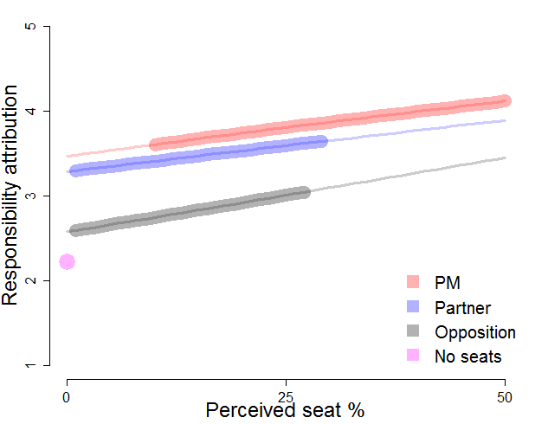
Note: Lines are thickened where the data live (between the 10th and 90th perceived seat size percentile for each perceived role)

Figure 4b: Marginal effects of perceived government partner role relative to
perceived opposition role over perceived party size in Denmark, 2014.
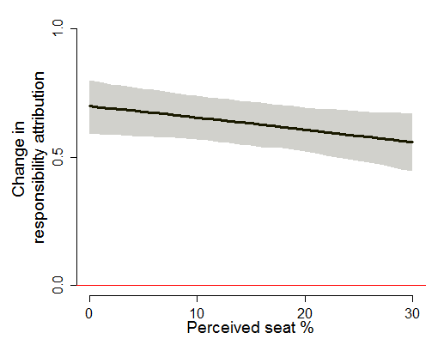
Note: Shared area represents 95% confidence intervals
Table 3b, Figure 5b and Figure 6b replicate the analysis for Denmark using the sample where respondents were allowed to assign parties the support party role option. This analysis provides further evidence for our argument in the main paper that (perceived) support parties are treated in a way that is comparable to that of opposition parties. Specifically, perceived support parties in Denmark are attributed roughly the same level of responsibility as parties perceived to be large opposition parties, but never as much responsibility as perceived government parties at realistic party sizes. Of course, the possibility remains that if there was a very large support party in Denmark then it would be attributed responsibility in a way that is similar to that of a small cabinet partner, but we do not have sufficient data to test this possibility because voter information about party roles and sizes tends to be reasonably accurate in our sample.

Table 3b: Responsibility attribution and perceived party
characteristics with support party option in Denmark, 2014
Parameter | Model 3b
PM | 2.977***  (0.298)
Cabinet partner | 1.988***  (0.203)
Support | 1.370***  (0.179)
Opposition | 0.831***  (0.169)
Percentage seats | 0.032***  (0.005)
PM* Percentage seats | -0.020**  (0.007)
Cabinet partner*Percentage seats | -0.003  (0.007)
Support*Percentage seats | -0.008  (0.007)
Opposition*Percentage seats | -0.006  (0.006)
Random intercept variance: Respondents | 0.529
Random intercept variance: Parties | 0.485
Obs. | 1,755
***p < .001, **p<.01, * p<.05
Note: The model is estimated with an ordered
probit estimator. The omitted role category is “no
seats in parliament”

Figure 5b: Responsibility attribution to perceived party roles with support party option
over perceived party size in Denmark, 2014
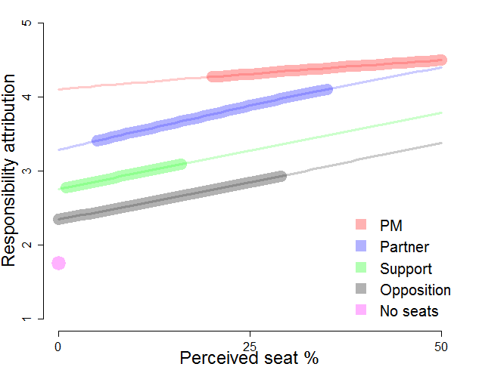
Note: Lines are thickened where the data live (between the 10th and 90th perceived seat size percentile for each perceived role)

Figure 6b: Marginal effects of perceived support party role in Denmark, 2014
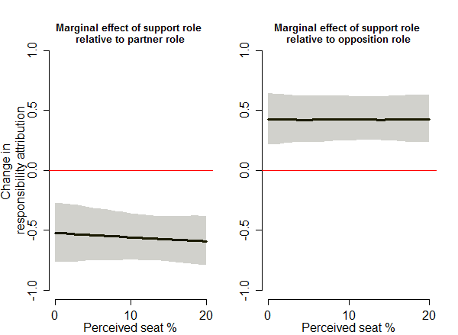

Note: Shared area represents 95% confidence intervals
Another interesting possibility is that voter classifications of support parties are related to how they treat support parties. To test this possibility Table 4b, Figure 7b and Figure 8b show results from the Netherlands where we again examine the relationship between responsibility attribution and perceived party characteristics, but we restrict the sample to only include observations for which the true party was the PVV (the true support party). The unit of analysis is thus the support party-respondent rather than the party-respondent. The substantive effects of this analysis, which are shown in Figure 7b, suggest that individuals who categorized the PVV as an opposition party attributed the party substantively more policy responsibility attribution than individuals who categorized the PVV as a coalition partner. Figure 8b shows that those results are statistically distinguishable from zero. This suggests that it matters for support party responsibility attribution whether this party type is perceived to be more like opposition parties instead of government coalition partners.

Table 4b: Support party classification and
responsibility attribution in the Netherlands, 2012
Parameter | Model 4b
PM | 1.608***  (0.402)
Cabinet partner | 1.121***  (0.232)
Opposition | 0.438*  (0.251)
Percentage seats | 0.039***  (0.011)
PM*Percentage seats | -0.048**  (0.017)
Cabinet partner*Percentage seats | -0.021  (0.013)
Opposition*Percentage seats | 0.0004  (0.014)
Obs. | 789
***p < .001, **p<.01, * p<.05
Note: The model is estimated with an ordered
probit estimator

Figure 7b: Support party classification and responsibility attribution in the Netherlands, 2012
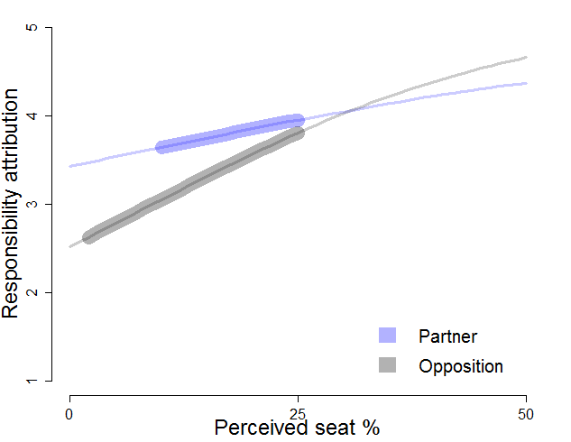
Note: Lines are thickened where the data live (between the 10th and 90th perceived seat size percentile for each perceived role)

Figure 8b: Marginal effects of a support party being classified as a cabinet partner relative to being classified as an opposition party in the Netherlands, 2012
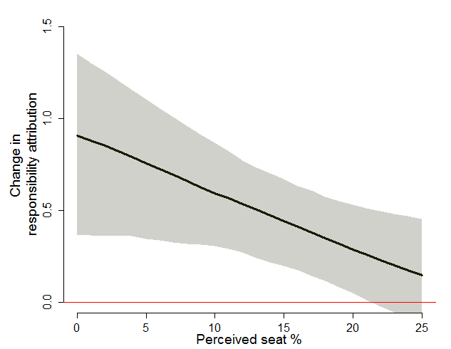
Note: Shared area represents 95% confidence intervals

Table 5b, Figure 9b and Figure 10b replicate this analysis in Denmark using the sample where respondents were not given the support party option. The dataset thus contains two rows per individual (one for each of the two true support parties in Denmark). Here it also appears to matter for responsibility attribution whether support parties were categorized as opposition parties or as government partners. Or, put differently, much like in the Netherlands support parties are attributed less policy responsibility when they are categorized as opposition parties compared to when they are categorized as government coalition partners.

Table 5b: Support party classification and
responsibility attribution in Denmark, 2014
Parameter | Model 5b
PM | 1.039**  (0.349)
Cabinet partner | 0.920***  (0.153)
Opposition | 0.419**  (0.419)
Percentage seats | 0.022***  (0.006)
PM* Percentage seats | 0.035  (0.021)
Cabinet partner*Percentage seats | 0.006  (0.008)
Opposition*Percentage seats | -0.005  (0.008)
Random intercept variance: Respondents | 0.720
Obs. | 1,444
***p < .001, **p<.01, * p<.05
Note: The model is estimated with an ordered
probit estimator. The omitted role category is “no
seats in parliament”
Figure 9b: Support party classification and responsibility attribution in Denmark, 2014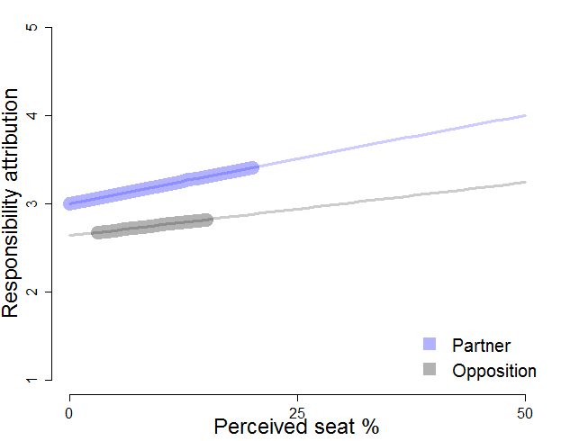
Note: Lines are thickened where the data live (between the 10th and 90th perceived seat size percentile for each perceived role)

Figure 10b: Marginal effects of a support party being classified as a cabinet partner relative to being classified as an opposition party in Denmark, 2014
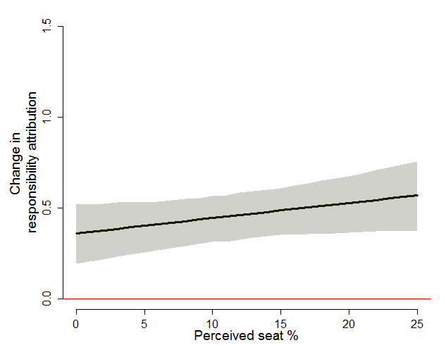
Note: Shared area represents 95% confidence intervals.

The figure does not show substantive effects for parties that were assigned to the “no seats in parliament role” over perceived legislative seat share for obvious reasons. However, it is worth noting that some respondents did in fact perceive that the parties which they assigned to this role had a legislative seat share greater than zero despite the fact that those two possibilities are not logically possible for the same party.
A final possibility would have been to examine whether role perceptions matter when respondents are allowed to classify support parties to their true role in Denmark. However, the data did not allow for a meaningful analysis of this question because there were too few cases where respondents did not categorize the support parties to their true roles when given the option to do so. Furthermore, even if the data were available such an analysis would be potentially problematic because it would compare responsibility attribution for two very different sample groups. Specifically, we would be comparing responsibility attribution to true support parties among those respondents who are politically informed (those who classified actual support parties to their true roles) with responsibility attribution among those respondents who were not informed (those who did not know that SF and EL were support parties at the time of our survey). Such a comparison is potentially problematic because it is not clear that these two types of voters attribute responsibility in similar ways.

