APPENDIX

Table A-1: Population mean differences between children born in Rogaland and in the control area, 1967-1969 cohorts. Numbers from Løken et al. (2012: 16).

|  |  |  |
| --- | --- | --- |
|  | Level  Rogaland | Difference  Rogaland-control area |
| Mother attended college | .07 | -.008 |
| Father attended college | .16 | -.006 |
| Mother’s age at child’s birth | 26.5 | .22 |
| Father’s age at child’s birth | 29.5 | -.14 |
| Number of siblings | 2.08 | .23 |
| Birth order | 2.18 | .11 |

Table A-2: Students per teacher in primary schools, 1970 and 1981 SSB 1971, 1983.

|  |  |  |  |
| --- | --- | --- | --- |
|  | 1970 | 1981 | Difference |
| Oppland | 19.30 | 21.60 | 2.29 |
| Buskerud | 19.48 | 21.31 | 1.83 |
| Telemark | 17.98 | 19.81 | 1.83 |
| Sør-Tr.lag | 19.54 | 20.86 | 1.32 |
| Hedmark | 19.39 | 20.44 | 1.05 |
| A-Agder | 18.73 | 19.64 | 0.91 |
| Rogaland | 19.75 | 20.59 | 0.85 |
| Vestfold | 19.97 | 20.71 | 0.73 |
| Nord-Tr.lag | 18.90 | 18.71 | -0.19 |
| Sogn og fj. | 17.72 | 16.74 | -0.98 |
| Møre og Roms. | 19.30 | 17.65 | -1.65 |

Table A-3: Gross per capita spending (in 1974 NOK) on child welfare institutions, 1967 and 1974 SSB 1969, 1976.

|  |  |  |  |
| --- | --- | --- | --- |
|  | 1967 | 1974 | Difference |
| Vestfold | 7.1 | 37.6 | 30.4 |
| Sør-Tr.lag | 10.8 | 36.9 | 26.1 |
| Rogaland | 8.0 | 29.5 | 21.5 |
| Buskerud | 11.5 | 31.1 | 19.6 |
| Sogn og fj. | 1.0 | 19.6 | 18.6 |
| Hedmark | 2.9 | 20.4 | 17.6 |
| Møre og Roms | 3.5 | 16.9 | 13.5 |
| Telemark | 2.0 | 14.6 | 12.6 |
| Oppland | 1.2 | 10.3 | 9.2 |
| Nord-Tr.lag | 1.3 | 7.5 | 6.2 |
| A-Agder | 2.1 | 6.0 | 3.9 |

Table A-4: Average turnout across municipalities in Rogaland and control area, 1969-

1981.

|  |  |  |
| --- | --- | --- |
|  | Rogaland | Control area |
| 1969 | 81.5 | 82.0 |
| 1973 | 79.6 | 78.5 |
| 1977 | 82.5 | 81.3 |
| 1981 | 83.3 | 81.5 |

Figure A.1: Map of Norwegian counties.

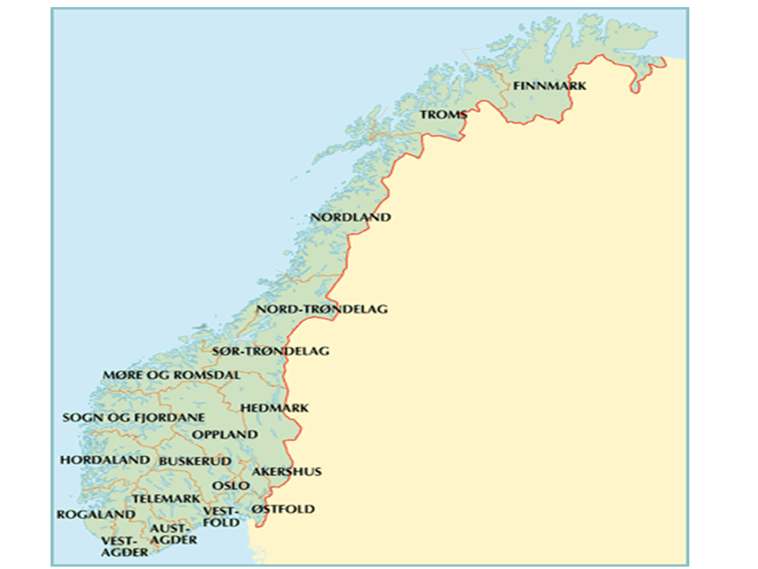

Figure A.2: Per capita current expenditure on education (in 1998 NOK) per year. Full line refers to Rogaland, the dotted line to the control counties. Source: Fiva, Halse and Natvik 2010.

