**Appendix for Juking the Stats**

Contents

Notes on variables, estimation techniques, etc.

Appendix Table 1: Dictatorships Cross-Nationally Report Higher GDP per capita

Appendix Table 2. Annual Data Summary Statistics

Appendix Table 3. Quarterly Data Summary Statistics

Appendix Table 4. Robustness Checks on Turnover, Annual Data

Appendix Table 5. Turnover and Lagged Turnover Patterns in Growth Differences

Appendix Table 6. Results Robust to Separating Types of Turnovers

Appendix Table 7. Results Robust to Dropping Officials Aged 65+

Appendix Table 8. Results Robust to Including Age

Appendix Figure 1. Continuity in Chinese Electricity Production & Gross Output Data

Appendix Figure 2. Exports Drop Precipitously in the Second Half of 2008

Appendix Figure 3. Rail Freight Traffic Also Declines in 2008 *Q*4

Appendix Figure 4. Provincial GDP – Electricity Production Growth Differential

Appendix Figure 5: Map of Provincial Electricity Importers and Exporters

Appendix Figure 6. Map of Inter-Provincial Electricity Infrastructure

On the Chinese national-level GDP growth series:

The GDP series is quarterly data representing year-on-year growth rates for that quarter. Where we have official statements about the growth rate, that is 2008 and 2009, we use those. For other years, the quarterly growth rate is estimated by adjusting the released data as follows: taking the released data - which is accumulated (1Q with 1Q, 1-6 months with 1-6 months, 1-9 with 1-9, and 1-12 with 1-12) and separating out the growth rate from that quarter based on an average quarterly GDP share for each quarter (.204, .232, .246, and .318, for the four quarters respectively).[1]

On provincial-level units:

The term “provincial-level units” is used here rather than provinces due to China’s different kinds of these units, namely 22 provinces, 4 municipalities (i.e. the cities of Beijing, Tianjin, and Shanghai plus Chongqing and a large area surrounding that city), and 5 minority-dominated Autonomous Regions. Officially, China has 34 provincial-level units, the 31 described and analyzed here plus Hong Kong and Macao Special Administrative Regions and Taiwan.

On the quarterly data analysis:

For the quarterly analysis, the ultimate dependent variable is the difference between a reported GDP growth series estimate and an electricity growth figure. The creation of this variable, however, is more complicated than the annual data series for two reasons: data availability and the nature of the data that are available. Estimates of electricity *production*—not consumption—levels and growth by province are available on a monthly basis.[2] The electricity production growth figures are year-on-year growth by month. A simple, three-month moving average of that growth series is used as the electricity growth data point for each quarter, that is, the value on the 3rd, 6th, 9th, and 12th month is taken as the quarterly value.

Provincial quarterly GDP growth estimates are not centralized. National level compilations of the quarterly GDP growth data are available only for 2007 *Q*2 to 2009 *Q*2. For the previous province-quarters, data was compiled through a number of resources including each province’s statistical website, databases of economic news such as ChinaINFOBANK, etc. The economic growth data that are reported are cumulative figures rather than the annualized, seasonally-adjusted quarter-over-quarter figures produced by the Bureau of Economic Analysis of the United States Department of Commerce. That is, the GDP growth estimate for the first quarter (*Q*1) for a given province represents an estimate of the year-on-year growth rate for the first quarter compared with the previous year’s *Q*1 growth rate, while the *Q*2 data point compares the combined result from *Q*1 and *Q*2 of year *t* with *Q*1 and *Q*2 of year *t -* 1. For the *Q*3 estimate, the first nine months of the given year are compared with the previous year’s first nine months. Quarter 4 estimates compare the whole year. These cumulative growth rates are then transformed into growth rates for the quarter by giving equal weight to each quarter in the decompositions.[3]

On political turnover:

Using China Vitae’s database of political leader biographies and domestic news sources when the record was incomplete, a dataset of provincial party secretaries and governmental leaders was assembled. “Governmental leaders” translates to Governors for provinces, Chairmen for Autonomous Regions, and Mayors of Municipalities.

On the cross-national analysis:

In footnote 18 above, the cross-national claims are stated to be robust to the use of the DD data from Cheibub, Gandhi, and Vreeland. Those results are presented below.

The correlations between GDP per capita and Electricity Consumption per capita (both logged) is 0.726 for dictatorships and 0.874 for democracies; without logging the variables, those figures are 0.695 and 0.786, for dictatorships and democracies respectively.

The GDP:Electricity ratio is similarly much higher in dictatorships than democracies using the DD data, as noted in footnote 19. For dictatorships, the mean was $4.12 for every kilowatt-hour of electricity consumption compared with less than $2.98 for democracies, p-value < 0.0001.

For the regression analysis noted in footnote 20, using the DD data, dictatorships report greater changes in GDP per capita after controlling for changes in electricity consumption. Using the DD data, the coefficient of that analysis is $46. These two regressions are presented below in Appendix Table 1.

Appendix Table 1. Dictatorships Cross-Nationally Report Higher GDP per capita

|  |  |  |
| --- | --- | --- |
| DV: ∆GDP per capita | A1.1  Geddes & Wright | A1.2  DD Data |
|  |  |  |
| ∆ Electricity Consumption | 0.48*** | 0.48*** |
| *per capita, kwh* | (0.10) | (0.10) |
| Dictatorship | 27.37** | 46.57** |
|  | (13.00) | (22.60) |
| Constant | 92.12 | 81.55 |
|  | (63.77) | (65.93) |
|  |  |  |
| Observations | 4,001 | 3,946 |
| R-squared | 0.10 | 0.10 |
| # of Countries | 122 | 122 |
| Country FE | YES | YES |
| Year FE | YES | YES |

n.b. DV: ∆GDP per capita, annual data from 1960 to 2008 for nondemocracies as coded using the relevant data set. Robust standard errors in parentheses. *** p<0.01, ** p<0.05, * p<0.1.

Appendix Table 2. Annual Data Summary Statistics

|  |  |  |  |  |  |
| --- | --- | --- | --- | --- | --- |
|  | Count | Mean | Std Dev | Min | Max |
| GDP - Electricity Consumption Growth | 299 | 0.47 | 5.62 | -17.49 | 15.28 |
| Turnover | 435 | 0.37 | 0.48 | 0.00 | 1.00 |
| Gov to PS Promotion | 465 | 0.05 | 0.23 | 0.00 | 1.00 |
| Other Turnover | 465 | 0.30 | 0.46 | 0.00 | 1.00 |
| Industrial Growth | 439 | 113.28 | 4.70 | 97.20 | 138.50 |
| GDP per capita, logged | 465 | 9.33 | 0.77 | 7.61 | 11.28 |
| Service Sector  (% of GDP) | 465 | 0.38 | 0.07 | 0.26 | 0.76 |
| Service Sector Growth | 465 | 111.41 | 2.51 | 105.10 | 134.90 |
| Construction Growth | 435 | 112.63 | 7.19 | 84.80 | 157.30 |
| Net Electricity Exports | 330 | -8.79 | 214.68 | -852.03 | 954.44 |
| GDP Growth | 464 | 11.53 | 2.53 | 4.80 | 23.80 |
| Electricity Consumption Growth | 300 | 11.50 | 6.17 | -6.00 | 32.48 |

n.b. Only 30 provinces are included in the annual analysis as Tibet is omitted due to missing electricity consumption data. Annual data for 30 provinces from 2000 to 2009.

Appendix Table 3. Quarterly Data Summary Statistics

|  |  |  |  |  |  |
| --- | --- | --- | --- | --- | --- |
|  | count | mean | sd | min | max |
| GDP – Electricity Production Growth | 828 | -0.35 | 11.18 | -52.97 | 44.50 |
| Turnover | 704 | 0.43 | 0.50 | 0.00 | 1.00 |
| Turnover, lagged | 828 | 0.43 | 0.49 | 0.00 | 1.00 |
| GDP Growth | 863 | 12.15 | 3.03 | -15.10 | 28.00 |
| Electricity Prod. Growth  *(3m moving avg.)* | 828 | 12.69 | 11.46 | -32.90 | 64.77 |
| Industrial Growth | 827 | 18.58 | 7.27 | -19.20 | 69.40 |
| Electricity Exports | 695 | 7.53 | 191.65 | -662.08 | 771.74 |
| GDP per capita  *(logged)* | 704 | 9.42 | 0.58 | 8.09 | 11.10 |

n.b. Quarterly data for each province from 2001 to 2008.

Appendix Table 4. Robustness Checks on Turnover, Annual Data

|  |  |  |  |  |
| --- | --- | --- | --- | --- |
|  | Model A4.1 | Model A4.2 | Model A4.3 | Model A4.4 |
|  |  |  |  |  |
| Turnover | 0.94* | 0.99* | 0.98* | 0.94* |
|  | (0.52) | (0.51) | (0.52) | (0.51) |
| Industrial Growth | -0.18*** |  |  |  |
|  | (0.06) |  |  |  |
| Service Sector | -12.35** |  |  |  |
| *(% of GDP)* | (5.66) |  |  |  |
| Service Sector Growth |  | 0.25 |  | 0.28 |
|  |  | (0.17) |  | (0.17) |
| GDP per capita, logged |  | 8.16** |  | 7.94** |
|  |  | (3.48) |  | (3.67) |
| Construction Growth |  |  | -0.03 | -0.02 |
|  |  |  | (0.06) | (0.06) |
| Constant | 23.58*** | -100.52*** | 2.33 | -100.31** |
|  | (7.19) | (34.08) | (6.86) | (37.02) |
|  |  |  |  |  |
| Observations | 299 | 299 | 296 | 296 |
| R-squared | 0.28 | 0.29 | 0.26 | 0.28 |
| # of Provinces | 30 | 30 | 30 | 30 |
| Province FE | YES | YES | YES | YES |
| Year FE | YES | YES | YES | YES |

n.b. Dependent variable is Provincial GDP Growth – Electricity Consumption Growth, annual data from 2000 to 2009. Robust standard errors in parentheses *** p<0.01, ** p<0.05, * p<0.1. Only 30 provinces are included as Tibet is omitted due to missing electricity consumption data.

Appendix Table 5. Turnover and Lagged Turnover Patterns in Growth Differences

GDP Growth – Electricity Production Growth, quarterly data[4]

|  |  |  |
| --- | --- | --- |
|  | Turnover=0 | Turnover=1 |
| Lag Turnover=0 | -1.49 | -0.07 |
| Lag Turnover=1 | -2.94 | -1.34 |

n.b. The following two-by-two table summarizes the results in a reasonable fashion. During normal periods (i.e. no turnover this term or prior), GDP growth is on average about 1.5% lower than electricity production growth. When a turnover occurs, the difference evaporates to essentially zero (-0.07). The following year, it explodes to -3%. Finally, during tumultuous moments (both this year and the previous year saw turnovers) the growth differential is about the same as what occurs during normal times.

Appendix Table 6. Results Robust to Separating Types of Turnovers

|  |  |  |  |  |
| --- | --- | --- | --- | --- |
|  | Model A6.1 | Model A6.2 | Model A6.3 | Model A6.4 |
|  |  |  |  |  |
| Gov to PS promotion | 0.12 | 0.16 | 0.24 | 0.37 |
|  | (0.86) | (0.87) | (0.88) | (0.84) |
| Other Turnovers | 1.18** | 1.10** | 1.02* | 1.14** |
|  | (0.55) | (0.53) | (0.52) | (0.54) |
| Industrial Growth |  | -0.15** | -0.22*** | -0.18*** |
|  |  | (0.07) | (0.08) | (0.07) |
| GDP per capita, logged |  |  | 11.04*** | 2.05** |
|  |  |  | (3.01) | (0.84) |
| Service Sector (% of GDP) |  |  |  | -6.12 |
|  |  |  |  | (5.08) |
| Constant | -0.83 | 15.71** | -74.49** | 3.09 |
|  | (0.95) | (7.61) | (28.82) | (10.78) |
|  |  |  |  |  |
| Observations | 299 | 299 | 299 | 299 |
| R-squared | 0.27 | 0.28 | 0.30 | 0.29 |
| Number of Provinces | 30 | 30 | 30 | 30 |
| Province FE | YES | YES | YES | NO |
| Year FE | YES | YES | YES | YES |

n.b. Dependent variable is Provincial GDP Growth – Electricity Consumption Growth, annual data from 2000 to 2009. Robust standard errors in parentheses *** p<0.01, ** p<0.05, * p<0.1. Only 30 provinces are included as Tibet is omitted due to missing electricity consumption data.

Appendix Table 7. Results Robust to Dropping Officials Aged 65+

|  |  |  |  |  |
| --- | --- | --- | --- | --- |
|  | Model A7.1 | Model A7.2  No 65+ Officials | Model A7.3 | Model A7.4  No 65+ Officials |
|  |  |  |  |  |
| Turnover | 1.02* | 1.02* | 1.01* | 1.21** |
|  | (0.52) | (0.55) | (0.53) | (0.55) |
| Industry Growth |  |  | -0.22*** | -0.18*** |
|  |  |  | (0.07) | (0.07) |
| GDP per capita |  |  | 10.07*** | 1.91** |
| (logged) |  |  | (2.43) | (0.76) |
| Service Share |  |  | -7.10 | -3.27 |
| (% of GDP) |  |  | (5.92) | (5.98) |
| Young Leader |  |  | -2.16 | -2.28* |
|  |  |  | (1.31) | (1.26) |
| 65+ Leader |  |  | -0.72 |  |
|  |  |  | (0.96) |  |
| Constant | -0.79 | -0.81 | -63.50** | 3.97 |
|  | (0.96) | (0.99) | (24.29) | (9.28) |
|  |  |  |  |  |
| Observations | 299 | 282 | 299 | 282 |
| R-squared | 0.27 | 0.29 | 0.31 | 0.31 |
| Number of Provinces | 30 | 30 | 30 | 30 |
| Province FE | YES | YES | YES | NO |
| Year FE | YES | YES | YES | YES |

n.b. Dependent variable is Provincial GDP Growth – Electricity Consumption Growth, annual data from 2000 to 2009. Robust standard errors in parentheses *** p<0.01, ** p<0.05, * p<0.1. Only 30 provinces are included as Tibet is omitted due to missing electricity consumption data.

Appendix Table 8. Results Robust to Including Age

|  |  |  |  |  |
| --- | --- | --- | --- | --- |
|  | Model A8.1 | Model A8.2 | Model A8.3 | Model A8.4 |
|  |  |  |  |  |
| Turnover | 1.16* | 1.12** | 1.07* | 1.13** |
|  | (0.60) | (0.54) | (0.61) | (0.54) |
| Average Age | 1.51 |  |  |  |
|  | (2.49) |  |  |  |
| (Average Age)2 | -0.01 |  |  |  |
|  | (0.02) |  |  |  |
| Party Secretary’s Age |  | 0.07 |  |  |
|  |  | (0.09) |  |  |
| Governor’s Age |  |  | 0.02 |  |
|  |  |  | (0.09) |  |
| 65+ Leader |  |  |  | -1.06 |
|  |  |  |  | (1.11) |
| Young Leader |  |  |  | -2.52* |
|  |  |  |  | (1.46) |
| Constant | -46.37 | -4.72 | -2.06 | -0.65 |
|  | (70.95) | (5.60) | (5.26) | (0.96) |
|  |  |  |  |  |
| Observations | 299 | 299 | 299 | 299 |
| R-squared | 0.27 | 0.27 | 0.27 | 0.28 |
| Number of Provinces | 30 | 30 | 30 | 30 |
| Province FE | YES | YES | YES | YES |
| Year FE | YES | YES | YES | YES |

n.b. Dependent variable is Provincial GDP Growth – Electricity Consumption Growth, annual data from 2000 to 2009. Robust standard errors in parentheses *** p<0.01, ** p<0.05, * p<0.1. Only 30 provinces are included as Tibet is omitted due to missing electricity consumption data.

Appendix Figure 1. Continuity in Chinese Electricity Production & Gross Output Data

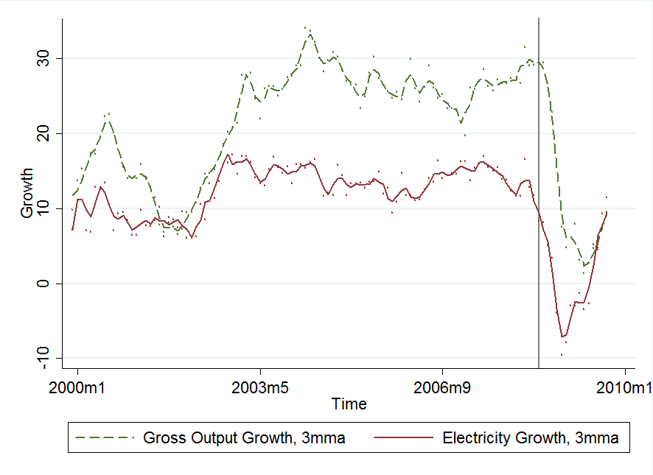

Appendix Figure 2. Exports Drop Precipitously in the Second Half of 2008

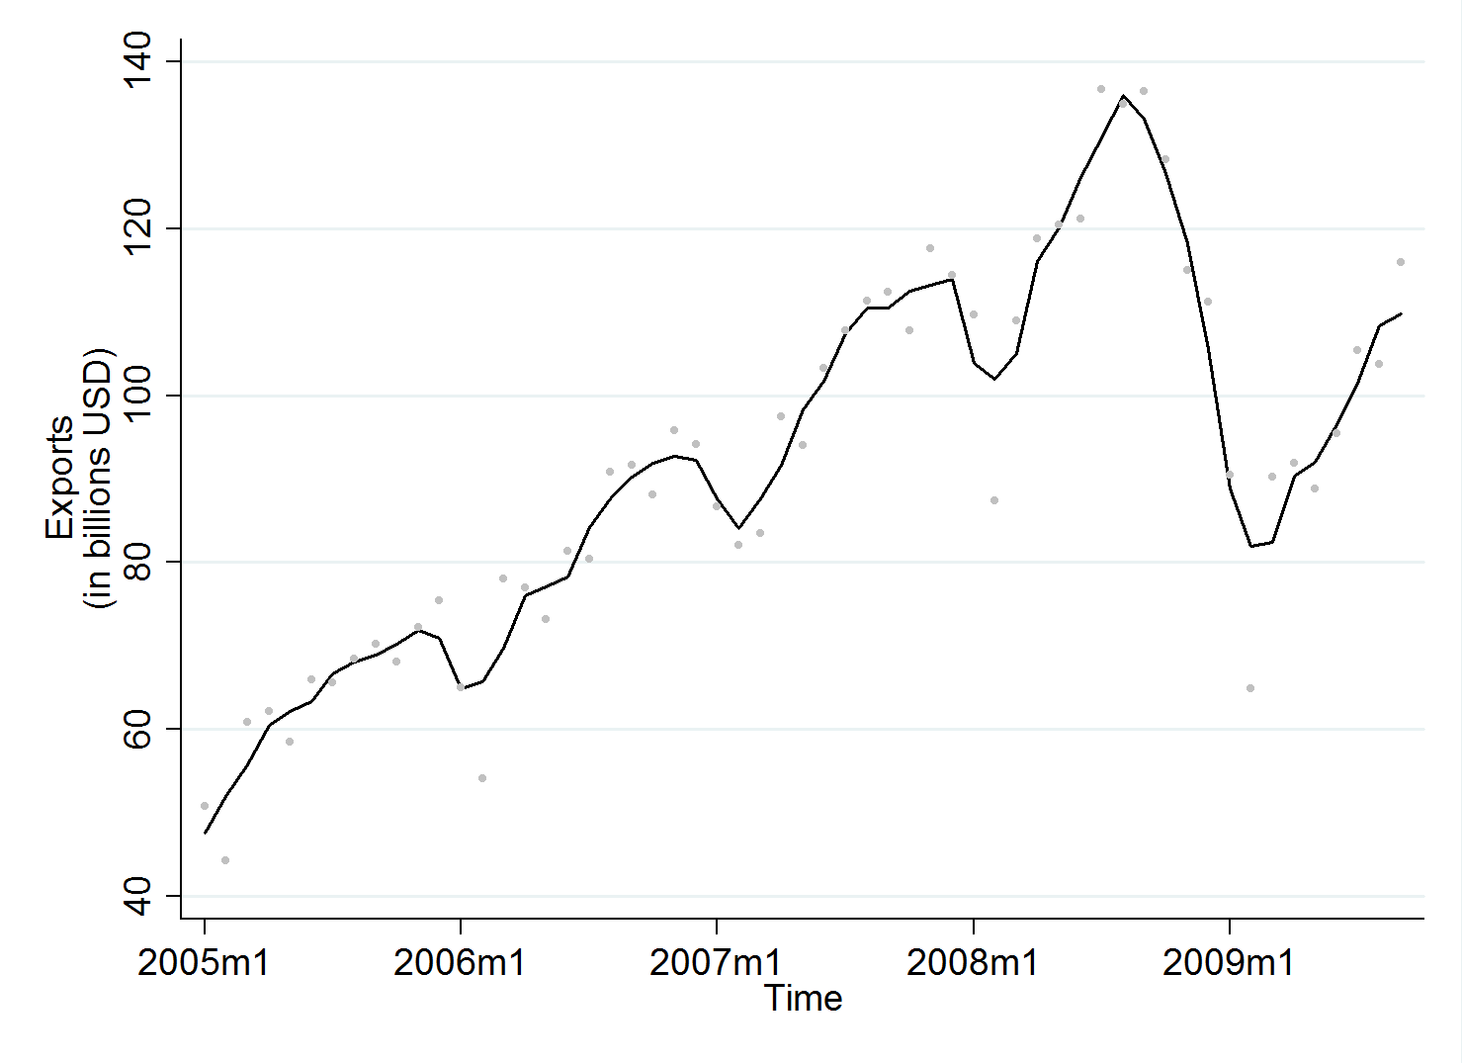

n.b. *Levels*—not growth—of Exports. Data from the National Bureau of Statistics. The line represents a 3-month moving average while the actual values are plotted.

Appendix Figure 3. Rail Freight Traffic Also Declines in 2008 *Q*4

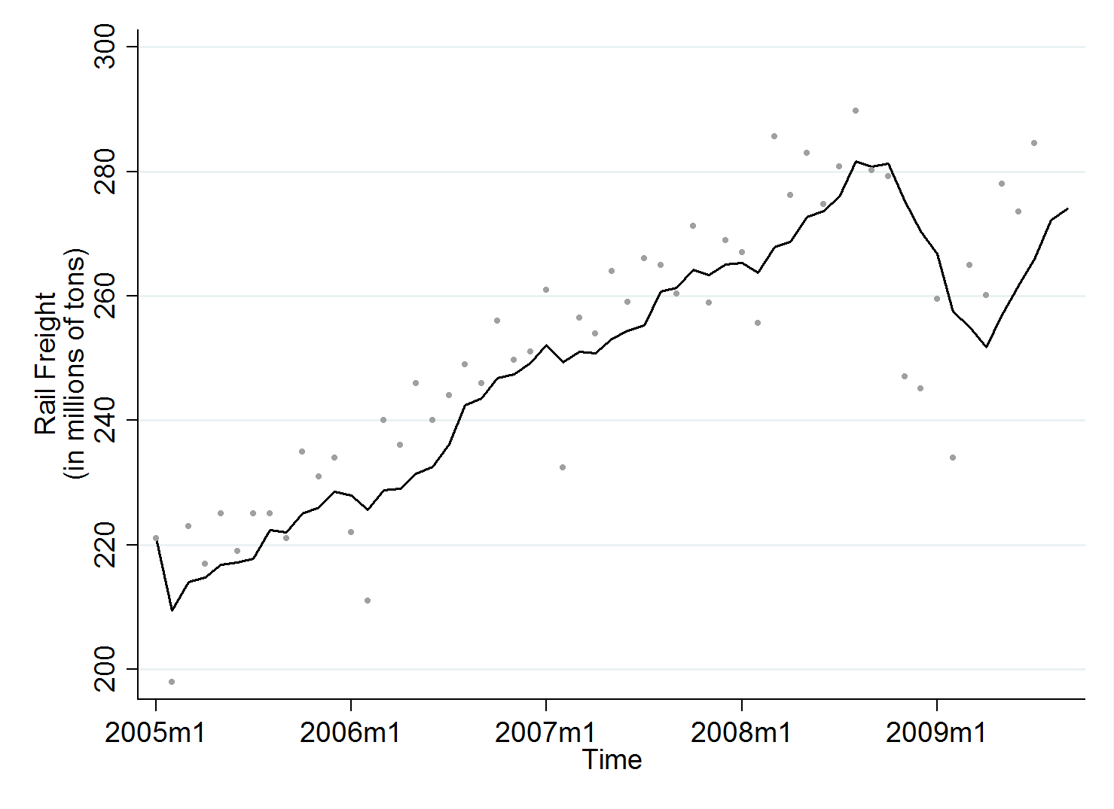

n.b. *Levels*—not growth—of Freight Traffic. Data from the National Bureau of Statistics. The line represents a moving average while the actual values are plotted. Whereas in that figure the line representing exports connects the values of a 3 month moving average of the series, here a six month moving average is used in order to smooth out the large drops in freight traffic at Chinese New Year.

Appendix Figure 4. Provincial GDP – Electricity Production Growth Differential

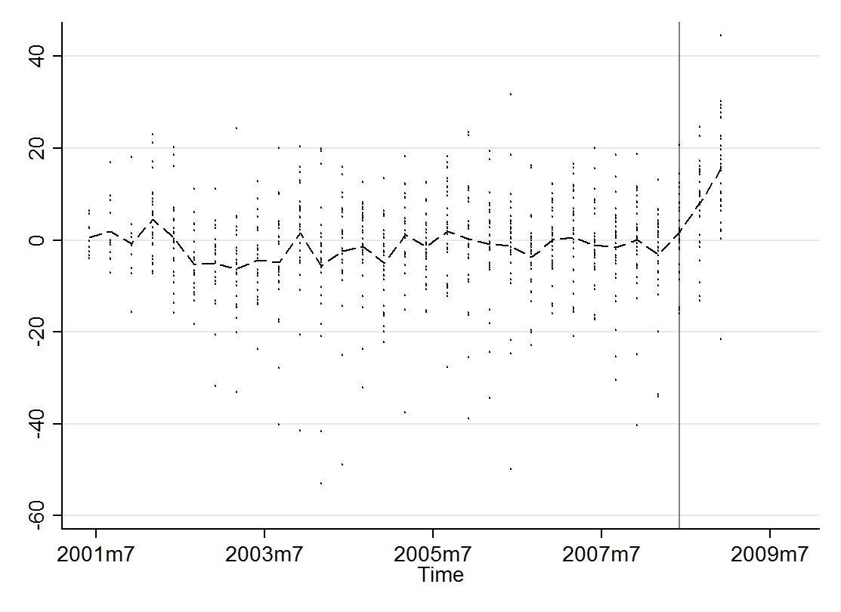

Appendix Figure 5: Map of Provincial Electricity Importers and Exporters



Appendix Figure 6. Map of Inter-Provincial Electricity Infrastructure



n.b. Map depicts Electric Supply and Transmission in China in September 2008. Image source: *China Electricity Monthly*, a report published by the energy consultancy 3E. <http://www.3-eee.net/3Echina/china_index.asp>

1. These GDP shares are calculated from the past decade of data.
2. As this is *not* consumption data, cross-provincial electricity trade could confound the analysis as discussed above.
3. At the national level, the economic growth data in Figure 1 are not decomposed in this manner but rather quarterly weights are assigned based on the data for this decade. This method was deemed inappropriate for the provincial level data as the quarterly weights differ by province but the quarterly GDP amounts needed to determine such weights for each province are not available.
4. Number of items per cell (turnover, lagturnover): (0,0) = 225; (1,0) = 207; (0,1) = 174; (1,1) = 98.