Parties, institutions and the politics of law and order: Online Appendix

Figure A.1: Government positions on law and order
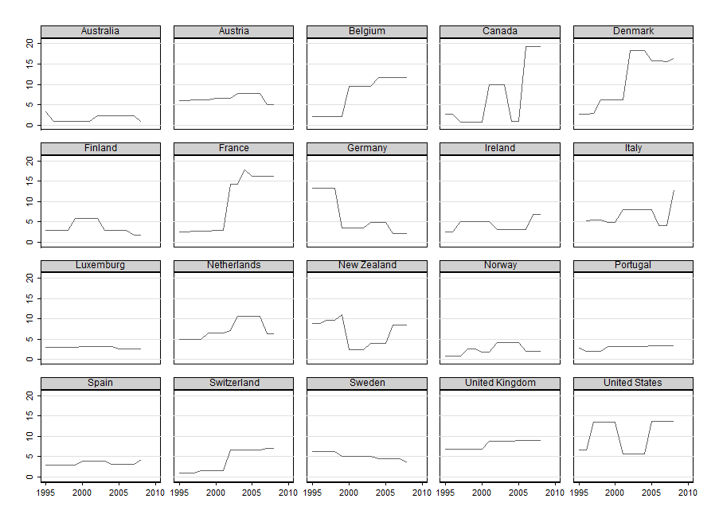
Note: Ideological position of the government on law and order according to the manifesto data set and the cabinet shares of the government parties.

Table A.1: Party position and position of constituency
Party Name | Party position  (Manifesto) | Position of the Constituency (ESS) | Party Name
Belgium
Groen/Ecolo | 4,68 | 6,05 | Groen/Ecolo
SPA/PS | 5,53 | 6,85 | NVA
CD&V/CDH | 8,18 | 6,9 | CD&V/CDH
VLD/MR | 9,4 | 6,92 | SPA/PS
NVA | 13,67 | 7,19 | VLD/MR
Denmark
EL | 2,99 | 3,16 | EL
SD | 5,61 | 4,15 | RV
RV | 5,69 | 5,38 | SF
KF | 7,25 | 5,76 | SD
SF | 7,69 | 5,85 | KF
DF | 9,75 | 6,19 | V
V | 12,62 | 7,06 | DF
EL | 2,99 | 3,16 | EL
Germany
B‘90\Die Grünen | 1,22 | 5,31 | B‘90\Die Grünen
Die Linke\PDS | 1,74 | 6,67 | SPD
FDP | 1,79 | 6,96 | Die Linke\PDS
SPD | 4,15 | 6,99 | FDP
CDU\CSU | 5,83 | 7,09 | CDU\CSU
Spain
PNV | 0,64 | 6,65 | PNV
IU | 1,11 | 7,06 | IU
CiU | 3,24 | 7,67 | PSOE
PSOE | 3,38 | 7,73 | CiU
PP | 6,09 | 8,06 | PP
Sweden
V | 1,02 | 5,43 | V
C | 3,24 | 5,6 | MP
S | 3,82 | 6,34 | C
MP | 4,04 | 6,44 | FP
KD | 5,57 | 6,51 | KD
M | 6,56 | 6,71 | M
FP | 6,72 | 6,75 | S
SD (2010) | 8,82 | 8,39 | SD
United Kingdom
LIB | 5,75 | 7,4 | LIB
CON | 7,93 | 7,42 | LAB
LAB | 8,18 | 7,8 | CON

Note: Party Position Manifesto: Mean of the party positions according to the coded manifestos during the period 1995-2008;
Ideological Position Constituency: Mean for the agreement on the question: “Much harsher sentences for people who break the law” for different groups of voters (discrimination by means of the recall question (“what party did you vote for in the last national election”)). Source: European Social Survey 5 (2010) in different countries (re-scaled on a 1-10 scale).

Table A.2: Variables (see Fig.2), measurement and data sources
Variable | Operationalization | Descriptive statistics | Data Source
Dependent variable
Public Spending on Law and Order | Public Spending in % of GDP | Mean=1.57, SD=0.36, Min=0.74, Max=2.61 | OECD National Accounts Database, Eurostat, national sources
Main independent variable
Ideological Position of Incumbent parties | Mean position of government using the partisan position on law-and-order (Chapel Hill, Manifesto Research Group) weighted by cabinet seats | Manifesto:  Mean=5.76, SD=4.18, Min=0.70, Max=19.34 | Party position:  Manifesto research group  Cabinet Seats: Own calculation
“Big trends”, socio-economic structures and developments
De-industrialisation | Civilian labour force employed in the 3rd sector minus labour force employed in the 1st and 2nd | Mean=39.87, SD=11.97,  Min=2.11, Max=59.56 | OECD Labour force statistics database
Globalisation | Openness of the economy in current prices, measured as total trade (sum of import and export) as a percentage of GDP | Mean=86.68, SD=53.11  Min=22.98, Max=319.55 | Armingeon, et al. 2010
Terror 9/11 | Dummy-variable for terrorist attacks after 2001 | Mean=0.5, SD=0.5  Min=0, Max=1 | Own calculation
Income inequality | Gini index (total population) | Mean=0.29, SD=0.04,  Min=0.21, Max=0.38 | OECD Social and Welfare Statistics
Welfare state retrenchment | Unemployment insurance replacement rate | Mean=0.60; SD=0.14  Min=.27, Max=.80 | Scruggs 2013
Unemployment | Unemployment rate as a percentage of civilian labour force | Mean=6.96, SD=3.284,  Min=1.73, Max=22.96 | Armingeon et al. 2010
Direct societal inputs into the political system
Crime rate | Total crimes registered by the police per inhabitants | Mean=7049, SD=2731,  Min=1939, Max=15004 | Eurostat  European Sourcebook of Crime, (Killias, et al. 2010)
Homicide rate | Total homicides per inhabitants | Mean= 1.61, SD=1.15  Min=0.4, Max=8.1 | UNODC, national sources
Fear of crime | Weighted country aggregates for the “standard fear of crime”-question | Mean=1.99, SD=0.22,  Min=1.53, Max=2.37  (here: mean) | Eurobarometer, European Social Survey, National surveys
Specific political institutions
Media system | 3 types of media systems: liberal, polarized-pluralist, democratic corporatist | Dummy variables | Hallin and Mancini 2004
Institutional constraints | Index of institutional barriers | Mean=2.82, SD=1.20,  Min=1, Max=5 | Schmidt 1996
Corporatism | Degree of Corporatism | Mean=3.05, SD=1.26,  Min=1.25, Max=5 | Siaroff 1999
Party system | Effective number of legislative parties | Mean=3.87, SD=1.50,  Min=1.94, SD=9.07 | Armingeon et al. 2010
Judicial review | Dummy-variable if judicial review | Mean=2.25, SD=1.02,  Min=1, Max=4 | Lijphart 2012
Election of judges | Dummy-variable for countries with direct election of actors in the justice system | Mean=0.05, SD=0,22  Min=0, Max=1 | Own calculation
Broad regime concepts: Welfare state regimes, VoC-approach, type of democracy
Regime type | 4 regime types: Social-democratic, conservative-corporatist, liberal, mediterranean | Dummy variables | Ferrera 1996
Varieties of Capitalism | Coordination Index | Mean=0.56, SD=0.29,  Min=0, Max=1 | Hall and Gingerich 2004
Type of democracy | Executive-parties-dimension (71-96) | Mean=0.32, SD=0.92,  Min=-1.48, Max=1.67 | Lijphart 2012
Budgetary context
Debt ratio (also lagged levels) | Debt ratio in % of GDP | Mean=60.49, SD=26.54,  Min=7.65, Max=135.40 | OECD National Accounts Database
Budget balance (also lagged levels) | Budget balance in % of GDP | Mean=-0.12, SD=4.01  Min=-9.67, Max=18.77 | OECD National Accounts Database
Control for automatic influence
GDP growth rate | GDP growth | Mean=2.94, SD=1.88  Min=-3, Max=11.5 | Armingeon et al. 2010

Table A.3: Further regression models using „underlying variables“
 | (1) | (2)
Law-and-order spending t-1 (LDV) | 0.991*** | 0.971***
 | (68.30) | (81.85)
Ideological position government | 0.000721 | 0.000488
 | (1.18) | (0.60)
Election of judges | 0.0224*
 | (1.91)
Judicial review | -0.00720***
 | (-2.70)
Effective no. of parties |  | -0.00119
 |  | (-0.51)
Institutional constraints |  | -0.00517**
 |  | (-2.30)
Media system democratic-corporat. | -0.0344***
 | (-5.15)
Media system polarized-pluralist. | -0.0121
 | (-0.80)
Corporatism |  | -0.00373
 |  | (-0.98)
Crime rate | 0.00000181
 | (1.47)
Homicide rate |  | 0.00888***
 |  | (2.68)
Fear of crime |  | 0.0932***
 |  | (4.47)
Budget balance t-2 | 0.00131 | 0.00229*
 | (0.95) | (1.73)
Deindustrialisation | -0.0000646 | 0.000272
 | (-0.17) | (0.75)
Unemployment | -0.00171 | -0.00375***
 | (-1.22) | (-3.01)
Dummy Terror 9/11 | -0.0133 | -0.0133
 | (-1.36) | (-1.30)
Economic growth | -0.0140*** | -0.0140***
 | (-5.06) | (-6.92)
Constant | 0.0985*** | -0.0565
 | (2.66) | (-0.94)
R² | 0.972 | 0.977
N | 244 | 263

Table A.4: Regression equations for interaction effects
 | (1) | (2) | (3)
Law-and-order spending t-1 (LDV) | 0.963*** | 0.976*** | 0.975***
 | (74.63) | (50.81) | (51.02)
Ideological position government | 0.00338 | 0.00296 | 0.00308
 | (1.64) | (1.52) | (1.13)
Judicial review | -0.00146
 | (-0.30)
Judicial review  *ideological position | -0.000943
 | (-1.32)
Institutional constraints |  | -0.00109 | -0.00564**
 |  | (-0.21) | (-2.20)
Institutional constraints  *ideological position |  | -0.000805
 |  | (-1.26)
Debt ratio |  | -0.000416** | -0.000257
 |  | (-2.04) | (-0.92)
Debt ratio  *ideological position |  |  | -0.0000384
 |  |  | (-0.97)
Election of judges | 0.0401**
 | (2.34)
Effective no. of parties | -0.00149 | 0.00195 | 0.00253
 | (-0.49) | (0.88) | (1.19)
Crime rate | 0.00000176
 | (1.05)
Homicide rate |  | 0.0112*** | 0.0102***
 |  | (3.01) | (2.89)
Fear of crime | 0.0786*** | 0.0735*** | 0.0770***
 | (4.06) | (3.26) | (3.35)
Budget balance t-2 | 0.00180
 | (1.28)
Deindustrialisation | 0.000410
 | (1.10)
Openness economy |  | 0.0000714 | 0.0000742
 |  | (0.72) | (0.75)
Inequality (gini) | 0.217 | 0.137 | 0.136
 | (1.64) | (1.13) | (1.10)
Unemployment | -0.00161 | -0.00284* | -0.00282*
 | (-1.10) | (-1.94) | (-1.91)
Dummy terror 9/11 | -0.0163 | -0.0123 | -0.0101
 | (-1.64) | (-1.16) | (-0.94)
Economic growth | -0.0125*** | -0.0151*** | -0.0151***
 | (-5.46) | (-5.95) | (-5.91)
Constant | -0.127*** | -0.0816** | -0.0871**
 | (-3.51) | (-2.56) | (-2.13)
R² | 0.977 | 0.977 | 0.977
N | 257 | 263 | 263
Note: t statistics in parentheses; * p < .1, ** p < .05, *** p < .01

References
Armingeon, Klaus, Sarah Engler, Potolidis Panajotis, Marlène Gerber, and Philipp Leimgruber. 2010. Comparative Political Data Set 1960-2008.
Ferrera, Maurizio. 1996. The “Southern” Model of Welfare in Social Europe. Journal of European Social Policy 6: 17-37.
Hall, Peter, and D.W. Gingerich. 2004. Varieties of Capitalism and Institutional Complementarities in the Macroeconomy: An Empirical Analysis (MPIfG Discussion Paper 04/5). Cologne: Max Planck Institute for the Study of Societies.
Hallin, Daniel C., and Paolo Mancini. 2004. Comparing Media Systems. Cambridge: Cambridge University Press.
Killias, Martin, Marcelo F. Aebi, Bruno Aubusson de Cavarlay, Gordon Barclay, Beata Gruszcynska, Stefan Harrendorf, Markku Heiskanen, Vasilika Hysi, Jörg-Martin Jehle, Olena Shostko, Paul Smit, and Annveig Dorisdottir. 2010. European Sourcebook of Crime and Criminal Justice Statistics - 2010. Den Haag: WODC.
Lijphart, Arend. 2012. Patterns of Democracy. New Haven/London: Yale University Press.
Schmidt, Manfred G. 1996. When parties matter: A review of the possibilities and limits of partisan influence on public policy. European Journal of Political Research 30: 155-183.
Scruggs, Lyle. 2013. Welfare State Entitlements Data Set: A Comparative Institutional Analysis of Eighteen Welfare States, Version 2.0. http://cwed2.org/ (8.5.2013)
Siaroff, Alan. 1999. Corporatism in 24 industrial democracies: Meaning and measurement. European Journal of Political Research 36: 275-305.

