APPENDIX A: DATA ENVELOPMENT ANALYSIS

In Data Envelopment Analysis (DEA), observations lying on the convex frontier of the sample are extracted using a simple algorithm. There are a number of algorithms in use today for the generation of convex hulls. One of the simplest algorithms is the QUICKHULL algorithm.[1] To illustrate this in the context of the growth-instability data, the axes of the growth-instability plots such as those shown in Figures 3b and 4 are transposed so that growth is on the horizontal axis and instability is on the vertical axis. In the first step, the scatter plot is divided into two parts by the line, say AB, joining the points with the minimal (point A) and maximal (point B) values in the x or growth coordinate (Figure A1a). In the second step, for the lower subsample, the point C in the subsample below the line AB and with the farthest distance from it is selected (Figure A1b). In the third step, the second step is applied to each of the two subsamples below the lines AC and CB (Figure A1c). This procedure is applied recursively until there are no points below the lines generated. The lower part of the convex hull is the concatenation of the points identified by this algorithm.[2] In order to generate a sufficient number of observations to estimate the shape of the hull, upon generating the convex hull, the points identified are deleted and a second hull, consisting of the layer of points which lies inside the first hull, is generated. This algorithm is repeatedly applied to the data until a predetermined number of observations, layers of data, or fraction of the original sample is extracted. Figures B2 and B3 (below) are plots of convex hulls obtained using this method. DEA is the preferred method of analysis for the estimation of frontier in a number of disciplines. Because the results of the public deliberation model predict a convex frontier, this method is appropriate for the estimation of the shape of the frontier.







APPENDIX B: GROWTH-INSTABILITY DATA AND DATA ENVELOPMENT ANALYSIS HULLS: TWO-DECADE DATA

APPENDIX C: FRONTIER ESTIMATES USING DATA ENVELOPMENT ANALYSIS

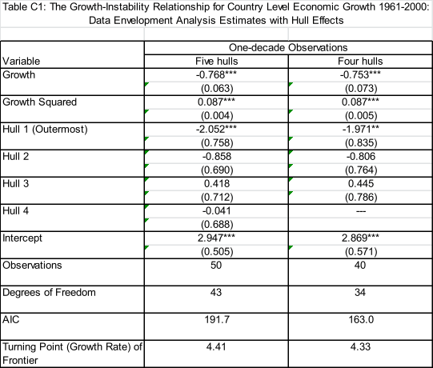

*** p<0.01;**p<0.05;*p<0.10

APPENDIX D: STOCHASTIC FRONTIER ESTIMATION

Frontier Estimation using Stochastic Frontier Estimation

Stochastic frontier estimation (SFE) is the second method that we use to test for and estimate the convex growth-instability frontier predicted by the public deliberation model. SFE uses the assumption of a one-sided error (hence the frontier interpretation). In other words, the error term is assumed to be distributed such that it is always 0 on the “outside” of the frontier, and can be non-zero on the “inside” of the frontier. The stochastic frontier model is written as

.

Here,  is the standard deviation of the growth rate of economy i over time period (for our purposes, decade) period t,  is the average growth rate of economy i over time period t, and  are curvature parameters of the frontier,  is an i.i.d. random variable with normal distribution, mean 0, and standard deviation , and is a non-negative random variable with a truncated (at 0) normal distribution, mean , and standard deviation . Further, the mean of this distribution  where the vector contains the factors hypothesized to affect the horizontal distance of an observation from the frontier (Figure 3), and is a vector of parameters. This method is based on Battese and Coelli (1995), and uses the FRONTIER software package (Coelli 1996).

Because stochastic frontier estimation is not based on any a priori convexity property of the data being analyzed, it can also be used to test hypotheses about the convexity of the frontier. The country-specific and time effects together represent growth-adjusted volatility, and their relationship with the hypothesized drivers of these effects are estimated after the estimation of the curvature of the frontier.

Table D1 contains the results of this analysis for the one- and two-decade data. The frontier estimate is convex. In sum, there is strong evidence of a convex growth-instability frontier for economic growth, as predicted by the model of informal public deliberation. This concludes our test of the first prediction of the model using SFE.

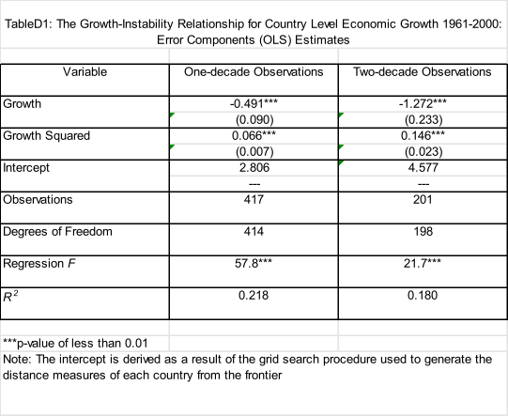

APPENDIX E: ROBUSTNESS CHECKS

Table E1: Models using the Dependent Variable Generated by SFE and the PARCOMP Residual Variable (Authoritarian Regimes Only)

|  |  |  |  |  |  |  |  |
| --- | --- | --- | --- | --- | --- | --- | --- |
|  | | Frontier Distance (Stochastic Frontier Estimation: 1-decade observations) | | | | | |
|  | Intercept | 5.85*** | -0.99 | 3.95* | -1.90 | 3.61* | -1.22 |
| 2.81 | -0.12 | 1.87 | -0.22 | 1.82 | -0.15 |
| Political variables | Allowance of public deliberation | -2.44*** | -4.02** | --- | --- | --- | --- |
| -3.09 | -2.61 |  |  |  |  |
| Exec Cnstrt | --- | --- | -0.47 | -0.72 | --- | --- |
|  |  | -1.17 | -0.85 |  |  |
| Allowance of public deliberation (residual) | --- | --- | --- | --- | -2.93 | -7.42** |
|  |  |  |  | -1.48 | -2.47 |
| Political Control Variable | Veto players | --- | 4.55 | --- | 4.30 | --- | 3.05 |
|  | 0.83 |  | 0.69 |  | 0.58 |
| Political Parties in the Legislature | --- | 0.96 | --- | 0.05 | --- | 0.32 |
|  | 0.92 |  | 0.04 |  | 0.33 |
| Standard Control Variables | GDP per capita | 0.23 | -0.24 | 0.18 | -0.50 | 0.11 | -0.00 |
| 0.82 | -0.26 | 0.61 | -0.51 | 0.35 | -0.00 |
| Primary Enrollment | --- | 0.02 | --- | -0.25 | --- | -0.89 |
|  | 0.01 |  | -0.15 |  | -0.53 |
| Openness (Imports + Exports % of GDP, logged) | --- | 1.56 | --- | 1.37 | --- | 1.34 |
|  | 1.07 |  | 0.88 |  | 0.90 |
| Sectoral Diversity | --- | 12.81 | --- | 15.82 | --- | 10.15 |
|  | 1.24 |  | 1.44 |  | 0.96 |
| Civil War | --- | 3.05 | --- | 3.81 | --- | 3.65 |
|  |  | 0.96 |  | 1.14 |  | 1.13 |
| Fuel Exports (% GDP, logged) | --- | -0.05 | --- | 0.06 | --- | -0.10 |
|  |  | -0.21 |  | 0.24 |  | -0.40 |
|  | Number of observations | 110 | 58 | 110 | 58 | 110 | 58 |
| Akaike's Information Criterion | 576 | 287.6 | 585 | 294.6 | 583.0 | 287.1 |

***p<0.01;**p<0.05;*p<0.10

Table E2: Models using the Civil Society Index (Full Sample)

|  |  |  |  |  |  |  |  |  |  |
| --- | --- | --- | --- | --- | --- | --- | --- | --- | --- |
|  | | | Dependent Variable | | | | | |  |
| Frontier Distance (Data Envelopment Analysis: 1-decade observations, 5-hull Model) | | | Frontier Distance (Stochastic Frontier Estimation: 1-decade observations) | | |  |
| Intercept | | | 4.09** | | | 2.44 | | |  |
| 2.48 | | | 1.37 | | |  |
| Civil Society Index | | | -14.17* | | | -22.57** | | |  |
| -1.80 | | | -2.72 | | |  |
| GDP per capita | | | -0.05 | | | 0.10 | | |  |
| -0.24 | | | 0.43 | | |  |
| Number of observations | | | 28 | | | 28 | | |  |
| R-Squared | | | 0.15 | | | 0.21 | | |  |
|  |  | | | |  | | | | |
| t-statistics in italics | |  | |  | | |  |  | |

***p<0.01;**p<0.05;*p<0.10

1. See Edelsbrunner (1987) for a broad description of computational geometry, including the computation of convex hulls. Barber, Dobkin, and Huhdanpaa (1996) is a recent example of advances in the computation of convex hulls.
2. The analogous algorithm may be applied to the subsample above the line AB to yield the upper part of the convex hull. Because these points do not lie on the growth-instability frontier, they are of no use for the estimation of the shape of the frontier using this method.