Supplementary Appendix for
“When Do Governments Resort to Election Violence?”
Version: September 28, 2012

This appendix provides supplementary information not included in the published draft. Supplementary Figure 1 shows the simulated predictions from the robustness checks included in Tables 2 and 3 of the published draft. Supplementary Figure 2 show estimates of the effect of Victory Uncertain and Polling Unfavorable on Pre-Election violence for each type of election. These estimates are different from those shown in the published draft, which are instead limited to elections in which the office of the incumbent is contested, regardless of whether an election is Parliamentary or Presidential. Supplementary Tables 2 and 3 show the estimates used to make Supplementary Figure 2. The final table is a list of countries included in the sample, along with summary information on the number of violent elections.

Supplementary Figure 1: Effect of Electoral Uncertainty on Pre-Election Violence Robustness Checks
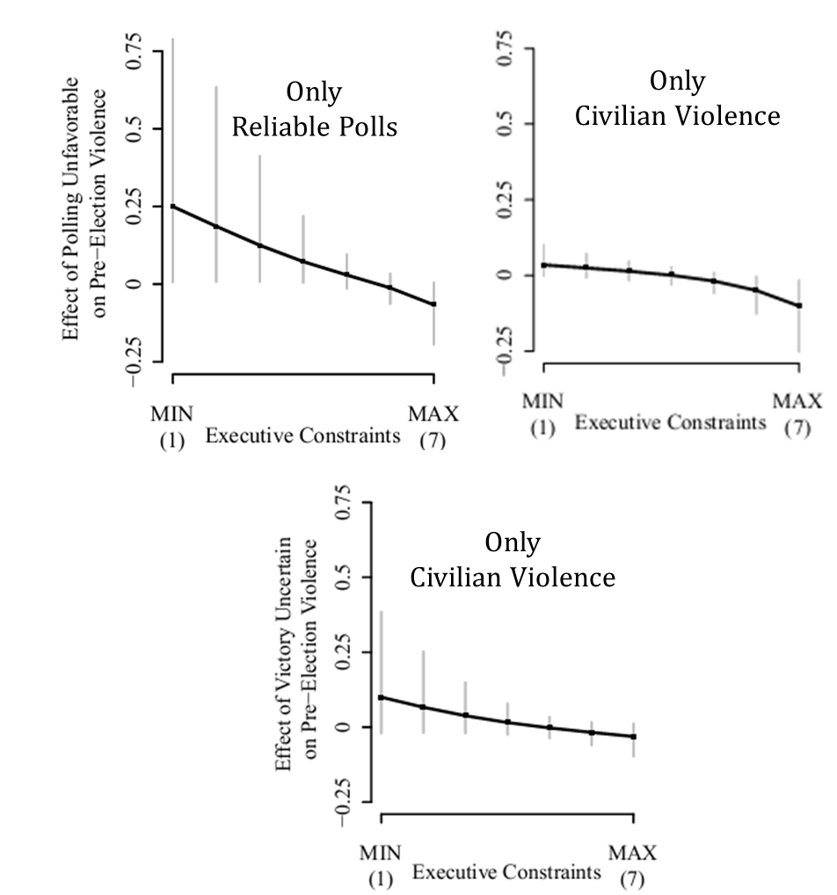
Shows the simulated effect of electoral uncertainty (a change from 0 to 1) on the probability of Pre-Election Violence for each value of Executive Constraints. Vertical lines indicate the 95% confidence interval.

Supplementary Figure 2: The Effect of Electoral Uncertainty on Pre-Election Violence by Election Type
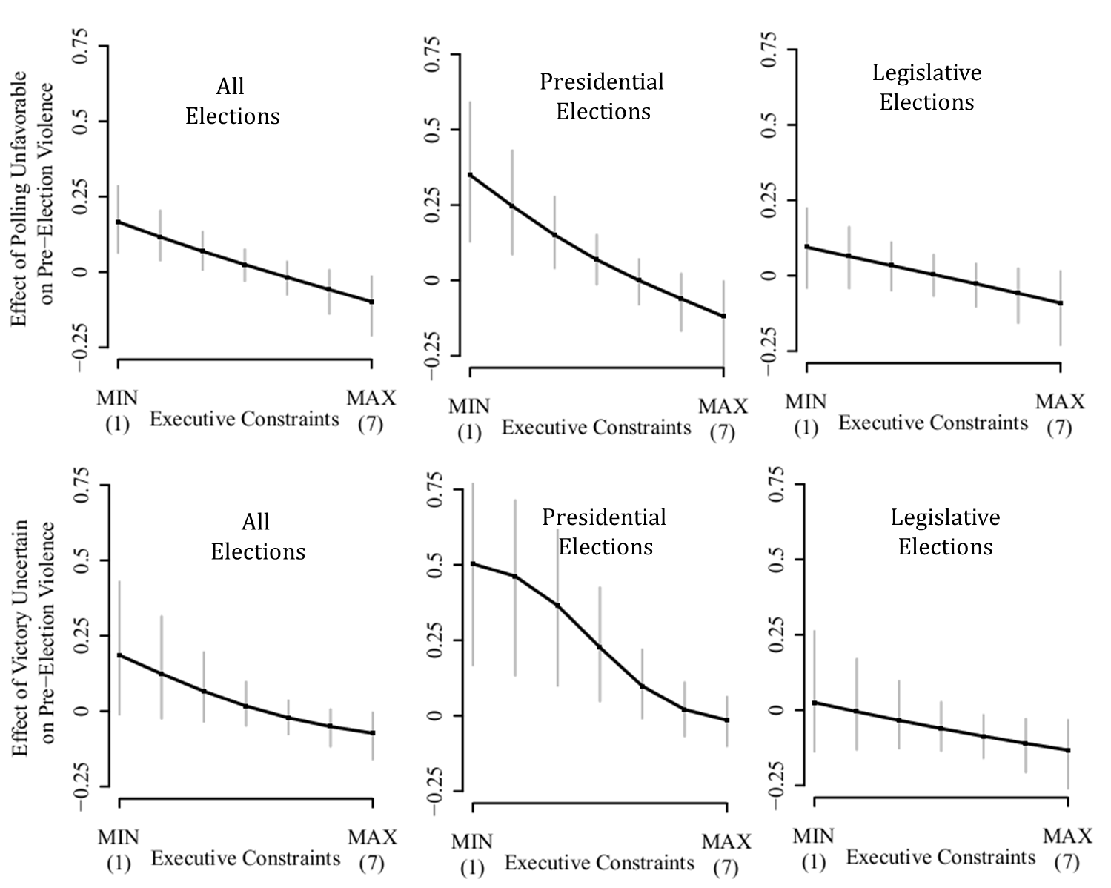
Shows the simulated effect of electoral uncertainty (a change from 0 to 1) on the probability of Pre-Election Violence for each value of Executive Constraints by type of election. Vertical lines indicate the 95% confidence interval. Estimated using a logit model with country random effects and controls for Physical Integrity (avg), Political Competitiveness (avg), Executive Recruitment (avg), Population (log), GDP (log), Leader Tenure, Leader Age, Civil War, Electoral Fraud and Demonstrations. The coefficient estimates for these figures are shown in Supplementary Tables 1 and 2.

Supplementary Table 1: Logit Estimates of the Effect of Unfavorable Polls on Pre-Election Violence by Election Type
 | (1)  All Elections | (2)  Presidential Elections | (3)  Legislative Elections
Unfavorable Polls | 1.70** | 3.27* | 1.04
 | 0.65 | 1.27 | 0.82
Polling * Exec. Const. | -0.37** | -0.66* | -0.25
 | 0.13 | 0.26 | 0.16
Executive Constraints | 0.15 | 0.21 | 0.11
 | 0.15 | 0.26 | 0.18
Physical Integrity (avg) | -0.42** | -0.52** | -0.36**
 | 0.08 | 0.14 | 0.09
Political Competitiveness (avg) | -0.02 | 0.01 | 0.00
 | 0.07 | 0.13 | 0.08
Executive Recruitment (avg) | 0.15 | 0.08 | 0.12
 | 0.11 | 0.20 | 0.12
Population (log) | 0.63** | 0.21 | 0.83**
 | 0.22 | 0.35 | 0.24
GDP (log) | -0.47** | -0.23 | -0.62**
 | 0.16 | 0.25 | 0.17
Leader Tenure | 0.00 | -0.00 | 0.01
 | 0.01 | 0.01 | 0.01
Leader Age | 0.06 | 0.17 | 0.02
 | 0.12 | 0.21 | 0.13
Civil War | 0.42** | 0.54+ | 0.31+
 | 0.14 | 0.28 | 0.16
Electoral Fraud | 1.53** | 1.52** | 1.38**
 | 0.27 | 0.54 | 0.32
Demonstrations | 0.09* | 0.10 | 0.07*
 | 0.03 | 0.09 | 0.04
Observations | 1,168 | 379 | 778
Log Likelihood | -458.3 | -158.6 | -315.4
+signiﬁcant at 10%; *signiﬁcant at 5%; **signiﬁcant at 1%. Standard errors are in parentheses. Model 1 includes all elections, regardless of type. Model 2 contains only presidential elections. Model 3 contains only legislative elections (including Parliamentary elections).

Supplementary Table 2: Logit Estimates of the Effect of Victory Uncertain on Pre-Election Violence by Election Type
 | (1)  All Elections | (2)  Presidential Elections | (3)  Legislative Elections
Victory Uncertain | 1.28 | 3.35* | 0.27
 | 0.82 | 1.54 | 1.03
Uncertain * Exec. Const. | -0.29+ | -0.53+ | -0.19
 | 0.15 | 0.29 | 0.19
Executive Constraints | -0.04 | -0.31 | 0.08
 | 0.12 | 0.19 | 0.14
Physical Integrity (avg) | -0.41** | -0.43** | -0.38**
 | 0.08 | 0.14 | 0.09
Political Competitiveness (avg) | -0.03 | 0.03 | -0.03
 | 0.08 | 0.13 | 0.09
Executive Recruitment (avg) | 0.11 | 0.04 | 0.09
 | 0.12 | 0.19 | 0.13
Population (log) | 0.54* | 0.05 | 0.72**
 | 0.22 | 0.34 | 0.23
GDP (log) | -0.34* | -0.12 | -0.48**
 | 0.15 | 0.24 | 0.16
Leader Tenure | 0.01 | -0.00 | 0.01+
 | 0.01 | 0.01 | 0.01
Leader Age | -0.03 | 0.04 | -0.05
 | 0.12 | 0.23 | 0.14
Civil War | 0.36* | 0.39 | 0.27+
 | 0.14 | 0.28 | 0.16
Electoral Fraud | 1.50** | 1.42** | 1.28**
 | 0.29 | 0.54 | 0.34
Demonstrations | 0.07* | 0.07 | 0.06
 | 0.03 | 0.10 | 0.04
Observations | 1,029 | 340 | 682
Log Likelihood | -404.3 | -141.6 | -272.6
+signiﬁcant at 10%; *signiﬁcant at 5%; **signiﬁcant at 1%. Standard errors are in parentheses. Model 1 includes all elections, regardless of type. Model 2 contains all presidential elections. Model 3 contains legislative elections.
List of Countries in the Sample

Country | Number of Elections | Cases of Pre-Election Violence | Cases of Protest | Cases of Post-Election Violence
AFGHANISTAN | 3 | 2 | 0 | 0
ALBANIA | 19 | 13 | 6 | 4
ALGERIA | 11 | 9 | 6 | 5
ANGOLA | 3 | 3 | 2 | 2
ARGENTINA | 22 | 3 | 2 | 2
ARMENIA | 12 | 2 | 5 | 2
AUSTRALIA | 10 | 0 | 0 | 0
AUSTRIA | 15 | 0 | 1 | 0
AZERBAIJAN | 13 | 6 | 5 | 2
BAHRAIN | 3 | 0 | 0 | 0
BANGLADESH | 10 | 9 | 6 | 1
BELARUS | 13 | 6 | 2 | 2
BELGIUM | 8 | 0 | 0 | 0
BENIN | 16 | 2 | 3 | 0
BHUTAN | 2 | 0 | 0 | 0
BOLIVIA | 14 | 2 | 0 | 0
BOSNIA-HERZEGOVINA | 9 | 2 | 0 | 0
BOTSWANA | 5 | 0 | 0 | 0
BRAZIL | 15 | 0 | 0 | 0
BULGARIA | 17 | 0 | 2 | 0
BURKINA FASO | 8 | 1 | 0 | 0
BURUNDI | 6 | 0 | 1 | 0
CAMBODIA | 6 | 3 | 1 | 0
CAMEROON | 11 | 4 | 4 | 2
CANADA | 8 | 0 | 0 | 0
CENTRAL AFRICAN REPUBLIC | 16 | 5 | 2 | 1
CHAD | 8 | 0 | 0 | 0
CHILE | 12 | 1 | 0 | 0
COLOMBIA | 19 | 14 | 0 | 0
COMORO ISLAND | 20 | 9 | 5 | 0
COSTA RICA | 15 | 0 | 0 | 0
CROATIA | 17 | 7 | 0 | 0
CUBA | 8 | 3 | 0 | 0
CYPRUS | 17 | 1 | 1 | 0
CZECH REPUBLIC | 20 | 0 | 1 | 1
DEMOCRATIC REPUBLIC OF THE CONGO | 6 | 5 | 2 | 2
DENMARK | 10 | 0 | 0 | 0
DJIBOUTI | 13 | 3 | 1 | 1
DOMINICAN REPUBLIC | 16 | 10 | 6 | 2
EAST GERMANY | 3 | 0 | 0 | 0
EAST TIMOR | 5 | 0 | 2 | 0
ECUADOR | 26 | 0 | 0 | 0
EGYPT | 19 | 14 | 9 | 5
EL SALVADOR | 16 | 7 | 0 | 0
EQUATORIAL GUINEA | 9 | 9 | 3 | 0
ESTONIA | 8 | 0 | 0 | 0
ETHIOPIA | 7 | 5 | 1 | 1
FIJI | 7 | 1 | 0 | 0
FINLAND | 15 | 0 | 0 | 0
FRANCE | 23 | 0 | 1 | 1
GABON | 17 | 4 | 4 | 1
GAMBIA | 12 | 4 | 0 | 0
GEORGIA | 13 | 4 | 1 | 0
GERMANY | 7 | 0 | 0 | 0
GHANA | 12 | 7 | 3 | 0
GREECE | 10 | 0 | 0 | 0
GUATEMALA | 22 | 19 | 2 | 2
GUINEA | 6 | 5 | 1 | 1
GUINEA BISSAU | 10 | 3 | 1 | 1
GUYANA | 5 | 4 | 3 | 1
HAITI | 21 | 16 | 12 | 8
HONDURAS | 14 | 2 | 1 | 0
HUNGARY | 11 | 3 | 0 | 0
INDIA | 23 | 7 | 5 | 2
INDONESIA | 8 | 3 | 1 | 1
IRAN | 24 | 8 | 3 | 1
IRAQ | 8 | 5 | 2 | 2
IRELAND | 11 | 1 | 0 | 0
ISRAEL | 10 | 1 | 0 | 0
ITALY | 8 | 0 | 0 | 0
IVORY COAST | 10 | 7 | 1 | 1
JAMAICA | 6 | 2 | 2 | 1
JAPAN | 15 | 0 | 0 | 0
JORDAN | 5 | 1 | 0 | 0
KAZAKHSTAN | 13 | 7 | 0 | 0
KENYA | 13 | 10 | 6 | 4
KUWAIT | 9 | 1 | 1 | 0
KYRGYZSTAN | 11 | 8 | 5 | 2
LAOS | 5 | 0 | 0 | 0
LATVIA | 5 | 1 | 0 | 0
LEBANON | 14 | 2 | 0 | 0
LESOTHO | 4 | 1 | 2 | 2
LIBERIA | 7 | 2 | 2 | 0
LITHUANIA | 16 | 0 | 0 | 0
MACEDONIA | 19 | 1 | 8 | 0
MADAGASCAR | 14 | 5 | 4 | 3
MALAWI | 9 | 6 | 5 | 1
MALAYSIA | 7 | 2 | 1 | 1
MALI | 19 | 3 | 5 | 4
MAURITANIA | 13 | 8 | 1 | 1
MAURITIUS | 7 | 0 | 0 | 0
MEXICO | 14 | 2 | 7 | 1
MOLDOVA | 8 | 2 | 1 | 0
MONGOLIA | 12 | 1 | 2 | 1
MONTENEGRO | 1 | 0 | 1 | 0
MOROCCO | 5 | 1 | 0 | 0
MOZAMBIQUE | 7 | 1 | 0 | 0
MYANMAR | 4 | 1 | 1 | 1
NAMIBIA | 6 | 0 | 0 | 0
NEPAL | 7 | 4 | 0 | 0
NETHERLANDS | 9 | 0 | 0 | 0
NEW ZEALAND | 10 | 0 | 0 | 0
NICARAGUA | 10 | 2 | 0 | 0
NIGER | 15 | 3 | 1 | 1
NIGERIA | 13 | 9 | 7 | 5
NORTH KOREA | 5 | 0 | 0 | 0
NORWAY | 7 | 0 | 0 | 0
OMAN | 2 | 0 | 0 | 0
PAKISTAN | 7 | 5 | 2 | 2
PANAMA | 11 | 2 | 4 | 2
PAPUA NEW GUINEA | 6 | 4 | 1 | 0
PARAGUAY | 16 | 6 | 0 | 0
PERU | 17 | 6 | 3 | 0
PHILIPPINES | 14 | 13 | 11 | 4
POLAND | 16 | 2 | 0 | 0
PORTUGAL | 13 | 0 | 0 | 0
REPUBLIC OF THE CONGO | 14 | 6 | 6 | 6
ROMANIA | 17 | 3 | 0 | 0
RUSSIA | 14 | 5 | 0 | 0
RWANDA | 8 | 2 | 0 | 0
SENEGAL | 12 | 4 | 2 | 2
SIERRA LEONE | 11 | 5 | 0 | 0
SINGAPORE | 8 | 2 | 0 | 0
SLOVAKIA | 8 | 0 | 0 | 0
SLOVENIA | 11 | 0 | 0 | 0
SOMALIA | 2 | 0 | 0 | 0
SOUTH AFRICA | 7 | 4 | 3 | 3
SOUTH KOREA | 14 | 2 | 2 | 2
SOUTH YEMEN | 1 | 0 | 0 | 0
SPAIN | 8 | 3 | 0 | 0
SRI LANKA | 11 | 8 | 1 | 0
SUDAN | 8 | 3 | 0 | 0
SWAZILAND | 5 | 0 | 1 | 0
SWEDEN | 8 | 0 | 0 | 0
SWITZERLAND | 7 | 0 | 0 | 0
SYRIA | 12 | 1 | 1 | 1
TAIWAN | 16 | 1 | 1 | 0
TAJIKISTAN | 10 | 7 | 0 | 0
TANZANIA | 10 | 0 | 3 | 0
THAILAND | 15 | 5 | 4 | 1
TOGO | 13 | 5 | 4 | 1
TRINIDAD AND TOBEGO | 9 | 0 | 0 | 0
TUNISIA | 10 | 8 | 0 | 0
TURKEY | 8 | 4 | 0 | 0
TURKMENISTAN | 8 | 2 | 0 | 0
UGANDA | 7 | 6 | 0 | 0
UKRAINE | 18 | 6 | 3 | 0
UNITED KINGDOM | 6 | 0 | 0 | 0
UNITED STATES | 20 | 0 | 0 | 0
URUGUAY | 11 | 0 | 0 | 0
UZBEKISTAN | 10 | 6 | 1 | 1
VENEZUELA | 14 | 1 | 2 | 2
VIETNAM | 7 | 0 | 0 | 0
YEMEN | 11 | 2 | 0 | 0
YUGOSLAVIA | 17 | 3 | 4 | 1
ZAMBIA | 15 | 2 | 3 | 0
ZIMBABWE | 12 | 11 | 2 | 2

