Web Appendix: Model Fits for Alternative Models
for

Do British Party Politics Exhibit Cycles?

Samuel Merrill, III, Bernard Grofman, and Thomas L. Brunell

Figure A1. Model Fit for Smoothed Share of All-Party Seats for Equally-spaced Time Points: United Kingdom 1832-2004

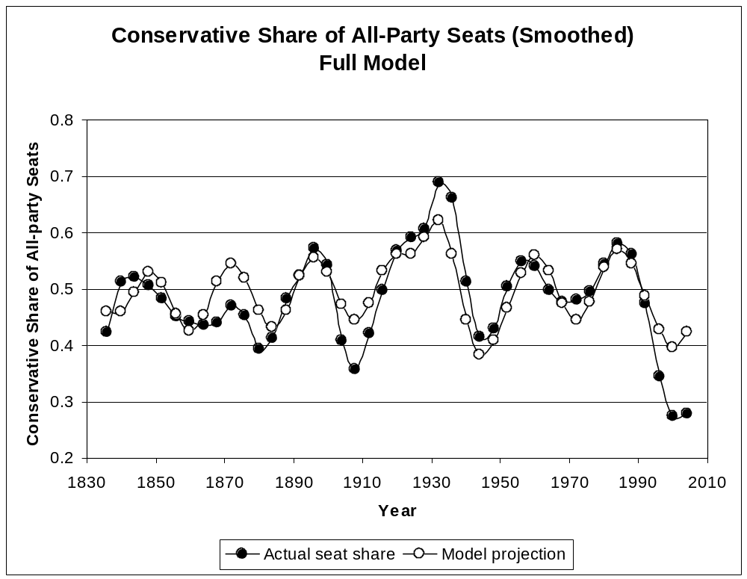

Figure A2. Model Fit for Smoothed Seat Share for a Reduced Model without Dummy Transition Variable: United Kingdom 1832-2004

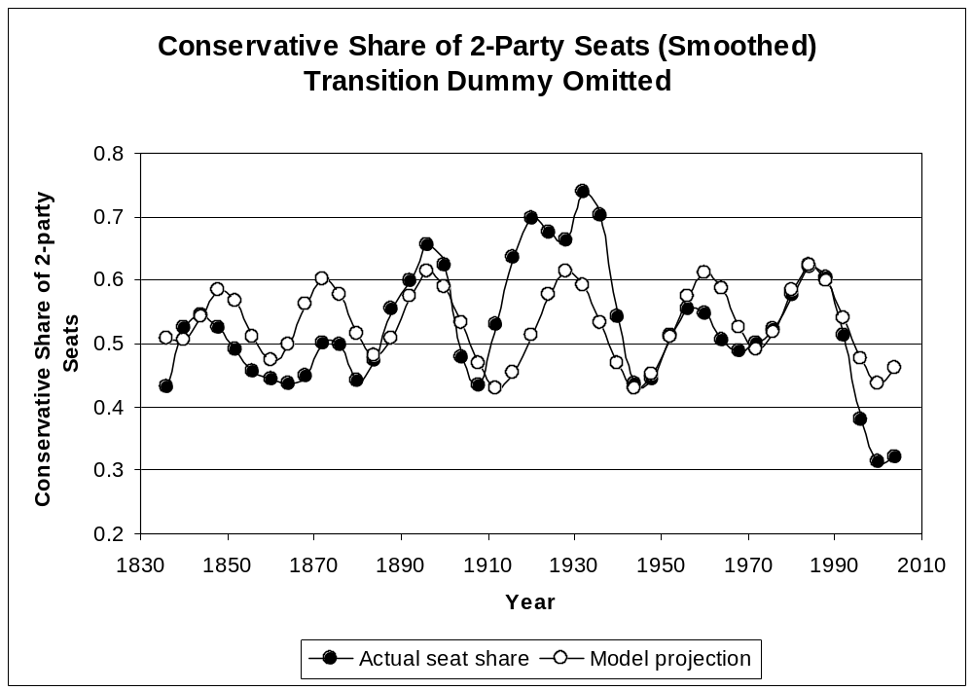
Figure A3. Comparison of Public Preference Estimates from Bartle et al. and Model Projections of the Median Voter Locations: 1950-2005

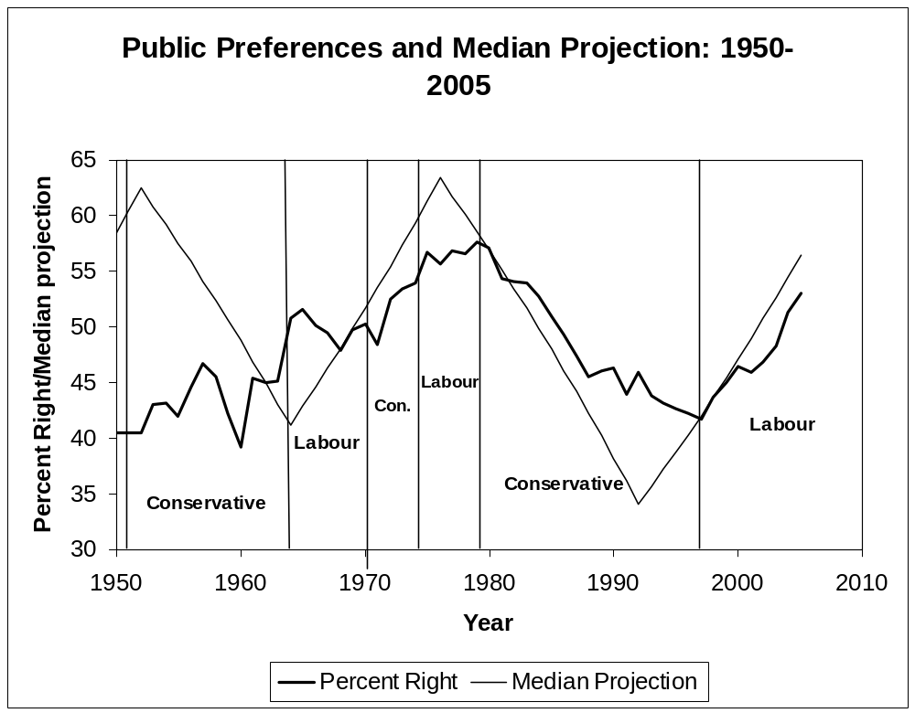

Source: Percent Right is from Bartle, Dellepiane, and Stimson (Bartle et al., ‘The Moving Centre’) and personal communication from John Bartle. Percent “Right” is the percent of “Right” preferences out of the total of “Left” and “Right” preferences on domestic issues, scaled using the Dyad Ratios algorithm (Stimson, Public Opinion in America). Periods of party control of the government are indicated. The projected median voter is projected from our voter-party interaction model fitted to the data for 1832-2005 (unsmoothed).

