Supplemental Table 1: Association between PUFA and Depression by Sex Interaction
 | BDI *Sex Interaction
Fatty Acid | Unadjusted p-value | Adjusted p-value^{b}
Diet EPAª | 0.016 | 0.017
Diet DHAª | 0.008 | 0.008
RBC EPA | 0.541 | 0.562
RBC DHA | 0.008 | 0.007
RBC EPA + DHA | 0.010 | 0.009
RBC Totaln3PUFA | 0.124 | 0.088
ª Energy adjusted
^{b} Controlling for age, age first homeless, and months without shelter

Supplemental Table 2: Association between PUFA and Anxiety by Sex Interaction
 | BAI *Sex Interaction
Fatty Acid | Unadjusted p-value | Adjusted p-value^{b}
Diet EPAª | 0.401 | 0.651
Diet DHAª | 0.324 | 0.582
RBC EPA | 0.558 | 0.714
RBC DHA | 0.203 | 0.403
RBC EPA + DHA | 0.196 | 0.447
RBC Totaln3PUFA | 0.778 | 0.906
ª Energy adjusted
^{b} Controlling for age, age first homeless, and months without shelter

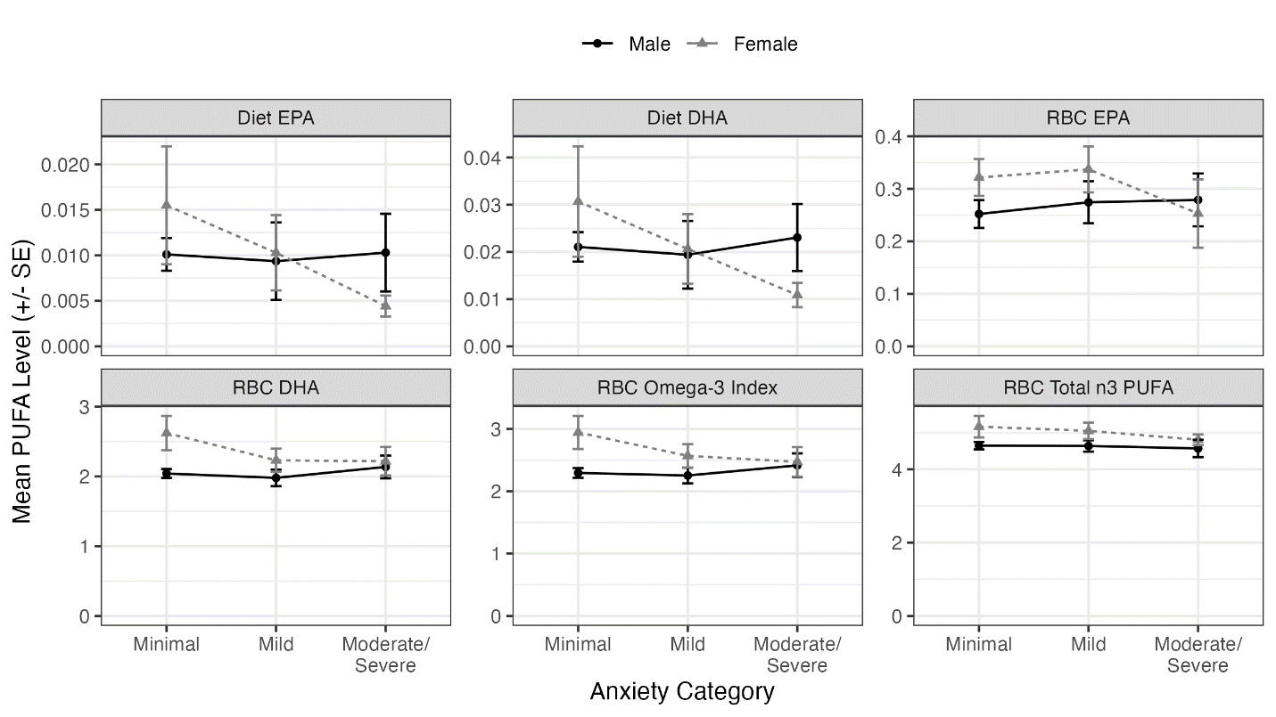
Supplemental Figure 1: Moderation of relationship of anxiety with n-3 PUFA intake and status by sex.
Diet PUFAs: % energy; RBC PUFA:% concentration.

