Supplementary Materials
- Supplementary Table S1: Search Strategy
- Supplementary Table S2: Summary of study characteristics
- Supplementary Table S3: GRADE (Grade of Recommendation, Assessment, Development and Evaluation) evidence profile and certainty of evidence; based on each intervention strategy
- Supplementary Figure S1(a-b): Risk of Bias (RoB-2) plots
- Supplementary Figure S2: Funnel Plots
- Supplementary Figure S3 – S20: Forest Plots
  - Leave one out sensitivity analysis: Figure S3
  - Secondary outcomes: Figure S4 –S8
  - Sub-group analyses by intervention strategy: Figure S9 – S17
  - Sub-group analyses by sex, intervention duration, BMI: Figure S18 – S20
- PRISMA Checklist

Supplementary Materials

Supplementary Table S1: Detailed search strategy
Databases | Search terms
Cochrane Central Register of Controlled Trials (CENTRAL)  Initial Hits: 177 | - MeSH descriptor: [Weight Loss] explode all trees  - Lifestyle interventions  - Programs or program*  - Applications or application* or apps*  - 2 or 3 or 4  - 1 and 5  - MeSH descriptor: [Adult] explode all trees  - MeSH descriptor: [Obesity] explode all trees  - MeSH descriptor: [Overweight] explode all trees  - 8 or 9  - 6 and 7 and 10  - Blue collar  - Low income  - Low socioeconomic  - Poor  - Disadvantaged  - Vulnerable  - 12 or 13 or 14 or 15 or 16 or 17  - 11 and 18 with Publication Year from 2012 to 2022, in Trials
PubMed  Initial Hits: 144 | - exp Weight loss  - exp Weight reduction  - 1 or 2  - Lifestyle interventions  - Programs or program*  - Applications or appl* or apps*  - 4 or 5 or 6  - 3 AND 7  - Adults  - Obese  - Overweight  - 10 or 11  - 8 AND 9 AND 12  - Blue collar  - Low income  - Low socioeconomic  - Poor  - Disadvantaged  - Vulnerable  - 14 or 15 or 16 or 17 or 18 or 19  - 13 AND 20  - Limit 21 to English language  - Limit 22 to Humans  - Limit 23 to Randomized Controlled Trial  - Limit 24 to Year from 2012-2022  - Limit 24 to Full Text available
Web of Science  Initial Hits: 229 | - Weight loss  - Weight reduction  - 1 or 2  - Lifestyle Interventions  - Programs or program*  - Applications or appl* or apps*  - 4 or 5 or 6  - 3 AND 7  - Adults  - Obese  - Overweight  - 10 or 11  - 8 AND 9 AND 12  - Blue Collar  - Low income  - Low socioeconomic  - Poor  - Disadvantaged  - Vulnerable  - 14 or 15 or 16 or 17 or 18 or 19  - 13 AND 20  - Limit 21 to English language  - Limit 22 to Humans  - Limit 23 to Randomized controlled trials  - Limit 24 to Yr = 2012 – Current  - Limit 25 to Full text available
EMBASE  Initial Hits: 199 | #1 - ('weight loss interventions' OR (('weight'/exp OR weight) AND ('loss'/exp OR loss) AND ('interventions'/exp OR interventions))) AND ('low income'/exp OR 'low income')  #2 - #1 AND [adult]/lim  #3 - #2 AND 'randomized controlled trial'/de  #4 - #4 AND (2012:py OR 2013:py OR 2014:py OR 2015:py OR 2016:py OR 2017:py OR 2018:py OR 2019:py OR 2020:py OR 2022:py OR 2023:py)

Supplementary Table S2: Summary of study characteristics
Author,  Year | Country/  Setting | Sample size  (Interventions/  Controls) | Sex (%)  (Females)  (Males) | Mean Age (SD) years | Mean BMI (SD) kg/m² | Evidence of low income | Trial duration
Balk-Moller et al, 2017 | Denmark  Work sites | 556  (355/211) | 93%  7% | 46.9 ( 9.9) | NR | Employees in the social and health sector | 16 weeks  22 weeks follow-up
Bennett et al, 2013 | USA  Community | 194  (97/97) | 100%  0% | 35.4 (5.5) | 30.2 (2.5) | 74.3% annual household income <$30,000 | 12 months  6 months follow-up
Bennett et al, 2018 | USA  Community | 351  (175/176) | 68%  32% | 50.7 (8.9) | 35.9 (3.9) | 67% annual household income < $35,000 | 12 months  No follow-up
Dombrowski et al, 2020 | Scotland  Community + Primary care | 105  (70/35)* | 0%  100% | 52.2 (13.1) | 35.7 (5.9) | Scottish Index of Multiple Deprivation quintiles  1 and 2 | 12 months  No follow-up
Gilmore et al, 2017 | USA  Community | 40  (20/20) | 100%  0% | 26.0 (5.4) | 32.0 (3.0) | Receiving WIC benefits | 16 weeks  No follow-up
Herring et al, 2014 | USA  Community | 18  (9/9) | 100%  0% | 24.2 (5.1) | 36.9 (6.1) | Receiving WIC benefits | 14 weeks  No follow-up
Hutchesson et al, 2018 | Australia  Community | 57  (29/28) | 100%  0% | 27.1 (4.7) | 29.4 (2.5) | 2/3 participants in lower-middle income groups | 6 months  No follow-up
Lombard et al, 2016 | Australia  Community | 649  (348/301) | 100%  0% | 39.6 (6.7) | 28.8 (6.9) | Socioeconomic index for areas (SEIFA) median score of 3 | 12 months  No follow-up
Mayer et al, 2019 | USA  Community | 402  (210/192) | 85%  15% | 45.5 (14.8) | 32.6 (5.9) | 48% annual income < $15,000 | 6 months  No follow-up
McRobbie et al, 2016 | UK  Primary care + community | 330  (221/109) | 72%  28% | 46.1 (14.7) | 35.2 (4.2) | Areas with high levels of social deprivation | 8 weeks  10 months
Phelan et al, 2017 | USA  Primary care | 371  (174/197) | 100%  0% | 28.1 (5.4) | 31.7 (5.1) | Receiving WIC benefits | 12 months  No follow-up
Rosas et al, 2015 | USA  Primary care | 207  (166/41)* | 77%  23% | 47.1 (11.1) | 35.6 (5.3) | 48% annual income <$20,000 | 12 months  12 months follow-up
Samuel-Hodge et al, 2013 | USA  Primary care + Community | 189  (126/63) | 100%  0% | 51.0 (NR) | 37.0 (NR) | 20% annual household income < $10,000 | 5 months  No follow-up
Van Name et al, 2016 | USA  Community | 139  (65/65) | 100%  0% | 43.4 (NR) | 35.3 (NR) | 90% annual income < 100% of federal poverty level | 12 months  No follow-up
BMI = Body Mass Index, NR = Not reported; WIC = Women, Infants and Children Programme for low income groups
*3-arm intervention trials (comprising of 2 intervention groups and 1 control group)
Supplementary Table S2: Summary of study characteristics (continued)
Author,  Year | Mode of delivery/  Description of intervention | Intervention Strategies¹ |  |  |  |  |  |  |  |  | Weight Change (kg) | Secondary Outcomes  WC (cm); BP (mmHg); TC (mmol/L)
 |  | CP | DC | FI | GS | IF | LC | PA | SM | SS
Balk-Moller et al, 2017^{[1]} | Mobile & Web App  Mobile and web based intervention focusing on team competition, pledges and incentives |  |  |  | ✔ |  |  |  | ✔ | ✔ | ΔI: -1.44 (4.90)  ΔC: 0.10 (2.76)  MD = -1.54 kg  [95% CI -2.18, -0.90];  P=0.03 | WC ΔI: -1.40 (0.47)  WC ΔC: 0.51 (0.37)  MD = -1.05 [95% CI -2.26, 0.16]; P=0.16  SBP ΔI: -2.27 (0.93)  SBP ΔC: -2.57(1.03)  MD = 0.30 [95% CI -2.41, 3.02]; P=0.83  DBP ΔI: -1.85 (0.64)  DBP ΔC: -1.48(0.72)  MD = -0.57 [95% CI -2.48, 1.35]; P=0.56
Bennett et al, 2013^{[2]} | Telephone Calls  SHAPE intervention treatment to create <200kcal calorie deficit, while encouraging tailored behaviour change goals, weekly self-monitoring via interactive voice response telephone calls, 12 counselling calls delivered monthly by trained RD, tailored skills training materials and 12 month YMCA membership | ✔ | ✔ |  |  | ✔ |  | ✔ | ✔ |  | ΔI: -1.0 (4.93)  ΔC: 0.5 (4.93)  MD = -1.4 kg  [95% CI -2.8, -0.1] | WC ΔI: -1.0 (6.89)  WC ΔC: 0.3 (6.89)  MD = -1.3cm  [95% CI -3.1, 0.5]  SBP ΔI: -1.6 (14.3)  SBP ΔC: -1.6 (14.5)  MD = 0.01 mmHg [95% CI -4.1, 4.2]  DBP ΔI: -2.3 (12.2)  DBP ΔC: -1.6 (10.8)  MD = -0.70 mmHg [95% CI -3.9, 2.5]  LDL ΔI: -0.13 (0.79)  LDL ΔC: 0.0 (0.71)  NET MD = -0.13mmol/L [95% CI -0.34, 0.08]
Bennett et al, 2018^{[3]} | Mobile Apps + Telephone Calls  Digital obesity treatment, comprising of app-based self-monitoring of behaviour change goals with tailored feedback, smart scale, dietitian-delivered counselling calls and clinician counselling informed by app-generated recommendations |  | ✔ |  | ✔ | ✔ |  |  | ✔ |  | ΔI: -4.1  [95% CI, -4.8, -3.3] ΔC: 0.3kg  [95% CI, -0.4, 1.1]  MD = -4.4kg  [95% CI -5.5, -3.3]; p<0.001  WC ΔI: -3.4  [95% CI, -4.3, -2.4]  WC ΔC: 0.1  [95% CI, -0.8, 1.1]  MD = -3.5cm [95% CI -4.8, -2.2]; p<0.0001 | SBP ΔI: -8.5  [95% CI -11.4, -5.3]  SBP ΔC: -7.5  [95% CI, -10.4, -4.5]  MD = --0.9 mmHg  [95% CI, -4.9, 3.1]  DBP ΔI: -5.2  [95% CI -.7.1, -3.3]  DBP ΔC: -4.2  [95% CI, -6.1, -2.4]  MD = -1.0 mmHg  [95% CI -3.5, 1.5]  LDL ΔI: -0.13  LDL ΔC: -0.5  MD = -0.08
Dombrowski et al, 2020^{[4]} | Text Messages + Social Media  Automated text messages according to predetermined schedule, without personalisation or tailoring. SMS + I group includes £400 incentive to be secured when participants achieved weight loss targets. Website to record engagement with self-monitoring tools (pedometer, steps, weight, waist circumference, belt notches). |  |  | ✔ |  |  |  | ✔ | ✔ |  | ΔI (SMS + I): -2.51 (4.94)  ΔI (SMS only): -1.29 (5.03)  ΔC: -0.86 (5.64)  MD: P=NS | NR
Gilmore et al, 2017^{[5]} | Mobile App  Personalized smartphone-based intervention to promote postpartum weight loss with tailored advice, real time weight/activity self-monitoring and scheduled delivery of health information with interventionist feedback |  | ✔ |  | ✔ | ✔ |  |  | ✔ |  | ΔI: -0.1 (4.02)  ΔC: 1.8 (4.02)  P=NS | SBP ΔI: -5.1 (2.4)  SBP ΔC: -5.3 (2.6)  MD: p=0.96  DBP ΔI: -1.9 (2.1)  DBP ΔC: -3.8 (2.2)  MD: p=0.54
Herring et al, 2014^{[6]} | Text Messages + Social Media + Telephone Calls  Technology-based behavioural weight loss intervention with facebook posts, coach calls, self-monitoring with personalized automated feedback, financial incentives $20 given for attending each assessment |  |  | ✔ |  | ✔ | ✔ |  | ✔ | ✔ | ΔI: -2.9 (3.6)  ΔC: 0.5 (2.3)  MD = -3.2kg  [95% CI -6.2, -0.1]  P=0.04 | NR
Hutchesson et al, 2018^{[7]} | Text messages + Social Media  600kcal deficit with resources to provide advice on weight loss, PA, healthy eating, online quizzes with feedback, dietetic counselling, goal setting, self-monitoring diary and regular text messages for reminders/tips. Private facebook/instagram groups were hosted for social support and interaction. | ✔ | ✔ |  | ✔ |  |  |  | ✔ | ✔ | ΔI: -1.94 kg  [95% CI, -3.59, -0.29]  ΔC: 0.01 kg  [95% CI, -1.69, 1.70]  MD = -1.94kg  [95% CI, -4.31, 0.42]; P=0.107 | WC ΔI: -4.9  [95% CI -6.6, -3.1]  WC ΔC: -3.5  [95% CI -5.1, -1.9]; p<0.001  SBP ΔI: -4.2  [95% CI -7.1, -1.3]  SBP Δ C: -1.3  [95% CI -3.9, 1.3]  MD: -2.9 mmHg  [95% CI -6.8, 1.0]; p=0.14  DBP ΔI: -3.0  [95% CI -5.5, -0.9]  DBP Δ C: -1.2  [95% CI -3.4, 1.0]  MD: -1.9 mmHg [95% CI -5.1, 1.4]; p=0.27  LDL-C ΔI: -0.3  [95% CI -0.5, -0.1]  LDL-C Δ C: -0.1  [95% CI, -0.5, 0.2]  MD: -0.39 mmol/L  [95% CI -0.60, 0.2]; p=0.33
Lombard et al, 2016^{[8]} | In-person delivery, Text Messages, Telephone Calls  Low intensity self-management lifestyle intervention consisting of one group session, monthly SMS text messages, one phone coaching session, program manual |  |  |  |  |  | ✔ |  | ✔ | ✔ | ΔI: -0.48  [95% CI, -0.99, 0.03]  ΔC: 0.44  [95% CI, -0.09, 0.97]  MD: -0.87kg [95% CI, -1.62, -0.13]; p<0.05 | WC ΔI: -0.43  [95% CI, -1.13, 0.27]  WC ΔC: 0.63  [95% CI -0.20, 1.50]  MD: -0.96 cm [95% CI, -2.30, 0.41]
Mayer et al, 2019^{[9]} | In-person delivery  Eight 90-minute peer-led workshop  sessions conducted at community sites. Sessions focused on nutrition and managing food budgets, healthy cooking with limited resources, cutting down on discretionary foods, reducing sedentary time and environmental triggers to unhealthy habits, stress handling tips and physical activity |  | ✔ |  | ✔ |  |  | ✔ |  | ✔ | ΔI: -1.22 (2.90)  ΔC: -0.42 (2.83)  MD: p=0.005 | HbA1c ΔI: -0.001 (0.24) HbA1c ΔC: 0.05 (0.27)  MD: -0.05 [95% CI -0.1, -0.001); p=0.046

McRobbie et al, 2016^{[10]} | In-person delivery  The Weight Action Programme (WAP) is a weight loss intervention that provides participants with tools  to lose weight and maintain a long-term healthy lifestyle. In the eight weekly sessions, participants are  equipped with tools to maintain a healthy lifestyle, with weekly individualised tasks and peer-support  group sessions. The initial course is followed by 10 monthly  maintenance sessions. |  | ✔ |  | ✔ |  |  | ✔ |  | ✔ | ΔI: -4.2 (7.3)  ΔC: -2.3 (6.6)  MD:-1.9kg (95% CI –3.7, –0.1); p=0.04 | WC ΔI: -2.0 (7.3)  WC ΔC: -4.1 (7.9)  MD: : 2.1cm (95% CI 0.33, 3.87); p=0.017  SBP ΔI: -2.8 (15.0)  SBP ΔC: -3.5 (16.0)  MD: 0.6mmHg (95% CI –4.3, 5.4); p=0.81  DBP ΔI: -1.7 (9.1)  DBP ΔC: -0.4 (10.2)  MD:-0.7mmHg (95% CI –3.6, 2.1); p=0.59
Phelan et al, 2017^{[11]} | In-person delivery, Videos, Website, Text Messages  A 12-month primarily internet-based weight loss program, including a website with weekly lessons, web diary, instructional videos, computerized feedback, text messages | ✔ |  | ✔ | ✔ | ✔ |  | ✔ |  |  | ΔI: -3.2  (95% CI –4.1, -2.4)  ΔC: -0.9  (95% CI –1.7, -0.1)  MD:-2.3kg (95% CI 1.1, 3.5); p<0.001 | WC ΔI: -4.0  (95% CI –5.1, -2.9)  WC ΔC: -1.2  (95% CI –2.2, -0.2)  MD: 2.8cm (95% CI 1.3, 4.3); p<0.001
Rosas et al, 2015^{[12]} | In-person delivery  Motivational interviewing, goal setting, hands-on cooking and physical activity demonstrations, group-based social support and coordinating with primary care providers and community workers |  |  |  | ✔ |  | ✔ | ✔ |  | ✔ | ΔI (CM + CHW): -1.9 [95% CI -2.9, -0.9];  ΔI (CM): -1.4  [95% CI -2.4, -0.3];  ΔC: -0.7  [95% CI, -2.2, 0.8] | SBP ΔI (CM + CHW): -1.3 [95% CI -4.3, 1.6]  SBP ΔI (CM): -2.2  [95% CI -5.1, 0.6]  SBP Δ C: -3.0  [95% CI 0.78, 1.7]  MD: P=NS  DBP ΔI (CM + CHW): 0.3 [95% CI -1.7, 2.2]  DBP ΔI (CM): -0.6  [95% CI -2.3, 1.1]  DBP Δ C: -1.3 [95% CI, -4.1, 1.5]  MD: P=NS  LDL-C ΔI (CM + CHW): 0.11 [95% CI -0.07, 0.28]  LDL-C ΔI (CM): 0.08  [95% CI -0.08, 0.23]  LDL-C Δ C: 0.05  [95% CI -0.19, 0.29]  MD: 0.04 mmol/L [95% CI -0.22, 0.30]  HbA1c ΔI (CM + CHW): -0.2 [95% CI, -0.5, 0.0]  HbA1c ΔI (CM): 0.0  [95% CI, -0.2, 0.2]  HbA1c Δ C: -0.1  [95% CI -0.5, 0.3]  MD: P=0.0 [95% CI -0.41, 0.41]
Samuel-Hodge et al, 2013^{[13]} | In-person delivery  16 weekly group sessions surrounding topics on nutrition, PA, goal setting and action planning, food diary and physical activity minutes with small weekly incentives earned through points system for achieving goals + incentives for completing measurements/assessments |  |  | ✔ |  |  |  | ✔ | ✔ | ✔ | ΔI: -3.7 (5.5)  ΔC: -0.4 (4.8)  MD = -3.3kg [95% CI 1.7, 4.9]; P=<0.0001 | SBP ΔI: -4.5 (1.7)  SBP ΔC: -4.2 (2.9)  MD: 0.3 [95% CI -3.8, 6.2]p=0.65  DBP ΔI: -3.4 (11.1)  DBP ΔC: -2.4 (1.5)  MD: 1.01mmHg (95% CI –3.4, 3.4); p=0.98
Van Name et al, 2016^{[14]} | In-person delivery  1-hour lifestyle class weekly focusing on nutrition, behavior change and hands-on learning including cooking demonstrations and group sessions at grocery stores/community farms + group exercise classes x 2-3 times/week |  | ✔ |  | ✔ |  |  | ✔ |  | ✔ | WT ΔI: -3.8  [95% CI, -4.6, -3.0]  WT ΔC: 1.4  [95% CI, 0.6, 2.2]  MD = -5.2kg [95% CI, -6.4, -4.0]; P<0.0001 | WC ΔI: -3.3  [95% CI -2.9, -1.0]  WC ΔC: 0.4  [95% CI -0.7, 1.4]  MD: -2.3 [95% CI -3.8, -0.9]; p=0.02  SBP ΔI: -1.5  [95% CI -5.0, 2.1]  SBP Δ C: 0  [95% CI -3.6, 3.6]  MD: -1.4 mmHg  [95% CI, -6.0, 3.1]; p=0.53  DBP ΔI: -0.50  [95% CI -2.8, 1.7]  DBP Δ C: -0.9  [95% CI -3.2, 1.4]  MD: 0.4 mmHg [95% CI -2.6, 3.3]; p=0.80  HbA1c ΔI: -0.1%  [95% CI -0.1, 0.0]  HbA1c ΔC: 0.0 %  [95% CI -0.1, 0.1]  MD: 0.0 [95% CI -0.1, 0.1]; p=0.30
¹Intervention strategies (CP = Calorie Prescription, DC = Dietary Counselling, FI = Financial Incentives, GS = Goal Setting, IF = Interactive Feedback, LC = Lifestyle Coaching, PA = Physical Activity, SM = Self-Monitoring, SS = Social Support)CI = Confidence intervals; DBP = Diastolic blood pressure; LDL-C = Low-density Lipoprotein Cholesterol; MD = Mean difference; NR = Not reported; SBP = Systolic blood pressure; WC = Waist Circumference

Supplementary Table S3: GRADE (Grade of Recommendation, Assessment, Development and Evaluation) evidence profile and certainty of evidence; based on each individual intervention strategy, relating to weight changes (kg)
Certainty assessment |  |  |  |  |  | No of patients |  | Effect |  | Certainty
No of studies | Study design | Risk of bias | Inconsistency | Indirectness | Imprecision | Intervention | Control | Absolute  (95% CI)
Calorie Prescription
3 | RCTs | Not serious | Not serious | Not Serious | Serious^{c} | 300 | 322 | MD: -1.98kg  (-2.79 – 1.16) |  | ⨁⨁⨁◯  Moderate
Dietary Counselling
5 | RCTs | Not Serious | Seriousª | Not Serious | Not serious | 577 | 446 | MD: -1.07kg  (-1.54, -0.6) |  | ⨁⨁⨁◯  Moderate
Financial Incentives
4 | RCTs | Not serious | Not serious | Serious^{b} | Not Serious | 379 | 304 | MD: -2.45kg  (-3.37, -1.53) |  | ⨁⨁⨁◯  Moderate
Goal Setting
6 | RCTs | Not serious | Not serious | Not Serious | Not serious | 820 | 587 | MD: -1.42kg  (-2.06, -0.78) |  | ⨁⨁⨁⨁  High
Interactive Feedback
4 | RCTs | Not serious | Not serious | Serious^{b} | Not Serious | 300 | 323 | MD: -2.09kg  (-2.88, -1.3) |  | ⨁⨁⨁◯  Moderate
Lifestyle Coaching
3 | RCTs | Not serious | Seriousª | Serious^{b} | Serious^{c} | 523 | 351 | MD: -1.18kg  (-2.13, -0.24) |  | ⨁◯◯◯  Very Low
Physical Activity
8 | RCTs | Not serious | Seriousª | Serious^{b} | Not serious | 1084 | 754 | MD: -1.63kg  (-2.3, 0.96) |  | ⨁⨁◯◯  Low
Self-Monitoring
7 | RCTs | Not serious | Seriousª | Not Serious | Not serious | 699 | 553 | MD: -1.77kg  (-2.58, -0.97) |  | ⨁⨁⨁◯  Moderate
Social Support
7 | RCTs | Not serious | Seriousª | Serious^{b} | Not serious | 1099 | 743 | MD: -1.53kg  (-2.24, 0.82) |  | ⨁⨁◯◯  Low
CI: confidence interval; MD: mean difference; RCTs: randomised controlled trials
ª Downgraded (-1) for inconsistencies due to high heterogeneity (I² = 50%; p>0.05), wide variation of point estimates. Heterogeneity as mainly explained by participant characteristics and presence of different follow-up times across studies.
^{b} Downgraded (-1) for indirectness due to differences in population and intervention which may impact the generalizability of the findings.
^{c} Downgraded (-1) for imprecision due to uncertainty over the true effect size as mainly explained by confidence intervals showing wide variation from large losses to large gains in weight (kg) and small sample sizes.

Supplementary Figures: Risk of Bias Plots and Funnel Plot

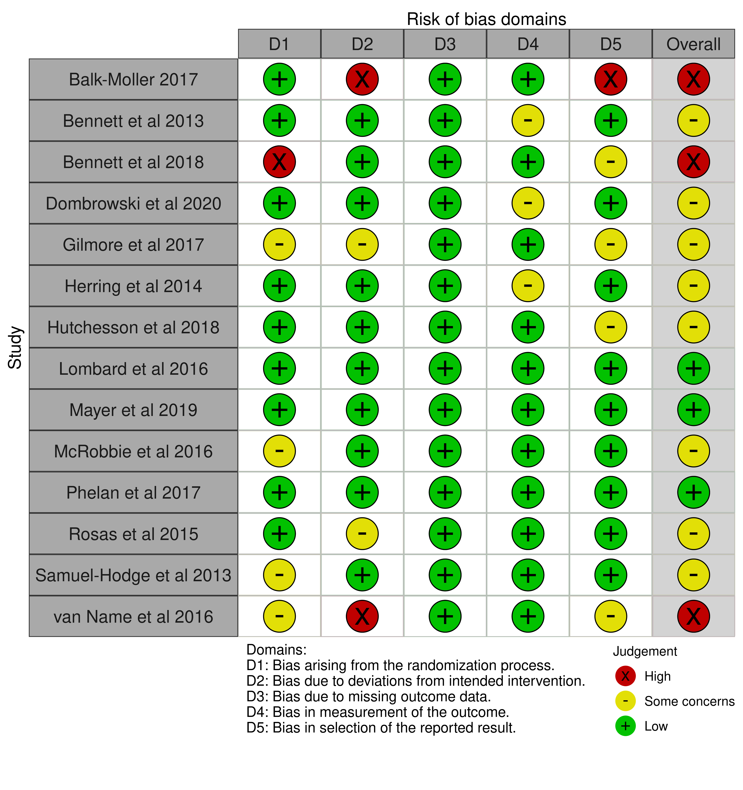
Fig S1(a): Summary table of studies assessed using RoB-2 risk of bias domains
Source: ^{[15]}

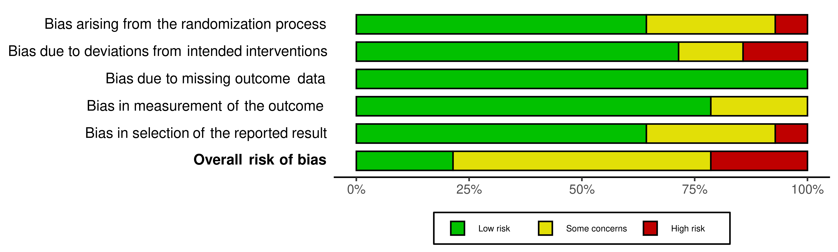 Fig S1(b): Summary plot using RoB2 risk of bias domains
Source: ^{[15]}

Supplementary Figures: Funnel Plot

Fig S2: Funnel plot of observed effect by mean difference (MD) for assessment of publication bias. The vertical dotted line represents the mean difference of zero or line of no effect. Each circle represents a study applying intervention. The diagonal dashed lines represent the pseudo 95% CI around the pooled estimate.

Supplementary Figures: Forest Plots
- Sensitivity Analysis (a)
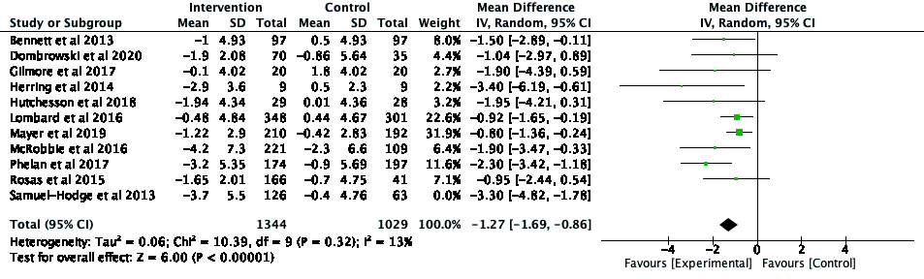Fig S3a: Forest plot on mean difference in weight change (kg) in response to intervention (leave-one-out sensitivity analysis

- Sensitivity Analysis (b)

- Secondary outcomes
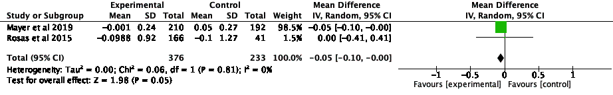Fig S4: Forest plot on mean difference in HbA1c (%), from baseline to end of intervention (studies with reported outcome)

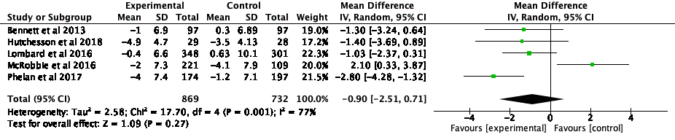Fig S5: Forest plot on mean difference in waist circumference (cm), from baseline to end of intervention

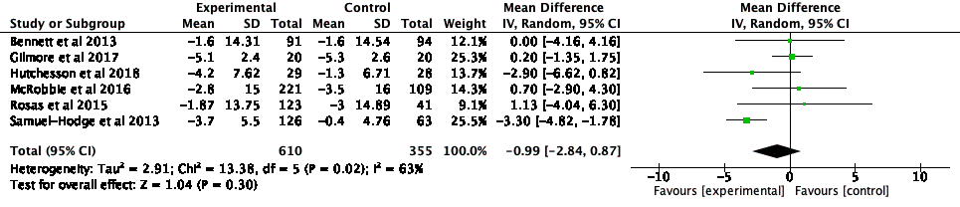Fig S6: Forest plot on mean difference in systolic blood pressure (mmHg), from baseline to end of intervention

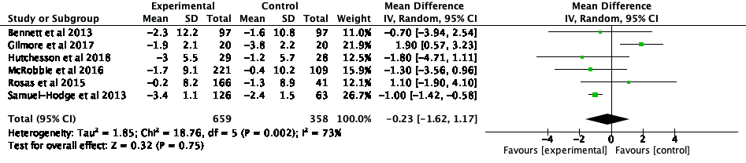Fig S7: Forest plot on mean difference in diastolic blood pressure (mmHg), from baseline to end of intervention

Fig S8: Forest plot on mean difference in LDL-cholesterol (mmoL/L), from baseline to end of intervention

Subgroup Analyses – by intervention strategy
Fig S9: Forest plot on mean difference in weight change (kg), from baseline to end of intervention; by intervention strategy subgroup: Financial Incentives

Fig S10: Forest plot on mean difference in weight change (kg), from baseline to end of intervention by intervention strategy subgroup: Interactive Feedback

Fig S11: Forest plot on mean difference in weight change (kg), from baseline to end of intervention; by intervention strategy subgroup: Calorie Prescription

Fig S12: Forest plot on mean difference in weight change (kg), from baseline to end of intervention; by intervention strategy subgroup: Self Monitoring

Fig S13: Forest plot on mean difference in weight change (kg), from baseline to end of intervention; by intervention strategy subgroup: Physical Activity

Fig S14: Forest plot on mean difference in weight change (kg) from baseline to end of intervention; by intervention strategy subgroup: Social Support

Fig S15: Forest plot on mean difference in weight change (kg from baseline to end of intervention; by intervention strategy subgroup: Goal Setting

Fig S16: Forest plot on mean difference in weight change (kg) from baseline to end of intervention; by intervention strategy subgroup: Lifestyle Coaching

Fig S17: Forest plot on mean difference in weight change (kg) from baseline to end of intervention; by intervention strategy subgroup: Dietary Counselling

Subgroup Analyses by Sex, Intervention Duration, and BMI classifications

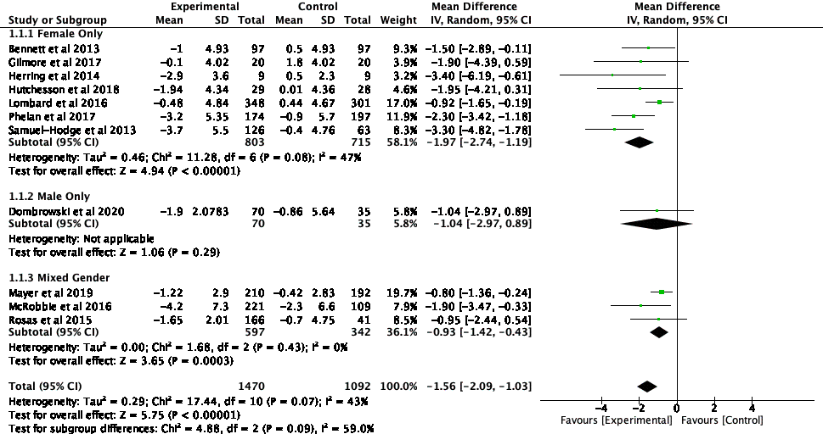
Fig S18: Forest plot on mean difference in weight change (kg) from baseline to end of intervention; Subgroup analyses by sex

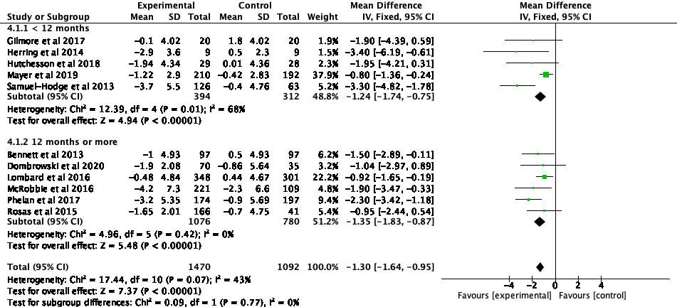
Fig S19: Forest plot on mean difference in weight change (kg) from baseline to end of intervention; Subgroup analyses by duration of intervention

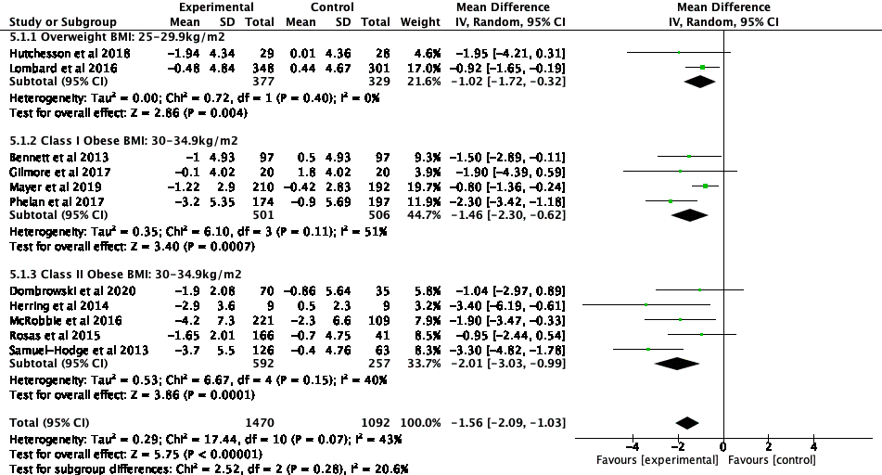
Fig S20: Forest plot on mean difference in weight change (kg) from baseline to end of intervention; Subgroup analyses by BMI classification

Supplementary Materials: PRISMA Checklist
Section and Topic | Item # | Checklist item | Location where item is reported
TITLE
Title | 1 | Identify the report as a systematic review. | Abstract, P2
ABSTRACT
Abstract | 2 | See the PRISMA 2020 for Abstracts checklist. | P1
INTRODUCTION
Rationale | 3 | Describe the rationale for the review in the context of existing knowledge. | P1-2
Objectives | 4 | Provide an explicit statement of the objective(s) or question(s) the review addresses. | P2
METHODS
Eligibility criteria | 5 | Specify the inclusion and exclusion criteria for the review and how studies were grouped for the syntheses. | P3
Information sources | 6 | Specify all databases, registers, websites, organisations, reference lists and other sources searched or consulted to identify studies. Specify the date when each source was last searched or consulted. | P3
Search strategy | 7 | Present the full search strategies for all databases, registers and websites, including any filters and limits used. | Table S1
Selection process | 8 | Specify the methods used to decide whether a study met the inclusion criteria of the review, including how many reviewers screened each record and each report retrieved, whether they worked independently, and if applicable, details of automation tools used in the process. | P3,4
Data collection process | 9 | Specify the methods used to collect data from reports, including how many reviewers collected data from each report, whether they worked independently, any processes for obtaining or confirming data from study investigators, and if applicable, details of automation tools used in the process. | P4
Data items | 10a | List and define all outcomes for which data were sought. Specify whether all results that were compatible with each outcome domain in each study were sought (e.g. for all measures, time points, analyses), and if not, the methods used to decide which results to collect. | P5, Table S2
 | 10b | List and define all other variables for which data were sought (e.g. participant and intervention characteristics, funding sources). Describe any assumptions made about any missing or unclear information. | P5, Table S2
Study risk of bias assessment | 11 | Specify the methods used to assess risk of bias in the included studies, including details of the tool(s) used, how many reviewers assessed each study and whether they worked independently, and if applicable, details of automation tools used in the process. | P6-7
Effect measures | 12 | Specify for each outcome the effect measure(s) (e.g. risk ratio, mean difference) used in the synthesis or presentation of results. | P5
Synthesis methods | 13a | Describe the processes used to decide which studies were eligible for each synthesis (e.g. tabulating the study intervention characteristics and comparing against the planned groups for each synthesis (item #5)). | Table S2
 | 13b | Describe any methods required to prepare the data for presentation or synthesis, such as handling of missing summary statistics, or data conversions. | P5
 | 13c | Describe any methods used to tabulate or visually display results of individual studies and syntheses. | P5-7
 | 13d | Describe any methods used to synthesize results and provide a rationale for the choice(s). If meta-analysis was performed, describe the model(s), method(s) to identify the presence and extent of statistical heterogeneity, and software package(s) used. | P5
 | 13e | Describe any methods used to explore possible causes of heterogeneity among study results (e.g. subgroup analysis, meta-regression). | P5
 | 13f | Describe any sensitivity analyses conducted to assess robustness of the synthesized results. | P5
Reporting bias assessment | 14 | Describe any methods used to assess risk of bias due to missing results in a synthesis (arising from reporting biases). | P4
Certainty assessment | 15 | Describe any methods used to assess certainty (or confidence) in the body of evidence for an outcome. | P4 GRADE criteria
RESULTS
Study selection | 16a | Describe the results of the search and selection process, from the number of records identified in the search to the number of studies included in the review, ideally using a flow diagram. | P5-6
 | 16b | Cite studies that might appear to meet the inclusion criteria, but which were excluded, and explain why they were excluded. | P5-6
Study characteristics | 17 | Cite each included study and present its characteristics. | P6
Risk of bias in studies | 18 | Present assessments of risk of bias for each included study. | Figure S1a  Figure S1b
Results of individual studies | 19 | For all outcomes, present, for each study: (a) summary statistics for each group (where appropriate) and (b) an effect estimate and its precision (e.g. confidence/credible interval), ideally using structured tables or plots. | Figure 3, Figures S3-S20
Results of syntheses | 20a | For each synthesis, briefly summarise the characteristics and risk of bias among contributing studies. | P7-9
 | 20b | Present results of all statistical syntheses conducted. If meta-analysis was done, present for each the summary estimate and its precision (e.g. confidence/credible interval) and measures of statistical heterogeneity. If comparing groups, describe the direction of the effect. | Forest plots Figures S3-S20
 | 20c | Present results of all investigations of possible causes of heterogeneity among study results. | P7
 | 20d | Present results of all sensitivity analyses conducted to assess the robustness of the synthesized results. | Figure S3, P9
Reporting biases | 21 | Present assessments of risk of bias due to missing results (arising from reporting biases) for each synthesis assessed. | P10
Certainty of evidence | 22 | Present assessments of certainty (or confidence) in the body of evidence for each outcome assessed. | P9-10
DISCUSSION
6Discussion | 23a | Provide a general interpretation of the results in the context of other evidence. | P10
 | 23b | Discuss any limitations of the evidence included in the review. | P11-12
 | 23c | Discuss any limitations of the review processes used. | P11-12
 | 23d | Discuss implications of the results for practice, policy, and future research. | P11
OTHER INFORMATION
Registration and protocol | 24a | Provide registration information for the review, including register name and registration number, or state that the review was not registered. | P12
 | 24b | Indicate where the review protocol can be accessed, or state that a protocol was not prepared. | P12
 | 24c | Describe and explain any amendments to information provided at registration or in the protocol. | NA
Support | 25 | Describe sources of financial or non-financial support for the review, and the role of the funders or sponsors in the review. | P12
Competing interests | 26 | Declare any competing interests of review authors. | P12
Availability of data, code and other materials | 27 | Report which of the following are publicly available and where they can be found: template data collection forms; data extracted from included studies; data used for all analyses; analytic code; any other materials used in the review. | Table S2, Table S3, Figures S1(a-b), Figure S2, Figure S3

