Table S1. Feed formulation and proximate analysis of experimental diets.
Ingredients (g kg ⁻¹) | Adequate choline | Choline deficiency
Casein | 360 | 360
Gelatin | 80 | 80
Fish oil | 30 | 30
Soybean oil | 30 | 30
Wheat flour | 250 | 250
Ascorbyl-2-polyphosphate | 10 | 10
NaCl | 10 | 10
Ca (H₂PO₄)₂·H₂O | 10 | 10
Vitamin premix¹ | 5 | 5
Mineral premix² | 5 | 5
Cellulose | 208.5 | 209.5
Choline chloride³ | 1.5 | 0.5
Proximate analysis (%, dry weight)
Moisture | 7.29 | 7.22
Crude protein | 40.54 | 39.99
Crude ash | 5.36 | 5.37
Crude lipid | 10.49 | 10.15
Choline (g kg⁻¹) | 1.61 | 0.59
¹Vitamin premix (mg or IU per kg diet): retinylacetate, 10000IU; cholecalciferol, 1000IU; all-rac-a- tocopheryl acetate, 30IU; menadione nicotinamide bisulfite, 7; thiamine hydrochloride, 6; riboflavin, 3; pyridoxine hydrochloride, 12; D-calcium pantothenate, 30; niacin, 50; biotin, 1; folic acid, 6; cyanocobalamine, 0.03.
²Mineral mixture (mg per kg diet): Ca(H₂PO₃)₂·H₂O, 1000; FeSO₄·₇H₂O, 40; ZnSO₄·₇H₂O, 40; MnSO₄·H₂O, 40; CuSO₄·5H₂O, 2; CaIO₃·6H₂O, 3; Na₂SeO₃, 0.05; CoSO₄, 0.05.
³Choline chloride: active choline percentage >98%; Macklin Biochemical Technology Co., Ltd. (Shanghai. China).

Table S2. Effects of dietary choline supplementation on growth performance and morphological parameters yellow catfish (Pelteobagrus fulvidraco) after 10 weeks.
Diet | Adequate choline | Choline deficiency
IBW, g/fish | 3.80±0.06 |  | 3.78±0.05
FBW, g/fish | 30.03±0.63 |  | 31.38±0.91
WG², % | 690.16±0.10 |  | 728.60±0.15*
FCR³ | 1.17±0.02 |  | 1.15±0.03
HSI⁴, % | 1.30±0.25 |  | 1.37±0.27
CF⁵, % | 1.69±0.34 |  | 1.70±0.06
Survival⁶, % | 96.00±4.00 |  | 98.66±2.30
¹Values are means ± SEM; n = 3 tanks (30 fish/tank). asterisks indicate significant differences between adequate choline and choline deficiency groups (* p < 0.05).
²WG = (FBW-IBW)/IBW×100.
³FCR = dry feed fed (g)/wet weight gain (g).
⁴HSI = 100×(liver weight)/(body weight);
⁵CF = 100×(live weight, g)/(body length, cm)³.
⁶Survival = 100 ×final fish number/initial fish number.

Table S3. Primers used for plasmid construction and RT-qPCR analysis
Gene | Accession No. | Forward primer (5'-3') | Reverse primer (5'-3') | PE(%) | AT (°C)
Bisulfite sequencing for methylation validation
ire-1α | MH078576.1 | TTTTTGGAATTTTGTTTTTATTAGTTG | ATTAACATCTTTTACAAAACCCTCAC | 98 | 54
Plasmid construction
ire-1α | MH078576.1 | ctagcgtttaaacttaagcttTGGCTAGAGGGCAGTTCTGT | aacgggccctctagactcgagATGGAGTCCACAGGTGCTTC | 97 | 56
RT-qPCR analysis
gapdh | KP938521 | TTTCAGCGAGAGAGACCCAG | ATGACTCTCTTGGCACCTCC | 99 | 55
β-actin | DQ211096.1 | ACCCTGAAGTACCCCATCGA | CAGAGGCATACAGGGACAGC | 102 | 60
accα | GU908474.1 | GCTTGCGGCGGTTATTACTG | AGCTGCCTCTCCAACCATTC | 101 | 57
srebp-1c | JX992742.1 | TGCAGGAGCTACAACACAGG | GGACTTTCGTCTGCCTGAAG | 105 | 58
pparγ | JX992741.1 | CCGTCATCGAGGTTCTCATT | CATCGAGCTCCAGCATGTTA | 96 | 59
me | XM_047818508.1 | AACCCGACTGCTAAAGCTGA | AGCCAGAGCTACACCAGGAA | 95 | 55
fas | GU433188 | TCATCCAGCAGTTCACTGGCATT | TGATTAGGTCCACGGCCACA | 94 | 56
6pgd | XM003444904.4 | GAAGGGCCTGCTGTTTGTTG | CCCAGTCACAACAAGGCTCT | 101 | 60
g6pd | XM005478106 | GAGAAGCCCTTTGGTCGTGA | ATCAAAGTACCCTCCACGGC | 103 | 58
hsla | KJ588764 | GTTATCGGAATGCCGTGACT | CAGAATCGTCCAACAGAGCA | 102 | 58
atgl | KF614123 | GCGGAAATGTGATTGAGGTT | CTTTGGAGCCGAAGTCTGAG | 98 | 58
mgl | KX980491.1 | TATGGCTCCCAGCCTCTCTA | CCGTGCAGAAGAAGAAAAGG | 96 | 59
pparα | JX992740 | CGAGGATGGGATGCTGGTG | CGTCTGGGTGGTTCGTCTGC | 98 | 57
cpt 1α | JQ074177 | CTGGCAAAGGACTTCCAGAG | TCTGGCAACTTGCAAATGAG | 98 | 63
echs1 | MG599820.1 | TTTTTGGCACACTGGAACAA | GCACCTGGAATGGTTCCTAA | 95 | 62
acadm | MG599804.1 | TGGTGTACAGACGGGTTTGA | TGAGCGTTCATCAGACCAAG | 99 | 61
hadhb | MG599812 | GAACAAGGCCAAGTCTCTCG | AGAGAGTGAGAGCGCAAAGC | 103 | 65
grp78 | FJ436356.1 | ATTTGTTCCGCTCCACCATG | AACTCTTTCACCAGCTGCTG | 102 | 66
grp94 | KR231692.1 | AGGGTGTGGTGGACTCTGAC | CTGTTGGAATGGTCCTCGAT | 103 | 65
crt | KM114875.1 | ATGCCAAAAAGCCTGATGAC | CAGACTTCACCTGCCACAGA | 101 | 66
perk | KP687344.1 | GGGAAACTGTGGAGGGATGG | TGCAGCCTTGACCACTTTCT | 96 | 58
eif2α | JN195739.1 | TCGGCCCCAGTCTCATTCTA | ATACACCACTCGCCTCTCCT | 96 | 60
ire1α | KY081668.1 | TTCTGCGGGAAACGTTTCAC | ACTACGCATGAACCGTTTGG | 98 | 62
xbp1 | MN701647 | CTCCTGAACAGAAGCAGCCA | CTCGAAGTGCTCTGCCATGA | 97 | 63
atf6 | XM005471382 | TCCCCGGATCATCGTATGGA | TCCTGCAGTGACTCCTAACG | 94 | 61
chop | NC062531.1 | GCAGTAGGGGTGGAGTACCA | GATGCTGCACGATAGGGATT | 99 | 60
chdh | XM047800082.1 | CTCCCAGGTGTGGGAAGTAA | CCAGATGAGCTGTAGCACCA | 98 | 65
badh | NC062531.1 | TCATCAATCCGTCCACTGAA | TCAATGTCCAGCACTGCTTC | 98 | 66
mat1α | XM_047812984.1 | GCCAAGTCTCTGGTCAAAGC | ACAATAACACCAGGCCGAAG | 101 | 62
mat2α | XM_027145751 | GTGGTGCCTTGCATTTACCT | CCTTCCCAGAGAAAGCTCCT | 98 | 65
dnmt1 | MH263731.1 | ATAACCACTGGGCTGGACTG | GTCCAGGATATTGCCGAAGA | 99 | 65
dnmt3α | MH263732 | CTCTGGTGCACTGAGATGGA | GGCTTCAGTAACAGGCGAAG | 100 | 61
dnmt3β | MH263733.1 | ACATTGAAAAATGGGGTCCA | GCTTTGTCCCTGGTGTTCAT | 101 | 61
siRNA sequences
siRNA- ire1a-839 |  | UAUCAUGAUUGCUGAGAAAUU | UUUCUCAGCAAUCAUGAUAUU
NC-siRNA |  | GCAUGUUUCUAGAGGCAAAUU | UUUGCCUCUAGAAACAUGCUU
Ire1α
Δ836-963
First-round |  | AAACCTAGCGGCATGGAC | CTAATGGTGATGGTGATGATGTAGTGCGTTGTCTTCTT
Second-round |  | ctagcgtttaaacttaagcttATGGGCTGGGGTGTTTGTAGC | aacgggccctctagactcgagCTAATGGTGATGGTGATGATGTAGTG
Mutation |  | TTTCTGGAGCCTTTCCGAGCTGCCTTCACGTAC | TCGGAAAGGCTCCAGAAAAAGGGATGTTTGAGC
PE: primer efficiency; AT: Annealing temperature.

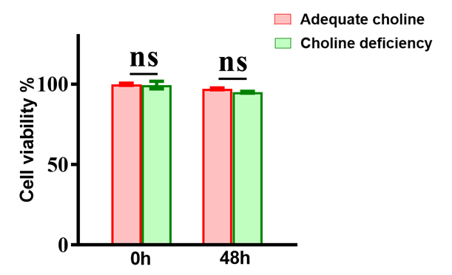
Fig. S1. MTT assay for the viability of primary hepatocyte of yellow catfish incubated with choline for 48 h. Values are means ± SEM.

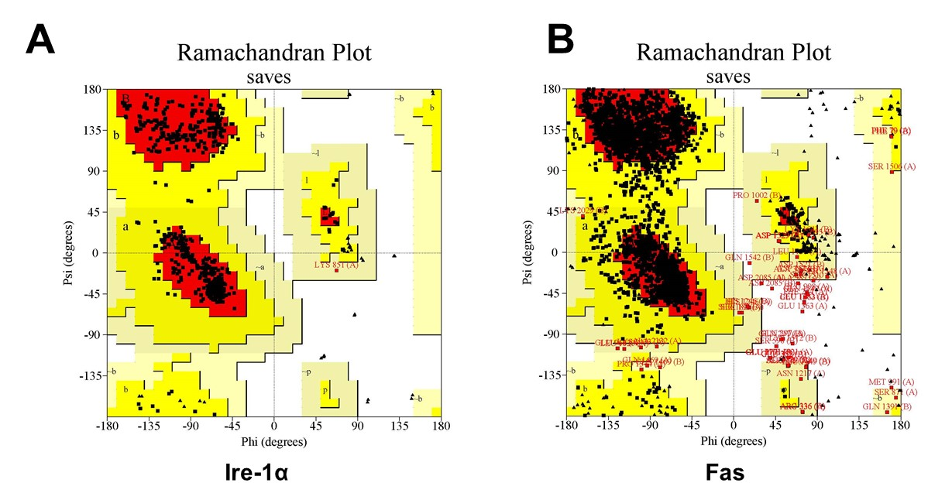
Fig. S2. Ramachandran plots for structure validation of Fas and Ire-1α.

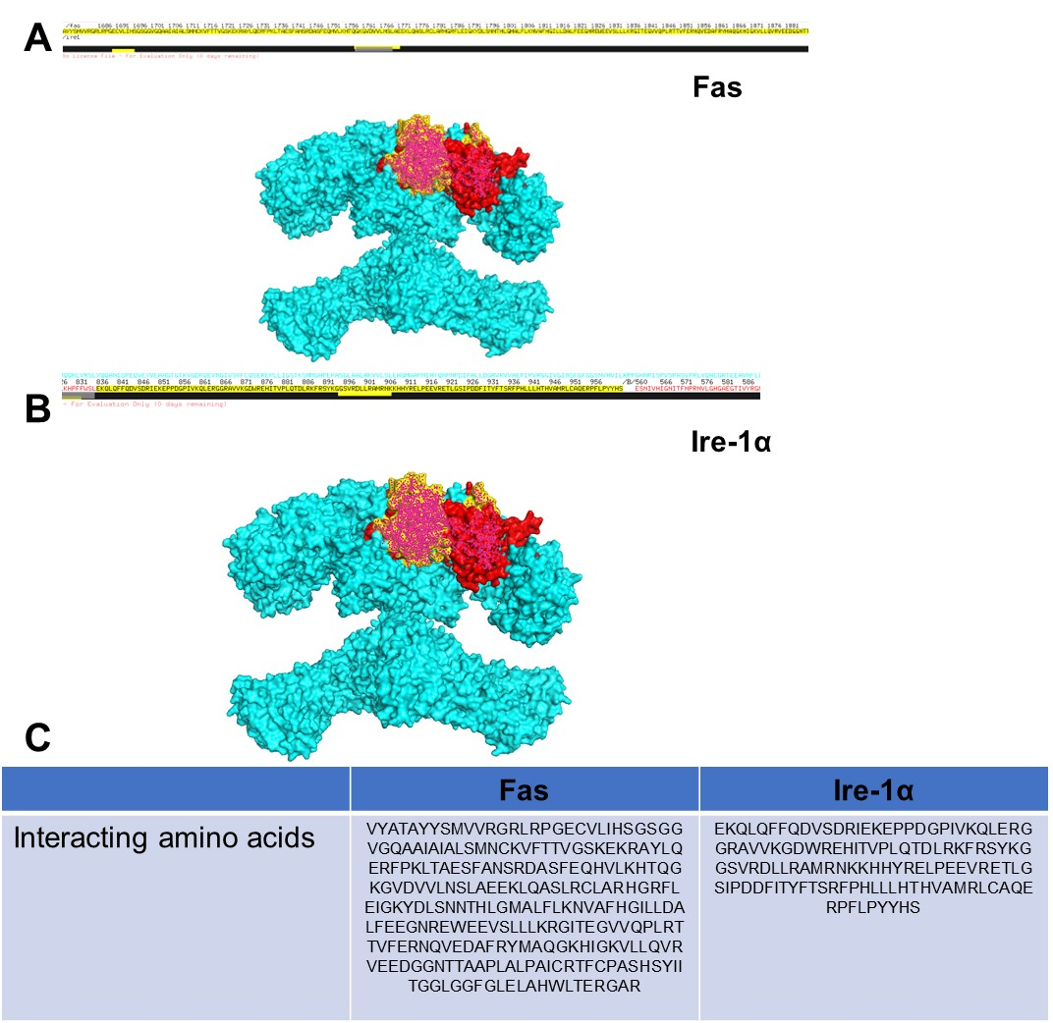
Fig. S3. The interacting amino acids between Fas and Ire-1α interaction.

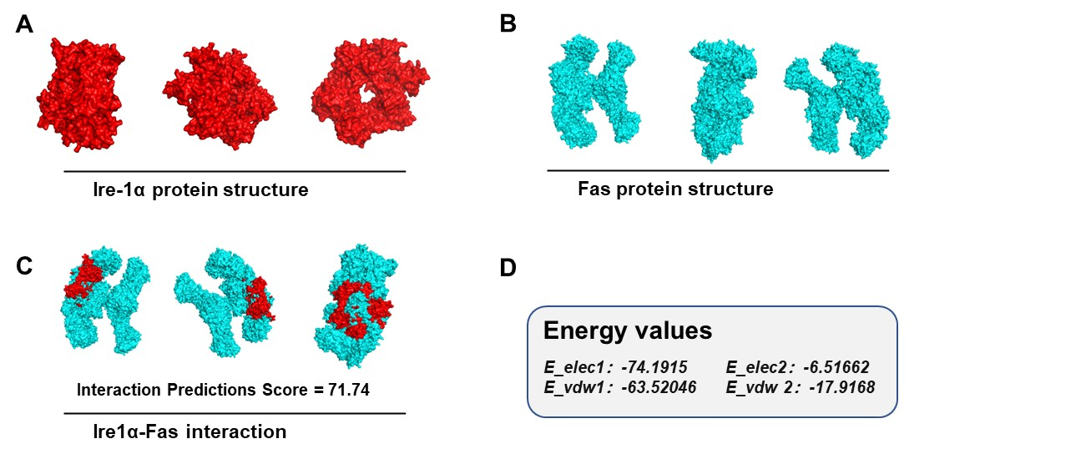
Fig. S4. The structural protein prediction model for Fas, Ire-1α, the interaction prediction score and energy values for Fas/Ire-1α.

