Comparison of Quansys Q-Plex™ Human Micronutrient (7-Plex) with s-ELISA in assessing biochemical indicators in pregnant women living in South Africa.

Chimhashu et al 2023
Supplementary tables

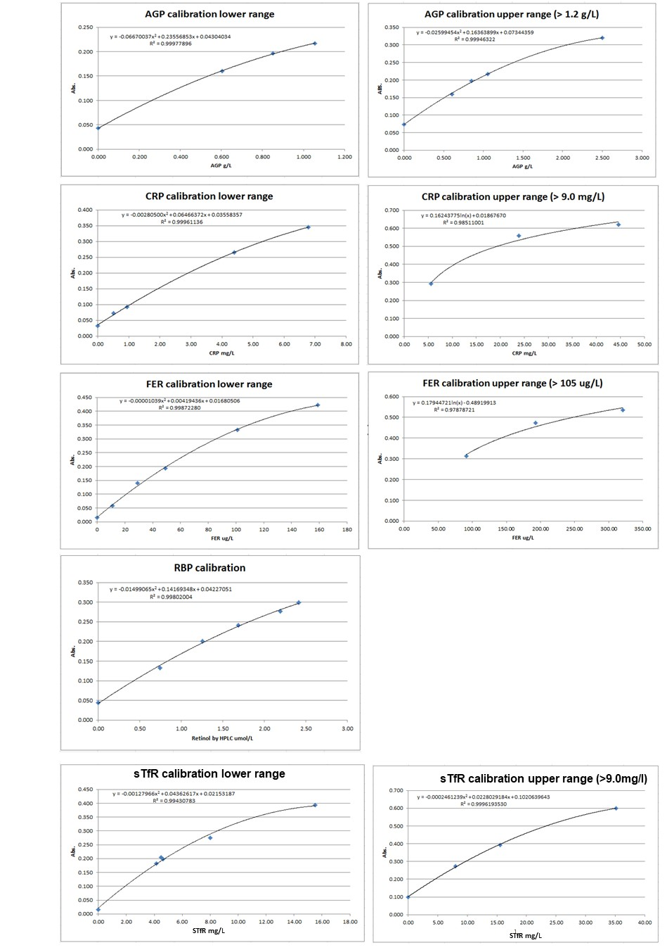
Supplementary Figure 1. Calibration curves from the VitMin Lab lab s-ELISA assays (lower and upper ranges); Calibration curves derived from commercially available serum control material (Bio-Rad Liquichek Immunology Control). Abbreviations: AGP, α-1-acid-glycoprotein; CRP, C-reactive protein; LOQ, limit of detection; Fer, Ferritin; RBP, retinol-binding protein; sTfR, soluble transferrin receptor

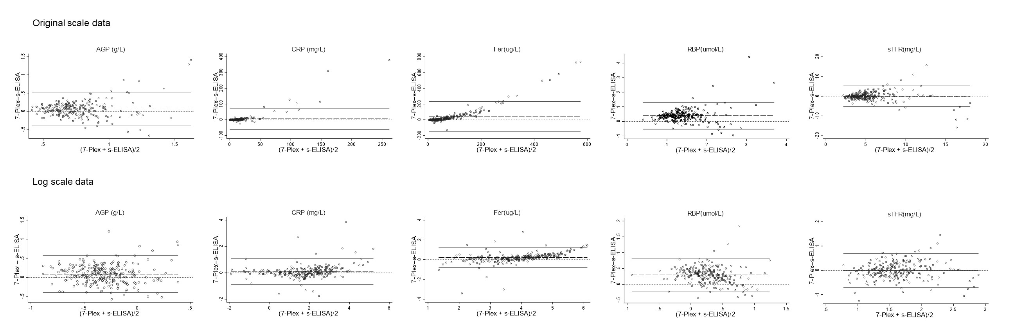
Supplementary Figure 2 illustrates Bland-Altman plots showing the concentration difference between the 7-Plex and the s-ELISA immunoassay results (y-axes) plotted against the average concentration (x-axes) on the original and log scale. AGP, α-1-acid glycoprotein; CRP, C-reactive protein; RBP, retinol binding protein, sTfR, soluble transferrin receptor. AGP, CRP, ferritin, RBP: n=249; and sTfR: n=243 (see text). The dashed line: linear regression line represents the assessment of non-constant difference line. The solid line: limits of agreement (mean difference ± 2 SD) calculated from the linear regression. Dotted horizontal line: line of identity (perfect concordance)

