Supplementary materials
Supplementary table 1. Inflammatory assessment tool and its components.
First Author | Inflammatory assessment tool | Number | Components
Sen S2016 | DII | 28 | energy, carbohydrate, protein, fat, alcohol, fiber, cholesterol, SFAs, MUFAs, PUFAs, n–3 and n–6 FAs, trans-fat, niacin, thiamin, riboflavin, vitamin B-12, vitamin B-6, iron, magnesium, zinc, selenium, vitamin A, vitamin C, vitamin D, vitamin E, folic acid, and β-carotene.
Zhao M2018 | DII | 20 | energy, carbohydrate, protein, fat, cholesterol, saturated fatty acids, monounsaturated fatty acids, polyunsaturated fatty acids, fiber, folic acid, vitamin A, vitamin C,
Shivappa N2019 | DII | 32 | energy, carbohydrate, protein, total fat, fiber, cholesterol, saturated fat, mono-unsaturated fat, poly unsaturated fat, omega-3, omega-6, trans fat, niacin, thiamin, riboflavin, vitamin B12, vitamin B6, iron, magnesium, selenium, zinc, vitamin A, vitamin C, vitamin D, vitamin E, folic acid, β-carotene, garlic, turmeric, onion, caffeine.
Zhang Z2021 | DII | 26 | carbohydrate, protein, fat, cholesterol, saturated fatty acids, monounsaturated fat, polyunsaturated fat, n-3 polyunsaturated fatty acid (PUFA), n-6 PUFA, fiber, folic acid, vitamin A, vitamin C, vitamin D, vitamin E, thiamin, riboflavin, niacin, vitamin B6, vitamin B12, β-carotene, Fe, Zn, Se, Mg, and isoflavone.
Soltani S2021 | DIP | 29 | energy, carbohydrate, fat, protein, cholesterol, saturated fat, vitamin B12, iron, mono-unsaturated fatty acids (MUFAs), poly unsaturated fatty acids (PUFAs), fiber, vitamin B6, folic acid, niacin, riboflavin, thiamin, vitamin A, vitamin C, vitamin D, vitamin E, β-carotene, caffeine, pepper, onion, garlic, tea, zinc, selenium, and magnesium.
Yang XF2021 | DII | 27 | energy, carbohydrate, fat, protein, cholesterol, saturated fatty acids, monounsaturated fatty acids, polyunsaturated fatty acids, n-3 PUFA, n-6 PUFA, fiber, folic acid, vitamin A, β-carotene, vitamin C, vitamin E, vitamin B1, vitamin B2, vitamin B3, vitamin B6, vitamin B12, vitamin D, iron, zinc, selenium, magnesium, soy isoflavones.
Killeen SL2021 | E-DII | 27 | carbohydrate, protein, fat, alcohol, fibre, cholesterol, saturated fatty acids, mono-unsaturated fatty acids, poly-unsaturated fatty acids, omega-3 fatty acids, omega–6 fatty acids, trans-fat, niacin, thiamine, riboflavin, vitamin B-12, vitamin B-6, iron, magnesium, zinc, selenium, vitamin A, vitamin C, vitamin D, vitamin E, folic acid, and β-carotene.
Pajunen L2022 | E-DII | 27 | carbohydrate, protein, total fat, alcohol, fiber, cholesterol, SFA, monounsaturated fatty acids, polyunsaturated fatty acids, omega-3 fatty acids, omega-6 fatty acids, trans fatty acids, niacin, thiamine, riboflavin, vitamin B12, vitamin B6, vitamin A, vitamin C, vitamin E, vitamin D, iron, magnesium, zinc, selenium, folic acid, and β-carotene.
Liu YH2022 | DII | 35 | energy, carbohydrate, protein, total fat, cholesterol, fatty acids, saturated fatty acids (SFAs), monounsaturated fatty acids (MUFAs), polyunsaturated fatty acids (PUFAs), omega-3 fats, omega-6 fats, soluble fiber, carotene, β-carotene, total carotenoids, thiamin, riboflavin, niacin, vitamin C, vitamin A, vitamin E, vitamin D, vitamin B6, vitamin B12, folic acid, magnesium, iron, zinc, selenium, total anthocyanidins, total flavonoids, total flavan-3-ol, total flavanones, total flavones and total flavonols.

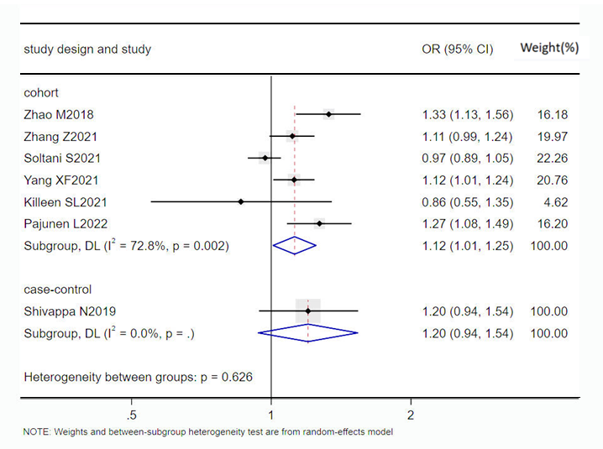
Supplementary figure S1 Forest plot of subgroup analysis of study design

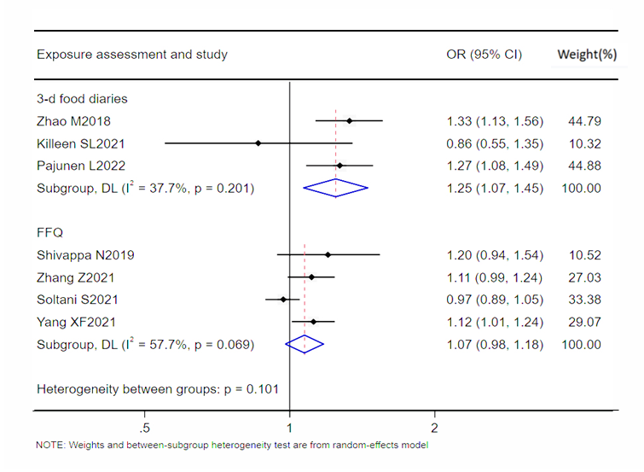
Supplementary figure S2 Forest plot of subgroup analysis of exposure assessment

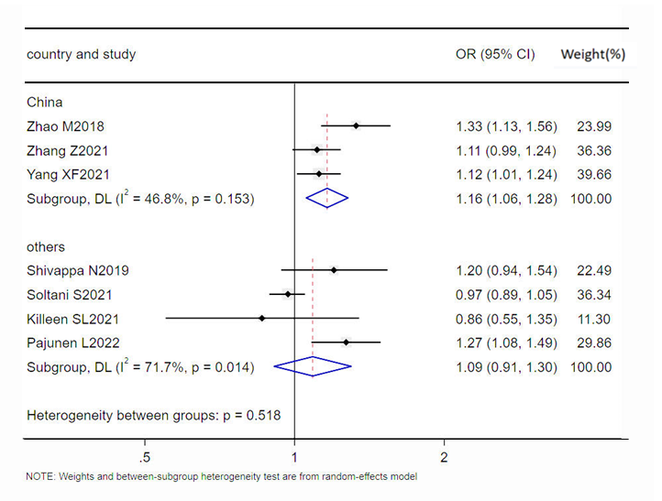
Supplementary figure S3 Forest plot of subgroup analysis of country

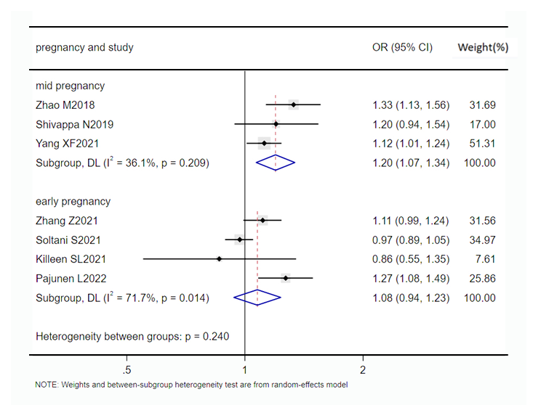
Supplementary figure S4 Forest plot of subgroup analysis of pregnancy

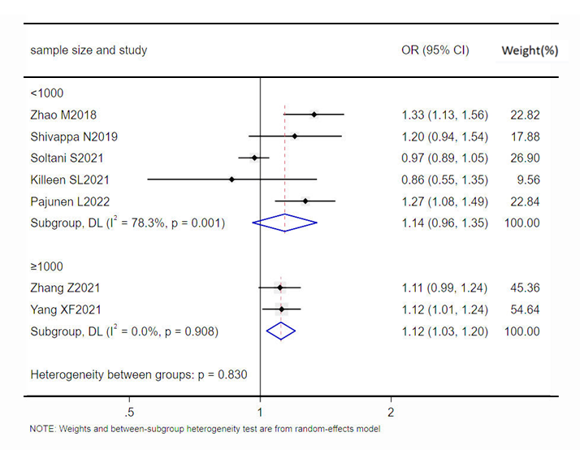
Supplementary figure S5 Forest plot of subgroup analysis of sample size

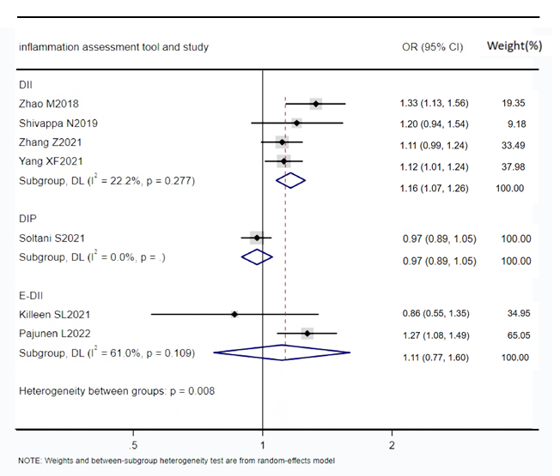
Supplementary figure S6 Forest plot of subgroup analysis of inflammation assessment tool

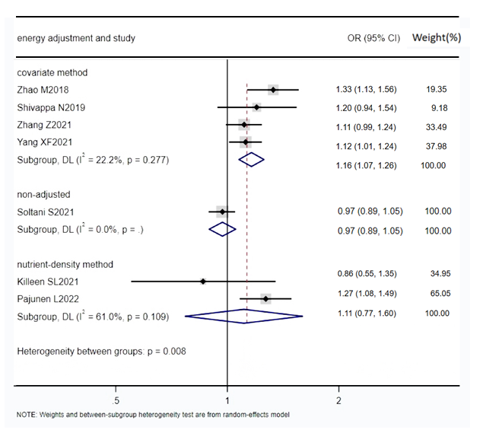
Supplementary figure S7 Forest plot of subgroup analysis of energy adjustment

