Supplemental Figure 1.
.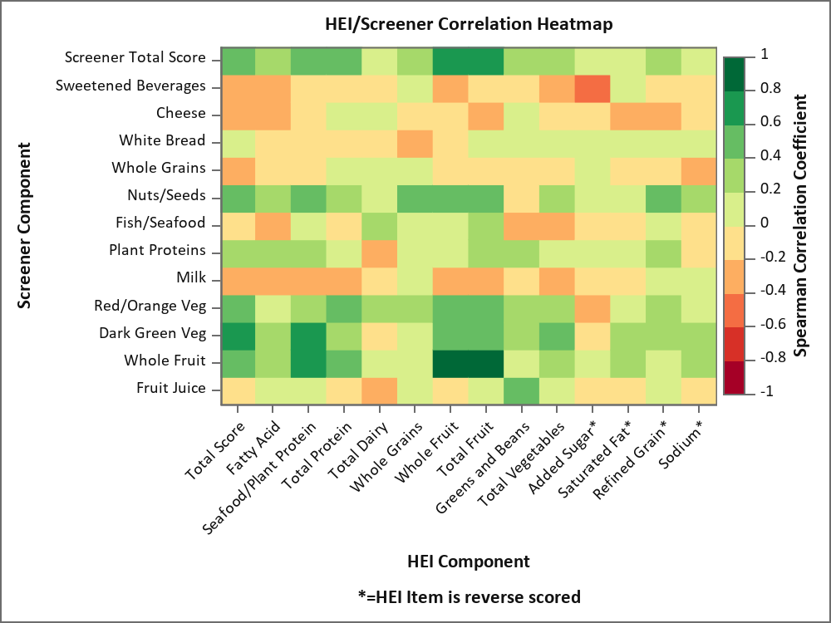

Supplemental Table 4. Simple Weighted Model Regression Coefficients
Screener Variable | Beta | Standard Error of Beta | P value
Refined Grains | -2.1961565 | 0.19334896 | <.0001
Cured Meat | -2.1946731 | 0.23581868 | <.0001
Fast Food Meals | -1.1453137 | 0.32970076 | 0.0034
Cheese | -1.1127715 | 0.14761155 | <.0001
Sweetened Beverages | -0.8483507 | 0.15560781 | <.0001
Desserts | -0.7595997 | 0.14602056 | 0.0001
Diet Soda | -0.7243505 | 0.33944826 | 0.0498
Red Meat or Pork | -0.3489616 | 0.16010702 | 0.0456
Coffee or Tea | 0.0319277 | 0.16495297 | 0.8491
Eggs | 0.2501552 | 0.22159713 | 0.2767
Savory Snacks | 0.2777606 | 0.27112701 | 0.3219
Poultry | 0.6279591 | 0.16651840 | 0.0018
Milk | 0.7892393 | 0.13855337 | <.0001
Alcohol | 1.0733378 | 0.12968521 | <.0001
Red/orange Vegetables | 1.1251402 | 0.50803519 | 0.0427
Seafood | 1.1749404 | 0.25443288 | 0.0003
Fruit Juice | 1.9659431 | 0.29618980 | <.0001
Plant Proteins | 2.2392096 | 0.11488590 | <.0001
Nuts/Seeds | 2.3358445 | 0.16437023 | <.0001
Whole Grains | 2.8452672 | 0.18591316 | <.0001
Dark Green Vegetables | 2.9802818 | 0.82442834 | 0.0025
Yogurt | 3.5405090 | 0.70137524 | 0.0001
Whole Fruit | 3.7917309 | 0.21542330 | <.0001

Penn Medicine BioBank Banner Author List and Contribution Statements

PMBB Leadership Team
Daniel J. Rader, M.D., Marylyn D. Ritchie, Ph.D., Michael D. Feldman M.D.
Contribution: All authors contributed to securing funding, study design and oversight. All authors reviewed the final version of the manuscript.

Patient Recruitment and Regulatory Oversight
JoEllen Weaver, Nawar Naseer, Ph.D., M.P.H., Afiya Poindexter, Ashlei Brock, Khadijah Hu-Sain, Yi-An Ko
Contributions: JW manages patient recruitment and regulatory oversight of study. NN manages participant engagement, assists with regulatory oversight, and researcher access. AP, AB, KH, YK perform recruitment and enrollment of study participants.

Lab Operations
JoEllen Weaver, Meghan Livingstone, Fred Vadivieso, Ashley Kloter, Stephanie DerOhannessian, Teo Tran, Linda Morrel, Ned Haubein, Joseph Dunn
Contribution: JW, ML, FV, SD conduct oversight of lab operations. ML, FV, AK, SD, TT, LM perform sample processing. NH, JD are responsible for sample tracking and the laboratory information management system.

Clinical Informatics

Anurag Verma, Ph.D., Colleen Morse, M.S., Marjorie Risman, M.S., Renae Judy, B.S.

Contribution: All authors contributed to the development and validation of clinical phenotypes used to identify study subjects and (when applicable) controls.

Genome Informatics
Anurag Verma Ph.D., Shefali S. Verma, Ph.D., Yuki Bradford, M.S., Scott Dudek, M.S., Theodore Drivas, M.D., PH.D.
Contribution: A.V., S.S.V. are responsible for the analysis, design, and infrastructure needed to quality control genotype and exome data. Y.B. performs the analysis. T.D. and A.V. provide variant and gene annotations and their functional interpretation of variants.

