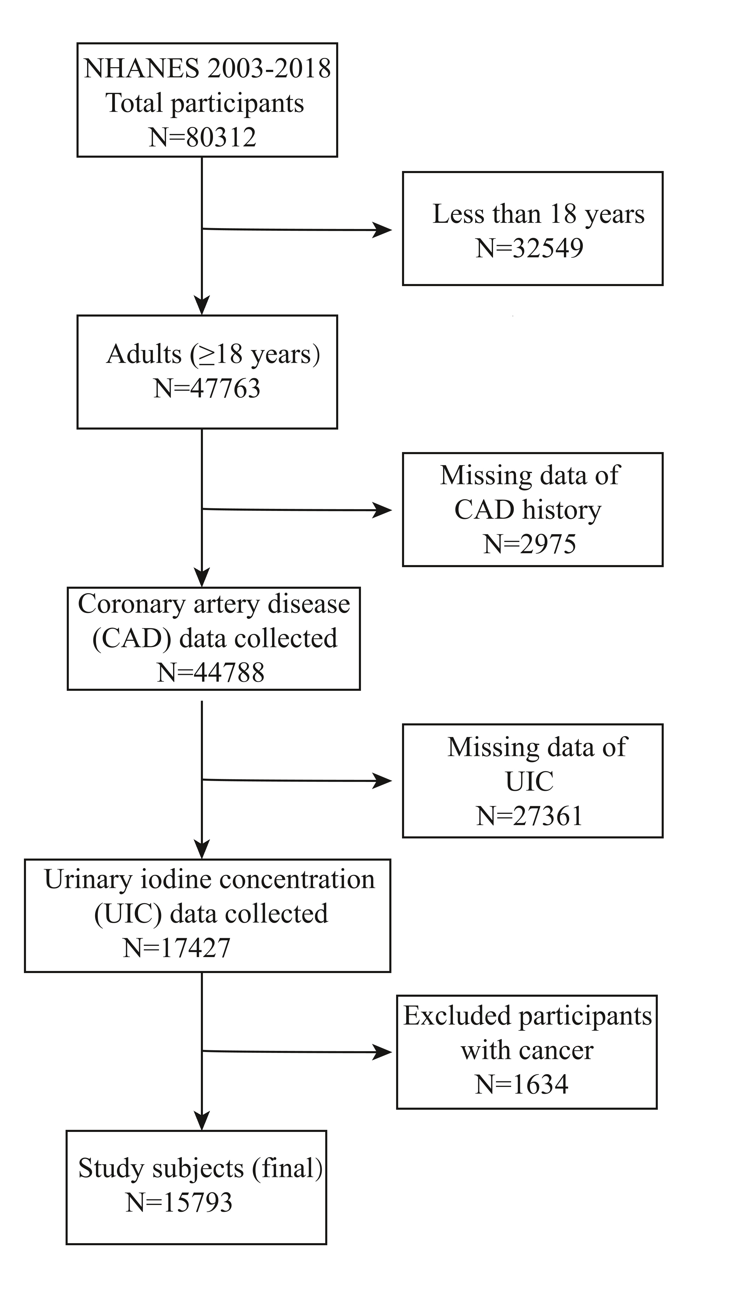
Figure S1. Flow diagram of participants’ inclusion

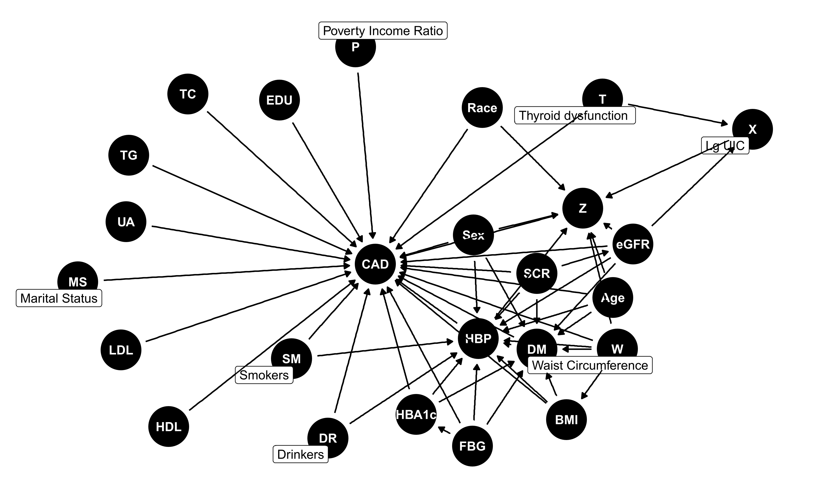
Figure S2. Directed acyclic graph for the hypothesized causal relationships.
Abbreviations: X urinary iodine concentration; CAD coronary artery disease; Z thyroid hormone, Oxidative stress or Metabolic disorders; DM diabetes; HBP hypertension; EDU Education level; BMI body mass index; FPG fasting plasma glucose; HbA1c hemoglobin A1c; TC total cholesterol; HDL high-density lipoprotein cholesterol; LDL low-density lipoprotein cholesterol; UA uric acid; SCR Serum creatinine; eGFR estimated glomerular filtration rate.

