Supplemental Figure 1: Relationship between the Average Weekly Fish Consumption and the Average Weekly n-3 PUFAs Consumption Based on the National Nutrition Survey conducted by Japan's Ministry of Health, Labor, and Welfare
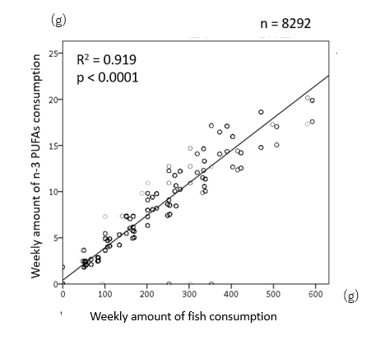
Caption: The Ministry of Health, Labor, and Welfare of Japan calculated the average daily amount of fish consumption and average daily amount of n-3 PUFAs consumption according to different age groups by estimating the “Net food supply per person per year of fishery products for human consumption,” which was based on data regarding domestic fish production, imports, and exports, changes in stocks, population, etc., that was obtained from the National Health and Nutrition Survey (Supplementary Table 2 and 3). Therefore, we estimated the correlation between the weekly amount of fish consumption and the weekly amount of n-3 PUFAs consumption. The R² coefficient of determination was 0.935, indicating fish consumption is reflected in n-3 PUFAs consumption because fish consumption is positively correlated with n-3 PUFAs consumption. This correlation diagram was constructed using data from the Trends in Mean Fish and Shellfish Intakes by Food Groups, 2001-2019 (by Gender and Age) (Supplemental Table 2) and Trends in Mean Daily Intakes of n-3 polyunsaturated fat, 2005-2019 (by Gender and Age) (Supplemental Table 3).

