Effect of probiotic supplementation on chemotherapy and radiotherapy-related diarrhea in patients with cancer: An umbrella review of systematic reviews and meta-analyses
Amiri Khosroshahi et al.
Online Supplementary Material

Supplementary data, including 6 supplementary Tables &6 supplementary Figures
content | page
Supplementary Table 1 | 2-3
Supplementary Table 2 | 4
Supplementary Table 3 | 5
Supplementary Table 4 | 6-8
Supplementary Table 5 | 9-10
Supplementary Table 6 | 11-13
Supplementary Figure 1 | 14
Supplementary Figure 2 | 15
Supplementary Figure 3 | 16
Supplementary Figure 4 | 17
Supplementary Figure 5 | 18
Supplementary Figure 6 | 19
Supplementary References | 20-22

Supplementary Table 1. Search strategies including the key terms and the queries for each database
Database  2/2/2022 | Key terms and the queries
PubMed  339 | #1 (((((((((((((((("Neoplasms"[Mesh]) OR "Neoplasm Metastasis"[Mesh]) OR "Neoplasm Invasiveness"[Mesh])) OR "Cancer Survivors"[Mesh]) OR "Cancer-Associated Fibroblasts"[Mesh]) OR "Chemotherapy, Cancer, Regional Perfusion"[Mesh]) OR "Cecal Neoplasms"[Mesh]) OR "Genes, Neoplasm"[Mesh]) OR "Carcinoma"[Mesh]) OR (cancer[Title/Abstract])) OR (tumor[Title/Abstract])) OR (malignan*[Title/Abstract])) OR (carcinoma*[Title/Abstract])) OR (oncolog*[Title/Abstract]))  #2 ("Meta-Analysis"[Title/Abstract] OR "meta-analyses"[Title/Abstract] OR "Meta-Analysis"[Title/Abstract] OR "meta-analyze"[Title/Abstract] OR "Systematic Review"[Title/Abstract] OR "Systematic Review"[Publication Type] OR "Systematic Reviews as Topic"[MeSH Terms] OR "Meta-Analysis as Topic"[MeSH Terms] OR "Meta-Analysis"[Publication Type]))  #3 (("Probiotics"[Title/Abstract] OR "Synbiotics"[Title/Abstract] OR "Prebiotics"[Title/Abstract] OR "Inulin"[Title/Abstract] OR "resistant dextrin"[Title/Abstract] OR "Microbiota"[Title/Abstract] OR "Microbiotas"[Title/Abstract] OR "Microbiome"[Title/Abstract] OR "Microbiomes"[Title/Abstract] OR "gut microflora"[Title/Abstract] OR "human microbiome"[Title/Abstract] OR "human microbiomes"[Title/Abstract] OR "microbiomes human"[Title/Abstract] OR "microbiome human"[Title/Abstract] OR "Bacteroides"[Title/Abstract] OR "Bacteroidetes"[Title/Abstract] OR "Bifidobacterium"[Title/Abstract] OR "Eubacterium"[Title/Abstract] OR "Clostridium"[Title/Abstract] OR "Lactobacillus"[Title/Abstract] OR "Fusobacterium"[Title/Abstract] OR "Firmicutes"[Title/Abstract] OR ("Probiotics"[MeSH Terms] OR "Synbiotics"[MeSH Terms] OR "Prebiotics"[MeSH Terms] OR "Inulin"[MeSH Terms] OR "Microbiota"[MeSH Terms] OR "Gastrointestinal Microbiome"[MeSH Terms] OR "Bacteroidetes"[MeSH Terms] OR "Bifidobacterium"[MeSH Terms] OR "Eubacterium"[MeSH Terms] OR "Clostridium"[MeSH Terms] OR "Lactobacillus"[MeSH Terms] OR "Fusobacterium"[MeSH Terms] OR "Firmicutes"[MeSH Terms]))  #4 #1 AND #2 AND #3
Scopus  1181 | #1 ( TITLE-ABS-KEY ( neoplasm ) OR TITLE-ABS-KEY ( carcinoma* ) OR TITLE-ABS-KEY ( cancer ) OR TITLE-ABS-KEY ( tumor ) OR TITLE-ABS-KEY ( malignan* ) OR TITLE-ABS-KEY ( oncolog* ) )  #2 ( TITLE-ABS-KEY ( "meta-analyses" ) OR TITLE-ABS-KEY ( "meta-analysis" ) OR TITLE-ABS-KEY ( "meta-analyze" ) OR TITLE-ABS-KEY ( "meta analysis" ) OR TITLE-ABS-KEY ( "systematic review" ) )  #3 ( TITLE-ABS-KEY ( probiotics ) OR TITLE-ABS-KEY ( synbiotics ) OR TITLE-ABS-KEY ( prebiotics ) OR TITLE-ABS-KEY ( inulin ) OR TITLE-ABS-KEY ( resistant AND dextrin ) OR TITLE-ABS-KEY ( microbiota ) OR TITLE-ABS-KEY ( microbiotas ) OR TITLE-ABS-KEY ( microbiome ) OR TITLE-ABS-KEY ( microbiomes ) OR TITLE-ABS-KEY ( "gut microflora" ) OR TITLE-ABS-KEY ( "human microbiome" ) OR TITLE-ABS-KEY ( "human microbiomes" ) OR TITLE-ABS-KEY ( "microbiomes, human" ) OR TITLE-ABS-KEY ( "microbiome, human" ) OR TITLE-ABS-KEY ( bacteroides ) OR TITLE-ABS-KEY ( bacteroidetes ) OR TITLE-ABS-KEY ( bifidobacterium ) OR TITLE-ABS-KEY ( eubacterium ) OR TITLE-ABS-KEY ( clostridium ) OR TITLE-ABS-KEY ( lactobacillus ) OR TITLE-ABS-KEY ( fusobacterium ) OR TITLE-ABS-KEY ( firmicutes )  #4 #1 AND #2 AND #3
Web of Science (ISI)  418 | #1:TOPIC: (neoplasm*) OR TOPIC: (carcinoma*) OR TOPIC: (cancer) OR TOPIC: (tumor) OR TOPIC: (malignan*) OR TOPIC: (oncolog*)  #2:TOPIC: ("meta-analyses") OR TOPIC: ("meta-analysis") OR TOPIC: (" meta-analyze") OR TOPIC: (" meta analysis") OR TOPIC: (" Systematic Review")  #3:TOPIC: ("probiotics") OR TOPIC: ("synbiotics") OR TOPIC: ("prebiotics") OR TOPIC: ("Inulin") OR TOPIC: ("ResistantDextrin") OR TOPIC: ("Microbiota") OR TOPIC: ("Microbiotas") OR TOPIC: ("Microbiome") OR TOPIC: ("Microbiomes") OR TOPIC: ("Gut microflora") OR TOPIC: ("Human Microbiome") OR TOPIC: ("Human Microbiomes") OR TOPIC: ("Microbiomes, Human") OR TOPIC: ("Microbiome,Human") OR TOPIC: ("Bacteroides") OR TOPIC: ("Bacteroidetes") OR TOPIC: ("Bifidobacterium") OR TOPIC: ("Eubacterium") OR TOPIC: ("Clostridium") OR TOPIC: ("Lactobacillus") OR TOPIC: ("Fusobacterium") OR TOPIC: ("Firmicutes")  #4: #1 AND #2 AND #3

Supplementary Table 2. Articles excluded during full text assessment and reasons for exclusion.
 | Author, publication year (ref.) | Reason(s) for exclusion
1 | Abt, 2021 ⁽¹⁾ | No eligible outcome
2 | Amitay, 2020 ⁽²⁾ | Not eligible outcome
3 | Cogo, 2021 ⁽³⁾ | Not eligible outcome
4 | Chen, 2020 ⁽⁴⁾ | No eligible outcome
5 | Colov, 2020 ⁽⁵⁾ | Not eligible outcome
6 | Calaca, 2017 ⁽⁶⁾ | Not eligible outcome
7 | Cao, 2017 ⁽⁷⁾ | Not eligible outcome
8 | Fuccio, 2009 ⁽⁸⁾ | Duplicate
9 | He, 2013 ⁽⁹⁾ | Not eligible outcome
10 | Henson, 2013 ⁽¹⁰⁾ | Not eligible intervention
11 | Hamad, 2013 ⁽¹¹⁾ | Duplicate
12 | Kamaluddin, 2020 ⁽¹²⁾ | Not eligible outcome
13 | Lytvyn, 2016 ⁽¹³⁾ | Not eligible outcome
14 | Ouyang, 2019 ⁽¹⁴⁾ | Not eligible outcome
15 | Rodriguez-Arrastia, 2021 ⁽¹⁵⁾ | Systematic review without meta-analysis
16 | Redman, 2014 ⁽¹⁶⁾ | Duplicate
17 | Shu, 2020 ⁽¹⁷⁾ | Not eligible outcome
18 | Suadoni, 2014 ⁽¹⁸⁾ | Systematic review without meta-analysis
19 | Sun, 2012 ⁽¹⁹⁾ | Not eligible intervention
20 | Tang, 2021 ⁽²⁰⁾ | Not eligible outcome
21 | Wei, 2018 ⁽²¹⁾ | Duplicate
22 | Wu, 2018 ⁽²²⁾ | Not eligible outcome
23 | Wedlake, 2013 ⁽²³⁾ | Systematic review without meta-analysis
24 | Yang, 2017 ⁽²⁴⁾ | Not eligible outcome
25 | Zeng, 2021 ⁽²⁵⁾ | Not eligible outcome
ref, reference.
Supplementary Table 3. Methodological quality of included systematic reviews and meta-analyses using AMSTAR2
Author, year (ref.) | Q1 | Q2 | Q3 | Q4 | Q5 | Q6 | Q7 | Q8 | Q9 | Q10 | Q11 | Q12 | Q13 | Q14 | Q15 | Q16 | Level of evidence
Bartsch, 2021 ⁽²⁶⁾ | Yes | Yes | Yes | PY | No | No | No | No | Yes | Yes | Yes | No | No | Yes | Yes | Yes | Critically low
Devaraj, 2019 ⁽²⁷⁾ | Yes | Yes | Yes | PY | Yes | Yes | PY | PY | Yes | Yes | Yes | Yes | No | Yes | Yes | Yes | Low
Fuccio, 2009 ⁽⁸⁾ | Yes | PY | Yes | PY | Yes | Yes | Yes | Yes | Yes | Yes | Yes | Yes | No | Yes | Yes | Yes | Low
Hassan, 2018 ⁽²⁸⁾ | Yes | Yes | Yes | Yes | Yes | No | PY | No | Yes | No | Yes | Yes | Yes | Yes | Yes | No | Low
Hamad, 2013 ⁽¹¹⁾ | Yes | PY | Yes | PY | No | Yes | Yes | Yes | Yes | Yes | Yes | Yes | No | Yes | Yes | Yes | Low
Lin, 2020 ⁽²⁹⁾ | Yes | PY | Yes | PY | Yes | Yes | Yes | No | Yes | Yes | Yes | Yes | No | Yes | Yes | Yes | Low
Lu, 2019 ⁽³⁰⁾ | Yes | PY | Yes | PY | Yes | Yes | PY | Yes | Yes | Yes | Yes | No | Yes | Yes | Yes | Yes | High
Liu, 2017 ⁽³¹⁾ | Yes | PY | Yes | PY | Yes | Yes | PY | Yes | Yes | Yes | Yes | Yes | No | Yes | Yes | Yes | Low
Qiu, 2019 ⁽³²⁾ | Yes | PY | Yes | PY | Yes | Yes | PY | Yes | Yes | Yes | Yes | No | No | Yes | Yes | Yes | Low
Redman, 2014 ⁽¹⁶⁾ | Yes | Yes | Yes | PY | Yes | Yes | PY | No | Yes | No | Yes | Yes | Yes | Yes | No | Yes | Low
Wardill, 2018 ⁽³³⁾ | Yes | No | Yes | PY | Yes | Yes | PY | No | Yes | Yes | Yes | Yes | No | Yes | Yes | Yes | Critically low
Wei, 2018 ⁽²¹⁾ | Yes | Yes | Yes | PY | Yes | Yes | PY | Yes | Yes | Yes | Yes | Yes | Yes | Yes | Yes | Yes | High
Wang, 2016 ⁽³⁴⁾ | Yes | PY | Yes | PY | Yes | Yes | PY | Yes | Yes | No | Yes | Yes | Yes | Yes | No | Yes | Low
Ref, references. PY, partially yes. Q1: Did the research questions and inclusion criteria for the review include the components of PICO?, Q2: 2. Did the report of the review contain an explicit statement that the review methods were established prior to the conduct of the review and did the report justify any significant deviations from the protocol?; Q3, Did the review authors explain their selection of the study designs for inclusion in the review?; Q4, Did the review authors use a comprehensive literature search strategy?; Q5, Did the review authors perform study selection in duplicate?; Q6, Did the review authors perform data extraction in duplicate?; Q7, Did the review authors provide a list of excluded studies and justify the exclusions?; Q8, Did the review authors describe the included studies in adequate detail?; Q9, Did the review authors use a satisfactory technique for assessing the risk of bias?; Q10, Did the review authors report on the sources of funding?; Q11, Did the review authors use appropriate methods for statistical combination of results?; Q12, Did the review authors assess the potential impact of RoB in individual studies on the results?; Q13, Did the review authors account for RoB in individual studies when interpreting/ discussing the results of the review?; Q14, Did the review authors provide a satisfactory explanation for, and discussion of, any heterogeneity?; Q15, Did the review authors carry out an adequate investigation of publication bias?; Q16, Did the review authors report any potential sources of conflict of interest?

Supplementary Table 4. Methodological quality of the RCTs from the systematic reviews and meta-analyses
Study, year | Random sequence generation | Allocation concealment | Blinding of participants & personnel | Blinding of outcome assessment | Incomplete outcome data | Selective outcome reporting | Other sources of bias | Overall quality
Any grade
Mego, 2015 | L | L | L | L | L | L | L | Good
Chitapanarux, 2010 | L | L | L | U | L | L | U | Fair
Demers, 2013 | L | L | L | L | H | L | L | Fair
Linn, 2018 | L | U | L | L | U | L | L | Fair
Delia, 2007 | H | L | H | H | H | H | U | Poor
Delia, 2002 | L | U | U | L | L | U | L | Poor
Giralt, 2008 | L | L | L | H | U | L | H | Poor
Ӧsterlund, 2007 | L | L | H | U | L | L | U | Poor
Salminen, 1988 | L | U | H | H | H | L | U | Poor
Mansouri-Tehrani, 2015 | U | U | L | U | H | L | L | Poor
Fang, 2011 | H | L | L | L | H | L | U | Poor
Liu, 2000 | L | L | U | H | H | L | U | Poor
Yi, 2018 | L | L | U | H | L | U | L | Poor
Wei, 2017 | U | H | L | H | L | L | L | Poor
Chen, 2014 | L | U | L | U | U | U | L | Poor
Okawa, 1949 | L | U | U | U | L | L | U | Poor
Grade ≥ 2
Mego, 2015 | L | L | L | L | L | L | L | Good
Chitapanarux, 2010 | L | L | L | U | L | L | U | Fair
Demers, 2013 | L | L | L | L | H | L | L | Fair
Delia, 2002 | L | U | U | L | L | U | L | Poor
Giralt, 2008 | L | L | L | H | U | L | H | Poor
Fang, 2011 | H | L | L | L | H | L | U | Poor
Liu, 2000 | L | L | U | H | H | L | U | Poor
Mansouri-Tehrani, 2015 | U | U | L | U | H | L | L | Poor
Grade ≥ 3
Mego, 2015 | L | L | L | L | L | L | L | Good
Chitapanarux, 2010 | L | L | L | U | L | L | U | Fair
Demers, 2013 | L | L | L | L | H | L | L | Fair
Linn, 2018 | L | U | L | L | U | L | L | Fair
Delia, 2007 | H | L | H | H | H | H | U | Poor
Delia, 2002 | L | U | U | L | L | U | L | Poor
Fang, 2011 | H | L | L | L | H | L | U | Poor
Liu, 2000 | L | L | U | H | H | L | U | Poor
Wei, 2017 | U | H | L | H | L | L | L | Poor
Giralt, 2008 | L | L | L | H | U | L | H | Poor
Ӧsterlund, 2007 | L | L | H | U | L | L | U | Poor
Anti-diarrheal medication use
Chitapanarux, 2010 | L | L | L | U | L | L | U | Fair
Demers, 2013 | L | L | L | L | H | L | L | Fair
Linn, 2018 | L | U | L | L | U | L | L | Fair
Lacouture, 2016 | L | U | L | L | L | L | U | Fair
Giralt, 2008 | L | L | L | H | U | L | H | Poor
Salminen, 1988 | L | U | H | H | H | L | U | Poor
Mansouri-Tehrani, 2015 | U | U | L | U | H | L | L | Poor
Urbancsek, 2001 | U | U | U | L | L | H | H | Poor
Soft stool
Chitapanarux, 2010 | L | L | L | U | L | L | U | Fair
Demers, 2013 | L | L | L | L | H | L | L | Fair
Giralt, 2008 | L | L | L | H | U | L | H | Poor
Watery stool
Chitapanarux, 2010 | L | L | L | U | L | L | U | Fair
Demers, 2013 | L | L | L | L | H | L | L | Fair
Giralt, 2008 | L | L | L | H | U | L | H | Poor
U, unclear risk of bias; L, low risk of bias; H, high risk of bias.

Supplementary Table 5. The GRADE quality of evidence for each outcome
Certainty assessment |  |  |  |  |  |  | No of patients |  | Effect |  | Certainty | Importance
No of studies | Design | Risk of bias | Inconsistency | Indirectness | Imprecision | Other  considerations | Treatment group | Control group | Relative  (95% CI) | Absolute  (95% CI)
Any grade diarrhea
16 | randomised trials | seriousª | serious^{b} | not serious | not serious^{c} | none | 284/883 (32.2%) | 482/866 (55.7%) | OR 0.35  (0.22 to 0.54) | 199 more per 1,000  (from 312 fewer to 105 fewer) | ⨁⨁◯◯  Low | IMPORTANT
Diarrhea ≥ grade 2
8 | randomised trials | Serious^{d} | not serious^{e} | not serious | Serious^{f} | none | 117/315 (37.1%) | 185/338 (54.7%) | OR 0.43  (0.25 to 0.74) | 250 fewer per 1,000  (from 337 fewer to 152 fewer) | ⨁⨁◯◯  Low | IMPORTANT
Diarrhea ≥ grade 3
11 | randomised trials | Serious^{g} | Serious^{h} | not serious | Serious^{i} | none | 73/689 (10.6%) | 185/662 (27.9%) | OR 0.30  (0.15 to 0.59) | 175 fewer per 1,000  (from 224 fewer to 93 fewer) | ⨁◯◯◯  Very low | IMPORTANT
Use of antidiarrheal drug
8 | randomised trials | not serious | Serious^{j} | not serious | Serious^{k} | none | 128/355 (36%) | 182/381 (47.7%) | OR 0.49  (0.27 to 0.88) | 120 fewer per 1,000  (from 185 fewer to 25 fewer) | ⨁⨁◯◯  Low | IMPORTANT
Soft stool
3 | randomised trials | not serious | not serious^{l} | not serious | Serious^{m} | none | 92/133 (69.1%) | 94/158 (59.4%) | OR 1.10  (0.44 to 2.76) | 20 fewer per 1,000  (from 134 fewer to 238 more) | ⨁⨁⨁◯  Moderate | IMPORTANT
Watery stool
3 | randomised trials | not serious | Serious^{n} | not serious | seriousº | none | 55/133 (41.3%) | 80/158 (50.6%) | OR 0.52  (0.29 to 1.29) | 112 fewer per 1,000  (from 178 fewer to 54 fewer) | ⨁◯◯◯  Very low | IMPORTANT
CI: confidence interval; RR: risk ratio
Explanations
a. Serious risk of bias since twelve studies were at high risk of bias. Downgraded.
b. Serious inconsistency since I2 = 67.7%, Phet <0.001. Downgraded.
c. Optimal information size met. The 95%CI exclude the null value (OR: 1.00). Not downgraded.
d. Serious risk of bias since five studies were at high risk of bias. Downgraded.
e. Not serious inconsistency since I2 = 48.9%, Phet = 0.048. Not downgraded.
f. Optimal information size did not meet. The 95%CI exclude the null value (OR: 1.00). Downgraded.
g. Serious risk of bias since seven studies were at high risk of bias. Downgraded.
h. Serious inconsistency since I2 = 67.6%, Phet <0.001. Downgraded.
i. Optimal information size did not meet. The 95%CI exclude the null value (OR: 1.00). Downgraded.
j. Serious inconsistency since I2 = 63.4%, Phet =0.008. Downgraded.
k. Optimal information size did not meet. The 95%CI exclude the null value (OR: 1.00). Downgraded.
l. Not serious inconsistency since I2 =49.8 %, Phet =0.113. Downgraded.
m. Optimal information size did not meet. The 95%CI include the null value (OR: 1.00) and the upper bound of the 95%CI >1.2. Downgraded.
n. Not serious inconsistency since I2 = 62%, Phet =0.049. Downgraded.
o. Optimal information size did not meet. he 95%CI include the null value (OR: 1.00) and the upper bound of the 95%CI >1.2. Downgraded.
Supplementary Table 6. Assessment of credibility of subgroup difference for the effect of probiotic supplementation on prevention or treatment of chemotherapy and/or radiotherapy related diarrhea based on ICEMAN.
Variable | Q1 | Q2 | Q3 | Q4 | Q5 | Q6 | Q7 | Q8 | Overall interpretation
Incidence of any grade diarrhea
Cancer treatment | Completely between | Mostly similar | Rather large | Unclear | Chance a very likely explanation | Probably no | Definitely yes | Probably yes | Low
Duration of intervention | Completely between | Mostly similar | Rather large | Unclear | Chance a very likely explanation | Probably no | Definitely yes | Probably yes | Low
Assessment criteria | Completely between | Mostly similar | Rather large | Unclear | Chance a very likely explanation | Probably no | Definitely yes | Probably yes | Low
Genus of probiotics | Completely between | Mostly similar | Rather small | Unclear | Chance a very likely explanation | Probably no | Definitely yes | Probably yes | Low
Single versus Combined Strains of Probiotics | Completely between | Mostly similar | Rather large | Unclear | Chance a very likely explanation | Probably no | Definitely yes | Probably yes | Low
Incidence of ≥ grade 2 diarrhea
Cancer treatment | Completely between | Mostly similar | Rather small | Unclear | Chance a very likely explanation | Probably no | Definitely yes | Probably yes | Low
Duration of intervention | Completely between | Mostly similar | Rather large | Unclear | Chance a very likely explanation | Probably no | Definitely yes | Probably yes | Low
Assessment criteria | Completely between | Mostly similar | Rather large | Unclear | Chance a very likely explanation | Probably no | Definitely yes | Probably yes | Low
Genus of probiotics | Completely between | Mostly similar | Very small | Unclear | Chance a very likely explanation | Probably no | Definitely yes | Probably yes | Low
Single versus Combined Strains of Probiotics | Completely between | Mostly similar | Very small | Unclear | Chance a very likely explanation | Probably no | Definitely yes | Probably yes | Low
Incidence of ≥ grade 3 diarrhea
Cancer treatment | Completely between | Mostly similar | Rather large | Unclear | Chance a very likely explanation | Probably no | Definitely yes | Probably yes | Low
Duration of intervention | Completely between | Mostly similar | Rather large | Unclear | Chance a very likely explanation | Probably no | Definitely yes | Probably yes | Low
Assessment criteria | Completely between | Mostly similar | Rather small | Unclear | Chance a very likely explanation | Probably no | Definitely yes | Probably yes | Low
Genus of probiotics | Completely between | Mostly similar | Very small | Unclear | Chance a very likely explanation | Probably no | Definitely yes | Probably yes | Low
Single versus Combined Strains of Probiotics | Completely between | Mostly similar | Rather small | Unclear | Chance a very likely explanation | Probably no | Definitely yes | Probably yes | Low
Use of antidiarrheal drug
Duration of intervention | Completely between | Mostly similar | Very small | Unclear | Chance a very likely explanation | Probably no | Definitely yes | Probably yes | Low
Genus of probiotics | Completely between | Mostly similar | Rather small | Unclear | Chance a very likely explanation | Probably no | Definitely yes | Probably yes | Low
Single versus Combined Strains of Probiotics | Completely between | Mostly similar | Rather small | Unclear | Chance a very likely explanation | Probably no | Definitely yes | Probably yes | Low
Q1, Is the analysis of effect modification based on comparison within rather than between trials? Q2, For within-trial comparisons, is the effect modification similar from trial to trial? Q3, For between-trial comparisons, is the number of trials large? Q4, Was the direction of the effect modification correctly hypothesized priori? Q5, Does a test for interaction suggest that chance is an unlikely explanation of the apparent effect modification? Q6, Did the authors test only a small number of effect modifiers? Q7, Did the authors use a random effects model? Q8, If the effect modifier is a continuous variable, were arbitrary cut points avoided?

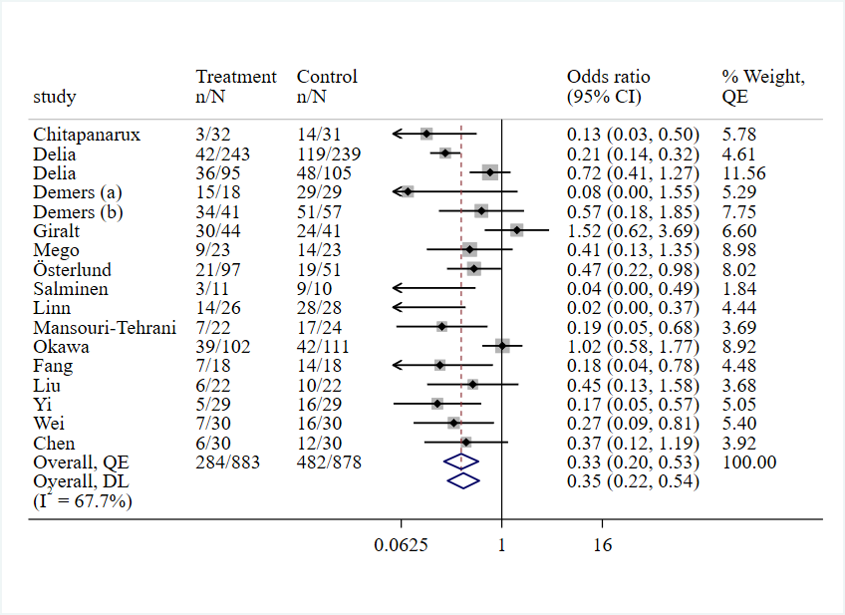
Supplementary Figure 1: The effect of probiotics on the incidence of diarrhea (any grade)

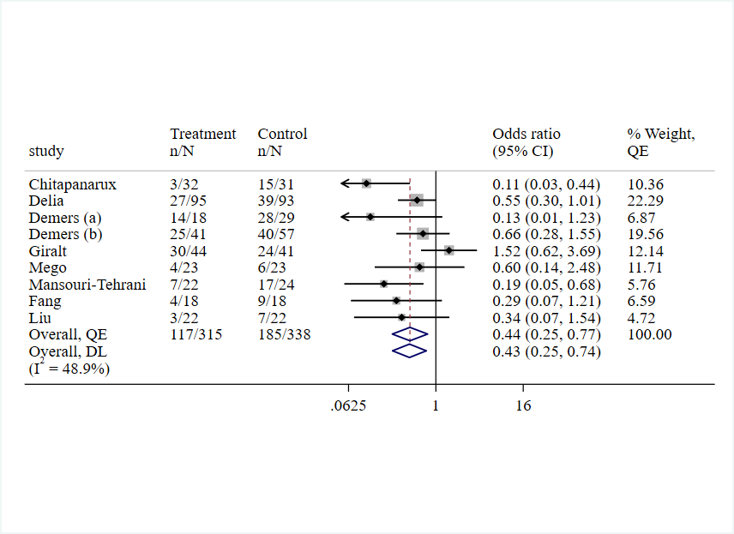
Supplementary Figure 2: The effect of probiotics on the incidence of grade ≥2 diarrhea

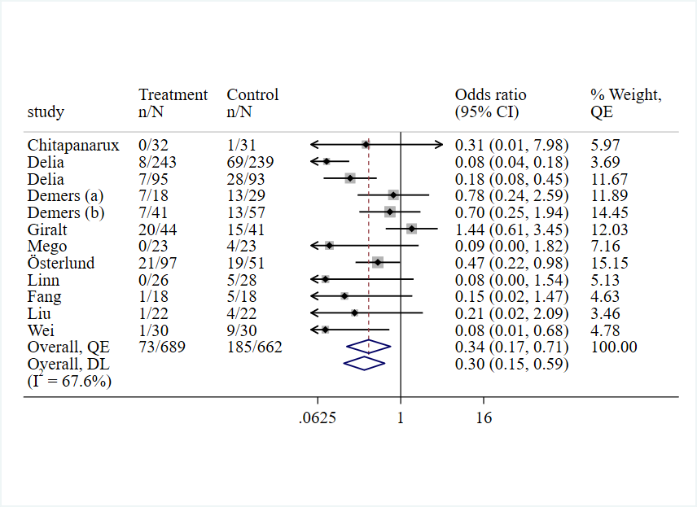
Supplementary Figure 3: The effect of probiotics on the incidence of grade ≥3 diarrhea

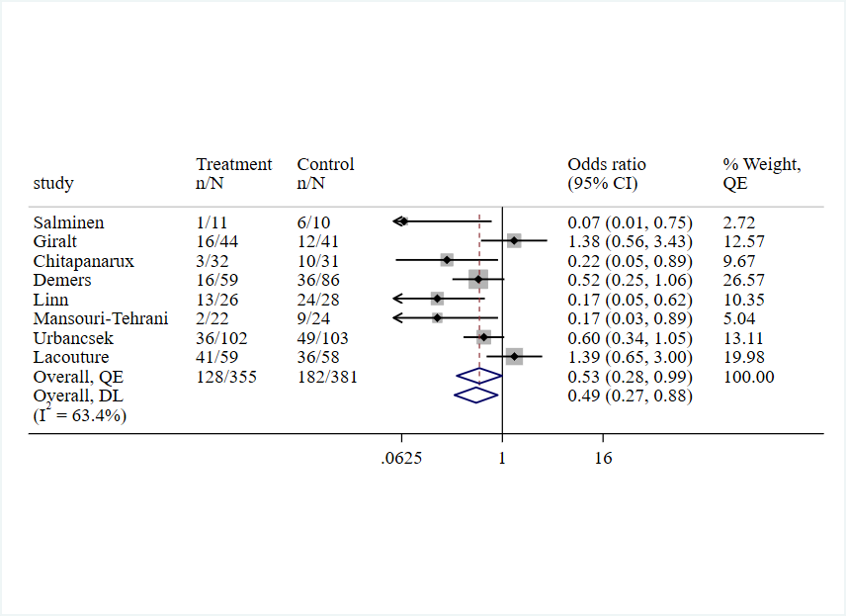
Supplementary Figure 4: The effect of probiotics on the use of antidiarrheal drug

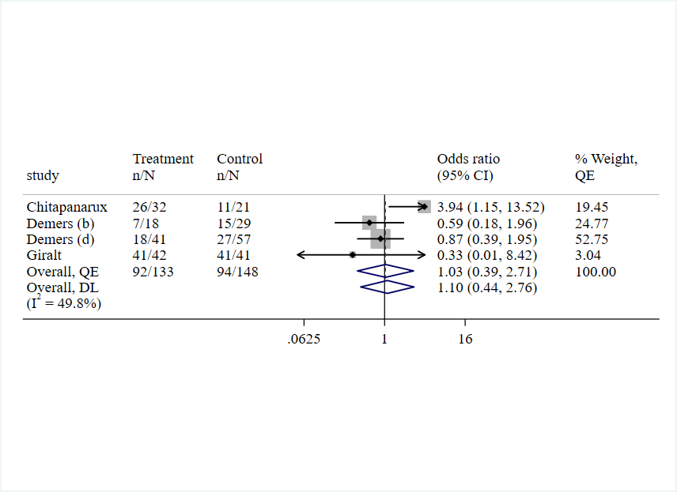
Supplementary Figure 5: The effect of probiotics on the incidence of soft stool consistency

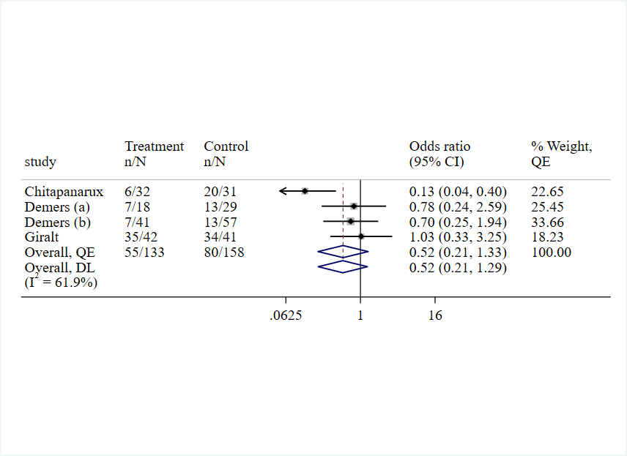
Supplementary Figure 6: The Effect of probiotics on the incidence of watery stool consistency

Supplementary References:
1. Abt E (2021) PROBIOTICS MAY LOWER THE RISK OF ORAL MUCOSITIS IN CANCER PATIENTS. The journal of evidence-based dental practice 21, 101639.
2. Amitay EL, Carr PR, Gies A et al. (2020) Probiotic/Synbiotic Treatment and Postoperative Complications in Colorectal Cancer Patients: Systematic Review and Meta-analysis of Randomized Controlled Trials. Clinical and translational gastroenterology 11, e00268.
3. Cogo E, Elsayed M, Liang V et al. (2021) Probiotics Evaluation in Oncological Surgery: A Systematic Review of 36 Randomized Controlled Trials Assessing 21 Diverse Formulations. Current oncology (Toronto, Ont) 28, 5192-5214.
4. Chen C, Wen T, Zhao Q (2020) Probiotics Used for Postoperative Infections in Patients Undergoing Colorectal Cancer Surgery. BioMed research international 2020, 5734718.
5. Colov EP, Degett TH, Raskov H et al. (2020) The impact of the gut microbiota on prognosis after surgery for colorectal cancer - a systematic review and meta-analysis. APMIS : acta pathologica, microbiologica, et immunologica Scandinavica 128, 162-176.
6. Calaca PRD, Bezerra RP, Albuquerque WWC et al. (2017) Probiotics as a preventive strategy for surgical infection in colorectal cancer patients: a systematic review and meta-analysis of randomized trials. Translational gastroenterology and hepatology 2.
7. Cao M, Wang M, Song F (2017) Effect of probiotics treatment on prevention of chemotherapy and radiation-related diarrhea among cancer patients: A Meta-Analysis of randomized controlled trials. Tumor 37, 650-656 and 680.
8. Fuccio L, Guido A, Eusebi LH et al. (2009) Effects of probiotics for the prevention and treatment of radiation-induced diarrhea. Journal of clinical gastroenterology 43, 506-513.
9. He D, Wang HY, Feng JY et al. (2013) Use of pro-/synbiotics as prophylaxis in patients undergoing colorectal resection for cancer: a meta-analysis of randomized controlled trials. Clinics and research in hepatology and gastroenterology 37, 406-415.
10. Henson CC, Burden S, Davidson SE et al. (2013) Nutritional interventions for reducing gastrointestinal toxicity in adults undergoing radical pelvic radiotherapy. The Cochrane database of systematic reviews, Cd009896.
11. Hamad A, Fragkos KC, Forbes A (2013) A systematic review and meta-analysis of probiotics for the management of radiation induced bowel disease. Clinical Nutrition 32, 353-360.
12. Kamaluddin W, Rismayuddin NAR, Ismail AF et al. (2020) Probiotic inhibits oral carcinogenesis: A systematic review and meta-analysis. Archives of oral biology 118.
13. Lytvyn L, Quach K, Banfield L et al. (2016) Probiotics and synbiotics for the prevention of postoperative infections following abdominal surgery: a systematic review and meta-analysis of randomized controlled trials. Journal of Hospital Infection 92, 130-139.
14. Ouyang X, Li Q, Shi M et al. (2019) Probiotics for preventing postoperative infection in colorectal cancer patients: a systematic review and meta-analysis. International journal of colorectal disease 34, 459-469.
15. Rodriguez-Arrastia M, Martinez-Ortigosa A, Rueda-Ruzafa L et al. (2021) Probiotic Supplements on Oncology Patients' Treatment-Related Side Effects: A Systematic Review of Randomized Controlled Trials. International journal of environmental research and public health 18.
16. Redman MG, Ward EJ, Phillips RS (2014) The efficacy and safety of probiotics in people with cancer: a systematic review. Annals of oncology : official journal of the European Society for Medical Oncology 25, 1919-1929.
17. Shu Z, Li P, Yu B et al. (2020) The effectiveness of probiotics in prevention and treatment of cancer therapy-induced oral mucositis: A systematic review and meta-analysis. Oral oncology 102, 104559.
18. Suadoni MT (2014) Are probiotics more efficacious than placebo at preventing radiotherapy-induced diarrhoea in adults with cancer. Journal of Radiotherapy in Practice 13, 226-235.
19. Sun J, Wang H, Hu H (2012) Glutamine for chemotherapy induced diarrhea: a meta-analysis. Asia Pacific journal of clinical nutrition 21, 380-385.
20. Tang G, Zhang LY, Tao J et al. (2021) Effects of Perioperative Probiotics and Synbiotics on Pancreaticoduodenectomy Patients: A Meta-Analysis of Randomized Controlled Trials. Frontiers in nutrition 8.
21. Wei D, Heus P, van de Wetering FT et al. (2018) Probiotics for the prevention or treatment of chemotherapyor-radiotherapy-related diarrhoea in people with cancer. Cochrane Database of Systematic Reviews.
22. Wu XD, Xu W, Liu MM et al. (2018) Efficacy of prophylactic probiotics in combination with antibiotics versus antibiotics alone for colorectal surgery: A meta-analysis of randomized controlled trials. Journal of Surgical Oncology 117, 1394-1404.
23. Wedlake L, Shaw C, Whelan K et al. (2013) Systematic review: the efficacy of nutritional interventions to counteract acute gastrointestinal toxicity during therapeutic pelvic radiotherapy. Alimentary pharmacology & therapeutics 37, 1046-1056.
24. Yang ZP, Wu Q, Liu YF et al. (2017) Effect of Perioperative Probiotics and Synbiotics on Postoperative Infections After Gastrointestinal Surgery: A Systematic Review With Meta-Analysis. Journal of Parenteral and Enteral Nutrition 41, 1051-1062.
25. Zeng J, Ji Y, Liang B et al. (2021) The effect of pro/synbiotics on postoperative infections in colorectal cancer patients: A systematic review and meta-analysis. Complementary therapies in clinical practice 43, 101370.
26. Bartsch B, Then CK, Harriss E et al. (2021) The role of dietary supplements, including biotics, glutamine, polyunsaturated fatty acids and polyphenols, in reducing gastrointestinal side effects in patients undergoing pelvic radiotherapy: A systematic review and meta-analysis. Clinical and Translational Radiation Oncology 29, 11-19.
27. Devaraj NK, Suppiah S, Veettil SK et al. (2019) The Effects of Probiotic Supplementation on the Incidence of Diarrhea in Cancer Patients Receiving Radiation Therapy: A Systematic Review with Meta-Analysis and Trial Sequential Analysis of Randomized Controlled Trials. Nutrients 11.
28. Hassan H, Rompola M, Glaser AW et al. (2018) Systematic review and meta-analysis investigating the efficacy and safety of probiotics in people with cancer. Supportive care in cancer : official journal of the Multinational Association of Supportive Care in Cancer 26, 2503-2509.
29. Lin S, Shen Y (2020) The efficacy and safety of probiotics for prevention of chemoradiotherapy-induced diarrhea in people with abdominal and pelvic cancer: A systematic review and meta-analysis based on 23 randomized studies. International journal of surgery (London, England) 84, 69-77.
30. Lu D, Yan J, Liu F et al. (2019) Probiotics in preventing and treating chemotherapy-induced diarrhea: a meta-analysis. Asia Pacific journal of clinical nutrition 28, 701-710.
31. Liu PC, Yan YK, Ma YJ et al. (2017) Probiotics Reduce Postoperative Infections in Patients Undergoing Colorectal Surgery: A Systematic Review and Meta-Analysis. Gastroenterology Research and Practice 2017.
32. Qiu G, Yu Y, Wang Y et al. (2019) The significance of probiotics in preventing radiotherapy-induced diarrhea in patients with cervical cancer: A systematic review and meta-analysis. International journal of surgery (London, England) 65, 61-69.
33. Wardill HR, Van Sebille YZA, Ciorba MA et al. (2018) Prophylactic probiotics for cancer therapy-induced diarrhoea: a meta-analysis. Current opinion in supportive and palliative care 12, 187-197.
34. Wang YH, Yao N, Wei KK et al. (2016) The efficacy and safety of probiotics for prevention of chemoradiotherapy-induced diarrhea in people with abdominal and pelvic cancer: a systematic review and meta-analysis. European journal of clinical nutrition 70, 1246-1253.

