Ultra-processed foods in a rural Ecuadorian community: associations with child anthropometry and bone maturation
SUPPLEMENTARY DATA
Supplementary Figure 1
Male at 32 months | Female at 36 months
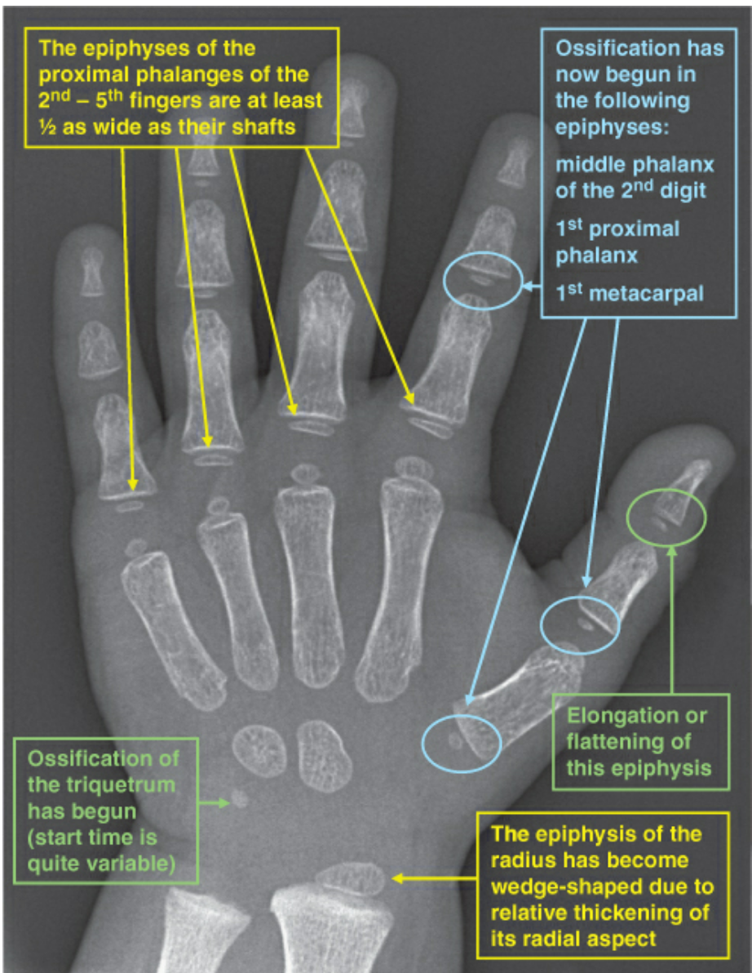 | 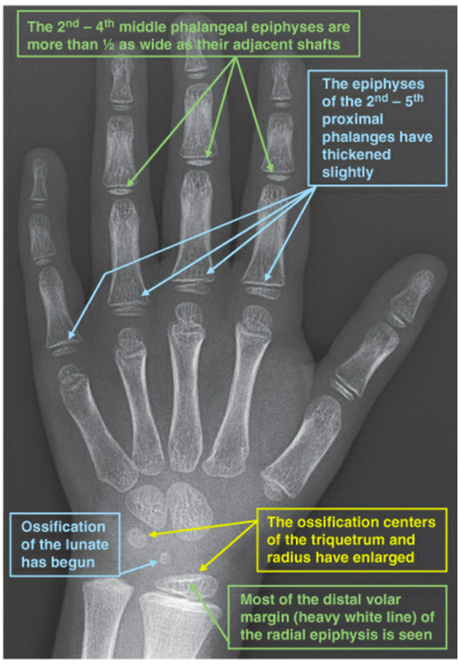
Images from: Gaskin CM, Kahn MM, Bertozzi JC, Bunch PM. Skeletal development of the hand and wrist: a radiographic atlas and digital bone age companion. Oxford University Press; 2011 Feb 1. Used with permission from publisher.

Supplementary Table 1: Ossification centers evaluated by age and sex of child based on standards of Greulich and Pyle
Age (months) | Male Child | Female Child
3 | - Capitate  - Hamate | - Capitate  - Hamate
12 | No new ossification | - Distal radial epiphysis  - Second metacarpal  - Second proximal phalanx  - Third metacarpal  - Third proximal phalanx  - Fourth proximal phalanx
15 | - Distal radial epiphysis | - Fourth metacarpal  - Thumb distal phalanx
18 | - Second metacarpal  - Second proximal phalanx  - Third proximal phalanx  - Fourth metacarpal  - Fourth proximal phalanx  - Thumb distal phalanx | - Fifth metacarpal  - Fifth proximal phalanx
24 | - Fifth metacarpal  - Fifth proximal phalanx  - Third middle and distal phalanx  - Fourth middle and distal phalanx | - Triquetrum  - Thumb metacarpal  - Thumb proximal phalanx
30 | NA | - Second distal phalanx  - Fifth middle phalanx
32 | - Thumb metacarpal  - Thumb proximal phalanx  - Triquetrum  - Second middle phalanx  - Second distal phalanx  - Fifth distal phalanx | NA
36 | - Lunate | - Lunate
42 | No new ossification, but size and morphology of second distal phalanx and fifth distal phalanx were evaluated | - Trapezium
48 | - Trapezium, all phalanges (evaluated for size and morphology) | NA
50 | NA | - Scaphoid  - Trapezoid

Supplementary Table 2: Bone-age mediated relationships between UPF consumption and linear growth indicators
UPF Intake | Direct effect (Bootstrap 95% CI) | P valueª | Indirect effect  (Bootstrap 95% CI) | P valueª
HAZ
Tertile 1 | Reference
Tertile 2 | 0.08  (-0.28—0.44) | 0.04 | 0.09  (-0.01—0.19) | 0.15
Tertile 3 | -0.36  (-0.74—0.02) |  | 0.11  (-0.01—0.23)
Stunting
Tertile 1 | Reference
Tertile 2 | 0.09  (-0.85—1.04) | 0.07 | -0.21  (-0.46—0.04) | 0.23
Tertile 3 | 1.07  (0.06—2.07) |  | -0.25  (-0.56—0.06)
ª Wald Chi-squared test
* Bolded P values indicate significance for Wald Chi-squared test.

Supplementary Table 3: List of ultra-processed foods sampled and summary of individual nutrition profilesª
ID | Product name | Energy, kJ | Energy, kcal | Saturated fat, g | Energy from saturated fats, kcal | Free sugars, g | Energy from free sugars, kcal | Sodium,  mg | Fiber, g | Protein, g | Percentage of whole fruit, vegetables, or nuts^{b}
1 | Sorbetitos Sami‡ | 1680 | 401.52 | 0 | 0 | 100 | 400 | 0 | 0 | 0 | 0
2 | Doritos Lemon Remix | 2096.7 | 501.1113 | 9.99 | 89.91 | 0 | 0 | 765.9 | 0 | 6.66 | 0
3 | Gelactica (Gomitas de Frutas/Jelly Fruit) ‡ | 420 | 100.38 | 0 | 0 | 25 | 100 | 0 | 0 | 0 | 0
4 | Recontra Acido boca loca (Red) ‡ | 840 | 200.76 | 0 | 0 | 20 | 80 | 0 | 0 | 0 | 0
5 | Sabor Uva Lengua‡ | 1260 | 301.14 | 0 | 0 | 75.3 | 301.2 | 20 | 0 | 0 | 0
6 | Chicle perlitas acido‡ | 1260 | 301.14 | 0 | 0 | 80 | 320 | 0 | 0 | 0 | 0
7 | Paletaufo Krazymon Maracuyá con Sal y Lemon‡ | 1260 | 301.14 | 0 | 0 | 50 | 200 | 10600 | 0 | 0 | 0
8 | Papa Nic Maracuya | 1726.1 | 412.5379 | 0 | 0 | 0 | 0 | 2735.2 | 10.52 | 15.78 | 0
9 | Papa Nic Limon | 1465 | 350.135 | 0 | 0 | 0 | 0 | 2700 | 10 | 15 | 0
10 | Recontra Acido boca loca (yellow)‡ | 840 | 200.76 | 0 | 0 | 20 | 80 | 0 | 0 | 0 | 0
11 | Chicle perlitas‡ | 1260 | 301.14 | 0 | 0 | 80 | 320 | 0 | 0 | 0 | 0
12 | Gelatina Sabor a frutas‡ | 24.31 | 5.81009 | 0 | 0 | 0 | 0 | 0 | 0 | 0 | 0
13 | Paletaufo Krazymon Mango con Sal y Lemon‡ | 1260 | 301.14 | 0 | 0 | 50 | 200 | 10600 | 0 | 0 | 0
14 | Los Habiteñitos Habitas ^{c} | 2510 | 599.89 | 10 | 90 | 0 | 0 | 550 | 20.5 | 20 | 0
15 | Nucita (Crema con sabor a leche, chocolate y nueces) ‡ | 2138 | 510.982 | 4.44 | 39.96 | 60 | 240 | 122 | 0 | 2.22 | 0
16 | Salticas Galletas Salatidas | 2094.6 | 500.6094 | 8.33 | 74.97 | 6.66 | 26.64 | 799 | 0 | 3 | 0
17 | TaniLact^{d‡} | 408.1 | 97.5359 | 1.59 | 14.31 | 8.48 | 33.92 | 42.4 | 0 | 2.12 | 0
18 | Colombina Piazza (barquillos Sabor a malteada de fresa) ‡ | 2108.7 | 503.9793 | 11.6 | 104.4 | 38.8 | 155.2 | 78 | 3.9 | 3.88 | 0
19 | Circus Galletas con crema sabor a fresa‡ | 1945.7 | 465.0223 | 8.93 | 80.37 | 32.1 | 128.4 | 410.6 | 0 | 3.6 | 0
20 | Topsy choc ice cream‡ | 500.5 | 119.6195 | 4.59 | 41.31 | 8.25 | 33 | 12.87 | 0 | 0 | 0
21 | Yellies Marshmallows (helados rellemos)^{e‡} | 1260 | 301.14 | 0 | 0 | 60 | 240 | 0 | 0 | 0 | 0
22 | Tango Báilate (Sabor a chocolate)^{f‡} | 2180 | 521.02 | 12 | 108 | 44 | 176 | 160 | 1.6 | 4 | 0
23 | Pipa Chos | 2725 | 651.275 | 5 | 45 | 0 | 0 | 250 | 5 | 15 | 0
24 | Led Chupi Tops‡ | 1400 | 334.6 | 0 | 0 | 62.5 | 250 | 37.5 | 0 | 0 | 0
25 | Golpe Oblea Rellena Cubrieta con Caramelo y Cereal Crocante‡ | 2171.9 | 519.0841 | 11.1 | 99.9 | 59.2 | 236.8 | 111 | 3.7 | 3.7 | 0
26 | Orbita Galettas Rellenas con Crema Sabor a vanilla con Cobertura sabor a chocolate‡ | 2012 | 480.868 | 16 | 144 | 36 | 144 | 120 | 0 | 4 | 0
27 | Frunas Frutas‡ | 354 | 84.606 | 2.08 | 18.72 | 56.2 | 224.8 | 0 | 0 | 0 | 0
28 | Colombina Max (Frutacidas) ‡ | 353 | 84.367 | 0 | 0 | 64.7 | 258.8 | 59 | 0 | 0 | 0
ª All quantities are per 100g of product sample.
^{b} Per UK NPM guidelines, excludes seeds which are not explicitly considered as nuts. Product items 14 and 23 include whole seeds—fava beans and sunflower seeds, respectively.
^{c} Sugar and fiber content based on USDA estimates for fiber and sugar in fava beans, the primary ingredient for this product.
^{d} Values adjusted for the density of yogurt (1.06 g/ml).
^{e} Fat content based on USDA estimates for fat in marshmallows, the primary ingredient for this product.
^{f} Fiber content based on USDA estimates for fiber in a generic chocolate wafer.
‡ Indicates sugary/sweetened snack

