Supplementary Material

Supplementary table 1. Classification criteria of DBI-16 indicators 2
Supplementary table 2. The variance inflation factor (VIF) of multiple linear regression in this study 3
Supplementary table 3. Metabolic characteristics in pregnancy of participants 4
Supplementary table 4. Participants’ dietary intakes during lactation 6
Supplementary table 5 Dietary intake of “Meat-Vegetable-Cereal” pattern during lactation 7
Supplementary table 6. Dietary intake of “Nut-Soybean” pattern during lactation 9
Supplementary table 7. Characteristics of DBI-16 indicators in this study 11
Supplementary figure 1. DAG for the association of human milk leptin with maternal metabolism in pregnancy and diet during lactation 12
Supplementary figure 2. Spearman correlation analyses among 23 metabolic profiles 13
Supplementary figure 3. Importance of selected variables of 23 metabolic profiles in pregnancy associated with breast milk leptin using LASSO regression model 14
Supplementary figure 4. Scree plot of PCA 15
Supplementary figure 5. Characteristics of DBI-16 components scores 16
Supplementary figure 6. Importance of selected variables of 28 predictors associated with breast milk leptin using LASSO regression model considering joint effect of metabolism in pregnancy and dietary patterns during lactation 17

Supplementary table 1. Classification criteria of DBI-16 indicators
DBI-16 indicators | DBI component scores
HBS
almost no diet problem | 0-9
low level | 10-18
moderate level | 19-27
high level | >27
LBS
almost no diet problem | 0-14
low level | 15-28
moderate level | 29-43
high level | >43
DQD
almost no diet problem | 0-19
low level | 20-38
moderate level | 39-57
high level | >57
Abbreviations: HBS, high bound score; LBS, low bound score; DQD, diet quality distance.

Supplementary table 2. The variance inflation factor (VIF) of multiple linear regression in this study
Independent variable | Adjustment | VIF
Metabolic profiles in pregnancy selected by LASSO
 | No | 1.31
 | Yes | 1.34
“Meat-Cereal-Vegetable” pattern
 | No | 1.51
 | Yes | 1.23
“Nut-Soybean” pattern
 | No | 1.51
 | Yes | 1.24
DBI-HBS
 | No | 1.01
 | Yes | 1.11
DBI-LBS
 | No | 1.85
 | Yes | 1.44
DBI-DQD
 | No | 1.97
 | Yes | 1.41
Metabolic profiles in pregnancy and dietary patterns during lactation selected by LASSO
 | No | 1.45
 | Yes | 1.39
Abbreviations: VIF, variance inflation factor; LASSO, least absolute shrinkage and selection operator; HBS, high bound score; LBS, low bound score; DQD, diet quality distance.

Supplementary table 3. Metabolic characteristics in pregnancy of participants
Characteristics | Value (n=295) *
Protein metabolism
TP (g/L) | 66.1 (64.3-68.5)
ALB (g/L) | 36.4 (35.1-37.9)
GLB (g/L) | 30.0 (28.3-31.6)
Glucolipid metabolism
GLU (mmol/L) | 4.25 (4.02-4.52)
TG (mmol/L) | 2.11 (1.74-2.64)
TC (mmol/L) | 6.19 (5.53-6.76)
HDL-C (mmol/L) | 2.01 (1.79-2.21)
LDL-C (mmol/L) | 3.48 (3.01-3.93)
Calcium and phosphorous metabolism
Ca (mmol/L) | 2.24 (2.20-2.30)
IP (mmol/L) | 1.20 (1.13-1.27)
Bilirubin metabolism
TBIL (umol/L) | 9.0 (7.7-10.9)
DBIL (umol/L) | 2.8 (2.3-3.4)
IBIL (umol/L) | 6.3 (5.5-7.6)
Enzymatic activity
ALT (U/L) | 15 (12-22)
AST (U/L) | 18 (15-22)
GGT (U/L) | 11 (9-14)
ALP (U/L) | 63 (54-72)
LDH (U/L) | 154 (140-172)
α-HBDH (U/L) | 126 (106-143)
CK (U/L) | 39 (31-49)
Renal function
Urea (mmol/L) | 2.88 (2.42-3.29)
CRE (umol/L) | 46 (42-50)
UA (umol/L) | 243 (212-274)
Abbreviations: TP, total protein; ALB, albumin; GLB, globulin; GLU, glucose; TG, triglyceride; TC, total cholesterol; HDL-C, high-density lipoprotein cholesterol; LDL-C, low-density lipoprotein cholesterol; IP, inorganic phosphorus; TBIL, total bilirubin; DBIL, direct bilirubin; IBIL, indirect bilirubin; ALT, alanine aminotransferase; AST, aspartate aminotransferase; GGT, gamma-glutamyl transferase; ALP, alkaline phosphatase; LDH, lactate dehydrogenase; α-HBDH, alpha-hydroxybutyrate dehydrogenase; CK, creatine kinase; CRE, creatinine; UA, uric acid.
* Values were median (IQR).

Supplementary table 4. Participants’ dietary intakes during lactation
Food groups | Intakes (n = 270)*
Cereal (g/d) | 205 (146-300)
Tuber (g/d) | 21 (5-50)
Soybean (g/d) | 29 (10-72)
Vegetable (g/d) | 471 (296-675)
Fungi and algae (g/d) | 10 (0-43)
Fruit (g/d) | 201 (100-300)
Nut and seed (g/d) | 3 (0-13)
Meat and poultry (g/d) | 95 (55-171)
Milk (g/d) | 200 (54-250)
Egg (g/d) | 79 (60-120)
Fish and shrimp (g/d) | 21 (8-43)
Snack (g/d) | 0 (0-3)
Beverage (g/d) | 0 (0-4)
Oil (g/d) | 20 (18-25)
Condiment (g/d) | 11 (0-21)
* Values were median (IQR).

Supplementary table 5 Dietary intake of “Meat-Vegetable-Cereal” pattern during lactation
Food groups/  Nutritional component | “Meat-Vegetable-Cereal” pattern* |  |  |  | r_{s} | P value
 | Q1 (n = 67) | Q2 (n = 68) | Q3 (n = 68) | Q4 (n = 67)
Food groups
Cereal(g/d) | 150 (95-200) | 199 (151-286) | 230 (164-308) | 300 (210-425) | 0.45 | <0.001
Tuber(g/d) | 14 (3-29) | 29 (4-65) | 21 (7-46) | 23 (5-58) | 0.04 | 0.468
Soybean(g/d) | 18 (6-79) | 27 (9-57) | 32 (15-73) | 44 (14-86) | 0.17 | 0.005
Vegetable(g/d) | 280 (143-337) | 405 (269-587) | 599 (457-804) | 671 (486-975) | 0.58 | <0.001
Fungi and algae(g/d) | 3 (0-29) | 9 (0-32) | 16 (0-43) | 29 (0-200) | 0.20 | 0.001
Fruit(g/d) | 200 (88-300) | 204 (113-300) | 213 (143-308) | 200 (86-300) | 0.00 | 0.944
Nut and seed(g/d) | 2 (0-15) | 5 (0-15) | 3 (0-11) | 6 (0-13) | -0.01 | 0.902
Meat and poultry(g/d) | 48 (31-66) | 86 (66-113) | 144 (90-187) | 195 (107-273) | 0.65 | <0.001
Milk(g/d) | 250 (71-400) | 165 (56-250) | 200 (49-250) | 125 (6-250) | -0.14 | 0.025
Egg(g/d) | 88 (60-150) | 100 (60-130) | 70 (60-120) | 65 (50-120) | -0.15 | 0.016
Fish and shrimp(g/d) | 8 (2-18) | 15 (9-35) | 29 (14-43) | 62 (21-126) | 0.56 | <0.001
Snack(g/d) | 0 (0-4) | 0 (0-1) | 0 (0-4) | 0 (0-4) | 0.02 | 0.712
Beverage(g/d) | 0 (0-14) | 0 (0-4) | 0 (0-3) | 0 (0-0) | -0.13 | 0.028
Oil(g/d) | 20 (18-25) | 20 (18-25) | 20 (17-25) | 25 (18-45) | 0.16 | 0.007
Condiment(g/d) | 5 (0-15) | 11 (0-21) | 15 (6-21) | 13 (0-26) | 0.22 | <0.001
Nutritional component†
Energy(kcal/d) | 1377 (1038-1915) | 1549 (1342-1835) | 1810 (1594-2162) | 2248 (2029-2781) | 0.54 | <0.001
Protein(g/d) | 86.0 (77.8-94.5) | 89.5 (80.8-96.6) | 95.0 (83.5-104.4) | 92.5 (79.4-114.3) | 0.19 | 0.002
Fat(g/d) | 85.3 (72.7-97.9) | 81.6 (65.9-93.1) | 75.8 (61.1-90.6) | 68.9 (50.8-97.3) | -0.20 | 0.001
CHO(g/d) | 199.8 (174.3-232.6) | 214.2 (186.9-241.9) | 216.6 (178.1-242.5) | 219.9 (162.7-253.6) | 0.10 | 0.116
Dietary fiber(g/d) | 13.0 (9.7-15.2) | 14.7 (11.3-17.6) | 16.5 (13.2-19.0) | 15.1 (11.4-23.2) | 0.21 | 0.001
Cholesterol(mg/d) | 229 (151-283) | 248 (174-330) | 331 (210-427) | 335 (172-520) | 0.25 | <0.001
Vitamin A(μgRAE/d) | 2184 (1534-3696) | 2121 (1379-5792) | 2614 (1175-6837) | 2338 (950-6883) | 0.10 | 0.096
Thiamin(mg/d) | 0.98 (0.88-1.07) | 1.04 (0.92-1.15) | 1.09 (1.00-1.22) | 1.08 (0.89-1.26) | 0.26 | <0.001
Riboflavin(mg/d) | 2.07 (1.71-2.70) | 2.06 (1.68-3.11) | 2.30 (1.62-3.29) | 1.86 (1.46-3.15) | -0.01 | 0.911
Niacin(mg/d) | 14.80 (10.98-17.25) | 17.68 (14.91-20.42) | 20.30 (16.96-24.94) | 21.50 (16.70-30.62) | 0.49 | <0.001
Vitamin C(mg/d) | 134.05 (82.90-171.69) | 179.38 (116.84-236.35) | 231.94 (178.67-270.53) | 227.57 (158.09-342.39) | 0.41 | <0.001
Vitamin E(mg/d) | 23.58 (19.98-29.93) | 27.39 (22.73-33.63) | 27.18 (20.43-32.54) | 28.97 (25.01-35.69) | 0.20 | 0.001
Ca(mg/d) | 845 (696-1008) | 787 (683-941) | 869 (681-1016) | 871 (608-1079) | 0.00 | 0.950
P(mg/d) | 1419 (1296-1603) | 1438 (1359-1624) | 1536 (1384-1702) | 1519 (1291-1831) | 0.15 | 0.011
K(mg/d) | 3015 (2432-3493) | 3226 (2691-3652) | 3446 (3017-4010) | 3521 (2622-4574) | 0.24 | <0.001
Na(mg/d) | 2459.8 (1369.2-3690.8) | 3449.7 (1382.2-3922.3) | 3450.8 (2706.0-4007.5) | 3348.8 (1161.4-4694.9) | 0.10 | 0.107
Mg(mg/d) | 380 (330-457) | 459 (386-505) | 538 (426-605) | 559 (433-684) | 0.44 | <0.001
Fe(mg/d) | 25.5 (21.6-30.6) | 29.9 (23.2-39.7) | 34.3 (26.7-45.9) | 38.0 (25.2-52.0) | 0.32 | <0.001
Zn(mg/d) | 10.31 (8.86-11.73) | 11.96 (10.47-13.03) | 13.88 (12.21-14.96) | 14.85 (11.52-17.41) | 0.53 | <0.001
Se(μg/d) | 44.68 (37.85-54.85) | 56.69 (46.53-68.3) | 66.32 (53.72-79.85) | 74.02 (54.88-87.68) | 0.48 | <0.001
Cu(mg/d) | 1.55 (1.36-1.83) | 1.64 (1.40-1.98) | 1.68 (1.50-1.90) | 1.71 (1.34-2.17) | 0.13 | 0.038
Mn(mg/d) | 3.62 (2.78-4.20) | 4.49 (3.45-5.46) | 4.79 (4.00-5.52) | 5.19 (4.02-6.46) | 0.39 | <0.001
* Values represent median (IQR).
† Nutrient intakes adjusted by energy using the residual method.

Supplementary table 6. Dietary intake of “Nut-Soybean” pattern during lactation
Food groups/  Nutritional component | “Nut-Soybean” pattern* |  |  |  | r_{s} | P value
 | Q1 (n = 67) | Q2 (n = 68) | Q3 (n = 68) | Q4 (n = 67)
Food groups
Cereal (g/d) | 198 (129-275) | 211 (145-300) | 222 (152-312) | 218 (150-376) | 0.13 | 0.030
Tuber (g/d) | 4 (0-20) | 21 (7-40) | 29 (12-59) | 35 (11-89) | 0.38 | <0.001
Soybean (g/d) | 7 (0-19) | 30 (16-64) | 42 (20-98) | 55 (21-114) | 0.44 | <0.001
Vegetable (g/d) | 457 (300-680) | 497 (300-664) | 500 (264-686) | 428 (300-600) | -0.05 | 0.369
Fungi and algae (g/d) | 0 (0-36) | 11 (0-72) | 14 (0-42) | 14 (0-43) | 0.12 | 0.041
Fruit (g/d) | 191 (71-250) | 200 (113-250) | 200 (99-331) | 250 (175-407) | 0.28 | <0.001
Nut and seed (g/d) | 0 (0-0) | 3 (0-10) | 7 (2-15) | 15 (6-32) | 0.58 | <0.001
Meat and poultry (g/d) | 75 (38-163) | 87 (60-161) | 113 (53-182) | 100 (57-176) | 0.12 | 0.044
Milk (g/d) | 71 (0-200) | 250 (93-280) | 200 (57-250) | 250 (86-450) | 0.29 | <0.001
Egg (g/d) | 60 (43-120) | 90 (60-125) | 70 (60-120) | 100 (60-143) | 0.13 | 0.037
Fish and shrimp (g/d) | 14 (6-36) | 21 (8-40) | 23 (9-43) | 38 (14-64) | 0.23 | <0.001
Snack (g/d) | 0 (0-0) | 0 (0-1) | 0 (0-7) | 1 (0-17) | 0.35 | <0.001
Beverage (g/d) | 0 (0-0) | 0 (0-0) | 0 (0-22) | 0 (0-33) | 0.23 | <0.001
Oil (g/d) | 20 (16-25) | 20 (17-25) | 20 (20-30) | 25 (20-45) | 0.28 | <0.001
Condiment (g/d) | 0 (0-6) | 6 (0-16) | 15 (0-21) | 22 (12-32) | 0.52 | <0.001
Nutritional component†
Energy (kcal/d) | 1448 (976-1794) | 1730 (1329-2050) | 1835 (1501-2282) | 2157 (1828-2682) | 0.50 | <0.001
Protein (g/d) | 94.1 (84.1-101.8) | 93.8 (86.1-104.1) | 90.6 (77.7-102.2) | 84.4 (74.4-95.4) | -0.24 | <0.001
Fat (g/d) | 71.2 (60.1-85.2) | 75.4 (61.5-89.2) | 82.7 (68.5-95.3) | 89.4 (68-103.7) | 0.25 | <0.001
CHO (g/d) | 224.9 (191-249.4) | 214.6 (180.3-244.4) | 197.9 (167.9-244.2) | 197.2 (151.4-240.7) | -0.18 | 0.003
Dietary fiber (g/d) | 14.8 (11.6-17.5) | 14.8 (12.3-17.3) | 15.2 (11.3-18.4) | 13.9 (10.3-19.6) | -0.04 | 0.494
Cholesterol (mg/d) | 289 (205-387) | 284 (195-353) | 282 (187-563) | 195 (128-335) | -0.17 | 0.006
Vitamin A (μgRAE/d) | 3833 (1953-7634) | 3569 (1498-6108) | 2072 (1078-3539) | 1400 (709-2798) | -0.34 | <0.001
Thiamin (mg/d) | 1.08 (0.98-1.22) | 1.08 (1.00-1.16) | 1.07 (0.94-1.22) | 0.91 (0.76-1.00) | -0.31 | <0.001
Riboflavin (mg/d) | 2.53 (1.75-3.36) | 2.46 (1.82-3.13) | 1.97 (1.39-2.69) | 1.78 (1.38-2.55) | -0.25 | <0.001
Niacin (mg/d) | 18.76 (15.74-24.74) | 18.09 (15.00-22.63) | 17.85 (14.01-21.88) | 16.12 (10.92-21.06) | -0.18 | 0.004
Vitamin C (mg/d) | 188.14 (137.70-270.38) | 198.70 (140.01-251.82) | 183.70 (109.73-242.76) | 176.41 (110.50-227.57) | -0.14 | 0.024
Vitamin E (mg/d) | 23.29 (20.15-28.02) | 25.08 (21.16-29.43) | 28.91 (24.03-34.56) | 29.40 (23.31-38.90) | 0.27 | <0.001
Ca (mg/d) | 783 (655-944) | 872 (713-1033) | 819 (630-1013) | 859 (672-1019) | 0.04 | 0.490
P (mg/d) | 1473 (1298-1583) | 1519 (1379-1672) | 1492 (1254-1714) | 1481 (1302-1655) | 0.00 | 0.968
K (mg/d) | 3222 (2754-3749) | 3341 (2955-3872) | 3320 (2602-3982) | 3233 (2506-3871) | -0.02 | 0.764
Na (mg/d) | 1525.1 (1104.5-3400.1) | 3423.1 (1454.4-3922.0) | 3384.1 (1533.0-4053.3) | 3512.7 (2946.3-4485.5) | 0.29 | <0.001
Mg (mg/d) | 488 (397-591) | 466 (402-597) | 479 (370-557) | 435 (362-536) | -0.13 | 0.032
Fe (mg/d) | 35.8 (25.8-45.4) | 31.5 (24.5-42.5) | 29.0 (23.0-37.4) | 26.6 (19.9-35.0) | -0.25 | <0.001
Zn (mg/d) | 12.69 (10.56-14.85) | 12.18 (10.80-14.79) | 12.98 (11.26-14.92) | 11.40 (9.22-12.70) | -0.17 | 0.005
Se (μg/d) | 55.24 (43.97-73.11) | 59.04 (48.61-72.29) | 62.68 (46.09-76.60) | 59.75 (42.32-77.24) | 0.04 | 0.551
Cu (mg/d) | 1.58 (1.42-1.80) | 1.63 (1.40-1.74) | 1.78 (1.45-2.09) | 1.71 (1.24-2.34) | 0.15 | 0.016
Mn (mg/d) | 4.37 (3.61-5.46) | 4.59 (3.66-5.35) | 4.35 (3.37-5.68) | 4.50 (2.68-5.40) | -0.06 | 0.333
* Values represent median (IQR).
† Nutrient intakes adjusted by energy using the residual method.

Supplementary table 7. Characteristics of DBI-16 indicators in this study
DBI-16 indicators | n (%) | Leptin (pg/ml)
 |  | Median (IQR) | P value*
HBS |  |  | 0.313
almost no diet problem | 218 (80.7%) | 275.13 (126.56-537.91)
low level | 41 (15.2%) | 217.64 (69.10-402.60)
moderate/high level | 11 (4.1%) | 463.15 (120.41-745.94)
LBS |  |  | 0.289
almost no diet problem | 51 (18.9%) | 320.17 (162.33-737.55)
low level | 126 (46.7%) | 266.56 (96.06-525.03)
moderate/high level | 93 (34.4%) | 237.31 (125.61-486.78)
DQD |  |  | 0.012
almost no diet problem | 41 (15.2%) | 417.88 (187.67-731.57)
low level | 163 (60.4%) | 253.48 (96.06-485.78)
moderate/high level | 66 (24.4%) | 241.67 (121.29-601.92)
Abbreviations: HBS, high bound score; LBS, low bound score; DQD, diet quality distance.
* Kruskal-Wallis tests were used for group comparisons.

Supplementary figure 1. DAG for the association of human milk leptin with maternal metabolism in pregnancy and diet during lactation
Abbreviations: DAG, directed acyclic graph.

Supplementary figure 2. Spearman correlation analyses among 23 metabolic profiles
Abbreviations: TP, total protein; ALB, albumin; GLB, globulin; GLU, glucose; TG, triglyceride; TC, total cholesterol; HDL-C, high-density lipoprotein cholesterol; LDL-C, low-density lipoprotein cholesterol; IP, inorganic phosphorus; TBIL, total bilirubin; DBIL, direct bilirubin; IBIL, indirect bilirubin; ALT, alanine aminotransferase; AST, aspartate aminotransferase; GGT, gamma-glutamyl transferase; ALP, alkaline phosphatase; LDH, lactate dehydrogenase; α-HBDH, alpha-hydroxybutyrate dehydrogenase; CK, creatine kinase; CRE, creatinine; UA, uric acid.

Supplementary figure 3. Importance of selected variables of 23 metabolic profiles in pregnancy associated with breast milk leptin using LASSO regression model
Abbreviations: GLU, glucose; ALB, albumin; GGT, gamma-glutamyl transferase; LDH, lactate dehydrogenase; TP, total protein; CK, creatine kinase; AST, aspartate aminotransferase; LDL-C, low-density lipoprotein cholesterol; ALT, alanine aminotransferase; CRE, creatinine; ALP, alkaline phosphatase; HDL-C, high-density lipoprotein cholesterol; UA, uric acid; TBIL, total bilirubin; α-HBDH, alpha-hydroxybutyrate dehydrogenase; IBIL, indirect bilirubin; GLB, globulin; IP, inorganic phosphorus; TG, triglyceride; DBIL, direct bilirubin; TC, total cholesterol.

Supplementary figure 4. Scree plot of PCA
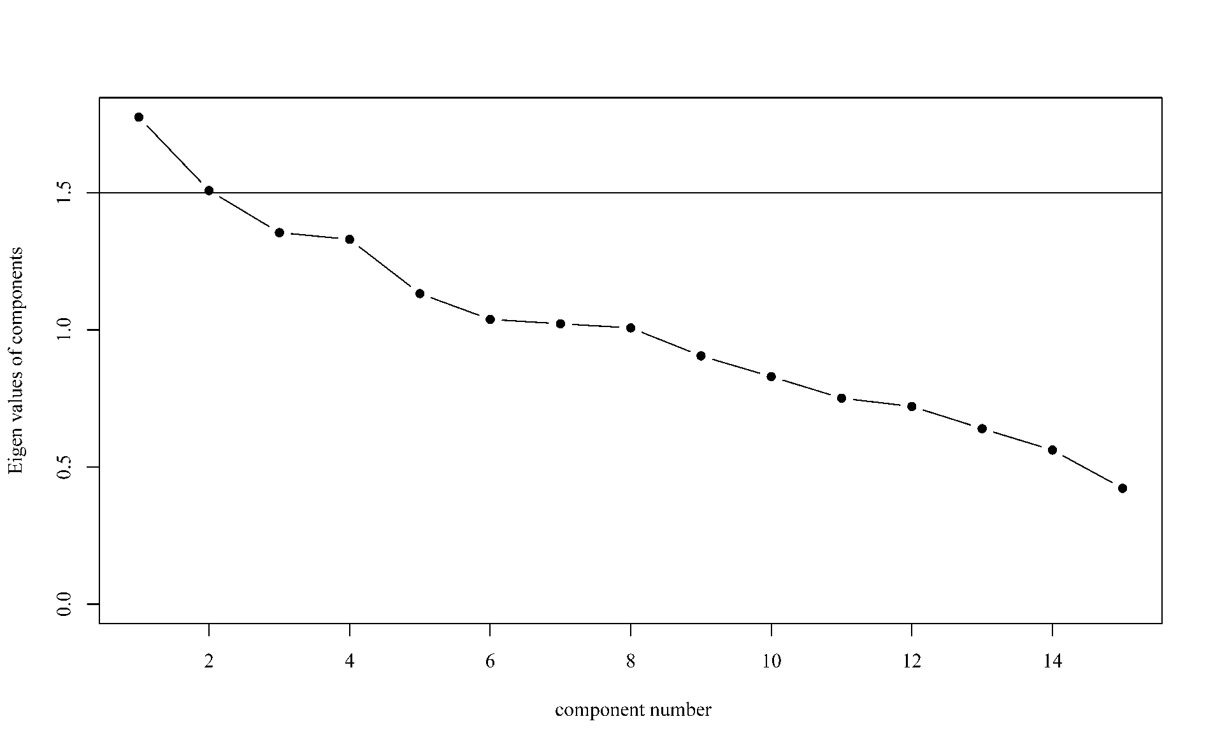

Supplementary figure 5. Characteristics of DBI-16 components scores
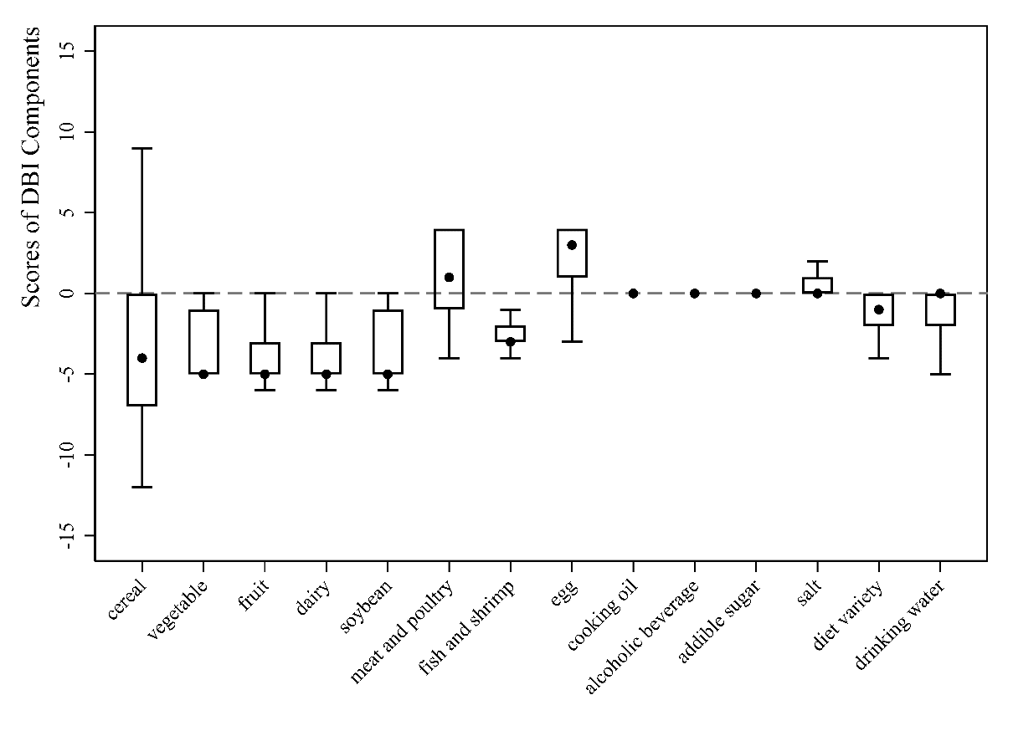

Supplementary figure 6. Importance of selected variables of 28 predictors associated with breast milk leptin using LASSO regression model considering joint effect of metabolism in pregnancy and dietary patterns during lactation
Abbreviations: GLU, glucose; ALB, albumin; GGT, gamma-glutamyl transferase; TP, total protein; DQD, diet quality distance; LDH, lactate dehydrogenase; CK, creatine kinase; LDL-C, low-density lipoprotein cholesterol; UA, uric acid; LBS, low bound score; IBIL, indirect bilirubin; DBIL, direct bilirubin; HBS, high bound score; ALT, alanine aminotransferase; HDL-C, high-density lipoprotein cholesterol; TBIL, total bilirubin; CRE, creatinine; AST, aspartate aminotransferase; GLB, globulin; TG, triglyceride; α-HBDH, alpha-hydroxybutyrate dehydrogenase; IP, inorganic phosphorus; ALP, alkaline phosphatase; TC, total cholesterol.

