Figure S1

Fig. S1 IF improves metabolism and promotes iWAT mitochondrial fusion in HFD mice.
(A) Blood serum concentrations of major metabolites between HFD with HFD-IF mice, n=3. (B) GTT (left) and ITT (right) analyses were performed (HFD n=3, HFD-IF n=3). (C) Identification of purified mitochondria of mice iWAT. (D) Janus Green B staining of HFD mice iWAT. Scale bar, 100 μm. * p < 0.05, ** p <0.01 compared with control group. Data are mean ± SEM.

Figure S2
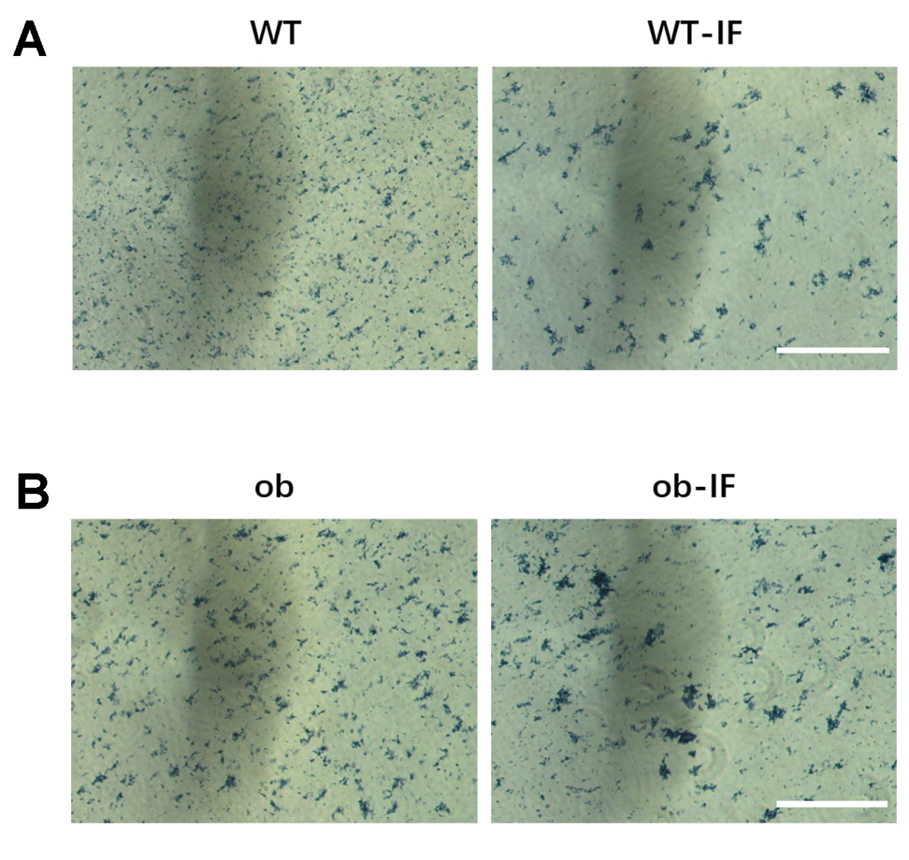
Fig. S2 IF leads to a tendency for mitochondria to fuse in wild-type and obese mice.
(A) Janus Green B staining of WT mice. Scale bar, 100 μm. (B) Janus Green B staining of obese mice. Scale bar, 100 μm.

Figure S3
Fig. S3 IF improves mitochondrial membrane potential in three models of mice.
(A) JC-1 staining and fluorescence quantification of iWAT mitochondria of HFD and HFD-IF mice. Scale bar, 100 μm. (B) JC-1 staining and fluorescence quantification of iWAT mitochondria of WT and WT-IF mice. Scale bar, 100 μm. (C) JC-1 staining and fluorescence quantification of iWAT mitochondria of ob and ob-IF mice. Scale bar, 100 μm. * p < 0.05, ** p <0.01 compared with control group. Data are mean ± SEM.

Figure S4
Fig. S4 Sirt3 promotes mitochondrial fusion and improves mitochondrial function in 3T3-L1 adipocytes.
(A) Identification of purified mitochondria of adipocytes. (B) Janus Green B staining. Scale bar, 300 μm. (C) Adipocytes ROS staining and fluorescence quantification. Scale bar, 100 μm. * p < 0.05, ** p <0.01 compared with control group. Data are mean ± SEM.

