Serum folate mediates the associations of MTHFR rs1801133 polymorphism with blood glucose levels and gestational diabetes mellitus in Chinese Han pregnant women
Yunguo Wang^{1,†}, Yiyun Wang^{2,3,†}, Yao Sun^{2,3}, Naijian Zhang³, Xiaoshan Liang^{3,4}, Suhui Luo^{3,4}, Lirong Dai⁵, Chao Sun⁵, Yungui Yang⁶, Shuying Li⁷, Xumei Zhang^{3,4}, Qiang Zhang^{2,3,*}
¹Department of Orthopedics Surgery, Second Hospital of Tianjin Medical University, Tianjin Medical University, Tianjin 300211, China
²Department of Occupational and Environmental Health, School of Public Health, Tianjin Medical University, Tianjin 300070, China
³Tianjin Key Laboratory of Environment, Nutrition and Public Health, School of Public Health, Tianjin Medical University, Tianjin 300070, China
⁴Department of Nutrition and Food Science, School of Public Health, Tianjin Medical University, Tianjin 300070, China
⁵Community Health Service Center of Yangliuqing Town, Tianjin 300380, China
⁶Community Health Service Center of Zhangjiawo Town, Tianjin 300393, China
⁷Department of Endocrinology, Tianjin Xiqing Hospital, Tianjin 300380, China

Short title: Folate mediates the effect of MTHFR on GDM
Key words: Gestational diabetes mellitus; MTHFR; Folate; Mediation effect

†These authors contributed equally to this work, and they shared co-first authorship.
*Corresponding author: Qiang Zhang; E-mail address: qiangzhang@tmu.edu.cn
Corresponding author at: Tianjin Key Laboratory of Environment, Nutrition and Public Health, School of Public Health, Tianjin Medical University, No. 22 Qixiangtai Road, Heping District, Tianjin 300070, China.
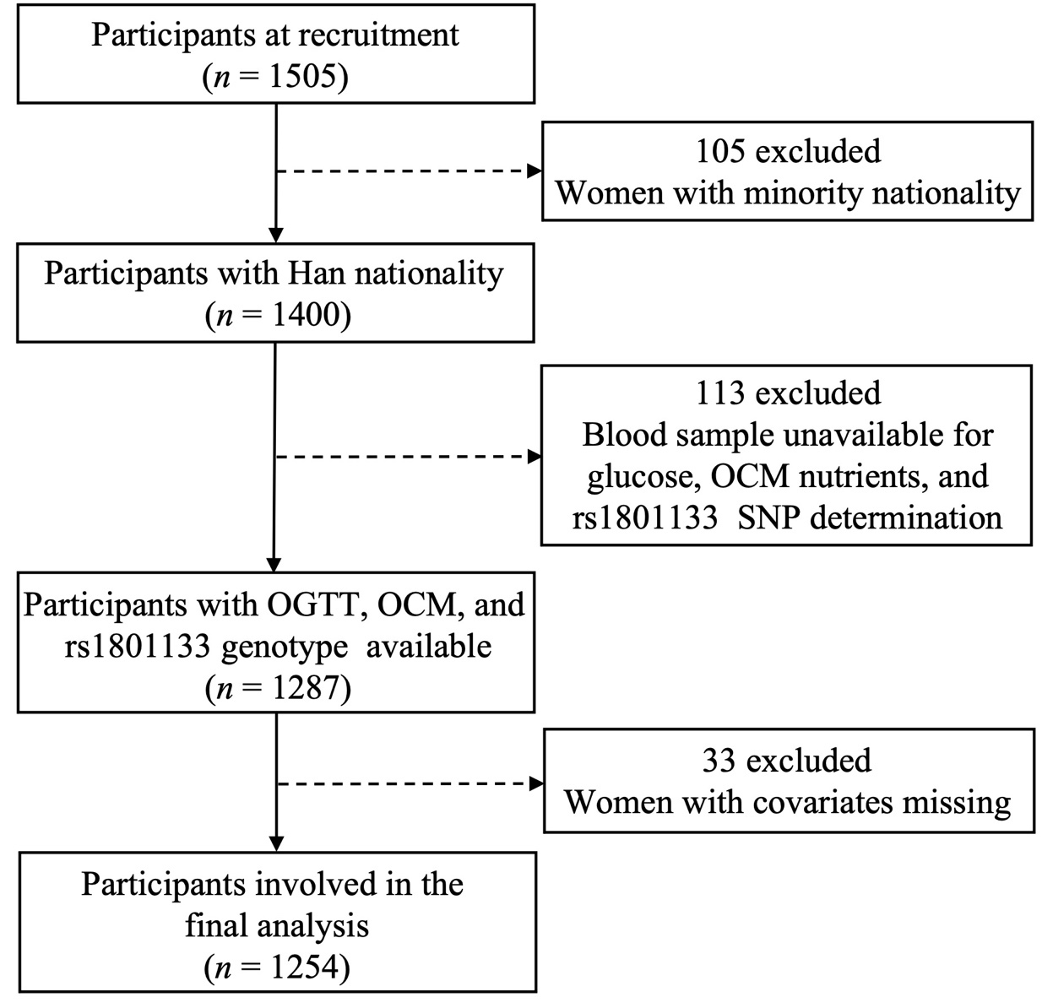
Supplementary Fig. 1 Study flowchart. OGTT, oral glucose tolerance test; OCM, one-carbon metabolism; SNP, single nucleotide polymorphism.
Supplementary Table 1 Distribution of MTHFR rs1801133 polymorphism in the study population
SNP | Gene | Genotype | n (%) | HWE P-values ª | Non-GDM | HWE P-values b | GDM | HWE P-values c
rs1801133 | MTHFR | CC | 240 (19.14) | 0.730 | 203 (84.58) | 0.338 | 37 (15.42) | 0.293
 |  | CT | 610 (48.64) |  | 481 (78.85) |  | 129 (21.15)
 |  | TT | 404 (32.22) |  | 322 (79.70) |  | 82 (20.30)
ª Hardy-Weinberg equilibrium checked in all subjects.
^{b} Hardy-Weinberg equilibrium checked in No-GDM subjects.
^{c} Hardy-Weinberg equilibrium checked in GDM subjects.

Supplementary Fig. 2 Spearman's correlation of serum folate, B₁₂, and Hcy. *** P < 0.001. Abbreviations: Hcy, homocysteine.

Supplementary Table 2 Association of MTHFR rs1801133 genotype with FPG, 1-h PG, and 2-h PG (n = 1254)
Per T allele increase in rs1801133 | FPG |  |  | 1-h PG |  |  | 2-h PG
 | β (95% CI) | P-values |  | β (95% CI) | P-values |  | β (95% CI) | P-values
Crude model | 0.01 (-0.02, 0.04) | 0.651 |  | 0.02 (-0.10 0.15) | 0.694 |  | -0.02 (-0.12, 0.08) | 0.694
Adjusted Model ª | -0.01 (-0.05, 0.02) | 0.463 |  | -0.03 (-0.16, 0.09) | 0.599 |  | -0.06 (-0.16, 0.05) | 0.285
ª Adjust for age, education, smoking, drinking, family history of diabetes, parity, prepregnancy BMI, serum folate, B₁₂, Hcy, and rs1801131 genotypes.

Supplementary Fig. 3 The mediation effect of B₁₂ on the association of MTHFR rs1801133 with (A) FPG, (B) 1-h PG, (C) 2-h PG, and (D) GDM in Chinese pregnant women. All models were adjusted for age, prepregnancy BMI, education, smoking, drinking, family history of diabetes, parity, rs1801131 genotypes, serum folate, and Hcy. a, regression coefficient of rs1801133 vs. B₁₂; b, regression coefficient of B₁₂ vs. FPG, 1-h PG, 2-h PG, and GDM; a*b, indirect effect, regression coefficient of the mediation effect; c, total effect, regression coefficient when rs1801133 vs. FPG, 1-h PG, 2-h PG, and GDM (no mediating variable B₁₂ in the model); c’, direct effect, regression coefficient when rs1801133 vs. FPG, 1-h PG, 2-h PG, and GDM (mediating variable B₁₂ in the model). * p < 0.05, ** p < 0.01, *** p < 0.001.
Supplementary Fig. 4 The mediation effect of Hcy on the association of MTHFR rs1801133 with (A) FPG, (B) 1-h PG, (C) 2-h PG, and (D) GDM in Chinese pregnant women. All models were adjusted for age, prepregnancy BMI, education, smoking, drinking, family history of diabetes, parity, rs1801131 genotypes, serum folate, and B₁₂. a, regression coefficient of rs1801133 vs. Hcy b, regression coefficient of Hcy vs. FPG, 1-h PG, 2-h PG, and GDM; a*b, indirect effect, regression coefficient of the mediation effect; c, total effect, regression coefficient when rs1801133 vs. FPG, 1-h PG, 2-h PG, and GDM (no mediating variable Hcy in the model); c’, direct effect, regression coefficient when rs1801133 vs. FPG, 1-h PG, 2-h PG, and GDM (mediating variable Hcy in the model). * p < 0.05, ** p < 0.01, *** p < 0.001.

