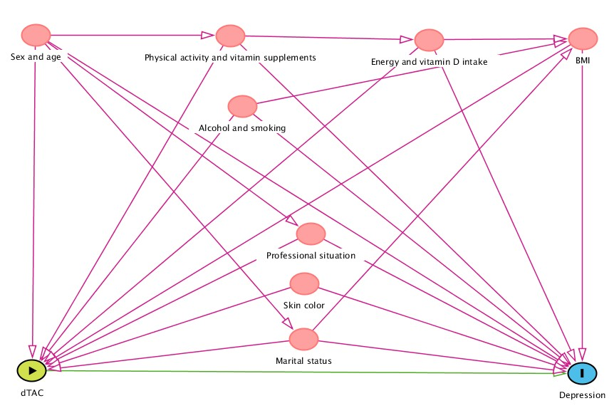
Supplementary figure 1. Direct acyclic graph (DAG) derived from previous literature search. Nodes represent variables, and arrows represent causal associations. Dietary Antioxidant Capacity (dTAC) is the exposure, and depression is the outcome. BMI (Body Mass Index).

