Supplementary
Supplementary Table 1 Intestinal sections and the ICD-codes included in the survival analysis
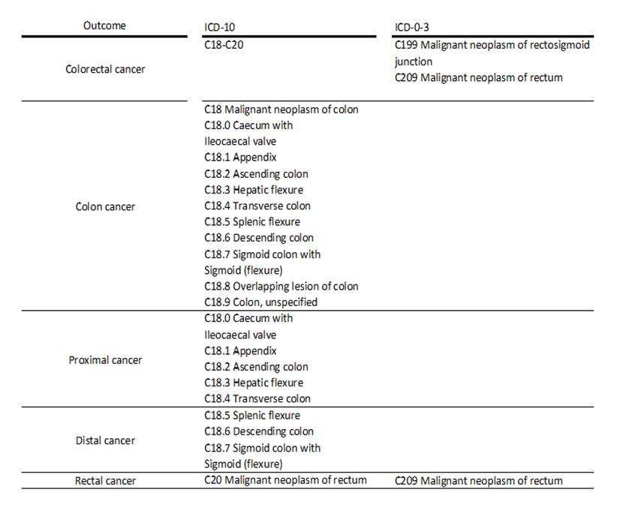

Supplementary Table 2 Selected characteristics of the study sample (n=95416) by vitamin D intake and colorectal cancer, colon cancer, proximal colon cancer, distal colon and rectal cancer at baseline (1996-2005). The Norwegian Woman and Cancer Cohort Study.
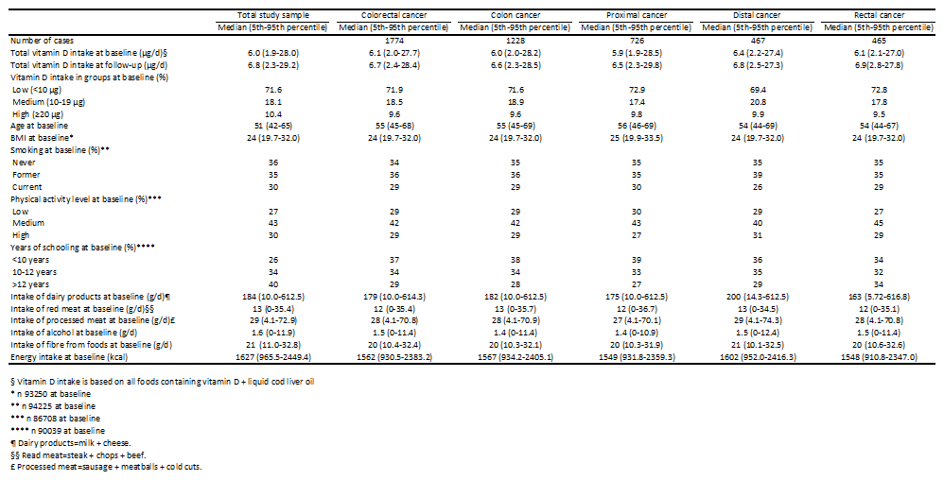
Supplementary Table 3 Percentage of vitamin D intake at baseline and follow-up (n 67527). The Norwegian Woman and Cancer Cohort Study (NOWAC).
