Table S1. Diet composition of the experimental diets
Ingredients (g/kg) | Control Diet | 60% Lysine  Deficient Diet
Wheat gluten*‖ | 188.2 | 196.1
Cornstarch | 388.1 | 387.6
Sucrose | 232 | 232.1
Corn oil | 70 | 70
Cellulose* | 50 | 50
Mineral mix*₶ | 35 | 35
Vitamin mix*£ | 10 | 10
Choline Bitartrate | 2.5 | 2.5
L-Methionine | 3 | 3
L-Threonine | 0.5 | 0.5
Potassium phosphate*¥ | 13.2 | 13.2
L-Lysine HCl*¶ | 7.5 | -

*Obtained from Dyets Inc., Bethlehem, Pennsylvania, USA.
‖The diets contained 10% protein coming exclusively from wheat gluten (76% protein).
₶"Phosphorus-free" mineral mix (AIN-93G mineral mix phosphorus-free, used as 35 g/kg of diet).
£Vitamin mix (AIN-93VX vitamin mix, used as 10 g/kg of diet).
¥Potassium phosphate KH2PO4, molecular weight 136 g/mol, of which phosphorus 31 g/mol.
¶L-Lysine HCl, molecular weight 182 g/mol, of which lysine 146 g/mol.

Table S2. The nutrition facts of the experimental diets
Nutrients | Control Diet | 60% Lysine-  Deficient Diet
Protein* (%) | 15.4 | 15.4
Carbohydrates* (%) | 67.9 | 67.9
Fat* (%) | 15.9 | 15.9
Total energy (kJ/kg) | 16,418 | 16,426
Lysine (g/kg) | 9.8 | 3.8

*values represent a percentage of total energy.
The nutrient content of diets was estimated based on the nutrition information on the label of the products.

Table S3. Primer sequences used in qRT-PCR
Rattus norvegicus gene | Sequence (5'- > 3') | Product size (pb) | Melting temperature
YWHAZ | F: CCCACTCCGGACACAGAATA  R: TGTCATCGTATCGCTCTGCC | 91 | 82
MyD88 | F: GAAATACATACGCAACCAGCAGAAA  R: CAGATGAAGGCGTCGAAAAGC | 156 | 86
IL-6 | F: ACAAGTCCGGAGAGGAGACT  R: ACAGTGCATCATCGCTGTTC | 167 | 80
IL-6R | F: AGCAGGCAATGCTACCATTCAC  R: GTCGGTATCGAAGCTCGAATTG | 611 | 86
IL-1β | F: AGGCTGACAGACCCCAAAAG  R: GGTCGTCATCATCCCACGAG | 264 | 85

Primers were brought from Macrogen (South Korea).

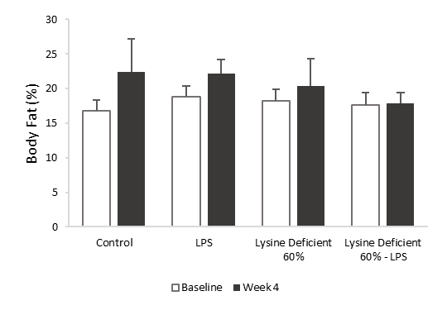

Figure S1. Percentage body fat

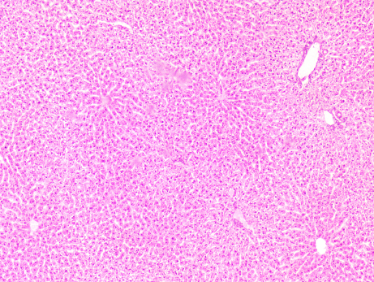
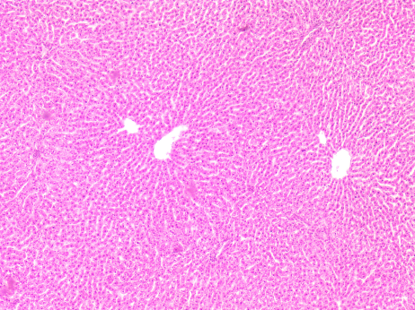
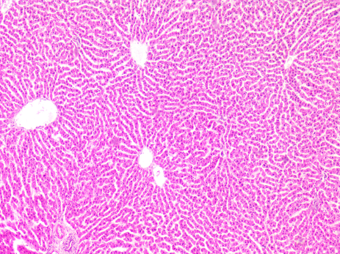
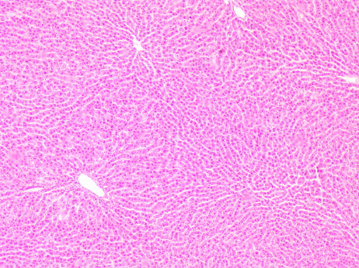
Control
LPS
Lysine Deficient 60%
Lysine Deficient 60% - LPS

Figure S2. Representative H&E staining of liver sections from the different groups of rats
Histopathological appearance of liver sections stained with hematoxylin–eosin (H&E) at ×4 magnification power rats fed a control diet or a 60% lysine deficient diet in the presence or absence of LPS challenge (n = 5 per group). Scale bar represents 100 µm.

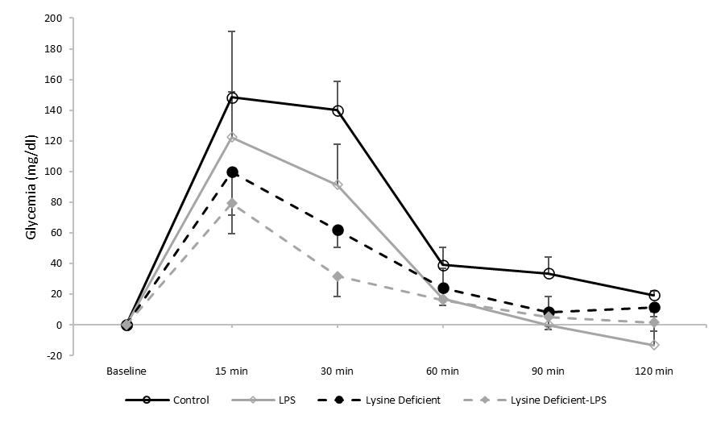
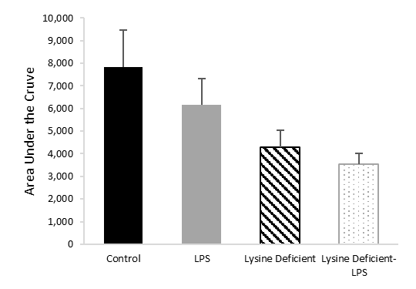
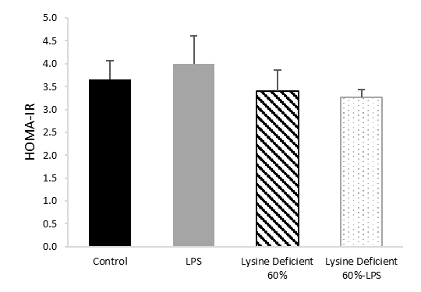
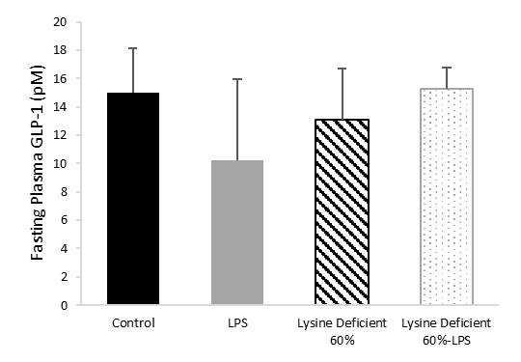
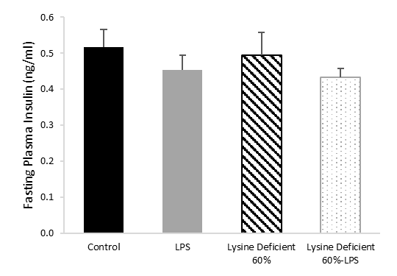
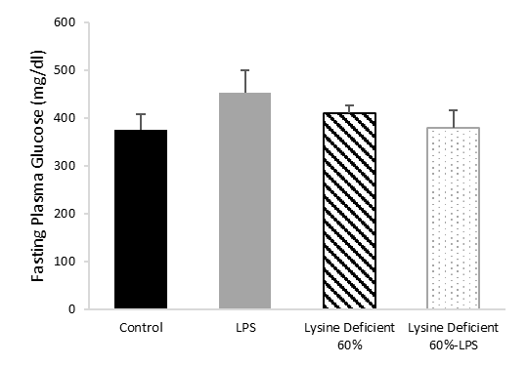
A
B
F
E
D
C

Figure S3. Glycaemic profile of rats
(A) Intraperitoneal glucose tolerance test (IPGTT) (n=4), (B) Area under the curve of the IPGTT, (C) Fasting plasma glucose (n=8), (D) Fasting plasma insulin (n=8), (E) Fasting plasma GLP-1 (n=8), and (F) HOMA-IR index (n=8) were measured in rats fed a control diet or a 60% lysine deficient diet in the presence or absence of LPS challenge.
Data are expressed as mean±SEM and analysed by one-way ANOVA to detect the difference between groups, followed by Fisher's least significant difference (LSD) for post hoc multiple comparisons.
Statistical significance was set at p-value<0.05.

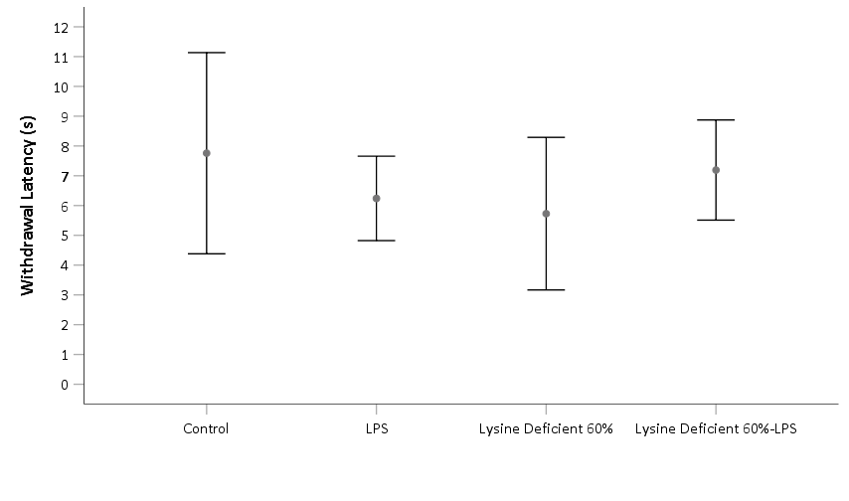

Figure S4. Thermal pain sensation in rats
This heat stimulus was applied thrice per rat, separated by an interval of 5 minutes. The average of the two closest values was reported. Data are expressed as mean±SEM and analysed by one-way ANOVA to detect the difference between groups, followed by Fisher's least significant difference (LSD) for post hoc multiple comparisons.
Statistical significance was set at p-value<0.05.

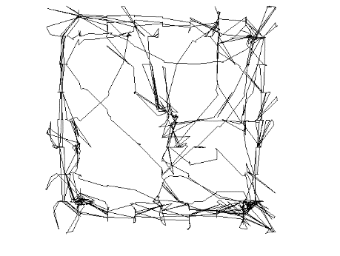
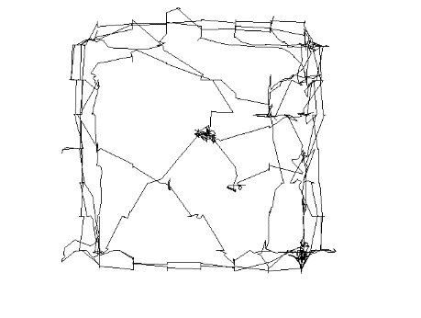
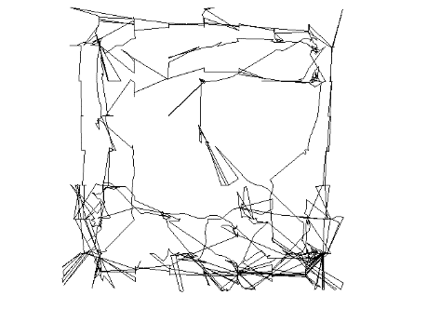
Control
LPS
Lysine Deficient 60%
Lysine Deficient 60%-LPS

Figure S5. Sample trajectory of the group during session 1 of the Open Field Test in rats
The trajectories were recorded for 5 minutes via a video camera connected to the tracking software Smart.

