Distribution of daily protein intake across meals and all-cause mortality in community-dwelling older adults
British Journal of Nutrition
Daniela B. Estrada-deLeón¹, Ellen A. Struijk¹, Francisco Félix Caballero¹, Humberto Yévenes-Briones¹, José Ramón Banegas¹, Fernando Rodríguez-Artalejo^{1,2}, Esther Lopez-Garcia^{1,2}

Online Supplementary Material

Author Affiliations:
1 Department of Preventive Medicine and Public Health. School of Medicine. Universidad Autónoma de Madrid; IdiPaz (Instituto de Investigación Sanitaria Hospital Universitario La Paz); and CIBERESP (CIBER of Epidemiology and Public Health), Madrid, Spain.
2 IMDEA-Food Institute, CEI UAM+CSIC, Madrid, Spain.

Corresponding Author:
Daniela B. Estrada-deLeón
Department of Preventive Medicine and Public Health
School of Medicine
Universidad Autónoma de Madrid
C/ Arzobispo Morcillo, s/n
28029 Madrid, Spain.
Phone number: +34 914 972 371
E-mail: danniestrada@gmail.com

Esther Lopez-Garcia
Department of Preventive Medicine and Public Health
School of Medicine
Universidad Autónoma de Madrid
C/ Arzobispo Morcillo, s/n
28029 Madrid, Spain.
E-mail: esther.lopez@uam.es

METHODOLOGICAL APPENDIX

The Dietary history ENRICA (DH-E) is a computerized questionnaire administered by a trained interviewer. In a first step, the subject is requested to indicate all the foods usually consumed in the previous year. The interview begins with the question: “What do you usually have to eat when you get up?” and continues asking about usual consumption on the six main intake occasions (when getting up, breakfast, mid-morning, lunch, mid-afternoon and diner) and between those occasions, like snacking, before bedtime and going out for a drink. To facilitate reporting of food consumed at lunch and dinner, we asked about the first and second course, dessert, beverage consumption, bread, etc.

During the interview, respondents are asked about food consumption during the week and on the weekend, as well as seasonal variations. All the information refers to a typical week, for which conversion factors are used that consider the weekly frequency of consumption of a food and the number of months in which it is consumed during the year. A food was “usually consumed” when it was eaten at least once every 15 days.

The second part of the interview asks about the food groups that were not reported, and about specific foods that are difficult to report spontaneously, like alcoholic beverages or bread. It begins with questions like “Do you like to eat bread with your meals?” This helps clarify or verify the information on some foods collected in the first part of the interview. The DH-E collects standardized information on 861 foods in the original version, since new foods were introduced after successive waves of diet assessment in the cohort, that can be cooked in 29 different ways. The software includes aids for the correct classification of some foods, and also 127 sets of digitalized photographs to estimate the size of food portions; specifically, for each individual food or food mixture the respondent is presented with photos of three portion sizes (small, large and medium), which allows classification in 7 different sizes. When no photo of a food was available, the amount consumed was estimated with natural units or household measures; the DH-E includes 122 household measures. The amount of oil added to salads or vegetables was evaluated by the respondent’s estimation of the number of spoonful of oil added, or of how oily the foods were.

The DH-E includes 184 recipes for dishes commonly eaten in Spain or typical of each region. The recipes are converted into simple foods based on the proportion and combination reported by the respondent or according to standard compositions. The DH-E collects information on the degree to which foods are processed, calculates the annual frequency of consumption based on seasonal consumption, and applies fat absorption coefficients for foods that are fried, coated, breaded, or sautéed. Furthermore, it automatically converts the foods to nutrients using food composition tables from Spain and other countries. The DH-E also asks about food consumed in association with other foods, but that are not cooked together (e.g. sugar added to coffee). Finally, to facilitate quality control of the diet interview, the DH-E generates alerts when unacceptable values are registered for energy intake, or when foods that are generally part of the main eating occasions are not reported.

Supplementary Table S1. Characteristics of the study participants by sex- specific tertiles of the coefficient of variation of animal protein intake across meals (N= 3225)
 | CV of animal protein intake across meals
 | Tertile 1  (More even distribution) | Tertile 2 | Tertile 3  (Less even distribution) | p-value*
N participants | 1076 | 1075 | 1074
Men range of protein CV | 0.08 – 0.59 | 0.60 – 0.75 | 0.76 – 1.73
Women range of protein CV | 0.01 – 0.58 | 0.59 – 0.75 | 0.76 – 1.62
Age, y | 69.6 ± 6.9 | 68.9 ± 6.4 | 68.7 ± 6.4 | 0.002
Sex, men % | 45.8 | 45.9 | 45.8 | 1.00
Educational level, % |  |  |  | 0.08
≤ Primary | 60.1 | 58.0 | 54.4
Secondary | 21.9 | 23.9 | 24.4
University | 18.0 | 18.1 | 21.2
Smoking status, % |  |  |  | 0.17
Current smoker | 10.4 | 11.2 | 13.7
Former smoker | 30.3 | 29.5 | 29.9
Never smoker | 59.3 | 59.3 | 56.4
Alcohol intake, g/day | 9.5 ± 15.9 | 9.9 ± 17.4 | 10.7 ± 19.1 | 0.28
TV watching, h/week | 18.7 ± 11.5 | 18.4 ± 11.3 | 17.9 ± 11.6 | 0.23
Physical activity,  METs-h/week | 20.7 ± 15.3 | 21.7 ± 15.1 | 21.7 ± 15.2 | 0.27
BMI, % |  |  |  | 0.68
Normal weight | 20.7 | 18.7 | 19.7
Overweight | 47.0 | 49.3 | 46.9
Obesity | 32.3 | 32.0 | 33.4
Baseline diagnosed morbidity, %
Musculoskeletal disease¹ | 51.1 | 51.4 | 48.5 | 0.33
Cardiovascular disease² | 6.2 | 6.1 | 4.8 | 0.27
Cancer | 2.1 | 3.2 | 1.5 | 0.03
Chronic lung disease | 7.0 | 8.4 | 7.6 | 0.47
Depression | 8.8 | 8.1 | 9.4 | 0.56
Incident diagnosed morbidity, %
Cardiovascular disease² | 11.3 | 8.2 | 8.2 | 0.01
Cancer | 4.9 | 5.1 | 5.7 | 0.72
Chronic lung disease | 12.0 | 10.2 | 9.7 | 0.19
Protein, g/day | 91.4 ± 25.4 | 91.9 ± 23.8 | 88.2 ± 25.6 | 0.001
Protein, g/kg/day | 1.26 ± 0.4 | 1.26 ± 0.3 | 1.21 ± 0.4 | 0.001
Breakfast protein, g/day | 19.5 ± 9.8 | 12.8 ± 6.8 | 10.9 ± 7.6 | <0.001
Lunch protein, g/day | 37.5 ± 13.1 | 42.8 ± 14.4 | 45.4 ± 17.0 | <0.001
Dinner protein, g/day | 31.4 ± 11.2 | 33.5 ± 12.8 | 29.2 ± 17.3 | <0.001
Snack protein, g/day | 3.0 ± 5.2 | 2.9 ± 4.6 | 2.7 ± 4.6 | 0.24
Animal protein, g/day | 60.5 ± 20.9 | 61.7 ± 19.6 | 58.5 ± 21.2 | 0.001
Plant protein, g/day | 30.9 ± 10.1 | 30.2 ± 10.0 | 29.7 ± 11.2 | 0.02
Energy, kcal/day | 2059 ± 582 | 2008 ± 553 | 1925 ± 581 | <0.001
Fat, g/day | 83.0 ± 31.6 | 81.1 ± 28.8 | 77.5 ± 30.3 | 0.001
Carbohydrate, g/day | 219 ± 65 | 209 ± 62 | 199 ± 65 | <0.001
MEDAS score | 6.8 ± 1.9 | 7.3 ± 1.7 | 7.3 ± 1.8 | <0.001
Abbreviations: CV, Coefficient of Variation; BMI, Body Mass Index; MET: metabolic equivalent
For continuous variables, mean and standard deviation are reported.
¹ Osteoarthritis, arthritis, and hip fracture.
² Ischemic heart disease, stroke, and heart failure.
*ANOVA test was used for quantitative variables and the chi-square test for categorical variables.

Supplementary Table S2. Characteristics of the study participants by sex- specific tertiles of the coefficient of variation of plant protein intake across meals (N= 3225)
 | CV of plant protein intake across meals
 | Tertile 1  (More even distribution) | Tertile 2 | Tertile 3  (Less even distribution) | p-value*
N participants | 1076 | 1075 | 1074
Men range of protein CV | 0.01 – 0.45 | 0.46 – 0.65 | 0.66 – 1.46
Women range of protein CV | 0.04 – 0.41 | 0.42 – 0.60 | 0.61 – 1.57
Age, y | 69.4 ± 6.7 | 68.7 ± 6.5 | 69.1 ± 6.5 | 0.06
Sex, men % | 45.8 | 45.9 | 45.8 | 1.00
Educational level, % |  |  |  | 0.41
≤ Primary | 56.5 | 56.3 | 59.6
Secondary | 23.2 | 24.7 | 22.2
University | 20.3 | 19.0 | 18.2
Smoking status, % |  |  |  | 0.26
Current smoker | 10.5 | 11.6 | 13.2
Former smoker | 29.6 | 31.3 | 28.9
Never smoker | 59.9 | 57.1 | 57.9
Alcohol intake, g/day | 8.2 ± 14.1 | 10.8 ± 19.0 | 11.1 ± 18.9 | 0.001
TV watching, h/week | 18.3 ± 11.6 | 17.9 ± 11.0 | 18.9 ± 11.8 | 0.12
Physical activity,  METs-h/week | 22.3 ± 14.9 | 21.0 ± 15.1 | 20.8 ± 15.5 | 0.05
BMI, % |  |  |  | 0.001
Normal weight | 21.6 | 18.5 | 18.9
Overweight | 50.0 | 49.0 | 44.2
Obesity | 28.4 | 32.5 | 36.9
Baseline diagnosed morbidity, %
Musculoskeletal disease¹ | 49.9 | 51.6 | 49.5 | 0.59
Cardiovascular disease² | 6.1 | 5.3 | 5.6 | 0.70
Cancer | 2.6 | 2.5 | 1.7 | 0.28
Chronic lung disease | 7.3 | 8.4 | 7.4 | 0.56
Depression | 8.2 | 7.9 | 10.2 | 0.11
Incident diagnosed morbidity, %
Cardiovascular disease² | 10.5 | 8.8 | 8.4 | 0.20
Cancer | 6.0 | 5.9 | 3.9 | 0.06
Chronic lung disease | 10.1 | 12.6 | 9.2 | 0.03
Protein, g/day | 91.9 ± 23.9 | 92.0 ± 25.1 | 87.7 ± 25.7 | <0.001
Protein, g/kg/day | 1.28 ± 0.3 | 1.25 ± 0.3 | 1.20 ± 0.4 | <0.001
Breakfast protein, g/day | 18.5 ± 9.5 | 14.0 ± 7.9 | 10.7 ± 7.5 | <0.001
Lunch protein, g/day | 38.4 ± 14.0 | 43.1 ± 15.2 | 44.2 ± 16.0 | <0.001
Dinner protein, g/day | 32.2 ± 12.5 | 32.1 ± 14.2 | 29.8 ± 15.4 | 0.001
Snack protein, g/day | 2.8 ± 4.7 | 2.9 ± 4.6 | 2.9 ± 5.1 | 0.80
Animal protein, g/day | 59.9 ± 19.6 | 61.5 ± 21.1 | 59.3 ± 21.1 | 0.04
Plant protein, g/day | 32.0 ± 10.4 | 30.5 ± 10.3 | 28.4 ± 10.3 | <0.001
Energy, kcal/day | 2074 ± 584 | 2018 ± 557 | 1901 ± 568 | <0.001
Fat, g/day | 83.8 ± 30.8 | 81.1 ± 29.9 | 76.8 ± 29.9 | <0.001
Carbohydrate, g/day | 223 ± 68 | 210 ± 61 | 195 ± 61 | <0.001
MEDAS score | 6.9 ± 2.0 | 7.2 ± 1.7 | 7.3 ± 1.7 | <0.001
Abbreviations: CV, Coefficient of Variation; BMI, Body Mass Index; MET: metabolic equivalent
For continuous variables, mean and standard deviation are reported.
¹ Osteoarthritis, arthritis, and hip fracture.
² Ischemic heart disease, stroke, and heart failure.
*ANOVA test was used for quantitative variables and the chi-square test for categorical variables.

Supplementary Table S3. Hazard ratios (95% confidence interval) for the association between the coefficient of variation of protein intake across meals by sex- specific tertiles and all-cause death during 10.6-year follow-up, by age subgroups (N= 3225)
 | Coefficient of variation of protein intake across meals |  |  | P- trend
 | Tertile 1  (More even distribution) | Tertile 2 | Tertile 3  (Less even distribution)
Total protein
<75 years (n = 2559) | 1.00 | 1.02 (0.77-1.35) | 0.92 (0.69-1.23) | 0.59
≥75 years (n = 666) | 1.00 | 0.91 (0.68-1.23) | 0.86 (0.63-1.16) | 0.31
Animal protein¹
<75 years (n = 2559) | 1.00 | 0.97 (0.73-1.28) | 0.77 (0.57-1.03) | 0.08
≥75 years (n = 666) | 1.00 | 0.97 (0.72-1.30) | 1.04 (0.77-1.40) | 0.82
Plant protein²
<75 years (n = 2559) | 1.00 | 0.86 (0.63-1.16) | 1.24 (0.93-1.65) | 0.11
≥75 years (n = 666) | 1.00 | 1.11 (0.83-1.49) | 0.83 (0.60-1.15) | 0.27
*p < 0.05; **p < 0.01; ***p < 0.001
¹ Additionally adjusted for the coefficient of variation of plant protein intake across meals.
² Additionally adjusted for the coefficient of variation of animal protein intake across meals.
Cox regression model adjusted for sex, age, protein (quintiles of g/kg/d), educational level (≤primary, secondary, or university), smoking status (never, former, current smoker), alcohol intake (quintiles of g/day), sedentary behavior (tertiles of h/week watching TV), physical activity (quintiles of MET-h/week), BMI (normal weight, overweight, obesity), energy intake (quintiles of kcal/day), MEDAS score (tertiles), baseline morbidity (musculoskeletal disease, cardiovascular disease, cancer, chronic lung disease, and depression), and incident morbidity in 2012, 2015, and 2017 (cardiovascular disease, cancer, and chronic lung disease).

Supplementary Table S4. Hazard ratios (95% confidence interval) for the association between the coefficient of variation of protein intake across meals by sex- specific tertiles and all-cause death during 10.6-year follow-up, by level of protein intake subgroups (N= 3225)
 | Coefficient of variation of protein intake across meals |  |  | P- trend
 | Tertile 1  (More even distribution) | Tertile 2 | Tertile 3  (Less even distribution)
Total protein
< median (n = 1613) | 1.00 | 0.85 (0.64-1.14) | 0.81 (0.61-1.07) | 0.13
≥ median (n = 1612) | 1.00 | 1.02 (0.76-1.37) | 0.91 (0.66-1.24) | 0.57
Animal protein¹
< median (n = 1613) | 1.00 | 0.96 (0.72-1.28) | 0.88 (0.66-1.18) | 0.40
≥ median (n = 1612) | 1.00 | 1.00 (0.75-1.33) | 0.84 (0.61-1.15) | 0.28
Plant protein²
< median (n = 1613) | 1.00 | 0.95 (0.70-1.28) | 0.88 (0.66-1.19) | 0.41
≥ median (n = 1612) | 1.00 | 0.95 (0.71-1.29) | 1.18 (0.87-1.60) | 0.32
*p < 0.05; **p < 0.01; ***p < 0.001
¹ Additionally adjusted for the coefficient of variation of plant protein intake across meals.
² Additionally adjusted for the coefficient of variation of animal protein intake across meals.
Cox regression model adjusted for sex, age, protein (quintiles of g/kg/d), educational level (≤primary, secondary, or university), smoking status (never, former, current smoker), alcohol intake (quintiles of g/day), sedentary behavior (tertiles of h/week watching TV), physical activity (quintiles of MET-h/week), BMI (normal weight, overweight, obesity), energy intake (quintiles of kcal/day), MEDAS score (tertiles), baseline morbidity (musculoskeletal disease, cardiovascular disease, cancer, chronic lung disease, and depression), and incident morbidity in 2012, 2015, and 2017 (cardiovascular disease, cancer, and chronic lung disease).
Median total protein intake: 88.5g; median animal protein intake: 57.8g; median plant protein intake: 29.3g.

Supplementary Table S5. Characteristics of the study participants by tertiles of categories of protein intake per kilogram of weight per meal (N= 3225)
 | Categories of protein intake per kilogram of weight per meal
 | Tertile 1  (0-1 main meal with ≥0.4 g of protein/kg) | Tertile 2  (2 main meals with ≥0.4 g of protein/kg) | Tertile 3  (3 main meals with ≥0.4 g of protein/kg) | p-value*
N participants | 1648 | 1480 | 97
Age, y | 69.6 ± 6.7 | 68.4 ± 6.4 | 69.0 ± 6.8 | <0.001
Sex, men % | 43.4 | 48.0 | 54.6 | 0.008
Educational level, % |  |  |  | 0.75
≤ Primary | 58.1 | 56.9 | 55.7
Secondary | 23.6 | 23.3 | 21.6
University | 18.3 | 19.8 | 22.7
Smoking status, % |  |  |  | 0.78
Current smoker | 11.2 | 12.4 | 13.4
Former smoker | 29.7 | 30.2 | 27.8
Never smoker | 59.1 | 57.4 | 58.8
Alcohol intake, g/day | 9.5 ± 17.4 | 10.6 ± 17.9 | 9.3 ± 14.3 | 0.22
TV watching, h/week | 18.8 ± 11.9 | 17.9 ± 11.0 | 17.1 ± 10.1 | 0.07
Physical activity,  METs-h/week | 20.7 ± 15.1 | 22.1 ± 15.3 | 21.8 ± 14.7 | 0.03
BMI, % |  |  |  | <0.001
Normal weight | 12.4 | 26.8 | 35.0
Overweight | 45.7 | 49.3 | 58.8
Obesity | 41.9 | 23.9 | 6.2
Baseline diagnosed morbidity, %
Musculoskeletal disease¹ | 52.9 | 47.8 | 45.4 | 0.01
Cardiovascular disease² | 5.7 | 5.4 | 9.3 | 0.28
Cancer | 2.1 | 2.4 | 3.1 | 0.77
Chronic lung disease | 8.4 | 7.0 | 6.2 | 0.29
Depression | 9.9 | 7.7 | 6.2 | 0.06
Incident diagnosed morbidity, %
Cardiovascular disease² | 9.8 | 8.6 | 10.3 | 0.49
Cancer | 5.0 | 5.2 | 9.3 | 0.19
Chronic lung disease | 11.0 | 10.5 | 6.2 | 0.32
Protein, g/day | 77.4 ± 19.9 | 103.1 ± 21.8 | 121.5 ± 21.3 | <0.001
Protein, g/kg/day | 1.02 ± 0.2 | 1.46 ± 0.3 | 1.81 ± 0.3 | <0.001
Breakfast protein, g/day | 13.3 ± 7.5 | 14.2 ± 8.9 | 34.6 ± 7.8 | <0.001
Lunch protein, g/day | 37.8 ± 15.0 | 46.4 ± 14.4 | 43.4 ± 13.0 | <0.001
Dinner protein, g/day | 23.6 ± 11.2 | 39.4 ± 12.1 | 40.6 ± 11.6 | <0.001
Snack protein, g/day | 2.7 ± 4.9 | 3.0 ± 4.8 | 3.0 ± 3.5 | 0.19
Animal protein, g/day | 50.4 ± 16.4 | 69.8 ± 19.1 | 81.6 ± 21.5 | <0.001
Plant protein, g/day | 27.0 ± 9.1 | 33.3 ± 10.5 | 40.0 ± 10.8 | <0.001
Energy, kcal/day | 1785 ± 512 | 2194 ± 545 | 2621 ± 486 | <0.001
Fat, g/day | 70.9 ± 27.5 | 89.5 ± 29.7 | 108.5 ± 27.2 | <0.001
Carbohydrate, g/day | 192 ± 58 | 225 ± 64 | 273 ± 72 | <0.001
MEDAS score | 7.0 ± 1.8 | 7.3 ± 1.8 | 6.4 ± 2.1 | <0.001
Abbreviations: CV, Coefficient of Variation; BMI, Body Mass Index; MET: metabolic equivalent
For continuous variables, mean and standard deviation are reported.
¹ Osteoarthritis, arthritis, and hip fracture.
² Ischemic heart disease, stroke, and heart failure.
*ANOVA test was used for quantitative variables and the chi-square test for categorical variables.

Supplementary Table S6. Hazard ratios (95% confidence interval) for the association between tertiles of categories of protein intake per kilogram of weight per meal and all-cause death during 10.6-year follow-up (N= 3225)
 | Categories of protein intake per kilogram of weight per meal |  |  | P- trend
 | Tertile 1  (0-1 main meal with ≥0.4 g of protein/kg) | Tertile 2  (2 main meals with ≥0.4 g of protein/kg) | Tertile 3  (3 main meals with ≥0.4 g of protein/kg)
Total protein | 1648 | 1480 | 97
Multivariable-adjusted  model | 1.00 | 1.17 (0.92-1.47) | 0.95 (0.56-1.64) | 0.43
Cox regression model adjusted for sex, age, protein (quintiles of g/kg/d), educational level (≤primary, secondary, or university), smoking status (never, former, current smoker), alcohol intake (quintiles of g/day), sedentary behavior (tertiles of h/week watching TV), physical activity (quintiles of MET-h/week), BMI (normal weight, overweight, obesity), energy intake (quintiles of kcal/day), MEDAS score (tertiles), baseline morbidity (musculoskeletal disease, cardiovascular disease, cancer, chronic lung disease, and depression), and incident morbidity in 2012, 2015, and 2017 (cardiovascular disease, cancer, and chronic lung disease).

Supplementary Table S7. Characteristics of the study participants by tertiles of categories of protein intake per meal (N= 3225)
 | Categories of protein intake per meal
 | Tertile 1  (0-1 main meal with ≥30 g of protein) | Tertile 2  (2 main meals with ≥30 g of protein) | Tertile 3  (3 main meals with ≥30 g of protein) | p-value*
N participants | 1795 | 1351 | 79
Age, y | 69.8 ± 6.8 | 68.1 ± 6.2 | 68.4 ± 6.1 | <0.001
Sex, men % | 35.3 | 58.2 | 72.2 | <0.001
Educational level, % |  |  |  | 0.32
≤ Primary | 58.9 | 55.3 | 60.7
Secondary | 22.5 | 24.6 | 22.8
University | 18.6 | 20.1 | 16.5
Smoking status, % |  |  |  | <0.001
Current smoker | 10.4 | 13.7 | 11.4
Former smoker | 25.4 | 35.2 | 40.5
Never smoker | 64.2 | 51.1 | 48.1
Alcohol intake, g/day | 8.3 ± 15.7 | 12.2 ± 19.5 | 11.3 ± 16.7 | <0.001
TV watching, h/week | 18.4 ± 11.9 | 18.2 ± 10.9 | 19.3 ± 10.4 | 0.67
Physical activity,  METs-h/week | 20.7 ± 14.9 | 22.4 ± 15.6 | 20.1 ± 14.9 | 0.01
BMI, % |  |  |  | 0.08
Normal weight | 20.6 | 19.1 | 8.9
Overweight | 48.0 | 47.2 | 51.9
Obesity | 31.4 | 33.7 | 39.2
Baseline diagnosed morbidity, %
Musculoskeletal disease¹ | 52.8 | 47.6 | 43.0 | 0.007
Cardiovascular disease² | 5.3 | 6.2 | 5.1 | 0.53
Cancer | 2.2 | 2.2 | 5.1 | 0.24
Chronic lung disease | 8.0 | 7.3 | 7.6 | 0.76
Depression | 9.9 | 7.6 | 3.8 | 0.02
Incident diagnosed morbidity, %
Cardiovascular disease² | 9.7 | 8.8 | 6.3 | 0.46
Cancer | 4.8 | 5.5 | 11.4 | 0.03
Chronic lung disease | 10.5 | 11.0 | 7.6 | 0.63
Protein, g/day | 75.8 ± 17.3 | 107.7 ± 19.7 | 132.2 ± 18.5 | <0.001
Protein, g/kg/day | 1.08 ± 0.3 | 1.44 ± 0.3 | 1.64 ± 0.3 | <0.001
Breakfast protein, g/day | 13.0 ± 7.2 | 14.9 ± 9.2 | 37.7 ± 7.0 | <0.001
Lunch protein, g/day | 36.8 ± 14.1 | 48.3 ± 14.2 | 47.8 ± 14.9 | <0.001
Dinner protein, g/day | 23.3 ± 10.1 | 41.5 ± 11.7 | 43.0 ± 9.1 | <0.001
Snack protein, g/day | 2.6 ± 4.7 | 3.1 ± 4.9 | 3.7 ± 4.7 | 0.01
Animal protein, g/day | 49.1 ± 14.7 | 73.4 ± 17.7 | 91.2 ± 18.5 | <0.001
Plant protein, g/day | 26.8 ± 8.9 | 34.3 ± 10.3 | 41.0 ± 11.5 | <0.001
Energy, kcal/day | 1738 ± 461 | 2295 ± 523 | 2802 ± 524 | <0.001
Fat, g/day | 68.5 ± 25.2 | 94.3 ± 28.8 | 118.8 ± 30.9 | <0.001
Carbohydrate, g/day | 189 ± 56 | 231 ± 64 | 281 ± 76 | <0.001
MEDAS score | 7.0 ± 1.8 | 7.3 ± 1.9 | 6.5 ± 1.9 | <0.001
Abbreviations: CV, Coefficient of Variation; BMI, Body Mass Index; MET: metabolic equivalent
For continuous variables, mean and standard deviation are reported.
¹ Osteoarthritis, arthritis, and hip fracture.
² Ischemic heart disease, stroke, and heart failure.
*ANOVA test was used for quantitative variables and the chi-square test for categorical variables.

Supplementary Table S8. Hazard ratios (95% confidence interval) for the association between tertiles of categories of protein intake per meal and all-cause death during 10.6-year follow-up (N= 3225)
 | Categories of protein intake per meal |  |  | P- trend
 | Tertile 1  (0-1 main meal with ≥30 g of protein) | Tertile 2  (2 main meals with ≥30 g of protein) | Tertile 3  (3 main meals with ≥30 g of protein)
Total protein (n) | 1795 | 1351 | 79
Multivariable-adjusted  model | 1.00 | 1.10 (0.88-1.36) | 1.07 (0.62-1.85) | 0.47
Cox regression model adjusted for sex, age, protein (quintiles of g/kg/d), educational level (≤primary, secondary, or university), smoking status (never, former, current smoker), alcohol intake (quintiles of g/day), sedentary behavior (tertiles of h/week watching TV), physical activity (quintiles of MET-h/week), BMI (normal weight, overweight, obesity), energy intake (quintiles of kcal/day), MEDAS score (tertiles), baseline morbidity (musculoskeletal disease, cardiovascular disease, cancer, chronic lung disease, and depression), and incident morbidity in 2012, 2015, and 2017 (cardiovascular disease, cancer, and chronic lung disease).

Supplementary Figure S1. Flow-chart
Seniors-ENRICA 1 study

Analytical sample

3225 participants
Exclusions

No diet history, energy intake outside the range of ≤800- ≥5000 kcal/d for men and ≤500- ≥4000 kcal/day for women or extremely high protein consumption above the 99.5th percentile of total protein intake (n=242).
No information on tobacco smoking and sedentary behavior (n=31).
Participants who died within the first two years of follow-up (n=20).

2008-2010 ENRICA cohort
12,948 Spanish adults
3518 participants ≥60 years
Seniors-ENRICA
3225 participants ≥60 years

January 31th, 2020
2017
Updated information on incident morbidity

2015
Updated information on incident morbidity

2012
Updated information on diet and incident morbidity

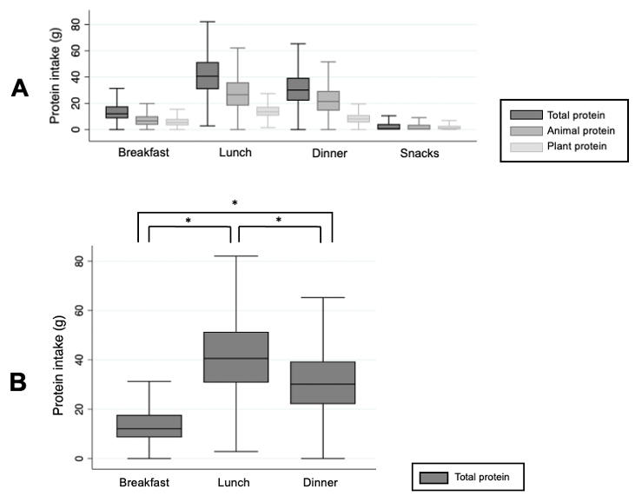

Supplementary Figure S2. Patterns of protein intake across meals. (A) Boxplots of total-, animal-, and plant-protein intake during the main meals. (B) Boxplots of total protein intake during the main meals. Protein intake was lower at breakfast compared to lunch and dinner. Lunch was the mealtime with the highest protein intake. Outliers were excluded. * p < 0.001, based on t test.

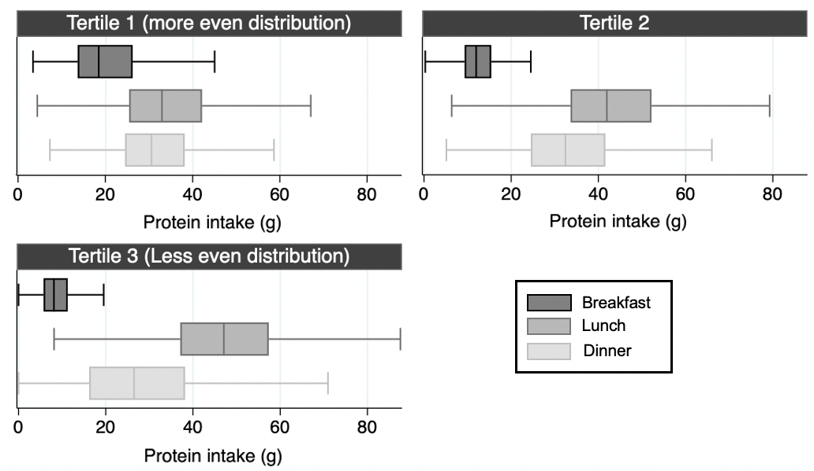

Supplementary Figure S3. Boxplots of protein intake across tertiles of the CV of protein intake across meals. Outliers were excluded.

