Supplemented figure 1

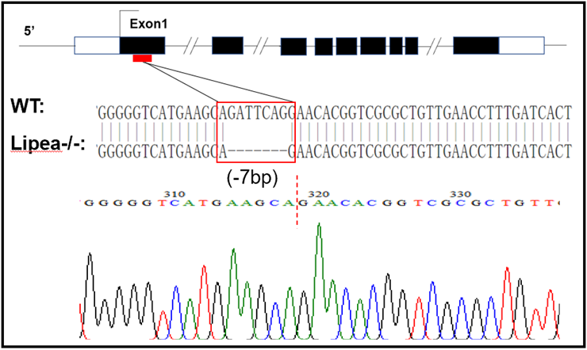

The deletion of -7bp fragment on the target sites in the establishment of hsla-knockout zebrafish line.

