A prospective cohort study of starchy and nonstarchy vegetable intake and mortality risk
Tengfei Zhang,^{1-4a} Zhaohong Peng,^{5a} Hairong Li,^{1a} Shaoxian Liang,¹ Mengfei Liu,¹ Shu Ye,¹ Yong Huang,¹ Yu Zhu,¹ Xiude Li,¹ Danni Wang,⁶ Wanshui Yang^{1-4*}

ªThese authors contributed equally as co-first authors.

*Correspondence: Wanshui Yang, Ph.D., Department of Nutrition, School of Public Health, Anhui Medical University, 81 Meishan Road, Hefei 230032, Anhui, China; E-mail: wanshuiyang@gmail.com; Telephone/Fax: +86-551-65165037.

Supplementary Table 1. The definitions of starchy and nonstarchy vegetables
Foods or food groups | Food items
Starchy vegetables
potatoes | Baked, boiled, mashed, scalloped, and fried potatoes; potato chips; and mixtures having potatoes as a main ingredient, such as potato salad, stuffed baked potatoes, and potato soup, etc.
Other starchy vegetables | Immature peas, lima beans, corn, breadfruit, burdock, cassava, dasheen, green bananas, hominy, jicama, lotus root, parsnips, plantains, salsify, tannier, tapioca, and taro, etc.
Nonstarchy vegetables
Dark-green vegetables | Raw and cooked broccoli and dark green leafy vegetables such as romaine, collards, mustard and turnip greens, kale, and spinach, etc.
Deep-yellow vegetables | Raw and cooked deep yellow or orange vegetables such as carrots, pumpkin, winter squash, and sweet potatoes, etc.
Other nonstarchy vegetables | Tomatoes, lettuce and mixed salad greens, lettuce salad with assorted vegetables, and other lettuce-based salads, etc.

Supplementary Table 2. Sensitivity analyses on the association of starchy and nonstarchy vegetables with risk of all-cause mortality in NHANES (1999-2014)
 | HR (95% CI)
 | 0 servings/day | < 1 serving/day | ≥ 1 servings/day | P _{trend}^{d}
Sensitivity analysis Ⅰ(N = 33,264)ª
Starchy vegetables
No. of deaths/person-years | 1197/119105 | 709/83935 | 723/77218
Multivariable adjusted model^{c} | 1 (Reference) | 0.97 (0.82-1.14) | 0.86 (0.74-1.00) | 0.049
Nonstarchy vegetables
No. of deaths/person-years | 607/55214 | 844/100757 | 1178/124286
Multivariable adjusted model^{c} | 1 (Reference) | 0.83 (0.69-1.00) | 0.73 (0.61-0.88) | 0.008
Sensitivity analysis Ⅱ(N = 38,766)^{b}
Starchy vegetables
No. of deaths/person-years | 1615/136729 | 934/96715 | 1047/90344
Multivariable adjusted model^{c} | 1 (Reference) | 0.98 (0.84-1.13) | 0.89 (0.79-1.01) | 0.070
Nonstarchy vegetables
No. of deaths/person-years | 753/62156 | 1134/114856 | 1709/146776
Multivariable adjusted model^{c} | 1 (Reference) | 0.81 (0.68-0.98) | 0.74 (0.62-0.88) | 0.006
CI, confidence interval; CVD, Cardiovascular diseases; GED, general educational development HR, hazard ratio; METS, Metabolic equivalent tasks; NHANES, National Health and Nutrition Examination Survey.
ª Sensitivity analysis with exclusion of individuals with a history of congestive heart failure, angina pectoris, coronary heart disease, heart attack, stroke, cancer, or diabetes at baseline;
^{b} Sensitivity analysis with exclusion of individuals who had died within 3 years after dietary assessment;
^{c} Multivariable adjusted model was adjusted for sex (male, female), age (18-45, 46-65, ≥66 years), and total energy intake (kcal/day, tertile), race/ethnicity (non-Hispanic white, non-Hispanic black, Hispanic or other race), education (≤ 12th grade, high school graduate/GED or equivalent, or more than high school), marital status (married, widowed/divorced/separated, or never married), ratio of family income to poverty (<1.30, 1.30-3.49, or ≥3.50), physical activity (<8.3, 8.3-16.7, or >16.7 METS-h/week), smoking (never smokers, former smokers, or current smokers), drinking (never drinking, low to moderate drinking, heavy drinking), body mass index (<18.5, 18.5-24.9, 25.0-29.9, and ≥30.0 kg/m²), diabetes (no, yes), hypertension (no, yes), other CVDs (no, yes), and cancer (no, yes), hei-2015 (tertile). Of note, starchy and nonstarchy vegetables were mutually adjusted.
^{d} Linear trend test was conducted by assigning medians to each quintile as continuous variable in the models.

NHANES 1999-2014
N = 82,091
N = 47,356
Individuals were excluded:
- < 18 years (n = 34,735)
N = 40,124
Individuals were excluded:
- had missing dietary data (n = 5,132)
- had implausible energy intake (n = 2,100)
N = 40,074

Individuals were excluded:
- had no linked mortality data (n = 50)

Supplementary Figure 1. Flow chart of selecting participants from the NHANES 1999-2000 cycle to 2013-2014 cycle in this analysis. NHANES, National Health and Nutrition Examination Survey.

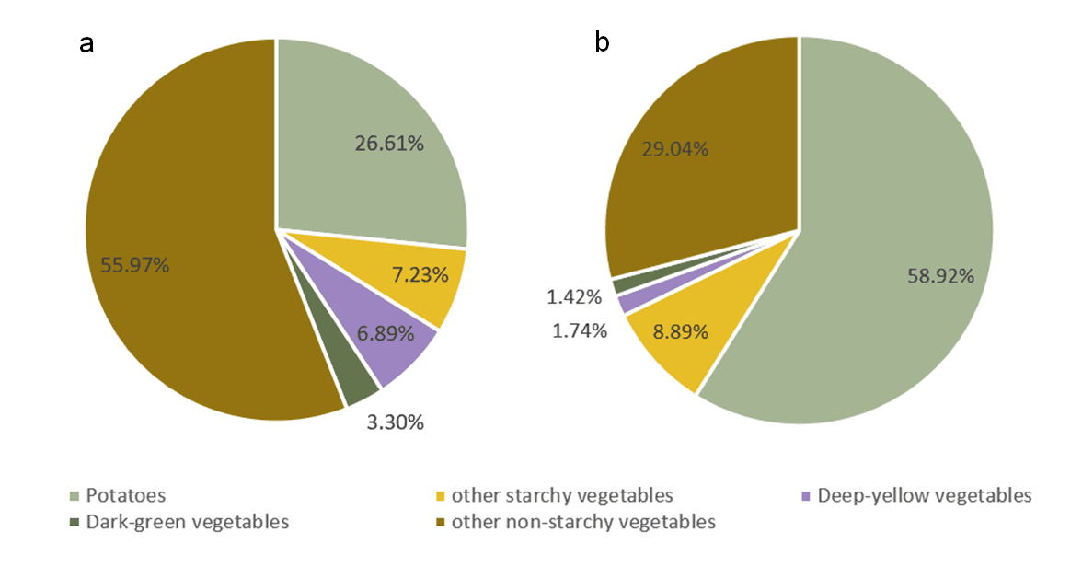
Supplementary Figure 2. Proportion of consumption (a, grams) and energy intake (b, kcal) of five different types of vegetables in the energy intake of total vegetables in NHNAES (1999-2014).
NHANES, National Health and Nutrition Examination Survey.

