Effects of selenium supplementation on glycaemic control markers in healthy rodents: A systematic review and meta-analysis
Ferreira RLU et al.

Supplementary Table S1. Equations used in article searches

EQUATION 1
Population: (Animal Model OR Animal Models OR Model, Animal OR Laboratory Animal Models OR Animal Model, Laboratory OR Animal Models, Laboratory OR Laboratory Animal Model OR Model, Laboratory Animal OR Models, Laboratory Animal OR Experimental Animal Models OR Animal Model, Experimental OR Animal Models, Experimental OR Experimental Animal Model OR Model, Experimental Animal OR Models, Experimental Animal OR Rodentias OR Rodents OR Rodent OR Castor Beaver OR Beavers OR Beaver OR Capybaras OR Capybara OR Hydrochaeris OR Hydrochaeri OR Jerboas OR Jerboa OR Dipodidae OR Rat OR Rattus OR Rattus norvegicus OR Rats, Norway OR Rats, Laboratory OR Laboratory Rat OR Laboratory Rats OR Rat, Laboratory OR Mus OR Mouse OR Mus musculus OR Mice,
Laboratory OR Laboratory Mice OR Mouse, Laboratory OR Laboratory Mouse)
AND
Intervention: (selenium OR selenium 80 OR ‘effects of selenium supplementation’ OR ‘levels of selenium’ OR ‘selenium level’ OR ‘selenium supplementation’ OR selenate OR selenite OR ‘sodium selenate’ OR ‘sodium selenite’ OR ‘selenate doses’ OR Selenite, Sodium OR Selenous Acid Disodium Salt OR Selenous Acid, Disodium Salt OR Disodium Selenite OR Selenite, Disodium OR Sodium Selenite Pentahydrate OR Pentahydrate, Sodium Selenite OR Selenite Pentahydrate, Sodium OR Monosodium Selenite OR Selenite, Monosodium OR Sodium
Biselenite OR Biselenite, Sodium)
AND
Outcomes: (Blood Sugar OR Sugar, Blood OR Glucose, Blood OR Blood Glucose OR Glucose Tolerance Tests OR Intravenous Glucose Tolerance Test OR Intravenous Glucose Tolerance OR Resistance, Insulin OR Insulin Sensitivity OR Sensitivity, Insulin OR insulin OR 'insulin response' OR ‘insulin resistance’ OR ‘Insulin-like’ OR insulinlike OR hyperinsulinaemia OR glucose OR 'glucose metabolism' OR ‘glucose tolerance’ OR ‘glucose transport’ OR hyperglycemia OR hyperglycemias diabetes OR ‘Diabetes Mellitus’ OR ‘Diabetes Mellitus, Type 2’)
AND
Filter: animal models.
EQUATION 2
Population: (Animal Model OR Animal Models OR Model, Animal OR Laboratory Animal Models OR Animal Model, Laboratory OR Animal Models, Laboratory OR Laboratory Animal Model OR Model, Laboratory Animal OR Models, Laboratory Animal OR Experimental Animal Models OR Animal Model, Experimental OR Animal Models, Experimental OR Experimental Animal Model OR Model, Experimental Animal OR Models, Experimental Animal OR Rodentias OR Rodents OR Rodent OR Castor Beaver OR Beavers OR Beaver OR Capybaras OR Capybara OR Hydrochaeris OR Hydrochaeri OR Jerboas OR Jerboa OR Dipodidae OR Rat OR Rattus OR Rattus norvegicus OR Rats, Norway OR Rats, Laboratory OR Laboratory Rat OR Laboratory Rats OR Rat, Laboratory OR Mus OR Mouse OR Mus musculus OR Mice, Laboratory OR Laboratory Mice OR Mouse, Laboratory OR Laboratory Mouse)
AND
Intervention: (selenium OR selenium 80 OR ‘effects of selenium supplementation’ OR ‘levels of selenium’ OR ‘selenium level’ OR ‘selenium supplementation’ OR selenate OR selenite OR ‘sodium selenate’ OR ‘sodium selenite’ OR ‘selenate doses’ OR Selenite, Sodium OR Selenous Acid Disodium Salt OR Selenous Acid, Disodium Salt OR Disodium Selenite OR Selenite,

Disodium OR Sodium Selenite Pentahydrate OR Pentahydrate, Sodium Selenite OR Selenite Pentahydrate, Sodium OR Monosodium Selenite OR Selenite, Monosodium OR Sodium Biselenite OR Biselenite, Sodium)
AND
('glutathione peroxidase 1' OR GPx1 OR glutathione OR ‘Selenium-dependent glutathione peroxidase’ OR ‘overexpression of glutathione peroxidase’ OR overexpression GPx’ OR ‘GPx activity’ OR ‘glutathione peroxidase activity’ OR Peroxidase, Glutathione OR Cytosolic Glutathione Peroxidase OR Glutathione Peroxidase, Cytosolic OR Selenoglutathione Peroxidase OR Peroxidase, Selenoglutathione OR Glutathione Lipoperoxidase OR Lipoperoxidase, Glutathione)
AND
Filter: animal models.

Supplementary Table S2. Extraction form

EXTRACTION FORM
Reviewer:

Included: ( ) YES ( ) NO

1. ARTICLE
Title:
First author:
Year of publication:
Publication identification DOI (Digital Object Identifier):
Journal:
Language:
2. STUDY DESIGN
Design:
Number of groups:
Allocation of groups:
Animal class:
Sex:
Age:
3. INTERVENTION
Supplement:
Dosage:
Frequency:
Exposure time:
4. CONTROL
Basal diet:
Dosage:
Frequency:
Exposure time:
5. OUTCOMES
Glycemic markers
fasting blood glucose
TOTG
serum insulin
HOMA-IR
Selenium status biomarkers
GPx expression/activity
SELENOP Activity
GPx concentration (plasma, tissues, erythrocytes)
SELENOP concentration (plasma, tissues, erythrocytes)
Selenium concentration (plasma, tissues, erythrocytes, urine)

Supplementary Figure S1. Summary of risk of bias of included studies using the SYRCLE tool.

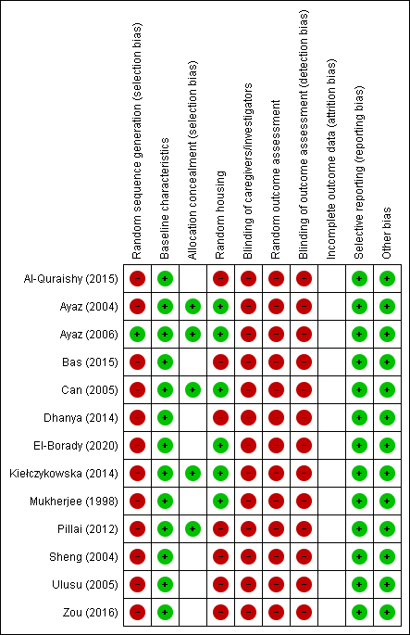
+ Low risk of bias
? Unclear risk of bias
- High risk of bias
?
?
?
?
?
?
?
?
?
?
?
?
?
?
?
?
?
?
?
?
?

Supplementary data

Supplementary Table S3. Summary of The Collaborative Approach to Meta-Analysis and Review of Animal Data from Experimental Studies (CAMARADES) tool.

